Estimating abundance of Roosevelt elk to improve species management.
Tristen Brush, Joanna Burgar, Daniel Guertin
Abstract
Aerial surveys are often used to estimate ungulate population abundance, an indicator which informs objective setting, harvest allocation and habitat protection decisions. Where populations are scarce or difficult to view from the air, abundance estimates may be derived from combining minimum count data with a sightability correction factor that is informed by professional expertise. However, these estimates tend to be highly variable, subject to bias, and do not include estimates of precision. We aimed to determine whether a Bayesian beta-binomial model with data augmentation could precisely estimate abundance of Roosevelt elk (Cervus canadensis roosevelti; hereafter 'elk'), a herd ungulate which is found in a mosaic of open and forested habitats from valley bottoms to steep mountainous terrain. The study area comprised the southern coast of British Columbia where elk are subject to limited-entry hunt and a subset of elk are radio-collared. We tested the model on field-collected minimum count survey data to assess the precision of the resulting estimates and their agreement with existing expert-informed ('standard') estimates. Radio-collared elk were observed in 77 sightability trials conducted during annual surveys in 2021, 2022 and 2023, which revealed a significant inverse correlation between estimated visual obstruction and detection probability. We paired 2021-2023 sightability trial observations with operational survey observations from 2016 through 2020 to estimate annual elk abundance in 26 management units from 2016 through 2023. The model was run on two datasets: the combined dataset included data from years where sightability trials were not conducted (2016-2020) while the sightability-only dataset excluded this data (2021-2023 only). Model performance on both datasets met our thresholds for acceptance. Mean estimate precision was best in the sightability-only dataset results (median CV = 0.139), but method agreement was greatest in the 2021-2023 estimates from the combined dataset results (CCC = 0.937, bias = +2.35). We show that including observations from prior years when sightability trials were not conducted has variable effects on agreement but tends to lower precision. The findings demonstrate that the beta-binomial model offers a reliable and replicable method for estimating elk abundance, essential for resource managers requiring an effective and feasible method for accurately and precisely measuring ungulate abundance.
Keywords: aerial survey, marked animals, ungulates, data augmentation, Bayesian, sightability model

Introduction
Effective conservation and management of any species of interest requires unbiased and precise population estimates. Aerial surveys were popularized in the 1940s to census ungulates in North America, and the practice continues today (Buechner et al., 1951; Hunter and Yeager, 1949). However, dense tree cover, rugged terrain, and wide-ranging species often prevent a complete census, requiring biologists to estimate population abundance. Ungulate abundance estimates are often derived from minimum count aerial surveys with informal corrections for sightability (McCorquodale et al., 2013; Noyes et al., 2000; Quayle et al., 2001; Resources Information Standards Committee, 2002; Steinhorst and Samuel, 1989), a method which exposes estimates to bias and offers no measures of precision. Furthermore, this method—hereafter the ‘correction factor’ method—relies on location-specific expertise of the species resulting from decades of survey experience, introducing concern when such expertise is no longer available (e.g., in the event of staff turnover). As such, there is a clear need for a reliable and replicable approach to estimating ungulate abundance with precision.

Sightability models are statistical models that attempt to estimate the proportion of animals missed on a survey and thus estimate the true population abundance. Since their invention in the 1970s, sightability models have been constantly developing. Steinhorst and Samuel’s (1989) modified Horvitz-Thompson model is a popular design-based estimator that makes use of radio-tagged animals. In “sightability trials,” surveyors perform an initial survey for a given area without using radiotelemetry, recording all observations of their target species and identifying any tagged animals seen. After their initial survey, telemetry is enabled on the aircraft and surveyors search for tagged individuals that were missed on the initial survey. Covariates such as group size and visual obstruction are collected with each observation so that their relationship with detection probability can be modelled. The resulting model is applied to initial survey data to derive abundance estimates. Unfortunately, design-based estimators like this one often underestimate and skew variance measures, limiting their effectiveness (Fieberg et al., 2013; Fieberg and Giudice, 2008)
As an alternative to design-based estimators, Bayesian model-based estimators have become more accessible with recent advancements in computational processing speeds and capabilities (Fieberg et al., 2013). Little (2008) notes that estimates produced from Bayesian modelling are typically similar to those of design-based models, though Bayesian approaches boast numerous added benefits. Their ability to incorporate stratification and random effects makes them better suited to the small sample sizes typical of aerial ungulate surveys, vastly improving estimate precision. Further improvements to precision are afforded by the option to include informative priors. Fieberg et al. (2013) developed a Bayesian alternative to Steinhorst and Samuel’s approach, following the same general survey methodology. Using a data augmentation approach adapted from Dorazio et al. (2006) and Royle et al. (2007), Fieberg et al. applied two Bayesian models to two years of moose survey observations in Minnesota. They found that both models resolved the variance issues introduced by the Steinhorst and Samuel model, and their beta-binomial model achieved the best fit and greatest precision of the two Bayesian models tested.
For decades, the abundances of elk in BC have been estimated using the correction factor method (FLNRO, 2015). These estimates have faced scrutiny in recent years due to their direct effect on government-set harvest allotments, especially as they relate to First Nations’ rights to cultural practice under UNDRIP (United Nations Declaration on the Rights of Indigenous Peoples (UN General Assembly, 2007); signed into BC law (SBC, 2019) and Canadian law (SC, 2021)).
Our study applies Fieberg’s beta-binomial model to eight years of Roosevelt elk (Cervus canadensis roosevelti; hereafter 'elk') survey observations collected in the South Coast region of BC. We aimed to expand on the findings of Fieberg et al. (2013) by testing model performance on a larger dataset of a herd ungulate species living in a mosaic of densely forested habitat, clear-cuts, and steep terrains. We compare estimates with those derived from the correction factor method (Fish and Wildlife Branch, 2015) and explore the effects of including survey data from years before the implementation of sightability trials. In doing so, we endeavoured to determine the feasibility of incorporating model estimates into future elk management decisions and provide a roadmap to managers hoping to begin employing a similar technique. These objectives serve our larger goal of providing land and resource managers with a reliable and feasible method for accurately and precisely monitoring wildlife populations to better inform objective-setting, harvest allocation, and habitat protection.

~Importance of good estimates to conservation/sustainable use balance~
~Importance for habitat protection, conflict management~

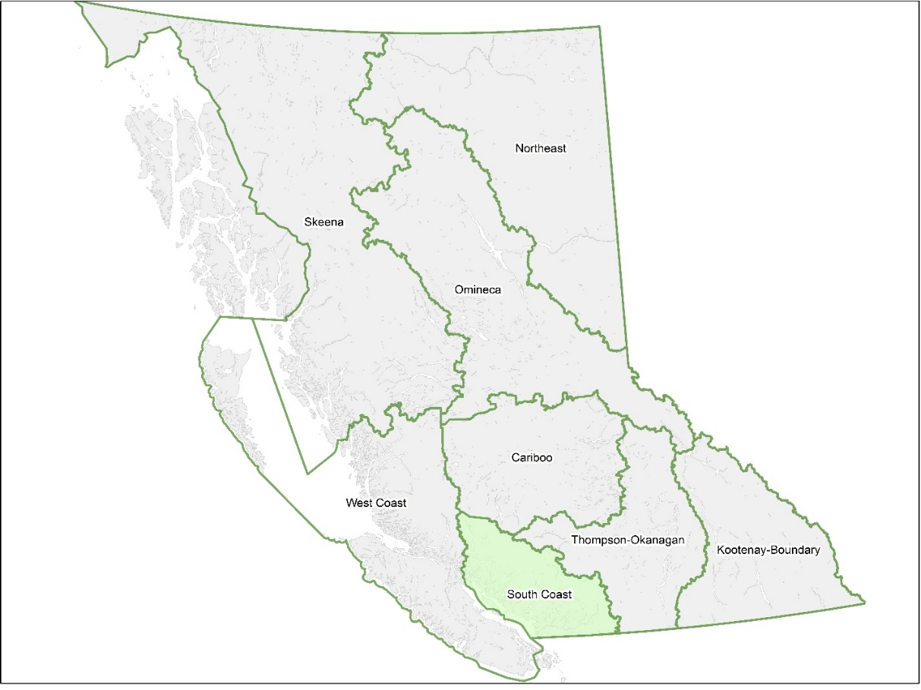
Fig. 1. British Columbia resource management regions as defined by the provincial government.

Methods

Study area
Elk population units (EPUs) are defined areas where Provincial biologists monitor and manage elk. EPU boundaries typically follow major watershed boundaries with modifications to account for known elk distribution, habitat use and movement (FLNRO, 2015). Roosevelt elk range is limited to the South Coast and West Coast natural resource regions as defined by the provincial government (Fig. 1). Within these regions, 149 EPUs are delineated, of which 113 have population estimates greater than zero as of 2018 (Fig. 2). Our study took place in the South Coast region, which contains 35 of the occupied EPUs. Our study includes surveys of 26 of these EPUs, ranging in size from 314 km² to 2,445 km² (mean = 801 km², median = 507 km²; Fig. 3). These areas have mean elevations ranging from 247m (Sechelt Peninsula) to 1,730m (Southgate; mean of means = 865.680 m ± 374.233 SD; GeoBC, 2014). Coastal Western Hemlock forests dominate this region, creating a landscape of dense vegetation cover.

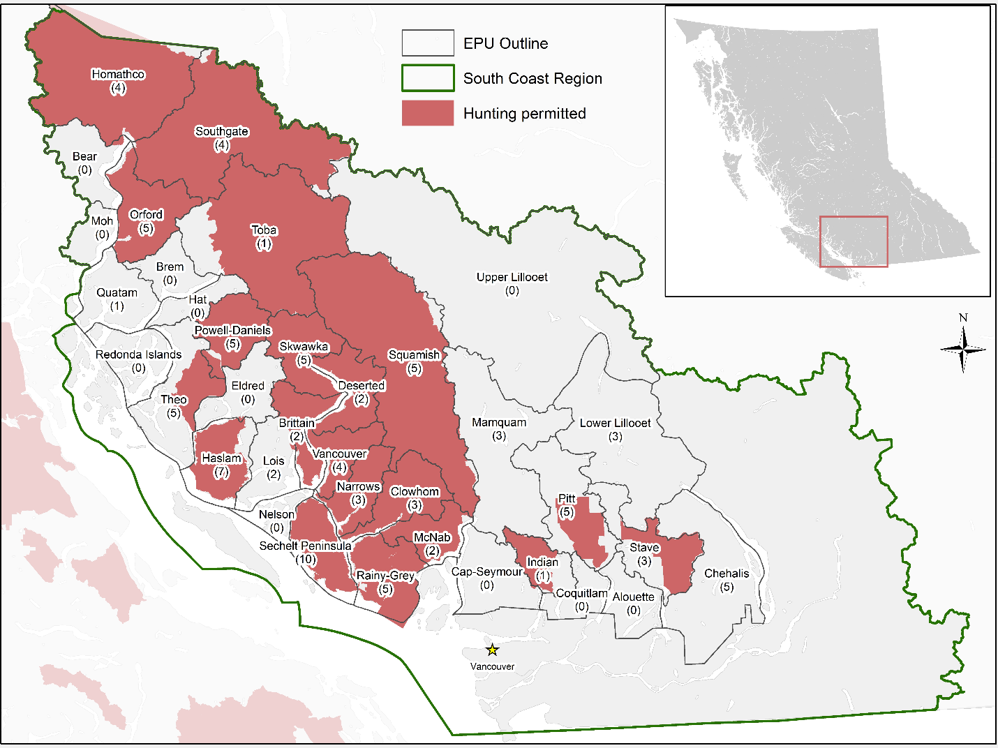
Fig. 2. Occupied Roosevelt elk population units in British Columbia’s South Coast natural resource management region and their 2023 hunting status. The number of active collars as of spring 2023 is given in parentheses.

Survey protocol
Since 2015, provincial biologists have opportunistically captured and fitted free-ranging elk with global positioning system (GPS) collars from Vectronic Aerospace (SURVEY model) during annual aerial inventory surveys. In spring 2021, 80 collars were in operation on 68 female elk and 12 males across 23 EPUs. As of spring 2022, 88 collars on 70 females and 18 males were active in 22 EPUs. In summer 2023, 96 elk (80 females and 16 males) had active collars in 25 EPUs (Fig. 3). The sex composition of collared elk in each year (mean 21 bulls per 100 cows) is similar to the expected sex composition of a stable population (20-25 bulls per 100 cows; (Fish and Wildlife Branch, 2015)) and thus is assumed to be a representative sample of the adult elk population in the South Coast. All 26 EPUs surveyed since 2016 have between 1 and 10 collared elk (mean = 3.83 ± 2.034 SD) except for the Brem and Eldred EPUs (Fig. 3). Mamquam is the only EPU with active collars that has not been surveyed since before 2016.
Inventory surveys of occupied South Coast EPUs occur on a variable schedule, prioritizing EPUs with hunting pressure, populations of concern, or high stakeholder interest. From 2016 through 2023, biologists surveyed 26 EPUs between 1 and 7 times (mean = 3.85 ± 0.29 SE). All surveys occurred between February and April. Surveying at this time of year allowed biologists to take advantage of remaining snow-cover to better spot elk, as well as elk gathering in locations of early forage, and males having yet to drop their antlers.
Sightability trial methods were adapted from Quayle et al. (2001) and McCorquodale et al. (2013) and consisted of inventory surveys and telemetry-assisted follow-up surveys. For the inventory surveys, elk were systematically searched for following provincial standards (RISC, 2002). When an observer spotted an elk, the helicopter circled the group, and observers recorded animal and habitat data (Table 1). Observers scrutinized the group for radio-collared elk and, if sighted, the telemetry system was activated to identify the collared individual(s). Once all data were collected, the telemetry system was deactivated, and the inventory survey protocol resumed. When the entire EPU had been surveyed and data collected for all observed elk, the telemetry system was reactivated, and the telemetry-assisted follow-up surveys began. Observers used telemetry to precisely locate elk previously missed on that day’s inventory survey. Once located, the same animal and habitat data were collected. If missed groups were in thick cover, the radio signal was pinpointed, and observers collected habitat data for the estimated location. When the group could be easily herded into nearby openings or sparser cover, the animal data for the group were also recorded. Where herding was not feasible, observers used database records to record animal data for the collared individual only. We observed 37 collared individuals in 2021, 19 in 2022, and 21 in 2023 for a total of 77 records in the sightability dataset.
Table 1. Animal and habitat data recorded during inventory and telemetry surveys. In addition, the date, EPU surveyed, light intensity (flat / bright), helicopter make / model and surveyors names and roles were recorded for each survey. Location data was also recorded for each observation.
Variable | Description
Survey type | Method of observation: Incidental / Inventory / Telemetry
Cows | Count of cows in group
Calves | Count of calves (<1 year) in group
Spikes | Count of spikes (yearling males) in group
Bulls | Count of bulls (>2 years) in group
Unclassified | Count of unclassified elk in group
Group Size | Total count of elk in the group
Visual obstruction | Proportion (from 0 to 1) of area around first sighted elk (~10m radius) where vision to ground-level is obstructed; following Unsworth et al. (1991) figures for evaluating vegetation cover.
Activity | Activity of first elk sighted at time of sighting:  Standing / Moving  Bedded
Habitat Category | Primary habitat within 10m radius of first elk sighted:  Non-forest (Riparian, field, wetland, road, etc.)  Young Forest (Cut block, deciduous)  Mature forest
Collars | Number of collars seen in group
Collar ID | If applicable, collar serial number(s)

We organized the data collected from sightability trials in 2021-2023 and inventory surveys in 2016-2020 into two datasets. The first dataset only included data from years where sightability trials were run (2021-2023; hereafter the “sightability-only dataset”), and the second dataset included survey data from prior years when sightability trials were not conducted (2016-2020) in addition to sightability trial years (hereafter the “combined dataset”). By comparing model outputs from these two datasets, we aimed to determine how including survey data from years when sightability trials were not performed affects estimate agreement, precision, and model performance.
We conducted an additional analysis using only the first year of sightability trial data (2021) to determine how the model performs with less sightability information. We modelled three more datasets: 2021-only, 2018-2021, and 2016-2021, comparing the 2021 output from each model. In doing so we aimed to make a recommendation on whether prior year survey data should be included to reduce bias and improve precision when only one year of sightability trial data is available (i.e., when using this methodology for the first time).

Statistical analysis
We used a beta-binomial model developed by Fieberg et al. (2013) to model detection probabilities as a function of covariates, as informed by sightability trial data. Observations were included in the sightability trial dataset only if the group contained a collared elk. Groups with collared elk were considered ‘detected’ if observed without telemetry assistance, and ‘undetected’ otherwise. We conducted correlation tests to identify relationships between detection probability and four variables: visual obstruction, group size, elk activity at first sighting, and habitat type. Visual obstruction and group size, being quantitative variables, underwent a Welch two-sample t-test (Welch, 1947) to detect significant differences between variable values of detected observations and those of undetected observations. As categorical variables, elk activity and habitat type underwent Pearson’s chi-squared test to determine correlation significance. We used the t.test and chisq.test functions in base R to carry out the correlation analyses (R Core Team, 2024). Variables significantly correlated with detection were included as model covariates.
Given a covariate value ${\hat{x}}_{l}$ of the lth sightability trial observation, the detection function models the likelihood of detection, $g_{l}$, as
$$logit\left(g_{l}\right)= γ_{0}+ γ_{1}{\hat{x}}_{l}$$
where $γ_{0}$ and $γ_{1}$ are vague priors normally distributed with mean 0 and variance 10.
Each EPU was considered to be one subunit for the sake of modelling. As EPUs encompass entire watersheds with both high- and low-quality elk habitat, we found it inappropriate to describe each subunit as belonging to a low-, medium-, or high-density stratum as Fieberg et al. did. We instead deemed it more useful to stratify our data by age and sex class, as this would allow us to produce robust class ratio estimates (e.g. calves per 100 cows and bulls per 100 cows) which are necessary for effective elk management. Abundance was therefore calculated for five strata: cows, calves, spikes (yearling males), bulls, and unclassified elk. Total abundance was calculated by summing all strata.
We followed a data augmentation scheme developed by Dorazio et al. (2006) and Royle et al. (2007). The dataset was augmented with $B_{h}- m_{h,i}$unobserved records, where $m_{h,i}$ is the number of animal groups observed in the ith subunit and hth stratum in one survey year and${ B}_{h}$ is a stratum-specific value larger than the maximum number of observations in any given EPU in one year. Because EPUs were surveyed exhaustively, we could assume that $m_{h,i}$ was near the true number of elk groups in each subunit. Thus, we did not use an additional model to satisfy the requirement that$B_{h}$ is greater than the true number of groups. We let ${ B}_{h}$ vary by stratum, so that:
$$B_{h}=\left\{\begin{aligned}max \left(m_{h,i}\right)*2, \\ max \left(m_{h,i}\right)*2+10,\end{aligned}\right. \begin{matrix} \text{if} max \left(m_{h,i}\right) ≥5 \\ \text{otherwise}\end{matrix}$$
In the sightability-only dataset our $\max\left(m_{h,i}\right)$ values were 15, 7, 13, 12, and 3 for the cow, spike, calf, bull, and unclassified strata respectively. For this dataset, $B_{h}$ was therefore set to 30, 14, 26, 24, and 16. The combined dataset had $\max\left(m_{h,i}\right)$ of 13, 8, 13, 16, and 3 for each stratum, leading to $B_{h}$ values of 26, 16, 26, 32, and 16 respectively.
The probability that each augmented data record was a part of the study population was modelled as $ψ$, a zero-inflation parameter where:
$$ψ_{h,i} \sim \text{beta }(a_{h}, b_{h})$$
Diffuse hyperpriors were specified for $a_{h} \text{and} b_{h}$ using a gamma distribution with shape =1 and rate = 0.01. See Fieberg et al. (2013) for further details on model formulation.
We applied the modelled sightability function to an operational dataset containing all inventory survey observations (including groups with and without collared individuals). Preliminary analysis showed major discrepancies between model and standard estimates when a large proportion of total observations were telemetry-assisted. Excluding all telemetry observations from the operational dataset produced unreasonably low estimates (e.g., estimates below the minimum count) and including all telemetry observations produced unreasonably high estimates (e.g., lower 95% confidence limits above the standard point estimate). Therefore, we chose to include telemetry-assisted observations only when doing so would bring the current year’s mean group size closer to the total mean for that EPU across all survey years. Incidental observations were not included in either dataset.
We ran the model in JAGS (Plummer, 2003), interfaced through the statistical program R (R Core Team, 2024) using the rjags package (Plummer, 2023). Three chains were run for 40,000 iterations with 50% thinning and the first 20,000 iterations were discarded as burn-in.
We evaluated model performance by assessing convergence. Convergence was determined using the Gelman-Rubin convergence diagnostic ($\hat{R}$; (Gelman and Rubin, 1992) and visual inspection of trace plots, autocorrelation plots, running means and marginal density plots. We deemed model performance acceptable when $\hat{R}<1.1$ and plots showed appropriate mixing of chains.
Model estimates were evaluated based on precision and agreement with standard estimates. We used coefficient of variation (CV) to measure precision, while agreement was evaluated using Lin’s (1989) concordance correlation coefficient (CCC) and Bland-Altman limits of agreement (Bland and Altman, 1999). We considered estimates precise if the coefficient of variation (CV) was at or below 0.2, as is common in population estimation (Efford and Boulanger, 2019; Pollock et al., 1990; Schmidt et al., 2022). To interpret agreement diagnostics, we referenced Pacheco et al. (2013) who reported a mean CCC (N=18) of 0.80. We considered values above 0.8 to be acceptable, but primarily assessed agreement in relative terms.

Results

Sightability covariates
In testing correlations between detection and (1) visual obstruction, (2) elk group size, (3) elk activity and (4) habitat type, only visual obstruction produced a correlation with a p-value < 0.05. Visual obstruction (VOC) was significantly greater in the undetected observations (mean 0.602 ± 0.281 SD) compared to detected observations (mean 0.346 ± 0.309 SD). VOC was thus chosen as the sole covariate used in the model.
Table 2. Correlation between sightability (1 if observed without telemetry assistance, 0 if observed with) and four observation-specific variables: visual obstruction (VOC; 0 to 1 where 0 is no obstruction), elk group size, activity of first elk spotted (bedded vs. standing/moving), and habitat (categorical by forest age). A p-value < 0.05 indicates significance.
Variable | Method | Statistic | df | p
VOC | Welch Two Sample t-test | 3.795 | 71.41147 | >0.001
Group size | Welch Two Sample t-test | -1.408 | 67.22084 | 0.164
Activity | Pearson's Chi-squared test with Yates' continuity correction | 0.034 | 1 | 0.854
Habitat | Pearson's Chi-squared test | 2.215 | 2 | 0.330

The correlation between detectability and group size (undetected: mean 14.829 ± 10.447 SD; detected: mean 18.639 ± 12.951 SD) was not significant. Activity was similar between the two datasets with 18.91% bedded in the undetected dataset and 23.53% bedded in the detected dataset. Lastly, differences in habitat types were not significant with non-forest, young forest, and mature forest making up 13.16%, 26.84%, and 50.00% of observations respectively in the undetected dataset and 25.00%, 38.89%, and 36.11% of observations in the detected dataset. Each variable’s relationship with sightability is visualized in Appendix B.

Model results
The 8-year dataset was modelled to produce 99 abundance estimates with confidence (Appendix A). All models converged with $\hat{R}$ < 1.1 and visual inspections of convergence plots showed sufficient mixing, suggesting that model performance was adequate. Of 99 CV values, only 30 were at or below the 0.20 cutoff. CV values showed a strong negative correlation (y = -0.106ln(x) + 0.661; R² = 0.931) with the number of animals directly observed in the respective EPU and survey year (Fig. 5).

Fig. 5. Coefficient of variation as a function of animals counted annually in 26 elk population units from 2016-2023 (N = 99) with a logarithmic trendline (y = -0.106ln(x) + 0.661; R² = 0.931).
Modelling the 3-year dataset produced 34 abundance estimates from 23 EPUs, all converging with $\hat{R}$ < 1.01. Visual inspection of convergence plots suggested adequate model performance. Of 34 CV values, only 9 were at or below 0.20. We identified a strong negative correlation (y = -0.119ln(x) + 0.7214; R² = 0.955) between number of animals directly observed and CV (Fig. 6).

Fig. 6. Coefficient of variation as a function of animals counted annually in 23 population units from 2021-2023 (N = 34) with a logarithmic trendline (y = -0.119ln(x) + 0.7214; R² = 0.955).
Bland-Altman agreement tests between standard and modelled estimates showed a mean bias of +13.29 (95% CI = 7.87 to 18.72) and limits of agreement at -40.05 (90% CI = -46.19 to -33.90) and +66.63 (90% CI = 60.49 to 72.78; Fig. 7). When evaluated individually by year, CCC values ranged from 0.767 (2017) to 0.979 (2022) with median 0.905. Agreement with standard estimates was slightly better for the 3-year output with an estimated bias of +12.76 (95% CI = 2.07 to 23.46). Limits of agreement were -47.29 (90% CI = -59.37 to -35.20) and +72.82 (90% CI = 60.73 to 84.90; Fig. 8). Annual CCC values were between 0.904 (2023) and 0.922 (2022) with median 0.917 (2021).
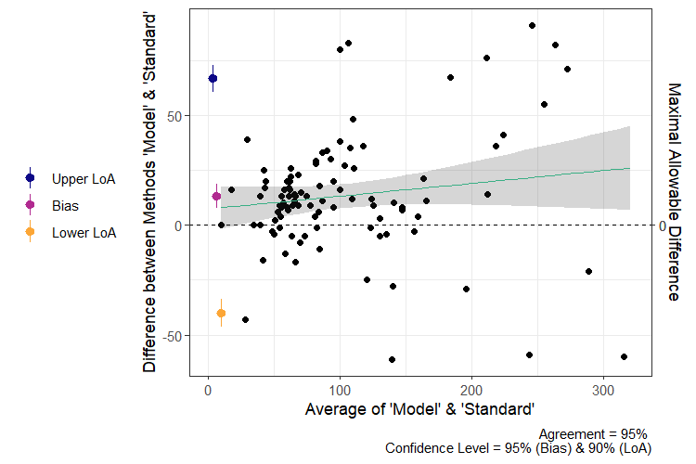
Fig. 7. Bland-Altman plot of elk population abundance estimates from 2016-2023 with trendline (green) and associated confidence (grey shaded).
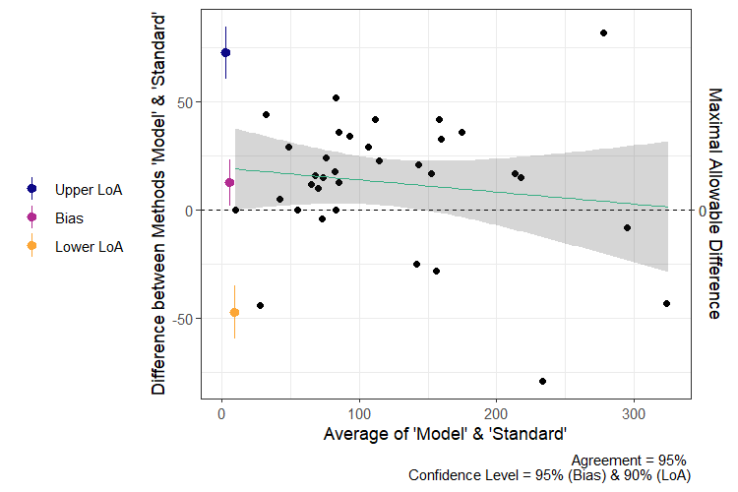
Fig. 8. Bland-Altman plot of elk population abundance estimates from 2021-2023 with trendline (green) and associated confidence (grey shaded).

Dataset comparison
To determine whether including prior year surveys (i.e., 2016-2020) improves model estimates for recent years (2021-2023), we subset the 2021-2023 estimates from the 8-year dataset output to compare with output from the 3-year dataset. The $\hat{R}$ diagnostics of the subset were significantly higher than those of the 3-year output (mean difference = 0.006; t = -6.35, df = 33, p < 0.001). The 2021-2023 estimates from the 8-year output also had higher CVs than the 3-year dataset output, though not significantly (mean difference = 0.023; t = 1.036, df = 33, p = 0.308).
Total agreement was slightly greater in the 2021-2023 subset compared to the 3-year dataset output, with an estimated bias of -0.971 (95% CI = -10.60 to +8.654), and limits of agreement at -55.04 (90% CI = -65.92 to -44.16) and +53.10 (90% CI = 42.21 to 63.98; Fig. 9). Annual CCC values were greater in the subset than the 3-year output with range 0.914 (2021) to 0.979 (2022) and median 0.947 (2023).
Dataset | N | Median $\hat{R}$ (Range) | Median CV (SD) | CCC (95% CI)
2016-2023 | 99 | 1.010 (1.001 – 1.066) | 0.234 (0.087) | 0.897 (0.852 – 0.929)
2021-2023 | 34 | 1.002 (1.001 – 1.006) | 0.243 (0.112) | 0.915 (0.839 – 0.956)
2021-2023 subset | 34 | 1.008 (1.002 – 1.024) | 0.217 (0.107) | 0.938 (0.883 – 0.968)

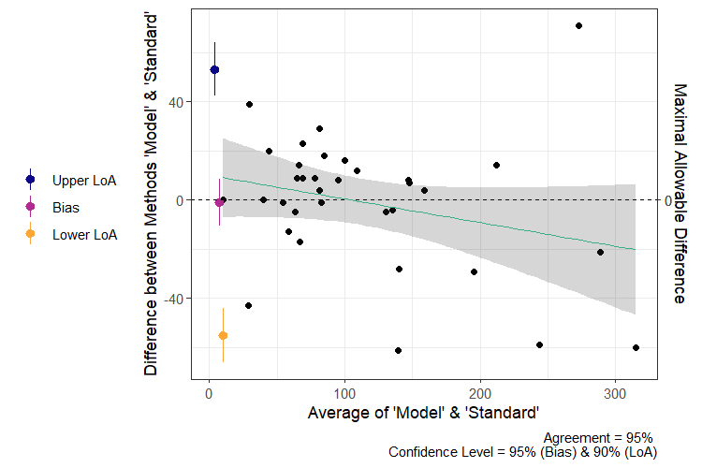
Fig. 9. Bland-Altman plot of elk population abundance estimates from 2021-2023 with trendline (green) and associated confidence (grey shaded), modelled using survey data from 2016-2023.
Lastly, we evaluated the effect of including prior years’ data on the current year estimate when only one year (37 trials) of sightability data is available. The convergence diagnostics for 2021 estimates were best when prior years were excluded from modelling (Table 3). Similarly, 2021 estimate agreement was highest in the 2021 only dataset output. For this dataset, estimated bias was -12.93 (95% CI = -28.97 to +3.11) with limits of agreement at -67.38 (90% CI = -90.42 to -44.35) and +41.53 (90% CI = 18.49 to 64.56). With three prior years included (2018-2021 dataset), the 2021 bias was -25.79 (95% CI = -43.33 to -8.24) with limits of agreement at -85.34 (90% CI = -110.539 to -60.15) and +33.77 (90% CI = 8.579 to 58.97). Finally, with 5 prior years included (2016-2021 dataset), the 2021 bias was -24.29 (95% CI = -42.87 to -5.70) and limits of agreement at -87.38 (90% CI = -114.07 to -60.69) and +38.81 (90% CI = 12.12 to 65.49; Fig. 10). Precision in 2021 was best in the 2018-2021 dataset output, while it was worst in the 2021-only dataset. CV values for 2021 were significantly different between the 2021-only output and each of the other two outputs, with the greatest mean difference between the 2021-only and 2018-2021 datasets (0.0439; t = 6.0775, df = 13, p < 0.001). The 2021-only and 2016-2021 CVs were different by a mean of 0.0311 (t = 3.351, df = 13, p = 0.005) and the 2016-2021 and 2018-2021 CVs were not significantly different (mean difference = 0.0127; t = 1.989, df = 13, p = 0.0681).
Table 3
Dataset | 2021 Median $\hat{R}$ (Range) | 2021 Median CV (SD) | 2021 CCC (95% CI)
2021 only | 1.001 (1.001 - 1.002) | 0.23 (0.14) | 0.935 (0.816 - 0.979)
2018-2021 | 1.005 (1.002 – 1.019) | 0.20 (0.14) | 0.884 (0.713 - 0.956)
2016-2021 | 1.066 (1.008 – 1.130) | 0.22 (0.13) | 0.879 (0.701 - 0.954)

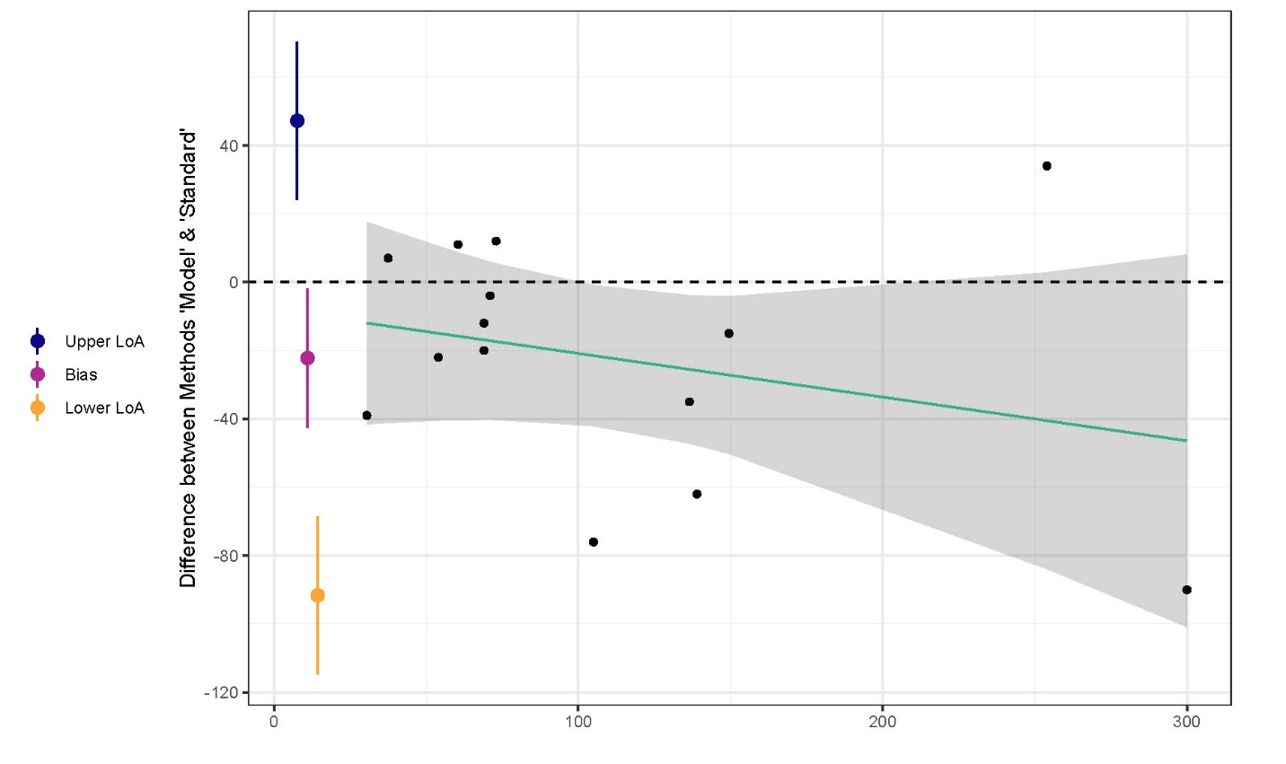
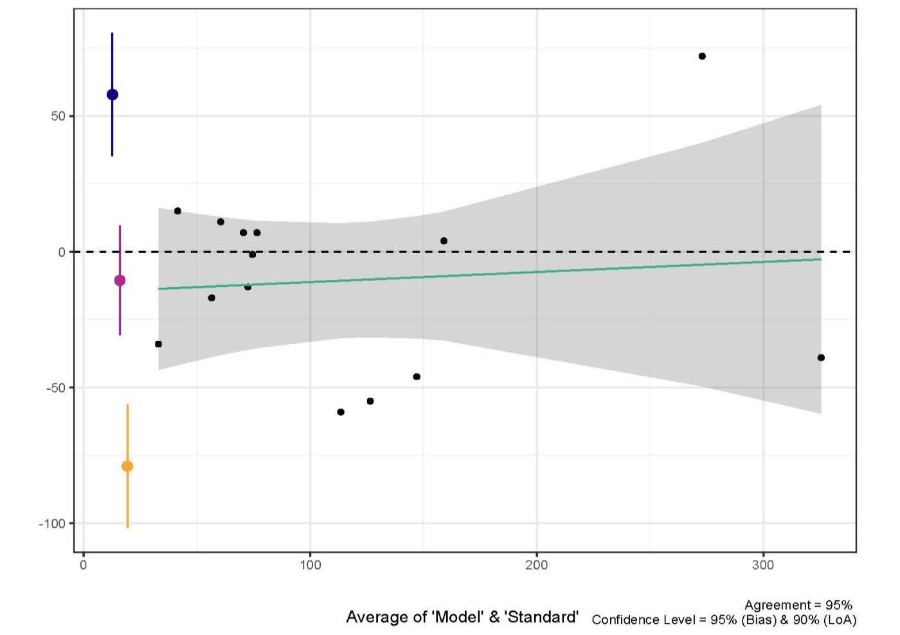
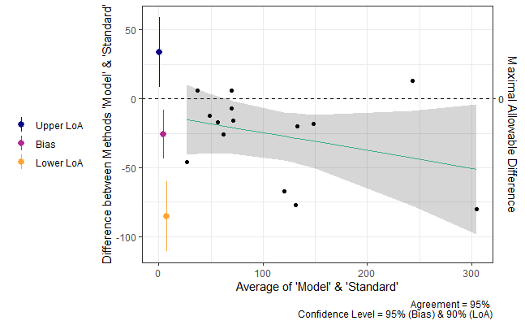
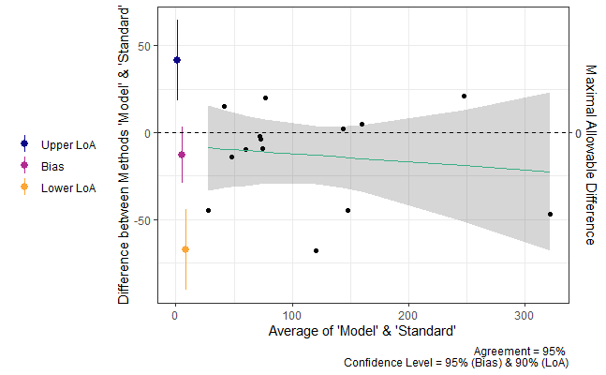
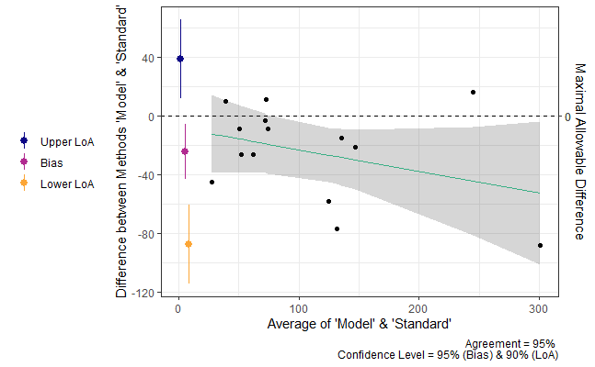
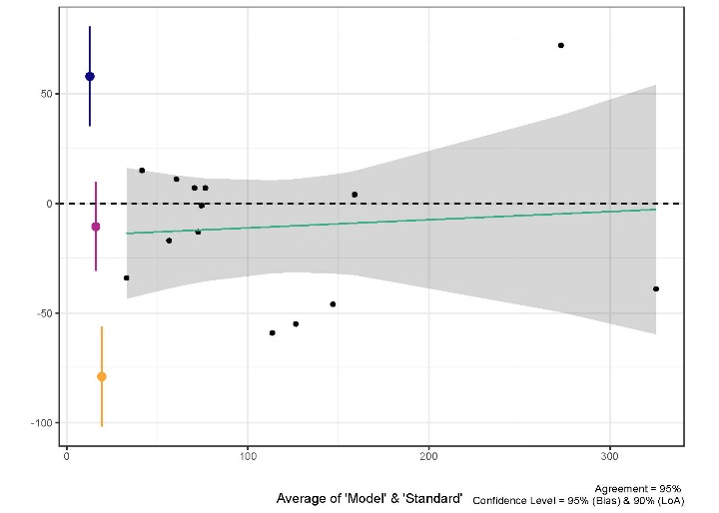

Fig. 10. Bland-Altman plot of elk population abundance estimates from 2021 with trendline (green) and associated confidence (grey shaded), modelled using zero years (top), 3 years (middle), and 5 years of prior data (bottom).

Discussion
Analysis of 77 sightability trials shows that visual obstruction (VOC) is the only variable significantly correlated to detection. Using VOC as the sole covariate, we model two datasets: the full 8-year dataset, and a dataset of only the years when sightability trials took place (3-year dataset). Model performance is acceptable in both cases, demonstrating that the model is appropriate for use with elk inventory data. The 3-year dataset shows superior model convergence, effective sample size, and estimate agreement. Approximately 50% of estimates meet our threshold for precision in the 8-year dataset results, compared to ~75% in the 3-year dataset. Results from both datasets show a negative correlation between animals counted annually and CV, suggesting that higher minimum counts improve estimate precision. The 8-year dataset results suggest that precise estimates are most likely when the minimum count is near or above 50 animals, while the 3-year dataset results show that when all years include sightability data, the minimum count need only be approximately 25 animals to ensure a CV below 0.2. This level of precision may not always be necessary, however, as Pacheco (2013) notes that estimates with a CV between 0.2 and 0.5 can still be useful for long-term population monitoring.
Total agreement is higher in the 3-year dataset results compared to the full 8-year dataset results. However, a direct comparison of 2021-2023 results from the 8-year and 3-year datasets reveal that agreement with standard estimates is slightly higher with a bias closer to zero in the 8-year dataset results. These findings suggest that incorporating survey data from years when sightability trials were not performed may lessen estimate bias at the cost of reduced precision and model performance. Still, agreement is similar between the two sets of 2021-2023 estimates, indicating the effects on bias are minor. In most cases, agreement between estimates decreased as estimate values increase. This information paired with the relationship between minimum count and CV suggests a trade-off between bias and precision where lower estimates (<100) tend to be less biased but less precise, and higher estimates (>200) have the potential to be more precise and simultaneously more biased.
Deciding between including or excluding observations from years when sightability trials were not completed will depend on how much precision is required and whether long-term trends are of interest. The most precise estimates will likely arise from only including observations from sightability trial years. However, the findings show that the model still produces useful results regardless of whether sightability trials were conducted in all years. When only one year of sightability data is available (i.e., the first time this methodology is used), we saw the greatest model performance and agreement/precision diagnostics when excluding prior year observations. Our findings demonstrate that the model produces reliable and precise from just one year of observations, and including prior years has variable affects on bias while generally reducing precision. Still, the model performs well and produces estimates with acceptable agreement levels when observations from prior years are included. Again, the decision to include prior year survey data will depend on whether long-term trends with confidence intervals are desired.
~Make connections between species, why this is useful for wildlife managers everywhere~
Bayesian modelling totes an advantage over other estimators in that multiple years of surveys can be taken into account when estimating abundance in a given year (ArchMiller et al., 2018). Repeated estimates will also allow for temporal analysis of Bayesian outputs, producing reliable interannual trends of elk population size. Elk harvest quotas can be informed by Bayesian modelling outputs with little additional cost. Expertise is beneficial in estimating any population using any method, but if such expertise is not available, our study has demonstrated that Bayesian estimates are in high agreement with expert-informed estimates. Subsequently, Bayesian modelling is superior to the existing method in that (1) modelling produces a measure of precision, (2) the modelling process can be standardized for easy reproduction year after year, and (3) estimates can be produced in the absence of species expertise. Harvest quotas may be set at the point estimate (tau hat) or more conservatively at the lower 50% confidence bound.
Sightability surveys should be continued in future years to increase the amount of information used to model sightability.
Credit authorship contribution statement
Tristen Brush: Methodology, Software, Formal analysis, Data curation, Writing – Original Draft, Visualization Joanna Burgar: Conceptualization, Methodology, Resources, Writing – Review & Editing Darryl Reynolds: Investigation John Kelly: Investigation Daniel Guertin: Conceptualization, Supervision
Add acknowledgements for Darryl and John and Andrew

References
ArchMiller, A.A., Dorazio, R.M., St. Clair, K., Fieberg, J.R., 2018. Time series sightability modeling of animal populations. PLoS ONE 13, e0190706. https://doi.org/10.1371/journal.pone.0190706
Bland, J.M., Altman, D.G., 1999. Measuring agreement in method comparison studies. Stat Methods Med Res 8, 135–160. https://doi.org/10.1177/096228029900800204
Buechner, H.K., Buss, I.O., Bryan, H.F., 1951. Censusing Elk by Airplane in the Blue Mountains of Washington. The Journal of Wildlife Management 15, 81–87. https://doi.org/10.2307/3796773
Dorazio, R.M., Royle, J.A., Söderström, B., Glimskär, A., 2006. Estimating species richness and accumulation by modeling species occurrence and detectability. Ecology 87, 842–854. https://doi.org/10.1890/0012-9658(2006)87%255B842:ESRAAB%255D2.0.CO;2
Efford, M.G., Boulanger, J., 2019. Fast evaluation of study designs for spatially explicit capture–recapture. Methods Ecol Evol 10, 1529–1535. https://doi.org/10.1111/2041-210X.13239
Fieberg, J., Alexander, M., Tse, S., St. Clair, K., 2013. Abundance estimation with sightability data: a Bayesian data augmentation approach. Methods Ecol Evol 4, 854–864. https://doi.org/10.1111/2041-210X.12078
Fieberg, J., Giudice, J., 2008. Variance of Stratified Survey Estimators with Probability of Detection Adjustments. The Journal of Wildlife Management 72, 837–844.
Fish and Wildlife Branch, 2015. A Management Plan for Roosevelt Elk in British Columbia. B.C. Ministry of Forests, Lands and Natural Resource Operations, Victoria, BC.
Gelman, A., Rubin, D.B., 1992. Inference from Iterative Simulation Using Multiple Sequences. Statistical Science 7, 457–472.
GeoBC, 2014. Digital Elevation Model for British Columbia - CDED - 1:250,000.
Hunter, G.N., Yeager, L.E., 1949. Big Game Management in Colorado. The Journal of Wildlife Management 13, 392–411. https://doi.org/10.2307/3795631
Lin, L.I.-K., 1989. A Concordance Correlation Coefficient to Evaluate Reproducibility. Biometrics 45, 255. https://doi.org/10.2307/2532051
Little, R.J., 2008. Weighting and Prediction in Sample Surveys. Calcutta Statistical Association Bulletin 60, 147–167. https://doi.org/10.1177/0008068320080301
McCorquodale, S.M., Knapp, S.M., Davison, M.A., Bohannon, J.S., Danilson, C.D., Madsen, W.C., 2013. Mark-Resight and Sightability Modeling of a Western Washington Elk Population. The Journal of Wildlife Management 77, 359–371.
Noyes, J.H., Johnson, B.K., Riggs, R.A., Schlegel, M.W., Coggins, V.L., 2000. Assessing Aerial Survey Methods to Estimate Elk Populations: A Case Study. Wildlife Society Bulletin (1973-2006) 28, 636–642.
Pacheco, M., Kajin, M., Gentile, R., Zangrandi, P.L., Vieira, M.V., Cerqueira, R., 2013. A comparison of abundance estimators for small mammal populations. Zoologia (Curitiba) 30, 182–190. https://doi.org/10.1590/S1984-46702013000200008
Plummer, M., 2023. rjags: Bayesian Graphical Models using MCMC.
Plummer, M., 2003. JAGS: A Program for Analysis of Bayesian Graphical Models Using Gibbs Sampling. Proceedings of DSC 2003.
Pollock, K.H., Nichols, J.D., Brownie, C., Hines, J.E., 1990. Statistical Inference for Capture-Recapture Experiments. Wildlife Monographs 3–97.
Quayle, J.F., MacHutchon, A.G., Jury, D.N., 2001. Modelling moose sightability in south-central British Columbia. Alces: A Journal Devoted to the Biology and Management of Moose 37, 43–54.
R Core Team, 2024. R: A Language and Environment for Statistical Computing.
Resources Information Standards Committee, 2002. Aerial-based Inventory Methods for Selected Ungulates: Bison, Mountain Goat, Mountain Sheep, Moose, Elk, Deer and Caribou (No. 32), Standards for Components of British Columbia’s Biodiversity. Ministry of Sustainable Resource Management, Victoria, BC.
Royle, J.A., Dorazio, R.M., Link, W.A., 2007. Analysis of Multinomial Models with Unknown Index Using Data Augmentation. Journal of Computational and Graphical Statistics 16, 67–85.
SBC, 2019. Declaration on the Rights of Indigenous Peoples Act.
SC, 2021. United Nations Declaration on the Rights of Indigenous Peoples Act.
Schmidt, G.M., Graves, T.A., Pederson, J.C., Carroll, S.L., 2022. Precision and bias of spatial capture–recapture estimates: A multi‐site, multi‐year Utah black bear case study. Ecological Applications 32, e2618. https://doi.org/10.1002/eap.2618
Steinhorst, R.K., Samuel, M.D., 1989. Sightability Adjustment Methods for Aerial Surveys of Wildlife Populations. Biometrics 45, 415. https://doi.org/10.2307/2531486
UN General Assembly, 2007. United Nations Declaration on the Rights of Indigenous Peoples, A/RES/61/295.
Unsworth, J.W., Leban, F.A., Sargeant, G.A., Garton, E.O., Hurley, M.A., Pope, J.R., Lepitch, D.J., 1991. Aerial survey: user’s manual. Boise, Idaho, USA.
Welch, B.L., 1947. The generalization of ‘Student’s’ problem when several different population variances are involved. Biometrika 34, 28–35. https://doi.org/10.1093/biomet/34.1-2.28

Appendix A
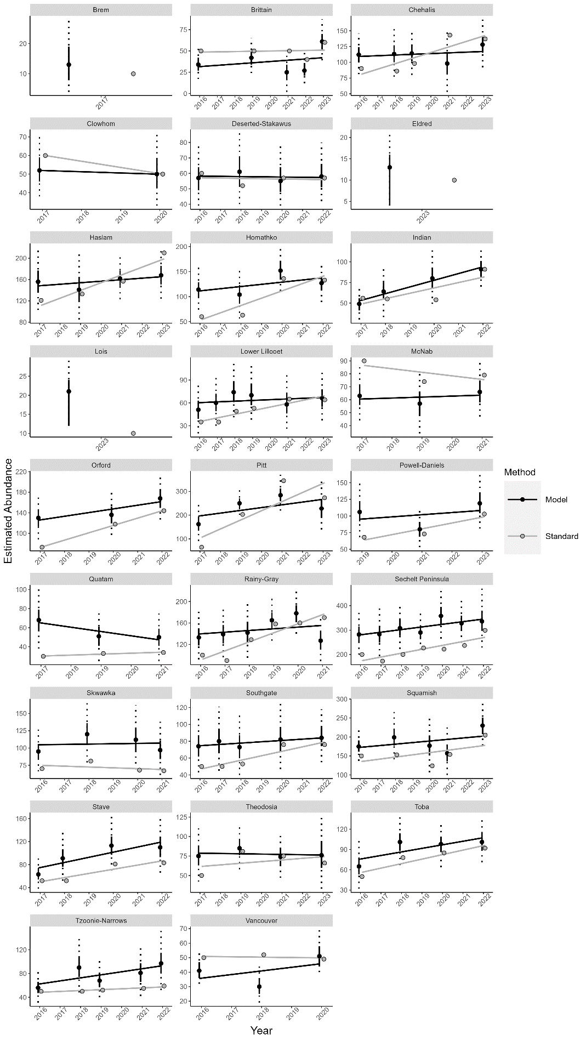

Appendix B
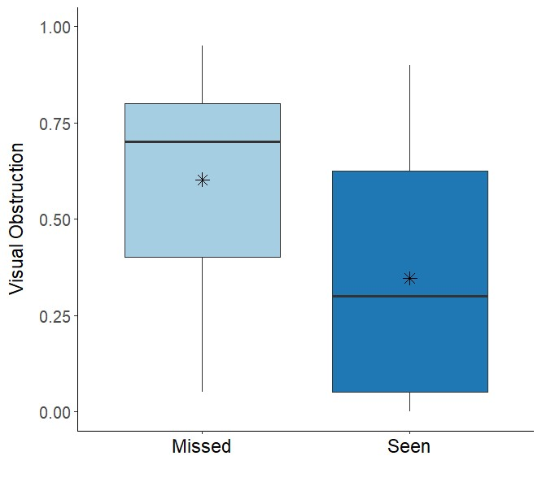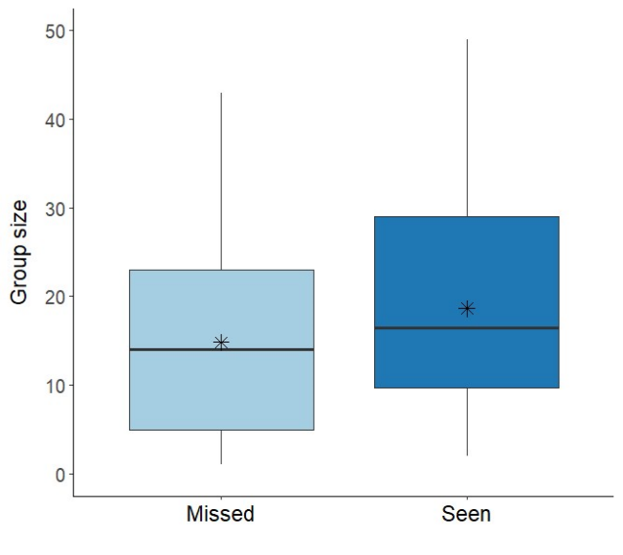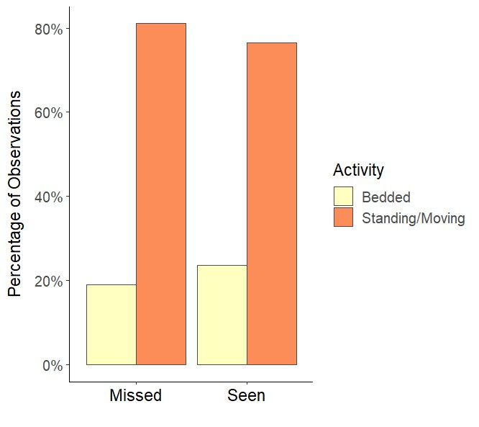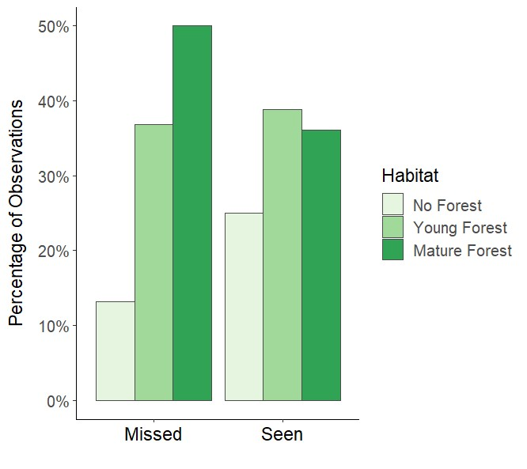
(d)
(c)
(b)
(a)
Figure 10. (a) Distribution of visual obstruction coefficients of missed (observed with telemetry) and seen (observed without telemetry) collared elk groups. Means are denoted with ‘*’. (b) Distribution of group sizes of missed and seen collared elk groups. (c) Percent of missed and seen collared elk groups by activity at first sight. (d) Percent of missed and seen collared elk groups by habitat type.

