Estimating abundance of Roosevelt elk to improve species management.
Tristen Brush, Joanna Burgar, Darryl Reynolds, John Kelly, Daniel Guertin
Abstract
Aerial surveys are often used to estimate ungulate population abundance, an indicator which informs objective setting, harvest allocation and habitat protection decisions. Where populations are scarce or difficult to view from the air, abundance estimates may be derived from combining minimum count data with a sightability correction factor that is informed by professional expertise. However, these estimates tend to be highly variable, subject to bias, and do not include estimates of precision. We wanted to determine the ability of a logistic regression Bayesian model to estimate abundance of Roosevelt elk (Cervus canadensis roosevelti; hereafter 'elk'), a herd ungulate living in heavily forested, rugged landscapes. The study area comprised the southern coast of British Columbia where elk are subject to limited-entry hunt and a subset of elk are radio-collared. We tested the model on field-collected minimum count survey data to assess precision of the resulting estimates and their agreement with existing expert-informed (hereafter 'standard') estimates. Radio-collared elk were observed in 77 sightability trials conducted during annual surveys from 2021 to 2023, revealing a significant inverse correlation between visual obstruction and detection probability. Sightability trial data was paired with standard elk survey data from 2016 through 2023 to estimate annual elk abundance in 26 management units. Data was stratified by age/sex class to produce class ratios useful for management. Mean coefficient of variation for model estimates was x and agreement between model and standard estimates reached y. The findings suggest that the logistic regression model can offer a reliable, non-subjective method for estimating elk abundance, essential for resource managers requiring an effective and feasible method for accurately and precisely measuring ungulate abundance.
Keywords: aerial survey, marked animals, ungulates, data augmentation, Bayesian, sightability model

Introduction
Effective conservation and management of any species of interest requires unbiased and precise population estimates. For the past few decades, most census techniques for ungulates in North America use aerial survey data adjusted for perceived sightability (i.e., detection rate) of animals (Noyes et al. 2000; FLNRO 2015). When a complete census is not possible abundance estimates are often derived from minimum count aerial surveys with corrections for sightability based on a subjective assessment of several factors informed by professional expertise (e.g., FLNRO, 2015). This correction factor exposes the resulting abundance estimates to subjectivity and offers no measures of precision. Furthermore, this method relies on location-specific expertise of the species which results from decades of survey experience, introducing concern when such expertise is no longer available (e.g., in the event of staff turnover). As such, there is a clear need for a reliable and replicable approach to estimating ungulate abundance with precision.
An early attempt to meet this need was Steinhorst and Samuel’s (1989) development of a design-based estimator using radio-tagged animals. Surveyors do an initial survey for a given area without using radiotelemetry, recording all observations of their target species, and then re-do the aerial search with the aid of telemetry to observe individuals previously uncounted. Covariates such as group size and visual obstruction are collected along with each observation so that detection can be modelled as a function of these covariates. . The resulting model is applied to initial survey data to derive abundance estimates. However, measures of variance resulting from this method are often right-skewed and underestimated due to the nature of design-based estimators (Fieberg and Giudice, 2008; Fieberg et al., 2013).
With the advancements in computation processing speeds and capabilities, model-based Bayesian estimators have become more accessible to managers and biologists (Fieberg et al., 2013). Little (2009) notes that estimates produced from Bayesian modelling are typically similar to those of design-based models, though Bayesian approaches boast the added benefits of incorporating random effects and stratification, producing better results when sample sizes are small, and incorporating prior information. Fieberg et al. (2013) developed a Bayesian alternative to Steinhorst and Samuel’s (1989) approach following the same general methodology. Using a data augmentation method adapted from Dorazio et al. (2006), and Royle et al. (2007), Fieberg et al. (2013) applied two Bayesian models to two years of moose survey data from Minnesota. They found that both models resolved the variance issues introduced by the Steinhorst and Samuel (1989) model and their beta-binomial model achieved the best fit and greatest precision of the two Bayesian models tested.
Our study applies Fieberg et al.’s (2013) beta-binomial model to eight years of Roosevelt elk (Cervus canadensis roosevelti; hereafter 'elk') survey data collected in the South Coast region of BC. Add in a couple sentences on the history of elk in BC, significance of elk, etc
We aimed to expand on the findings of Fieberg et al. (2013) to test the model on a larger dataset of a herd ungulate species living in a mosaic of densely forested habitat, clearcut, and steep terrains. We compare estimates with those derived from standard practices as described by FLNRO (2015) and explore the effects of including annual data from years prior to sightability trial implementation. In doing so we endeavored to determine the feasibility of incorporating model estimates into future elk management decisions and provide a roadmap to managers hoping to begin employing a similar technique. This serves our larger goal of providing land and resource managers with a reliable and feasible method for accurately and precisely monitoring wildlife populations to better inform objective-setting, harvest allocation, and habitat protection.
.
~Importance of good estimates to conservation/sustainable use balance~
~Importance for habitat protection, conflict management~

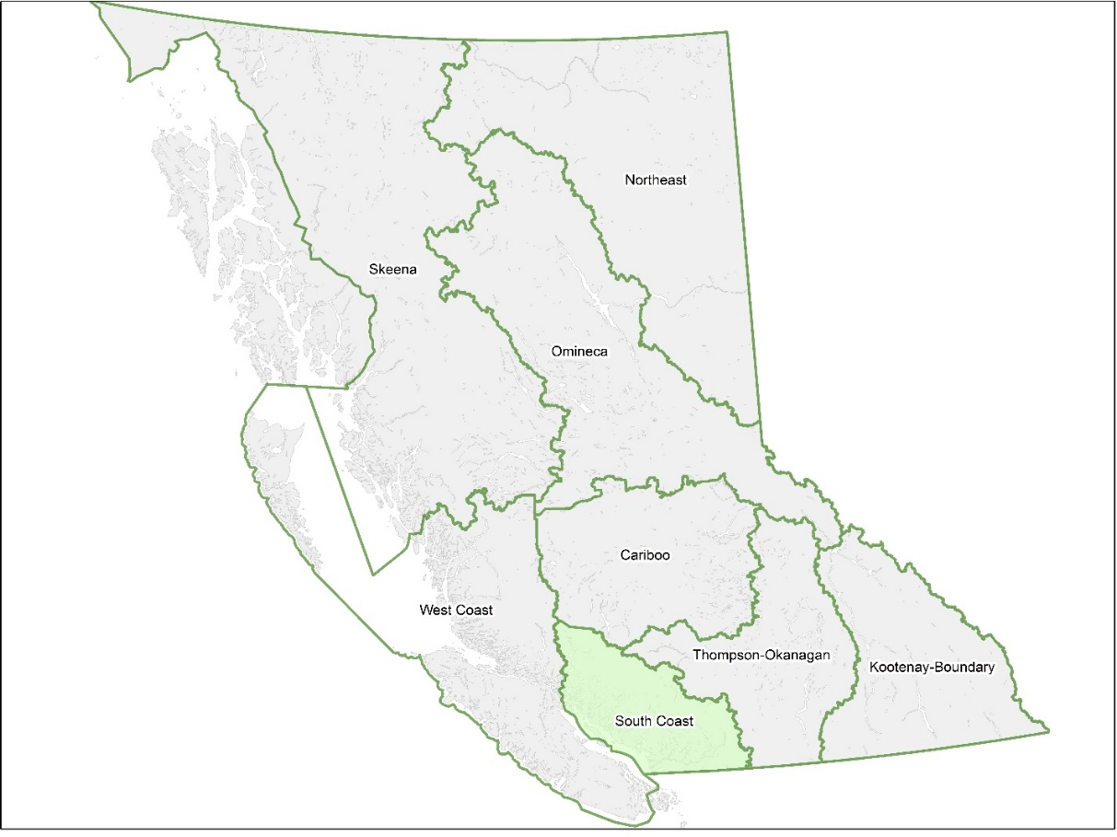
Fig. 1. British Columbia resource management regions as defined by the provincial government.

Methods

Study Area
Elk population units (EPUs) are defined areas where elk are monitored and managed. Boundaries typically follow major watershed boundaries, but are modified to account for known elk distribution, habitat use and movement (FLNRO, 2015). Roosevelt elk range is limited to the South Coast and West Coast regions of BC (Fig. 1). Between these regions, 149 EPUs are delineated, of which 113 have population estimates greater than zero as of 2018 (Fig. 2). Our study took place in the South Coast region, which contains 35 of these occupied EPUs, ranging in size from 237 km² to 4,821 km² (mean size = 889 km² ± 149 SE; Fig. 3).
Surveys of occupied South Coast EPUs occur on a variable schedule, prioritizing EPUs with hunting pressure, populations of concern, or high stakeholder interest. Since 2016, 26 EPUs have been surveyed between 1 and 7 times (mean = 3.85 ± 0.29 SE; Fig. 4). These areas have mean elevations ranging from 247m (Sechelt Peninsula) to 1,730m (Southgate; total mean = 901m ± 69.6 SE) with the highest peak at 3,557m (Homathko; GeoBC, 2014). Dominant vegetation is primarily Coastal Western Hemlock (lower elevations) and Coastal Mountain-heather (high elevations) with Mountain Hemlock in transition zones.

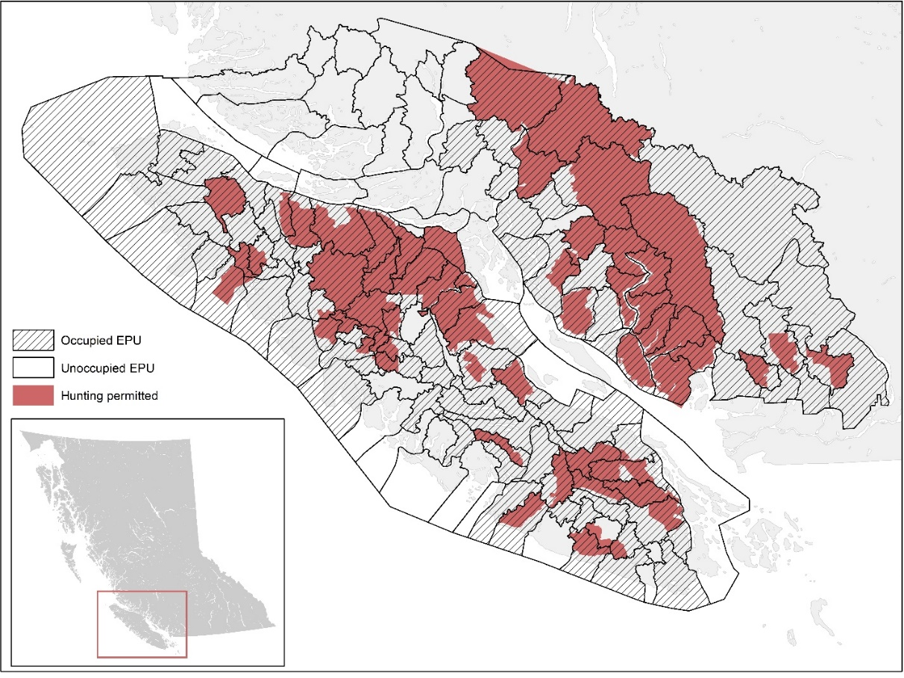
Fig. 2. Roosevelt elk population units (EPUs) in British Columbia and whether hunting is permitted as of 2023.
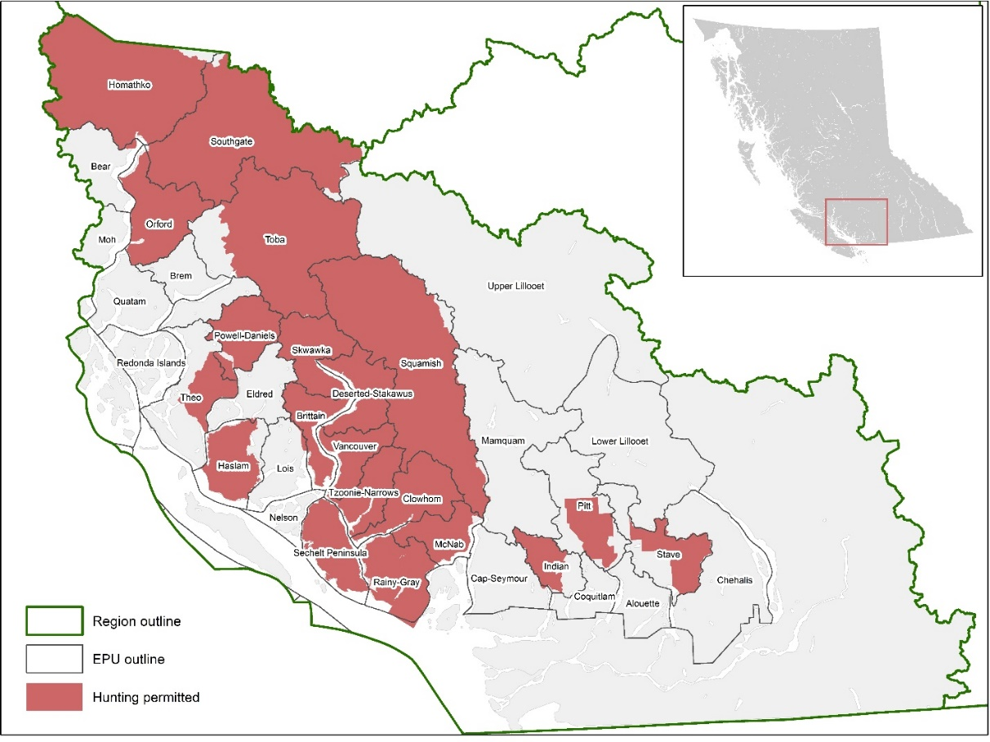
Fig. 3. Occupied Roosevelt elk population units (EPUs) in British Columbia’s South Coast natural resource management region and their 2023 hunting status.
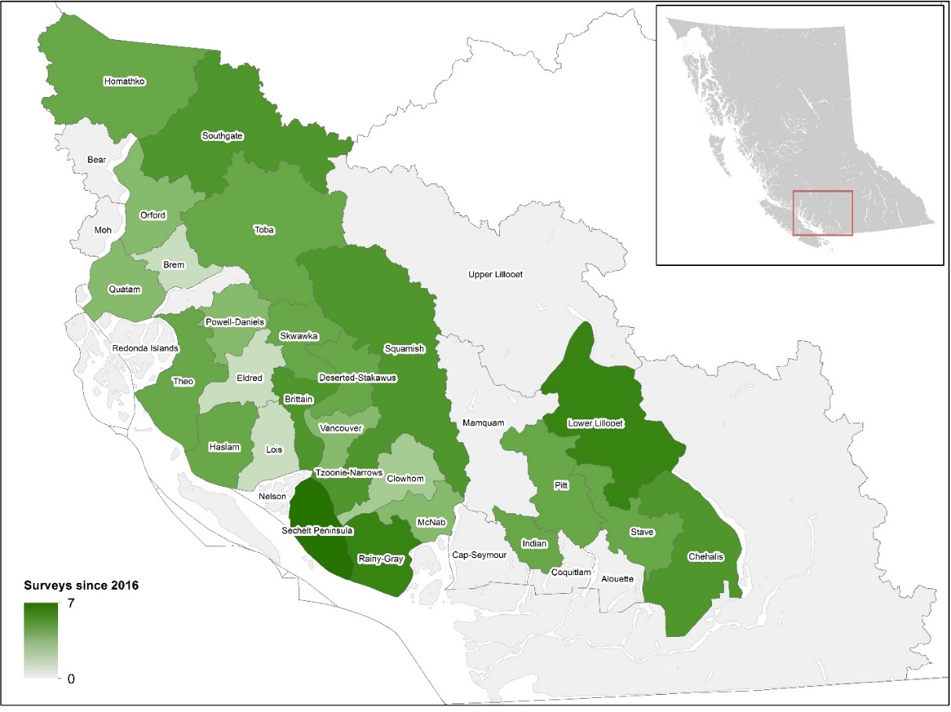
Fig. 4. South Coast elk population unit survey frequency from 2016 through 2023.

Survey methods
Multiple elk were darted and fit with radio-collars each year starting in 2015. As of summer 2023, 88 elk are wearing operational collars in 24 EPUs. All EPUs surveyed since 2016 have between 1 and 10 collared elk (mean = 3.67 ± 0.40 SE) except for the Brem, Eldred, and Indian EPUs. Mamquam is the only EPU not surveyed since 2016 that has collared elk.
Sightability trial methods were adapted from Quayle et al. (2001) and McCorquodale et al. (2013) and consisted of inventory surveys and telemetry-assisted follow up surveys. For the inventory surveys, elk were systematically searched for following provincial standards (Ministry of Sustainable Resource Management, 2002). When an elk was sighted, the elk group was circled, and animal and habitat data was recorded (Table 5). The group was scrutinized for radio-collared elk and, if sighted, the telemetry system was activated to identify collared individual(s) and then deactivated once all data were collected, and the visual survey protocol was resumed. When the entire EPU had been surveyed and data collected for all sighted elk, the telemetry system was reactivated and the telemetry-assisted follow up surveys began. These consisted of locating missed elk precisely via telemetry and, once located, the same animal and habitat data was collected as for the inventory surveys. If missed groups were in cover, the radio signal was pinpointed, and habitat data was collected for the estimated location. If the group could be easily hazed into openings or sparser cover, the animal data was also recorded. Where this was not feasible, the animal data for only the collared individual was recorded using database records. Sightability trials were conducted simultaneously with annual elk inventory surveys to minimize additional costs.
Table 5. Animal and habitat data recorded during inventory and telemetry surveys. In addition, the date, EPU surveyed, light intensity (flat / bright), helicopter make / model and surveyors names and roles were recorded for each survey. Location data was also recorded for each observation.
Variable | Description
Cows | Count of cows in group
Calves | Count of calves (<1 year) in group
Spikes | Count of spikes (yearling males) in group
Bulls | Count of bulls (>2 years) in group
Unclassified | Count of unclassified elk in group
Group Size | Total count of elk in the group
Survey type | Method of observation: Incidental / Inventory / Telemetry
Habitat Category | 4 = Mature Forest  3 = Cut block  2 = Field / Riparian  1 = Road / Non-vegetated
Visual obstruction | Proportion (from 0 to 1) of area around first sighted elk (~10m radius) where vision to ground-level is obstructed; following Unsworth et al. (1991) figures for evaluating vegetation cover.
Activity | Activity of first elk sighted:  1 = Standing / Moving  0 = Bedded
Collars | Number of collars seen in group
Collar ID | If applicable, collar serial number(s)

Model
A beta-binomial model developed by Fieberg et al. (2013) was used to model detection probabilities as a function of a covariate, informed by sightability trial data. Only observations of groups with collared elk included in the sightability trial dataset. Groups were considered ‘detected’ if they were observed without telemetry assistance, and ‘undetected’ otherwise. The dataset underwent Kendall’s (1938) bivariate correlation test using the cor.test function in the stats R package to identify relationships between detection probability and four variables: visual obstruction, elk activity at first sighting, habitat type, and group size. Variables significantly correlated with detection were included as model covariates.
The modelled sightability function was applied to an operational dataset containing all inventory survey observations (including groups with and without collared individuals). EPUs were treated as subunits and estimates were calculated for five strata: cows, calves, spikes, bulls, and total. Model performance was only assessed for the ‘total’ stratum, as estimates for the other strata were only used to determine age/sex ratios.
Preliminary analysis showed major discrepancies between model and standard estimates when a large proportion of total observations were telemetry-assisted. Excluding all telemetry observations from the operational dataset produced unreasonably low estimates (e.g., estimates below the minimum count) and including all telemetry observations produced unreasonably high estimates (e.g., lower 95% confidence limits above the standard point estimate). Therefore, we chose to include telemetry-assisted observations only when doing so would bring the current year’s mean group size closer to the total mean for all years for that EPU. Incidental observations were not included in either dataset.
The model was run in JAGS (Plummer, 2003), interfaced through the statistical program R (R Development Core Team, 2021), using the rjags package (Plummer, 2016). Three chains were run for 40,000 iterations with 50% thinning and the first 20,000 iterations were discarded as burn-in. See Fieberg et al. (2013) for further details on model development.

Analysis
Model performance was evaluated by convergence and autocorrelation. Convergence was measured using the Gelman-Rubin convergence diagnostic ($\hat{R}$; Gelman and Rubin 1992) while autocorrelation was evaluated using effective sample size (ESS). There is no universal acceptable value for either of these diagnostics. Gelman et al. (2004) have recommended accepting convergence when $\hat{R}≤1.1$, though other researchers argue this is much too high and a cutoff of 1.05 or 1.01 is more likely to ensure convergence (Vats and Knudson 2020). We deemed model performance acceptable when $\hat{R}≤1.05$ and ESS > 100.
Model estimates were assessed for precision and agreement with standard estimates. Coefficient of variation (CV) was used to measure precision and agreement was evaluated using Lin’s (1989) concordance correlation coefficient (CCC) and Bland-Altman limits of agreement (Bland and Altman 1999). We considered estimates precise if the coefficient of variation (CV) was at or below 0.2, as is common in population estimation (Pollock et al. 1990, Efford and Boulanger 2019, Schmidt et al. 2022). To interpret agreement diagnostics, we referenced Pacheco et al. (2013) who reported a mean CCC (N=18) of 0.80. We considered values above 0.8 to be acceptable, but primarily used agreement metrics in relative terms.
To determine whether including prior years’ data improves current-year estimates, we ran the model separately on two datasets: the 8-year (2016-2023) dataset and a 3-year (2021-2023) dataset. In doing so we aimed to determine how including additional data from years where sightability trials were not performed affects estimate agreement, precision, and model performance. Additionally, we subset the 8-year dataset to simulate results with just one year of sightability data. We compared model results from a dataset only including 2021 data (i.e., the first year sightability trials were run) to those of a dataset including three prior years without sightability data (2016-2020). In doing so we aimed to make a recommendation on whether prior year data should be included when only one year of sightability data is available (i.e., the case when using this methodology for the first time).

Results

Sightability covariates
Correlation tests were conducted on the sightability dataset to determine the relationship between detection and (1) visual obstruction, (2) elk group size, (3) habitat type and (4) elk activity. Out of the four variables tested, only visual obstruction produced a p-value < 0.05. Visual obstruction showed an inverse correlation with detection and was ultimately chosen to be the sole covariate used in the model.

Table 6. Results of Kendall’s (1938) correlation test between detection (1 if observed without telemetry assistance, 0 if observed with) and four observation-specific variables: visual obstruction (VOC; 0 to 1 where 0 is no obstruction), habitat (ordinal from 1 to 4 by vegetation height), elk group size, and activity of first elk spotted (0 if bedded, 1 if standing or moving).
Variable | Correlation | p
VOC | -0.34 | 0.0005
Activity | -0.06 | 0.6369
Habitat | -0.16 | 0.1502
Group size | 0.12 | 0.2182

Model results
One hundred abundance estimates with confidence were derived from the 8-year dataset (Appendix A). All models converged with $\hat{R}$ < 1.05 (median = 1.003; range = 1.001 to 1.021). All ESS values were acceptable, ranging from 110 to 30000 with median 890. CV values ranged from 0.115 to 0.531 (median = 0.199) and showed a strong (R² = 0.88) correlation with the number of animals counted in the respective EPU and survey year (Fig. 5).

Fig. 5. Coefficient of variation as a function of animals counted annually in 26 elk population units from 2016-2023 (N = 100) with a power function trendline.
Modelling the 3-year dataset produced 34 abundance estimates from 23 EPUs, all converging with $\hat{R}$ < 1.05 (median = 1.002; range = 1.001 to 1.005). ESS values ranged from 1,000 to 30,000 with median 3,350. CV values were between 0.078 and 0.371 with median 0.139. A negative correlation (R² = 0.82) between number of animals counted and CV was identified (Fig. 6).

Fig. 6. Coefficient of variation as a function of animals counted annually in 23 population units from 2021-2023 (N = 34) with a power function trendline.
Total agreement between standard and model estimates was high in the 8-year dataset (CCC = 0.866; 95% CI = 0.813 to 0.905) with an estimated bias of +17.8 (95% CI = 11.4 to 24.2) and limits of agreement at -45.0 (90% CI = -52.2 to -37.8) and +80.6 (90% CI = 73.4 to 87.8). When evaluated individually by year, CCC values ranged from 0.664 (2017) to 0.962 (2022) with median 0.875. Total agreement was higher in the 3-year dataset (CCC = 0.934; 95% CI = 0.876 to 0.966) and estimated bias was +14.4 (95% CI = 4.8 to 24.0). Limits of agreement were -39.6 (90% CI = -50.5 to -28.8) and +68.4 (90% CI = 57.5 to 79.3). Annual CCC values were between 0.900 (2022) and 0.971 (2023) with median 0.927.
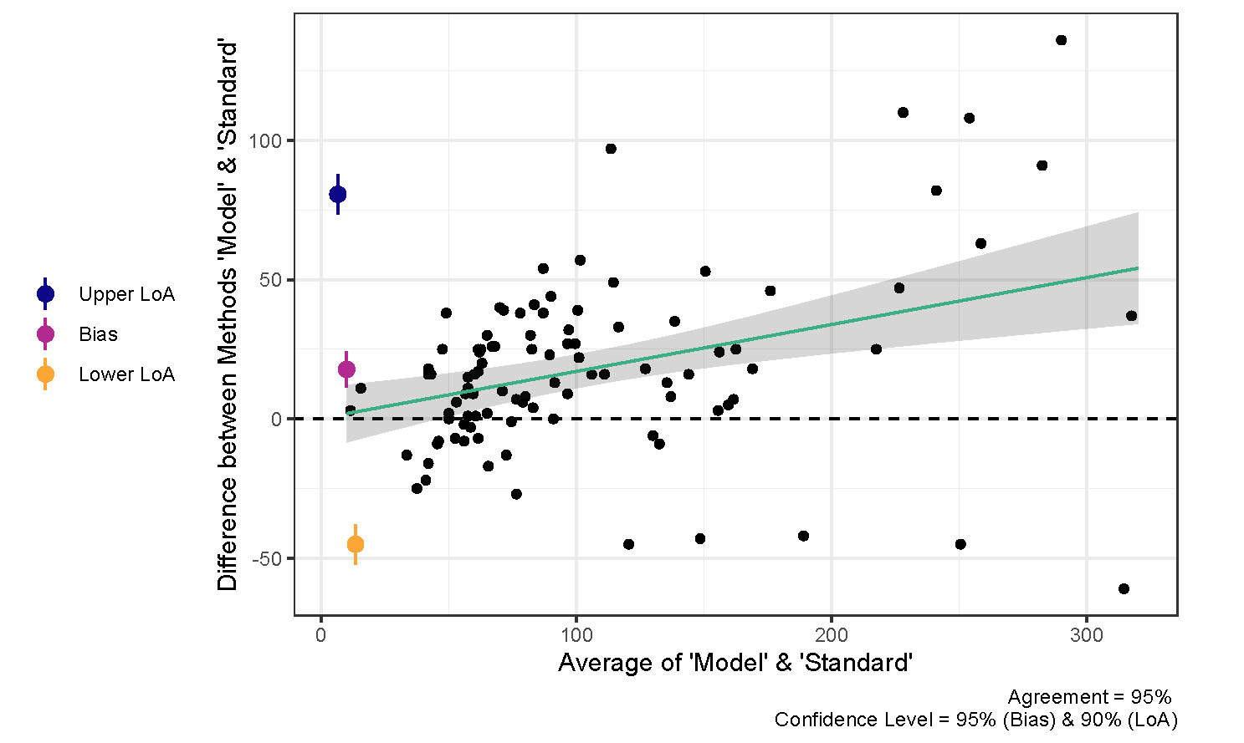
Fig. 7. Bland-Altman (1983) plot of elk population abundance estimates from 2016-2023 with trendline (green) and associated confidence (grey shaded).
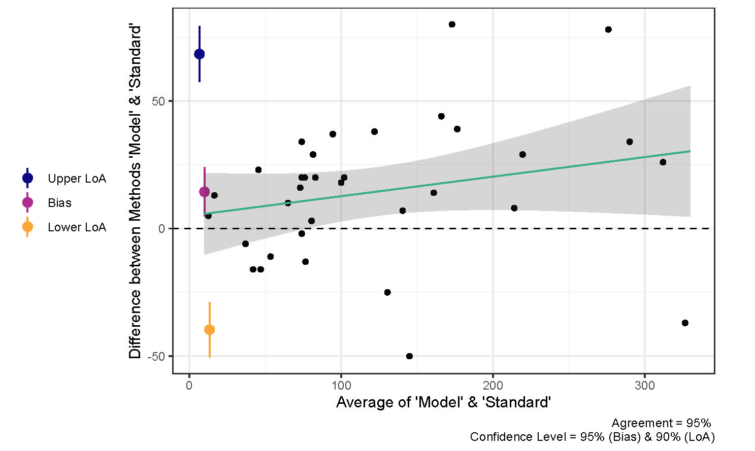
Fig. 8. Bland-Altman (1983) plot of elk population abundance estimates from 2021-2023 with trendline (green) and associated confidence (grey shaded).

Dataset comparison
To determine whether including prior years’ data (i.e., 2016-2020) improves model estimates for recent years (2021-2023), we separated out the 2021-2023 estimates from the 8-year dataset results to compare with results from the 3-year dataset. Model performance diagnostics for 2021-2023 estimates from the 8-year dataset were similar to those of the 3-year dataset. $\hat{R}$ ranged from 1.001 to 1.006 with median 1.002, and ESS ranged from 380 to 20,000 with median 1,700. However, 2021-2023 estimates from the 8-year dataset had higher CVs than the 3-year dataset estimates (median = 0.198, range = 0.128 to 0.527) with a relationship between CV and animals counted that mirrored that of the whole dataset (Fig. 5).
Total agreement was slightly greater in the 2021-2023 estimates from the 8-year dataset compared to the 3-year dataset, with a CCC of 0.937, bias of +2.35 (95% CI = -7.79 to 12.5), and limits of agreement at -54.6 (90% CI = -66.1 to -43.2) and +59.3 (90% CI = 47.9 to 70.8). Agreement was less positively biased at high estimate values compared to the 3-year dataset results (Fig. 8; Fig. 9). Annual CCC values were lower for 2021 (0.906 vs. 0.927) and 2023 (0.961 vs. 0.971) but higher for 2022 (0.962 vs. 0.900).
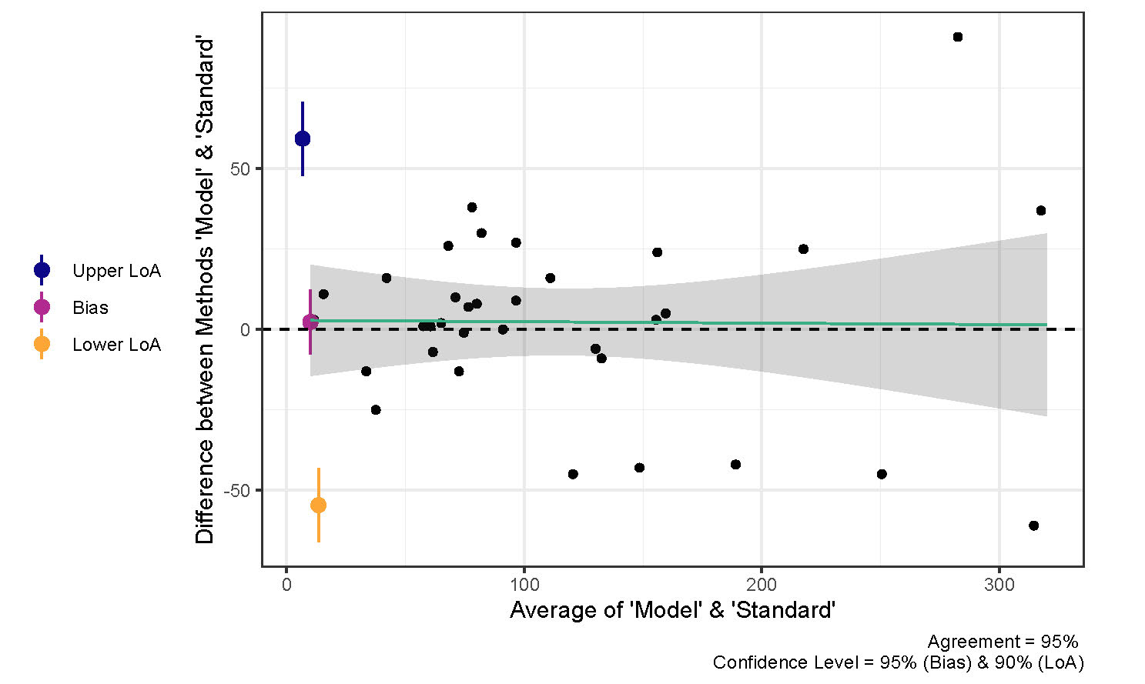
Fig. 9. Bland-Altman (1983) plot of elk population abundance estimates from 2021-2023 with trendline (green) and associated confidence (grey shaded).
~ 2021 alone vs 2016-2021 dataset~

Discussion
Analysis of 77 sightability trials showed that visual obstruction (VOC) was the only variable significantly correlated to detection. Using VOC as the sole covariate, two datasets were modeled: the full 8-year dataset, and a dataset of only the years where sightability trials took place (3-year dataset). Model performance was acceptable in both cases, demonstrating that the model is appropriate for use with elk inventory data. Model convergence, effective sample size, and estimate precision were better in the 3-year dataset. Approximately 50% of estimates were considered precise in the 8-year dataset results, while ~75% of the 3-year dataset results met the threshold for precision. Results from both datasets showed a negative correlation between animals counted annually and estimate CV, suggesting that higher minimum counts improve estimate precision. The 8-year dataset results suggest that precise estimates are most likely when the minimum count is near or above 50 animals, while the 3-year dataset results show that the minimum count need only be approximately 25 animals to ensure a CV below 0.2. Such precise estimates may not always be necessary, however, as Pacheco (2013) notes that estimates with a CV between 0.2 and 0.5 can still be useful for long-term population monitoring.
Total agreement was also higher in the 3-year dataset results compared to the full 8-year dataset results. However, a direct comparison of 2021-2023 results from the 8-year and 3-year datasets revealed that agreement with standard estimates was slightly higher with a bias closer to zero in the 8-year dataset results. These findings suggest that incorporating data from years where sightability trials were not performed may lessen estimate bias at the cost of reduced precision and model performance. Still, agreement was similar between the two sets of 2021-2023 estimates, indicating the effects on bias were not strong.
Deciding between including or excluding data from years where sightability trials were not completed will depend on how much precision is required, and whether long-term trends are of interest. The most precise estimates will likely arise from only including data from sightability trial years. However, the findings show that the model still produces useful results regardless of whether sightability trials were conducted in all years.
~ whether first-time users should include prior year data~

Bayesian modelling totes an advantage over other estimators in that multiple years of data can be taken into account when estimating abundance in a given year (ArchMiller et al. 2018). Repeated estimates will also allow for temporal analysis of Bayesian outputs, producing reliable interannual trends of elk population size.
Elk harvest quotas can be informed by Bayesian modelling outputs with little additional cost. Expertise is beneficial in estimating any population using any method, but if such expertise is not available, this report has demonstrated that Bayesian estimates are in high agreement with expert-informed estimates. Subsequently, Bayesian modelling is superior to the existing method in that (1) it produces a measure of precision, (2) the modelling process can be standardized for easy reproduction year after year, and (3) estimates can be produced in the absence of species expertise. Harvest quotas may be set at the point estimate (tau hat) or more conservatively at the lower 50% confidence bound.
Sightability surveys should be continued in future years to increase the amount of information used to model sightability.
Credit authorship contribution statement
Tristen Brush: Methodology, Software, Formal analysis, Data curation, Writing – Original Draft, Visualization Joanna Burgar: Conceptualization, Methodology, Resources, Writing – Review & Editing Darryl Reynolds: Investigation John Kelly: Investigation Daniel Guertin: Conceptualization, Supervision

References
Altman, D.G., Bland, J.M., 1983. Measurement in Medicine: The Analysis of Method Comparison Studies. J. R. Stat. Soc. Ser. Stat. 32, 307–317. https://doi.org/10.2307/2987937
ArchMiller, A.A., Dorazio, R.M., Clair, K.S., Fieberg, J.R., 2018. Time series sightability modeling of animal populations. PLOS ONE 13, e0190706. https://doi.org/10.1371/journal.pone.0190706
Bland, J.M., Altman, D.G., 1999. Measuring agreement in method comparison studies. Stat. Methods Med. Res. 8, 135–160. https://doi.org/10.1177/096228029900800204
Dorazio, R.M., Royle, J.A., Söderström, B., Glimskär, A., 2006. Estimating species richness and accumulation by modeling species occurrence and detectability. Ecology 87, 842–854. https://doi.org/10.1890/0012-9658(2006)87[842:esraab]2.0.co;2
Efford, M.G., Boulanger, J., 2019. Fast evaluation of study designs for spatially explicit capture–recapture. Methods Ecol. Evol. 10, 1529–1535. https://doi.org/10.1111/2041-210X.13239
Fieberg, J., Alexander, M., Tse, S., St. Clair, K., 2013b. Abundance estimation with sightability data: a Bayesian data augmentation approach. Methods Ecol. Evol. 4, 854–864. https://doi.org/10.1111/2041-210X.12078
Fieberg, J., Giudice, J., 2008. Variance of Stratified Survey Estimators with Probability of Detection Adjustments. J. Wildl. Manag. 72, 837–844.
Forests, Lands and Natural Resource Operations, Ministry of, 2015. A Management Plan for Roosevelt Elk in British Columbia. British Columbia.
Gelman, A., Carlin, J.B., Stern, H.S., Dunson, D.B., Vehtari, A., Rubin, D.B., 2004. Bayesian Data Analysis, 2nd ed. Chapman & Hall/CRC, Boca Raton, Florida.
Gelman, A., Rubin, D.B., 1992. Inference from Iterative Simulation Using Multiple Sequences. Stat. Sci. 7, 457–472.
GeoBC, 2014. Digital Elevation Model for British Columbia - CDED - 1:250,000.
Kendall, M.G., 1938. A New Measure of Rank Correlation. Biometrika 30, 81–93. https://doi.org/10.1093/biomet/30.1-2.81
Kruschke, J., 2014. Doing Bayesian Data Analysis, 2nd ed. Academic Press.
Lin, L.I.-K., 1989. A Concordance Correlation Coefficient to Evaluate Reproducibility. Biometrics 45, 255–268. https://doi.org/10.2307/2532051
Little, R.J., 2008. Weighting and Prediction in Sample Surveys. Calcutta Stat. Assoc. Bull. 60, 147–167. https://doi.org/10.1177/0008068320080301
McCorquodale, S., Knapp, S., Davison, M., Ringo, J., Danilson, C., Madsen, W., 2013. Mark-Resight and Sightability Modeling of a Western Washington Elk Population. J. Wildl. Manag. 77, 359–371. https://doi.org/10.2307/23361294
Ministry of Sustainable Resource Management, 2002. Aerial-based Inventory Methods for Selected Ungulates: Bison, Mountain Goat, Mountain Sheep, Moose, Elk, Deer and Caribou.
Noyes, J., Johnson, B., Riggs, R., Schlegel, M., Coggins, V., 2000. Assessing Aerial Survey Methods to Estimate Elk Populations: A Case Study. Wildl. Soc. Bull. 28, 636–642. https://doi.org/10.2307/3783614
Pacheco, M., Kajin, M., Gentile, R., Zangrandi, P.L., Vieira, M.V., Cerqueira, R., 2013. A comparison of abundance estimators for small mammal populations. Zool. Curitiba 30, 182–190. https://doi.org/10.1590/S1984-46702013000200008
Plummer, M., 2023. rjags: Bayesian Graphical Models using MCMC.
Plummer, Martyn, 2003. JAGS: A Program for Analysis of Bayesian Graphical Models using Gibbs Sampling. 3rd Int. Workshop Distrib. Stat. Comput. DSC 2003 Vienna Austria 124.
Pollock, K.H., Nichols, J.D., Brownie, C., Hines, J.E., 1990. Statistical Inference for Capture-Recapture Experiments. Wildl. Monogr. 3–97.
Quayle, James F., MacHutchon, A.G., Jury, D.N., 2001. Modelling Moose Sightability in South-Central British Columbia. Alces J. Devoted Biol. Manag. Moose 37, 43–54.
R Development Core Team, 2023. R: A language and environment for statistical computing.
Royle, J.A., Dorazio, R.M., Link, W.A., 2007. Analysis of Multinomial Models with Unknown Index Using Data Augmentation. J. Comput. Graph. Stat. 16, 67–85.
Rubin, A.G., John B. Carlin, Hal S. Stern, David B. Dunson, Aki Vehtari, Donald B., 2015. Bayesian Data Analysis, 3rd ed. Chapman and Hall/CRC, New York. https://doi.org/10.1201/b16018
Schmidt, G.M., Graves, T.A., Pederson, J.C., Carroll, S.L., 2022. Precision and bias of spatial capture–recapture estimates: A multi-site, multi-year Utah black bear case study. Ecol. Appl. 32, e2618. https://doi.org/10.1002/eap.2618
Steinhorst, R.K., Samuel, M.D., 1989. Sightability Adjustment Methods for Aerial Surveys of Wildlife Populations. Biometrics 45, 415–425. https://doi.org/10.2307/2531486
Vats, D., Knudson, C., 2021. Revisiting the Gelman–Rubin Diagnostic. Stat. Sci. 36, 518–529. https://doi.org/10.1214/20-STS812

Appendix A
