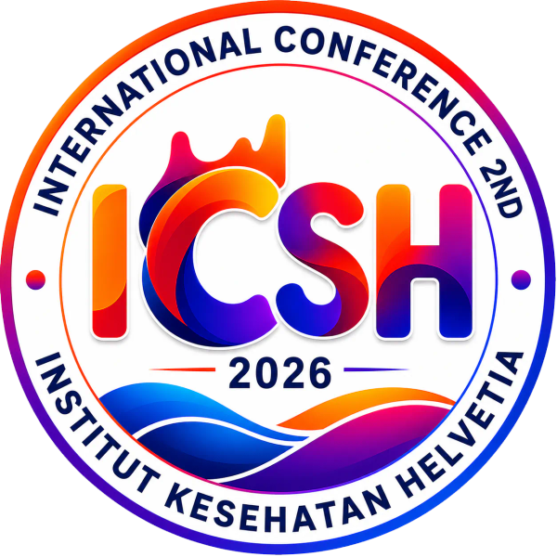
THE 2ND INTERNATIONAL CONFERENCE ON SCIENCES OF HEALTH (ICSH 2026)
Theme: Integrating Research, Technology, Traditional and Innovation Across Disciplines: Sustainable Health 5.0
5-7 October 2026 | Selecta Convention Hall, Medan, Indonesia & Zoom Virtual | https://ikhconference.com

OFFICIAL ABSTRACT SUBMISSION TEMPLATE & AUTHOR GUIDELINES
MANUSCRIPT SUBMISSION METADATA
Important Notice for Authors: To ensure automatic metadata matching and expedited double-blind peer review, we strongly advise registering your conference account first at https://ikhconference.com/registration. Registered participants receive this template with their verified Order ID and presentation track pre-filled automatically.
Paper ID / Order ID: [ PENDING REGISTRATION ]
Research Track Classification: Track 02: Medicine (Sustainable Health 5.0)
Presentation Mode: [ X ] Oral Presentation [ ] Poster Presentation
Publication Preference: [ X ] Asian Journal of Medicine and Biomedicine (AJMB) [ ] ICSH 2026 Proceedings
Effectiveness of Interventions to Reduce Non-Prescription Antibiotic Dispensing in LMIC Pharmacies: Meta-Analysis
Tengku Muhammad Lufthi Hannur^{1*}
¹ Study Program of Medicine, Faculty of Medicine, Universitas Islam Sumatera Utara, Medan, North Sumatra, Indonesia
* Corresponding Author: Tengku Muhammad Lufthi Hannur | Email: tengkumuhammadlufthihannur@fk.uisu.ac.id | WhatsApp: +62 822-6740-3241 | ORCID: https://orcid.org/0009-0008-1306-2485
ABSTRACT
Background: Non-prescription antibiotic dispensing (NPD) in community pharmacies contributes to antimicrobial resistance, yet no quantitative review has pooled intervention effect estimates specifically from private community pharmacies in low- and middle-income countries (LMICs). Methods: We conducted a systematic review and meta-analysis following PRISMA 2020 guidelines. PubMed, OpenAlex, and the Cochrane Central Register of Controlled Trials were searched up to September 2026. Eligible studies were controlled trials evaluating interventions to reduce NPD in private community pharmacies in LMICs, with outcomes assessed by unannounced simulated client methods. Cluster-adjusted odds ratios were pooled using a random-effects model with the DerSimonian-Laird estimator and inverse-variance weighting. A Hartung-Knapp-Sidik-Jonkman sensitivity analysis was performed to assess the robustness of the confidence interval given the small number of included studies. Results: Three trials from Vietnam, Nigeria, and Indonesia met eligibility criteria (k = 3; 345 pharmacies; 1,683 simulated client encounters). The odds of NPD were 83.6% lower in intervention pharmacies compared with control pharmacies (pooled OR = 0.164; 95% CI: 0.102 to 0.265; Z = -7.38; p < 0.0001). The Hartung-Knapp-Sidik-Jonkman method yielded a wider interval (OR = 0.164; 95% CI: 0.064 to 0.419; p = 0.042). Statistical heterogeneity was not detected (I-squared = 0.0%; Q = 1.58, df = 2, p = 0.454). Conclusion: To our knowledge, this is the first meta-analysis to pool controlled trial data on NPD interventions from private community pharmacies in LMICs. Multifaceted interventions combining dispenser education, rapid diagnostic testing, and peer supervision were associated with lower odds of non-prescription antibiotic dispensing.
Keywords: Antimicrobial Resistance; Community Pharmacy; Non-Prescription Antibiotic Dispensing; Meta-Analysis; Low- and Middle-Income Countries

ACADEMIC FORMATTING & SUBMISSION COMPLIANCE CHECKLIST
[X] Word Count Limit: 200 - 300 words strictly for the abstract body (excluding title, authors, and keywords).
[X] Language & Style: Formal academic English (UK or US, must remain consistent throughout). Proofread for grammar.
[X] No Visuals/Citations: Do NOT include references, footnotes, tables, figures, or non-standard abbreviations in the abstract.
[X] File Format: Must be saved and uploaded in Microsoft Word format (.docx or .doc), maximum file size 10 MB.
[X] Review Process: All submissions undergo double-blind peer review by the ICSH 2026 Scientific Review Board.
ETHICAL STATEMENT & AUTHOR DECLARATION
[ X ] Originality: The authors certify that this abstract is original, has not been published previously, and is not under consideration elsewhere.
[ X ] Ethical Approval: Ethical approval was not required as this study is a secondary systematic review and meta-analysis of publicly available, published trial data.
[ X ] Conflict of Interest: The authors declare that they have no financial, personal, or professional conflicts of interest regarding this work.
[ X ] Author Consent: The listed author has reviewed, approved this submission, and agreed to present at ICSH 2026 if accepted.

