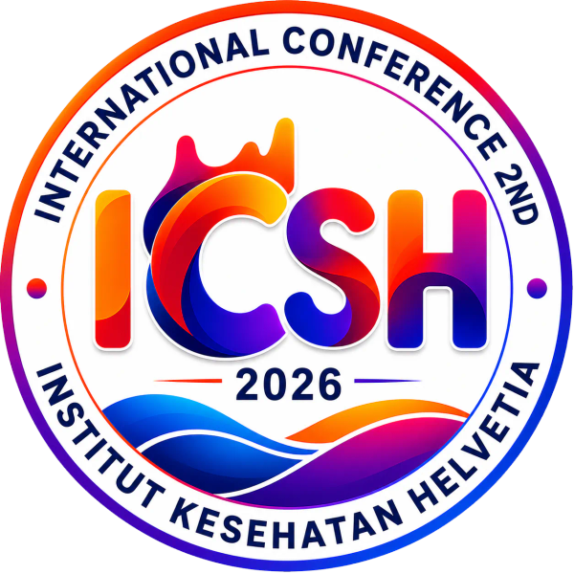
THE 2ND INTERNATIONAL CONFERENCE ON SCIENCES OF HEALTH (ICSH 2026)
Theme: Integrating Research, Technology, Traditional and Innovation Across Disciplines: Sustainable Health 5.0
5-7 October 2026 | Selecta Convention Hall, Medan, Indonesia & Zoom Virtual | https://ikhconference.com

OFFICIAL ABSTRACT SUBMISSION TEMPLATE & AUTHOR GUIDELINES
MANUSCRIPT SUBMISSION METADATA
Important Notice for Authors: To ensure automatic metadata matching and expedited double-blind peer review, we strongly advise registering your conference account first at https://ikhconference.com/registration. Registered participants receive this template with their verified Order ID and presentation track pre-filled automatically.
Paper ID / Order ID: [ e.g., IKH-682403-VQEW ]
Research Track Classification: [ Select Track 01 to Track 10 - e.g., Track 01: Public Health & Epidemiology ]
Presentation Mode: [ ] Oral Presentation [ ] Poster Presentation
Publication Preference: [ ] Asian Journal of Medicine and Biomedicine (AJMB) [ ] ICSH 2026 Proceedings
[TITLE OF THE MANUSCRIPT: CONCISE, IMPACTFUL, AND DESCRIPTIVE, MAXIMUM 15-20 WORDS, TIMES NEW ROMAN 14 PT, BOLD, CENTERED]
First Author Name^{1*}, Second Author Name², Third Co-Author Name¹
¹ Department of Health Sciences, Faculty / Institution Name, City, Country
² Department of Biomedical Sciences, Faculty of Medicine, University/Institution Name, City, Country
* Corresponding Author: First Author Name | Email: author@institution.ac.id | WhatsApp: +62 812-xxxx-xxxx | ORCID: https://orcid.org/0000-0002-xxxx-xxxx
ABSTRACT
Background: Provide a concise context of the study, clinical or public health significance, and the specific gap in existing literature that this research addresses within the framework of Sustainable Health 5.0. Objective: State the primary research objective, specific aim, or hypothesis clearly and concisely. Methods: Specify the research design (e.g., randomized controlled trial, cross-sectional, cohort, systematic review), study setting, population/sampling method, sample size (n), key interventions/variables measured, statistical tools used for data analysis, and ethical clearance reference. Results: Report the main findings with relevant quantitative data (e.g., percentages, mean +/- SD, odds ratios, 95% confidence intervals, and p-values). Highlight significant differences or correlations observed rather than vague generalities. Conclusion: Summarize the main conclusions supported directly by the findings, key clinical/practical implications, potential impact on healthcare policy, and relevance to sustainable health development. (Total abstract word count must be strictly between 200-300 words).
Keywords: Sustainable Health 5.0; Digital Healthcare; Epidemiology; Public Health; Telemedicine [Provide 3 to 5 keywords, separated by semicolons, preferably indexed in Medical Subject Headings / MeSH]
[ EXAMPLE OF AN ACCEPTED ABSTRACT — FOR REFERENCE ONLY ]
[ Note for Authors: This example illustrates the expected academic rigor, quantitative depth, and professional narrative style for ICSH 2026 / AJMB / Scopus indexing. You may delete this reference box once your own abstract is drafted above. ]
Effectiveness of AI-Assisted Remote Cardiovascular Risk Screening in Community Health Centers: A Multicenter Randomized Controlled Trial
Ahmad F. Siregar^{1*}, Siti N. Rahmah², David K. Wong³, Nurul H. Hidayati¹
1 Department of Public Health, Faculty of Public Health, Institut Kesehatan Helvetia, Medan, Indonesia | 2 Department of Cardiology, Faculty of Medicine, Universitas Sumatera Utara, Medan, Indonesia | 3 Faculty of Health Sciences, Universiti Kebangsaan Malaysia, Bangi, Malaysia | * Corresponding Author: ahmad.siregar@helvetia.ac.id
Cardiovascular diseases (CVD) remain the primary contributor to global premature mortality, particularly in resource-constrained community settings where specialist evaluation is delayed. Sustainable Health 5.0 integrates artificial intelligence (AI) to enhance decentralized primary diagnostics. This study evaluated the diagnostic accuracy, clinical efficiency, and referral compliance of an AI-assisted point-of-care cardiovascular risk screening algorithm compared to standard care in rural and peri-urban community health centers (Puskesmas). A parallel-group, multicenter randomized controlled trial was conducted across 18 community health centers from October 2025 to March 2026 (n = 1,420 adult patients aged 40–70 years with ≥1 metabolic risk factor). Centers were randomly assigned (1:1) to either AI-assisted screening (automated ECG and photoplethysmography telemetry analysis with predictive risk stratification; n = 712) or standard clinical risk scoring (n = 708). The primary outcome was early diagnostic detection of high-risk atherosclerotic cardiovascular disease (ASCVD), verified by blinded cardiologist adjudication. Secondary outcomes included time to clinical consultation and 90-day specialized referral compliance. Ethical approval was granted (IRB/EC: 084/KEPK-IKH/2025). AI-assisted screening demonstrated significantly superior diagnostic sensitivity (91.4%, 95% CI: 87.8%–94.2%) versus standard evaluation (72.6%, 95% CI: 67.9%–76.9%; p < 0.001). Median clinical triage time decreased by 58% (14.2 min vs. 33.8 min; p < 0.001). 90-day cardiologist referral adherence was substantially higher in the intervention arm (82.3% vs. 54.1%; Relative Risk = 1.52, 95% CI: 1.37–1.69; p < 0.0001). Integration of AI-assisted remote screening into primary community health workflows dramatically accelerates risk stratification, enhances diagnostic precision, and optimizes referral pathways within Sustainable Health 5.0 paradigms.
Keywords: Artificial Intelligence; Cardiovascular Disease; Community Health; Primary Care; Remote Screening; Sustainable Health 5.0

ACADEMIC FORMATTING & SUBMISSION COMPLIANCE CHECKLIST
[X] Word Count Limit: 200 - 300 words strictly for the abstract body (excluding title, authors, and keywords).
[X] Language & Style: Formal academic English (UK or US, must remain consistent throughout). Proofread for grammar.
[X] No Visuals/Citations: Do NOT include references, footnotes, tables, figures, or non-standard abbreviations in the abstract.
[X] File Format: Must be saved and uploaded in Microsoft Word format (.docx or .doc), maximum file size 10 MB.
[X] Review Process: All submissions undergo double-blind peer review by the ICSH 2026 Scientific Review Board.
ETHICAL STATEMENT & AUTHOR DECLARATION
[ X ] Originality: The authors certify that this abstract is original, has not been published previously, and is not under consideration elsewhere.
[ X ] Ethical Approval: Ethical clearance was formally granted by [Insert IRB/Ethics Committee Name & Approval Number: e.g., EC/2026/042].
[ X ] Conflict of Interest: The authors declare that they have no financial, personal, or professional conflicts of interest regarding this work.
[ X ] Author Consent: All listed co-authors have reviewed, approved this submission, and agreed to present at ICSH 2026 if accepted.

