Compromised
Half-Life 2
Document Date: 3/10/08

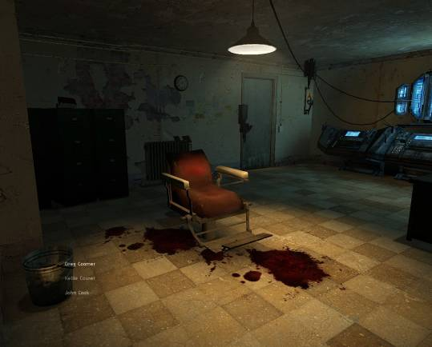

Designer: Eric Bakutis
Intended Level Delivery Date: 7/3/08

Table of Contents
Revision Notes 3
Quick Summary 4
Gameplay Overview 4
Objective Summary 4
Technical Overview 4
Campaign 4
Mission Location 5
Mission Difficulty (1-5) 5
Mission Metrics 5
Technical Details 5
Level Atmosphere/Mood 5
Story 6
Introduction 6
In-Game 6
Extro 8
Major Areas/Visual Themes 9
Area 1 – ‘City 17 Exterior’ 9
Area 2 – ‘Apartment Building Interior’ 14
Area 3 – ‘Apartment Building Basement’ 18
Area 4 – ‘Forest’ 20
Map Objectives 22
Challenge Highlights 22
Water Cooler Moments 23
Actors 23
Player (Jack Carter) 23
Key Actors 23
Badger 23
Sabrina Jackson 23
Hayden ‘Doc’ Cross 23
Nathan Jackson 23
Supporting Actors 24
Combine Gate Guards (2) 24
Combine Security Staff (2) 24
Combine Interrogator (1) 24
Combine Interior Guards – While Nathan’s Alive (8) 24
Combine Reinforcements – After Alarm is Tripped (infinite, spawned) 24
Combine Helicopters – After Alarm is Tripped (3) 24
Combine Interior Guards – After Nathan’s Dead (infinite, spawned) 24
Key Assets 25
User Interface 25
Gameplay Details 26
Gameplay Mechanics 26
Level Progression Chart 26
Walkthrough/Detailed Map Description 26
Area 1.1 – City 17 Exterior 26
Area 2.1 – Apartment Building Interior (Floor 1) 28
Area 2.2 – Apartment Building Interior (Floor 2) 29
Area 2.3 – Apartment Building Interior (Floor 1) 30
Area 3 – Apartment Basement 31
Area 4 – Forest 32

Revision Notes
3/10/08 – Initial version of document
3/16/08 – Initial Feedback Pass Completed

Quick Summary
In this single-player mission, players take on the role of rebel soldier Jack Carter and infiltrate a Combine prison to rescue a rebel arms supplier, Nathan Jackson.

Gameplay Overview
The player’s objectives are to infiltrate the building, find Nathan, and get him to safety. The commander of the player’s cell also gives the player another objective—if he can’t get Nathan out, he is to kill him. Nathan knows too much about rebel operations to remain in Combine hands—if broken, he’ll betray dozens of rebel cells.

Gameplay focuses on short bouts of intense combat interspersed with story development through NPC interaction. Each combat session is more intense than the last. Players alternate between combat and story development as they progress.

Objective Summary
- Speak with Badger to get your mission briefing.
  - Obtain a crossbow and Combine SMG.
  - Kill the guards outside the building with the crossbow.
  - Descend the fire escape to meet Sabrina and Hayden.
- Speak with Sabrina and Hayden to learn their plan to infiltrate the building.
  - Learn Sabrina is Nathan's daughter.
  - Get a Combine soldier disguise from Hayden.
- Infiltrate the building and find Nathan Jackson.
  - Explore the building to find where the Combine is holding Nathan.
  - Break into the interrogation room and kill the Combine.
  - Free Nathan Jackson (this sets off an alarm).
- After the alarm sounds, get Nathan Jackson out of the building.
  - Kill Combine guards who try to recapture Nathan.
  - Reach the building entrance.
  - After seeing that Combine have surrounded the building, follow Nathan Jackson into the basement.
- Once in the basement, choose to protect Nathan Jackson or kill him.
  - If the player chooses to protect Nathan, he fights off waves of stunstick-wielding Combine until Sabrina gets an escape door open.
  - If the player chooses to kill Nathan, he fights off waves of aggressive Combine (using SMGs) until overwhelmed and knocked out.
- Watch the ending sequence (this sequence varies based on player actions)

Technical Overview

Campaign
- Name: Rescue Mission (only level in campaign)
  - One day before the mission starts, the Combine attacked Nathan’s farm and captured him. The player must work with two City 17 Rebels, Sabrina Jackson and Hayden Cross, to rescue Nathan Jackson from the building. The player must either protect him from the Combine (until they escape) or kill him (ensuring the Combine can’t interrogate him).

Mission Location
- Theme: Urban occupation
- Mood: Overcast, stormy, dark, and threatening
- Setting: City 17 rebelling against the Combine
- Time: Afternoon
- Season: Fall
- Weather: Overcast and rainy

Mission Difficulty (1(easy) - 5(hard))
- Starting - 1
- Middle - 2
- Ending - 4

Mission Metrics
- Play Time: 5 to 10 minutes
- Physical Length: 7000 Half-Life units (583 feet)
- Physical Area: One city block (215 feet high x 340 feet wide)
- Max New Characters: None
- Max Visual Themes: 4
  - City 17 Exterior
  - Combine Building Exterior/Interior
  - Combine Building Basement
  - Abandoned Forest Road

Technical Details

Level Atmosphere/Mood
The level constantly reminds players of the fact that Combine have occupied Earth. A strange mixture of Combine technology and blood-stained, damaged walls subtly conveys all the ways the Combine has damaged humanity’s home.

The mood of the level is threatening—the overcast and stormy cityscape and the dark, ill-lit hallways work together to create a feeling of foreboding and dread in the player. Beginning with the stormy exterior, the player feels increasingly ill at ease as he enters an unnaturally dark building and navigates its dilapidated halls.

The overcast exterior is accented by the sound of rumbling thunder from time to time, building anticipation for a storm. Inside the building, the player encounters other subtly unnerving sounds, such as the electrical hum of bare bulbs, the creaking of rotting wood and foundation in the wind, and the subtle hum of Combine electronic devices affixed to the walls.

Story

Introduction
- The mission starts in City 17 during the week Gordon Freeman and Alyx Vance are missing due to a teleporter malfunction. Human rebels in City 17 rise up in open rebellion against the Combine.
- The story opens with Jack (the player) on a building roof, across from where the Combine is holding Nathan. Jack has a suit but no weapons. Badger (Jack’s commander) contacts him via radio.
- Badger tells Jack he’s to work with two City 17 rebels (Sabrina and Hayden) to infiltrate the building and get Nathan out.
- Jack learns from Badger that the Combine are intent on keeping Nathan alive, and won’t use lethal force on Nathan. Badger lets Jack know that it’s too his advantage to keep Nathan alive—as long as he’s safe, the Combine won’t use lethal force to try and get him back, and that gives them both an advantage.
- Badger gives Jack one last objective--if Nathan is too injured to escape, or it looks like they may be recaptured, Jack is to kill Nathan. If the Combine breaks Nathan through torture, he’ll compromise too many City 17 cells.
- Badger also warns Jack that if he does have to kill Nathan, the Combine can attack full force—the gloves are off at that point.
- Badger tells Jack a Crossbow Rifle and a Combine Assault Rifle are hidden in a crate nearby—Jack must grab these weapons before he can continue.

In-Game
- After Jack takes the Crossbow Rifle and Combine Assault Rifle from the crate, Sabrina contacts him from an alley nearby.
- Sabrina tells Jack she’s ready to jam Combine communications, preventing the Combine from radioing in that they are under attack. She’s also set up an audio loop to fake the guards returning ‘All Clear’ messages when queried.
- Sabrina tells Jack to take out the two Combine guards at the entrance on her signal. She then jams the radio and starts a jamming loop. Jack has 10 seconds to snipe both guards—otherwise, Jack fails the mission and restarts.
- After Jack eliminates the guards, Sabrina radios and asks Jack to descend from the building via the fire escape. A gate prevents Jack from reaching the fire escape until after he’s sniped the guards, but opens after they’re dead.
- Jack descends the fire escape to meet up with Sabrina and Hayden.
- Sabrina introduces herself—she’s here to jam Combine transmissions and prevent the Combine from calling for backup during the rescue.
- Hayden introduces himself—he’s here to heal Nathan once he’s out, and heal Jack if he’s injured during the rescue.
- Sabrina tells Jack she has started looping footage and audio to disable transmissions coming in and out of the building—it will fool the Combine for ten minutes. Jack has that long to rescue Nathan.
- Sabrina assures Jack she is not going to let her personal feelings for her father interfere with this mission. She thanks him for getting Nathan out and reveals she is unaware that Badger has ordered Jack to kill Nathan if it proves impossible to rescue him.
- After Sabrina wishes Jack luck, Hayden approaches Jack and gives him a captured Combine uniform. Jack puts on the uniform and enters the building.
- Inside the building, Jack sees patrolling Combine soldiers. They do not attack Jack as long as he doesn’t attack them, but Jack can kill them if he wants. They will react to gunshots and begin searching, but not attack Jack unless they see him shoot a fellow guard or he shoots one of them.
- If Jack searches the first floor, he can find a guarded terminal that will allow him to disable the force field generator blocking his access to Nathan's cell. The player may kill the guard stealthily or loudly, alerting the entire building.
- Jack heads up to the second floor, where he finds Nathan in a closed interrogation rooms with two guards—the door is locked. Jack sees Combine torturing Nathan through a large glass window.
- To get into the interrogation room, Jack must smash the window and kill the guard. Jack enters the room and kills the interrogator and guards, then releases Nathan. Nathan is injured but can still walk. Unfortunately, Jack's destruction of the glass window sets off an alarm Sabrina cannot stop.
- After the alarm goes off, Jack must rush down to the first floor with Nathan, fighting Combine as he goes. The Combine will focus fire on Jack and will not shoot Nathan Jackson, who they wish to recapture. Nathan is unarmed and will not fight back.
- When Jack tries to escape the building, a helicopter swoops down from the sky and Combine elites cover the front area of the building. Jack and Nathan can’t escape.
- Nathan yells at Jack to head for the basement, then leads Jack to the stairs. Jack must follow Nathan to the basement... the door out is blocked.
- Once inside the locked basement with Combine about to bust inside and attempt to recapture Nathan Jackson, Jack has a moment to make
- Jack can kill Nathan, ensuring Nathan won’t be recaptured and tortured, or try to fight his way out with Nathan, and risk all resistance fighters in City 17.
  - Ending 1: If Jack chooses to kill Nathan, the Combine bust in after Jack shoots Nathan dead. Because Nathan is dead, they use SMGs and grenades and hold nothing back. After Jack defeats several waves of combine, they drop in a flash bang bomb that knocks him out.
  - Ending 2: If Jack chooses to fight to help Nathan escape, the Combine bust the door open and attack with stunsticks. Jack fights them off in close quarters. After a few waves, Sabrina manages to hack open a door and open an escape route. Jack and Nathan escape into the sewer, where Sabrina and Hayden are waiting.

Extro
- Epilogue 1: Jack wakes in the back of a Combine armored car, being driven to Nova Prospekt.
  - The armored car is ambushed by rebels—players see a cinematic where Sabrina and Hayden appear, kill the guards, and rescue Jack.
  - Sabrina and Hayden then speak to Jack and learn Nathan Jackson is dead. Sabrina is devastated and Hayden comforts Jack.
  - Jack has one last final conversation where Hayden tells Jack he understands why he killed Nathan, and is glad he didn't have to make that choice.
- Ending 2: Jack finds himself in a lonely forest with a buggy nearby, with Nathan, after they escaped City 17. Sabrina and Hayden are with them.
  - Sabrina thanks Jack for rescuing her father, Nathan, and Sabrina and Nathan say their goodbyes, heading off to hide out in a nearby mansion.
  - Hayden berates Jack for taking the risk, reminding Jack that if Nathan was recaptured, many rebels would have been killed, including Hayden's uncle and brother. When Jack asks if Hayden would have done things differently, Hayden relents and admits he is glad he didn't have to make that choice.

Major Areas/Visual Themes

Area 1 – ‘City 17 Exterior’
- Text Description: This is several city blocks located in City 17—all typical Eastern European architecture as seen in Half-Life 2. The player starts on the roof of a building then descends via the fire escape.
- Visual References:
  - Terrain/Vegetation: None
  - Models/Architecture:

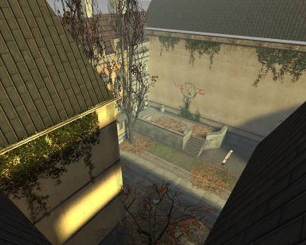 | Models/Architecture - Rooftop  A view similar to the player’s starting point, looking down from a roof onto the city block below.
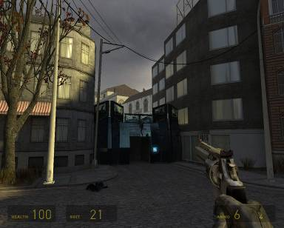 | Models/Architecture -  City Block / Combine Checkpoint  A view of a typical City 17 block, similar to that the player sees after descending from the rooftop. Combine checkpoints, one of which is also visible in this shot, prevent the player from leaving the city block.

Area 1 – ‘City 17 Exterior’ (cont)
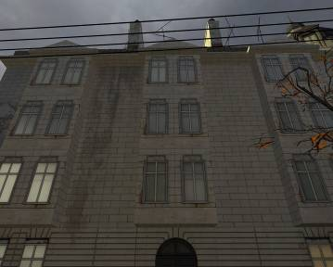 | Models/Architecture -  Refurbished Apartment Building  A building similar to the apartment building the Combine have taken over and turned into their prisoner interrogation center.
 | Models/Architecture –  City Street  The type of architecture that inspired City 17. The exterior is a close, narrow street like this with buildings towering overhead. There are no parked cars, however.
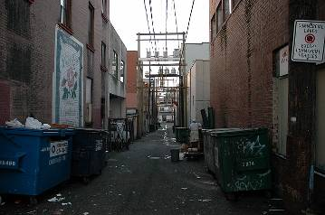 | Models/Architecture –  Alley  A narrow, trash filled alley similar to the one in which the player meets Sabrina and Hayden.

Area 1 – ‘City 17 Exterior’ (cont)
  - Textures/Lighting
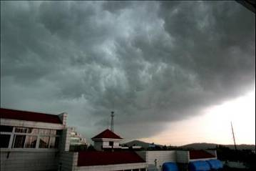 | Textures/Lighting -  City Street  An overcast sky in a city, similar to the threatening atmosphere hanging over City 17 during the level.
 | Textures/Lighting –  City 17  The type of overcast day the player sees in City 17. Threatening clouds hang over the city’s buildings. The normally bright day is dark and gloomy, causing a feeling of trepidation.
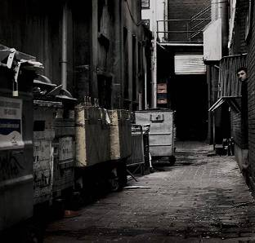 | Models/Architecture –  Alley  The lighting in the alley looks similar to the lighting in this shot thanks to the cloud cover—everything is gray and washed out.

Area 1 – ‘City 17 Exterior’ (cont)
  - Characters/Vehicles
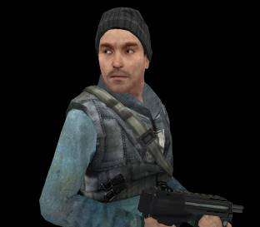 | Characters/Vehicles -  Jack Carter  Jack Carter’s in-game character model. Jack is the City 17 Rebel the player controls. The player sees Jack as his avatar during cinematics.
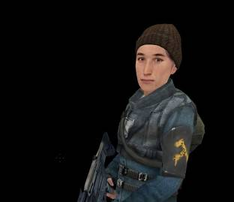 | Characters/Vehicles –  Sabrina Jackson  Sabrina Jackson’s in-game character model.
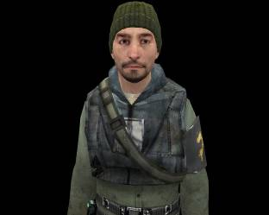 | Characters/Vehicles –  Hayden ‘Doc’ Cross  Hayden Cross’ in-game character model.

Area 1 – ‘City 17 Exterior’ (cont)
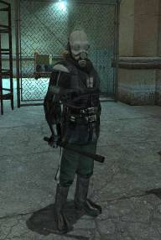 | Characters/Vehicles -  Combine Gate Guards / Combine Security Staff  The Combine Gate Guards in-game model (Metro Police). The player snipes these at the start of the level. Two more guards sit inside a glassed in security area inside the building, but the player never interacts with them.
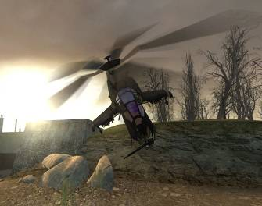 | Characters/Vehicles –  Combine Helicopter Gunship  The Combine Helicopter Gunship in-game model. One of these descends to cover the street after Jack rescues Nathan and alerts the Combine, forcing Jack and Nathan back inside.
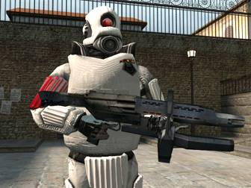 | Characters/Vehicles –  Combine Elites  The Combine Elite in-game model. A number of these surround the building after Jack rescues Nathan and alerts the Combine, forcing Jack and Nathan back inside.

Major Areas/Visual Themes

Area 2 – ‘Apartment Building Interior’
- Text Description: This is the interior of the apartment building where the Combine holds Nathan Jackson. The grungy, dilapidated interior mixes decaying human architecture with Combine technology, creating a disconcerting, dark, and unsettling environment that keeps the player on edge.
- Visual References:
  - Terrain/Vegetation: None
  - Models/Architecture:

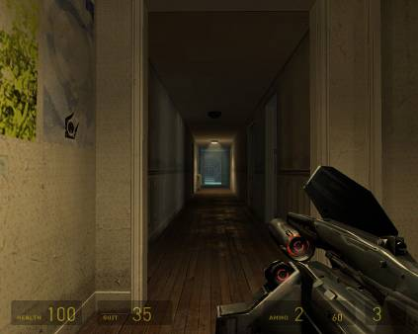 | Models/Architecture -  Apartment Building Interior  The interior of the Combine apartment building. The halls looks similar to this with a few more high-tech devices on the walls. The halls are also narrower (more claustrophobic) and in a much worse state of disrepair.
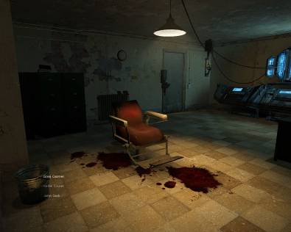 | Models/Architecture -  Interrogation Room  A room like that in which Jack finds Nathan, where the Combine are torturing him. It also shows the mixture of modern human architecture and sci-fi technology that pervades the building interior.

Area 2 – ‘Apartment Building Interior’ (cont)
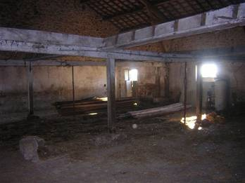 | Models/Architecture -  Dilapidated Interior  The interior of the apartment building—grungy, run down, filled with rubble. The apartment building where the Combine holds Nathan looks similar to this.
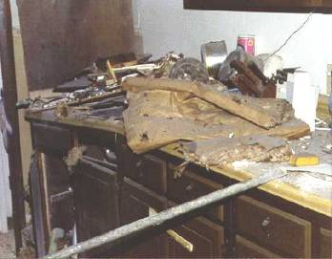 | Models/Architecture –  Abandoned Room  The interior of one of several empty, abandoned rooms in the apartment building. The rooms are filled with junk and rubble. One of the empty rooms has a .357 magnum hidden in it.
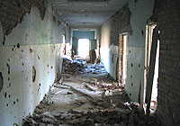 | Models/Architecture –  Rubble Filled Hallway  A hallway similar to the more damaged hallways of the apartment building—strewn with rubble, with bullet holes marking the walls.

Area 2 – ‘Apartment Building Interior’ (cont)
  - Textures/Lighting
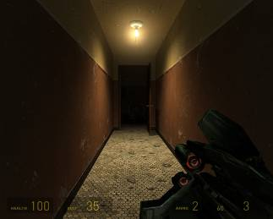 | Textures/Lighting -  Darkened Interior with Bare Bulb Lights  The lighting in this hall is similar to that which fills the Combine building. The Combine have boarded up most of the windows, making the building fairly dark. The only light comes from overhead lamps (usually bare bulbs) and sci-fi gear.
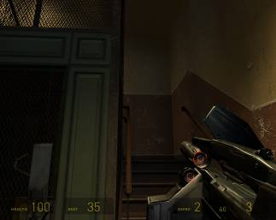 | Textures/Lighting –  Stairwell with Limited Daylight  An example of a stairwell with daylight coming in from windows near the top. A few windows in the stairwell still admit light, though the hallways and rooms themselves are dark. The light draws players up the stairwell to the second floor.
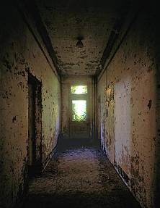 | Models/Architecture –  Hallway Lighting  The end of a dimly lit hallway. This lighting is similar to the hallways inside the apartment building. The window at the end would be boarded up instead of open.

Area 2 – ‘Apartment Building Interior’ (cont)
  - Characters/Vehicles
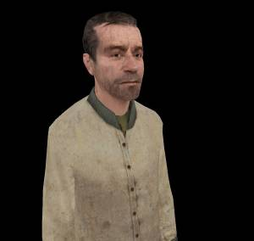 | Characters/Vehicles -  Nathan Jackson  Nathan Jackson’s in-game character model.
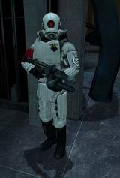 | Characters/Vehicles –  Combine Interrogator  The Combine Interrogator’s in-game model—a Combine Elite using a stunstick.
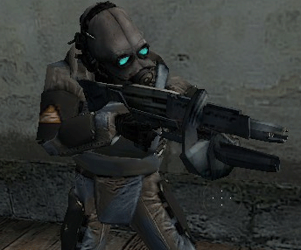 | Characters/Vehicles –  Combine Interior Guard  The Combine Interior Guards in-game model—the player encounters these throughout the building.

Major Areas/Visual Themes (cont)

Area 3 – ‘Apartment Building Basement’
- Text Description: This is the basement of the apartment building where the player and Nathan take cover from the Combine. It is dark and rubble-filled.
- Visual References:
  - Terrain/Vegetation: None
  - Models/Architecture:

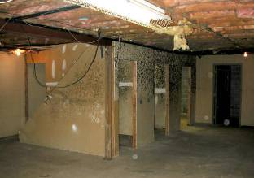 | Models/Architecture -  Basement Walls and General Look  A room with walls and a floor similar to that of the apartment basement. The apartment basement has more rubble and is considerably more run down.
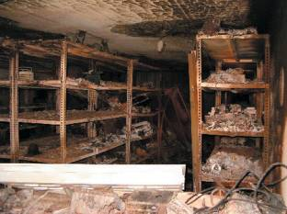 | Models/Architecture -  Shelves, Clutter and Claustrophobia  The claustrophobic nature of the basement—rubble and shelves block in most of the space, leaving very little room to fight.
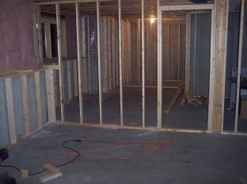 | Textures/Lighting -  Dark Basement  The lighting in the basement is similar to lighting in this shot—a single bulb provides the only light. There are no windows.

Area 3 – ‘Apartment Basement’ (cont)
  - Characters/Vehicles

Characters/Vehicles –
Combine Interior Guard (if Nathan is dead)

The Combine Interior Guards that storm the basement if the player kills Nathan Jackson are shown here. They wield SMGs and Grenades.
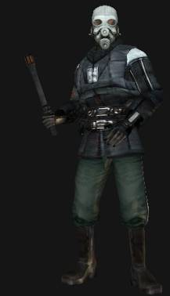 | Characters/Vehicles –  Combine Interior Guard (if Nathan is alive)  The Combine Interior Guards that storm the basement if the player keeps Nathan Jackson alive are shown here. They wield stunsticks and wear heavy armor that makes them tougher to kill than normal guards.

Major Areas/Visual Themes

Area 4 – ‘Forest’
- Text Description: This is the forested area to which the player and Nathan Jackson escape (if the player rescues him) or from which Sabrina and Hayden rescue the player (if he kills Nathan Jackson).
- Visual References:
  - Terrain/Vegetation:

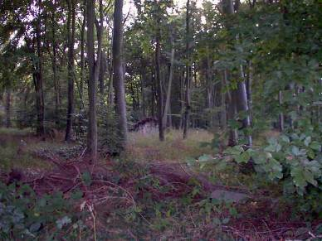 | Terrain/Vegetation -  Quiet, Abandoned Forest at Night  A remote, abandoned forest. This scene is the backdrop for the final scripted sequence or cinematic that wraps up the level. The forest would be dark since the scene takes place at night.
  - Models/Architecture: None
  - Textures/Lighting:

 | Textures/Lighting -  Quiet, Abandoned Forest at Night  The forest is lit similar to the forest in this shot—it’s the middle of the night, so the forest is dark and lit only by moonlight.

Area 4 – ‘Forest’ (cont)
  - Characters/Vehicles
    - None

Map Objectives
- Primary Objective 1:
  - The player’s must infiltrate the building, find Nathan Jackson, and get him safely out of the building.
- Primary Objective 2:
  - After the Combine reinforcements arrive, the player’s objective is to defend Nathan from Combine (risking capture and torture for them both) or kill Nathan (ensuring the Combine can’t interrogate him).
- Secondary Objective:
  - None
- Bonus Objective:
  - None
- Hidden Objective:
  - Find a .357 magnum hidden in an empty apartment.

Challenge Highlights
- Combat:
  - Snipe Combine Metro Police outside the building.
  - Kill the Combine interrogator torturing Nathan Jackson.
  - Kill Combine guards inside the building, after the alarm goes off, and later in the basement.
  - Kill Combine guards armed with SMGs and grenades in the building’s basement (these only appear if the player kills Nathan Jackson).
- Stealth
  - Avoid guards while exploring the apartment building in disguise.
- Puzzles
  - Stealthily kill a guard and close the door to the room before disarming the force field to avoid alerting all guards of the breakout attempt.
- Conversation
  - Speak with Badger to get the mission briefing.
  - Speak with Sabrina to find out how she’s hacked into the building and allowed you to break in undetected.
  - Speak with Hayden to find out he’s ready to heal you or Nathan if you get injured.
  - Speak with Nathan to find out his son was killed by the Combine during the war, after which he joined the rebels. He was captured while fighting off Combine so his wife and daughter could escape.
  - Speak with Sabrina, Hayden, and Nathan (if he’s still alive) at the end of the mission.
- Boss Battles
  - Fight off waves of Combine guards with stunsticks in close quarters in the basement (assuming Nathan Jackson is still alive).
  - Fight off waves of Combine guards with SMGs and grenades in close quarters in the basement (assuming Nathan Jackson is dead).

Water Cooler Moments
- Area 2 (Apt. Interior): Seeing Combine torturing Nathan through a window.
- Area 2 (Apt. Interior): Smashing the window to the interrogation room with the support bar and jumping in, guns blazing.
- Area 2 (Apt. Interior, Post Alarm): Reaching the building exit to see Combine troops swarming in, and a helicopter arriving.
- Area 3 (Apt. Basement): Choosing between killing Nathan Jackson, or protecting him against impossible odds in ‘Jack’s Last Stand’.

Actors

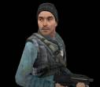
Player (Jack Carter)
- Model(s): City 17 Rebel Male Model
- Inventory: None
- Start Location: The roof of an abandoned building
- Motives/Objectives: Rescue Nathan Jackson from the Combine. Survive the mission to fight again.

Key Actors

Badger
- Model(s): None (Badger is never seen, he is only a voice)
- Inventory: None
- Motives/Objectives: Pass important rebel objectives on Jack.
- Starting Location: None (Badger is never seen, he is only a voice)

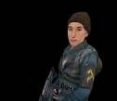
Sabrina Jackson
- Model(s): City 17 Rebel Female Model
- Inventory: None
- Motives/Objectives: Help Jack break into the building and rescue Nathan Jackson, her father.
- Starting Location: The alley beside the abandoned building where Jack starts.

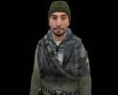
Hayden ‘Doc’ Cross
- Model(s): City 17 Rebel Male Model (Medic)
- Inventory: Shotgun
- Motives/Objectives: Heal Jack and Nathan once they escape the building. Starting Location: The alley beside the abandoned building where Jack starts.

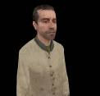
Nathan Jackson
- Model(s): City 17 Civilian Male Model
- Inventory: None
- Motives/Objectives: Escape the Combine. Resist interrogation. Get back to his family. Help Jack.
- Starting Location: Interrogation room inside an apartment building the Combine have taken over.

Supporting Actors

Combine Gate Guards (2)
- Model(s): Combine City Police
- Inventory: Combine Assault Rifle
- Motives/Objectives: Prevent Rebels from infiltrating the building.
- Uses Within Level: Hapless sniper targets for the player.

Combine Security Staff (2)
- Model(s): Combine City Police
- Inventory: SMGs.
- Motives/Objectives: Scan people entering the building.
- Uses Within Level: Observe the player from the security room as he enters the building in disguise, make the player nervous about detection.

Combine Interrogator (1)
- Model(s): Combine Elite
- Inventory: SMG.
- Motives/Objectives: Torture Nathan Jackson until Nathan gives up the location of rebel cells.
- Uses Within Level: Encourage the player to hurry to free Nathan.

Combine Interior Guards – While Nathan’s Alive (8)
- Model(s): Combine Soldier
- Inventory: SMGs and Stunsticks
- Motives/Objectives: Guard the building from Rebels. Retrieve Nathan Jackson using non-lethal force if Rebels try to rescue him.
- Uses Within Level: Opposition for the player after the alarm goes off.

Combine Reinforcements – After Alarm is Tripped (3)
- Model(s): Combine Elite
- Inventory: Combine Assault Rifle, Grenades
- Motives/Objectives: Kill the player.
- Uses Within Level: Show the player they cannot exit the building.

Combine Helicopter – After Alarm is Tripped (1)
- Model(s): Combine Helicopter
- Inventory: None
- Motives/Objectives: Kill the player.
- Uses Within Level: Show the player they cannot exit the building.

Combine Interior Guards – After Nathan’s Dead (spawned in waves)
- Model(s): Combine Soldier
- Inventory: Combine Assault Rifle, Grenades
- Motives/Objectives: Kill the player.
- Uses Within Level: Bring the level to a close if the player chooses to kill Nathan Jackson.

Key Assets
- Weapons/Ammo
  - Crossbow Rifle (accessible to player from a crate after briefing)
  - Combine Assault Rifle (accessible to player from a crate after briefing)
  - Crowbar (accessible to player from a crate after briefing)
  - Combine Disguise (given to the player after briefing)
  - Combine Assault Rifle Ammo (retrieved from dead guards)
  - .357 Magnum (hidden bonus weapon in the building)
- Vehicles
  - Combine Helicopter
  - Jalopy
- Interactive Elements
  - Computer console (player accesses the console to disarm the force field blocking them away from Nathan Jackson's cell)
  - Glass Window (player shatters this to rescue Nathan Jackson from the Combine interrogator).

User Interface
- Pre-Game Information
  - The player’s objective is to rescue Nathan Jackson from a building where the Combine are interrogating him.
- In-Game Information
  - After receiving the briefing from Badger, Sabrina tells the player to take out the guards at the building entrance with the Crossbow.
  - Sabrina tells the player ‘Use the fire escape to get down to us’.
  - Sabrina tells the player how she’s jamming Combine signals, and asks the player to find information about her missing husband.
  - Hayden tells the player to use the stolen Combine uniform to infiltrate the building.
  - After the player discovers the Combine have surrounded the building, Nathan tells him to hurry to the basement and hide there.
  - If the player chooses to protect Nathan, Sabrina tells him she’s opened an escape for them (after the player fights off waves of guards).
  - If the player chooses to kill Nathan, the player overhears Combine radio chatter authorizing the Combine to use lethal force.
- Post Game Information
  - Debriefing
    - If the player killed Nathan, Sabrina and Hayden rescue the player as the Combine transport him to Nova Prospekt. Sabrina is devastated and Hayden tries to comfort the player.
    - If the player protected Nathan, he and Nathan escape and Nathan thanks the player for returning him to his family. Hayden chastises the player.
- HUD Elements
  - Normal Elements Used
    - All
  - Special Elements Required
    - None

Gameplay Details

Gameplay Mechanics
- Prerequisite Skills: Standard first-person shooter skills—shooting weapons, switching weapons, evading and killing enemies, navigating 3D environments.
- Skills Learned: None

Level Progression Chart
- See final page – page 36.

Walkthrough/Detailed Map Description

Area 1.1 – City 17 Exterior
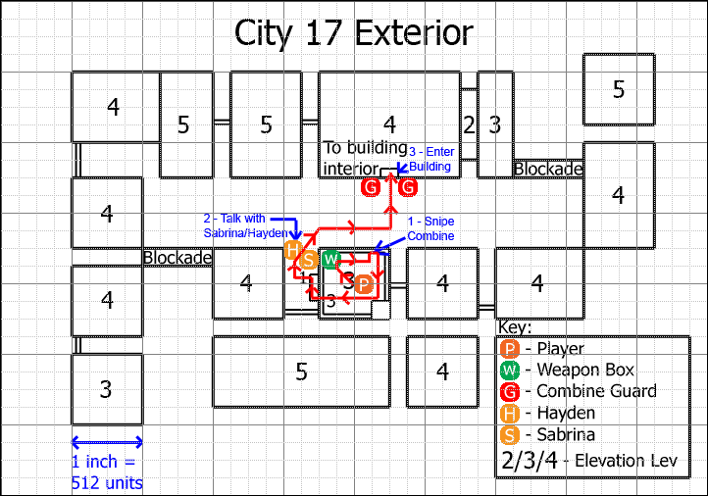
- Detailed Map
- Gameplay
  - The player starts at the ‘P’ on the map and receives the mission briefing from Badger.
  - The player retrieves his weaponry and suit from the weapons locker on the rooftop, marked ‘W’.
  - Sabrina instructs the player to snipe the two Combine soldiers (marked by ‘G’s) on the street, from the rooftop. Each soldier carries an SMG. The player must kill them to receive his next objective. (1)
  - The player descends the fire escape to meet Sabrina and Hayden (marked by ‘S’ and ‘H’). (2)
  - The player grabs a Combine uniform from Hayden, disguises himself as a Combine soldier, and enters the apartment building where the Combine are holding Nathan Jackson (the player enters at the red arrow leading into the largest building on the map). (3)
- Dialog
  - Speak with Badger to receive mission briefing.
    - “Jack—glad you made it safely to City 17. Yesterday night the Combine captured a man named Nathan Jackson in a raid on his farm—we need you to rescue him. Nathan has been the major arms supplier for the City 17 revolt, and he has info on a number of our cells. We believe the Combine may be torturing him even now in hopes of getting those names.”
    - “We’ve got a local crew there with you… they’ve acquired a Combine disguise and will contact you soon. We need to get Nathan out of there—I’m counting on you to pull this off. One thing to keep in mind—as long as Nathan’s alive, the Combine will keep the gloves on. They won’t use lethal force on you as long as Nathan is alive, so use that to your advantage.”
    - “There’s one last thing. I don’t have to tell you how important Nathan is, to us and the Combine. If you can’t get him out—if you’re trapped, or he’s injured, or you’re certain there’s no way to escape—Jack. I want you to kill him. We both know it’s far more merciful than what the Combine will do to him. We’ll do everything in our power to rescue him, but this is your call. If you think you won’t make it—take Nathan out. It’s the only way to protect all the rebel cells he could betray.”
  - Speak with Sabrina to find out how to break into the building—this is queued after the player picks up his weapon loadout from the crate.
    - “Jack? Hi. The name’s Sabrina. I’m here to help you get into that building and get Nathan out. The first thing we have to do is take out the sentries—in a few seconds, I’m going to jam their transmissions so they can’t call for backup. Use your crossbow and take them out. You ready?”
    - “3… 2… 1… jamming now. Take ‘em out, Jack!”
  - Speak with Sabrina to find out how she’s jamming Combine transmissions (allowing you to break into the building).
    - “I’m glad you’re here, Jack. My name is Sabrina, and I’ll be making sure the Combine don’t call for backup after we hit them. I’ve got a line on their alarm and communication systems and I’ve already shut down their alarms, but it’ll be up to you to get him out as quick as possible—the best I can do is hold them up for 10 minutes. Any longer than that, they’ll figure out they’ve been hacked and send out an alarm. So, you’ll have to be quick.”
  - Speak with Sabrina to receive the goal to find a list of Combine prisoners (Sabrina’s husband may be on that list).
    - “Jack—there’s one other thing. The Combine have my husband. They caught him in a sweep almost two weeks ago. I don’t know where he is, but I’m certain he’s alive. It’s possible there may be a list of Combine prisoners in that building—if you can find it, my husband’s name might be on that list. We can find out where he is and free him. I know it’s not your mission, and I understand you can’t guarantee anything—but I need to get him back. Please, Jack. If you find something, let me know.”
  - Speak with Hayden to find out why he’s there (he’ll fix Nathan up after he’s rescued).
    - “So you’re Jack Carter—it’s an honor, man. What you did over in City 14 is the stuff of legend around here. You’re an ex-Marine, right? I’m ex-army myself—left about the time the brass surrendered to the Combine. I’m here to make sure you and Nathan are taken care of as best I can—I’ll patch up your wounds and get you moving.”
  - Speak with Hayden to receive the Combine disguise.
    - “A couple of days back we ambushed some Combine north of the city and managed to take some intact uniforms. I’ve got one of them right here. Put it on and those bastards won’t even know who are you until you shoot them in the face. This uniform should get you close enough to find Nathan and get him out. We’re counting on you, Jack. Good luck.”
- Visual References
  - See Major Areas / Visual Themes – Area 1 – ‘City 17 Exterior’

Walkthrough/Detailed Map Description (cont)

Area 2.1 – Apartment Building Interior (Floor 1)
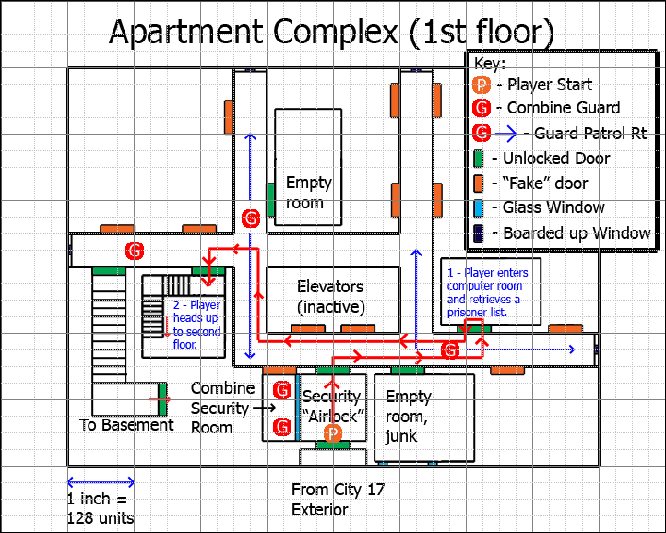
- Detailed Map
- Gameplay
  - The player starts at the ‘P’ on the map, entering on Floor 1.
  - The player explores the building. Combine Soldiers (marked by ‘G’s) patrol the building on regular routes, but do not attack. If the player attacks them, they fight back but don’t alert other soldiers unless soldiers see the attack (Sabrina is jamming their communications).
  - The player may disarm the forcefield blocking them from reaching Nathan Jackson's cell. (1)
  - The player may explore the empty abandoned apartments.
  - After exploring the first floor to his satisfaction, the player heads to the stairwell and heads up to Floor 2. (2)
- Dialog
  - None
- Visual References
  - See Major Areas / Visual Themes – Area 2 – ‘Apartment Building Interior’

Walkthrough/Detailed Map Description (cont)

Area 2.2 – Apartment Building Interior (Floor 2)
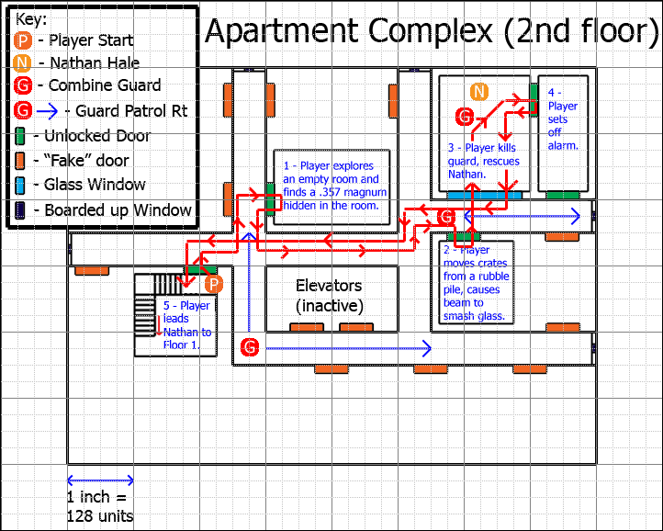
- Detailed Map
- Gameplay
  - The player starts at the ‘P’ at the exit to the stairwell from Floor 1.
  - Combine Soldiers (marked by ‘G’s) patrol the building on regular routes, but do not attack. If the player attacks them, they fight back but don’t alert other soldiers (Sabrina is jamming their communications).
  - The player may find a .357 magnum hidden in one of the abandoned rooms on the second floor, if he looks hard enough. (1)
  - The player finds Nathan Jackson’s interrogation room, smashes the glass and enters the interrogation room. (2)
  - Player kills the guards and frees Nathan (unlocks door to room). (3)
  - Player (or Nathan) sets off alarm. (4)
  - Player leads Nathan back down the stairwell to Floor 1. (5)

- Dialog
  - The player finds out who Nathan Jackson is and how he was captured.
    - “Who are you? Nevermind… names aren’t important. You’re with the resistance, and that’s all I need to know. My name’s Nathan—the Combine captured me yesterday night. I got my wife and daughter out, but the bastards killed the rest of my squad and took me hostage. Thank God you’re here.”
    - (after standing up). “I can walk, boy. I’m old, not decrepit, and I’ll fight those bastards with everything I’ve got left. The Combine killed my son during the war, and I’ve never forgiven them. I don’t care what the bastards do to me, I’m not giving them a damn thing.”
    - (after the alarm goes off) “We’ve got to get out of here now, boy. Lead the way! I’ve got your back!”
- Visual References
  - See Major Areas / Visual Themes – Area 2 – ‘Apartment Building Interior’

Walkthrough/Detailed Map Description (cont)

Area 2.3 – Apartment Building Interior (Floor 1)
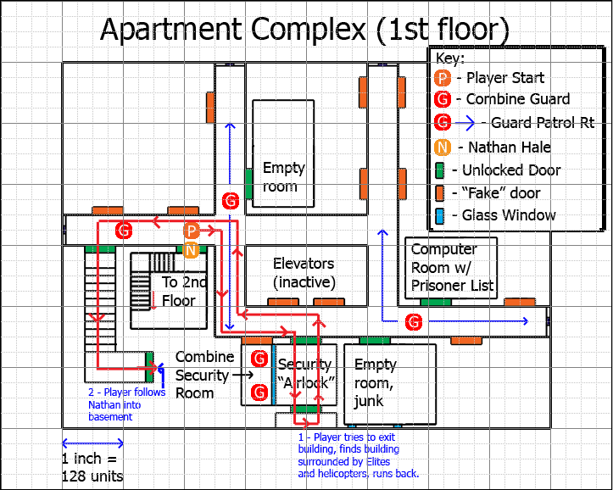
- Detailed Map
- Gameplay
  - The player starts at the ‘P’ on the map, when he enters the building on Floor 1. Nathan starts at the ‘N’.
  - The player kills Combine guards heading for the Security “Airlock”.
  - When the player reaches it and tries to exit, Combine reinforcements (including Elites as well as a helicopter) overrun the street. (1)
  - The player cannot use the door and thus cannot go out into the street.
  - Nathan turns and limps toward the basement, yelling at the player to follow him. The player follows Nathan down into the basement. (2)
- Dialog
  - Nathan tells the player there’s too many to fight.
    - “Dammit, they’ve got us boxed in! There’s too many to fight, boy… follow me. We can barricade ourselves in the basement!”
- Visual References
  - See Major Areas / Visual Themes – Area 2 – ‘Apartment Building Interior’
Walkthrough/Detailed Map Description (cont)

Area 3 – Apartment Basement
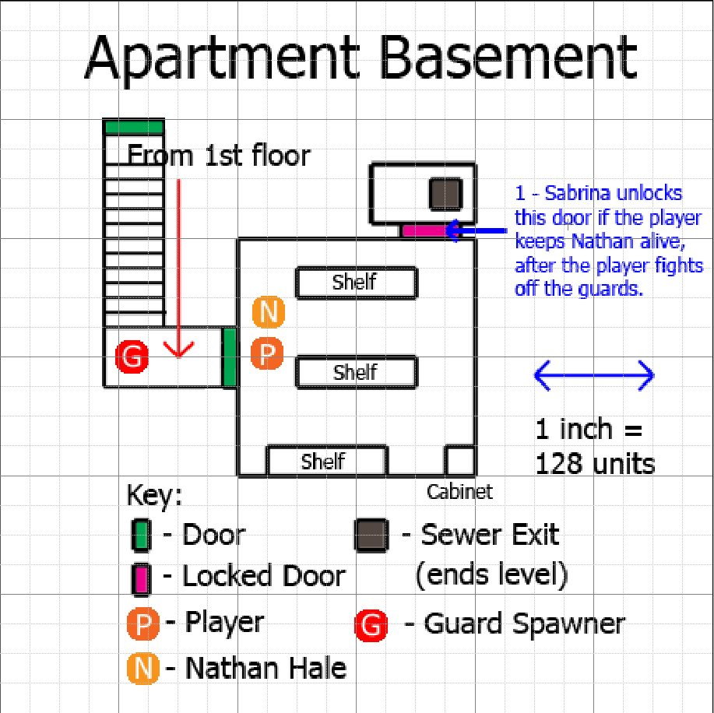
- Detailed Map
- Gameplay
  - The player starts at the ‘P’ on the map, when he enters the basement. Nathan starts at the ‘N’.
  - Nathan blockades the door with a fallen piece of furniture.
  - The player must choose to either execute Nathan (ensuring he can’t be recaptured) or fight to the death to protect him (meaning they could both be captured and interrogated).
  - If the player kills Nathan, Combine Interior Guards with SMGs and Grenades storm the basement and knock him out (fade to black).
  - If the player defends Nathan, Combine Interior Guards with Stunsticks storm the basement (Sabrina unlocks the door after a few waves).

- Dialog
  - Nathan asking the player not to kill him.
    - “I know what you’re thinking, boy—you’re thinking we’re not getting out of this. I also know what your cell commander probably asked you to do. What I’m asking is that you give me a chance. I promise you, if I think the Combine are going to take us, I’ll do it myself. But give me a chance, boy. I want to see my wife and daughter again.”
  - Sabrina telling the player she’s found an exit (if he defends Nathan).
    - “Jack! It’s Sabrina! I’ve hacked into their system and we’ve got you an exit from the basement. I’m opening a door into the sewers. Get in there and get out there ASAP!”
  - The Combine radioing in that they’ve captured a rebel (if the player executes Nathan Jackson) as the screen fades to black.
    - “We’ve secured another prisoner—he killed Jackson. Understood. We’ll bring him to Nova Prospekt for interrogation.”
- Visual References
  - See Major Areas / Visual Themes – Area 3 – ‘Apartment Basement’

Walkthrough/Detailed Map Description (cont)

Area 4 – Forest
- Gameplay
  - None (an ending cinematic plays)
- Dialog
  - If the player killed Nathan, Sabrina and Hayden tell the player they rescued the player while the Combine was transporting him to Nova Prospekt.
  - If the player rescued Nathan, he talks with Sabrina, Hayden, and Nathan to wrap up the mission.
- Visual References
  - See Major Areas / Visual Themes – Area 4 – ‘Forest’
- Detailed Map: N/A (the area is a skybox filled with open terrain with scattered trees—basically just displacement with scattered tree meshes)

