Input file (ie Brief Data Input) normally named as ‘<SAM ID>-MDU to DP’, exp: 3KYG-66 MDU to DP. So it varies SAM to SAM. While reading input file, file name will be diffrenet based on SAM ID. Create a new button in main menu window ‘**Reset’**, it will delete all the files in ‘**Files’** folder.

Output:

a)Genreate Order Template as normal excel file, file name shoulde be <SAM ID>_Order_Template

b) Genreate Item Template as **.csv** file, file name shoulde be <SAM ID>_Item_Template

c) Genreate Bulk B Number Template as **.csv** file, file name shoulde be <SAM ID>_Bulk B No_Template

There should not be any blank row in any of these generated files.

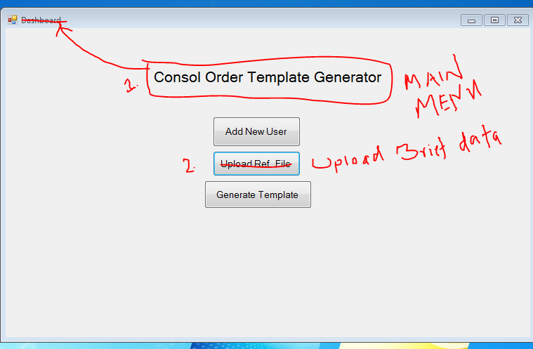

1. Rename ‘**Dashboard’** to **‘Consol Order Template Generator’**
2. Rename **‘Upload ref file’** to **‘Upload Brief Data’.** And add **‘Reset’** button under ‘**Generate Template**’ button

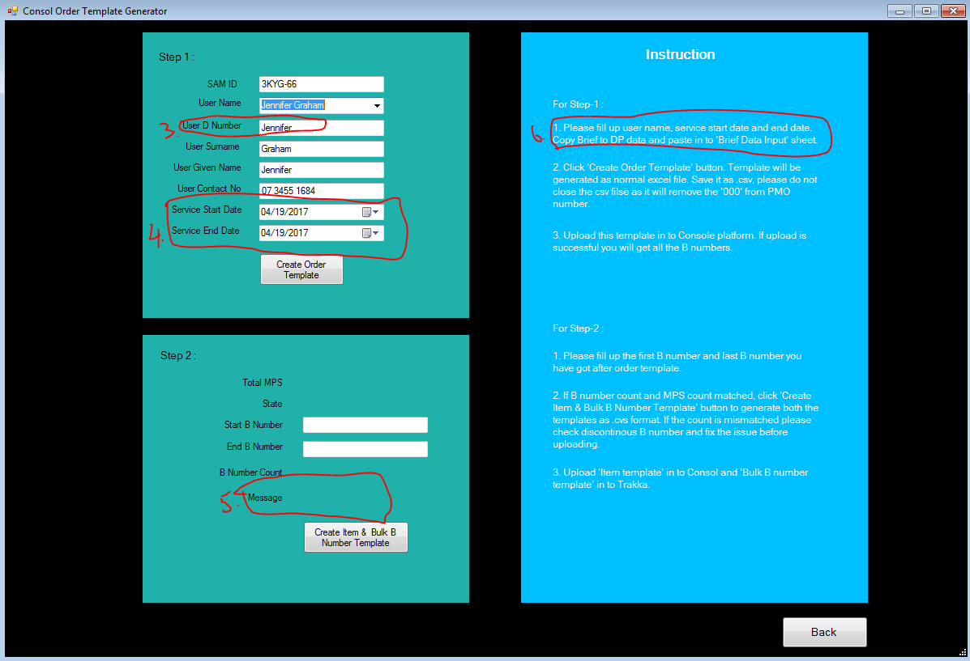

1. D number should be the ‘ID’ number, wrong field populated here.
2. Date format should be d/mm/yyyy, ie: 18/04/2017
3. Message: if Total MPS count (site count) = total B number count> **“Site count matched with B number count. You can generate the template now.”**

if Total MPS count (site count) not qual to total B number count> **“ Site count mismatched with B number count. Generate the template and fix the discontinuous B number in your template.”**  If possible with red colour. It’s a warning message.

1. Change the comment to ‘1. Please fill up user name, service start date and end date.’

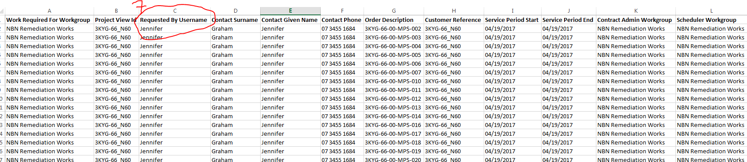

1. In order template “column C” should be the user ID number, ie D number /C number

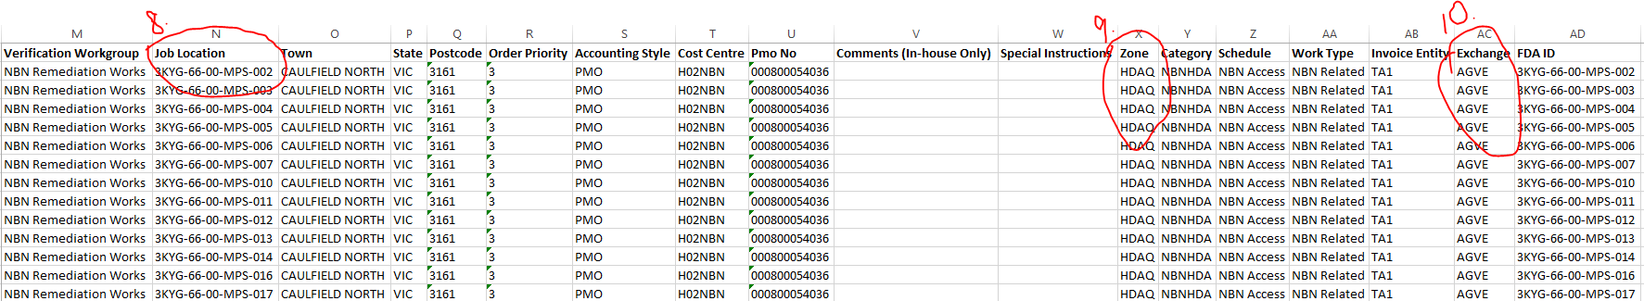

1. In order template, job location is wrong. It should be coming from column G (Property address 1) in Brief input file.
2. For Zone a new ref table required as below.

|  |  |
| --- | --- |
| State | Zone |
| NSW | HDAN |
| VIC | HDAV |
| QLD | HDAQ |
| SA | HDAS |
| WA | HDAW |
| TAS | HDAT |
| NT | HDANT |
| ACT | HDAA |

1. Exchange is not populating correctly. Check ESA ref file.