**IFB105 Project – Part A**

**TASK 1:**

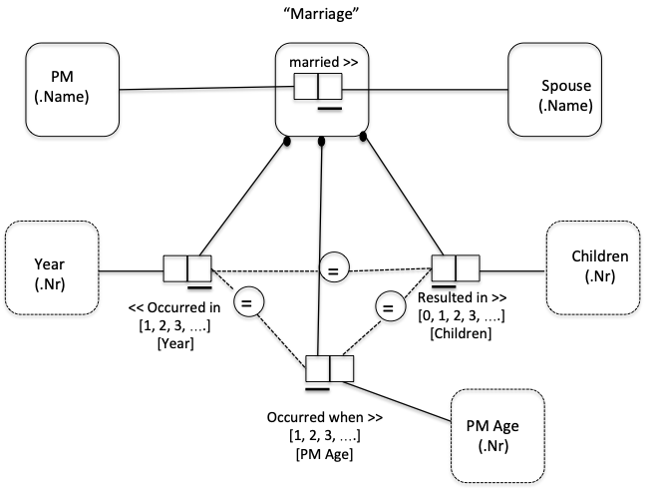

**CSDP Steps:**

**Step 1:**

Reference Schemes:

PM (.name); Spouse (.name); Year (.nr); Children (.nr); PM Age (.nr)

The facts are:

PM ‘Watson JC’ married Spouse ‘Low AJ’

This marriage occurred in Year ‘1889’

This marriage resulted in ‘0’ Children

This marriage occurred when PM’s age was ‘22’

**Step 2:**

Check diagram

**Step 3:**

Entities ‘PM’ and Spouse’ cannot be combined because in the given report (UoD), no PM is a spouse and no spouse is a PM. Also, both entities are not unit based. Therefore, both entities are not combined.

**Step 4:**

**Adding uniqueness constraints:**

Each PM can have multiple spouses

Year of marriage is unique to each marriage

PM’s age at marriage is unique to each marriage

Number of children is unique to each marriage

**Step 5:**

**Adding mandatory role constraints:**

Each marriage has to have:

1. A year of marriage

2. Number of children (Since no value is null in the report. 0 is not null)

3. PM’s age at marriage

**Step 6:**

**Adding equality constraints:**

The values of the nested “Marriage” entity are identical in all its roles. Therefore corresponding equality constraints are added.

**TASK 2:**

**Relational Database Schema:**

**Applying Rule 1:**

Taught_In: {Institution_Name, Lecturer_Name}

Degree_Awarded: {Lecturer_Name, Degree_Code, Year}

**Applying Rule 2:**

Lecturer: {Lecturer_Name, Sex_Code, Nickname, Birth_Year}

**Applying Rule 3:**

No nested Facts

**Applying Rule 4:**

Degree**:** {Degree_Code, Degree_Title}

**Final Solution:**

**Taught_In**: {Institution_Name, Lecturer_Name}

**Degree_Awarded**: {Lecturer_Name, Degree_Code, Year}

**Lecturer**: {Lecturer_Name, Sex_Code, Nickname, Birth_Year}

**Degree:** {Degree_Code, Degree_Title}