Create and manage work streams | MicrosoftDocs

anjgupta

# Create and manage work streams

[!INCLUDE[cc-applies-to-update-9-0-0](../../includes/cc_applies_to_update_9_0_0.md)]

This topic explains how you can create a live chat work stream and a CDS entity work stream in the Omni-channel Engagement Hub.

## Create a new live chat work stream

Follow these steps to create a new live chat work stream.

1. In the Omni-channel site map, select **Work Distribution > Work Streams**.

* The **Active Work Streams** view is shown.
* [!div class=mx-imgBorder] 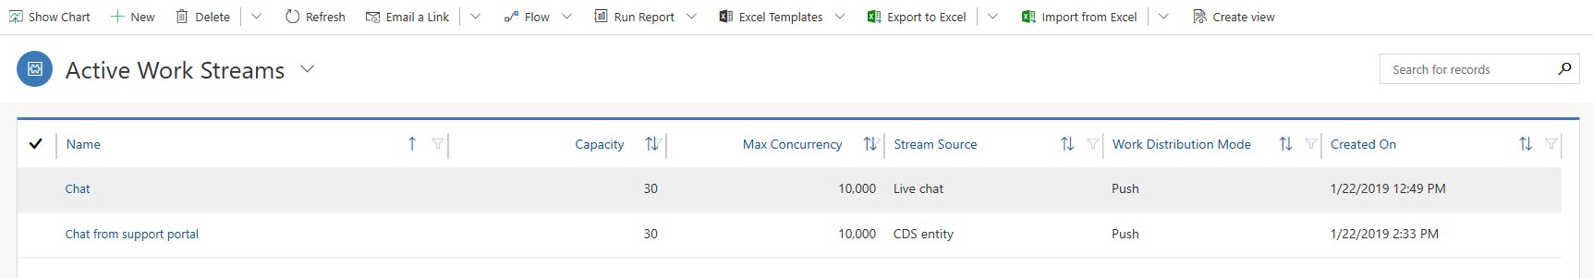

1. On the command bar, select **New** to create a work stream.
2. In the **Summary** tab of the new work stream page, follow these steps:
   * In the **General information** section, provide the following information:
     1. **Name**: Enter a name for the work stream.
     2. **Stream Source**: Select the channel that is supported for the work stream: **Live Chat** or **CDS Entity**. > [!NOTE] > If you select **CDS Entity**, see the CDS entity work stream section later in this topic.
     3. **Capacity**: Specify the units of capacity that are required to process a conversation for the work stream.
     4. **Auto-close after inactivity**: Specify the amount of time after which a conversation is moved from the **Waiting** state to the **Closed** state because of inactivity.
     5. Select **Save** to save the work stream.
   * In the **Work distribution** section, follow these steps:
     1. Select whether the **Work distribution mode** should be **Push** or **Pick**.
     2. In the **Notification** field, select the type of notification setting.
     3. In the **Screen pop timeout** field, select the amount of time before the screen pop times out.
     4. Select the **Allowed Presences** from the drop-down list.
   * [!div class=mx-imgBorder] 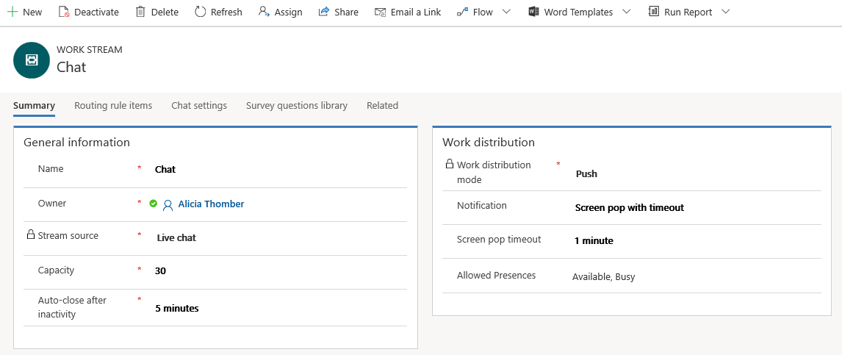
3. Define the routing rules in the **Routing Rule Items** tab. To know how to configure a routing rule, see [Create and manage routing rules in Omni-channel](routing-rules.md).
4. In the **Chat settings** tab, follow this step:
   * Add a new chat widget in the **Chat widget** section. For more information, see [Create a chat widget](set-up-chat-widget.md).
5. Add a new chat question and create a question library in the **Survey questions library** tab. For more information, see [Create a question library](create-question-library.md).
6. Select **Save** to save the live chat work stream.

After you’ve finished defining all the settings, the work stream is ready to receive conversations so that agents can start to work on them.

## Create a new CDS Entity work stream

CDS entity work streams help route entities from Common Data Service (CDS) to the Omni-channel Engagement Hub. For example, you can enable high-priority cases to be routed to Omni-channel so that they can be automatically distributed and assigned to agents.

[!NOTE] You can route any activity enabled entity.

To set up CDS entity routing, you need to configure a work stream in Omni-channel Engagement Hub and set up a corresponding flow in Microsoft Flow. Follow the detailed steps as given below.

### In Omni-channel Engagement Hub

1. In the Omni-channel site map, select **Work Distribution > Work Streams**.
2. Fill in the **General information** section as given in Create a new live chat work stream. For CDS work stream, select **Stream Source** as **CDS Entity**.

* 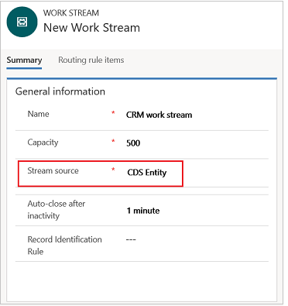
* Setting for CDS in work stream

1. Fill in the **Work distribution** section as given in Create a new live chat work stream.
2. In the **Work Stream Entity Configuration** section, select **Add** to add the entity that should be routed. A relationship is created between this entity and work stream.
3. Set up routing rules and queues for the work stream. For more information, see Create a new live chat work stream.

### In Microsoft Flow

1. Go to [portal.office.com](https://www.office.com/?auth=2&home=1), and select **Flow** in the list of apps.

* 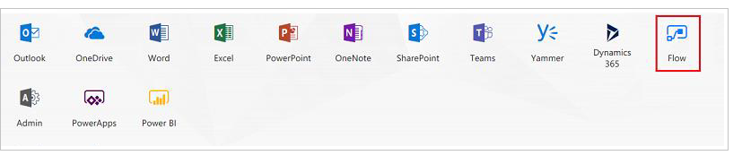
* CDS in Flow

1. Go to **Settings > Custom Connectors**, and then select **Create Custom Connector** to create a custom connector.

* 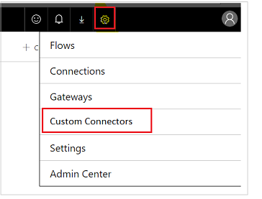
* custom connector

1. On the **Create Custom Connector** menu, select **Import an API file**
2. Enter a name for the custom connector, import **CSS-Entity.swagger.json** file and continue.

* 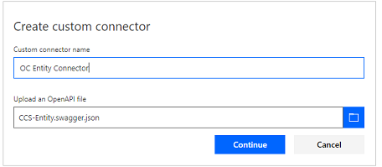
* Custom connector name
* [!NOTE] You can get **CSS-Entity.swagger.json** file from Insider portal.

1. Update the host name in the **General** tab in the following format: *https://****orguniquename****-public.omnichannelengagementhub.com*

* You can get **orguniquename** from [Organization unique name](../../developer/developer-resources-page.md#organization-unique-name).
* [!div class=mx-imgBorder] 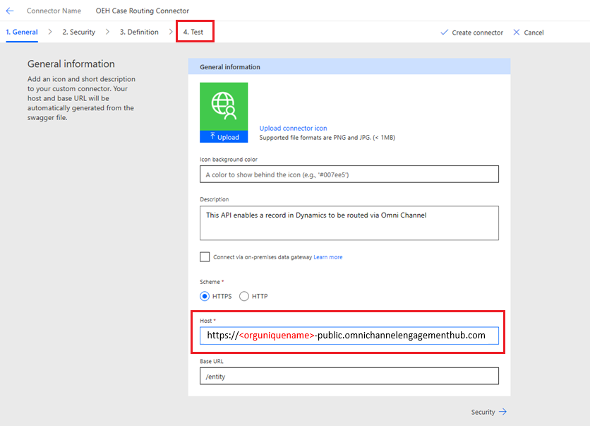

1. Go to **Test** tab to test the connector.
2. Select **Create connector** to create a new connector.

* 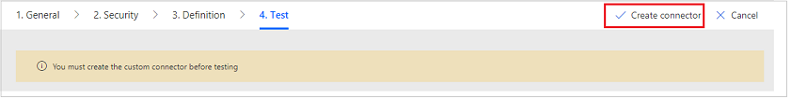
* Test connector

1. After the connector is created, select **New Connection**. A new connection is created, and the connection name is automatically selected.
2. Provide the following information, and then select **Test Operation** to test the connection:
   1. **Organization ID**: Enter your organization ID.
   2. **Work stream ID**: Enter the ID of work stream configured in Dynamics 365. You can get this ID from URL of the work stream record page.
   3. **Entity logical name**: Enter the logical name of the CDS entity that you choose to be routed.
   4. **Entity set name**: Enter the set name of the CDS entity that you choose to be routed. (Typically, this is a plural form of the logical name.)
   5. **Record ID**: Enter the ID of work stream entity configuration record, configured in Dynamics 365. You can get this id from URL of the work stream entity configuration record page.
   6. **Relationship name with work stream**: Enter the name of the entity relationship with the work stream. You can get this relationship name from **Settings** > **Customizations** > **Entities**.
   * 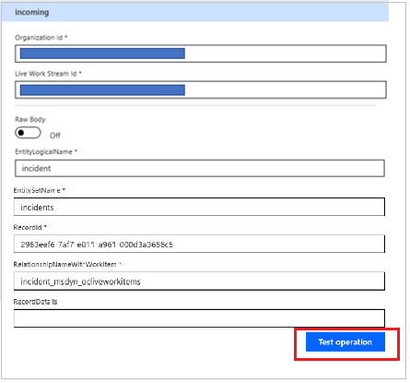
   * Connector details

* [!NOTE] You should receive response 202 when this connection is successfully set up. Usually this takes around 15 minutes.

1. Once the connection is successfully set up, go to **My Flows**.
2. Select **Create from Blank** to create a flow.

* 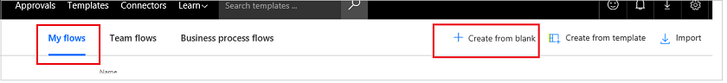
* create flow

1. Search for the **Dynamics 365 - When a record is created** trigger and select it.

* 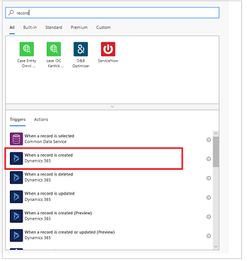
* Record connector

1. Select **New Step > Add an action**. Search for the custom connector you configured, and then select the action to send entity information.
2. Provide the following information:
   1. **Entity Logical Name**: Enter the logical name of the CDS entity that you choose to be routed.
   2. **Entity Set Name**: Enter the set name of the CDS entity that you choose be routed. (Typically, this is a plural form of the logical name.)
   3. **Record ID**: Use **Add dynamic content** option to search for and select entity name. For example for case entity select **Case** from dyanmic content
   4. **Name of Entity Relationship With**: Enter the name of the entity relationship with the work stream. You can get this relationship name from **Settings** > **Customizations** > **Entities**. For example for case entity the relationship name would be **incident_msdyn_ocliveworkitems**.
   5. **Record details**: Use **Add dynamic content** option and select **value-key-item-output**.
   6. **Organization ID**: Enter the ID of your organization.
   7. **Work Stream ID**: Enter the ID of work stream configured in Dynamics 365. You can get this id from URL of the work stream record page.
   * 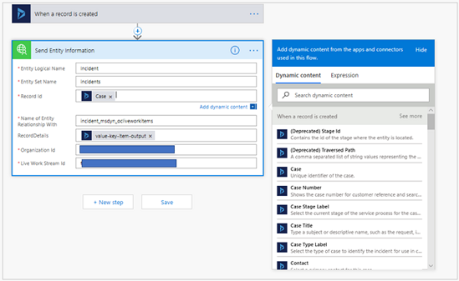
   * connector action
3. After all the information is entered, save and select **Test** to test the flow. Then select **I’ll perform the trigger action and save the flow**.

* To test the flow with the entity, create a new record for the entity that you’ve selected to route.
* After a successful run, you should see the following page.
* 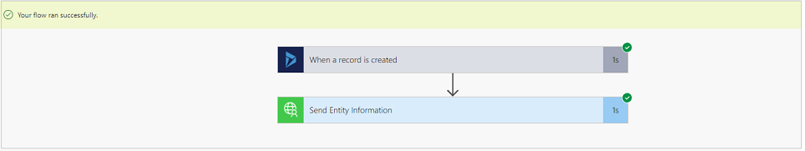
* Test saved connector

### See also

[Understand work streams in the Omni-channel Engagement Hub](work-streams-introduction.md)