**User Guide**

**Geospatial Risk Analysis Tool**

**V 1.0.1**

### Contents

1 General Information 2

1.1 System Overview 2

1.2 Software Requirements 2

1.3 Hardware Requirements 2

2 System Installation 3

2.1 System Pre-Installation 3

2.2 Geospatial Risk Analysis Tool Installation 3

3 Getting Started 6

3.1 Launching the Application 6

3.2 Data preparation 6

3.3 Choose a meteorological data file 7

3.4 Map attributes from the file 8

3.5 Choose the station where data was measured 9

3.6 Set the layer depth 10

3.7 Convert to ARL file 12

3.8 Set up and run the model 13

3.9 Run Potential source density function (PSDF) 14

3.10 About 17

3.11 Help 18

4 Uninstall 19

5 Disclaimer 20

# General Information

## System Overview

Developed by the Pacific Northwest National Laboratory (PNNL), the Geospatial Risk Analysis Tool (GRAT) links to  Hybrid Single-Particle Lagrangian Integrated Trajectory (HySPLIT), a complete system for computing simple air parcel trajectories, as well as complex transport, dispersion, chemical transformation, and deposition simulations. The HYSPLIT model was developed by the [National Oceanic and Atmospheric Administration](https://en.wikipedia.org/wiki/National_Oceanic_and_Atmospheric_Administration) (NOAA) [Air Resources Laboratory](https://en.wikipedia.org/wiki/Air_Resources_Laboratory) and the [Australian Bureau of Meteorology Research Centere](https://en.wikipedia.org/wiki/Bureau_of_Meteorology) in 1998.

GRAT is used to batch process meteorological data into ARL format. While HySPLIT GUI limits users to convert meteorological data up to 6 date time points per operation, GRAT enables users to convert a significantly large amount of data (For example, 10 years of meteorological data measured with an interval of 5 minutes) within one operation. Incorporated with the Potential source distribution function (PSDF), GRAT can also be used to determine the areas influenced by the emission of hazardous chemicals.

## Software Requirements

The GRAT will run using any of the following operating systems:

* Windows 10 64bits

Software:

* Python 3. x with the following packages:
  + numpy
  + openpyxl
  + scipy
  + matplotlib
  + basemap
  + basemap-data-hires
  + daal4py

## Hardware Requirements

Systems running the SFC software require:

* At least Pentium 233-megahertz (MHz) processing
* At least 64 megabytes (MB) of RAM (128 MB recommended) • At least 1.5 gigabytes (GB) of available space on the hard disk.

# System Installation

## System Pre-Installation

To ensure proper performance of the GRAT, HySPLIT, and Python need to be installed. Please download HySPLIT from <https://www.ready.noaa.gov/HYSPLIT.php> and extract it to C:\HYSPLIT. Download Python from <https://www.python.org/downloads/>, and follow installation instructions, then use PIP to install the following Python packages: numpy, openpyxl, scipy, matplotlib, basemap, basemap-data-hires, daal4py.

## Geospatial Risk Analysis Tool Installation

A compressed file will be provided for program installation.

**Step 1:** Navigate to the installation file location.

**Step 2**. Unzip the compressed file to a local folder. Two files are required for installation:

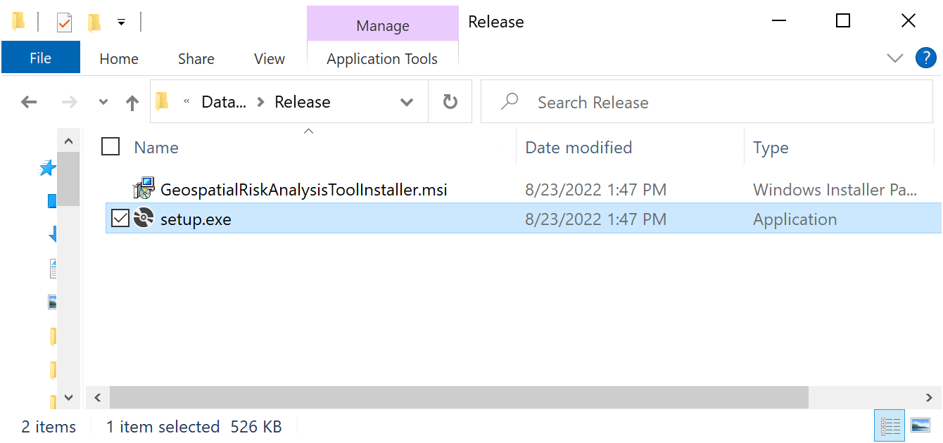

**Step 3:** Double-click the “setup.exe” file to begin the installation process. The Setup Wizard will begin the installation process, as depicted in the following figures.

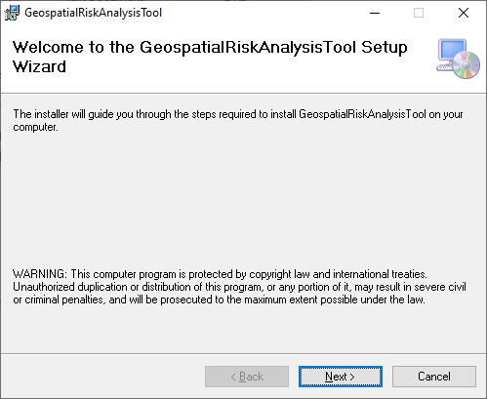

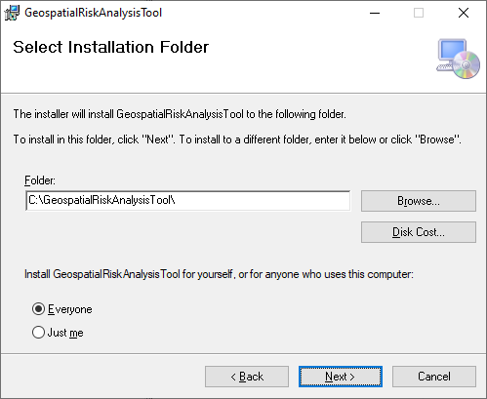

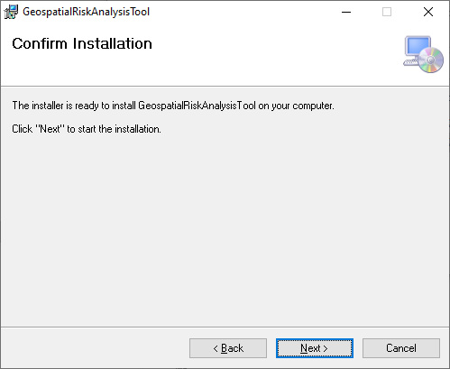 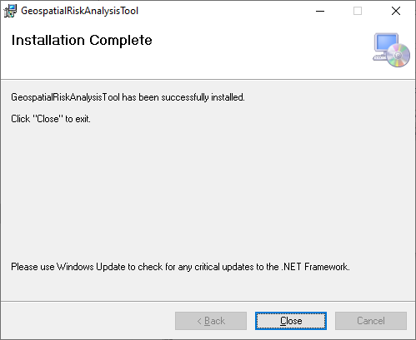

# Getting Started

## Launching the Application

There are two ways to start the GRAT application:

* Click the Windows Start icon. Select “All Programs” and navigate to and select “GeospatialRiskAnalysisTool”.
* Go to the installation file specified when installing the program (Section 2.2).

The startup screen will open:

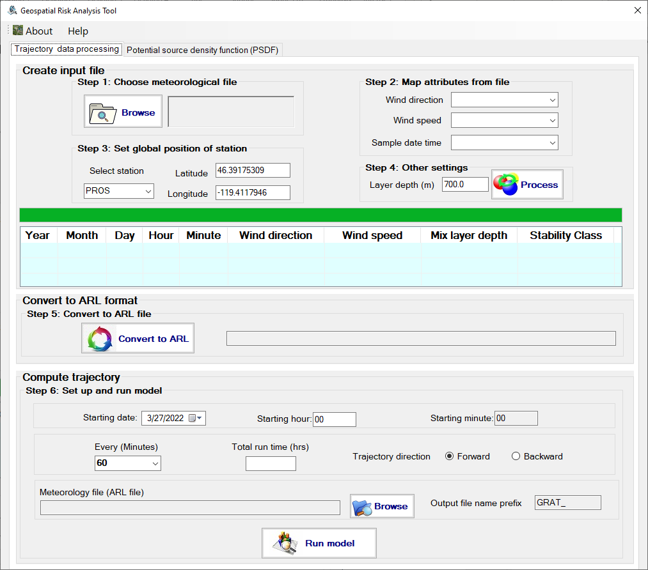

## Data preparation

The expected input files for GRAT should be in .csv format. Each file should contain at least three columns, the wind direction values, the wind speed values, and the timestamp associated with each measurement. Here is an example:

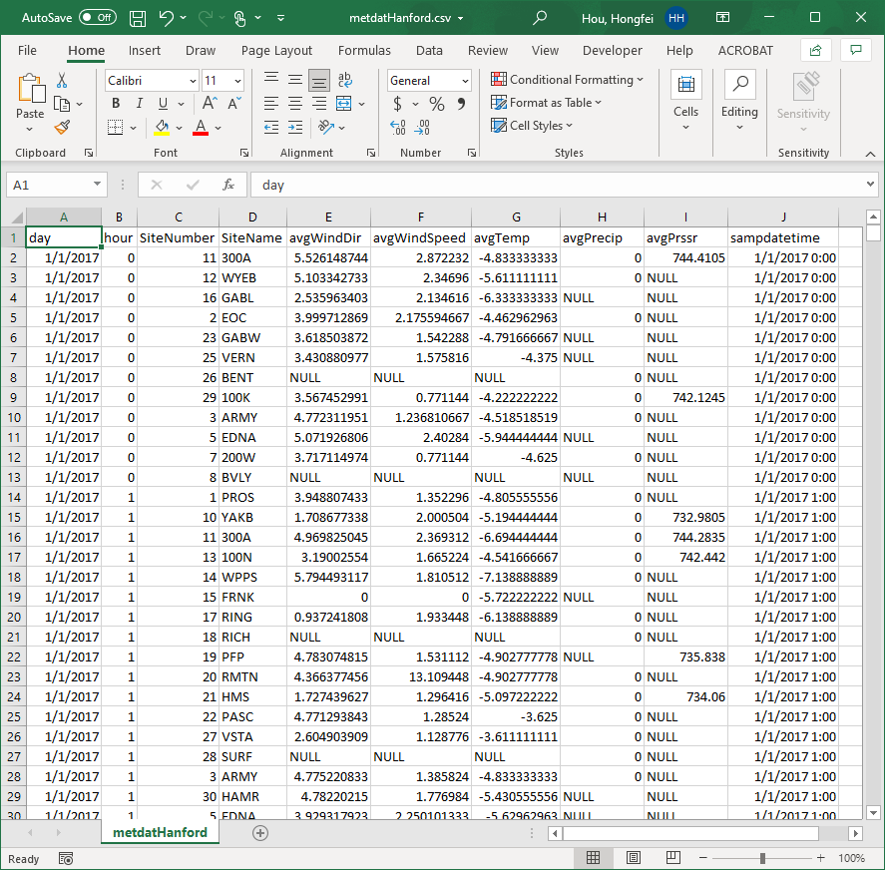

## Choose a meteorological data file

Select the “Trajectory data processing” tab, and click the “Browse” button in “Step 1”, then select the desired data file and click the “Open” button in the pop-up window:

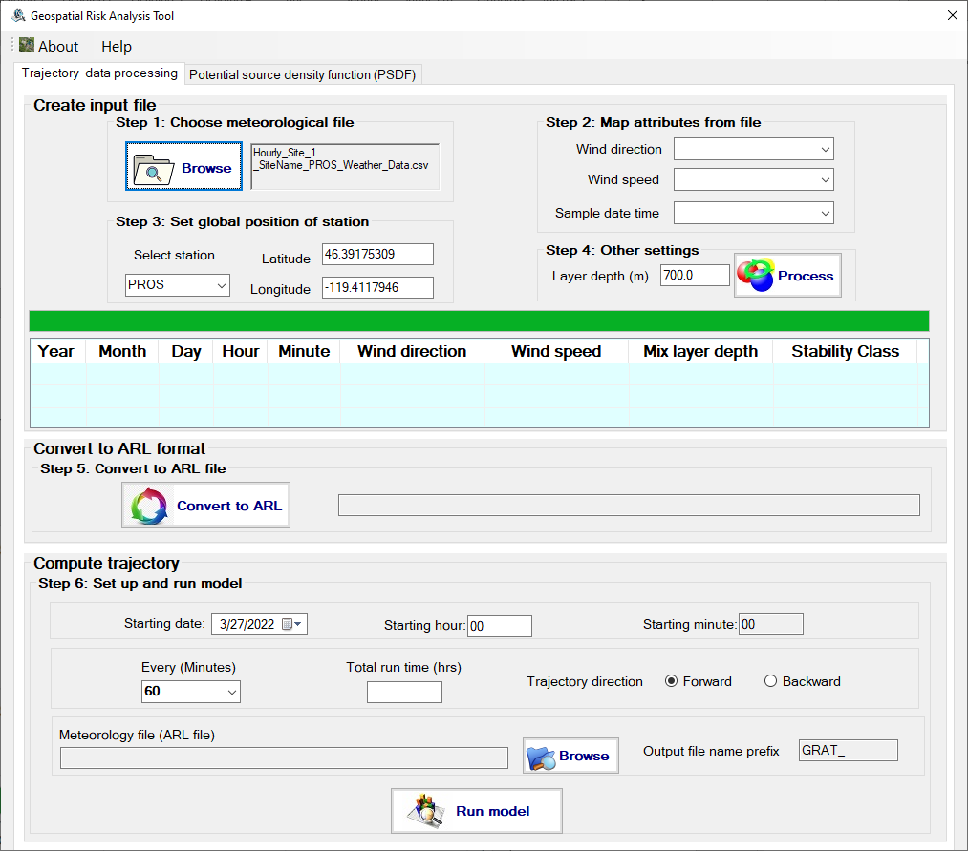

## Map attributes from the file

Click the combo box on the immediate right of the “Wind direction” label and choose the column which contains the measured wind direction data. Make similar selections for wind direction and time stamp.

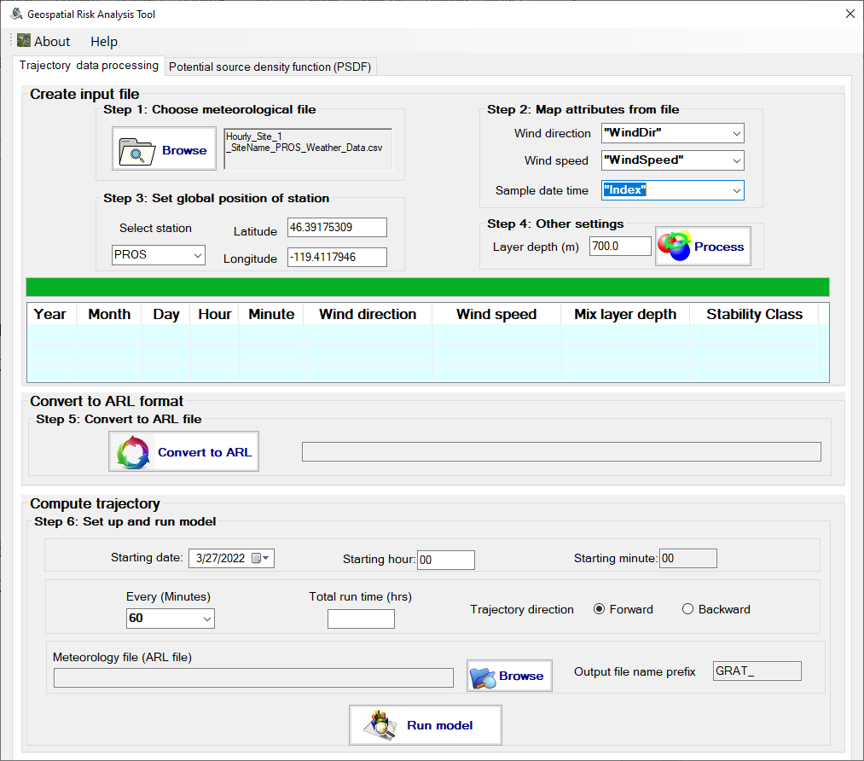

## Choose the station where data was measured

Click the combo box right below the “Select station” label and select the station where data was measured. If there is no matching item in the combo list, input the station and fill in the corresponding latitude and longitude.

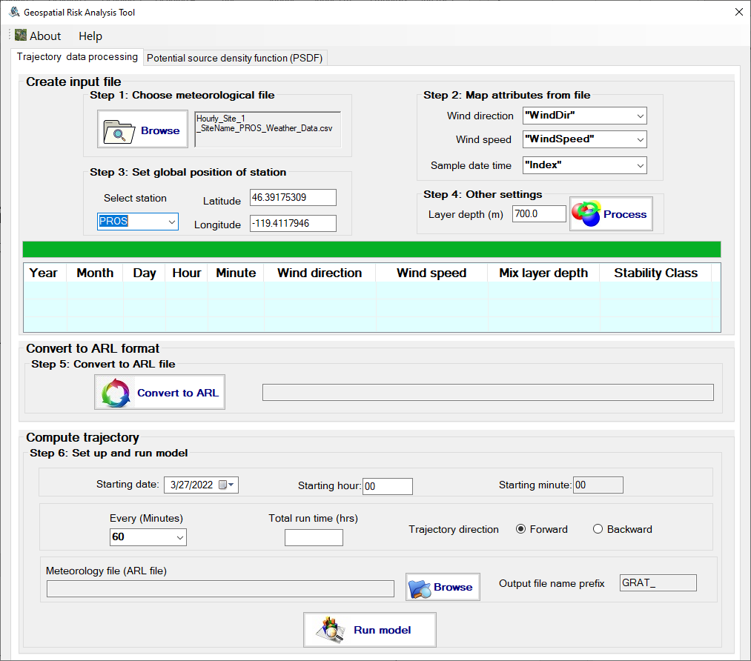

## Set the layer depth

Input the estimated height within which the wind direction and wind speed are assumed to be constant. Based on the HySPLIT user guide, the default value is 150 meters and is related to the typical vertical resolution of the meteorological data. A resolution near the surface of 15 hPa is typical of pressure-level data files. This suggests that it is difficult to infer a mixed layer depth of less than 150 m (10 m per hPa) for most meteorological input data.

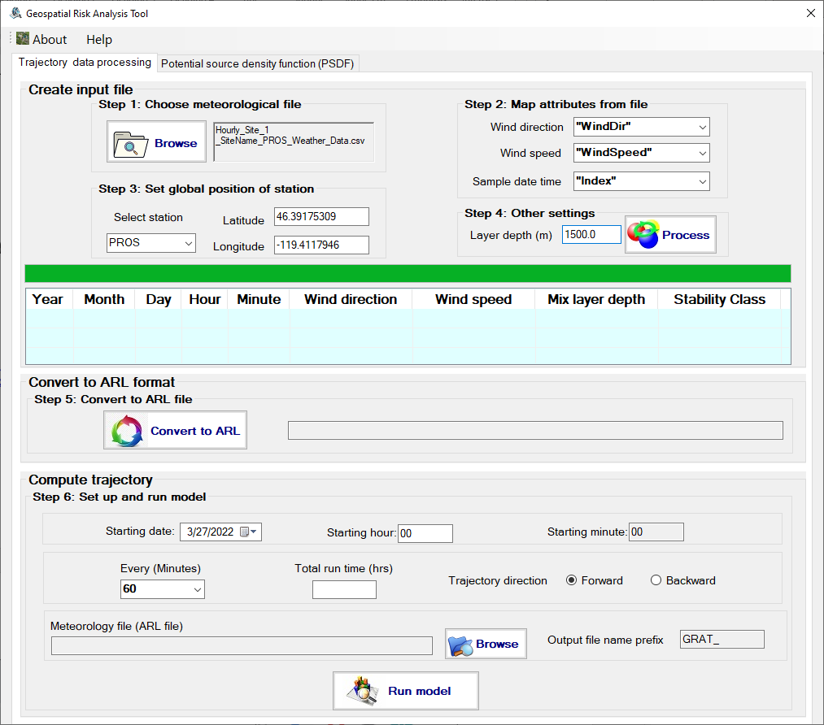

Click the “Process” button, and GRAT will prepare an associated input file from the select meteorological data file for conversion. The stability class for each measurement will be automatically assigned to 4. Please refer to the following page for more information: <https://www.ready.noaa.gov/READYpgclass.php>:

A corresponding row will be created for each row from the selected data file:

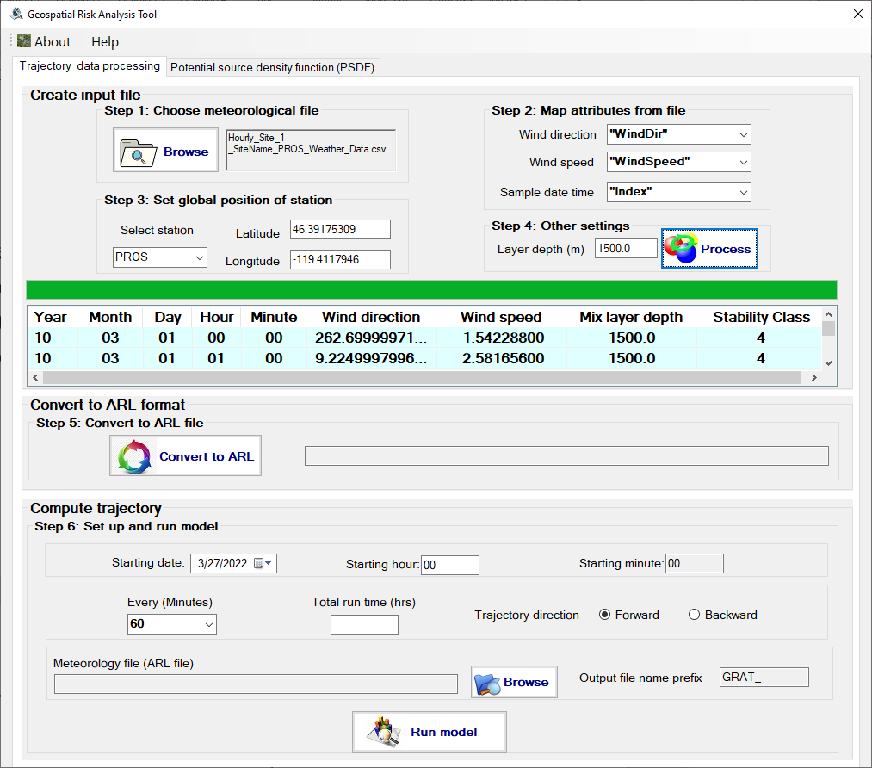

## Convert to ARL file

Click the “Convert to ARL” button to convert the dataset produced in 3.6 to ARL format. GRAT is using the executable stn2arl.exe from HySPLIT to accomplish this. This process is time-consuming and takes 4 minutes to convert a 10-year of hourly meteorological data file. The following pop-up windows will show after the conversion is done.

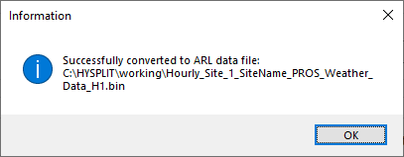

## Set up and run the model

Here are the steps:

1. Select the start date and start time, for example, 8/29/2017 at 23:00.
2. Set the value for “Every (Minutes)” as the measurement interval of the data file, such as 60 minutes, and so on.
3. Input the expected hours of data to run. For example, 312 hours for data for the whole of December.
4. Choose the “backward” trajectory.
5. Click the “Browser” button to choose the ARL file, for example: “C:\HYSPLIT\working\Hourly_Site_1_SiteName_PROS_Weather_Data_H1.bin”.
6. Fill in the output file name prefix. For example, “tj.PNNL.PROS.”.
7. Click the “Run model” button.

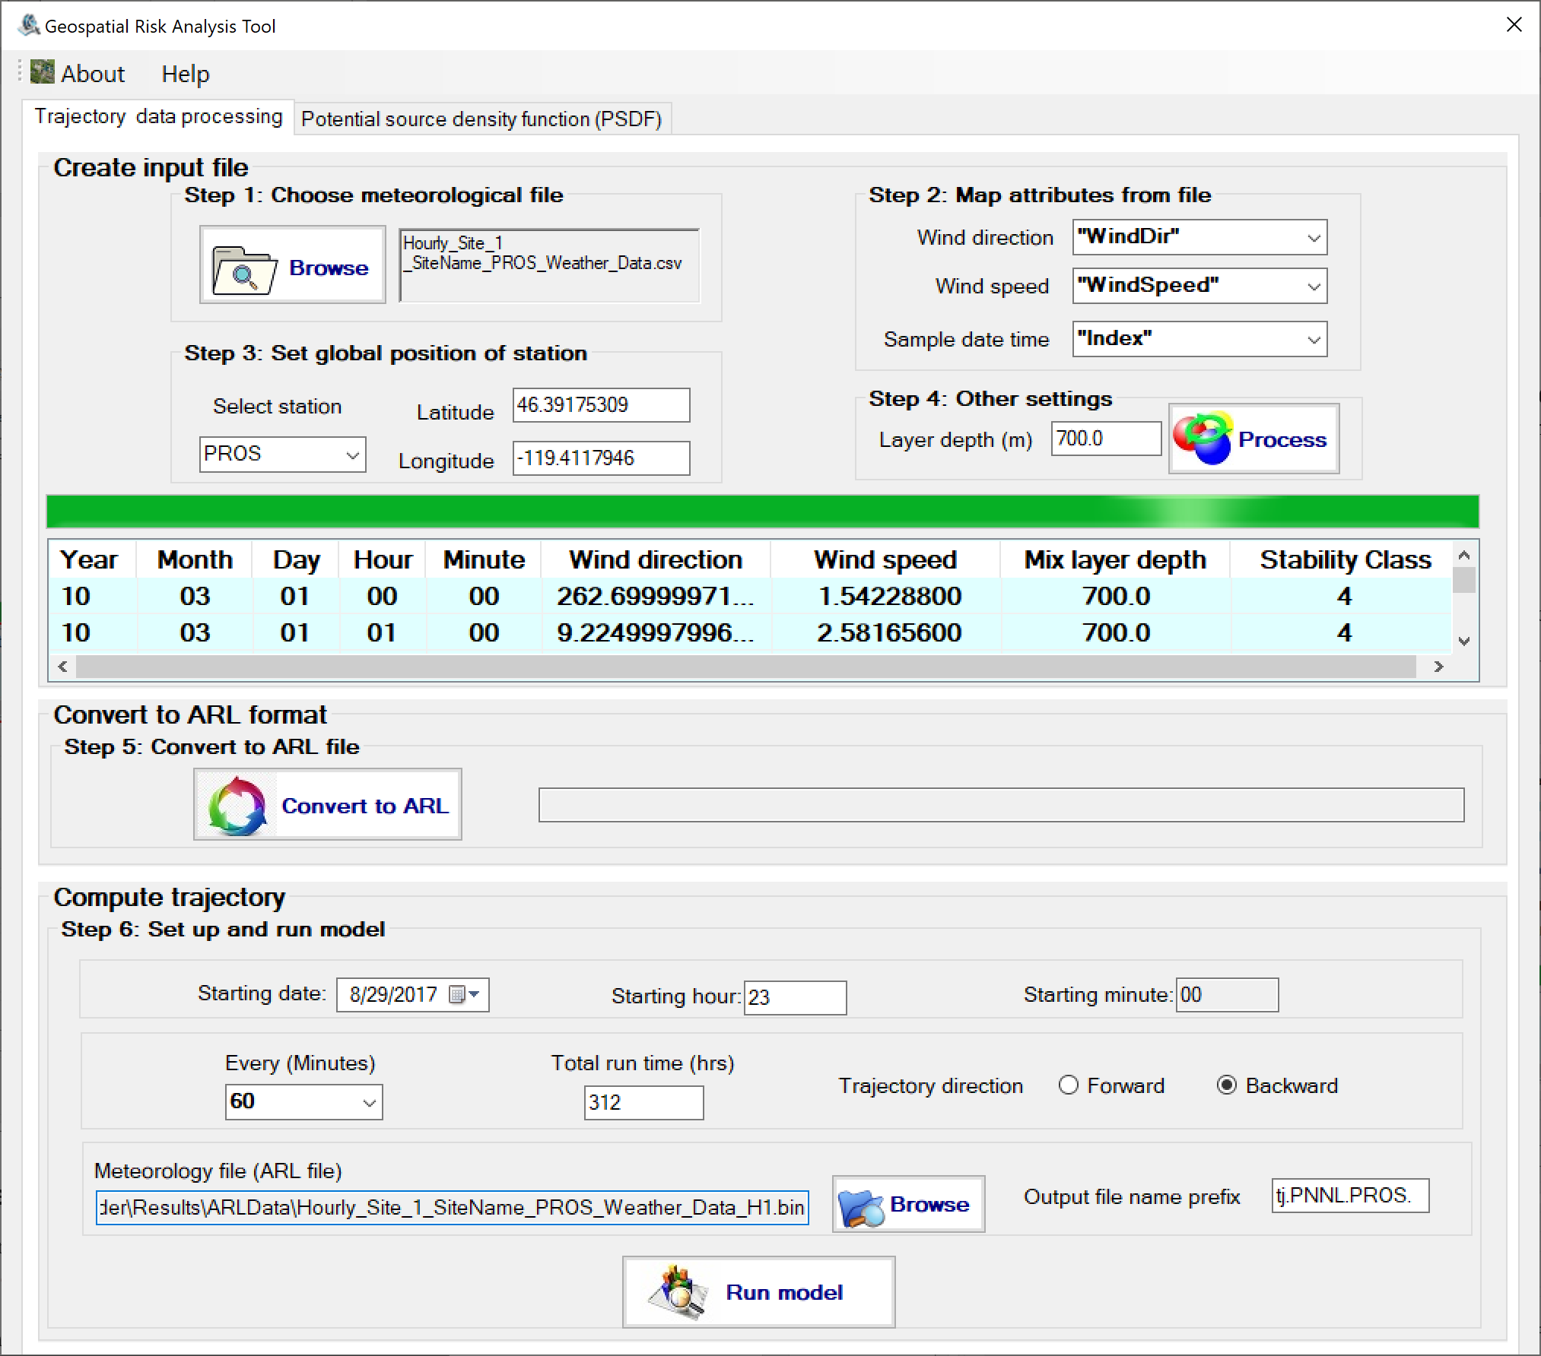

GRAT uses the executable hyts_std.exe from HySPLIT to accomplish this. This process is very time consuming and takes about 12 minutes for the data for the whole of December.

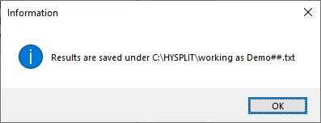

The converted trajectory files are stored under C:\HySPLIT\working directory:

## Run Potential source density function (PSDF)

Follow the following steps to run PSDF.

1. Choose the PTR-MS data file, then choose the chemical from the list:

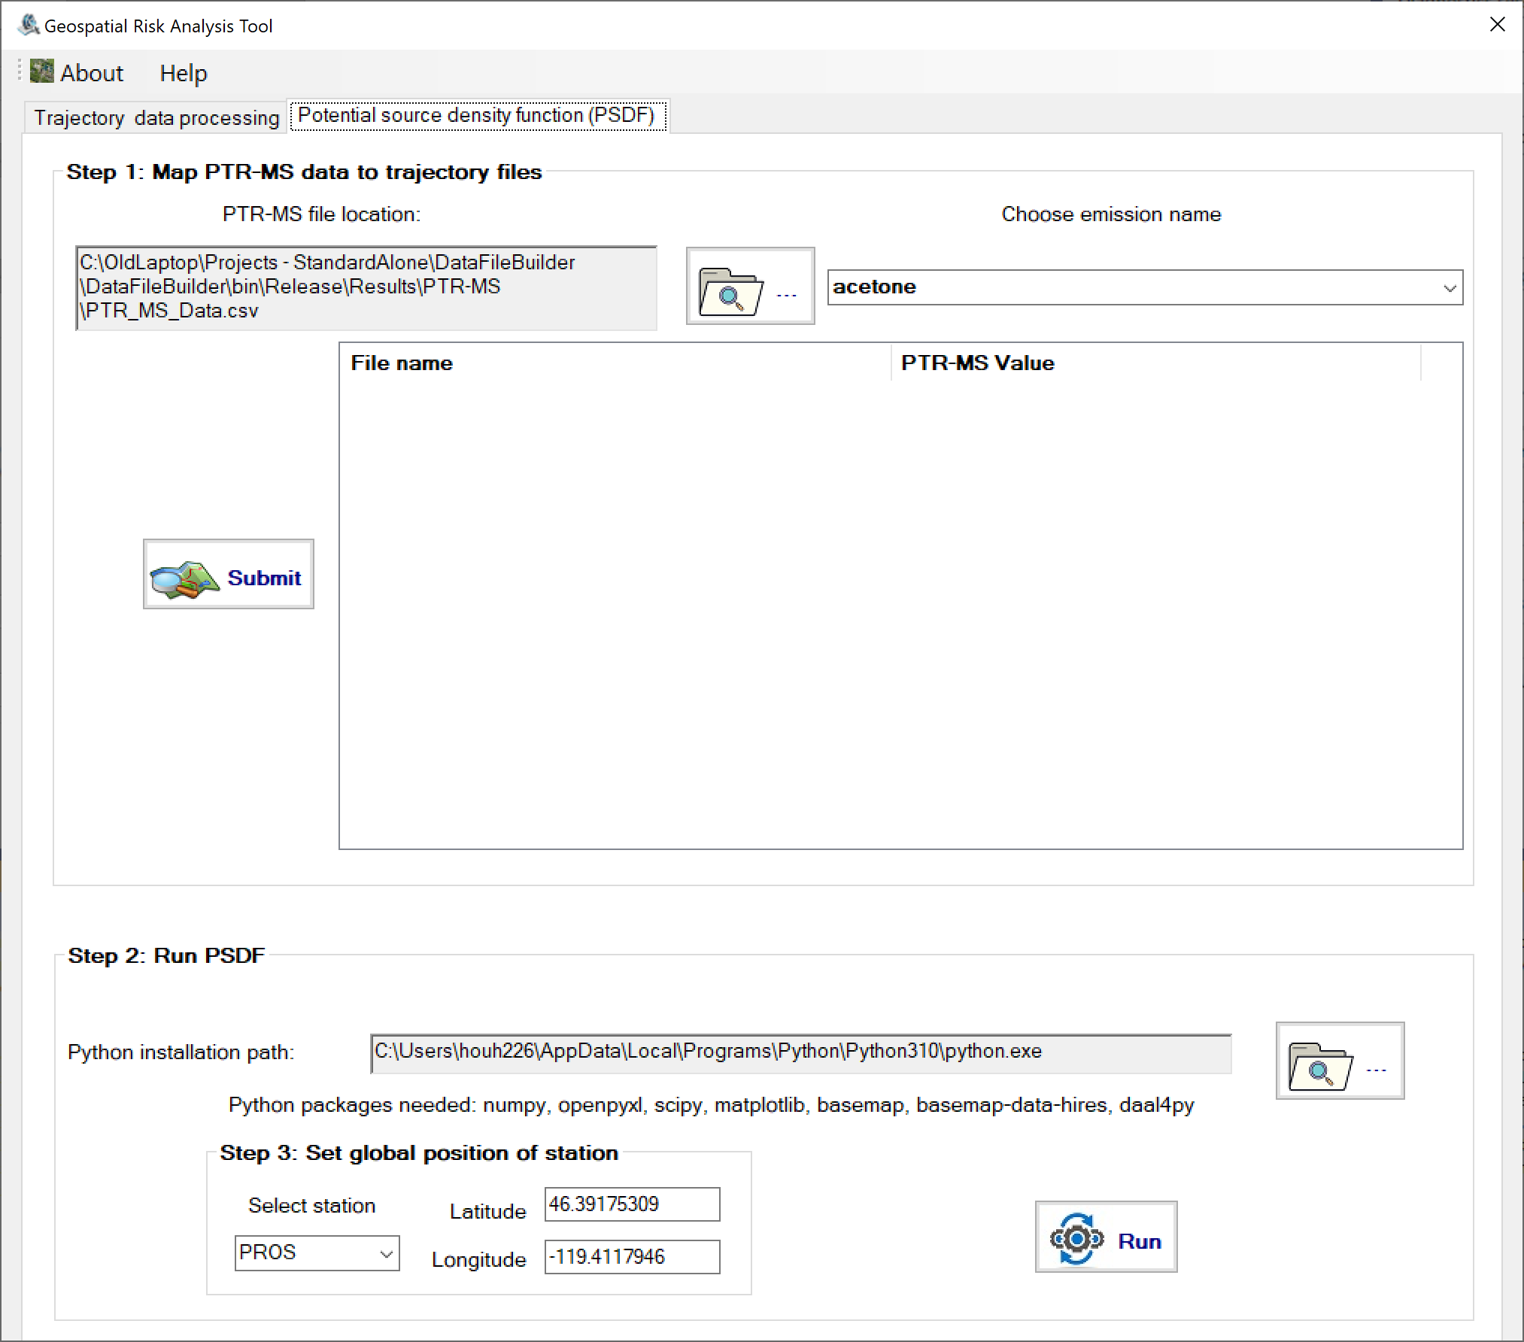

1. Click “Submit”, and it will generate the file containing the trajectory file names and the corresponding PTR-MS value for the selected chemical.

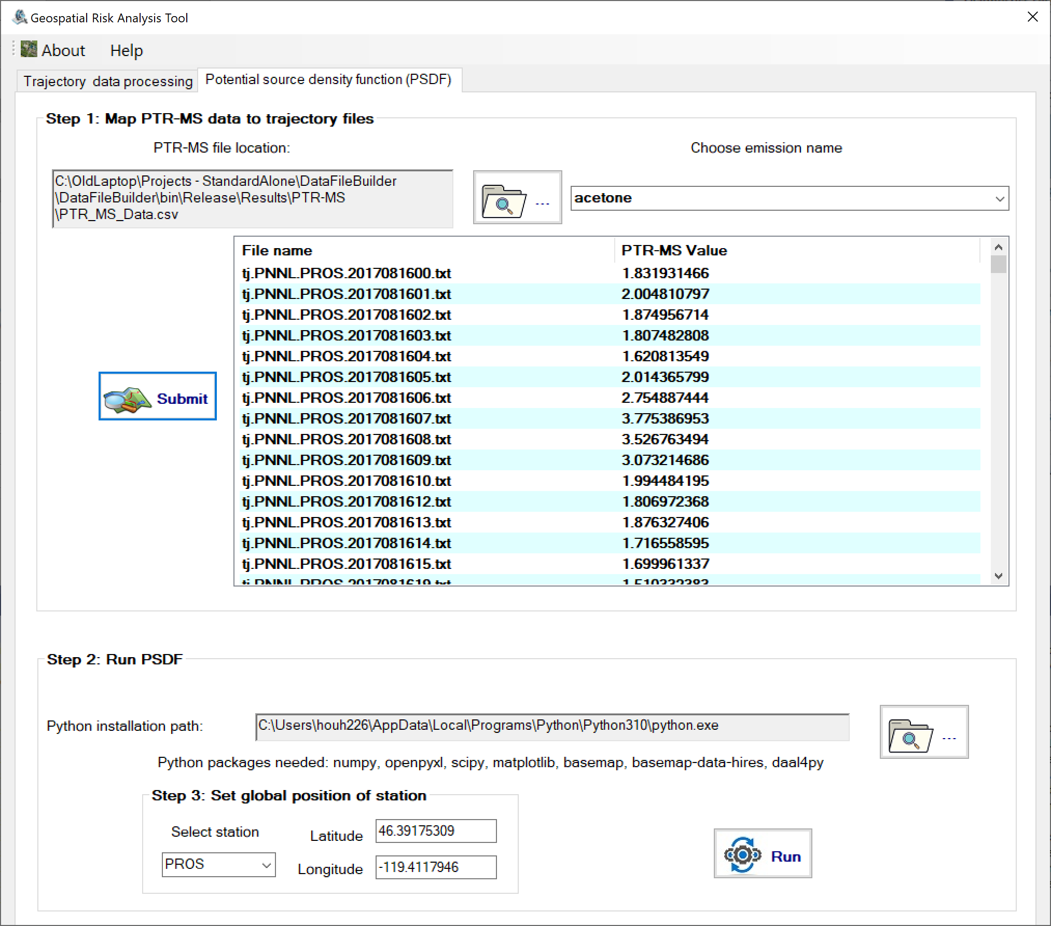

1. Choose the full path of the executable “python.exe”, then choose the station. Click “Run”. This process may take several minutes. A plot will show up once the execution is done.

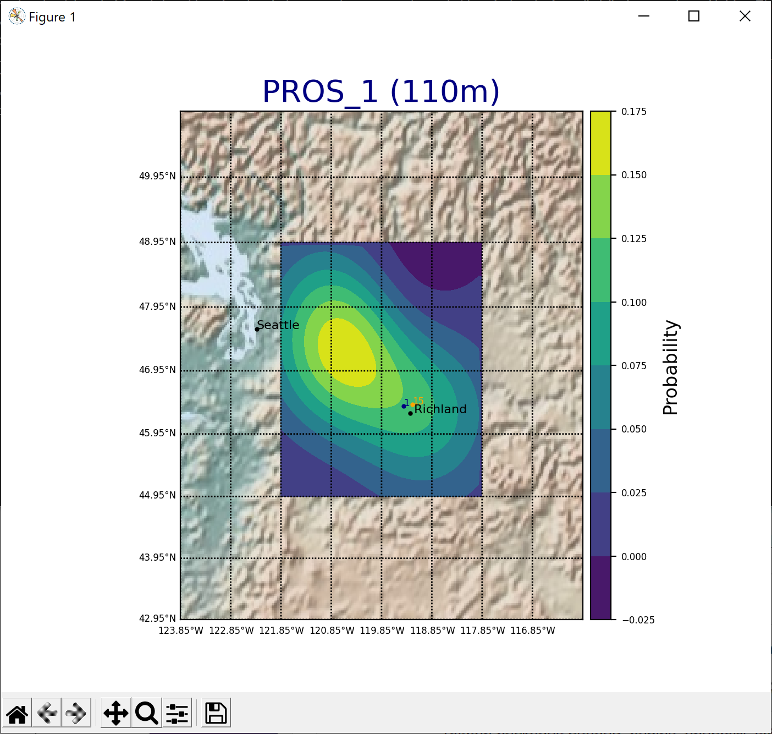

1. There would be another file, results.xlsx, created under the “Results” subfolder of the installation path, which could be used to calculate the infected areas: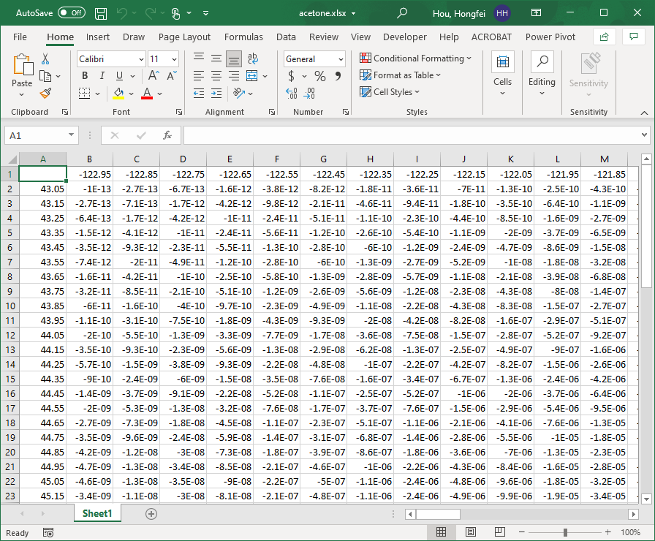

## About

Selecting “About” on the menu bar reveals the software version information and disclaimer.

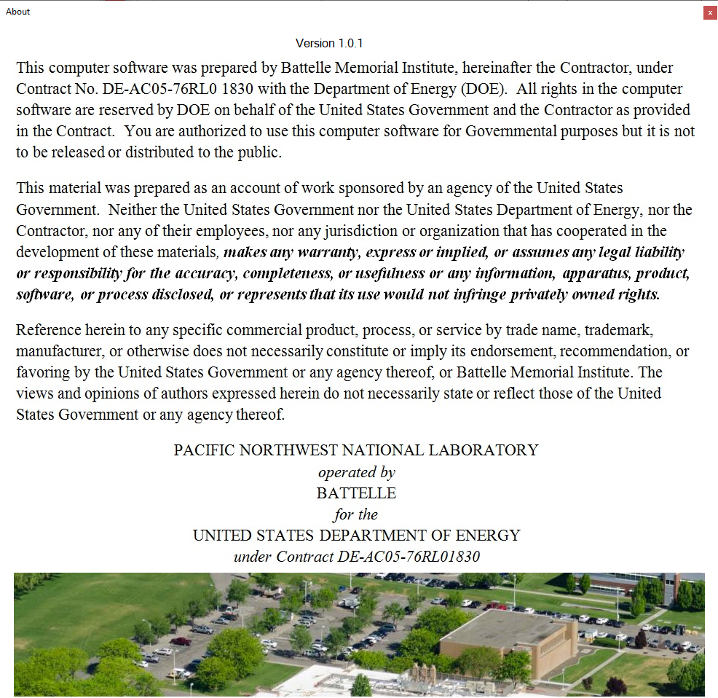

## Help

Selecting “Help” in the menu bar will open a copy of the user manual associated with the software version.

# Uninstall

To uninstall the GRAT program, select the Windows Start button, go to Settings, and select “Apps.” In the program list, navigate to and select “GeospatialRiskAnalysisTool,” click “Uninstall,” and follow the provided instructions.

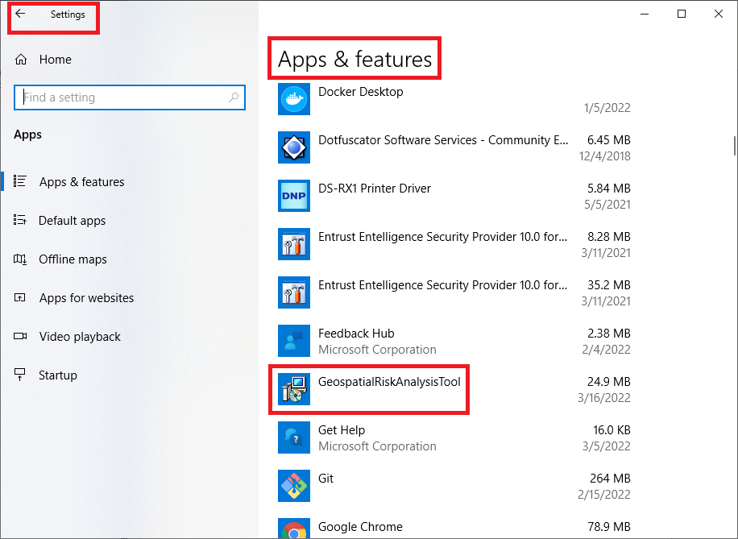

# Disclaimer

This computer software was prepared by Battelle Memorial Institute, hereinafter the Contractor, under Contract No. DE-AC05-76RL0 1830 with the Department of Energy (DOE). All rights in the computer software are reserved by DOE on behalf of the United States Government and the Contractor as provided in the Contract. You are authorized to use this computer software for Governmental purposes but it is not to be released or distributed to the public.

This material was prepared as an account of work sponsored by an agency of the United States Government. Neither the United States Government nor the United States Department of Energy, nor the Contractor, nor any of their employees, nor any jurisdiction or organization that has cooperated in the development of these materials, **makes any warranty, express or implied, or assumes any legal liability or responsibility for the accuracy, completeness, or usefulness or any information, apparatus, product, software, or process disclosed, or represents that its use would not infringe privately owned rights.**

Reference herein to any specific commercial product, process, or service by trade name, trademark, manufacturer, or otherwise does not necessarily constitute or imply its endorsement, recommendation, or favoring by the United States Government or any agency thereof, or Battelle Memorial Institute. The views and opinions of authors expressed herein do not necessarily state or reflect those of the United States Government or any agency thereof.

PACIFIC NORTHWEST NATIONAL LABORATORY *operated by*

BATTELLE *for the*

UNITED STATES DEPARTMENT OF ENERGY

*under Contract DEAC05-76RL01830*