# Types of RBF Networks implemented

For this project, I implemented the random centers selection and the supervised adaptation of the centers using a k-means process. For all experiments, the learning rate (η) was set to be 1x10-5. The Radial Basis Function used is the following:

$$f\left(\vec{x}\right)= e^{-\frac{m*{\left|\left|\vec{x}-\vec{t}\right|\right|}^{2}}{d_{max}^{2}}}$$

Where *m* is the number of centers, *dmax* is the maximum distance between any two pairs of centers. All weights were chosen to start at 1.0 and only the output weights were learned. The output node is a standard McCulloch-Pitts neuron with a linear activation function. The stopping criteria for all networks was when the total RMS error of the system was 10% of the initial RMS error of the first epoch – a maximum of 2000 epochs were considered.

## Random Selection of Centers

For the next few graphs, I chose some number of centers using a uniformly random distribution. The centers were then used to calculate the spreads of the RBF functions by taking the maximum distance between any two pairs of centers. The centers stayed in place during the learning process.

## Supervised Adaptation of Centers

In this type of RBF network, the centers are initially chosen uniformly at random. During the learning process, the centers are adjusted based on the following formula:

$$t_{k}\left(n+1\right)=t_{k}\left(n\right)+ η[x\left(n\right)-t_{kdw}(n)]$$

Where *k* is the closest center to presentation *x(n)* and *t(n)* is the center of the RBF at presentation *n*.

## Results

The weights were then trained over the four-class dataset given out in Homework 5. For all graphs, the average was not taken, so the RMS error is the total RMS error over an entire epoch. This allowed for a little bit higher fidelity when analyzing the results of the network. The results are as follows:

### 2 Hidden RBF Network

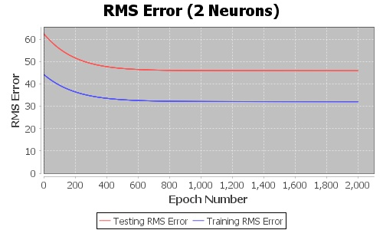

As you can see, in this network the RMS error stays pretty high when compared to the initial RMS of the first epoch. This would be due to the lack of RBF functions to approximate all the transitions and plateaus of the training data.

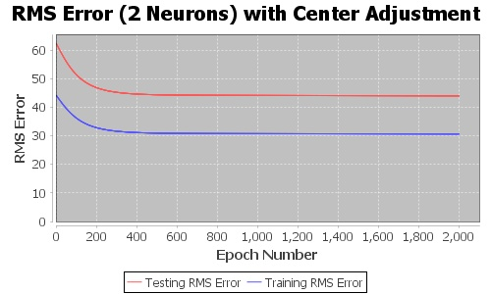

With center adjustment, we get reduce the total RMS error by a little bit as well as observe a faster convergence to the flat part of the graph. The behavior is likely due to the two RBFs finding the centers for two of the classes in the dataset.

### 4 Hidden RBF Network

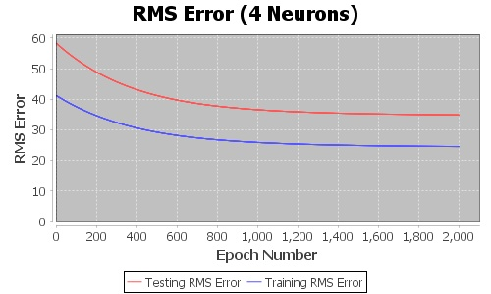

Here we see a little lower final value of the total RMS error of the network but the same rough shape as the 2 neuron network. This could have been due to two nodes being randomly selected out of the same class thereby raising the total RMS error over the epoch by a bit due to the classification errors on one of the RBF functions.

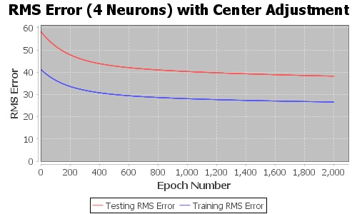

With center adjustment, we see the initially sharper decrease like in the 2-Neuron model, however this flattens sooner and does not reach a minimum similar to just the random sampling model. However, we do see a slightly larger slope at the end of the 2000 epochs which might mean if we let this train long enough it will surpass the previous model. The adjustments to the centers of the neurons may be too small to make any serious improvements.

### 10 Hidden RBF Network

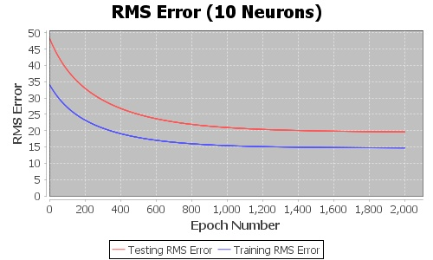

With more hidden RBF neurons we start to see a greater decrease in total RMS error across epochs. With 10 neurons we can almost certainly say we have a center in each one of the classes. However we can still improve as we have not reached the 10% of the first epoch’s error yet even after 2000 epochs.

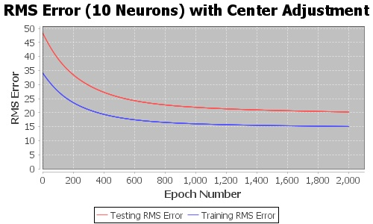

This graph looks nearly identical to the previous one. This shows that adjusting the centers when you have this many centers makes almost no difference. The reason is likely to be that each center has a very small number of closest presentations and is relatively unmoved throughout an epoch.

### 25 Hidden RBF Network

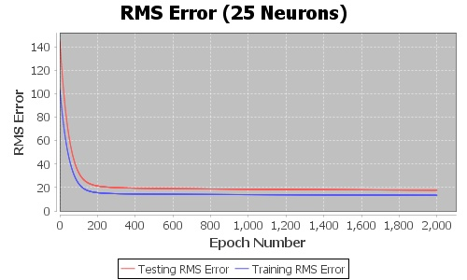

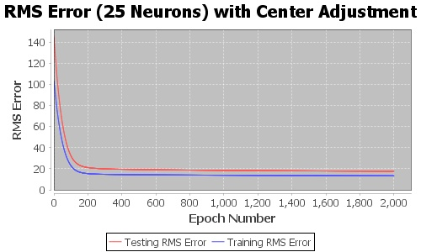

With this network, there is no difference between the randomly selected centers and adjusted centers. As we saw in the 10-neuron network, this is likely that for an entire epoch, the centers are not pulled in any meaningful direction. We do, however, start approaching the 10% of the first epoch’s RMS error. We should start seeing a finer edge granularity in the transition sections between classes when we look at the decision surface in the last section.

### 50 Hidden RBF Network

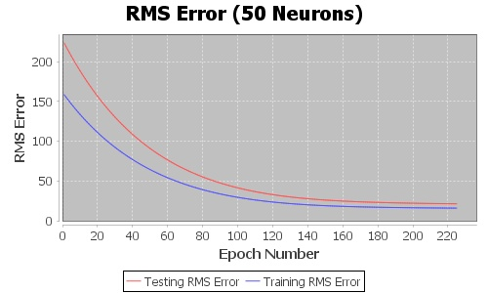

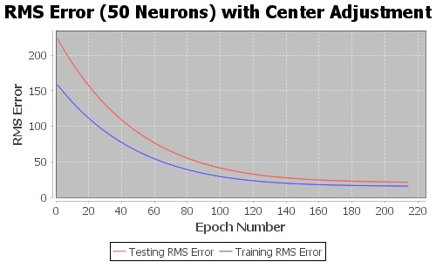

As with the 10 and 25-neuron network, there is no difference when attempting to adjust the centers of the RBFs. With this many neurons, we are able to reach the 10% convergence criteria in approximately 215 epochs.

## Decision Surfaces

Since the RMS errors were best or no different when using the center adjustment algorithm, the decision surfaces are shown below.

#### 2 RBF Surface

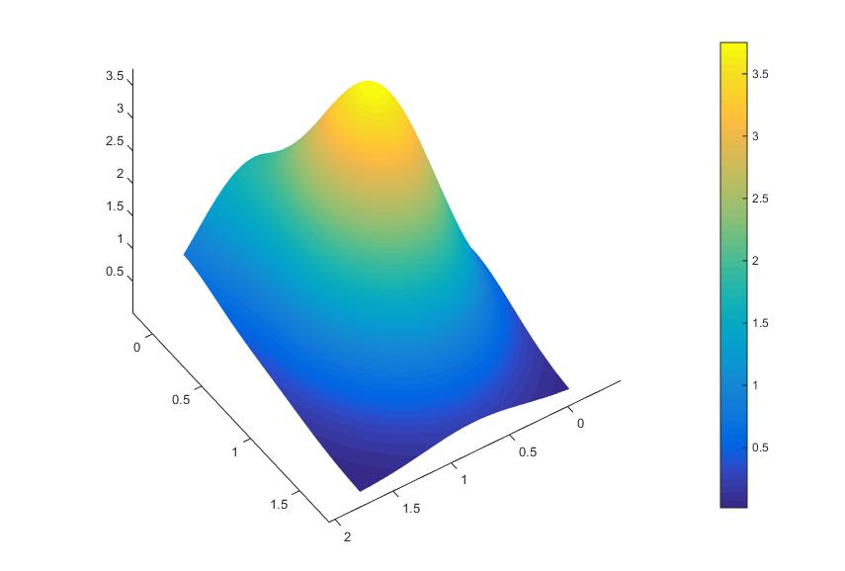

We see a very high output near the center of the surface and it tapers off to the edges. We can’t really distinguish any plateau surfaces where a class’ true value lies.

#### 4 RBF SurfaceC:\Users\Taylor\Neural_Networks\NeuralNetworksHW6\grid_surfaces\4_node_surface.jpg

We seem to have a very good definition for both class four and class three with two distinguishable plateaus. Class one and two seem to be non-existent. This suggest that the 4 randomly chosen centers lie somewhere in the class four and three range.

#### 10 RBF Surface

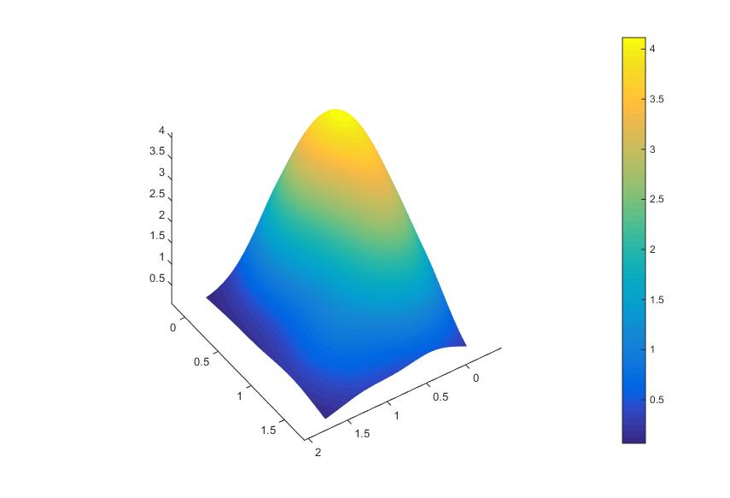

This surface is very smooth compared to the previous one. We lost any plateau-like features we had in the last one, however, the structure of this surface resembles more of the underlying class structure. The heights of the classes are in very well defined ranges as seen by the shape of the surface. We should see plateaus start to form in the later surfaces.

#### 25 RBF Surface

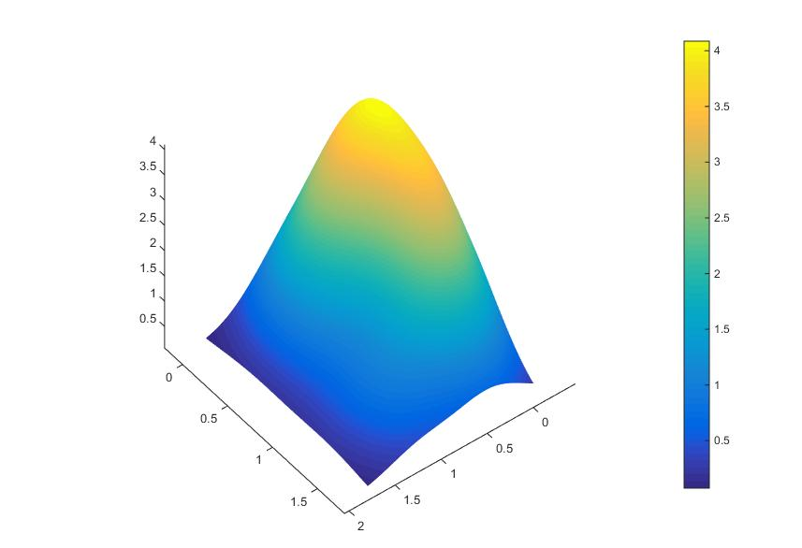

Very similar to the 10 RBF surface, however, we start to see a better defined area for some of the classes. The edges of the surface are starting to lift up to the desired class values (most notable on the bottom, right edge). We do see a small amount of plateauing on the bottom most corner.

#### 50 RBF Network

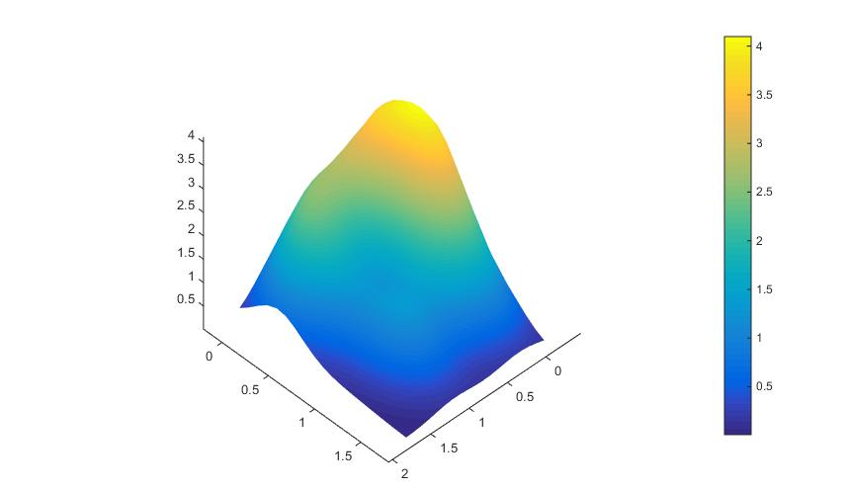

We finally have some very well defined plateaus noticeable on the bottom-left, bottom-center and top-center parts of the surface. This would contribute to the network meeting the convergence criteria. As an experiment, we let this one run to 2000 epochs as well and obtained this surface:

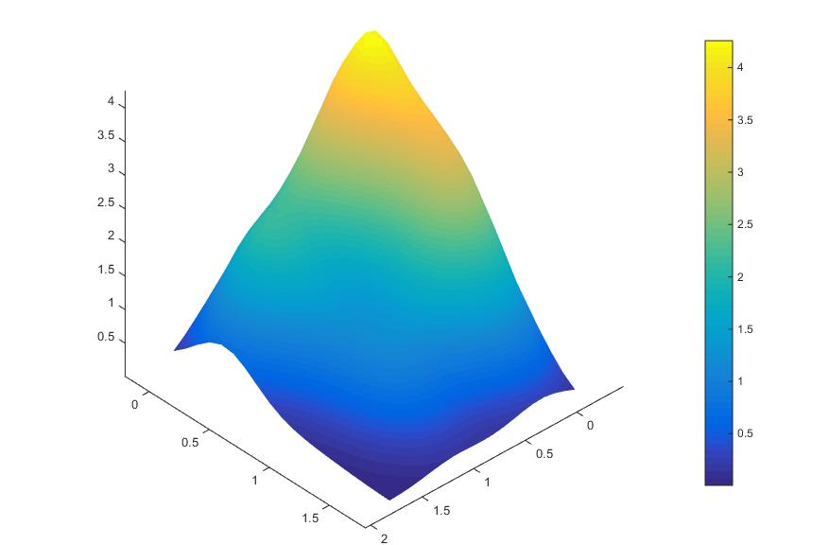

In comparison, it looks very similar, only with better defined plateaus in the class three and two areas. As always, my code can be found on my github (https://github.com/teberger/