

Cloud Solution

for

Keyloop

By Sifiso Mokhele

Table of Contents

Page 1 Milestone #1 - Cloud Principles and Design
Business Description and Research
Deployment Model
Service Model
Infrastructure Diagram
Page 4 Milestone #2 - Cloud Networking & Storage
Additional Business Research
Procedures when ISP goes down
Virtual Private Network
Kinds of Files Stored
How will Business Connect?
Domain Name System
Storage Providers
Content Delivery Network
Page 5 Milestone #3 - Assessing Cloud Needs
Research
Framework Diagram
Baseline
Feasibility
Gap Analysis
Gap Analysis Diagram
Page 6 Milestone #4 - Engaging Cloud Vendors
Capital and Operating Expenditures
Potential Cloud Vendors
Variable and Fixed Costs
Licensing Model
Evaluation of Cloud Vendors
Service Level Agreement
Migration Principles

Page 7 Milestone #5 - Management and Technical Operations
Aspects of Operating
Development & Operations
Financial Planning
Page 8 Milestone #6 - Compliance and Security
Data Sovereignty
Regulatory Concerns
Industry-Based Requirements
International Standards
Certifications
Security Concerns, Measures, and Concepts

Page 9 Milestone #7 - Governance and Risk
Risk Assessment
Risk Response
Documentation
Vendor Lock-In
Policies and Procedures

Milestone #1 - Cloud Principles and Design

Business Research

Business Name | Keyloop
Number of Employees | 5000
Location(s) | - Headquarters: Reading, UK  - South Africa Office: WeWork, 155 West Street, Sandton, Johannesburg  - India Office: Hyderabad  - Additional offices worldwide (Europe, North America, Asia)
How long has the company  been in business | Founded in 1976 (formerly CDK Global International, rebranded as Keyloop in 2021)
Purpose of the Business | Keyloop provides automotive retail technology solutions, connecting dealerships, manufacturers, and customers. Their platforms streamline sales, service, marketing, and inventory management, helping dealerships deliver better customer experiences.
Existing Technologies | Dealer Management System (DMS): Autoline  - Autoline Drive (modern version)  - Autoline Rev8 (legacy version still in use at some dealerships)  Customer Relationship Management (CRM) platforms  Cloud-based applications for dealership operations  Analytics and AI-driven insights  Collaboration tools (Microsoft 365, Teams, etc.)  Regional offices using shared workspace infrastructure (e.g., WeWork Sandton
Other Notes | Some dealerships still rely on Autoline Rev8, which limits integration and scalability. Migrating to cloud-based Autoline Drive will improve performance and compatibility with modern CRM and analytics tools.

Deployment Model

Keyloop requires a Hybrid Cloud deployment to balance compliance, security, and scalability across its global operations. Sensitive dealership and customer data will remain in secure private cloud environments to comply with regional data sovereignty laws such as GDPR in Europe and POPIA in South Africa. Meanwhile, public cloud resources will be leveraged for customer-facing applications, analytics, and collaboration tools, ensuring cost efficiency and global accessibility. By distributing workloads across multiple regions, including the UK, South Africa, and India, Keyloop can achieve high availability and resilience against localized outages. This hybrid approach provides the flexibility to meet regulatory requirements while enabling innovation and scalability across Keyloop’s worldwide footprint.

Service Model

Keyloop will adopt a multi-layered service model that combines Software as a Service (SaaS), Platform as a Service (PaaS), and Infrastructure as a Service (IaaS). SaaS will provide dealerships with subscription-based access to CRM platforms, Autoline DMS, and analytics tools, reducing reliance on local infrastructure and ensuring seamless updates across global offices. PaaS will enable Keyloop’s developers to build, customize, and integrate dealership-specific solutions on cloud-native platforms, accelerating innovation and supporting continuous improvement. IaaS will deliver scalable hosting infrastructure for global operations, allowing Keyloop to expand capacity during peak dealership demand without investing in new hardware. Together, these models reduce IT overhead, improve agility, and align with Keyloop’s strategic goal of modernizing dealership platforms while supporting global collaboration.

Cloud Design for your Business

Keyloop’s cloud solution will incorporate redundancy by replicating dealership and customer data across multiple regions. This ensures that if one data center experiences downtime, another can seamlessly take over, protecting critical operations. High availability will be achieved through load balancing and clustering, allowing dealership systems to remain accessible during peak demand or hardware failures.

For disaster recovery, automated backups will be scheduled daily, with recovery sites established in different geographic regions to meet compliance requirements. Recovery testing will be performed quarterly to ensure that Dealer Management Systems (DMS) and CRM platforms can be restored quickly, minimizing downtime and safeguarding dealership operations worldwide.

Infrastructure Diagram
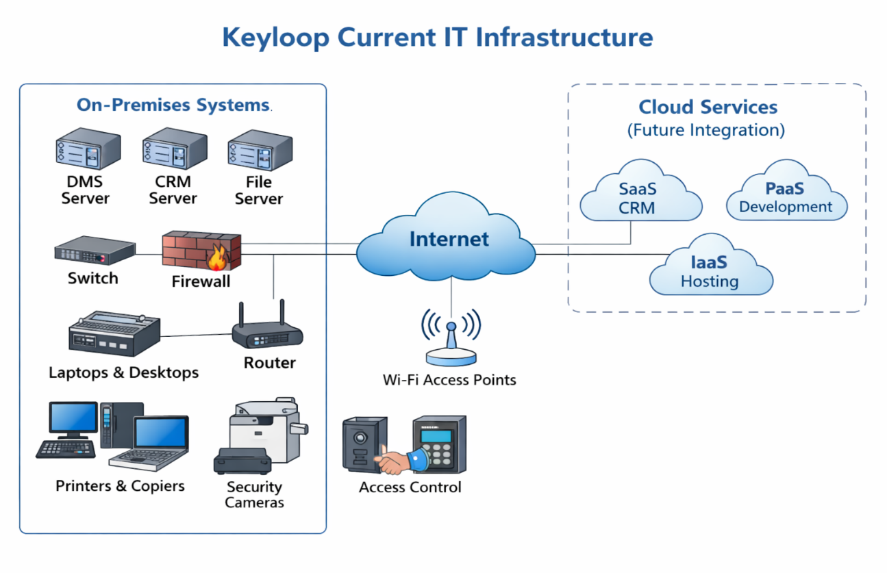
Figure 1: Keyloop’s current IT infrastructure showing on-premises systems, networking equipment, user devices, and internet connectivity prior to cloud migration.

Milestone #2 - Cloud Networking and Storage

Additional Business Research

Internet Service  Provider Name | Primary ISP (UK HQ): BT Business  - Connection Type: Fiber-optic  - Download/Upload Speeds: 1 Gbps / 500 Mbps  - Secondary ISP (South Africa Office): Vodacom Business Fiber  - Connection Type: Fiber-optic  - Download/Upload Speeds: 500 Mbps / 250 Mbps
Data Connection Type | Primary offices (UK HQ, South Africa, India) use fiber-optic connections for high-speed, low-latency access.  - Automatic failover to secondary ISP where available ensures continuity.  - Local caching of dealership data maintains operations during outages.  - VPN fallback routing through alternate regional offices provides resilience.  - IT team alerts stakeholders and initiates disaster recovery protocols when disruptions occur.
Download and Upload speeds | UK HQ: 1 Gbps download / 500 Mbps upload  - South Africa Office: 500 Mbps download / 250 Mbps upload  - India Office: 750 Mbps download / 300 Mbps upload  - These speeds support cloud-hosted DMS, CRM, analytics, and collaboration tools.
More than one ISP? | Yes. Multiple ISPs are required across different countries to ensure redundancy and compliance with local regulations.  - Each office contracts with a regional ISP (e.g., BT Business in the UK, Vodacom in South Africa, Airtel in India).

Procedures when ISP goes down

- Automatic failover to backup ISP where available.
- Cached dealership data ensures continuity of sales and service operations.
- VPN reroutes traffic through alternate regional offices.
- IT team communicates outage status and initiates disaster recovery protocols.

Virtual Private Network

- Employees connect securely to dealership systems via encrypted VPN tunnels.
- VPN ensures secure access to CRM, DMS, and collaboration tools from remote offices.
- Multi-factor authentication (MFA) is required for VPN login.
- VPN traffic is monitored to ensure compliance with GDPR and POPIA

Kinds of Files Stored

- Customer records and vehicle sales data
- Service and maintenance histories
- Inventory and parts management files
- Financial and compliance documents
- Collaboration files (Microsoft 365, Teams

How will the Business Connect?

- Dealerships connect to Autoline Drive hosted in the cloud via secure HTTPS protocols.
- Regional offices connect to CRM and analytics platforms through VPN and identity management systems.
- DNS ensures seamless resolution of cloud service URLs (CRM portals, DMS dashboards).
- CDN reduces latency by caching dealership applications closer to end-users.

Domain Name System

- DNS translates dealership application URLs into IP addresses for cloud services.
- Redundant DNS servers prevent downtime and ensure global accessibility.
- DNS load balancing distributes traffic across multiple cloud regions

Storage Providers

- Recommended Providers: Microsoft Azure Storage, Amazon S3
- Benefits:
  - Global replication for resilience
  - Compliance with GDPR and POPIA
  - Scalable storage for dealership data
  - Integration with analytics and AI services

Content Delivery Network

- CDN reduces latency by caching dealership applications closer to end-users.
- Ensures faster access to CRM dashboards and customer portals worldwide.
- Improves customer experience by minimizing delays in transactions.
- Distributes content across multiple regions to support Keyloop’s global footprint.

Updated Infrastructure Diagram

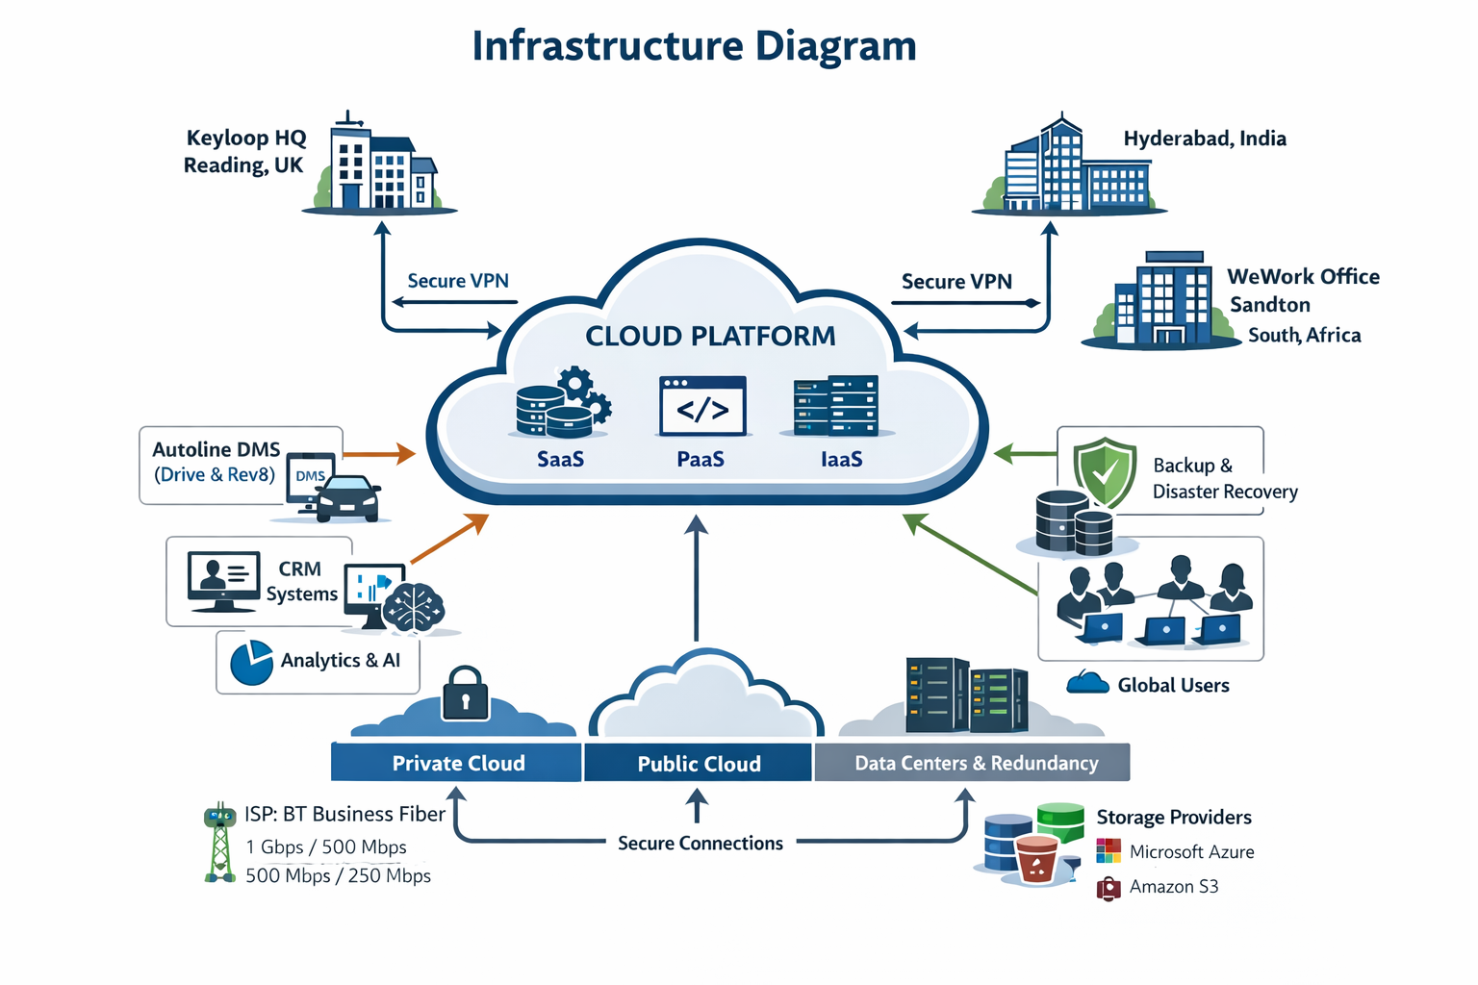

Milestone #3 – Assessing Cloud Needs

Research

Key Stakeholders | Executive Leadership (CEO, CIO, CFO), IT Department (Cloud Architects, Network Engineers), Operations Managers (UK, SA, India), Customer Service & Dealer Support Teams.
Single Point of Contact for each department | IT: Lead Cloud Architect  Operations: Regional Logistics Manager  Customer Service: Head of Dealer Experience
SPOC for the organization | CIO (Chief Information Officer)

Framework Diagram

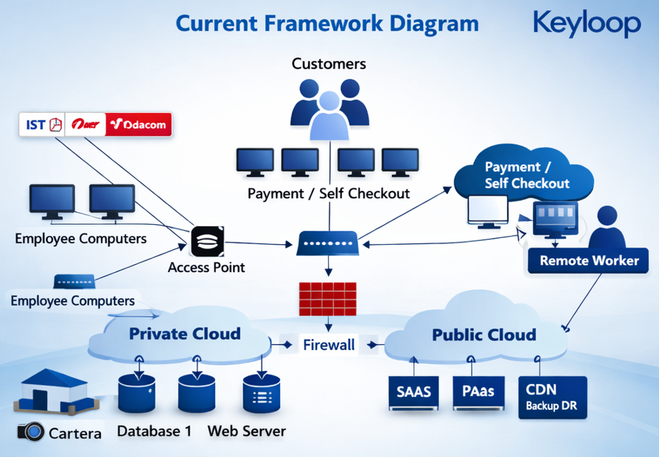

Baseline

- Current infrastructure is stable but regionally siloed.
- Benchmarks: ISP speeds, VPN uptime, storage latency.
- Limited scalability for global dealership expansion.

Feasibility

- Future requirements (global dealership expansion, CRM scaling) require a hybrid cloud approach.
- Keyloop can migrate gradually via hybrid model.
- Capabilities to offload: SaaS dealer management, PaaS analytics, backup & disaster recovery.
- Future requirements highlight the flexibility advantage of cloud-native platforms, which enable scalable SaaS dealer management, PaaS analytics, and automated disaster recovery compared to rigid, siloed legacy systems.

Gap Analysis

Keyloop’s infrastructure is strong regionally but lacks global scalability and automation.
- Compliance: Limited to GDPR and POPIA → requires unified global governance.
- Human Capital: IT teams need cloud-native training.
- Security: Must evolve beyond VPN/firewall to multi-layered IAM, encryption, MFA.
- Operations: Move from manual redundancy to automated disaster recovery and CDN-based resilience.

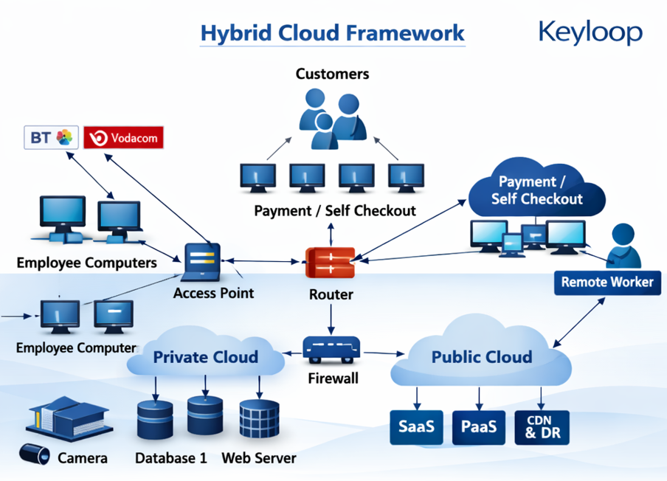

Gap Analysis Diagram

Category | Current  State | Goal | Action  Needed | Priority | Owner | Due  Date
Business | Regional scalability | Global scalability | Adopt hybrid cloud | High | CIO | 6 months
People | IT team focused on maintenance | Upskilled in cloud-native tools | Training in Azure, AWS, CDN | Medium | HR Director | 9 months
Governance | GDPR & POPIA compliance only | Unified global compliance | Implement cloud governance | High | Compliance Officer | 6 months
Platform | Mix of on-prem and cloud storage | Fully hybrid cloud | Migrate workloads to Azure + AWS S3 | High | Cloud Architect | 12 months
Security | VPN + firewall | Multi-layered cloud security | Deploy IAM, encryption, MFA | High | Security Lead | 6 months
Operations | Manual redundancy checks | Automated DR & backups | Implement DRaaS + CDN redundancy | Medium | Ops Manager | 9 months

Milestone #4 – Engaging Cloud Vendors

Capital and Operating Expenditures

Capital Expenditure (CapEx):
    - Investment in migrating Keyloop’s legacy dealer management applications into cloud-native architectures.
    - Purchase of secure networking appliances to connect dealership branches with centralized cloud services.
Operating Expenditure (OpEx):
    - Monthly subscription fees for compute, storage, and networking resources supporting dealership operations.
    - Ongoing costs for managed services such as monitoring, automated backups, and technical support.
Justification: CapEx reflects upfront modernization costs, while OpEx represents recurring expenses tied to Keyloop’s consumption-based pricing model.

Potential Cloud Vendors

For Keyloop, which provides automotive retail software solutions to dealerships worldwide, two cloud service providers were selected for evaluation: Amazon Web Services (AWS) and Microsoft Azure. Both vendors offer global infrastructure, advanced analytics, and enterprise-grade support. Their services directly impact Keyloop’s ability to deliver scalable dealer management systems, CRM integration, and secure data handling for customer and vehicle records.

Variable and Fixed Costs

Variable Costs:
    - Pay-as-you-go compute instances that scale with seasonal dealership demand (e.g., new car launches).
    - Data transfer charges that fluctuate based on customer CRM activity and vehicle record updates.
Fixed Costs:
    - Reserved instances for predictable workloads such as nightly batch processing of dealership transactions.
    - Licensing fees for enterprise software subscriptions integrated into Keyloop’s platform.
Justification: Variable costs align with fluctuating dealership activity, while fixed costs provide predictability for core operational workloads.

Licensing Model

A subscription-based licensing model is recommended for Keyloop. This allows dealerships to pay monthly or annually for services, ensuring flexibility and scalability while avoiding large upfront costs. Both AWS and Azure support this model, with enterprise agreements tailored to automotive retail businesses.

Evaluation of Cloud Vendors

A proof of concept (PoC) was conducted with both vendors:
- AWS PoC: Demonstrated strong scalability for Keyloop’s dealer management systems. AWS’s ecosystem supports containerized applications and advanced analytics, enabling predictive insights into dealership performance.
- Azure PoC: Showed seamless integration with Microsoft products such as Dynamics 365 and Active Directory. Azure’s hybrid cloud capabilities align well with Keyloop’s need to support dealerships that maintain partial on-premises infrastructure.

Service Level Agreement

AWS SLA:
- Guarantees up to 99.99% uptime for core services.
- Provides service credits in case of outages, scaled by downtime severity.
Azure SLA:
- Guarantees 99.95% to 99.99% uptime depending on service tier.
- Compensates with service credits for outages beyond SLA thresholds.
Comparison: Both vendors deliver high availability (“four nines”), but Azure’s SLA is slightly more conservative for certain services. Compensation mechanisms are similar, focusing on credits rather than direct reimbursement.

Migration Principles

The following principles will guide Keyloop’s migration:
- Phased Migration: Move dealership workloads incrementally to reduce risk.
- Hybrid Approach: Maintain critical dealership systems on-premises while leveraging cloud scalability.
- Data Integrity and Security: Ensure encryption during transit and storage of sensitive customer and vehicle data.
- Testing and Validation: Conduct regression testing after each migration phase to ensure dealership operations remain uninterrupted.

Aspects of Operating

Data Management: Replication, Locality, and Backup | Keyloop will replicate dealership and customer data across multiple regions (UK, South Africa, India) to ensure resilience. Locality rules will keep sensitive data within regional boundaries to comply with GDPR and POPIA. Automated daily backups with quarterly recovery testing will minimize downtime and protect operations.
Availability: Zone &  Geo-Redundancy | Cloud workloads will be distributed across availability zones and geo-redundant regions. This ensures that if one data center fails, another can seamlessly take over, maintaining high availability for dealer management systems and CRM platforms.
Disposable  Resources | Cloud resources such as virtual machines and containers will be treated as disposable. They can be spun up or terminated on demand, reducing costs and enabling rapid scaling during peak dealership activity.
Monitoring and Visibility:  Alerts & Logging | Centralized monitoring dashboards will track performance, uptime, and security events. Automated alerts will notify IT teams of anomalies, while logging will provide audit trails for compliance and troubleshooting.
Optimization: Auto-scaling  & Right-Sizing | Autoscaling will adjust compute resources dynamically based on dealership demand. Rightsizing tools will ensure workloads use the most cost-efficient instance types, avoiding over-provisioning and reducing operational expenses.

Development & Operations

- Provisioning: Infrastructure as Code and Templates
Infrastructure as Code (IaC) will allow Keyloop to define cloud environments using reusable templates. This ensures consistency across regions and accelerates deployment of dealership applications.
- Continuous Integration and Continuous Delivery (CI/CD)
CI/CD pipelines will automate testing and deployment of updates to CRM and DMS platforms. This reduces human error, speeds up innovation, and ensures dealerships always have access to the latest features without service disruption.

Financial Planning

- Infrastructure: Compute, Storage, and Networking
Budgeting will account for scalable compute instances, secure storage (Azure Storage, AWS S3), and high-speed networking across global offices. Costs will be forecasted based on dealership transaction volumes and seasonal demand.
- Instances: Reserved and Spot
Reserved instances will be purchased for predictable workloads such as nightly batch processing. Spot instances will be leveraged for non-critical analytics tasks, reducing costs by taking advantage of unused cloud capacity.
- Licensing Type and Quantity
Subscription-based licensing will be adopted for SaaS applications like Autoline Drive and CRM platforms. Licenses will be allocated per dealership user, ensuring predictable monthly costs while allowing scalability as Keyloop expands globally.

Milestone #6 – Compliance and Security

Data Sovereignty

Keyloop’s operations in India, UK, and South Africa must comply with local data sovereignty laws:
- India: Personal Data Protection Bill requires localization and strict consent rules.
- UK/EU (GDPR): Governs personal data storage and transfer, especially relevant for UK operations and OEM partnerships in Germany.
- South Africa (POPIA): Enforces lawful processing and storage of customer and dealership data.
Because Keyloop partners with OEMs such as Mercedes-Benz (Germany), GDPR compliance is reinforced through collaboration, ensuring dealership and customer data is legally managed across all regions.

Regulatory Concerns

- FedRAMP: While designed for U.S. federal agencies, it illustrates how CSPs certify compliance for government workloads. For Keyloop, the takeaway is that CSPs (like Microsoft Azure or AWS) adopt similar frameworks globally, which benefits operations in India, UK, South Africa, and OEM partnerships in Germany.
- FISMA: Again U.S.-specific, but it highlights the principle that the business itself (Keyloop) is responsible for demonstrating compliance, even if the CSP infrastructure is certified. This mirrors GDPR in Europe and POPIA in South Africa.
- FIPS: Though U.S.-based, FIPS encryption standards (AES, SHA) are widely adopted internationally. CSPs used by Keyloop often implement FIPS-compliant cryptography, ensuring dealership and customer data is protected across all regions.

Industry-Based Requirements

- FERPA vs HIPAA: Both protect sensitive records — FERPA for student data, HIPAA for health data. For Keyloop, the principle applies to dealership and customer records, which must be safeguarded with confidentiality and access controls.
- FINRA: Ensures financial institutions retain records of transactions and communications. For Keyloop, this parallels the need to retain dealership finance and accounting records, including chat logs and transaction histories.
- GLBA: Protects customer financial data. Keyloop must apply similar safeguards to customer financing and payment information processed through its platforms.
- SOX: As a publicly traded company, Keyloop must ensure accurate financial reporting and internal controls, especially in its accounting and ERP modules.
- MPAA: While media-focused, the principle applies to Keyloop’s intellectual property (software code, proprietary algorithms), which must be protected against piracy and misuse.

International Standards

Standards such as ISO/IEC 27001 provide a globally recognized framework for information security management. By aligning with these, Keyloop ensures consistent compliance across India, UK, South Africa, and OEM regions like Germany, simplifying audits and reinforcing customer trust.

Certifications

- Confidentiality: Protect dealership and customer data with encryption and role‑based access.
- Integrity: Ensure chat logs and financial records are accurate and unaltered.
- Availability: Guarantee that dealership systems and chat services remain accessible during operations.

Security Concerns, Measures, and Concepts

Keyloop’s cloud operations must include:
- Encryption (data at rest and in transit).
- Access controls (least privilege, RBAC).
- Auditing and monitoring (to detect unauthorized access).
- Incident response plans (to handle breaches quickly).

Threats and Vulnerabilities
- Threat example: A hacker attempting to intercept dealership chat communications.
- Difference: A threat is the external danger (e.g., hacker), while a vulnerability is the internal weakness (e.g., unencrypted chat logs).

Security Assessment Tools
Keyloop would use:
- Vulnerability scans (to identify weaknesses in dealership systems).
- Penetration tests (to simulate attacks on chat and finance modules).
- Audits (to verify compliance with GDPR, POPIA, SOX).
- Application scans (to check proprietary software for insecure code).

Data Security Categories
- Public: Marketing material and dealership brochures.
- Private: Internal HR records (e.g., staff bonus lists).
- Sensitive: Admin passwords, dealership financial records, and network diagrams.

Access vs Authorization
- Access: The ability to reach dealership systems or chat logs.
- Authorization: The specific permissions granted (e.g., finance staff can view transactions but not alter system configurations).

Milestone #7 – Governance and Risk

Risk Assessment

Keyloop’s assets are divided into tangible and intangible categories:
- Tangible assets: Data centers storing dealership backups, employee laptops, printers, and scanners located on premises or in storage.
- Intangible assets: Dealer Management Systems (Autoline Drive), CRM platforms, proprietary software, and customer/dealership data.
Risks are assessed using both quantitative methods (financial impact of downtime, cost of replacing stolen laptops, penalties for noncompliance) and qualitative methods (loss of customer trust, reputational damage, competitive disadvantage).
Assets are classified into risk levels based on value and probability of threat:
- Level 5: Data center outage (loss of connectivity halts dealership operations).
- Level 4: Theft of dealership financial records or customer data.
- Level 3: Loss of laptops or mobile devices by remote employees.
- Level 2: Misuse of office supplies or minor resources.
- Level 1: Temporary office power outage.
Ownership is clearly defined:
- Risk Owners: Executives and department heads (CIO, CFO, Regional Operations Managers) who decide on risk responses.
- Asset Owners: Product owners and system managers (Autoline Drive lead architect, CRM platform manager, IT hardware custodian) responsible for day to day safeguarding of assets.

Risk Response

Keyloop applies the four standard risk responses:
- Mitigation: Firewalls, anti-malware, MFA, encryption, and CSP-provided isolation controls reduce the probability of threats.
- Acceptance: Low-value risks (e.g., minor office supply misuse) are accepted without resource expenditure.
- Avoidance: High-risk scenarios (e.g., storing sensitive dealership data in non-compliant regions) are avoided by enforcing strict data locality rules under GDPR and POPIA.
- Transfer: Using CSP services (Azure, AWS) transfers part of the risk to vendors, especially for infrastructure uptime and disaster recovery.

Documentation

Documentation underpins compliance and governance:
- Audit trails: Logs of dealership transactions and CRM activity for GDPR and POPIA compliance.
- Findings reports: Examples include identifying unpatched software vulnerabilities or detecting unauthorized access attempts.
- Risk register: Maintains classification, ownership, and response strategies for all assets.

Vendor Lock-In

Vendor lock in occurs when Keyloop becomes overly dependent on a single CSP (e.g., Azure or AWS), making migration costly or complex.
- Data portability: Ensures dealership data can be exported in standard formats (JSON, CSV) to avoid lock in.
- Mitigation: Hybrid cloud strategy (Azure + AWS) reduces dependency and provides flexibility.

Policies and Procedures

Keyloop enforces policies to ensure governance and risk are managed consistently:
- Data privacy: GDPR and POPIA compliance ensures dealership and customer data is processed lawfully.
- Change management: Structured approval workflows for updates to Autoline Drive and CRM platforms prevent disruption.
- Resource management: Ensures optimal allocation of compute, storage, and networking resources across regions.
- Incident response: Steps include detection, containment, eradication, recovery, and post incident review.
- Access control policies: Based on ACLs, with three basic rights (read, write, execute) extended into advanced role-based permissions.

