8:40 PM, 6 July 2023

-Implemented features for organization

Updated sdd file

Updated project to implement organization features

When users register to system, they have to select company. If it doesn’t exist company that users belonged to, they can create company

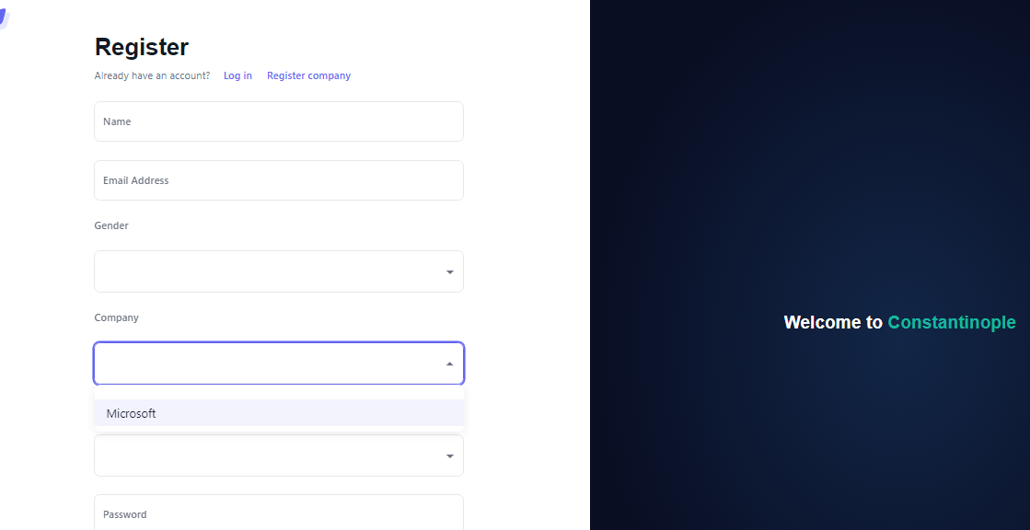

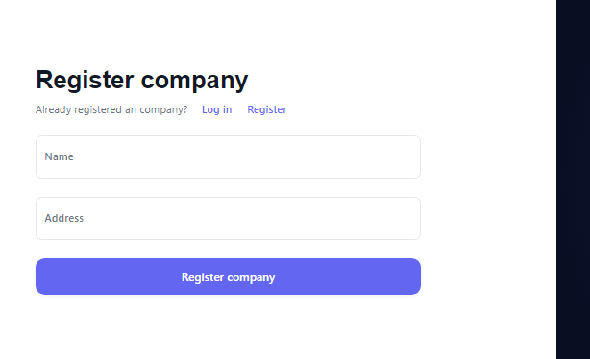

After they logined, they can do crud actions by the their role.

In case of admins, they can add and delete customers of other company, and view, update and delete employee of their company.

In case of managers, they can only view customers of other company, and view, update employees of their company.

Normal can only view data of his company.

customer page.

-Containerization using docker.

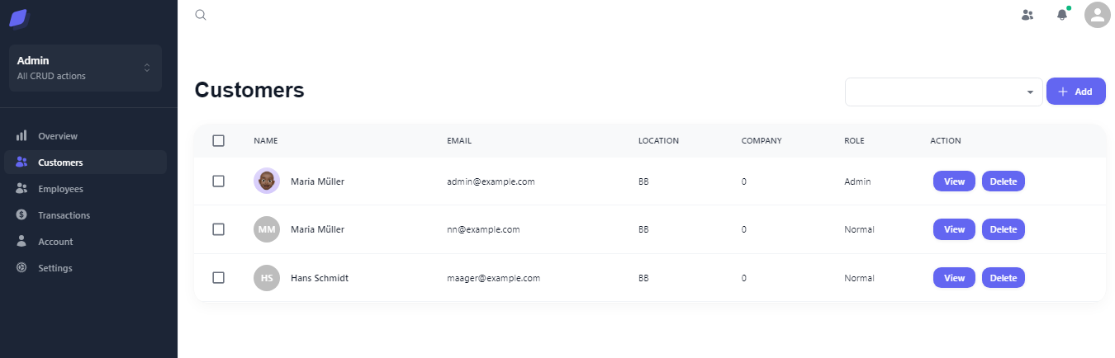

8:40 PM, 3 July 2023

-frontend

update dashboard and login page

-backend

initial initial complete

use AWS S3 bucket in updating user’s avatar

-avatar uploading…

-API documentation…

-Register page

You can register to the IM service system

Insert name, email, gender, role, password.

Email: unique…

Role: Admin, Manager, Normal

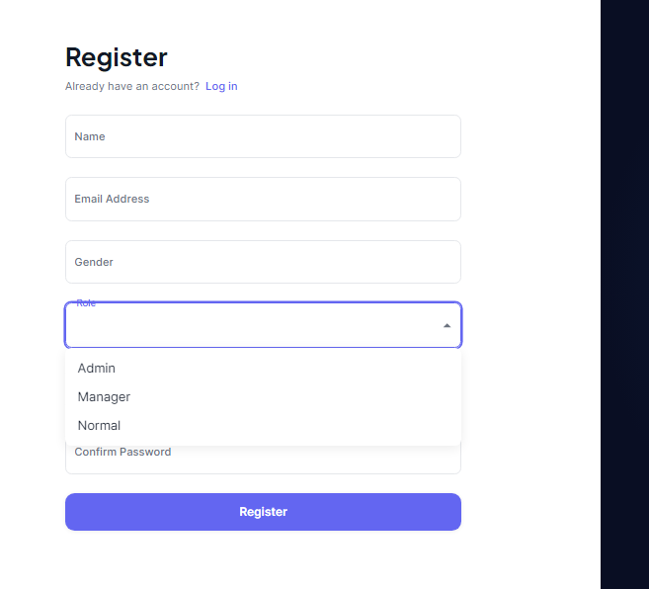

-Login page

If you registered, you can login to system….

-dashboard page

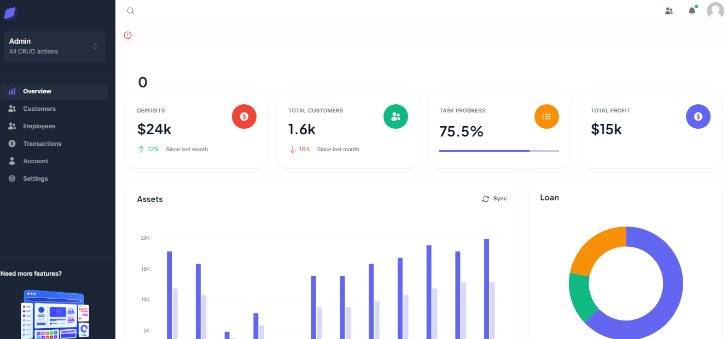

Your Role

-Customer, Employees, Transactions Page

If you are Admin, you can all CRUD action by click button…

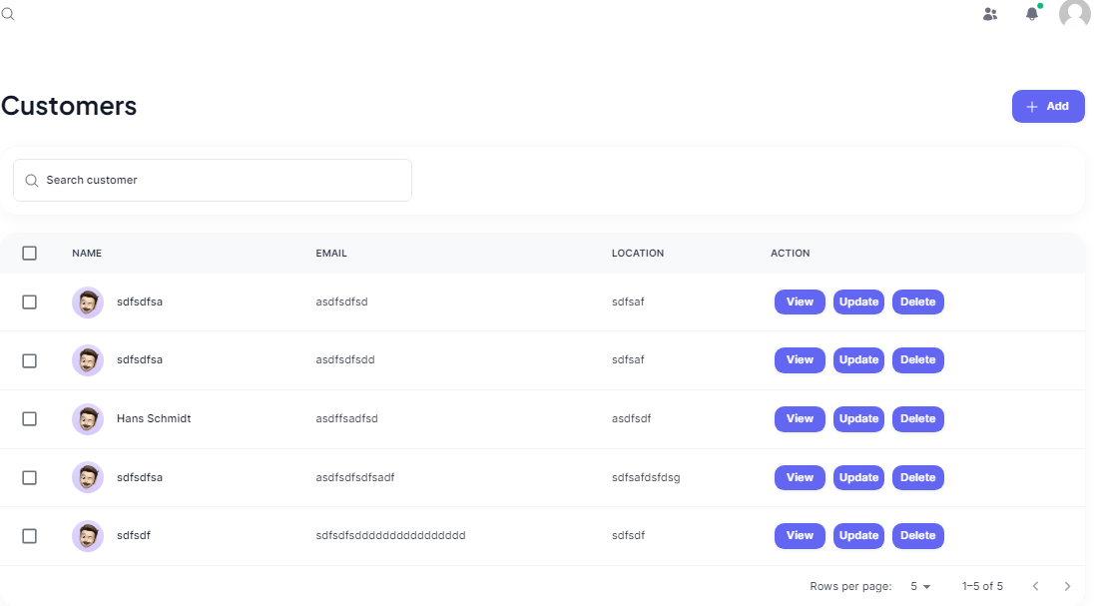

CRUD action’s button

If you are manager, you can view and update data.

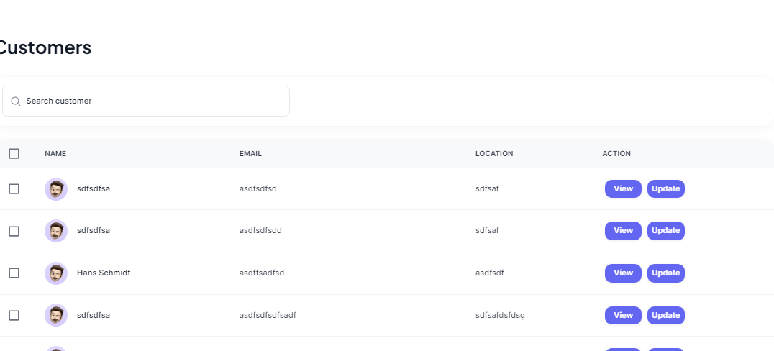

If you are Normal, you can only view data…

-Use AWS S3 bucket to update avatar

You can update your avatar.

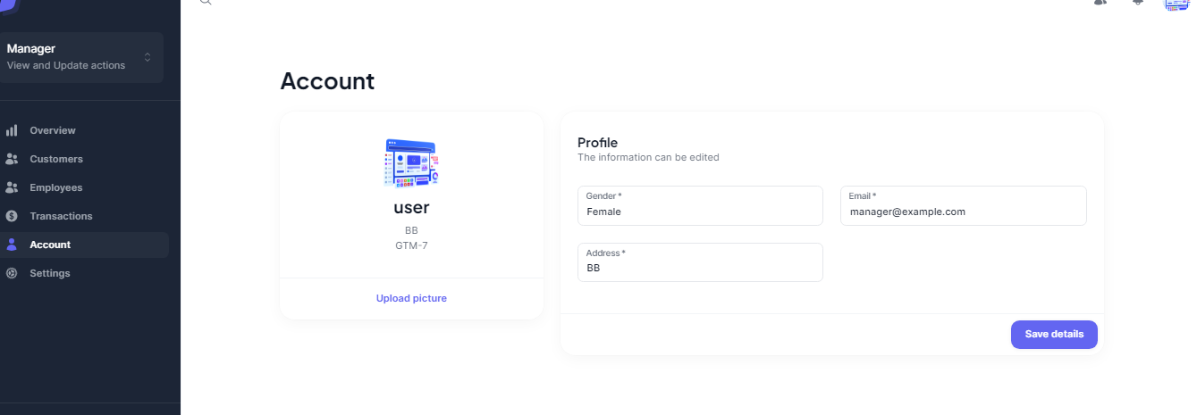

Please click to update avatar