

The Quantum Crucible: Transforming Cryptography and Data Security in the Age of Quantum Computing
Research Pack

Prepared for: Lily AI
Generated: October 26, 2023

Table of Contents

1. About Lily AI

1.1. Heading
About Lily AI

1.2. Content
Introducing Lily AI & Research Assistant UK
Who We Are
Research Assistant UK was founded with a simple mission: to make academic research more accessible, less intimidating, and more productive for students at all levels. We believe that quality research skills are fundamental to academic success and professional development.
Who is Lily?
Lily is your AI research co-pilot—think of her as your personal research assistant who's available 24/7. Unlike a typical AI chatbot, Lily has been specifically designed to understand the academic research process and provide guidance tailored to your specific topic and education level.
How Lily Works
Lily is powered by a frontier AI model that has been specially trained to excel in academic research across all disciplines. When you provide your topic and paper title, Lily spends approximately 10 minutes becoming an expert in that specific domain. During this time, she processes vast amounts of information from academic sources, synthesizes key concepts, and organizes the most relevant insights for your research journey.
What makes Lily different from general-purpose chat interfaces is her ability to create a comprehensive, structured research pack that you can revisit throughout your academic project. Rather than just answering questions in the moment, Lily provides you with a complete toolkit that guides your research process from start to finish—something you can work through day by day as you develop your project.
Our Evolution
When we first created Lily, we focused on providing example papers to help students understand what good academic writing looks like. However, we quickly realized something important: showing a finished product doesn't teach you how to create one yourself.
That's why we've transformed our approach. Instead of just giving you a fish (an example paper), we're teaching you how to fish (the complete research journey). This research pack represents that evolution—a comprehensive toolkit that guides you through every stage of the research process.
What Makes This Research Pack Different
This pack isn't just information—it's a structured journey with practical tools:
• Research Journey Map: A visual guide to the entire research process
• Practical Templates: Ready-to-use tools for planning, organizing, and evaluating your research
• Contextual Guidance: Lily's callouts provide advice exactly when you need it
• Personalized Content: Everything in this pack is tailored to your specific topic
• Academic Resources: Curated citations, expert recommendations, and methodology guidance
Our Commitment
At Research Assistant UK, we're committed to continuously improving Lily and our research packs based on student feedback and educational best practices. We believe that everyone deserves access to tools that make academic research more approachable and effective.
Wishing you success on your research journey,
The Team at Research Assistant UK
www.researchassistant.uk

2. How to Use This Pack

2.1. Heading
How to Use This Pack

2.2. Content
How to Use This Research Pack
Lily's Guidance: Welcome to Your Research Pack
Welcome to your comprehensive research pack! I'm Lily, your AI Research Assistant, and I've prepared this pack specifically for you. Throughout this document, I'll be sharing insights, asking questions, and offering suggestions to help strengthen your research. Look for my comments like this one to guide you along the way!
Pack Overview
This research pack provides everything you need to succeed with your project. You'll find guidance, templates, and expert tips tailored for your education level.
Key Learning Goals
• Understand the core concepts and debates in your topic area
• Develop a strong research question and plan
• Master research methodology and source evaluation
• Structure your arguments effectively
• Present your findings with academic rigor
Research Journey Map
The research process can be visualized as a journey with distinct phases, each with its own activities and milestones:
1. Explore: Define your topic and gather background information
2. Gather: Collect sources and take notes
3. Analyze: Identify key arguments, gaps, and debates
4. Draft: Organize your ideas and start writing
5. Refine: Edit, seek feedback, and improve
6. Finalize: Polish and submit your work
How to Use Lily's Callouts
Throughout this pack, you'll find Lily's callouts—these are contextual insights, tips, questions, and encouragement designed to help you think more deeply about your topic. They're like having a research mentor looking over your shoulder, pointing out opportunities and helping you avoid common pitfalls.
Types of callouts you'll encounter:
• Tips: Practical advice for research or writing
• Insights: Deeper understanding of concepts
• Questions: Thought-provoking questions to consider
• Warnings: Important cautions or potential pitfalls
• Confidence Boosters: Encouragement and motivation
• Brainstorming Prompts: Ideas for further exploration
• Research Directions: Suggestions for additional research
• Guidance: Step-by-step instructions or methodological advice
• Reflections: Prompts for personal reflection on the topic
• Connections: Links between different concepts or ideas
• Examples: Illustrative examples or case studies
• Definitions: Clarification of key terms or concepts
Navigation Tips
• Use the Table of Contents to jump to any section
• Each section is self-contained—read in any order
• Look for Lily's callouts for extra guidance
• Use the appendix for templates and checklists
• Come back to this pack as your research progresses
Study Suggestions
• Set clear milestones for each research phase
• Take notes as you read and reflect
• Use the templates in the appendix to organize your work
• Don't hesitate to revisit earlier sections as your ideas evolve
• Remember: Progress, not perfection!

3. Introduction

3.1. Heading
Introduction

3.2. Content
The advent of quantum computing represents a paradigm shift in computational capabilities, promising to tackle problems currently intractable for even the most powerful classical computers. While the potential applications of quantum computing span diverse fields from drug discovery to materials science, its implications for information security, particularly cryptography and data security, are profound and necessitate urgent consideration. Current cryptographic algorithms, the bedrock of secure communication and data protection in the digital age, rely on the computational difficulty of certain mathematical problems for classical computers. However, quantum algorithms, such as Shor's algorithm and Grover's algorithm, pose a significant threat to the security of these widely deployed cryptographic schemes.
Lily's Insight: The Quantum Threat to Cryptography
Understanding the fundamental difference between classical and quantum computing is key to grasping why quantum computers pose a threat to current cryptography. Classical computers rely on bits representing 0 or 1, while quantum computers use qubits which can be 0, 1, or a superposition of both, enabling them to explore many possibilities simultaneously.

This paper will explore the transformative impact of quantum computing on cryptography and data security, addressing the vulnerabilities it introduces and the ongoing efforts to develop post-quantum cryptography to safeguard future information systems. Specifically, this research aims to answer the question: How will quantum computing transform cryptography and data security?
Lily's Question: Framing Your Research Question
The research question 'How will quantum computing transform cryptography and data security?' is broad. Consider breaking it down into sub-questions to guide your research more effectively. For example: Which specific cryptographic algorithms are most vulnerable? What are the leading approaches to post-quantum cryptography? What are the timelines and challenges for transitioning to post-quantum standards?

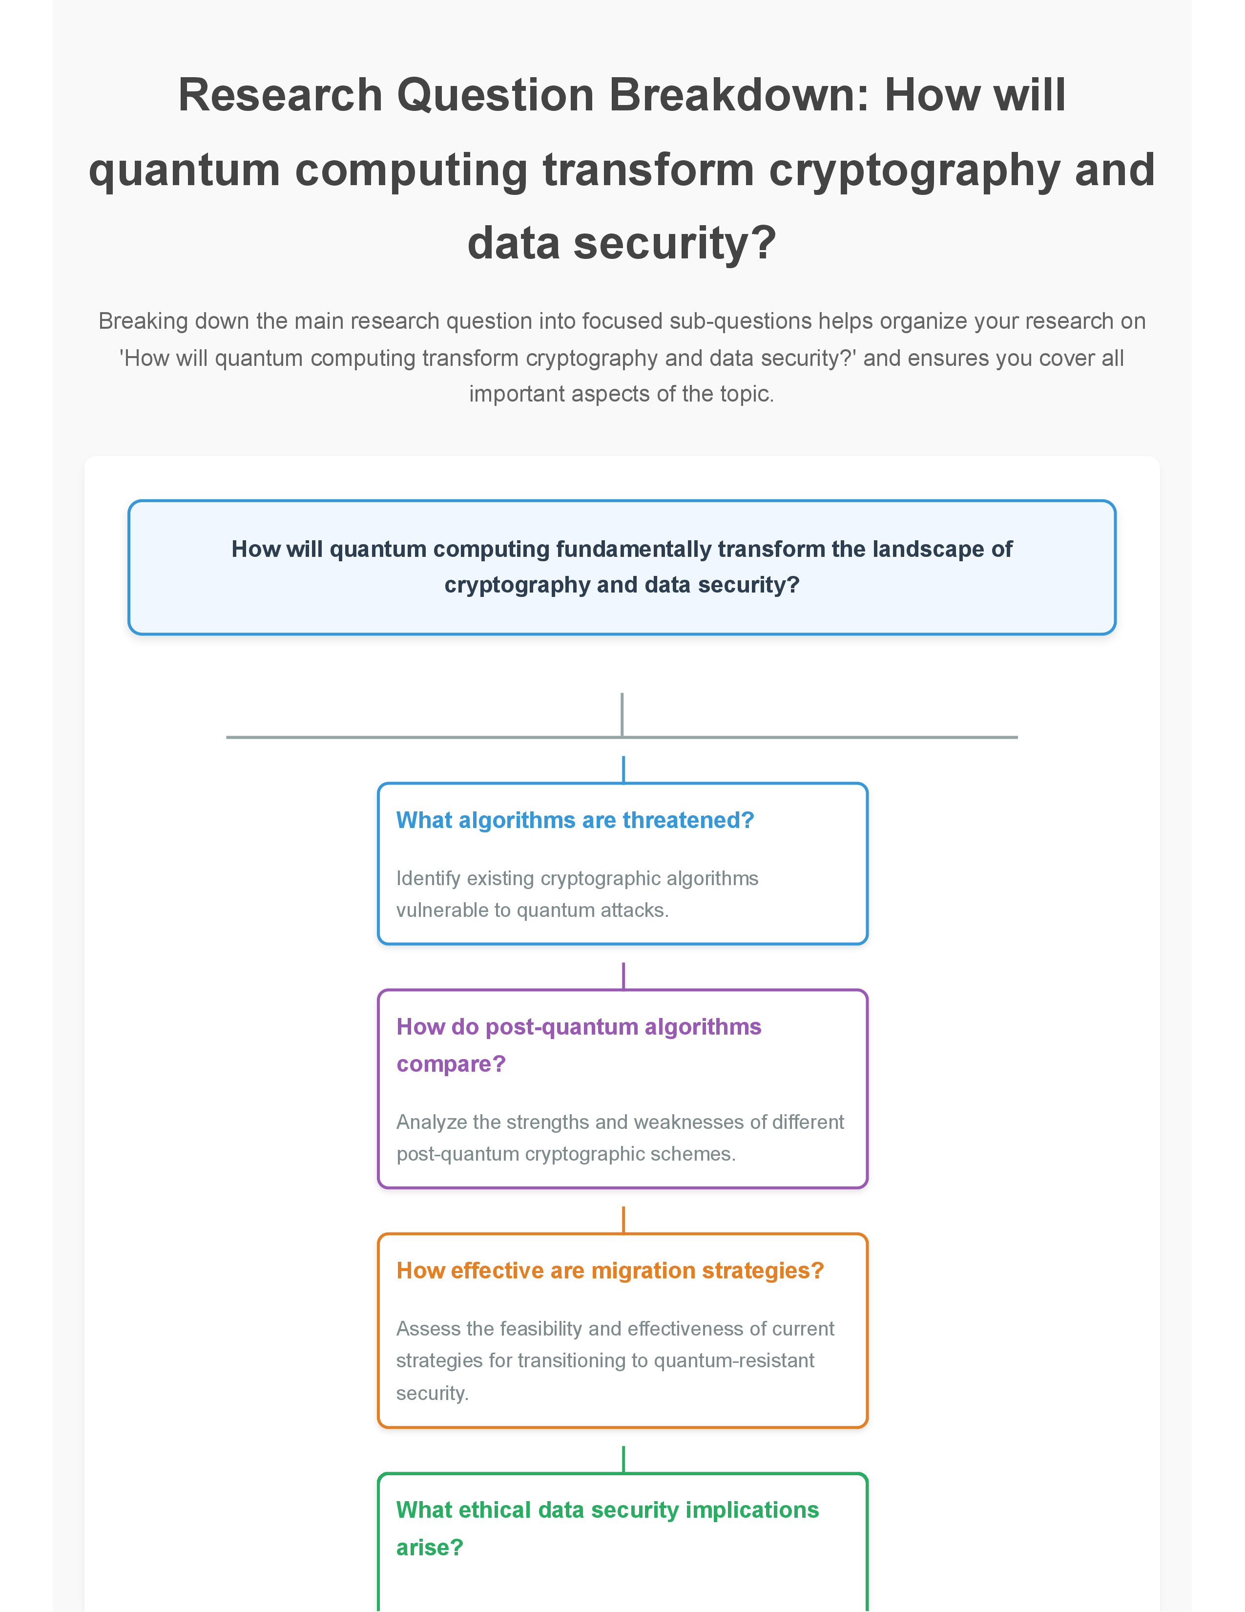
Figure: Question Breakdown: How will quantum computing transform cryptography and data security?

4. Topic Analysis

4.1. Heading
Topic Analysis

4.2. Content
This research paper delves into the intersection of quantum computing and information security. The core concepts explored include: 1) Quantum Computing Fundamentals: Understanding the principles of quantum mechanics, such as superposition and entanglement, that enable quantum computation. Key quantum algorithms, specifically Shor's algorithm for factoring large numbers and Grover's algorithm for searching unsorted databases, are central to the analysis due to their direct implications for cryptography.
Lily's Insight: Importance of Quantum Algorithms
Understanding the specific capabilities of Shor's and Grover's algorithms is crucial because they directly demonstrate the potential threat quantum computers pose to current cryptographic systems.

2) Classical Cryptography: Examining the foundational principles of current cryptographic schemes, including symmetric-key cryptography (e.g., AES) and asymmetric-key cryptography (e.g., RSA, ECC). The security of these algorithms is predicated on the computational limitations of classical computers. 3) Quantum Cryptanalysis: Analyzing how quantum algorithms can be applied to break existing cryptographic schemes. Shor's algorithm's ability to efficiently factor large numbers directly threatens public-key cryptography like RSA, while Grover's algorithm can significantly speed up brute-force attacks on symmetric-key algorithms.
Lily's Connection: Quantum Threat to Classical Crypto
This section highlights the direct link between the computational power of quantum algorithms and the vulnerability of widely used classical encryption methods.

4) Post-Quantum Cryptography (PQC): Investigating the emerging field of cryptography designed to be resistant to attacks from both classical and quantum computers. This includes exploring different approaches to PQC, such as lattice-based cryptography, code-based cryptography, multivariate cryptography, and hash-based cryptography.
Lily's Research: Exploring PQC Approaches
When researching PQC, consider focusing on the underlying mathematical problems each approach relies on, as this is what makes them resistant to quantum attacks.

5) Data Security Implications: Beyond breaking algorithms, the paper will explore the broader impact on data security, including the need for secure key exchange, digital signatures, and the protection of sensitive data in a quantum era. The 'harvest now, decrypt later' threat, where encrypted data is stolen today in anticipation of future quantum decryption capabilities, is a critical concern.
Lily's Warning: The 'Harvest Now, Decrypt Later' Threat
Be aware that the threat of quantum computing is not just future-oriented; data encrypted today could be vulnerable to decryption by future quantum computers if not protected with post-quantum methods.

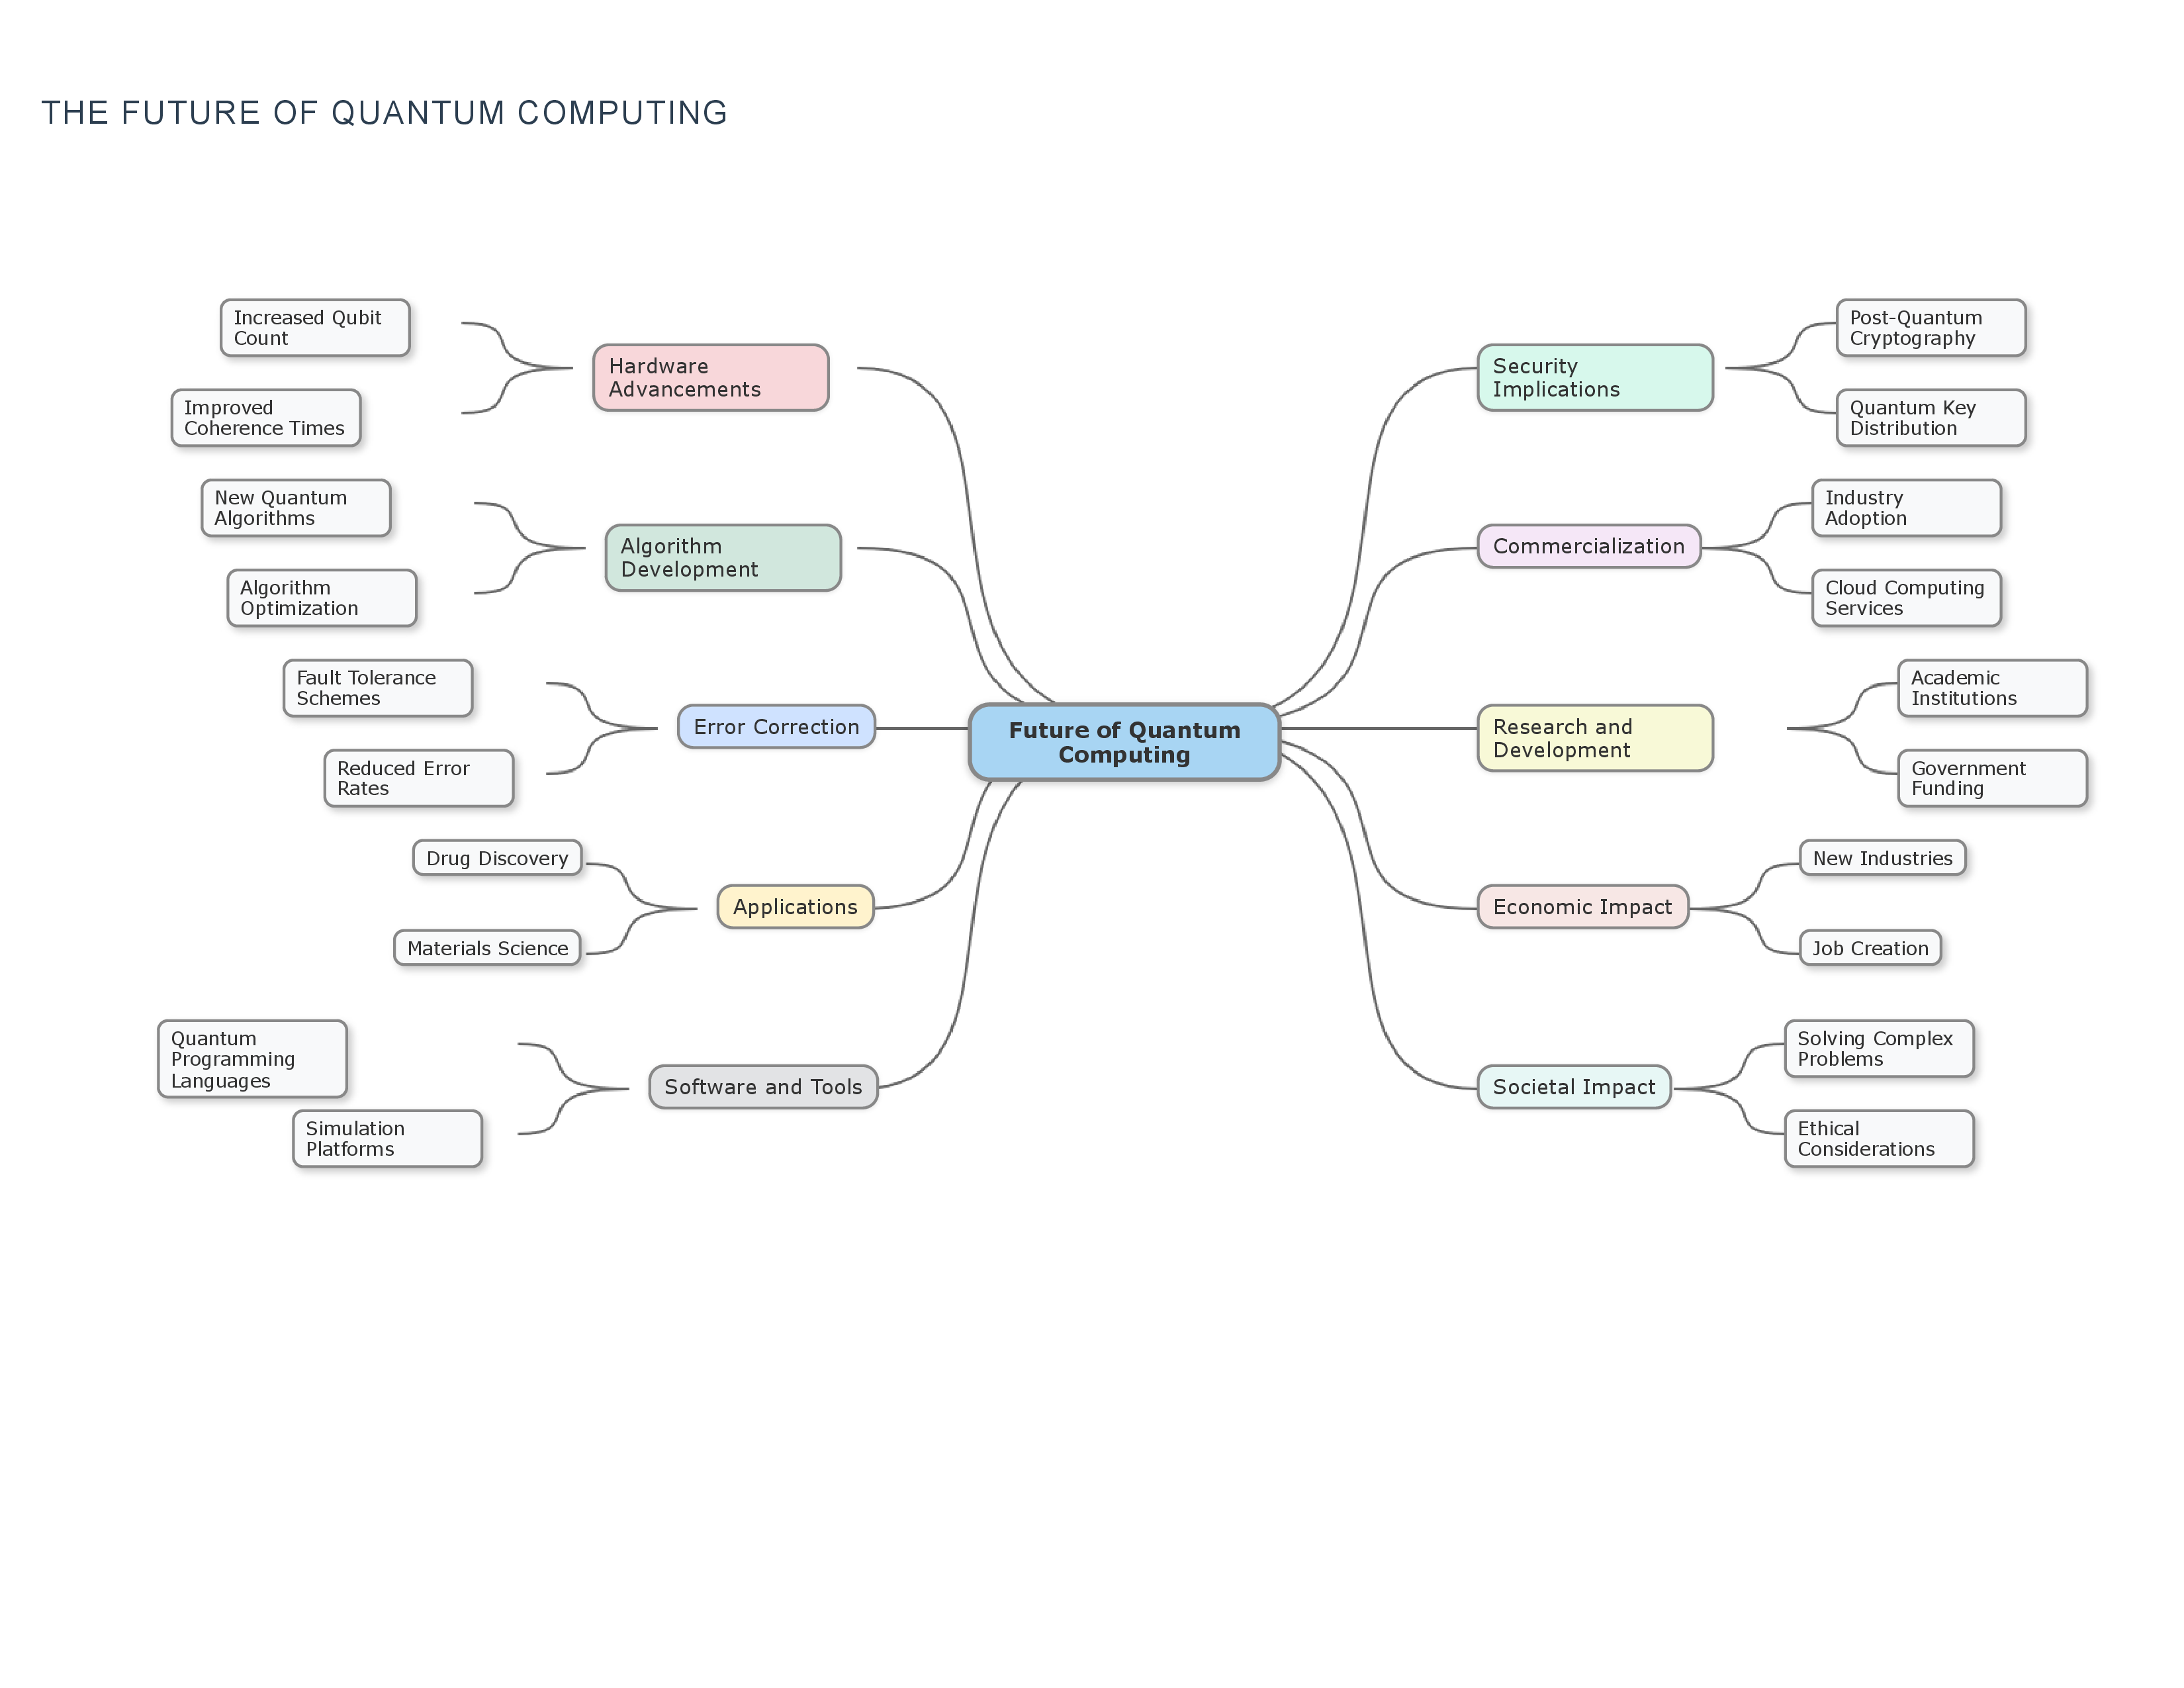
Figure: Mind Map: The future of quantum computing

5. Methodological Approaches

5.1. Heading
Methodological Approaches

5.2. Content
This research will primarily employ a literature review methodology. A comprehensive analysis of existing academic papers, research reports from government agencies (e.g., NIST), industry white papers, and relevant conference proceedings will form the basis of the study. The research will involve: 1) Identifying key publications on quantum computing, quantum algorithms, classical cryptography, and post-quantum cryptography. 2) Critically analyzing the mathematical foundations and security assumptions of both classical and post-quantum cryptographic schemes. 3) Evaluating the computational complexity of quantum algorithms in relation to the security parameters of current cryptographic standards. 4) Synthesizing findings from diverse sources to build a cohesive understanding of the current state of quantum computing and its projected impact on information security. 5) Comparing and contrasting different post-quantum cryptographic approaches based on their security guarantees, efficiency, and implementation challenges.
Lily's Tip: Effective Literature Review
When conducting your literature review, create a system for organizing your sources (e.g., using citation management software) to keep track of key findings and arguments from each publication.

While this paper is primarily theoretical and analytical, future research could incorporate simulation studies or experimental analysis of early quantum hardware and its capabilities relevant to cryptanalysis.
Lily's Brainstorm: Expanding Your Research
Consider how you might design a simulation study or a small-scale experiment using publicly available quantum computing platforms to test a specific aspect of quantum algorithm performance relevant to cryptography.

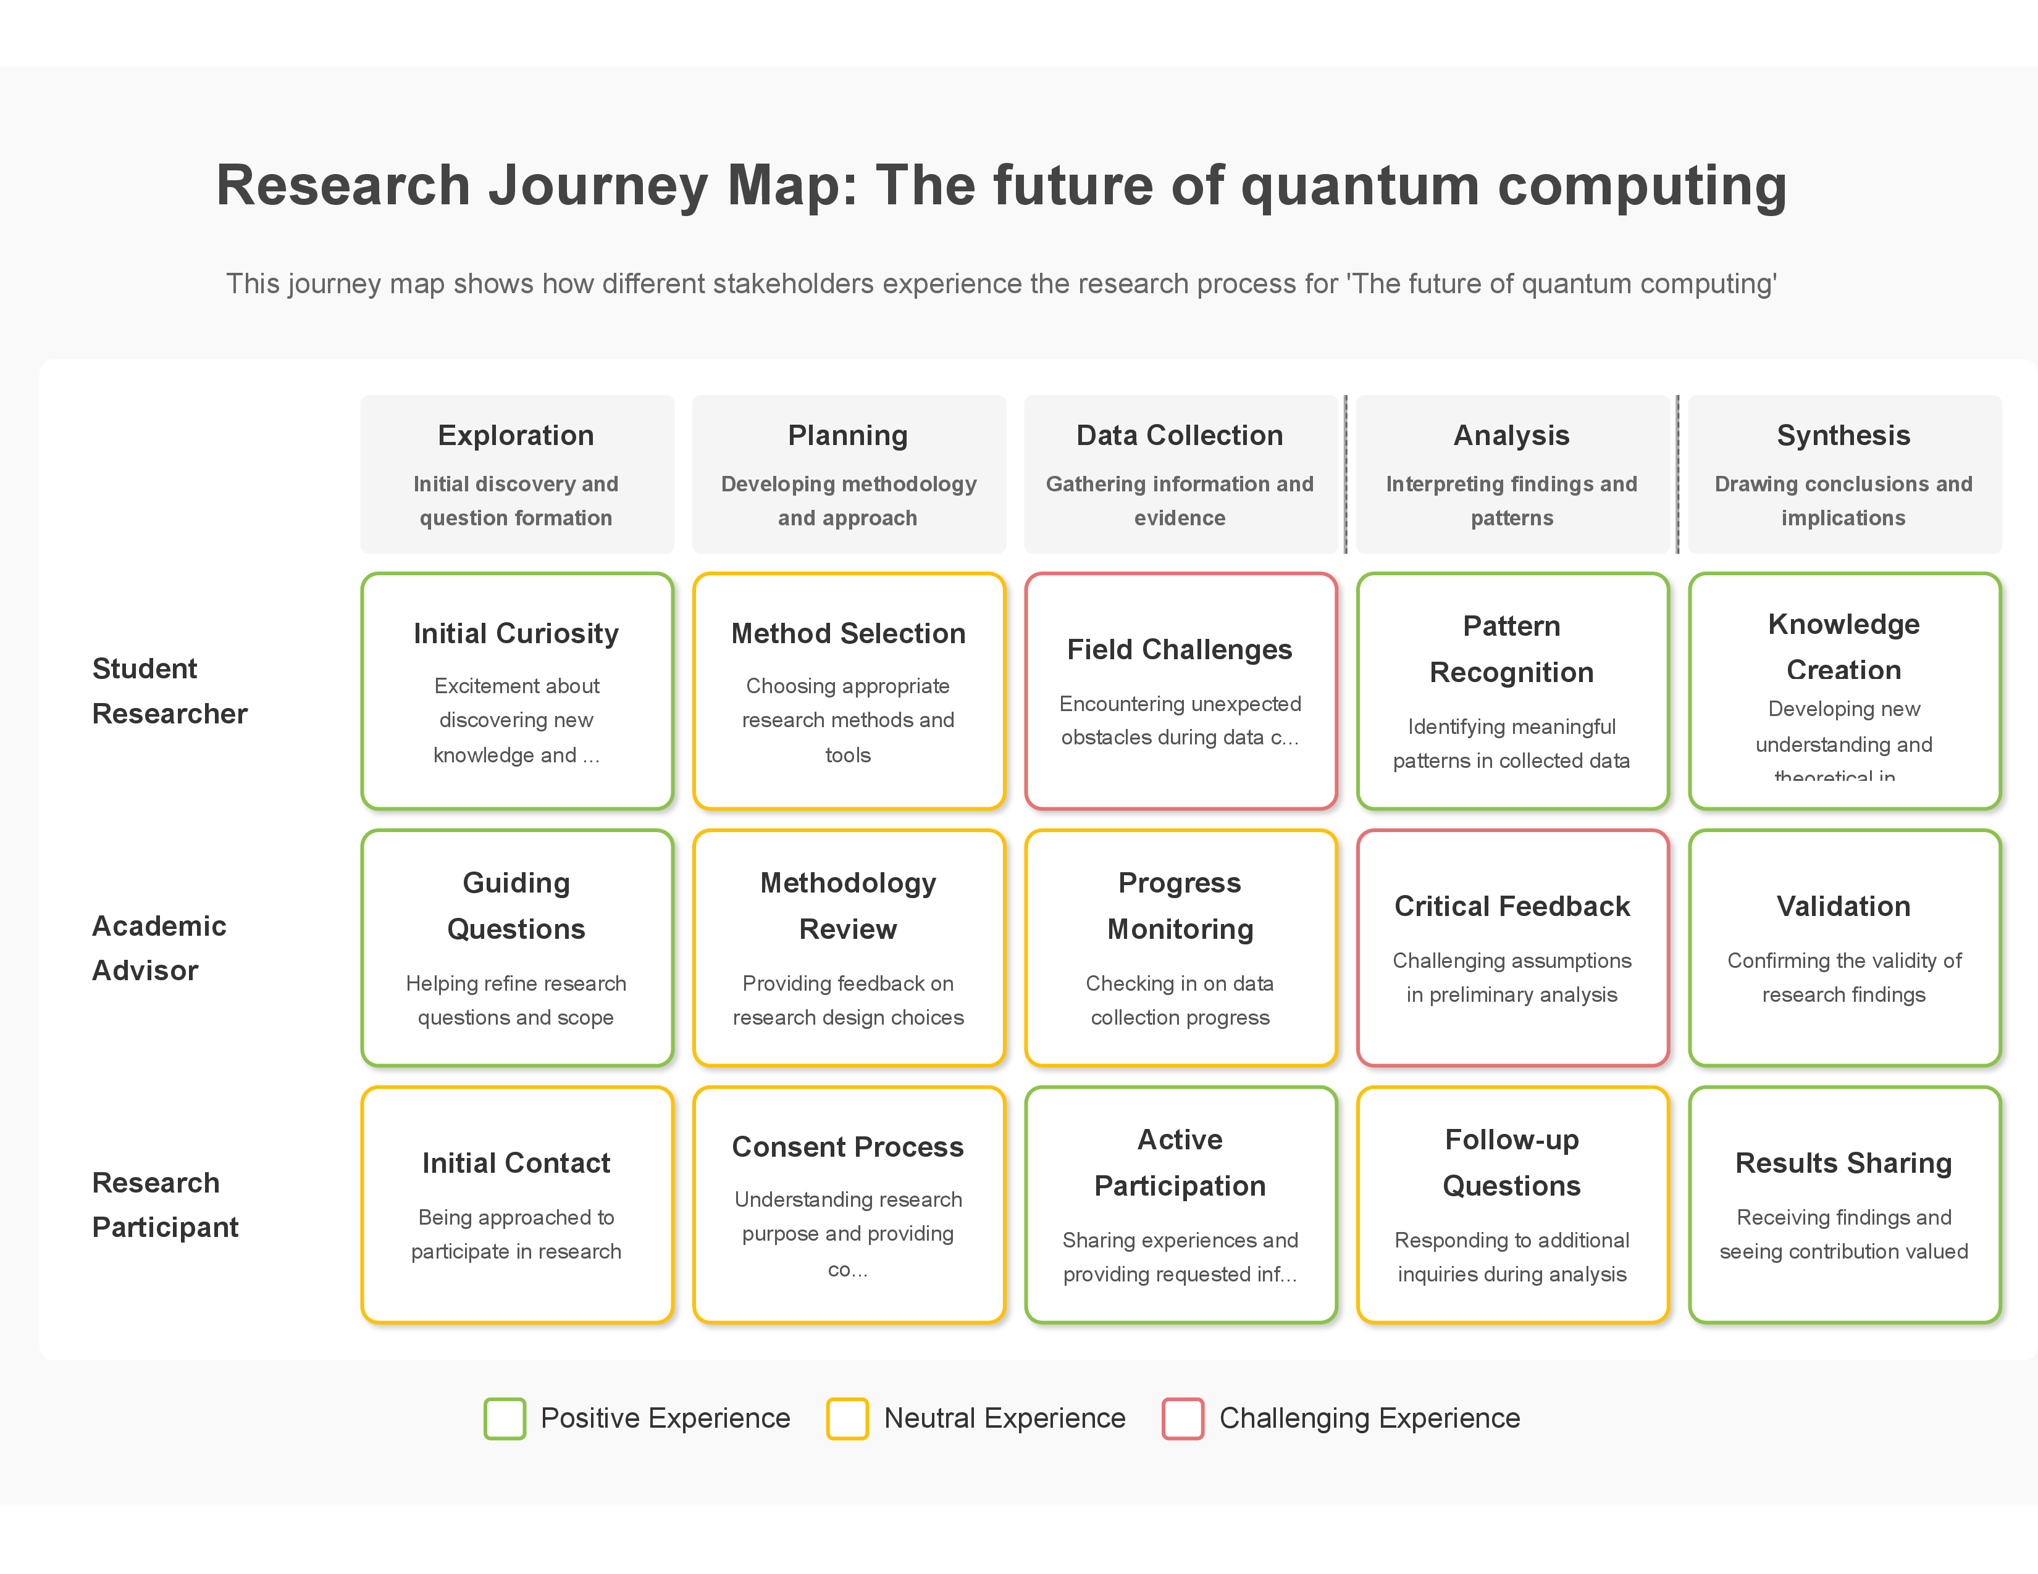
Figure: Research Journey Map: The future of quantum computing

6. Key Arguments

6.1. Heading
Key Arguments

6.2. Content
The central argument of this paper is that the development of fault-tolerant quantum computers will render a significant portion of currently deployed public-key cryptography vulnerable to efficient attacks, necessitating a global transition to post-quantum cryptographic standards. Specific key arguments include:
Quantum Supremacy and Cryptographic Vulnerabilities: The achievement of quantum supremacy, while a milestone in quantum computing, highlights the potential for quantum algorithms to outperform classical algorithms on specific tasks. Shor's algorithm, in particular, poses an existential threat to widely used public-key cryptosystems like RSA and ECC, which underpin secure communication protocols like TLS/SSL.
Lily's Insight: Shor's Algorithm's Impact
Shor's algorithm demonstrates the non-trivial power of quantum computers for specific mathematical problems, specifically factoring large numbers and finding discrete logarithms, which are the basis for many current cryptographic systems.

Grover's Algorithm and Symmetric-Key Cryptography: While the threat to symmetric-key cryptography from Grover's algorithm is less immediate than that posed by Shor's algorithm to public-key cryptography, it still necessitates an increase in key lengths to maintain the same level of security against quantum adversaries.
Lily's Connection: Complementary Threats
While Shor's algorithm targets asymmetric encryption, Grover's algorithm primarily affects symmetric encryption and hash functions by speeding up brute-force searches, requiring a different mitigation strategy.

The Urgency of Post-Quantum Cryptography: The 'harvest now, decrypt later' threat, where adversaries collect encrypted data today with the expectation of decrypting it with future quantum computers, underscores the immediate need to develop and deploy post-quantum cryptographic solutions.
Lily's Warning: The 'Harvest Now, Decrypt Later' Threat
This concept highlights the importance of acting before fault-tolerant quantum computers are built. Data encrypted today, if it needs to remain secure for decades, is already at risk.

Challenges in Developing and Deploying PQC: The transition to PQC faces significant challenges, including the need for new mathematical foundations, standardization efforts, interoperability issues with existing systems, and the potential for new vulnerabilities in the nascent PQC schemes.
The Need for a Coordinated Global Response: Addressing the quantum threat to cryptography requires a coordinated global effort involving governments, academic institutions, and industry to research, standardize, and deploy post-quantum cryptographic algorithms.

Figure: Argument Mapping: The future of quantum computing

Figure: Comparative Analysis: The future of quantum computing

7. Citations and Resources

7.1. Heading
Citations and Resources

7.2. Content
This section provides a starting point for further research. You should expand upon this list with additional relevant and credible sources.
Lily's Guidance: Expanding Your Research
Remember that this list is just a starting point. Use these sources as springboards to find other relevant academic papers, reports, and reputable websites.

National Institute of Standards and Technology (NIST). (n.d.). Post-Quantum Cryptography. Retrieved from [https://www.nist.gov/standardsgov/post-quantum-cryptography](https://www.nist.gov/standardsgov/post-quantum-cryptography)
Lily's Research: Exploring Standards Bodies
Investigate the work of standards bodies like NIST and ETSI. Understanding their role in post-quantum cryptography is crucial for appreciating the practical implementation challenges.

Shor, P. W. (1999). Polynomial-Time Algorithms for Prime Factorization and Discrete Logarithms on a Quantum Computer. SIAM Review, 41(2), 303-332.
Grover, L. K. (1996). A fast quantum mechanical algorithm for database search. Proceedings of the twenty-eighth annual ACM symposium on Theory of computing, 212-219.
Lily's Connection: Connecting Theory to Impact
Shor's and Grover's algorithms are foundational examples of quantum algorithms that demonstrate the potential power of quantum computers. Think about how these theoretical breakthroughs drive research in post-quantum cryptography.

Bernstein, D. J., Buchmann, J., & Dahmen, E. (Eds.). (2017). Post-Quantum Cryptography. Springer.
Mosca, M. (2018). Cybersecurity in an era with quantum computers: Will we be ready?. IEEE Security & Privacy, 16(5), 38-41.
European Telecommunications Standards Institute (ETSI). (n.d.). Quantum-Safe Cryptography. Retrieved from [https://www.etsi.org/technologies/quantum-safe-cryptography](https://www.etsi.org/technologies/quantum-safe-cryptography)
IBM Quantum. (n.d.). Quantum Computing. Retrieved from [https://www.ibm.com/quantum](https://www.ibm.com/quantum)
Google AI Quantum. (n.d.). Quantum Computing. Retrieved from [https://ai.google/research/teams/applied-science/quantum](https://ai.google/research/teams/applied-science/quantum)
Lily's Brainstorm: Industry Perspectives
Beyond academic papers, explore resources from major technology companies involved in quantum computing like IBM and Google. Their websites often provide insights into current developments and applications.

8. Personalized Questions

8.1. Heading
Personalized Questions

8.2. Content
Consider these questions to deepen your understanding and guide your further research:
What are the specific mathematical problems that form the basis of current public-key cryptography, and how does Shor's algorithm exploit their structure?
Beyond factoring and searching, are there other quantum algorithms that could potentially impact cryptographic security?
What are the different families of post-quantum cryptographic algorithms, and what are their respective strengths and weaknesses in terms of security, performance, and key sizes?
What are the major challenges in the standardization and deployment of post-quantum cryptography across different industries and critical infrastructure?
How might the development of fault-tolerant quantum computers impact the security of blockchain technology?
What are the ethical considerations surrounding the potential for quantum computing to break existing encryption and the need for a timely transition to PQC?
How are different countries and international organizations approaching the development and adoption of post-quantum cryptography standards?
What is the current estimated timeline for the development of quantum computers capable of breaking current cryptographic algorithms, and how does this influence the urgency of PQC deployment?
What are the potential economic and societal impacts of a successful large-scale quantum attack on current cryptographic infrastructure?
How can individuals and organizations prepare for the transition to a post-quantum cryptographic landscape?

9. Appendices

9.1. Heading
Appendices

9.2. Content
Appendices: Research Tools and Templates
Research Planning Tools
Research Question Formulation Template
Step 1: Topic Exploration
Broad area of interest:
Specific aspect to focus on:
Key concepts/terms:
Step 2: Question Development
Preliminary question:
Is this question...
- Specific enough? Yes/No
- Answerable within scope? Yes/No
- Relevant to field? Yes/No
- Interesting to you? Yes/No
Step 3: Question Refinement
Revised question:
Type of question (circle one): Descriptive / Explanatory / Evaluative / Prescriptive
Step 4: Final Research Question
Final question:
Key variables/concepts:
Potential sources of evidence:
Research Timeline Planner
| Phase | Tasks | Start Date | End Date | Resources Needed |
|-------|-------|------------|----------|------------------|
| Topic Exploration | • Review background literature<br>• Identify key concepts<br>• Narrow focus | | | |
| Research Question | • Formulate question<br>• Test with supervisor/peers<br>• Refine as needed | | | |
| Literature Review | • Identify sources<br>• Read and take notes<br>• Synthesize findings | | | |
| Methodology | • Select approach<br>• Design research tools<br>• Plan analysis | | | |
| Data Collection | • Gather information<br>• Organize data<br>• Track progress | | | |
| Analysis | • Process data<br>• Identify patterns<br>• Draw conclusions | | | |
| Writing | • Create outline<br>• Draft sections<br>• Revise content | | | |
| Finalization | • Edit for clarity<br>• Format document<br>• Submit final version | | | |
Note-Taking and Analysis Tools
Source Evaluation Checklist
Authority
- Who is the author?
- What are their credentials?
- Is the publisher reputable? Yes/No
Accuracy
- Is the information supported by evidence? Yes/No
- Can facts be verified through other sources? Yes/No
- Are there citations for key claims? Yes/No
Currency
- When was it published?
- Is this information still valid? Yes/No
- Has newer research superseded this? Yes/No
Relevance
- How does this relate to my research question?
- What specific aspects are most useful?
Objectivity
- Is there bias present? Yes/No
- Are multiple perspectives considered? Yes/No
- Is the tone academic/professional? Yes/No
Overall Assessment
- Quality rating (1-5):
- Key insights to use:
- Limitations to note:
Literature Review Matrix
| Source | Key Arguments | Methodology | Findings | Relevance to My Research | Limitations |
|--------|---------------|-------------|----------|--------------------------|------------|
| | | | | | |
| | | | | | |
| | | | | | |
| | | | | | |
Writing and Structure Tools
Outline Template
Title:
Introduction
- Background context
- Research problem/gap
- Research question
- Significance of study
- Overview of approach
Literature Review
- Theoretical framework
- Previous research on [subtopic 1]
- Previous research on [subtopic 2]
- Synthesis and gaps
Methodology
- Research approach
- Data collection methods
- Analysis techniques
- Limitations
Results/Findings
- Finding 1
- Finding 2
- Finding 3
Discussion
- Interpretation of findings
- Relation to existing literature
- Implications
- Limitations
Conclusion
- Summary of key points
- Answer to research question
- Recommendations
- Future research directions
Paragraph Structure Guide
Topic Sentence: State the main idea of the paragraph
Example: The impact of climate change on marine ecosystems has accelerated dramatically in the past decade.
Supporting Evidence: Provide facts, statistics, examples, or expert opinions
Example: According to Smith (2020), coral reef degradation has increased by 30% since 2010.
Analysis: Explain how the evidence supports your point
Example: This rapid increase demonstrates the urgent need for intervention, as coral reefs are essential habitats for thousands of marine species.
Connection: Link to your broader argument or next paragraph
Example: Understanding these impacts is crucial for developing effective conservation strategies, which will be discussed in the next section.
Methodology Tools
Research Method Selection Guide
Quantitative Methods (When you need numerical data and statistical analysis)
- Surveys/Questionnaires: For collecting structured data from large groups
- Experiments: For testing cause-effect relationships under controlled conditions
- Statistical Analysis: For identifying patterns and relationships in numerical data
Qualitative Methods (When you need in-depth understanding of experiences or concepts)
- Interviews: For detailed personal perspectives
- Focus Groups: For interactive discussions and multiple viewpoints
- Case Studies: For in-depth analysis of specific instances
- Content Analysis: For examining patterns in texts or media
Mixed Methods (When you need both breadth and depth)
- Sequential: Qualitative followed by quantitative (or vice versa)
- Concurrent: Both types collected simultaneously
- Transformative: Guided by theoretical framework for social change
Data Collection Planning Template
Research Question:
Data Needed:
Collection Method(s):
- Primary:
- Secondary:
Sampling Strategy:
- Population:
- Sample size:
- Selection method:
Timeline:
- Start date:
- End date:
- Key milestones:
Ethical Considerations:
- Permissions needed:
- Confidentiality measures:
- Potential issues:
Resources Required:
- Tools/equipment:
- Software:
- Personnel:
- Budget:
Revision and Feedback Tools
Self-Review Checklist
Content
- [ ] Research question is clearly stated
- [ ] Arguments are logical and well-supported
- [ ] Evidence is relevant and properly cited
- [ ] Counter-arguments are addressed
- [ ] Conclusions follow from the evidence
Structure
- [ ] Introduction effectively sets up the paper
- [ ] Paragraphs have clear topic sentences
- [ ] Transitions between sections are smooth
- [ ] Conclusion synthesizes key points
Language
- [ ] Academic tone is maintained throughout
- [ ] Terminology is used accurately
- [ ] Sentences are clear and concise
- [ ] Grammar and spelling are correct
Formatting
- [ ] Citations follow required style guide
- [ ] Reference list is complete and properly formatted
- [ ] Tables/figures are properly labeled
- [ ] Page layout meets requirements
Common Errors Checklist
Content Errors
- [ ] Overgeneralization from limited evidence
- [ ] Confusing correlation with causation
- [ ] Cherry-picking evidence
- [ ] Ignoring contradictory findings
- [ ] Making claims beyond the scope of research
Structural Errors
- [ ] Inadequate introduction or conclusion
- [ ] Topic drift within paragraphs
- [ ] Imbalanced coverage of key aspects
- [ ] Poor logical flow between sections
Language Errors
- [ ] Overuse of passive voice
- [ ] Excessive jargon without explanation
- [ ] Informal language or colloquialisms
- [ ] Wordiness and redundancy
Citation Errors
- [ ] Missing citations for key claims
- [ ] Inconsistent citation format
- [ ] Secondary sources cited as primary
- [ ] Outdated sources for current topics

10. Additional Diagrams
Figure: Comparative Analysis: The future of quantum computing (Comparative Analysis)

11. Introduction

11.1. Heading
Introduction

11.2. Content
The advent of quantum computing represents a paradigm shift in computational capabilities, promising to tackle problems currently intractable for even the most powerful classical computers. While the potential applications of quantum computing span diverse fields from drug discovery to materials science, its implications for information security, particularly cryptography and data security, are profound and necessitate urgent consideration. Current cryptographic algorithms, the bedrock of secure communication and data protection in the digital age, rely on the computational difficulty of certain mathematical problems for classical computers. However, quantum algorithms, such as Shor's algorithm and Grover's algorithm, pose a significant threat to the security of these widely deployed cryptographic schemes.
Lily's Insight: The Quantum Threat to Cryptography
Understanding the fundamental difference between classical and quantum computing is key to grasping why quantum computers pose a threat to current cryptography. Classical computers rely on bits representing 0 or 1, while quantum computers use qubits which can be 0, 1, or a superposition of both, enabling them to explore many possibilities simultaneously.

This paper will explore the transformative impact of quantum computing on cryptography and data security, addressing the vulnerabilities it introduces and the ongoing efforts to develop post-quantum cryptography to safeguard future information systems. Specifically, this research aims to answer the question: How will quantum computing transform cryptography and data security?
Lily's Question: Framing Your Research Question
The research question 'How will quantum computing transform cryptography and data security?' is broad. Consider breaking it down into sub-questions to guide your research more effectively. For example: Which specific cryptographic algorithms are most vulnerable? What are the leading approaches to post-quantum cryptography? What are the timelines and challenges for transitioning to post-quantum standards?

Figure: Question Breakdown: How will quantum computing transform cryptography and data security?

12. Topic Analysis

12.1. Heading
Topic Analysis

12.2. Content
This research paper delves into the intersection of quantum computing and information security. The core concepts explored include: 1) Quantum Computing Fundamentals: Understanding the principles of quantum mechanics, such as superposition and entanglement, that enable quantum computation. Key quantum algorithms, specifically Shor's algorithm for factoring large numbers and Grover's algorithm for searching unsorted databases, are central to the analysis due to their direct implications for cryptography.
Lily's Insight: Importance of Quantum Algorithms
Understanding the specific capabilities of Shor's and Grover's algorithms is crucial because they directly demonstrate the potential threat quantum computers pose to current cryptographic systems.

2) Classical Cryptography: Examining the foundational principles of current cryptographic schemes, including symmetric-key cryptography (e.g., AES) and asymmetric-key cryptography (e.g., RSA, ECC). The security of these algorithms is predicated on the computational limitations of classical computers. 3) Quantum Cryptanalysis: Analyzing how quantum algorithms can be applied to break existing cryptographic schemes. Shor's algorithm's ability to efficiently factor large numbers directly threatens public-key cryptography like RSA, while Grover's algorithm can significantly speed up brute-force attacks on symmetric-key algorithms.
Lily's Connection: Quantum Threat to Classical Crypto
This section highlights the direct link between the computational power of quantum algorithms and the vulnerability of widely used classical encryption methods.

4) Post-Quantum Cryptography (PQC): Investigating the emerging field of cryptography designed to be resistant to attacks from both classical and quantum computers. This includes exploring different approaches to PQC, such as lattice-based cryptography, code-based cryptography, multivariate cryptography, and hash-based cryptography.
Lily's Research: Exploring PQC Approaches
When researching PQC, consider focusing on the underlying mathematical problems each approach relies on, as this is what makes them resistant to quantum attacks.

5) Data Security Implications: Beyond breaking algorithms, the paper will explore the broader impact on data security, including the need for secure key exchange, digital signatures, and the protection of sensitive data in a quantum era. The 'harvest now, decrypt later' threat, where encrypted data is stolen today in anticipation of future quantum decryption capabilities, is a critical concern.
Lily's Warning: The 'Harvest Now, Decrypt Later' Threat
Be aware that the threat of quantum computing is not just future-oriented; data encrypted today could be vulnerable to decryption by future quantum computers if not protected with post-quantum methods.

Figure: Mind Map: The future of quantum computing

13. Methodological Approaches

13.1. Heading
Methodological Approaches

13.2. Content
This research will primarily employ a literature review methodology. A comprehensive analysis of existing academic papers, research reports from government agencies (e.g., NIST), industry white papers, and relevant conference proceedings will form the basis of the study. The research will involve: 1) Identifying key publications on quantum computing, quantum algorithms, classical cryptography, and post-quantum cryptography. 2) Critically analyzing the mathematical foundations and security assumptions of both classical and post-quantum cryptographic schemes. 3) Evaluating the computational complexity of quantum algorithms in relation to the security parameters of current cryptographic standards. 4) Synthesizing findings from diverse sources to build a cohesive understanding of the current state of quantum computing and its projected impact on information security. 5) Comparing and contrasting different post-quantum cryptographic approaches based on their security guarantees, efficiency, and implementation challenges.
Lily's Tip: Effective Literature Review
When conducting your literature review, create a system for organizing your sources (e.g., using citation management software) to keep track of key findings and arguments from each publication.

While this paper is primarily theoretical and analytical, future research could incorporate simulation studies or experimental analysis of early quantum hardware and its capabilities relevant to cryptanalysis.
Lily's Brainstorm: Expanding Your Research
Consider how you might design a simulation study or a small-scale experiment using publicly available quantum computing platforms to test a specific aspect of quantum algorithm performance relevant to cryptography.

Figure: Research Journey Map: The future of quantum computing

14. Key Arguments

14.1. Heading
Key Arguments

14.2. Content
The central argument of this paper is that the development of fault-tolerant quantum computers will render a significant portion of currently deployed public-key cryptography vulnerable to efficient attacks, necessitating a global transition to post-quantum cryptographic standards. Specific key arguments include:
Quantum Supremacy and Cryptographic Vulnerabilities: The achievement of quantum supremacy, while a milestone in quantum computing, highlights the potential for quantum algorithms to outperform classical algorithms on specific tasks. Shor's algorithm, in particular, poses an existential threat to widely used public-key cryptosystems like RSA and ECC, which underpin secure communication protocols like TLS/SSL.
Lily's Insight: Shor's Algorithm's Impact
Shor's algorithm demonstrates the non-trivial power of quantum computers for specific mathematical problems, specifically factoring large numbers and finding discrete logarithms, which are the basis for many current cryptographic systems.

Grover's Algorithm and Symmetric-Key Cryptography: While the threat to symmetric-key cryptography from Grover's algorithm is less immediate than that posed by Shor's algorithm to public-key cryptography, it still necessitates an increase in key lengths to maintain the same level of security against quantum adversaries.
Lily's Connection: Complementary Threats
While Shor's algorithm targets asymmetric encryption, Grover's algorithm primarily affects symmetric encryption and hash functions by speeding up brute-force searches, requiring a different mitigation strategy.

The Urgency of Post-Quantum Cryptography: The 'harvest now, decrypt later' threat, where adversaries collect encrypted data today with the expectation of decrypting it with future quantum computers, underscores the immediate need to develop and deploy post-quantum cryptographic solutions.
Lily's Warning: The 'Harvest Now, Decrypt Later' Threat
This concept highlights the importance of acting before fault-tolerant quantum computers are built. Data encrypted today, if it needs to remain secure for decades, is already at risk.

Challenges in Developing and Deploying PQC: The transition to PQC faces significant challenges, including the need for new mathematical foundations, standardization efforts, interoperability issues with existing systems, and the potential for new vulnerabilities in the nascent PQC schemes.
The Need for a Coordinated Global Response: Addressing the quantum threat to cryptography requires a coordinated global effort involving governments, academic institutions, and industry to research, standardize, and deploy post-quantum cryptographic algorithms.
Figure: Argument Mapping: The future of quantum computing
Figure: Comparative Analysis: The future of quantum computing

15. Citations and Resources

15.1. Heading
Citations and Resources

15.2. Content
This section provides a starting point for further research. You should expand upon this list with additional relevant and credible sources.
Lily's Guidance: Expanding Your Research
Remember that this list is just a starting point. Use these sources as springboards to find other relevant academic papers, reports, and reputable websites.

National Institute of Standards and Technology (NIST). (n.d.). Post-Quantum Cryptography. Retrieved from [https://www.nist.gov/standardsgov/post-quantum-cryptography](https://www.nist.gov/standardsgov/post-quantum-cryptography)
Lily's Research: Exploring Standards Bodies
Investigate the work of standards bodies like NIST and ETSI. Understanding their role in post-quantum cryptography is crucial for appreciating the practical implementation challenges.

Shor, P. W. (1999). Polynomial-Time Algorithms for Prime Factorization and Discrete Logarithms on a Quantum Computer. SIAM Review, 41(2), 303-332.
Grover, L. K. (1996). A fast quantum mechanical algorithm for database search. Proceedings of the twenty-eighth annual ACM symposium on Theory of computing, 212-219.
Lily's Connection: Connecting Theory to Impact
Shor's and Grover's algorithms are foundational examples of quantum algorithms that demonstrate the potential power of quantum computers. Think about how these theoretical breakthroughs drive research in post-quantum cryptography.

Bernstein, D. J., Buchmann, J., & Dahmen, E. (Eds.). (2017). Post-Quantum Cryptography. Springer.
Mosca, M. (2018). Cybersecurity in an era with quantum computers: Will we be ready?. IEEE Security & Privacy, 16(5), 38-41.
European Telecommunications Standards Institute (ETSI). (n.d.). Quantum-Safe Cryptography. Retrieved from [https://www.etsi.org/technologies/quantum-safe-cryptography](https://www.etsi.org/technologies/quantum-safe-cryptography)
IBM Quantum. (n.d.). Quantum Computing. Retrieved from [https://www.ibm.com/quantum](https://www.ibm.com/quantum)
Google AI Quantum. (n.d.). Quantum Computing. Retrieved from [https://ai.google/research/teams/applied-science/quantum](https://ai.google/research/teams/applied-science/quantum)
Lily's Brainstorm: Industry Perspectives
Beyond academic papers, explore resources from major technology companies involved in quantum computing like IBM and Google. Their websites often provide insights into current developments and applications.

16. Appendices

16.1. Research Tools and Templates
Appendices: Research Tools and Templates
Research Planning Tools
Research Question Formulation Template
Step 1: Topic Exploration
Broad area of interest:
Specific aspect to focus on:
Key concepts/terms:
Step 2: Question Development
Preliminary question:
Is this question...
- Specific enough? Yes/No
- Answerable within scope? Yes/No
- Relevant to field? Yes/No
- Interesting to you? Yes/No
Step 3: Question Refinement
Revised question:
Type of question (circle one): Descriptive / Explanatory / Evaluative / Prescriptive
Step 4: Final Research Question
Final question:
Key variables/concepts:
Potential sources of evidence:
Research Timeline Planner
| Phase | Tasks | Start Date | End Date | Resources Needed |
|-------|-------|------------|----------|------------------|
| Topic Exploration | • Review background literature<br>• Identify key concepts<br>• Narrow focus | | | |
| Research Question | • Formulate question<br>• Test with supervisor/peers<br>• Refine as needed | | | |
| Literature Review | • Identify sources<br>• Read and take notes<br>• Synthesize findings | | | |
| Methodology | • Select approach<br>• Design research tools<br>• Plan analysis | | | |
| Data Collection | • Gather information<br>• Organize data<br>• Track progress | | | |
| Analysis | • Process data<br>• Identify patterns<br>• Draw conclusions | | | |
| Writing | • Create outline<br>• Draft sections<br>• Revise content | | | |
| Finalization | • Edit for clarity<br>• Format document<br>• Submit final version | | | |
Note-Taking and Analysis Tools
Source Evaluation Checklist
Authority
- Who is the author?
- What are their credentials?
- Is the publisher reputable? Yes/No
Accuracy
- Is the information supported by evidence? Yes/No
- Can facts be verified through other sources? Yes/No
- Are there citations for key claims? Yes/No
Currency
- When was it published?
- Is this information still valid? Yes/No
- Has newer research superseded this? Yes/No
Relevance
- How does this relate to my research question?
- What specific aspects are most useful?
Objectivity
- Is there bias present? Yes/No
- Are multiple perspectives considered? Yes/No
- Is the tone academic/professional? Yes/No
Overall Assessment
- Quality rating (1-5):
- Key insights to use:
- Limitations to note:
Literature Review Matrix
| Source | Key Arguments | Methodology | Findings | Relevance to My Research | Limitations |
|--------|---------------|-------------|----------|--------------------------|------------|
| | | | | | |
| | | | | | |
| | | | | | |
| | | | | | |
Writing and Structure Tools
Outline Template
Title:
Introduction
- Background context
- Research problem/gap
- Research question
- Significance of study
- Overview of approach
Literature Review
- Theoretical framework
- Previous research on [subtopic 1]
- Previous research on [subtopic 2]
- Synthesis and gaps
Methodology
- Research approach
- Data collection methods
- Analysis techniques
- Limitations
Results/Findings
- Finding 1
- Finding 2
- Finding 3
Discussion
- Interpretation of findings
- Relation to existing literature
- Implications
- Limitations
Conclusion
- Summary of key points
- Answer to research question
- Recommendations
- Future research directions
Paragraph Structure Guide
Topic Sentence: State the main idea of the paragraph
Example: The impact of climate change on marine ecosystems has accelerated dramatically in the past decade.
Supporting Evidence: Provide facts, statistics, examples, or expert opinions
Example: According to Smith (2020), coral reef degradation has increased by 30% since 2010.
Analysis: Explain how the evidence supports your point
Example: This rapid increase demonstrates the urgent need for intervention, as coral reefs are essential habitats for thousands of marine species.
Connection: Link to your broader argument or next paragraph
Example: Understanding these impacts is crucial for developing effective conservation strategies, which will be discussed in the next section.
Methodology Tools
Research Method Selection Guide
Quantitative Methods (When you need numerical data and statistical analysis)
- Surveys/Questionnaires: For collecting structured data from large groups
- Experiments: For testing cause-effect relationships under controlled conditions
- Statistical Analysis: For identifying patterns and relationships in numerical data
Qualitative Methods (When you need in-depth understanding of experiences or concepts)
- Interviews: For detailed personal perspectives
- Focus Groups: For interactive discussions and multiple viewpoints
- Case Studies: For in-depth analysis of specific instances
- Content Analysis: For examining patterns in texts or media
Mixed Methods (When you need both breadth and depth)
- Sequential: Qualitative followed by quantitative (or vice versa)
- Concurrent: Both types collected simultaneously
- Transformative: Guided by theoretical framework for social change
Data Collection Planning Template
Research Question:
Data Needed:
Collection Method(s):
- Primary:
- Secondary:
Sampling Strategy:
- Population:
- Sample size:
- Selection method:
Timeline:
- Start date:
- End date:
- Key milestones:
Ethical Considerations:
- Permissions needed:
- Confidentiality measures:
- Potential issues:
Resources Required:
- Tools/equipment:
- Software:
- Personnel:
- Budget:
Revision and Feedback Tools
Self-Review Checklist
Content
- [ ] Research question is clearly stated
- [ ] Arguments are logical and well-supported
- [ ] Evidence is relevant and properly cited
- [ ] Counter-arguments are addressed
- [ ] Conclusions follow from the evidence
Structure
- [ ] Introduction effectively sets up the paper
- [ ] Paragraphs have clear topic sentences
- [ ] Transitions between sections are smooth
- [ ] Conclusion synthesizes key points
Language
- [ ] Academic tone is maintained throughout
- [ ] Terminology is used accurately
- [ ] Sentences are clear and concise
- [ ] Grammar and spelling are correct
Formatting
- [ ] Citations follow required style guide
- [ ] Reference list is complete and properly formatted
- [ ] Tables/figures are properly labeled
- [ ] Page layout meets requirements
Common Errors Checklist
Content Errors
- [ ] Overgeneralization from limited evidence
- [ ] Confusing correlation with causation
- [ ] Cherry-picking evidence
- [ ] Ignoring contradictory findings
- [ ] Making claims beyond the scope of research
Structural Errors
- [ ] Inadequate introduction or conclusion
- [ ] Topic drift within paragraphs
- [ ] Imbalanced coverage of key aspects
- [ ] Poor logical flow between sections
Language Errors
- [ ] Overuse of passive voice
- [ ] Excessive jargon without explanation
- [ ] Informal language or colloquialisms
- [ ] Wordiness and redundancy
Citation Errors
- [ ] Missing citations for key claims
- [ ] Inconsistent citation format
- [ ] Secondary sources cited as primary
- [ ] Outdated sources for current topics

17. Additional Diagrams
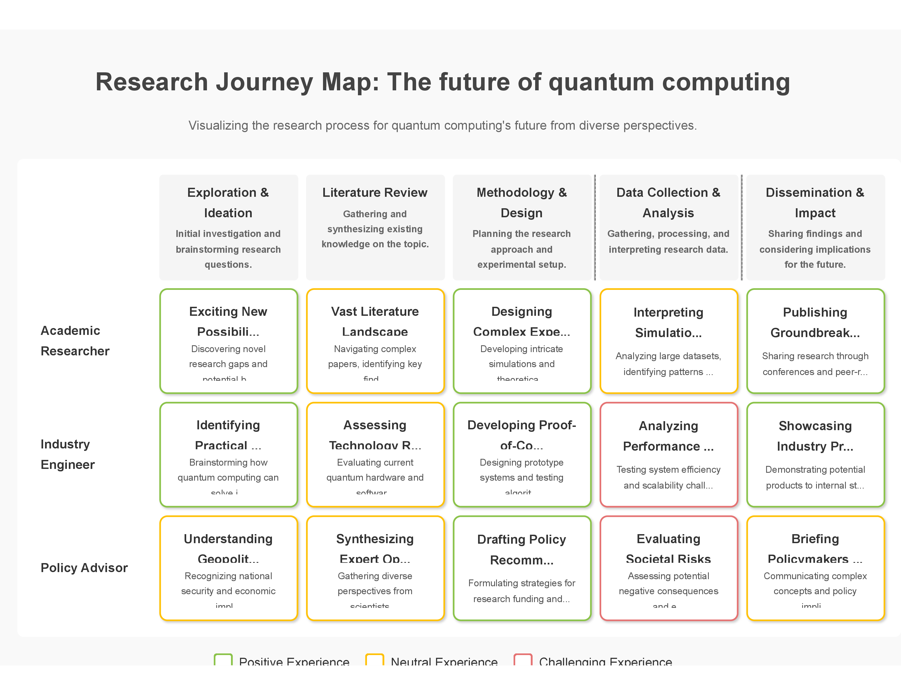
Figure: Diagram 1 (Journey Map)
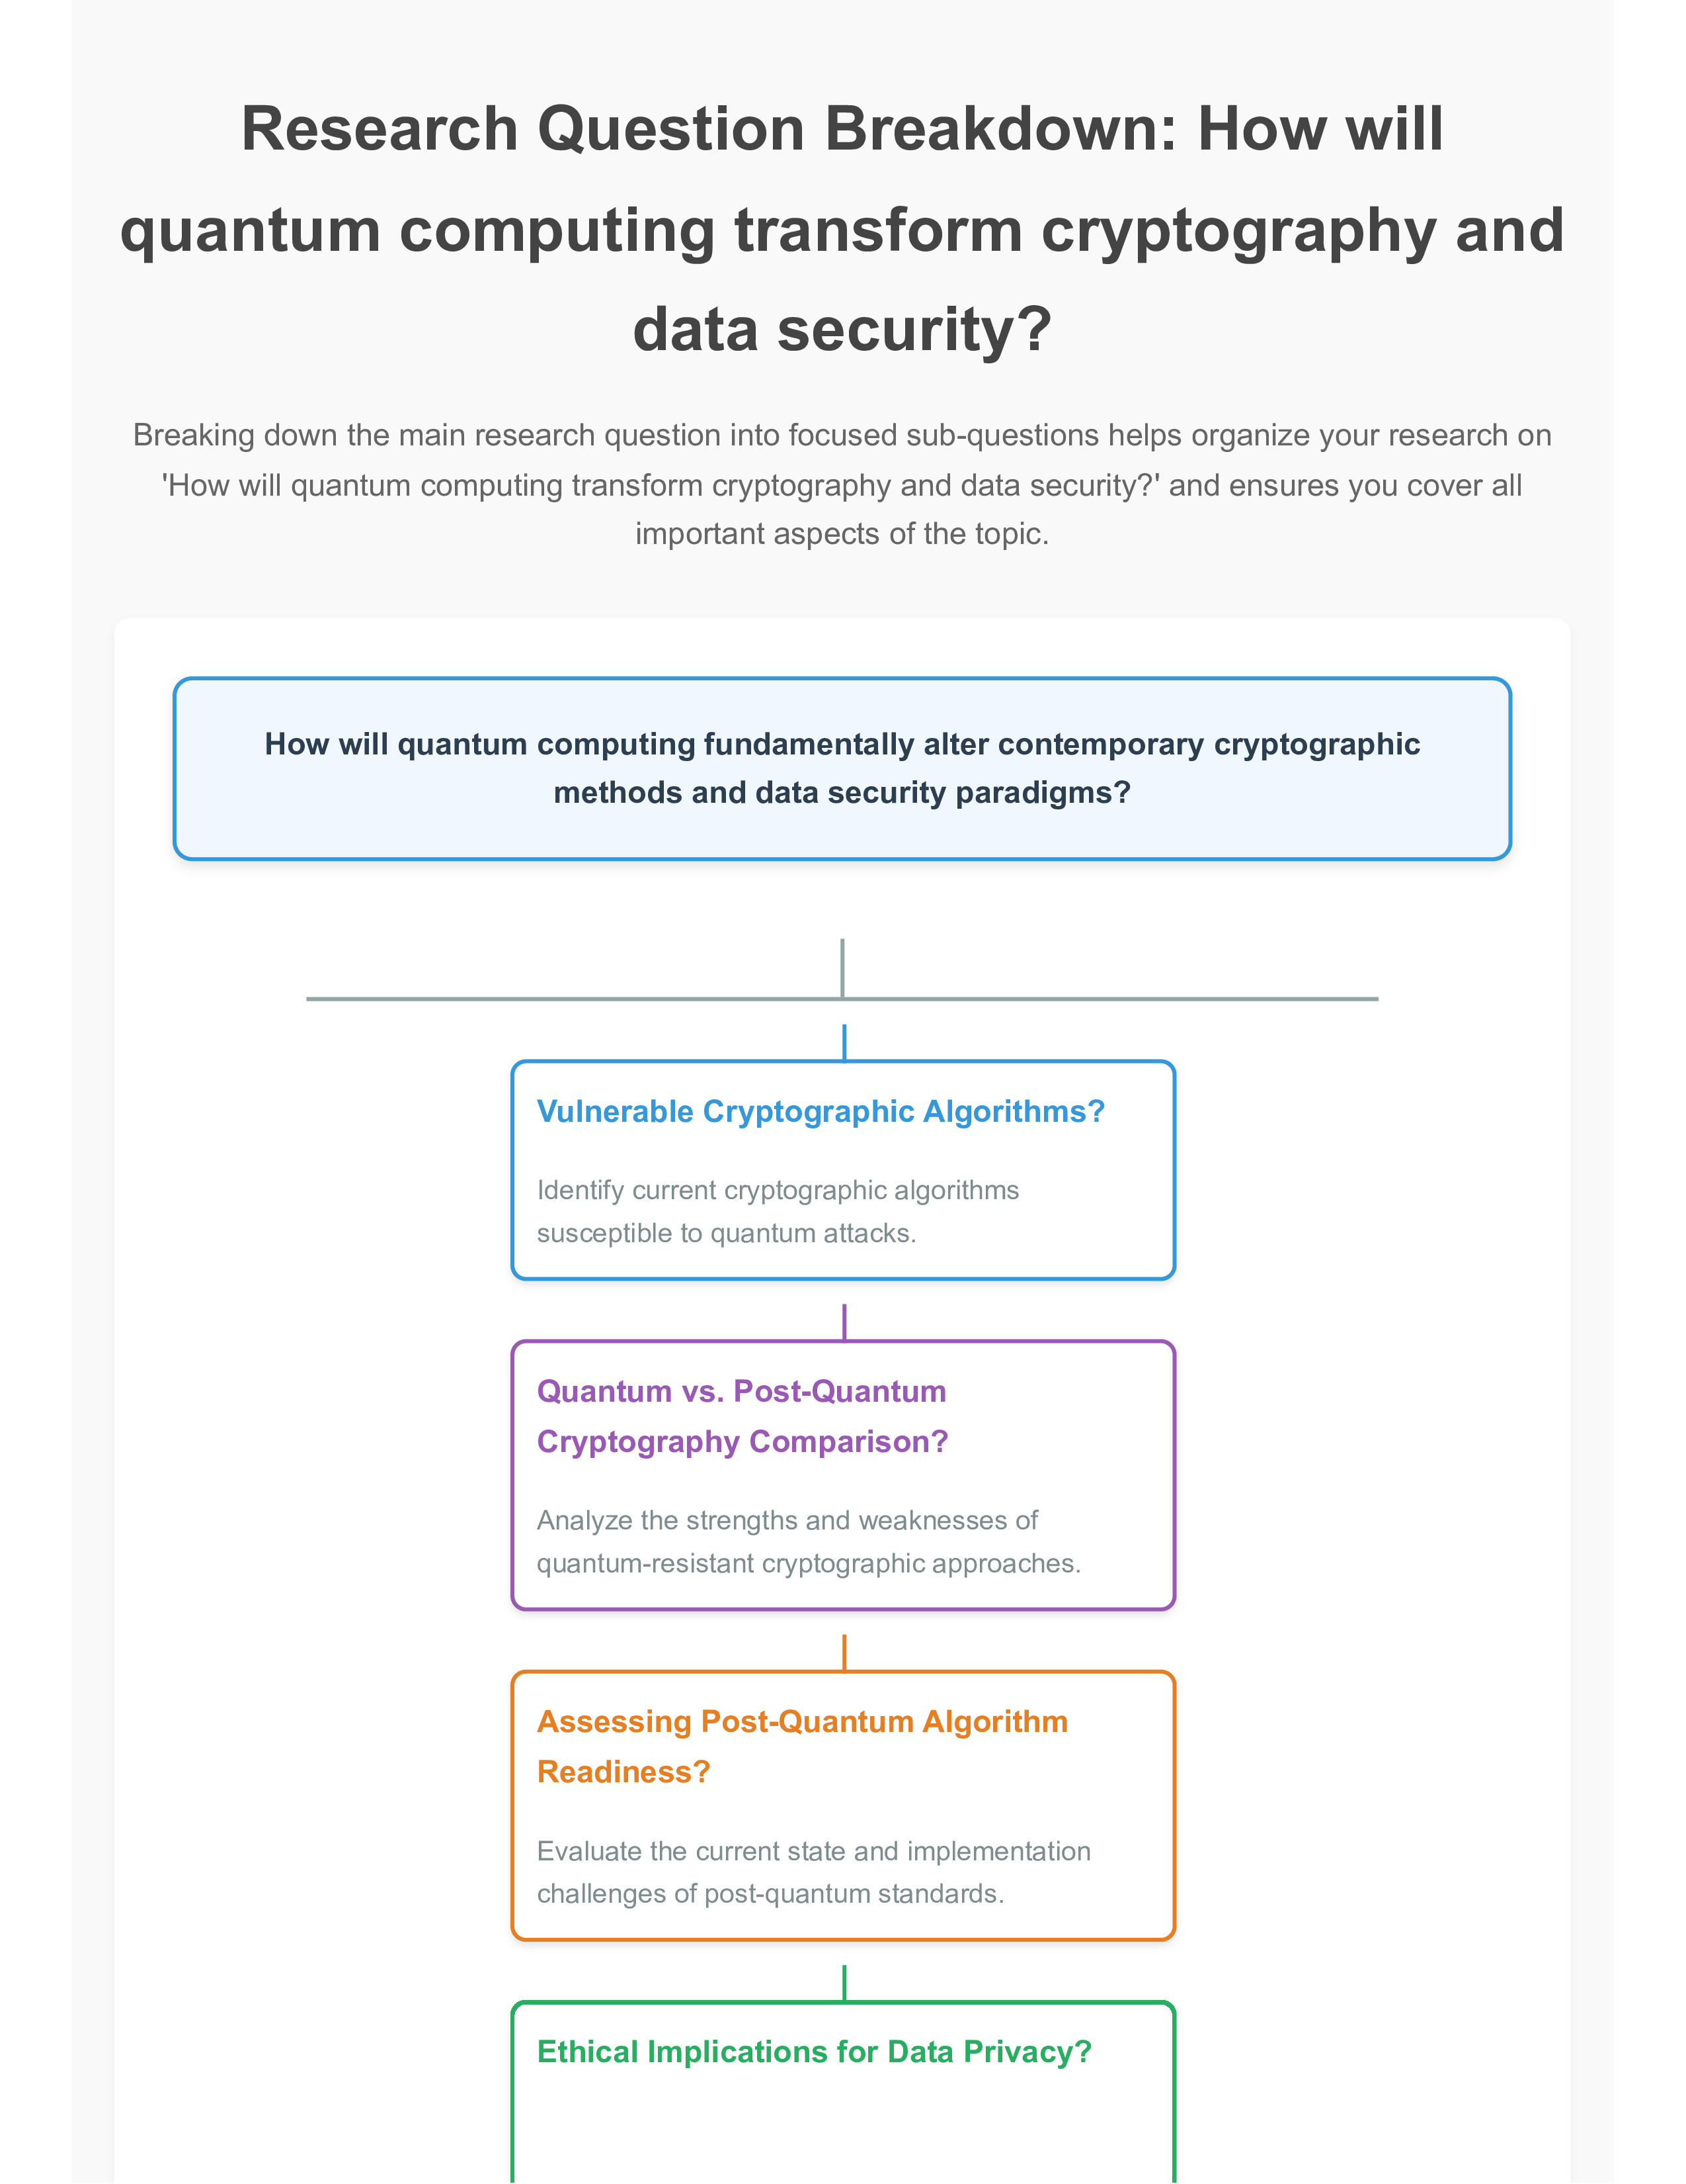
Figure: Diagram 2 (Question Breakdown)
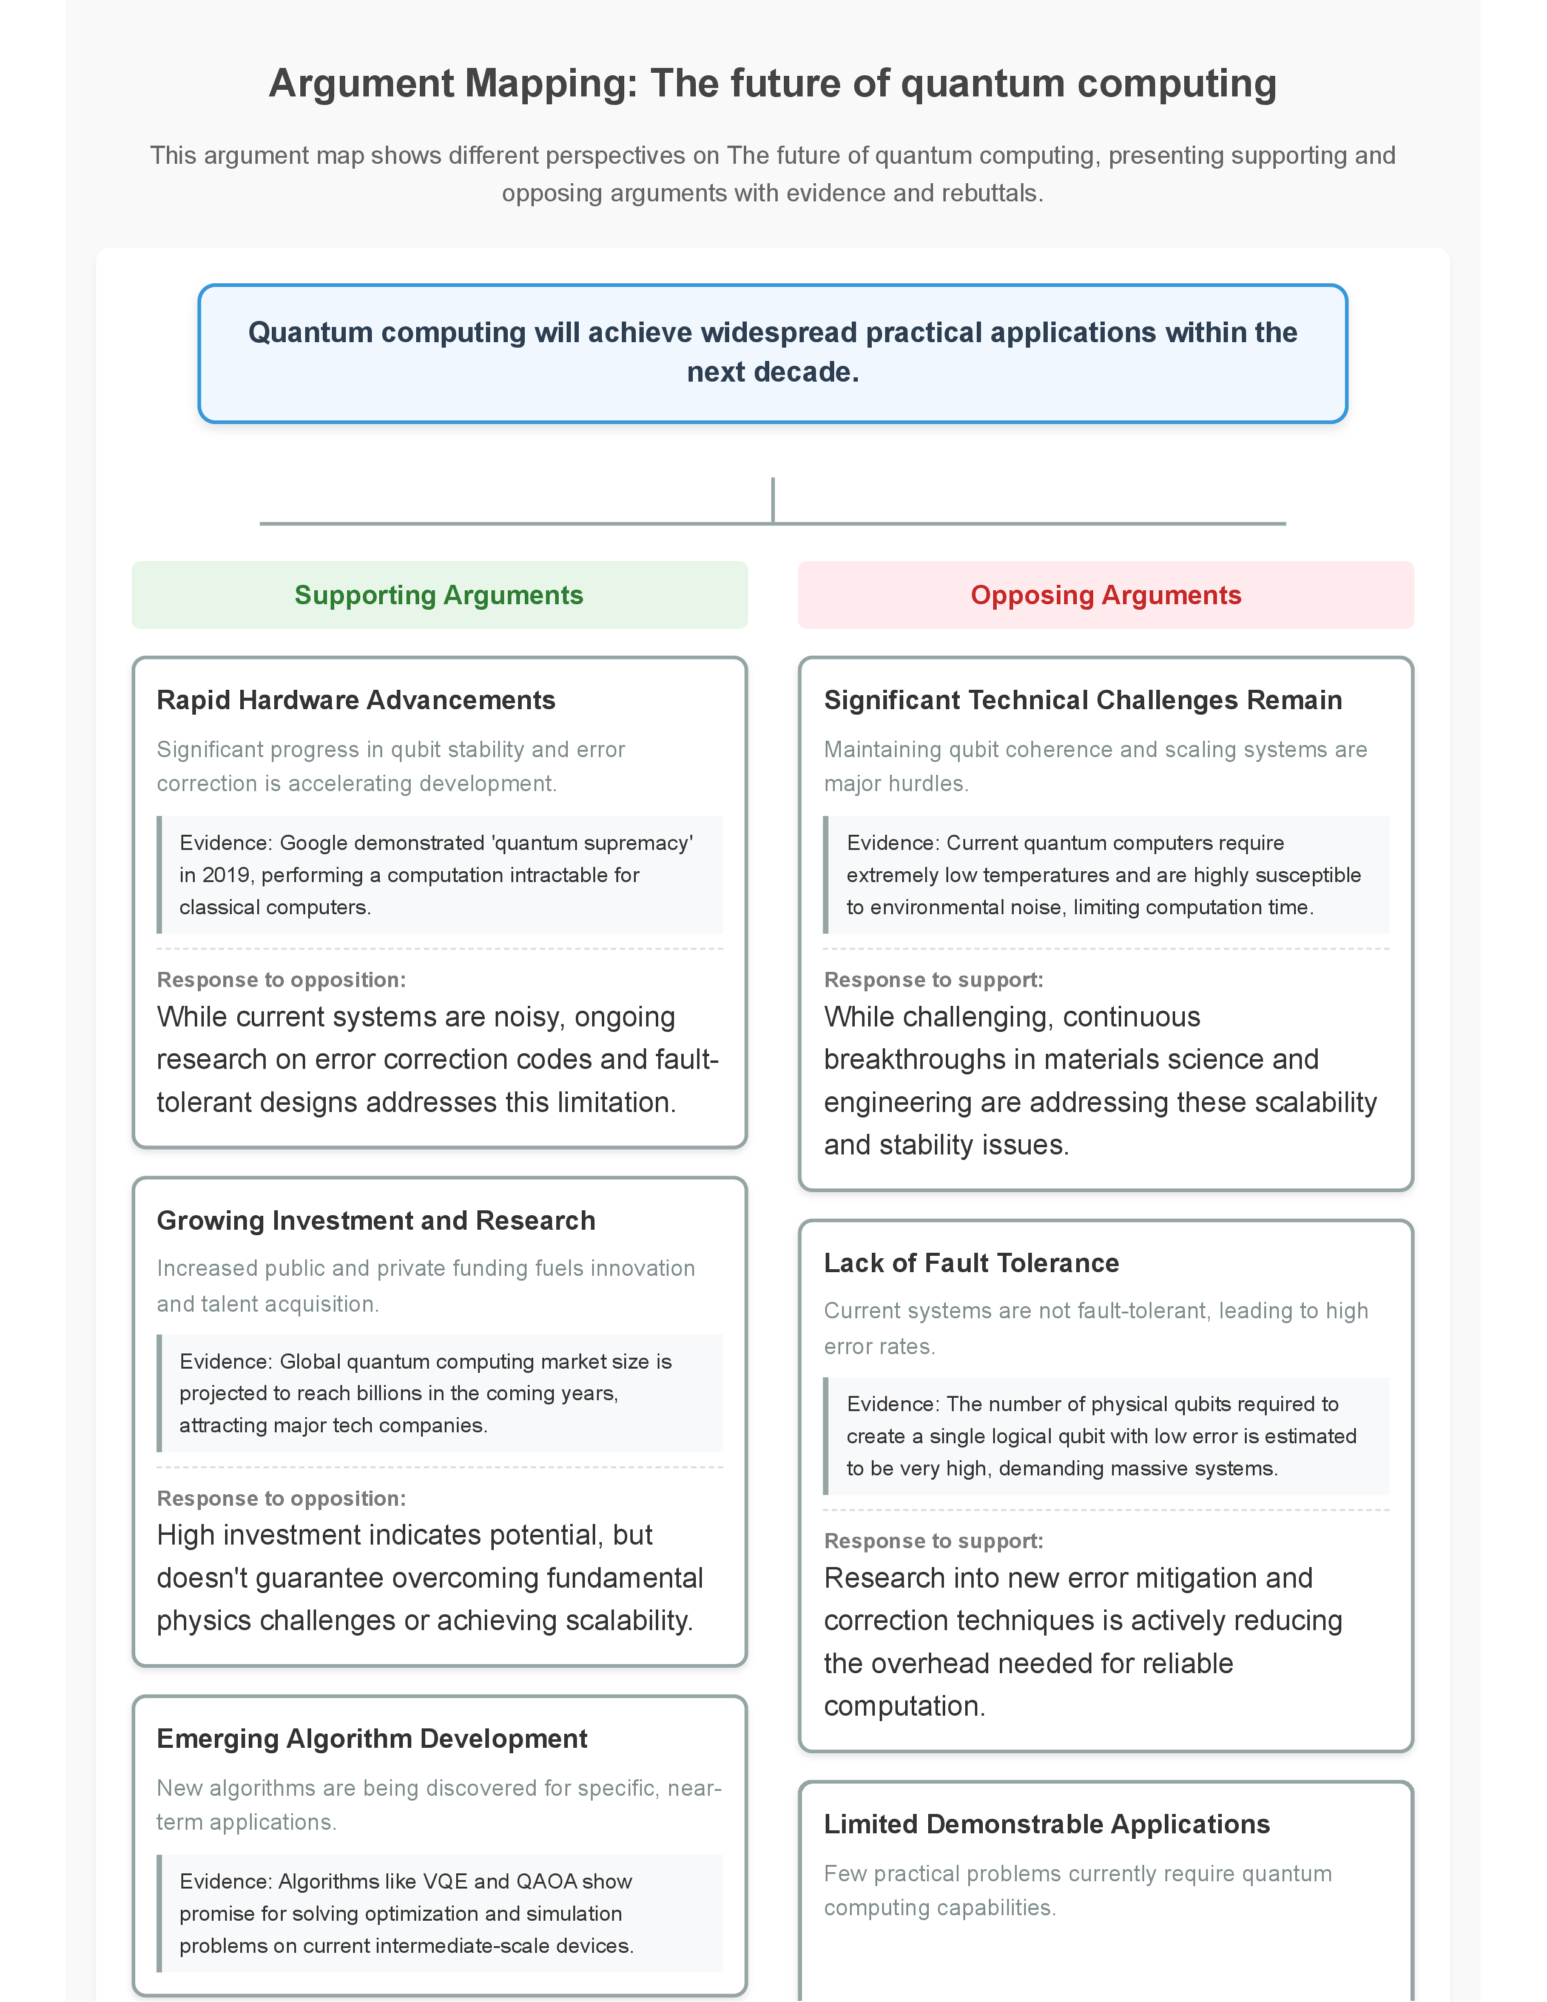
Figure: Diagram 3 (Argument Mapping)

