Woosoo Restaurant Operations And Handover Manual
Deployment, operations, troubleshooting, rollback, and acceptance guide
Prepared: 2026-05-22
Scope: Restaurant production LAN
Deliverable: DOCX handover manual with screenshot placeholders
Operator Safety
This manual is documentation-only. It does not change app code, Docker behavior, API contracts, or order logic. Never expose secrets in screenshots or chat.

Network Item | Restaurant Value
Woosoo server/Pi public host | 192.168.1.31
Krypton Woosoo PC / POS host | 192.168.1.32
Krypton subnet mask | 255.255.255.0
Krypton gateway | 192.168.1.1
POS database | krypton_woosoo
POS database port | 2121

Source of truth: Use this restaurant manual and the platform-root deployment docs for handover. Do not copy non-restaurant values from older examples.

1. Business Requirements
- Restaurant ordering must run on the local LAN during normal service.
- Backend owns truth: Woosoo Nexus owns pricing, packages, sessions, orders, POS/Krypton integration, realtime events, and print events.
- The Tablet Ordering PWA sends customer intent only and must not send pricing, tax, totals, POS mapping, or backend state.
- The Print Bridge proves last-mile printer outcome through heartbeat, reserve, ACK, and failed flows.
- Operators need repeatable deployment, log checking, troubleshooting, rollback, and handover acceptance steps.
- Customer-facing screens must never show raw technical errors.

2. Restaurant Network And System Specifications
Specification | Value
Woosoo server/Pi public host | 192.168.1.31
Krypton Woosoo PC / POS host | 192.168.1.32
Krypton subnet mask | 255.255.255.0
Krypton gateway | 192.168.1.1
POS database | krypton_woosoo
POS database port | 2121

POS Port Lock
Restaurant deployment uses POS database port 2121. Confirm this value in the live restaurant config before cutover and do not substitute older sample ports.

Service | Published Endpoint | Purpose
Nexus admin/API | https://192.168.1.31 | Admin UI and backend API
Tablet PWA | https://192.168.1.31:4443 | Customer tablet app
Reverb WebSocket | wss://192.168.1.31/app/{REVERB_APP_KEY} | Realtime events through nginx
Krypton POS DB | 192.168.1.32:2121 | External POS database connection

3. Generated Diagrams
Restaurant network topology
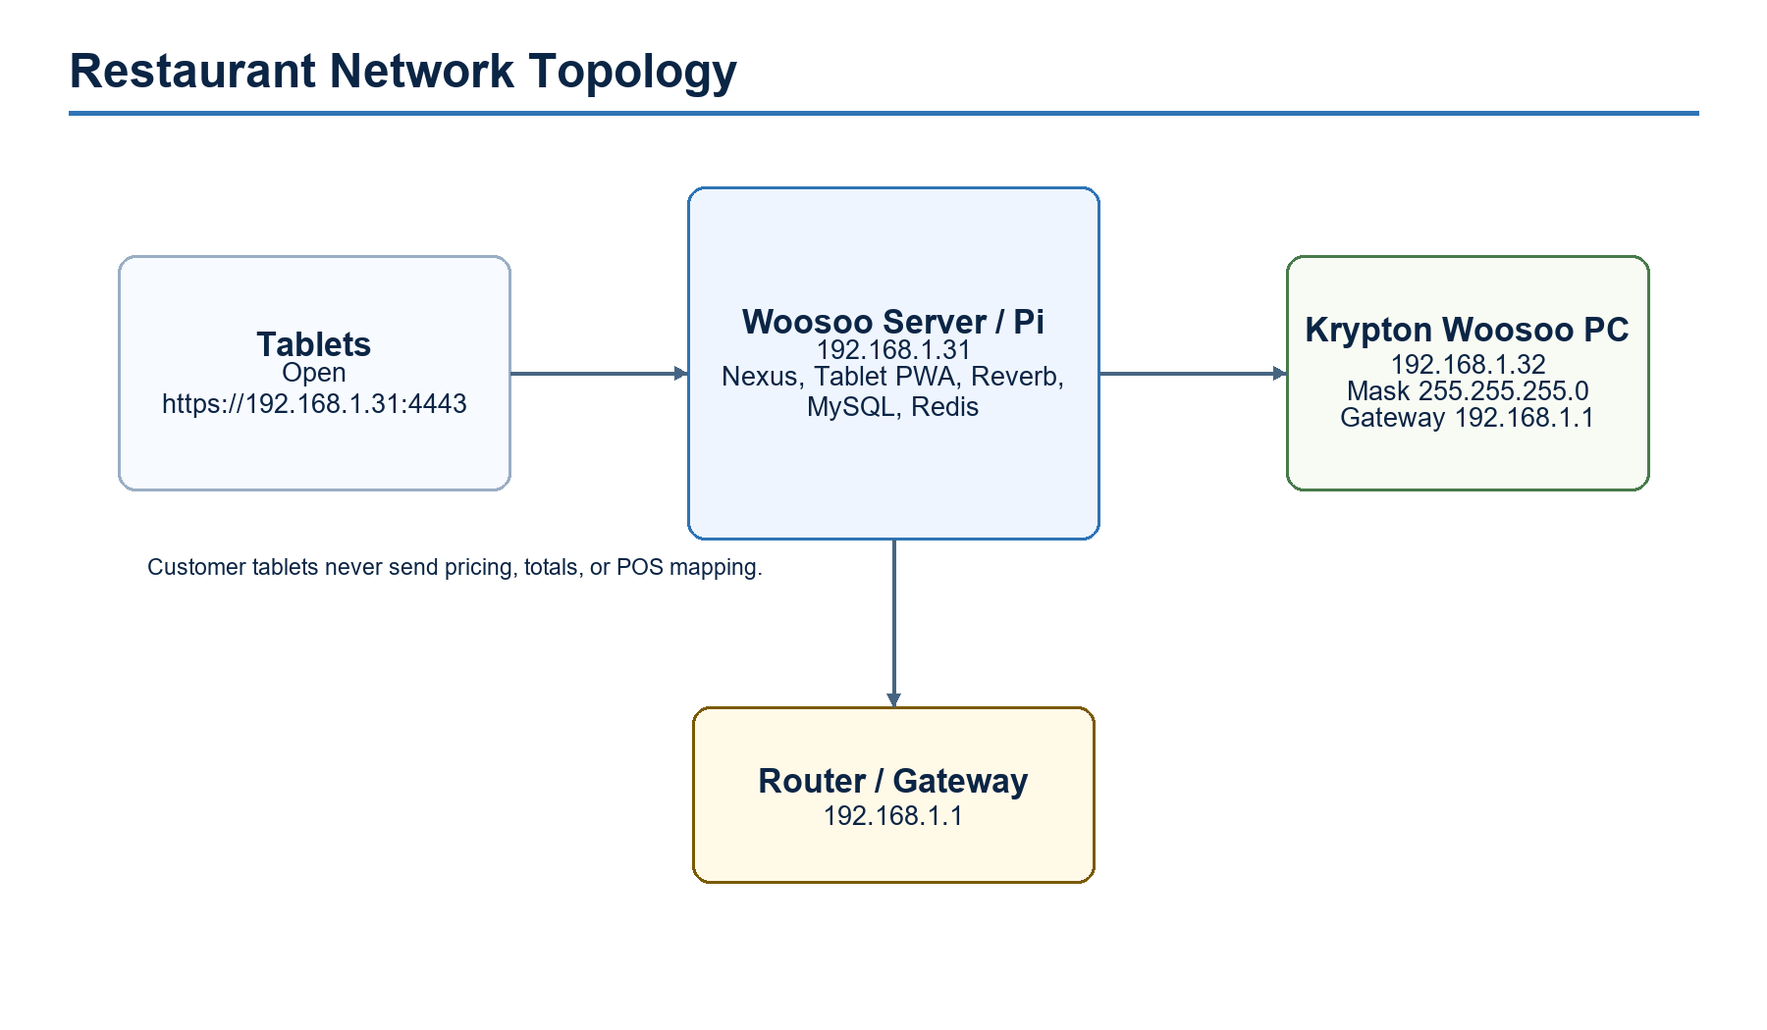

Application responsibility map
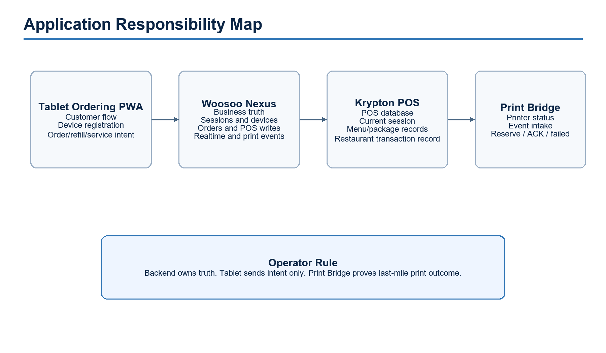

Order flow
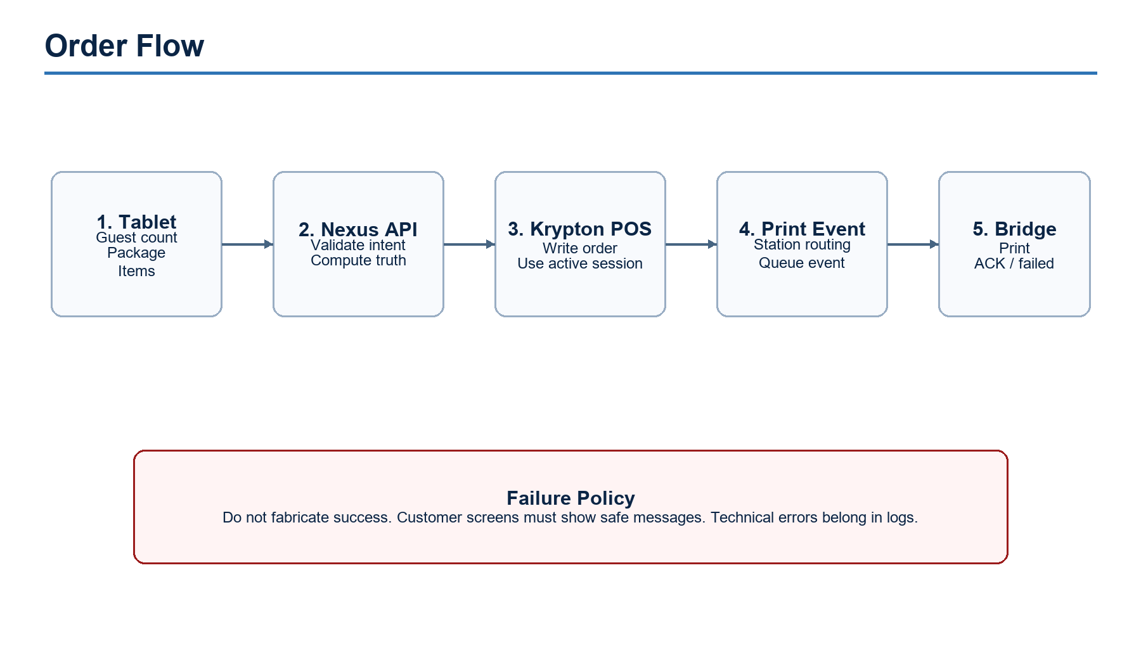

Deployment and redeployment workflow
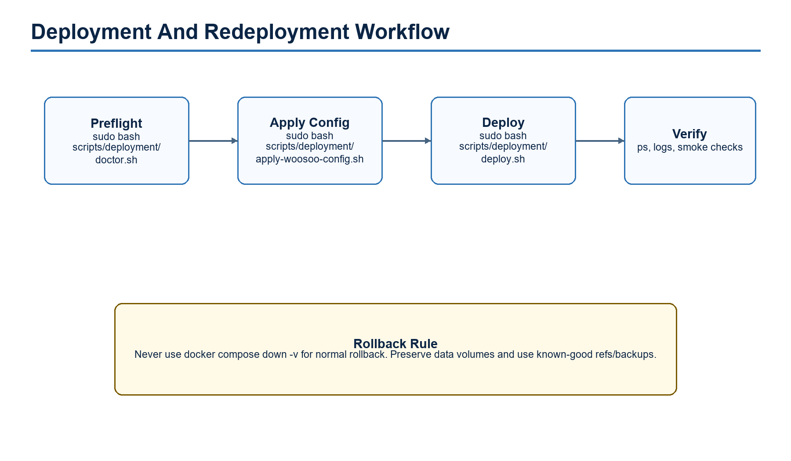

4. App Manuals

Woosoo Nexus
- Purpose: Laravel admin panel, backend API, POS/Krypton integration, sessions, orders, Reverb, and print events.
- Operators use it for device setup, order monitoring, menu/package management, and operational checks.
- Check logs first in app, nginx, reverb, mysql, and redis before changing configuration.

Tablet Ordering PWA
- Purpose: customer-facing tablet ordering flow.
- Flow: welcome, device registration/settings, guest count, package selection, menu/cart, review, submit, in-session refill/service request.
- Tablet sends intent only; backend computes truth.
- Installed tablets update after deployment through service-worker/build-info checks; staff may force update from settings when needed.

Woosoo Print Bridge
- Purpose: Android relay for actual printer dispatch.
- The bridge reports heartbeat and acknowledges print outcome.
- Print lifecycle is reserve, ack, or failed; retry must not create duplicate physical prints.

Krypton Woosoo PC / POS
- Purpose: external POS database and restaurant transaction record.
- Static IPv4 must be set to 192.168.1.32 with mask 255.255.255.0 and gateway 192.168.1.1.
- Connectivity must be verified before deployment acceptance.

Platform Docker Stack
- Purpose: runtime orchestration from /opt/woosoo/woosoo-platform.
- compose.yaml is the runtime authority.
- Use the platform-root compose command with --env-file ./woosoo-nexus/.env.

5. How To Navigate The Apps

Woosoo Nexus Admin
After login, use the left sidebar. Admin users see Main, Analytics, and Configuration groups.
Group | Pages | When to use
Main | Dashboard, Orders, POS, Menus, Packages, User Management, Devices, Service Requests | Daily operations, device setup, order monitoring, staff/user work, menu/package updates
Analytics | Reports, Daily Sales, Hourly Sales, Guest Count, Menu Items, Order Status, Print Audit, Discount & Tax | End-of-day checks, sales analysis, print audit, guest and menu reporting
Configuration | Branches, Access Control, Accessibility, Event Logs, Reverb Service, Monitoring | System setup, role/permission control, audit logs, realtime health, queue/database checks

- Use Dashboard for the live overview.
- Use Orders for live orders and order history.
- Use Devices for tablet and relay setup.
- Use Monitoring for queue, database, and Reverb health.
- Use Manual for the in-app guide library.
- Use POS for POS-specific terminal, table, and order inspection.

Tablet Ordering PWA
The customer-facing tablet path is:
- Open the welcome screen at /.
- If the tablet is not registered, open Settings from the gear icon, enter or create the PIN, and complete registration.
- Tap Begin the Feast.
- Select guest count on /order/start.
- Choose a dining package on /order/packageSelection.
- Browse meats, sides, desserts, and drinks on /menu.
- Open the order summary and continue to /order/review.
- Submit the order; the app sends POST /api/devices/create-order.
- Use /order/in-session for submitted items, refills, service requests, and session status.
- When the session ends, /order/session-ended returns the tablet toward the welcome screen for the next table.
Staff-only tablet maintenance
Tablet settings live under /settings. The /sw-reset route is an emergency same-origin reset path and should be used only for dedicated-origin recovery when normal settings maintenance cannot refresh the active tablet app.

6. Directory Structure And Common Commands
/opt/woosoo/woosoo-platform/
compose.yaml
docker/
certs/
nginx/
mysql/
php/
scripts/deployment/
woosoo-nexus/
tablet-ordering-pwa/
/etc/woosoo/woosoo.env

Navigation
cd /opt/woosoo/woosoo-platform
pwd
ls -la
cd woosoo-nexus
cd ../tablet-ordering-pwa
cd ..

Docker Status And Logs
docker compose --env-file ./woosoo-nexus/.env -f compose.yaml ps
docker compose --env-file ./woosoo-nexus/.env -f compose.yaml logs --tail=100 app
docker compose --env-file ./woosoo-nexus/.env -f compose.yaml logs --tail=100 nginx
docker compose --env-file ./woosoo-nexus/.env -f compose.yaml logs --tail=100 reverb
docker compose --env-file ./woosoo-nexus/.env -f compose.yaml logs --tail=100 mysql redis

Deployment Commands
sudo bash scripts/deployment/doctor.sh
sudo bash scripts/deployment/apply-woosoo-config.sh
sudo bash scripts/deployment/deploy.sh

Smoke Checks
ping 192.168.1.32
curl -k https://192.168.1.31
curl -k https://192.168.1.31:4443/build-info.json
docker compose --env-file ./woosoo-nexus/.env -f compose.yaml exec -T app php artisan route:list
docker compose --env-file ./woosoo-nexus/.env -f compose.yaml exec -T app php artisan config:clear

7. Operational Workflows

First-Time Restaurant Setup
- Set Krypton Woosoo PC IPv4 to the required restaurant values.
- Confirm Woosoo server/Pi is reachable at 192.168.1.31.
- Confirm /etc/woosoo/woosoo.env exists and contains restaurant production values with secrets hidden from screenshots.
- Run deployment doctor and resolve all blocking errors.
- Apply config, deploy, then verify Nexus, Tablet PWA, POS, Reverb, and print flow.

Daily Startup Check
- Run compose ps and confirm expected services are running.
- Open Nexus admin and Tablet PWA.
- Ping the POS host.
- Review app, nginx, reverb, mysql, and redis logs for blockers.
- Confirm Print Bridge is online before service starts.

Redeployment
- Run deployment doctor.
- Confirm no uncommitted emergency changes are present on deployed repos.
- Run deploy.sh from platform root.
- Check service health and build-info.
- Run final acceptance checks.

Rollback
- Preserve Docker volumes. Do not use down -v for normal rollback.
- Return app repos to the previous known-good refs.
- Rebuild and start only the affected services when possible.
- Verify Nexus, Tablet PWA, POS connectivity, Reverb, and print flow again.

8. Screenshot Placeholders
SCREENSHOT PLACEHOLDER
Windows adapter list
Proof required: Active Ethernet adapter is selected on the Krypton Woosoo PC.

SCREENSHOT PLACEHOLDER
Krypton PC IPv4 properties
Proof required: IPv4 shows IP 192.168.1.32, mask 255.255.255.0, gateway 192.168.1.1.

SCREENSHOT PLACEHOLDER
Restaurant environment config
Proof required: /etc/woosoo/woosoo.env shows restaurant values and hides secrets.

SCREENSHOT PLACEHOLDER
Docker service status
Proof required: docker compose ps shows expected services running or healthy.

SCREENSHOT PLACEHOLDER
Nexus admin
Proof required: Nexus opens at https://192.168.1.31.

SCREENSHOT PLACEHOLDER
Tablet PWA
Proof required: Tablet app opens at https://192.168.1.31:4443.

SCREENSHOT PLACEHOLDER
POS connectivity
Proof required: Ping or equivalent check reaches 192.168.1.32.

SCREENSHOT PLACEHOLDER
Print Bridge
Proof required: Bridge status screen shows printer/relay online before service.

9. Troubleshooting
Symptom | First Check | Command / Action
Nexus admin unreachable | nginx and app logs | docker compose --env-file ./woosoo-nexus/.env -f compose.yaml logs --tail=100 nginx app
Tablet app unreachable | tablet endpoint | curl -k https://192.168.1.31:4443/build-info.json
POS connection fails | Krypton PC network | ping 192.168.1.32
Realtime/WebSocket fails | reverb and app logs | docker compose --env-file ./woosoo-nexus/.env -f compose.yaml logs --tail=100 reverb app
MySQL/Redis unhealthy | service logs | docker compose --env-file ./woosoo-nexus/.env -f compose.yaml logs --tail=100 mysql redis
Tablet stuck on old build | build-info | curl -k https://192.168.1.31:4443/build-info.json
Orders do not print | Bridge status and print events | Check bridge app and Nexus print-event logs
Deployment script fails | preflight config | sudo bash scripts/deployment/doctor.sh

10. Final Handover Acceptance
- [ ] Nexus reachable at https://192.168.1.31.
- [ ] Tablet PWA reachable at https://192.168.1.31:4443.
- [ ] Krypton POS host 192.168.1.32 reachable.
- [ ] A test order reaches POS.
- [ ] Print flow verified by bridge ACK or operator-confirmed print.
- [ ] Logs reviewed with no unresolved deployment blockers.
- [ ] Operator knows where /etc/woosoo/woosoo.env, compose.yaml, docker/certs, and scripts/deployment live.
- [ ] Rollback path and backup location explained.
- [ ] Screenshots inserted or queued for insertion without exposing secrets.

