Steps to follow to get access to source code

1. Install virtual box and then ubuntu 20.4 inside virtualbox
2. Type this command in the Ubuntu terminal:
   1. ssh-keygen -t ed25519 -C "your_email@example.com"
3. Then follow the steps in this link:<https://docs.github.com/en/authentication/connecting-to-github-with-ssh/generating-a-new-ssh-key-and-adding-it-to-the-ssh-agent#adding-your-ssh-key-to-the-ssh-agent>
4. Then follow these 8 steps:<https://docs.github.com/en/authentication/connecting-to-github-with-ssh/adding-a-new-ssh-key-to-your-github-account>
5. Send mail to admin@omnirom.net requesting access to omnirom repositories.
6. Next, follow these steps:
   1. sudo apt install curl
   2. sudo apt-get install python-is-python3
   3. mkdir ~/bin
   4. curl https://storage.googleapis.com/git-repo-downloads/repo-1 > ~/bin/repo
   5. chmod a+x ~/bin/repo
   6. git config --global user.email "example@gmail.com”
   7. git config --global user.name "your username"
   8. mkdir omni-rom
   9. cd omni-rom
   10. python3 ~/bin/repo init -u git://github.com/omnirom/android.git -b android-11
   11. python3 ~/bin/repo sync -j4
   12. sudo apt-get install git-core gnupg flex bison build-essential zip curl zlib1g-dev gcc-multilib g++-multilib libc6-dev-i386 lib32ncurses5-dev x11proto-core-dev libx11-dev lib32z1-dev libgl1-mesa-dev libxml2-utils xsltproc unzip fontconfig kpartx sudo dosfstools rsync libncurses5 libssl-dev python3-mako unzip
   13. git clone https://github.com/omnirom/android_device_brcm_rpi4.git -b android-11 device/brcm/rpi4/
   14. git clone https://github.com/omnirom/proprietary_vendor_brcm.git -b android-11 vendor/brcm/
   15. export ROM_BUILDTYPE=WEEKLY
   16. export TEMPORARY_DISABLE_PATH_RESTRICTIONS=true
   17. export PRODUCT_EXCLUDE_EXTRA_PACKAGES=true
   18. source build/envsetup.sh
   19. breakfast rpi4 userdebug
   20. ls ~/.repo/local_manifests/
   21. If the above directory is not present: mkdir .repo/local_manifests/
   22. If it contains roomservice.xml, continue further or else manually add it to the folder.
       1. Manually copy roomservice.xml to .repo/local_manifests/
       2. python3 ~/bin/repo sync --force-sync -j4

*ctrl + H to show hidden files (useful in finding .repo)

*ctrl + R to search for previous commands easily

* 1. m -j4

#build should be completed in 5-6 hours

1. Create an Image by running the script (mk-raspi64-large-image-isana.sh). This is slightly technical, reach out to Isana incase of doubts.
   1. Variables IN_IMAGE_DIR, IN_BOOT_FILES and OUT_IMAGE_FILE need to be set to proper paths
   2. The loop device used must be numbered correctly. Run lsblk to find existing loop devices. The scripts in the directory point to loop13 and loop14.
2. Insert the SD card in the card reader and connect it to the machine (also make sure the sdcard is transferred to the Virtual Machine).

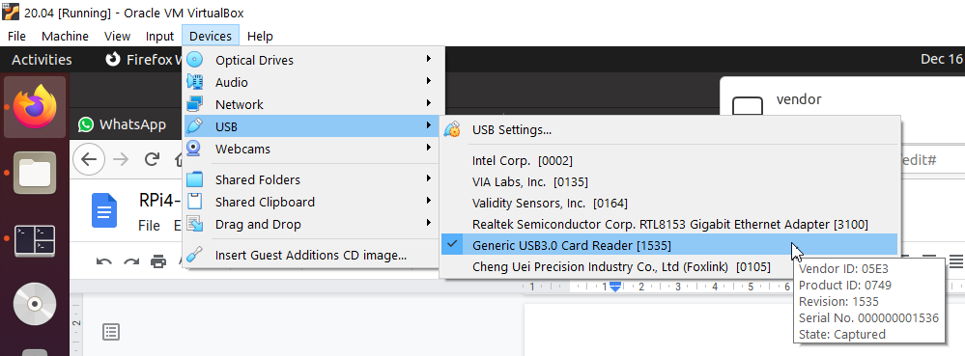  
  
Now you flash the image created in the above step into the sdcard

In this command carefully choose the sd card or else the main hard disk will be wiped out; never choose sda as that is the main hard disk in the system…

This is how your system looks without the sd card inserted

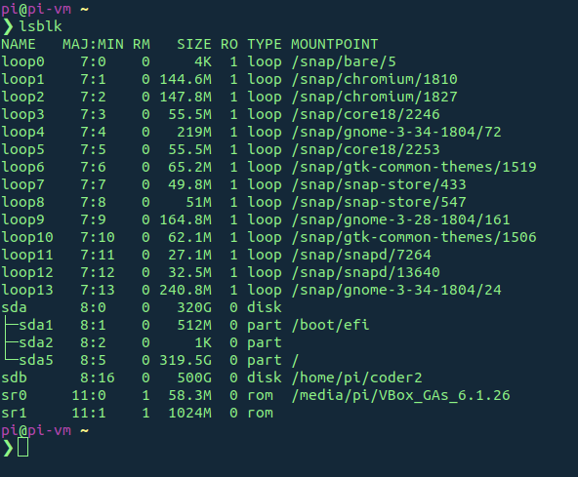

Insert the sdcard and your sd card will be named as sdb/sdc/sdd etc.,

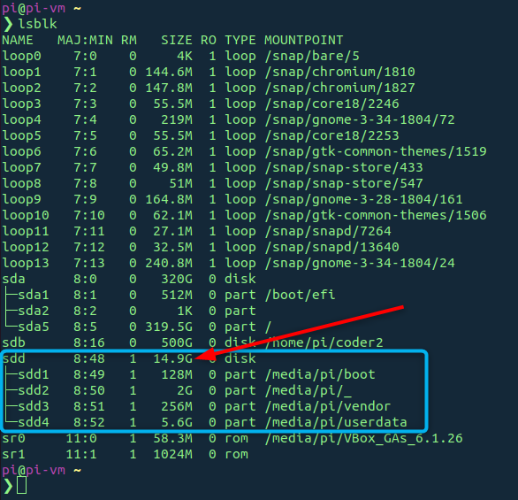

* 1. Then do this command   
     sudo dd if=~/omni-WEEKLY-13.12.2021-2120.img of=/dev/sdb bs=1M