# VBox setup steps

1. <https://download.virtualbox.org/virtualbox/6.1.30/Oracle_VM_VirtualBox_Extension_Pack-6.1.30.vbox-extpack> (download image in host system)
2. create a folder called vmshare in documents which contains a shell script (host system).
3. enable shared folders in VM and add the path of the above vmshare folder to the machine folder.
4. sudo mount -t vboxsf vmshare /mnt/vmshare

# VBox Settings

**Overall settings of the VBox :**

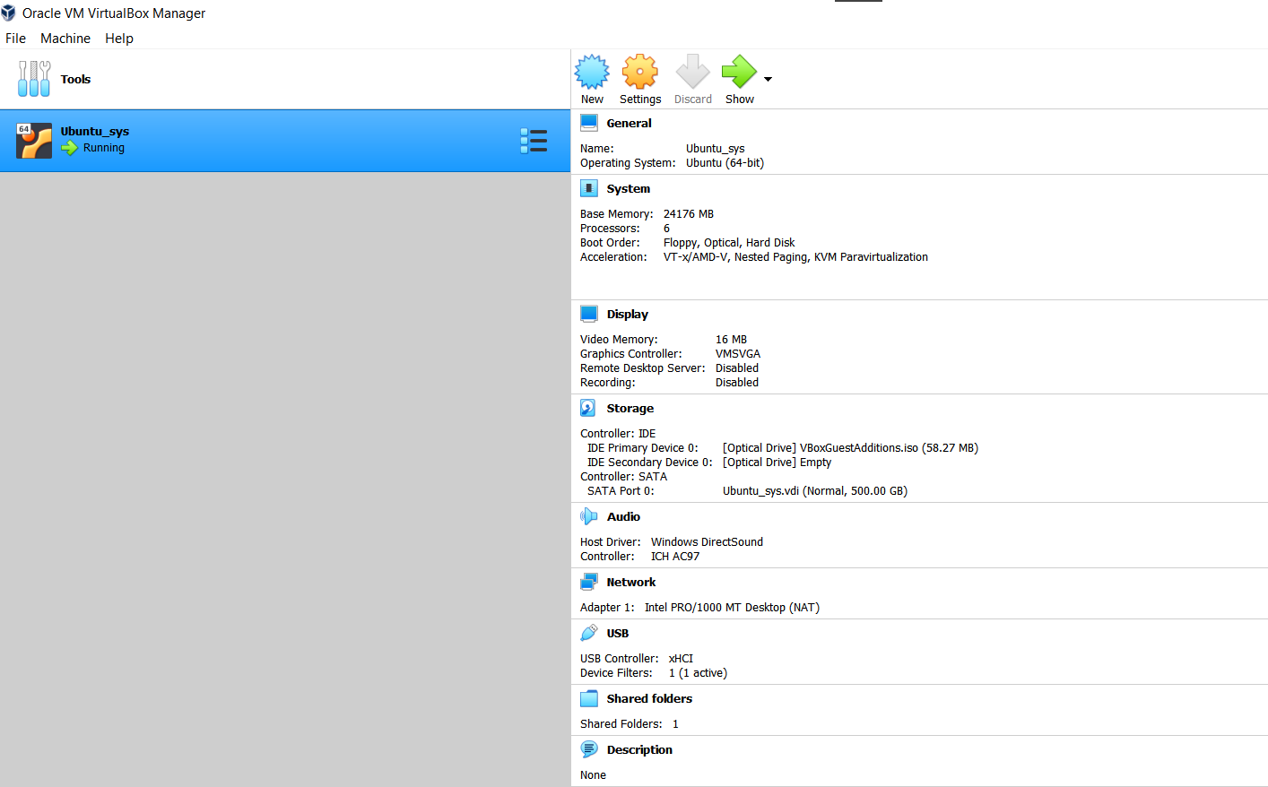

**RAM settings:** Set the RAM to be 24 GB

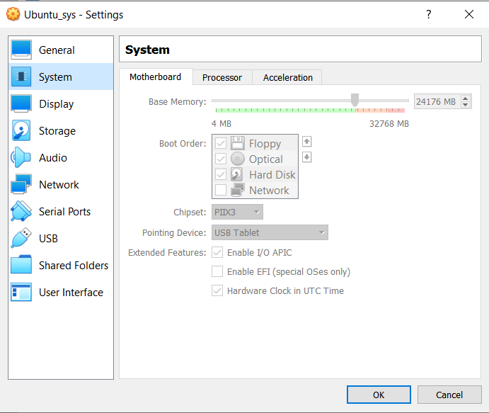

**Processor settings:** For a 12 CPU system set the no. of processors to be at 6

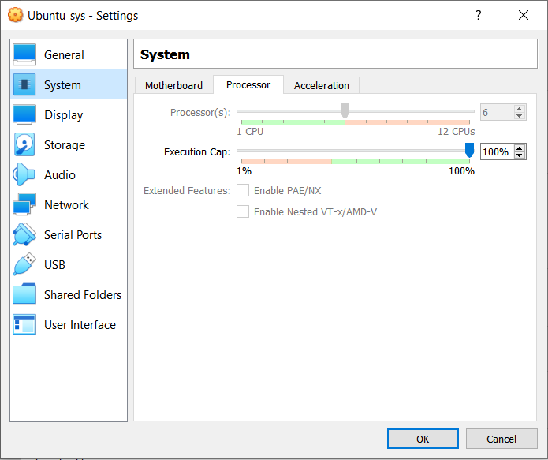

**Storage settings:**

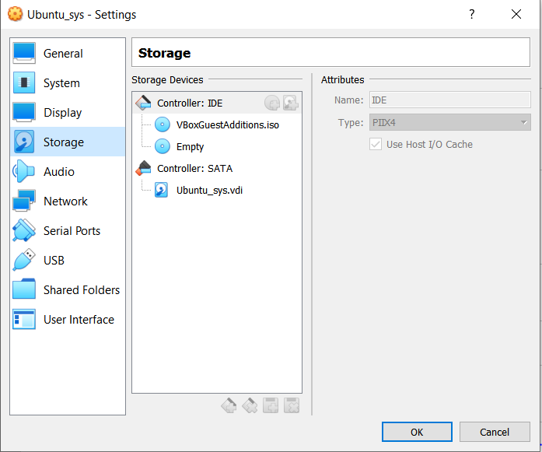

**USB settings:** Select the USB 3.0 (xCHI) controller

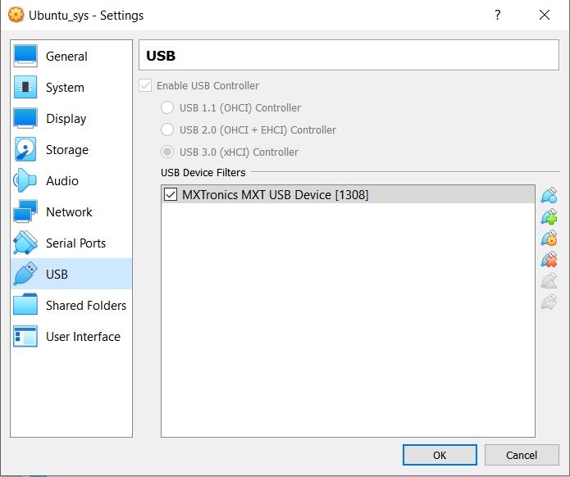

**Shared folder settings:** In Machine Folders, add the path of vmshare folder

