Homepage: <https://kumartech.pythonanywhere.com>  
  
Top Navigation - Menu (LearnersLeaf - Home, About Us, Find Tutor,   
  
**Banners Punchlines**

“Learn, Grow, and Succeed with Learnsleaf”  
“Empowering Students, Elevating Tutors”  
  
**Statistics:**  
9500+ subjects covered  
1500+ unique skills  
1000+ Languages

**Overview:**  
Welcome to Learnsleaf, your one-stop solution for both online and in-person learning! We offer personalized tutoring services from primary classes to degree level, across all streams, Academic Writing, Engineering, Arts, and more. We cater to every learner’s needs, whether you’re a student seeking academic guidance or someone looking to acquire a new skill, our platform connects you with top-notch tutors across 1000+ languages.

**About Learnsleaf:**  
At Learnsleaf, we’re dedicated to transforming education. Our mission is to connect students with the best tutors for academic and professional skill-building. Our expert tutors are rigorously selected to ensure only top-quality educators work with our students. Whether you're preparing for exams, improving your communication skills, or learning advanced programming, we have a tutor for every need.  
  
**Why Choose Us:**

* Easy tutor search: Find tutors with one click
* Customizable learning: Choose how you learn, online or offline
* Quality assurance: Only 55% of applicants are selected
* 24/7 support and learning resources

### **Find a Tutor**

Searching for the right tutor has never been easier! At Learnsleaf, our search feature allows you to browse tutors based on subject expertise, teaching style, and availability. Whether it’s online or in-person tutoring, we guarantee you’ll find the perfect match to help you excel.

**How It Works**:

* Search by subject or skill
* Browse tutor profiles with ratings
* Schedule sessions instantly
* Online and in-person options available

### **Find a Job**

Looking for a tutoring job? Learnsleaf connects you with students eager to learn. Whether you prefer online or in-person teaching, we offer flexible work options with competitive pay. Join our global network of educators and start making an impact today!

**What We Offer**:

* Access to a wide range of students
* Flexibility to teach online or in-person
* Competitive pay for your expertise
* Support in building your teaching profile

CTA: *Apply to Teach Now!*

### **Login**

Your learning journey starts here! Log in to access your personalized dashboard, manage your tutor sessions, and track your progress. If you're a tutor, log in to view student requests and schedule lessons.

**Features**:

* Seamless access to all subjects and sessions
* Real-time updates and notifications
* Simple interface for students and tutors

CTA: *Log in to Learn Now!*

### ***Assessment***

*At Learnsleaf, we believe in evaluating progress to ensure the best learning outcomes. We offer assessments across 9500+ subjects and 1500+ skills. Our assessments are tailored to test your knowledge, identify gaps, and provide insights for improvement.*

***Key Features****:*

* *Comprehensive subject coverage*
* *Instant feedback on performance*
* *Personalized reports to help you improve*

*CTA: Take an Assessment Now!*

Quality Check  
  
Tutor Request - Alignment Issue: https://kumartech.pythonanywhere.com/tutor_request  
  
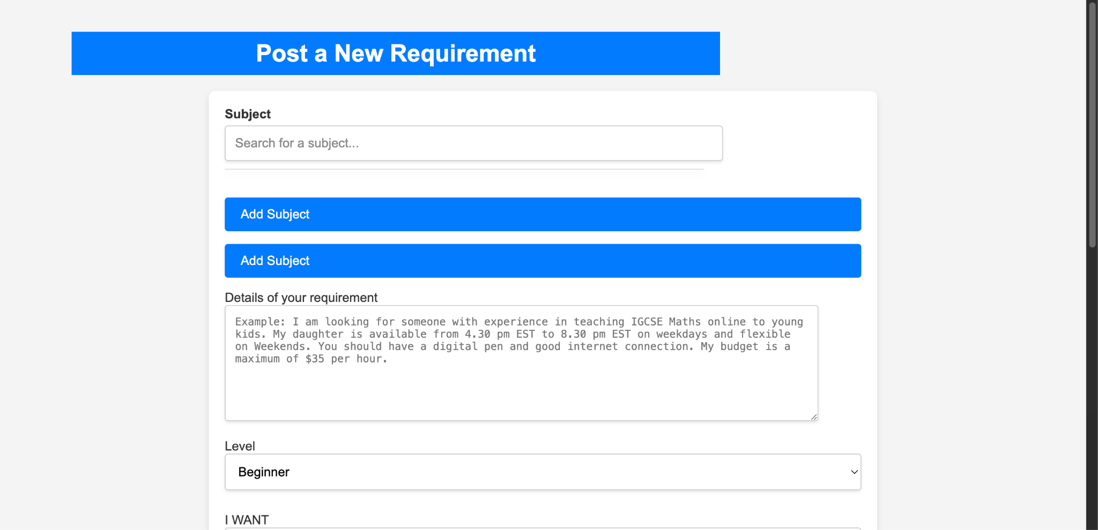

Post submitting requirement <https://kumartech.pythonanywhere.com/add_post/afshaa.akhtar@gmail.com> - The first letter should be caps  
  
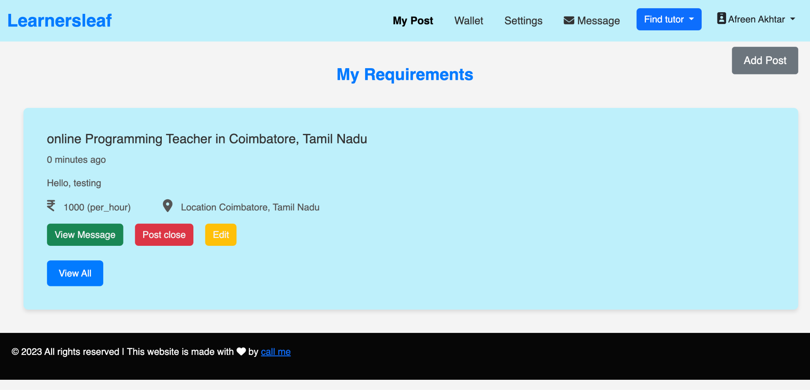

View Message - Inbox:  
The footer link should be aligned   
The Message should have been displayed as Inbox (refer Gmail)  
  
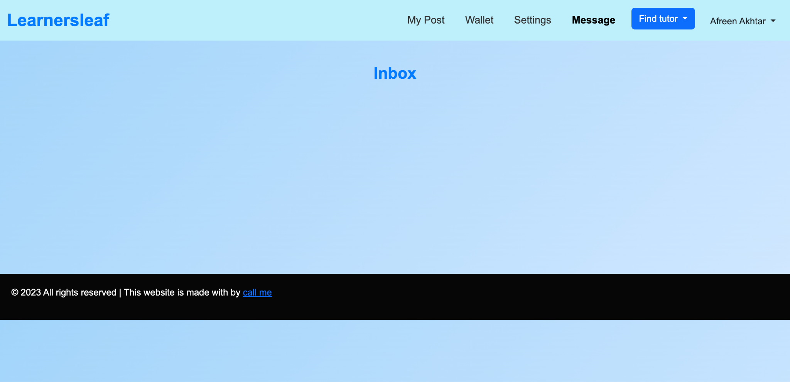

My Post: Post should be in caps the first letter

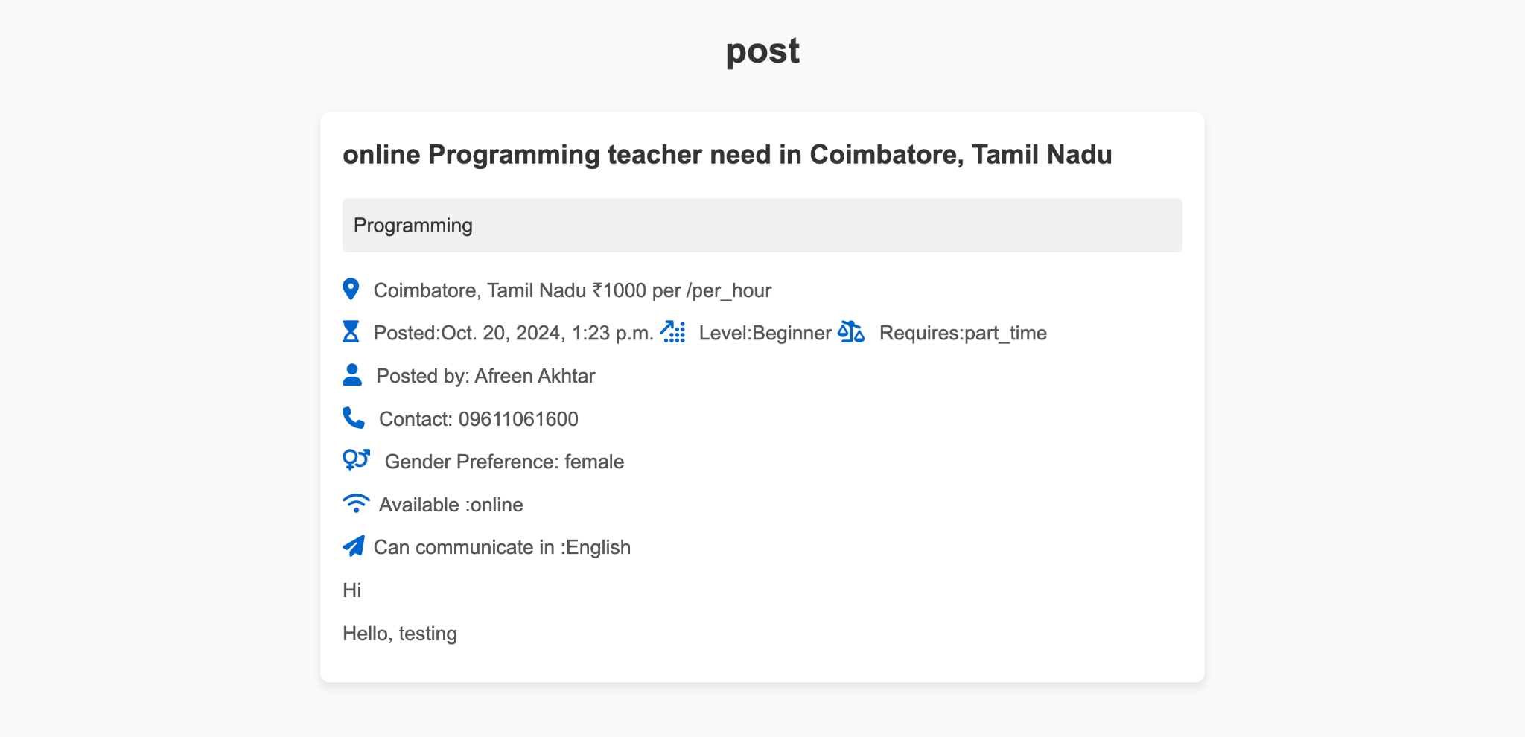

## online Programming teacher - Online ‘O’ should be in caps, teacher ‘t’ should be in caps There should be back button to go back to the dashboard

Homepage:

There should be a banner which talks about the Learnsleaf  
  
The search bar section should be little narrow as its taking too much space and not aligned

Statistics - can add the icons related  
  
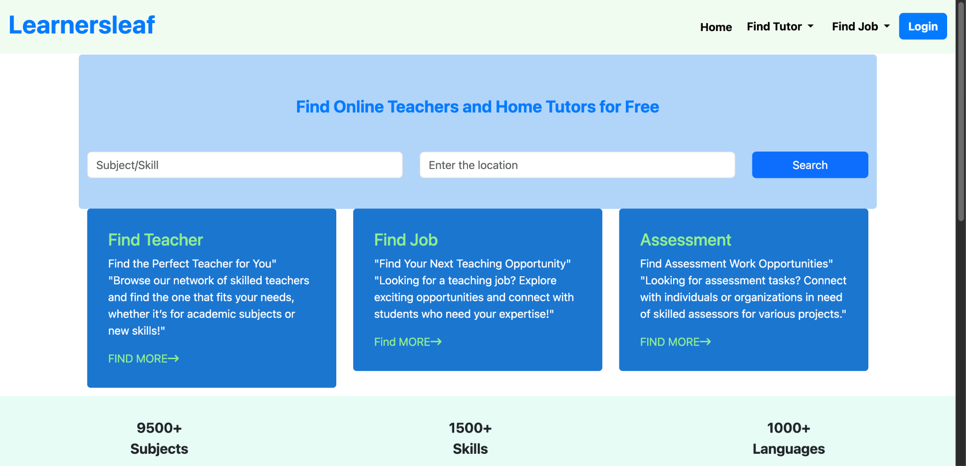

Experience Quality Teachers - Below this add some top Teacher details which can be presented in a slider

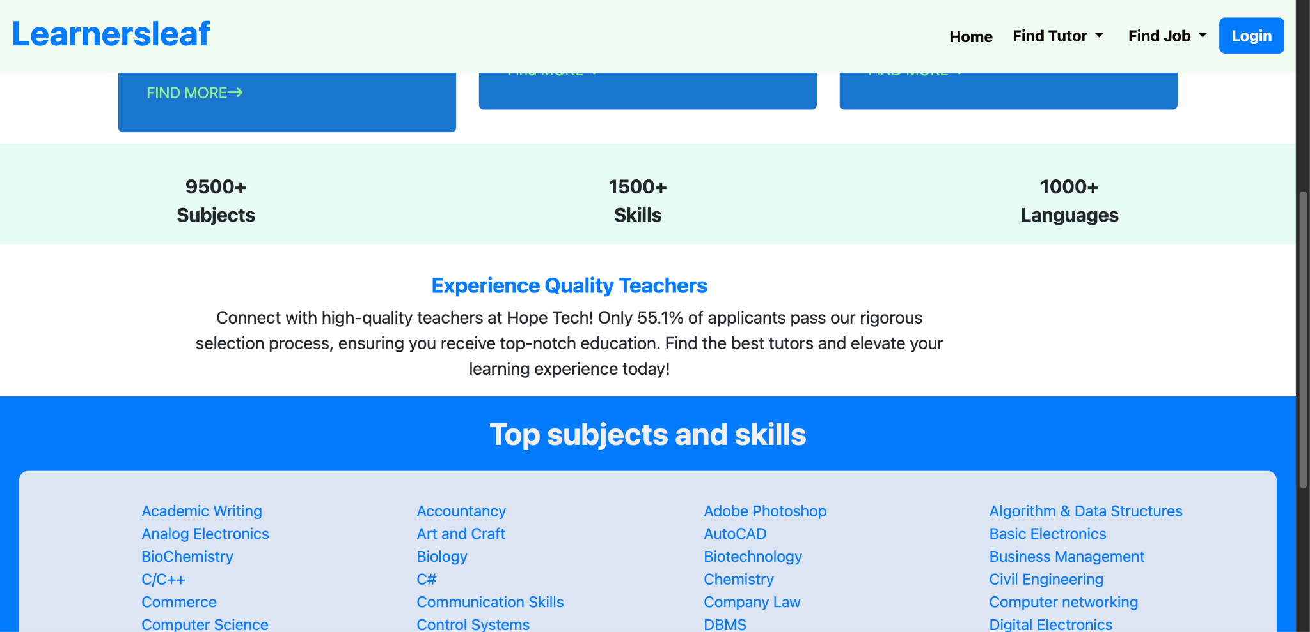

Top Subjects & Skills - the first letters should be caps

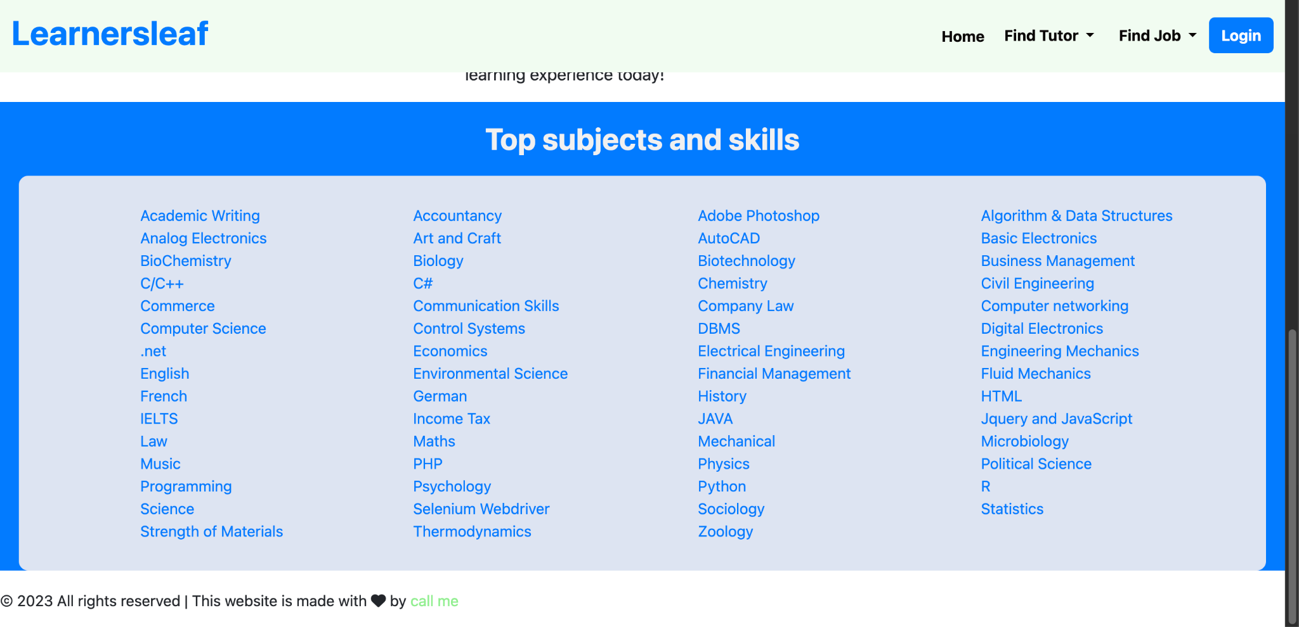

Below Top Subjects & Skills - Add a footer which includes the following:

Learsnleaf Logo in the left side

Home

About Us

Find a Tutor

Find a Job

Assessment

Contact Details:

Address

Phone Number

Email id

Form in the right as following:

Contact us Today

Name

Phone Number

Email id

Message

Header - When you click on learnsleaf it should take to homepage

Add another page as About us section

Assessment page is not opening

CTA homepage - Instead of Find More - make it as Learn More



Copyright should be 2024

Make a page for Contact us