|  |
| --- |
| cRITICAL ANALYSIS OF website features  sovereigntrade.co.uk |
| By Manzar Janjua |





**Issues with Backend (Admin Panel) -**

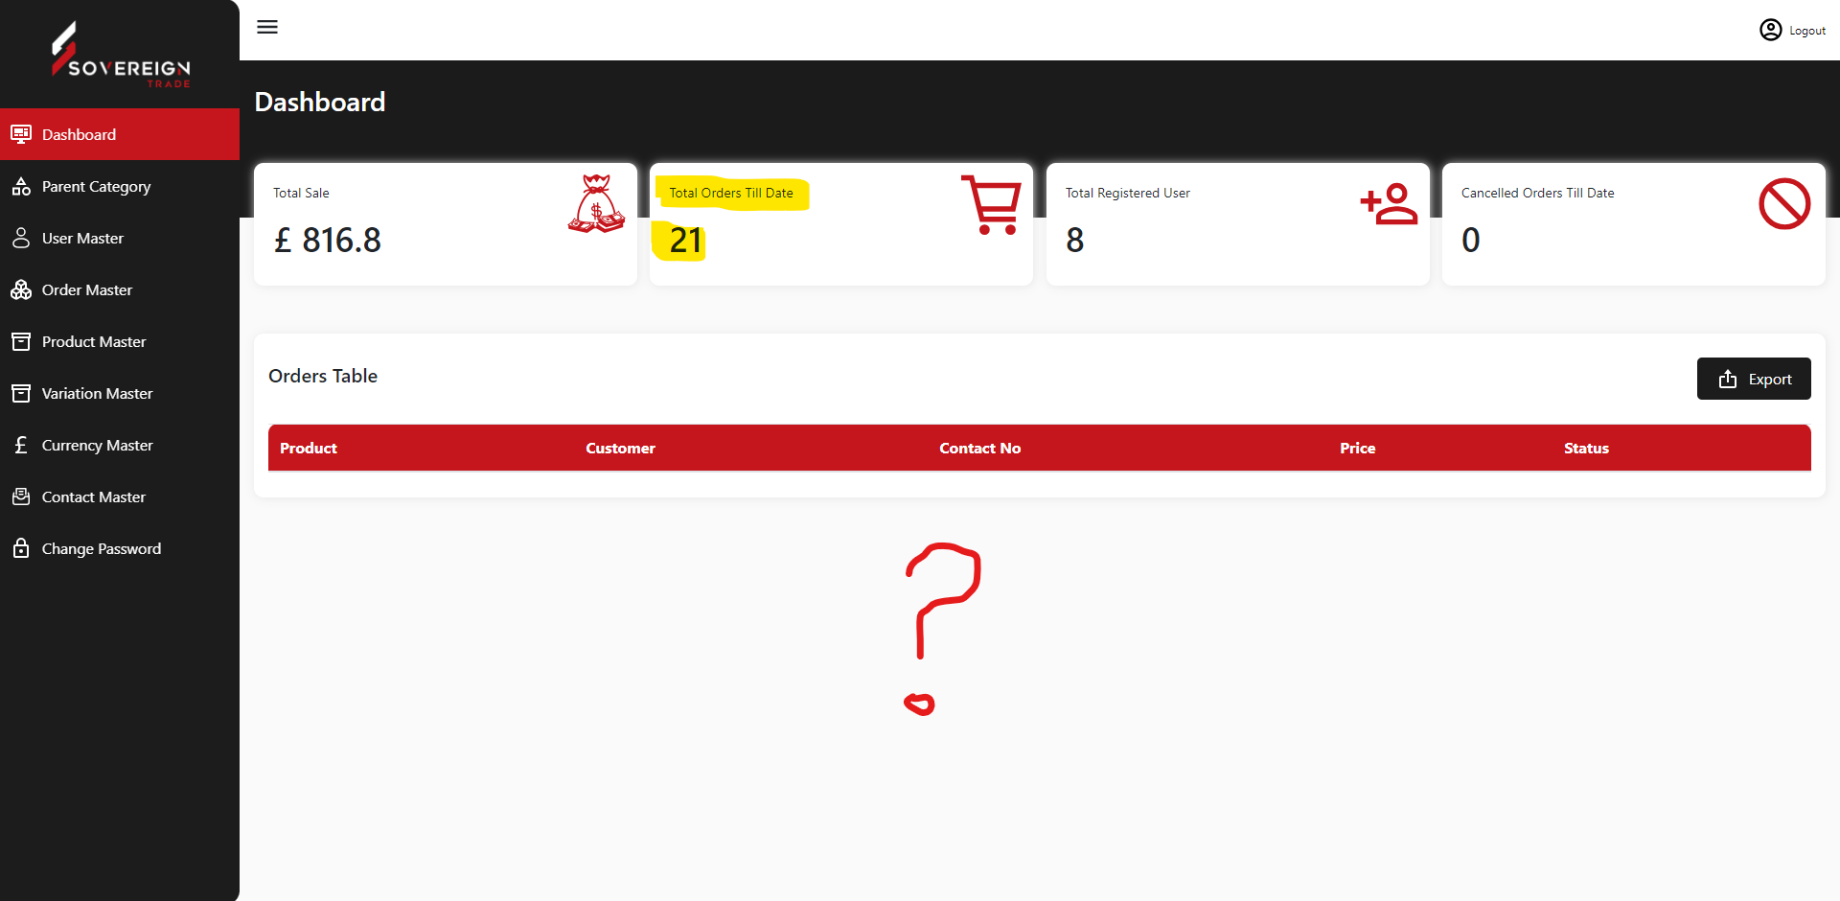**Orders table on dashboard shows nothing**. – The Dashboard shows today’s orders only. The list of orders can be seen from the Order Master section.

**Categories edit feature does not work**.

**Categories Image , heading , status is not visible**

**How we can delete the categories? – There are 6 categories which are fixed (asked by the Sovereign team) in the initial discussion, hence we provided the option to edit only. The images, heading and status are for future development, we have given the provision incase we need it in future. If needed we can enable it.**

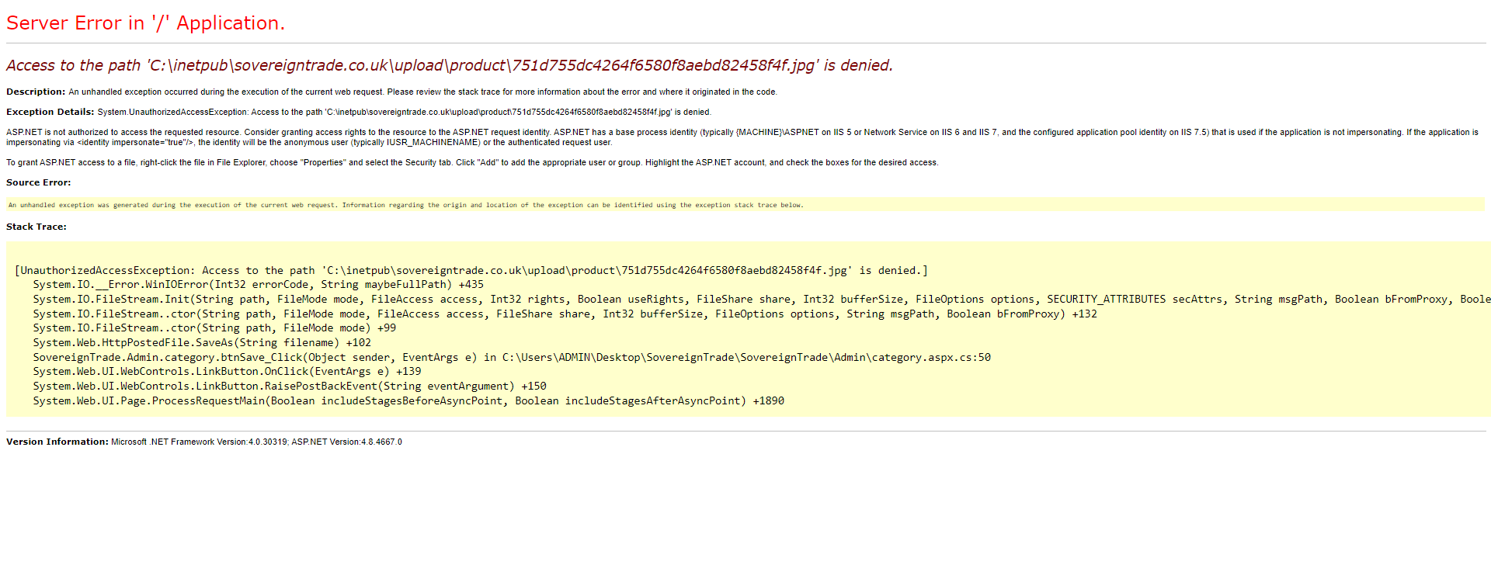 **When we try to add category this error appeared. – The categories list was provided and mentioned that there are only 3 products in pallet category at the present and we have added them to the website, the provision to add category is for future development only.**

**User master is a static page admin has no control over it – These are the buyers/customers, please specify what controls do we need?**

Order master filters are broken.

61 orders are shown here , while on dashboard it shows 21 order till this date

You cant change status of the order, this module has no practical use. – On Dashboard it shows only those Orders which are paid and confirmed, whereas on Order Master it shows all status.

Filters – Error, will solve the errors by Monday latest

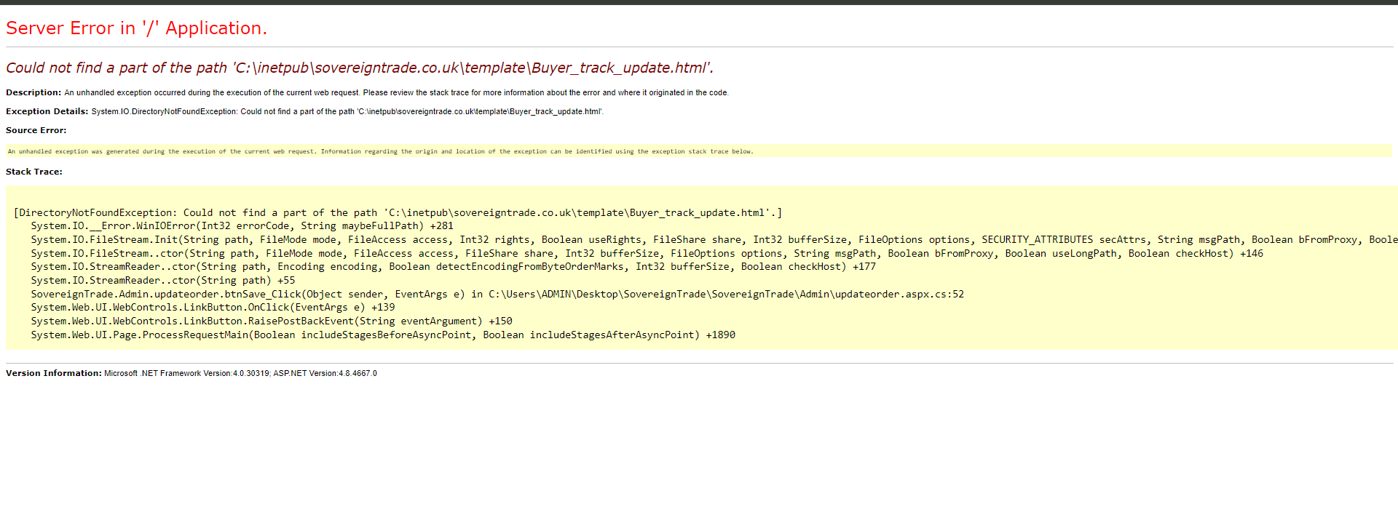When we try to update the tracking number the code is broken. – For future development, incase we integrate it with the 3rd party shipping companies

When trying to upload a product, the code is broken.

The product is added after showing this error but is not visible on the front end. – Error will be solved tomorrow

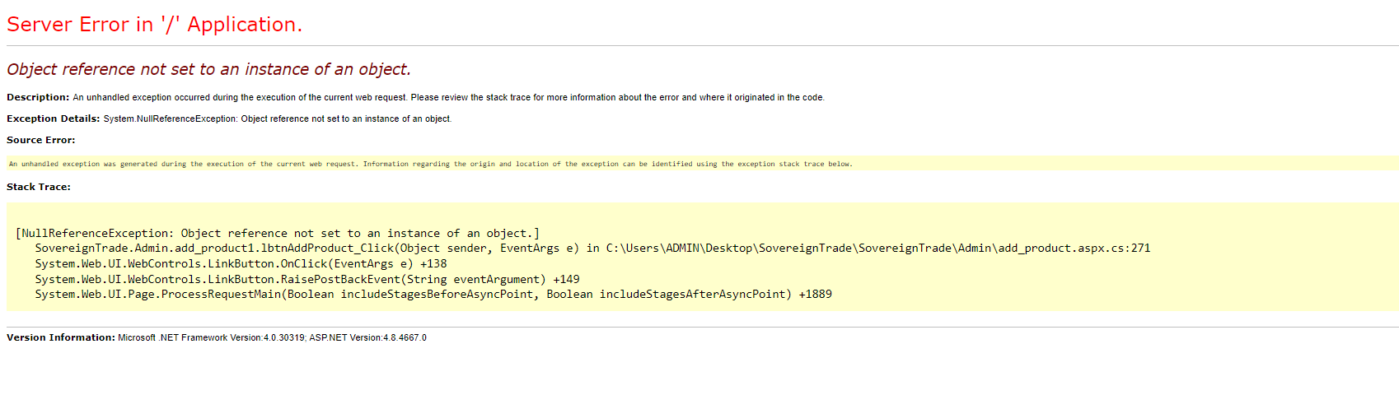

Error when we try to edit the product.

When uploading product images, they appear incorrectly. One picture is replacing all the images – Error will be solved tomorrow

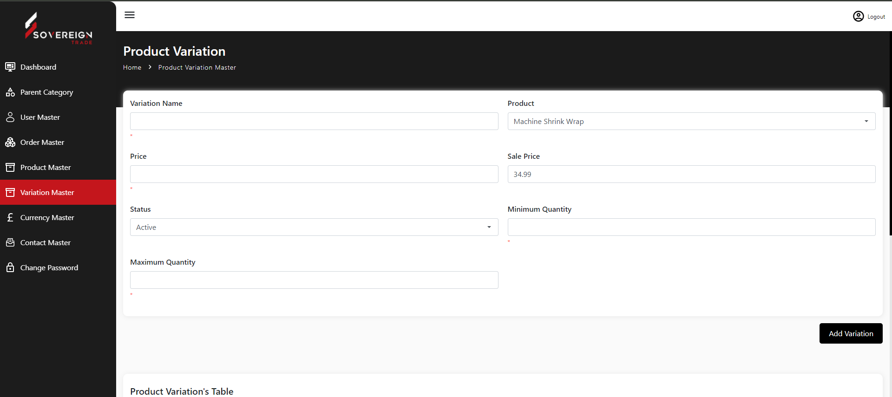

Product variation edit feature does not work. – We have tested it again, it is working. Can we have the meeting to see the steps so that we can replicate the error.

Currency master feature does not work

If you try to change rate of currency it adds a value instead of updating it .

The new values are not editable.

No remove/delete options for those junk values. – This provision is for future development, currently it supports only Pounds and Euros as requested by Sovereign team.

Admin has no control over contact master module.

It’s a static table and values were entered manually to show data in table. – It is the data which is captured from the front end of the website from Contact Us page form, it is meant for the information purpose only.

I did not test the change password module because the entire system seems to be broken, throwing multiple errors. It may not correctly handle password hashing, potentially resulting in a lockout of the admin panel.

**Issues with Front End (User Experience)**

When attempting to register, I encountered errors upon submission through the website. – Error, will solve it tomorrow

These Links are dead links and do not work

We had asked for the content which we did not get

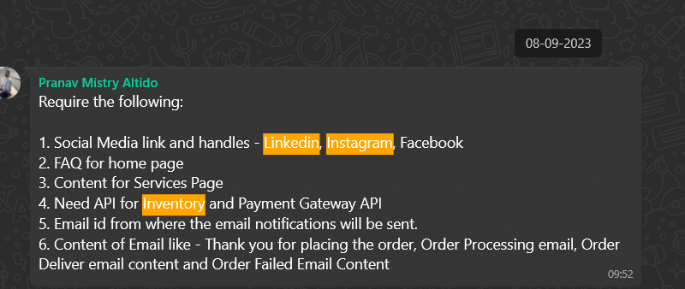

**Reply**

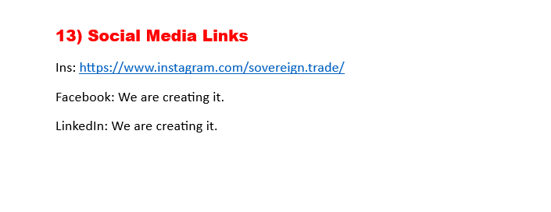

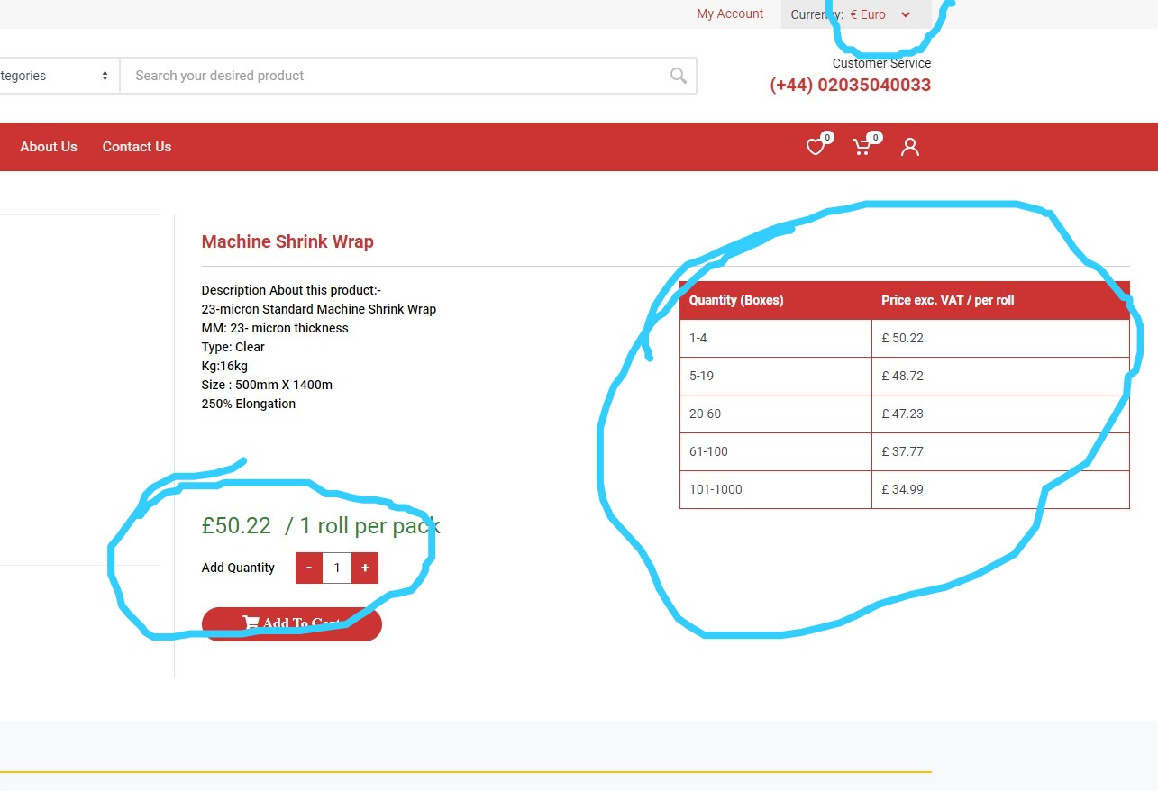

When we changed currency it doesn't work – Error when changing the quantity, will be solved by tomorrow

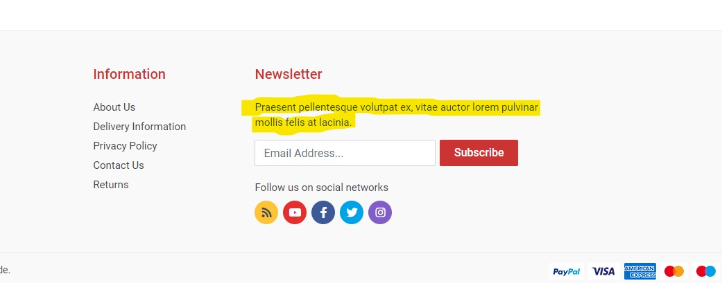

Dummy text detected – We had asked for the data from the Sovereign team

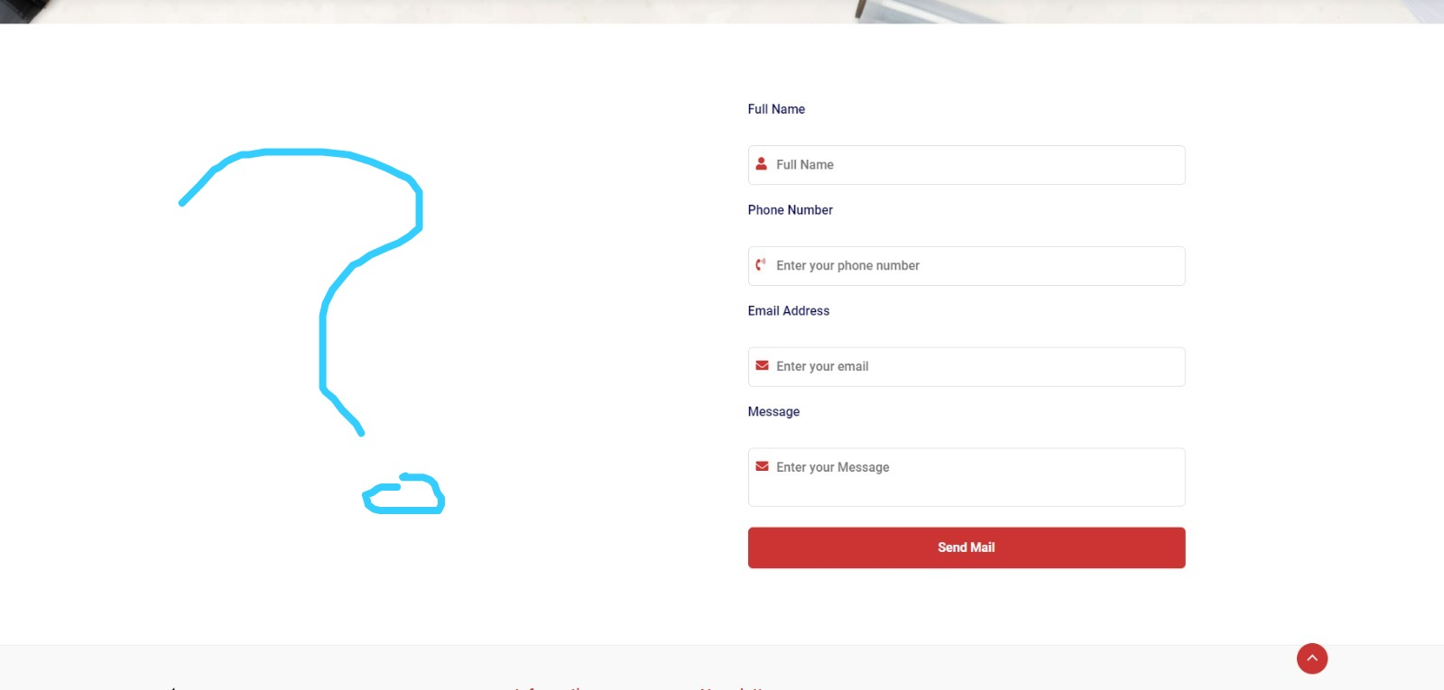

There is a big void here; something is missing. – Never pointed out, there was an image needed

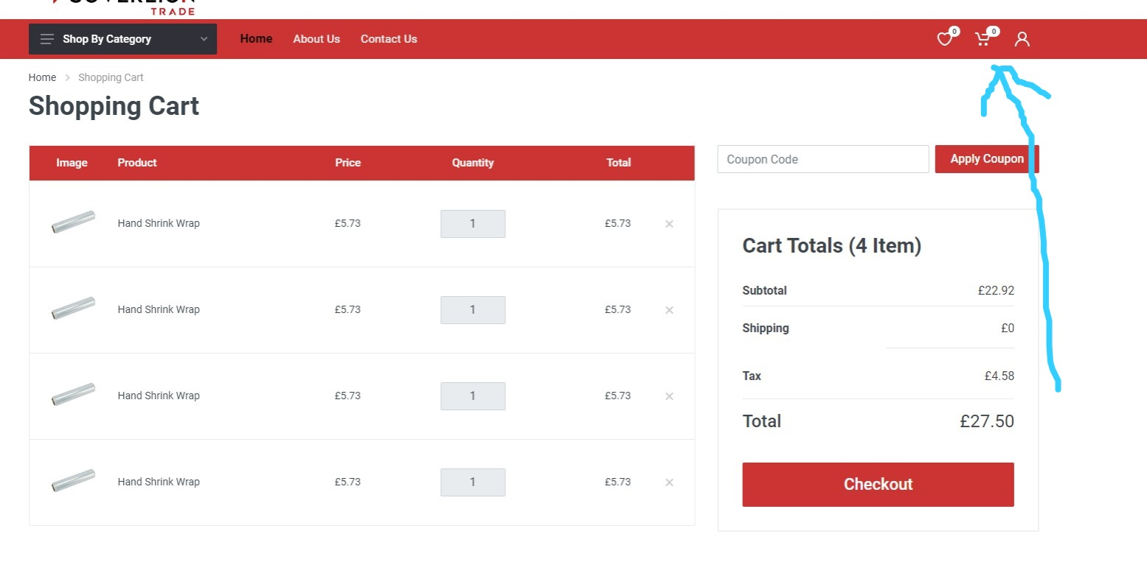

Items we added to cart but looks like the count feature is not working in header > cart icon – We have tested it again, it is working. Can we have the meeting to see the steps so that we can replicate the error.

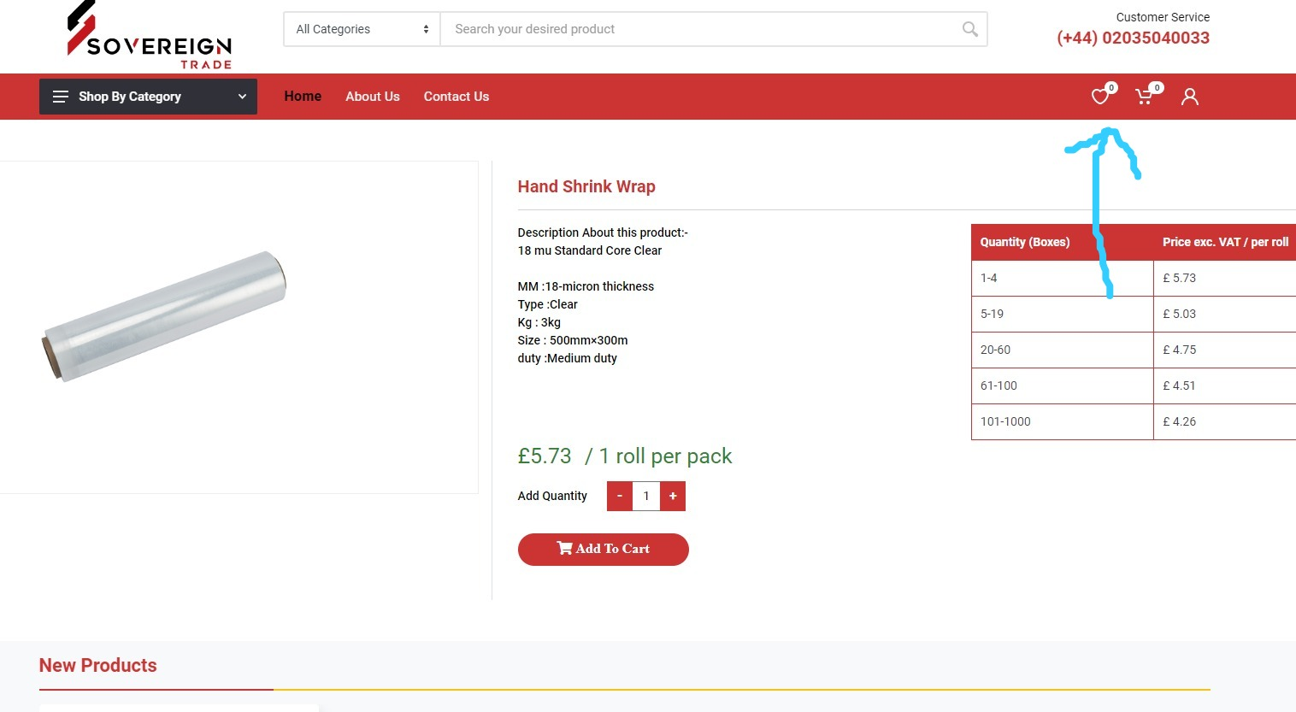

add to wish list icon or button is missing in product detail page although we have wish list counter in header. – Will be added

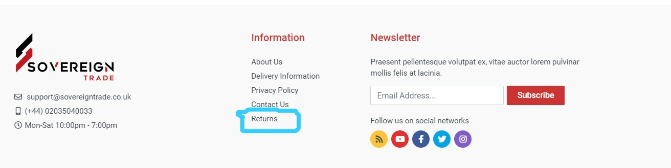Returns is a dead link . looks like its for return policy which is very crucial for the payment gateway registration - Refer point/page 9

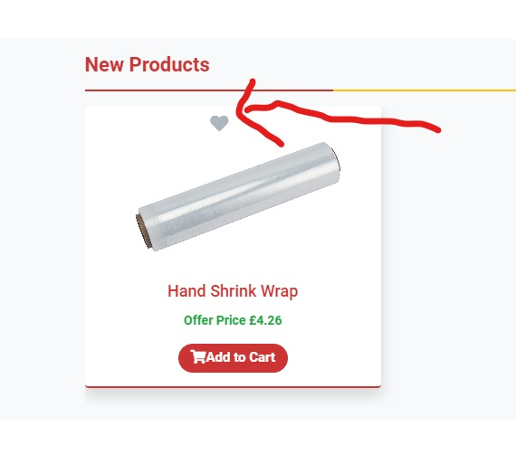

.

If you click this icon nothing happens also wish list counter shows that wish list is empty.- It is the icon for add to Wishlist, error will be solved by Friday.

Highlighted area is empty and showing a void in design . – There was a call image/icon which was asked to be removed.



Copyright is not updated it should show 2024 – It shows the year in which it was made live, however needed will make it dynamic

Only Instagram is clickable all other icons are dead links . – Refer point/page 9

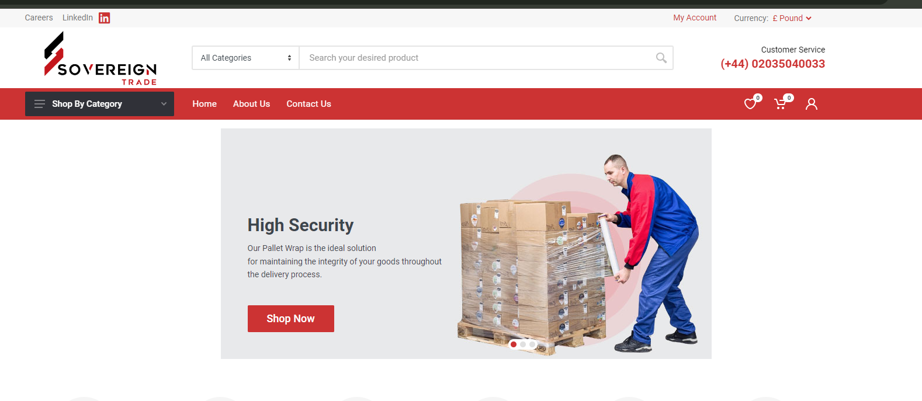

Shop now button does not work. – Which product to link with?

Search does not work – We were waiting for the confirmation from the Sovereign team to keep or remove as we currently have only 3 products.

Compare icon does not work. No such feature detected in website. – Design error there is no compare option, will be removed

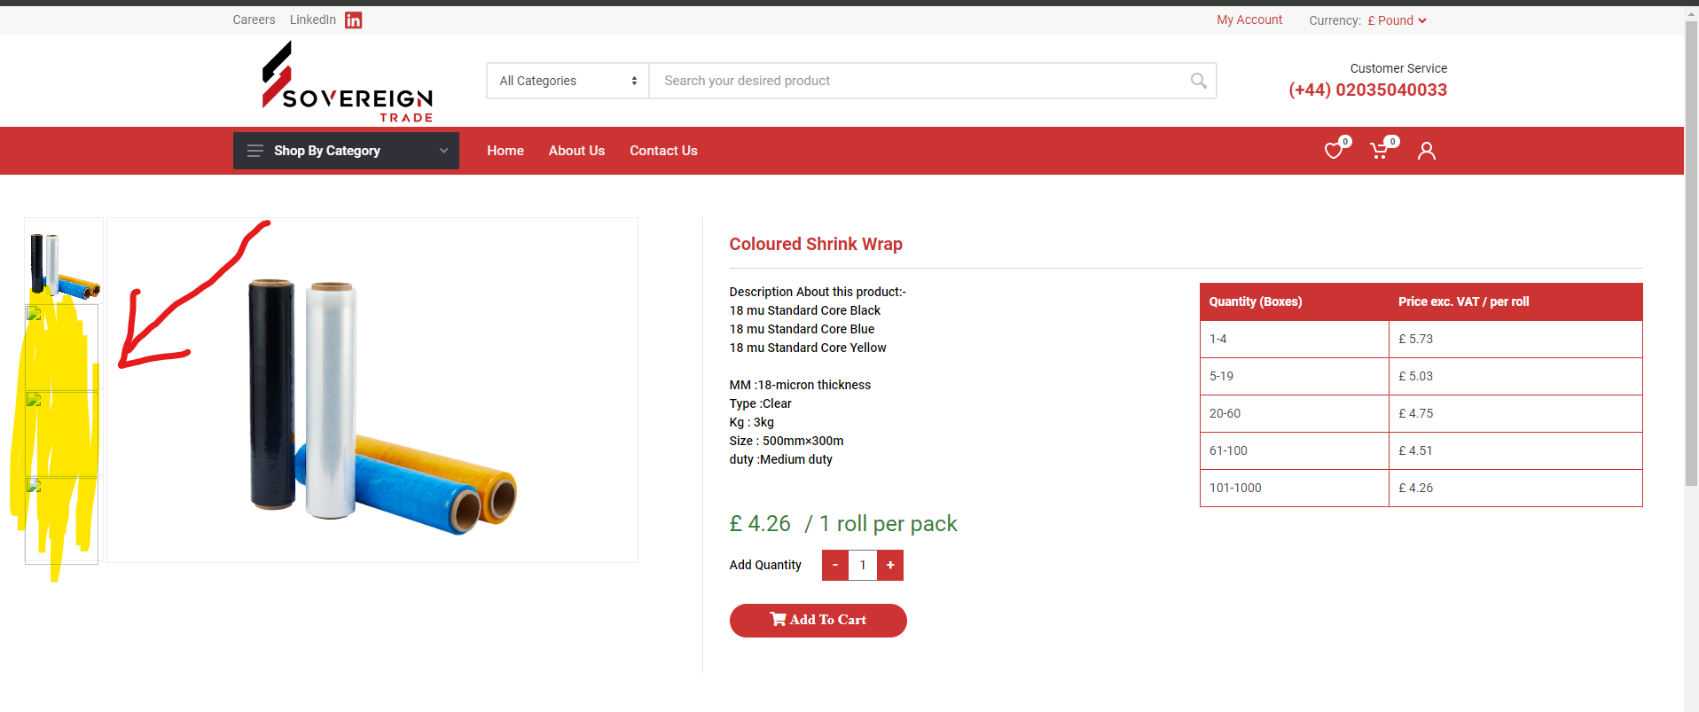

Procut images do no load. – We have tested it again, it is working. Can we have the meeting to see the steps so that we can replicate the error

**Remarks:**

After a thorough review of the front end of our website, it is evident that there are numerous issues that severely hinder its functionality and, consequently, provide no practical use or valuable customer experience.

The admin panel is currently experiencing critical issues, rendering it practically unusable for website management. None of the modules function properly, consistently throwing multiple errors. This compromises the panel's intended purpose and severely hampers its effectiveness in overseeing and controlling website operations. Urgent attention and debugging are required to restore functionality and ensure a seamless user experience.