**OPTHALMOLOGY – EYE CARE DETAILS**

**Dr. Ganesh Kalyanshetti**

**M.B.B.S; M.S. Ophthalmology**

**Navi Mumbai, Maharashtra, India**

**+91 98695 54499 – Whatsapp**

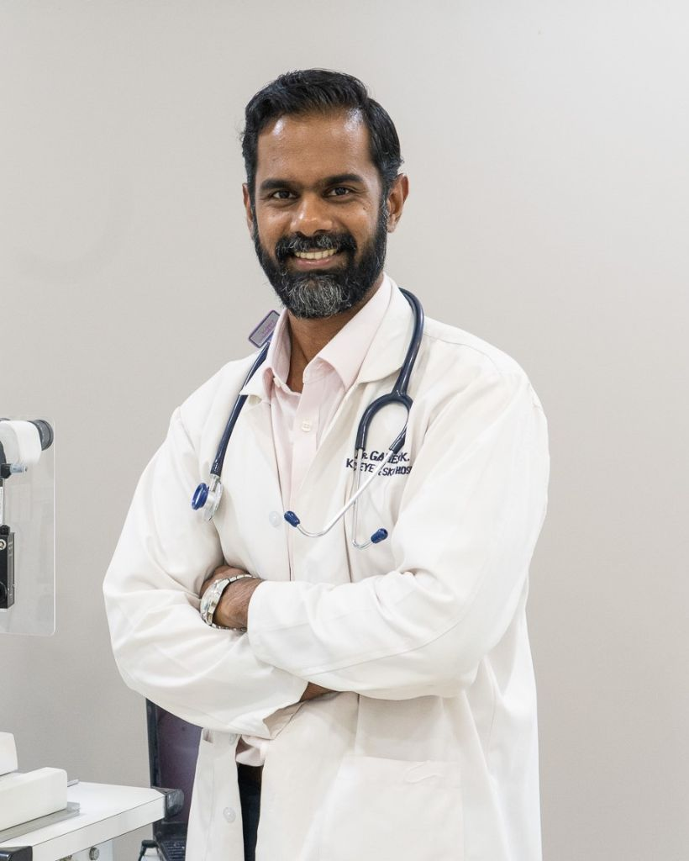**info@kmchospitals.in**

**What is Cataract**

**All of us are born with a flexible, clear lens in our eye called the “crystalline lens.” As this lens becomes cloudy and less flexible, it is known as a cataract, and is responsible for cloudy distance vision, occasional poor near vision and problems with contrast and glare.**

**Cataract surgery involves replacing the cloudy lens with a clear, artificial lens (also called an IOL, or intraocular lens). There are different types of technologies available to remove the cataract, and there are different types of implants available that can give distance, intermediate, and near vision.**

**Many people think that cataracts are removed with a laser, however contrary to popular belief, ultrasound energy is actually used. We use this technology and method and have performed over 3000 surgeries!  The laser is used to make incisions, but the cataract is eaten with the use of ultrasound energy.**

**Small Incision Cataract Surgery is another suture (stitch) free option for removing the cataract and is a safe, comfortable and fast option.**

**All methods of cataract removal are safe and good. However, before deciding on any process the patient should discuss with the surgeon which method and Intraocular lens will best suit their condition and requirements.**