QUESTION 1

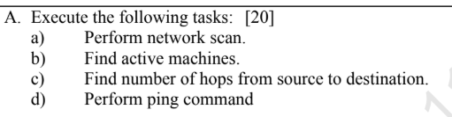

NMAP - 1st - nmap 192.168.0.0/24

- NMAP - 2nd- nmap -sn 192.168.0.0/24

- Perform Network Scan - arp -a (only work in cmd)

- Find Active Machines - net view (only work in cmd)

- Find Number of Hops (Traceroute) - tracert google.com

- Perform Ping Command - ping google.com

QUESTION 2

Any question - NUMBER OF HOPS - tracert in CMD and NMAP

QUESTION 3

- nmap -sn www.sports.com
- nmap -sn -v www.sports.com
- LAST LINE

QUESTION 4
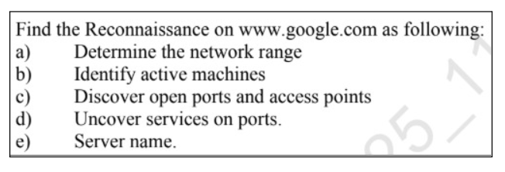
Find IP Address - nslookup google.com IN CMD

- Find Network Range - whois 142.250.205.206 (NOT WORKING IN COMMAND PROMPT)

- Identify Active Machines - nmap -sn google.com

- Discover Open Ports - nmap -F google.com

- Uncover Services on Ports - nmap -sV google.com

- Find Server Name - nslookup google.com

QUESTION 5

nslookup
Ping

QUESTION 6

INTENSE SCAN
nmap -T4 -A -v scanme.nmap.org

