Experiment-1
Aim: Phases in software Development project,overview,need,coverage of topics.
Project Tile :ATM
Introduction:
Our project is an ATM application . This application is used to run an ATM to perform certain operations like Cash Withdrawal , Balance Enquiry , Mini Statement
, etc. It is a client-server based networking application. This system has very much advantages than the existing system due to its multiple handling of clients at a time.
It saves time as well as crowd which were the major disadvantages of the existing system.

Life-CycleModel :The Lifecycle Model we are using for our project is Water-fall Model.

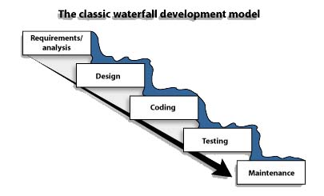

Phases :
Analysis:
- This phaseinvolves the analysis of the problem and collection of all relevant information relating to the product such as the different data items which would be input to the system, the processing required to be carried out on these data, the output data required to be produced by the system as well as various constraints on the behavior of the system.
- The user requirements are systematically organized into a software requirement specification(SRS) document. The important components of this document are functional requirements, the nonfunctional requirements, and the goals of implementation. The SRS document is written in end-user terminology. This makes the SRS document understandable by the customer. After all, it is important that the SRS document be reviewed and approved by the customer.

Design:
- Identifying software components like functions, data streams and data stores.

2) Specifying software structure.

- Architectural Design–It involves:

1. Identifying the software components.
2. Decouplingand decomposing the software components into modules and conceptual data structures.
3. Specifying the interconnection between the various components.

b) Detailed Design - It is concerned with details of the implementation procedures to process the algorithms, data structures and interaction between the modules and data structures. The various activities that this phase includes are
1. Adaptation of existing code.
2. Modification of existing algorithms.
3. Design of data representation and
4. Packaging of the software product.

Coding:
It involves the translation of the design specifications into source code. It also involves activities like debugging, documentation and unit testing of the source code. In this stage various styles of programming can be followed like built-in and user defined data types, secure type checking, flexible scope rules, exception handling, concurrency control etc.

Testing:
It involves two kinds of activities

1. Integration Testing - It involves testing of integrating various modules and testing there overall performance due to their integration.
2. Acceptance Testing - It involves planning and execution of various types of tests in order to demonstrate that the implemented software system satisfies the requirements stated in the requirements document.

Why We Choose This Life-Cycle Model:We are choosing this Waterfall model as our project lifecycle model because we are aware with all our requirements for this project and they are fixed.

Analysis: We analyze our project as per its requirements.The basic requirements were:-
- An Atm machine to implement our project.
- An Atm card to get the input of the user for authentication.
- No. of programmer needed.
- Hardware and Software platform.
Using the requirements and their analysis we will prepare the SRS and then move on to next phase i.e design.
Design:After the SRS we made we will start designing the architecture of our project.We will also add the Structure charts, DFDs, UseCase diag., Activity diag, etc.
Coding:In this phase we will use the models made in design phase and we will implement them in any Object Oriented Programming Language i.e Java,C#,etc
Testing:In this phase we will test our project on different levels like:-
In Unit Testing we will test the different modules separately.
In Integration Testing we will test the overall project after integrating all the modules of our Project.

Experiment - 2
Aim : To assign the requirement engineering tasks.
Introduction :-
Requirement :-
1.The requirement for a system is the description of the services provided by the system and its operational constraint.
2.A requirement is simply a high level, abstract statement of a service that the system should provide or a constraint on the system.

Requirement Engineering: -The process of finding out, analyzing, documenting and checking these services and constraints is called requirement engineering.

Requirement Engineering Process :-
1. The goal of the requirement engineering process is to create and maintain a system requirement specification (SRS) document.
2. The overall process includes four high-level requirements engineering sub-processes.
3. These are concerned with
a) Assessing whether the system is useful to the business i.e. feasibility study,
b) Discovering requirements i.e. requirement elicitation and analysis,
c) Converting these requirements into some standard form i.e. requirements specification, and
d) Checking that the requirements actually define the system that the customer wants i.e. requirement validation.

1.Feasibility Studies :- A feasibility study is a short, focused study that aims to answer a number of questions:
a) Does the system contribute to the overall objectives of the organization?

b) Can the system be implemented using current technology and within cost and schedule constraints?
c) Can the system be integrated with other systems which are already in place?

2.Requirements elicitation and analysis (Requirement Gathering) :- In this activity, software engineers work with customers and system end-users to find out about the application domain, what services the system should provide, the required performance of the system, hardware constraints, and so on.
The process activities are:-
- Requirement discovery - This is the process of interacting with stakeholders in the system to collect their requirements. Domain requirements from stakeholders and documentation are also discovered during this activity.
b) Requirement classification and organization - This activity takes theunstructured collection of requirements, group related requirements and organizes them into coherent clusters.
c) Requirement prioritization and negotiation - Inevitably, where multiple stakeholders are involved, requirements will conflict. This activity is concerned with prioritizing requirements, and finding and resolving requirements conflicts through negotiation.
d)Requirements documentation - The requirements are documented and input into the next round of the spiral. Formal and informal requirements documents may be produced.
3. Requirements Validation :- Requirements validation is concerned with showing that the requirements actually define the system that the customer wants.
Different checks for Validation are :

- Validity checks – A user may think that a system is needed to perform certain functions. However, further thought and analysis may identify additional or different functions that are required. Systems have diverse stakeholders with distinct needs, and any set of requirements is inevitably a compromise across the stakeholder community.

b)Consistency checks – Requirements in the document should not conflict. That us, there should be no contradictory constraints or descriptions of the same system function.
c)Completeness checks- The requirements document should include requirements, which define all functions, and constraints intended by the system user.
d)Realism checks - Using knowledge of existing technology, the requirements should be checked to ensure that they could actually be implemented. These checks should also take account of the budget and schedule for the system development.

e) Verifiability - To reduce the potential for dispute between customer and contractor, system requirements should always be written so that they are verifiable. This means that you should be able to write a set of tests that are demonstrate that the delivered system meets each specified requirement.

4. Requirement Management :- Requirements management is the process of understanding and controlling changes to system requirements. The process of requirements management should start as soon as a draft version of the requirements document is available, but you start planning how to manage changing requirements during the requirements elicitation process.

Now as per our Project (ATM) :-
Feasibility Study :-
So far , as per the study we think our project is both economically and technically feasible and also we can implement our project as per the current technology i.e using Java,c# etc…
Requirements elicitation and analysis (Requirement Gathering) :-
In this phase we will communicate with the stake holder asper our project ATM. Different stakeholders of our projetcs are:-

Bank customers
Representatives of other banks
Bank managers
Counter staff
Database administrators
Security managers
Marketing department
Hardware and software maintenance engineers
Banking regulators
Requirements Validation :-
In this phase we have applied many validations and checks.
Following are some validations in our project :-
- The pin contains only 4 digits.
- The 4 digits much be number only.
- If user has already input wrong pin for 3 times then his account will be locked for 24 hours.
Requirement Management :-
As we use the waterfall model due to no change into the requirements in future so this phase is not very useful, still In this phase we will manage all our requirements by overviewing each requirement step-by-step.

Experiment – 03
Aim :- To perform the system analysis: Requirement analysis, SRS of the ATM.
Introduction : - The SRS is the result of the Analysis Phase of the Project.
1.Introduction :-
1.1 Purpose :- The main purpose of ATM application i.e our project is to provide banking services parallel to so many users at a time and also to save time of the clients.
1.2 Scope :- It is a generic application and can be implemented in any type of Atm machine.
1.3 Definitions, Acronyms, and Abbreviations :- Some following are :-
ATM/Atm :- Automated teller machine.
Bal :- Balance.
Fd :- Fixed Deposit.
Enq :- Enquiry.
1.4 References :- Internet and Live Example.
1.5 Overview :- This project asks for a debit card as an input with its accurate pin and provides a user to access his/her banking services very easily in no time like Cash-Withdrawal , Cash-Transfer , etc..

2. Overall Description :-

2.1 Product Perspective :-
Our projects perspective is clients ease for the cash withdrawal , Bal Enq , and other banking services.
2.2 Product Functions :-
cashWithdrawal : This function is used to withdraw the money from clients account.
balEnquiry : This function is used to get the details of the balance available in the clients account.
miniStatement : this shows the last 10 transactions with the account.

2.3 General Constraints :-
General constraints are:-
- Pin must be a four digit number.
- To verify Language selection
- To verify invalid Pin entry 3 times
- To verify Amount entry

3.Specific Requirements :-

3.1 External Interface Requirements :-
3.1.1 User Interfaces :- Button , Audio , Frame
3.1.2 Hardware Interfaces :- Atm-machine , keyboard , speaker, Sensors
3.1.3 Software Interfaces :- Java Technology( JDK 1.8) ,Ecllipse
3.2 Functional Requirements
3.2.1 Withdrawal :
3.2.1.1 Functional Requirement 1 :- The user must have sufficient funds to withdraw the amout he wanted.
3.2.1.2 Functional Requirement 2 :- If the accout is a join-account then at the time of withdraw no one else should withdraw or deposit cash to the account.
3.2.1.3 Functional Requirement 3:- All the general constraints must be check before doing this operation.
3.2.2 Balance Enquiry :
3.2.2.1 Functional Requirement 1 :- The pin must be correct i.e should match with the debit card account.
3.2.2.2 Functional Requirement 2 :-In case no receipt available then the result should be show on the Monitor only.
3.2.3 Lock:
3.2.3.1 Functional Requirement 1 :- If pin entered wrong 3 or more than 3 times account shold be locked for 24 hours.

Scenario for aur ATM application :-

1.To verify ATM card Insertion
2.To verify ATM card Insertion in wrong angle
3.To verify invalid ATM card Insertion
4.To verify Language selection
5.To verify Pin entry
6.To verify invalid Pin entry
7.To verify invalid Pin entry 3 times
8.To verify Account Type selection
9.To verify Invalid Account Type selection with respective
to inserted card
10.verify withdrawal option selection
11.verify Amount entry
12.verify Amount entry with wrong denominations(fr eg:999Rs)
13.verify withdrawal success operation
14.Verify operation when our entered amount is greater than
possible balance
15.Verify operation when our entered amount is greater than
day limit
16.Verify when our ATM have lack of Amount
17.Verify when our ATM have network problem
18.Verify Current transaction No.exceeded than day limit
19.Verify operation with exceeded delay in between
operations in ATM
20.Verify Cancel after insert card
21.Verify Cancel after Language selection
22.Verify Cancel after Pin entry

Experiment – 4
Aim :- To perform the function oriented diagram:DFD and Structured chart.
DFD:-
Data flow diagrams (Bubble chart)
1) These are directed graphs in which the nodes specify processing activities and arcs (lines with arrow heads) specify the data items
transmitted between the processing nodes.
2) Like flowcharts, data flow diagrams can be used at any desired level of abstraction.
3) Unlike flowcharts, data flow diagrams do not indicate decision logic or conditions under which various processing nodes in the diagram
might be activated.

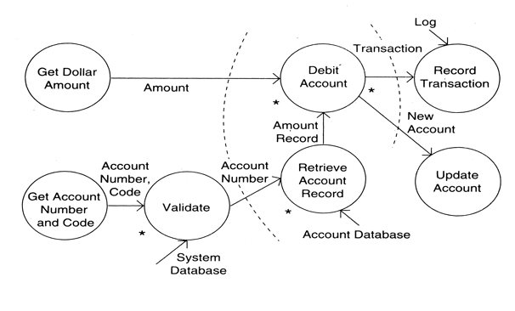

Structure Chart:-
- They are used during architectural design for documenting hierarchical structure, parameters and interconnections in a system.
- In a structure chart a module is represented by a box with the module name written in the box.
- An arrow from a module A to a module B represents that the module A invokes module B. the arrow is labeled by the parameters received by B as input and the parameters returned by B.

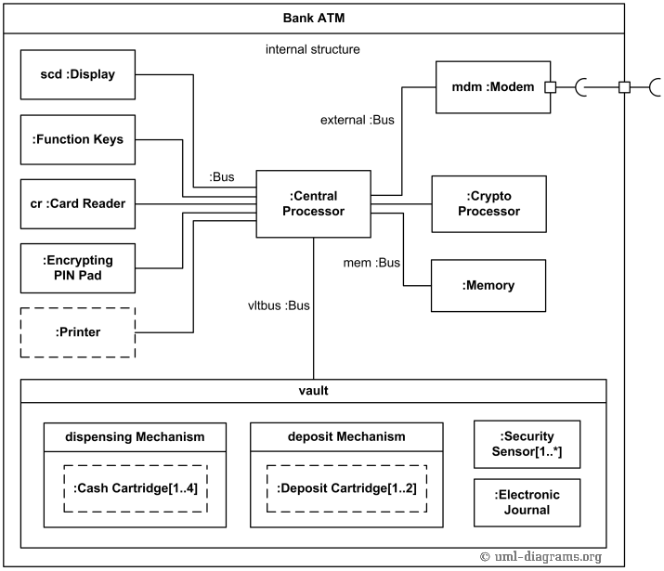

Experiment - 5
Aim:To perform the user’s view analysis: Use case diagram.
Use Case Diagram: It is a representation of user’s interaction with system that shows relationship hardware user and different use cases in which the user is involved.
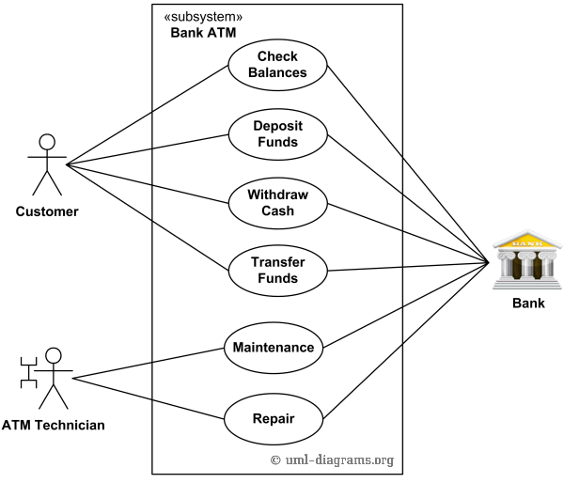

Experiment - 6
Aim: To draw the structural view diagram: Class diagram, object diagram.
Class Diagram:
It is the type of static structure of that diagram. The structure of system by showing system classes, attributes, operations, or methods and the relationship among objects.
The Class Diagram of the Project is given below :-
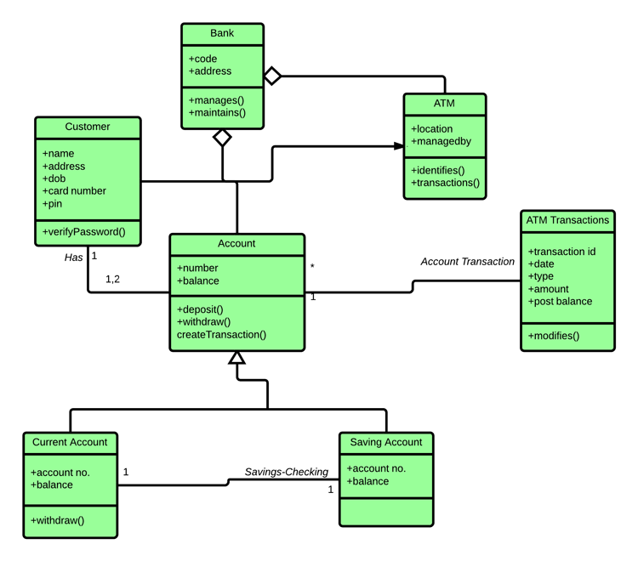

Object Diagram:
It is designed from the class diagram show object diagrams are dependent upon class diagram. Object diagram represents an instance of class diagram. The basic for similar for class diagram and object diagram. It also represent the static view of a system but this static view of a system but this static view is snap sort of system a particular moment.

The Object Diagram of the Project is given below :-

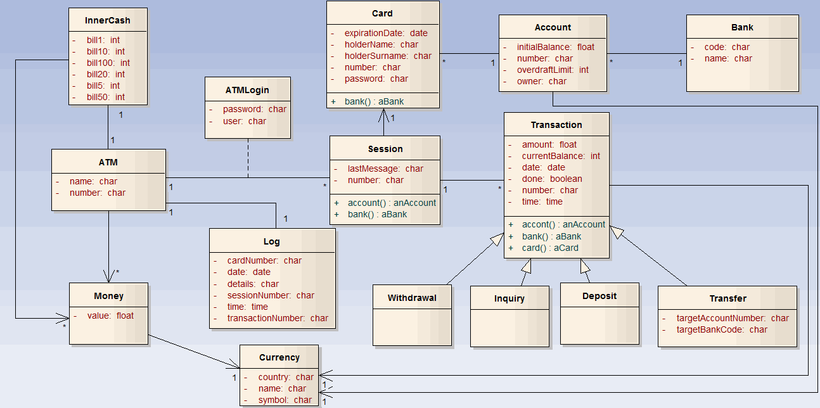

Experiment - 7
Aim:To draw the behaviour view diagram: Sequence diagram, Collaboration diagram.
Sequence Diagram:
It shows object interaction in time sequence in time sequence it represent object & classes involved in scenario and sequence of message exchanged between the object needed to carry out functionality of the scenario. Parallel vertical line represents the lifetime of process. Different processes of objects that leaves simultaneously. Horizontal line message exchange between and the order occur.
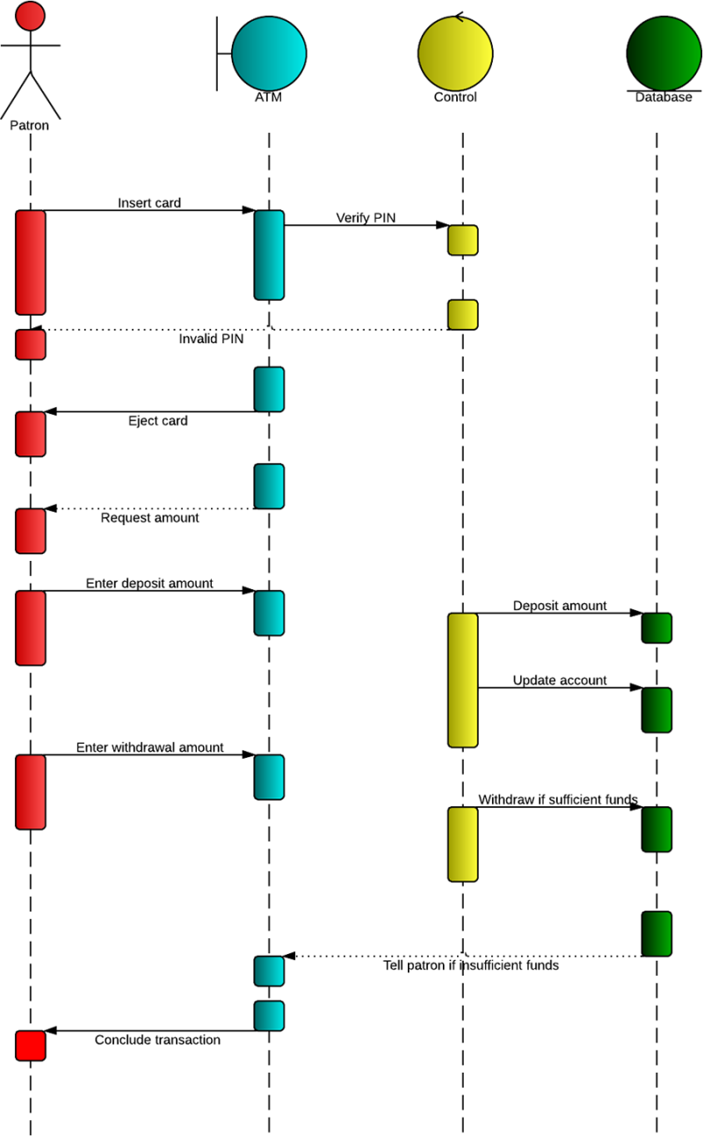
Collaboration Diagram:
It describes among object in terms of sequence messages, retries object oriented implements and also empty association (relation) between classes.
The collaboration Diagram of the Project is given below :-

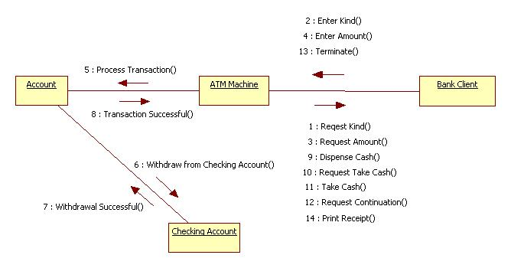

Experiment – 8
Aim :- To draw the behavioral view diagram : State-chart diagram, Activity diagram .
State Chart Diagram :- It shows the Flow of control form state to state.
The State Chart Diagram of the Project is given below :-

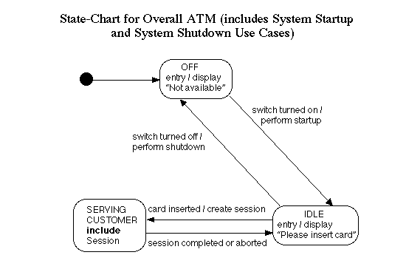

Activity Diagram :- It is a graphical representation of the workflow of the stepwise activity and actions with support for choice , iteration and concurrency . In UML activity diagram shows the overall flow of Control.
The Activity Diagram of the Project is given below :-
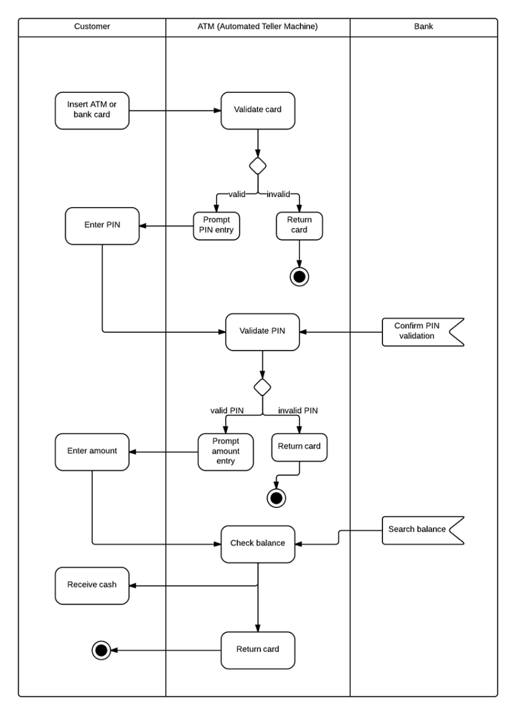
Experiment – 9
Aim :- To draw the implementation view diagram: Component diagram.
Component Diagram :- It display the structure relationship of component of a software system this use mostly when working with complex system that has many components. Component communication with each other using interfaces . the interfaces are linked with connectors.
The Component Diagram of the Project is given below :-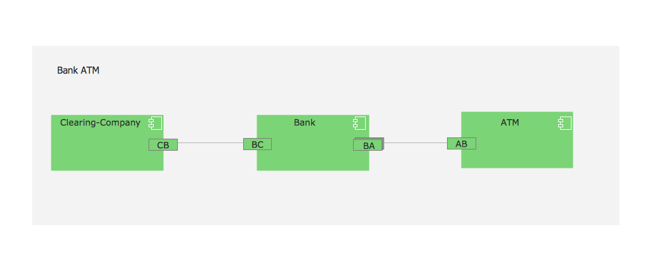

Experiment – 10
Aim :- To draw the implementation view diagram: Deployment diagram.
Deployment Diagram :- It shows the hardware of the node system and software . It useful when software functions is deployed across multiple machine each having unique configurations .
The Deployment Diagram of the Project is given below :-

