Assignment #2 –

**Due Date:** As per dropbox

**Purpose:** The purpose of this assignment is to help you:

1. Become familiar with Cursors, Exceptions, Procedures , Functions and Triggers

**Instructions**: Be sure to read the following general instructions carefully:

This assignment should be completed individually by all the students. Submit your solution **through the dropbox.** Your submission should include PL/SQL code and the screenshot of code execution result, the submission must be named according to the following rule: **studentID(yourlastname)_Assignment#number.doc**. e.g., 300123456(**smith)_Assignment#2**.doc

Upload your ascii text file to the Dropbox with .txt extension.

Your files must be in sql script format so that they can be run in SQL Developer and have DBMS_OUTPUT.PUT_LINE for presenting results.

Update database with script file(s) from `Student Data` of Oracle 11g: PL/SQL Programming -- Chapter 3.

Assignment 3-9: Retrieving Pledge Totals Create a PL/SQL block that retrieves and displays information for a specific project based on Project ID. Display the following on a single row of output: project ID, project name, number of pledges made, total dollars pledged, and the average pledge amount.

Assignment 3-10: Adding a Project Create a PL/SQL block to handle adding a new project. Create and use a sequence named DD_PROJID_SEQ to handle generating and populating the project ID. The first number issued by this sequence should be 530, and no caching should be used. Use a record variable to handle the data to be added. Data for the new row should be the following: project name = HK Animal Shelter Extension, start = 1/1/2013, end = 5/31/2013, and fundraising goal = $65,000. Any columns not addressed in the data list are currently unknown.

Assignment 3-11: Retrieving and Displaying Pledge Data Create a PL/SQL block to retrieve and display data for all pledges made in a specified month. One row of output should be displayed for each pledge. Include the following in each row of output:

• Pledge ID, donor ID, and pledge amount • If the pledge is being paid in a lump sum, display “Lump Sum.” • If the pledge is being paid in monthly payments, display “Monthly - #” (with the # representing the number of months for payment). • The list should be sorted to display all lump sum pledges first.

Assignment 3-12: Retrieving a Specific Pledge Create a PL/SQL block to retrieve and display information for a specific pledge. Display the pledge ID, donor ID, pledge amount, total paid so far, and the difference between the pledged amount and total paid amount.

Assignment 3-13: Modifying Data Create a PL/SQL block to modify the fundraising goal amount for a specific project. In addition, display the following information for the project being modified: project name, start date, previous fundraising goal amount, and new fundraising goal amount.

**Output for 3.9, 3.11, 3.12, 3.13:**

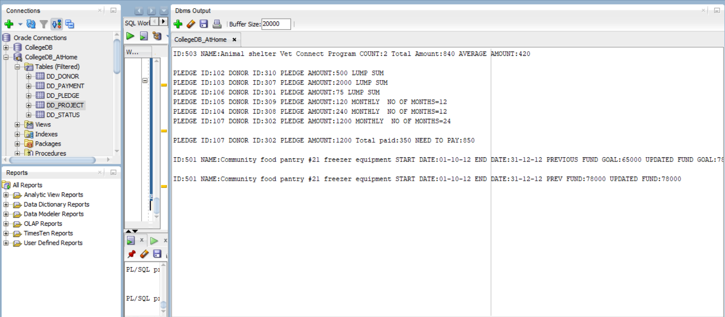

Changes in the table DD_PROJECT for 3.10, 3.13.

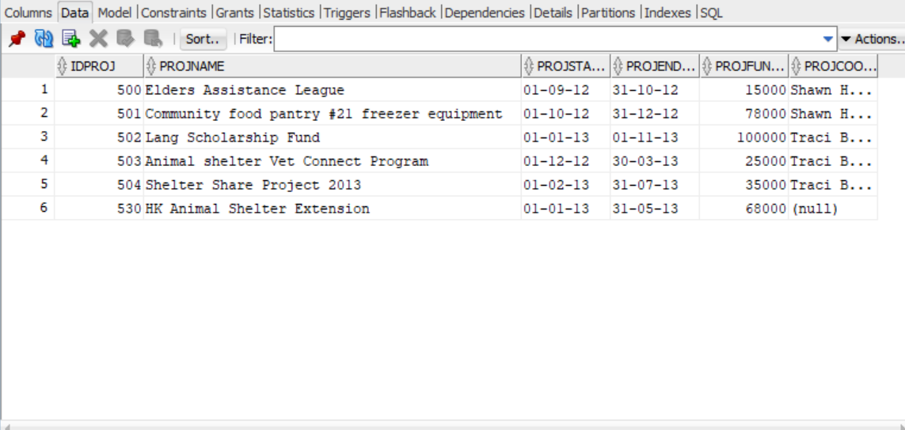

3.9

DECLARE

TYPE pledge_totals_type IS RECORD(

project_id dd_project.idproj%TYPE,

project_name dd_project.projname%TYPE,

no_of_pledges NUMBER(3),

total_amount NUMBER(5),

average_amount NUMBER(5));

rec_pledges pledge_totals_type;

lv_project_id NUMBER(3):= 503;

BEGIN

SELECT d1.idproj, d1.projname, d2.pledges, d2.total, d2.average

INTO rec_pledges

FROM dd_project d1 INNER JOIN (

SELECT idproj, COUNT(idpledge) pledges, SUM(pledgeamt) total, AVG(pledgeamt) average

FROM dd_pledge

GROUP BY idproj) d2

ON d1.idproj = d2.idproj

WHERE d1.idproj = lv_project_id;

IF SQL%NOTFOUND THEN

DBMS_OUTPUT.PUT_LINE('NO DATA FOUND');

END IF;

DBMS_OUTPUT.PUT_LINE('ID:'|| rec_pledges.project_id ||' NAME:'|| rec_pledges.project_name

||' COUNT:'|| rec_pledges.no_of_pledges ||' Total Amount:'|| rec_pledges.total_amount

||' AVERAGE AMOUNT:'|| rec_pledges.average_amount);

END;

3.10

CREATE SEQUENCE DD_PROJID_SEQ

INCREMENT BY 1

START WITH 530;

DECLARE

lv_project_name VARCHAR(40);

lv_start DATE;

lv_end DATE;

lv_fund_goal NUMBER(6);

BEGIN

lv_project_name := 'HK Animal Shelter Extension';

lv_start := '01-01-13';

lv_end :='31-05-13';

lv_fund_goal := 68000;

INSERT INTO dd_project (idproj, projname, projstartdate, projenddate, projfundgoal)

VALUES (dd_projid_seq.nextval, lv_project_name, lv_start, lv_end, lv_fund_goal);

END;

3.11

DECLARE

CURSOR cur_pledge(p_month NUMBER) IS

SELECT idpledge, iddonor, pledgeamt, paymonths

FROM dd_pledge

WHERE Extract(Month from pledgedate) = p_month

ORDER BY paymonths;

TYPE type_pledge IS RECORD(

pledge_id dd_pledge.idpledge%TYPE,

donor_id dd_pledge.iddonor%TYPE,

pledge_amount dd_pledge.pledgeamt%TYPE,

pay_months dd_pledge.paymonths%TYPE);

rec_pledges type_pledge;

lv_month VARCHAR(2);

BEGIN

lv_month:= '10';

OPEN cur_pledge(lv_month);

LOOP

FETCH cur_pledge INTO rec_pledges;

EXIT WHEN cur_pledge%NOTFOUND;

IF rec_pledges.pay_months = 0 THEN

DBMS_OUTPUT.PUT_LINE('PLEDGE ID:'|| rec_pledges.pledge_id

||' DONOR ID:'||rec_pledges.donor_id||' PLEDGE AMOUNT:'||rec_pledges.pledge_amount||' LUMP SUM');

ELSE

DBMS_OUTPUT.PUT_LINE('PLEDGE ID:'|| rec_pledges.pledge_id

||' DONOR ID:'||rec_pledges.donor_id||' PLEDGE AMOUNT:'||rec_pledges.pledge_amount

||' MONTHLY #'|| rec_pledges.pay_months);

END IF;

END LOOP;

CLOSE cur_pledge;

END;

3.12

DECLARE

TYPE type_pledge IS RECORD(

pledge_id dd_pledge.idpledge%TYPE,

donor_id dd_pledge.iddonor%TYPE,

pledge_amount dd_pledge.pledgeamt%TYPE,

total_paid NUMBER(5),

need_to_pay NUMBER(5));

rec_pledges type_pledge;

lv_pledge_id dd_pledge.idpledge%TYPE;

BEGIN

lv_pledge_id:=107;

SELECT d1.idpledge, d1.iddonor, d1.pledgeamt, total_paid, (pledgeamt-total_paid) need_pay

INTO rec_pledges

FROM dd_pledge d1 INNER JOIN (SELECT SUM(payamt) total_paid, idpledge

FROM dd_payment

GROUP BY idpledge) d2

ON d1.idpledge = d2.idpledge

WHERE d1.idpledge = lv_pledge_id;

DBMS_OUTPUT.PUT_LINE('PLEDGE ID:'|| rec_pledges.pledge_id

||' DONOR ID:'||rec_pledges.donor_id||' PLEDGE AMOUNT:'||rec_pledges.pledge_amount

||' Total paid:'||rec_pledges.total_paid||' NEED TO PAY:'|| rec_pledges.need_to_pay );

END;

3.13

DECLARE

lv_project_id NUMBER(3);

lv_project_name VARCHAR(70);

lv_start DATE;

lv_end DATE;

lv_prev_fund_goal NUMBER(6);

lv_updated_fund_goal NUMBER(6);

BEGIN

lv_project_id:= 501;

lv_updated_fund_goal :=78000;

SELECT projname, projstartdate, projenddate, projfundgoal

INTO lv_project_name, lv_start, lv_end, lv_prev_fund_goal

FROM dd_project

WHERE idproj = lv_project_id;

UPDATE dd_project

SET projfundgoal = lv_updated_fund_goal

WHERE idproj = lv_project_id;

DBMS_OUTPUT.PUT_LINE('ID:'|| lv_project_id ||' NAME:'|| lv_project_name

||' START DATE:'|| lv_start ||' END DATE:'|| lv_end

||' PREV FUND:'|| lv_prev_fund_goal ||' UPDATED FUND:'||lv_updated_fund_goal);

END;