Grocery Ordering Application

A grocery ordering application that allows business owners to receive online orders from customers. The application utilizes Oracle Database for storing, managing, and accessing diverse types of data, including customer information, orders, grocery items and delivery information.

# Members:

* Deanne Laylay:
* Haneef Muhammad: 301287005
* Syed Ikramuddin: 301318212
* Dilshan Liyanage: 301279203

# ERD:

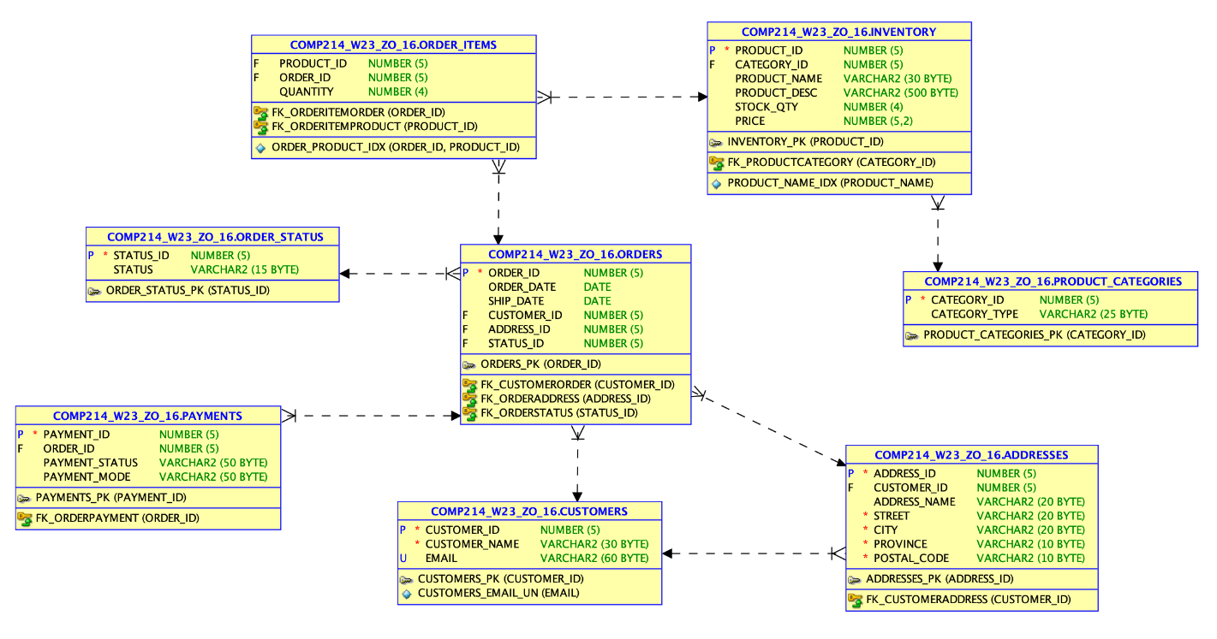

# SCREENSHOTS:

### - Testing code for the function product price

### - Testing the functions and procedures associated with calculating the subtotal, shipping cost, and total cost.

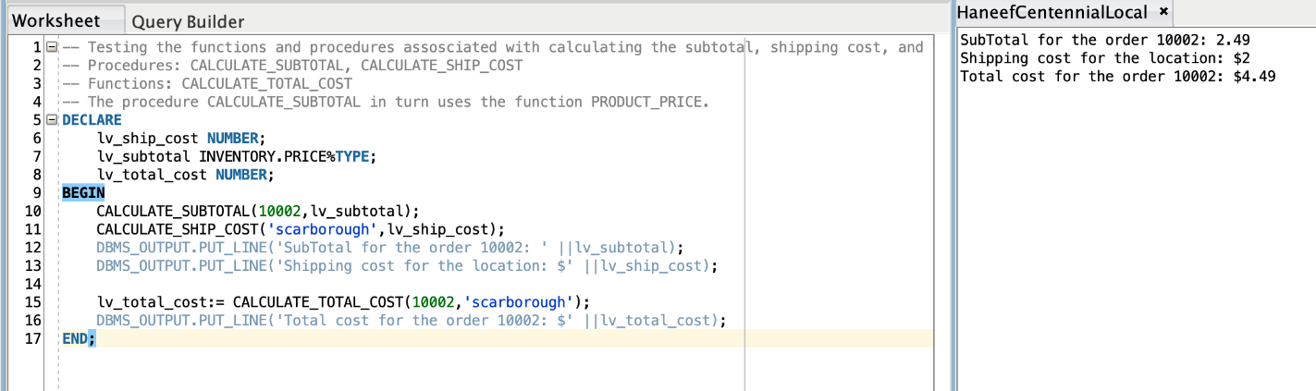

- Testing code for the Procedure UPDATE_CUSTOMER_INFO

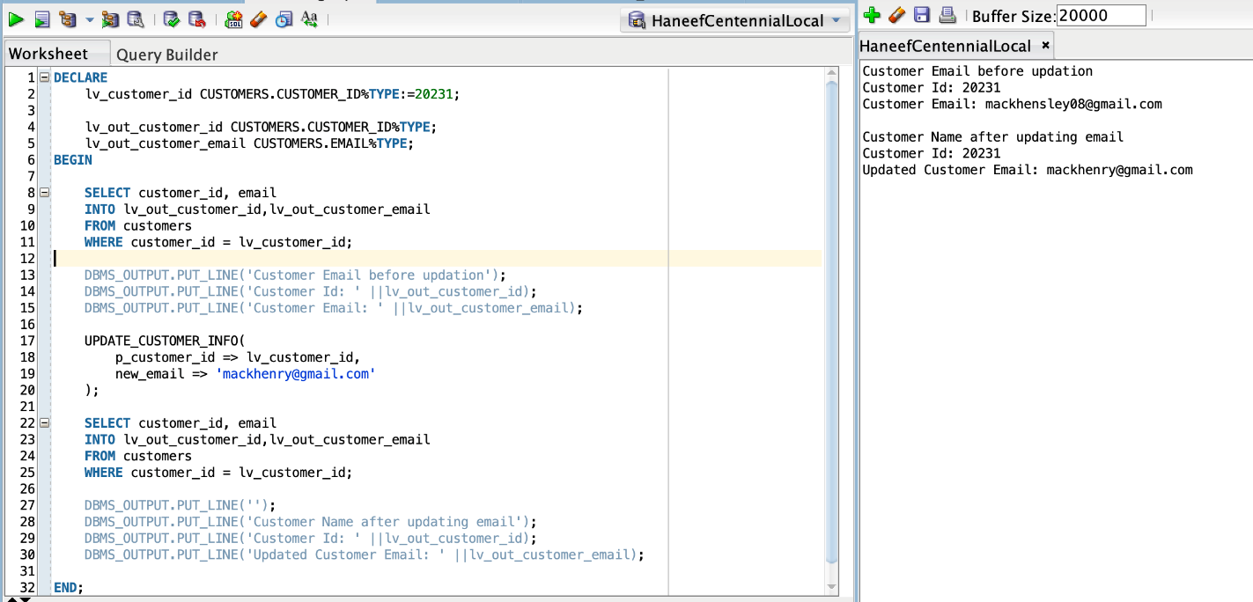

- Testing code for the procedure update_order_status

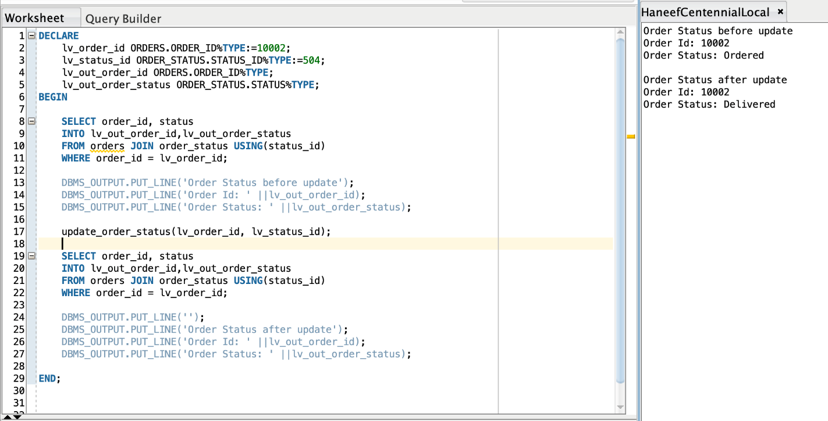

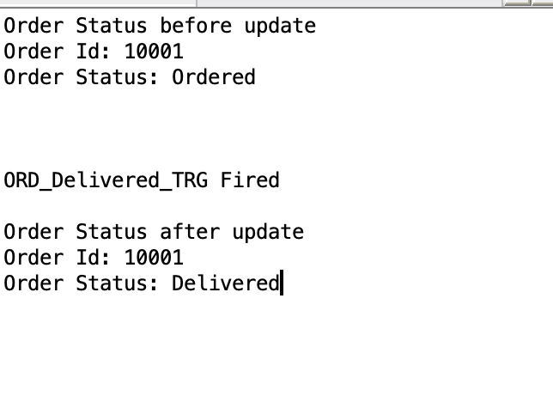

- Testing code for the trigger ord_delivered_trg

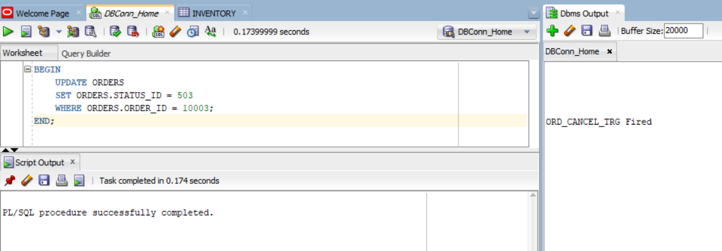

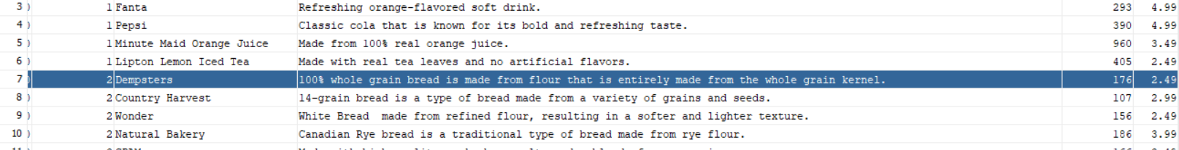

- Testing code for the trigger update_order_status

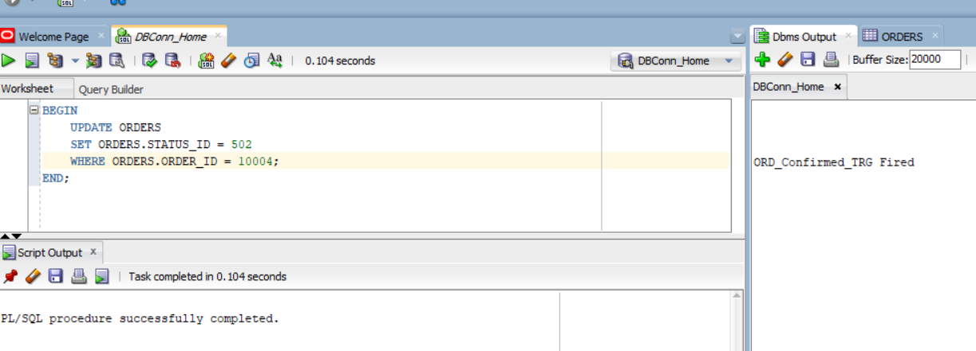

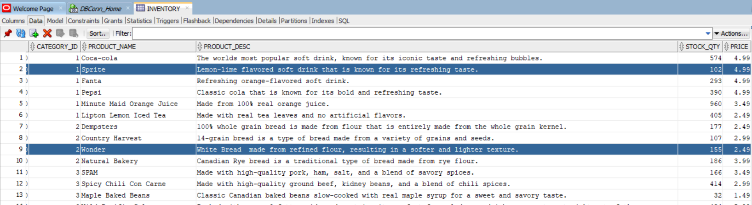

# User Interface Mockups

LANDING PAGE

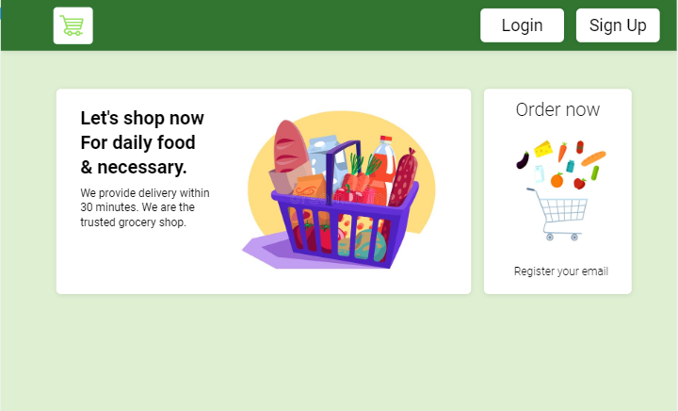

SIGN UP PAGE

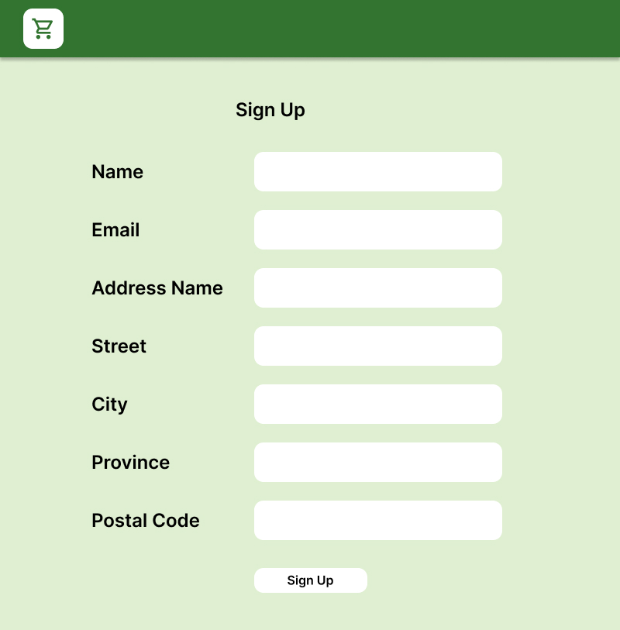

LOGIN PAGE

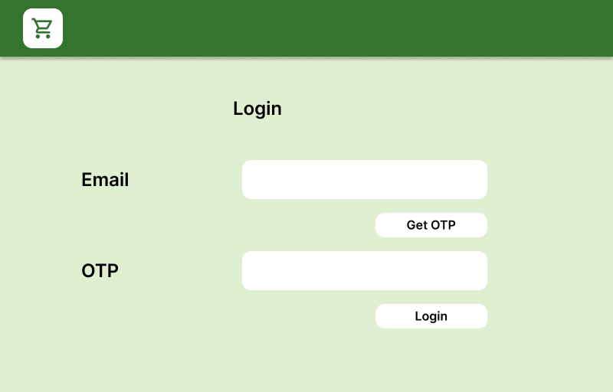

WELCOME BACK PAGE

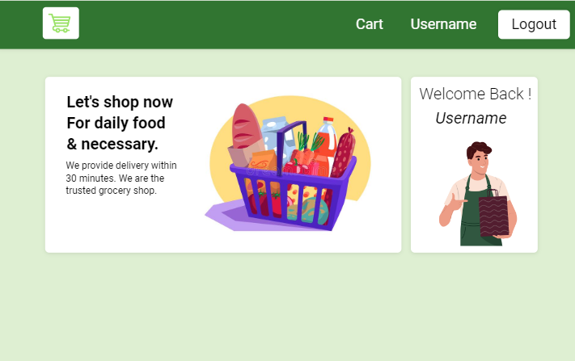

ORDER DASHBOARD

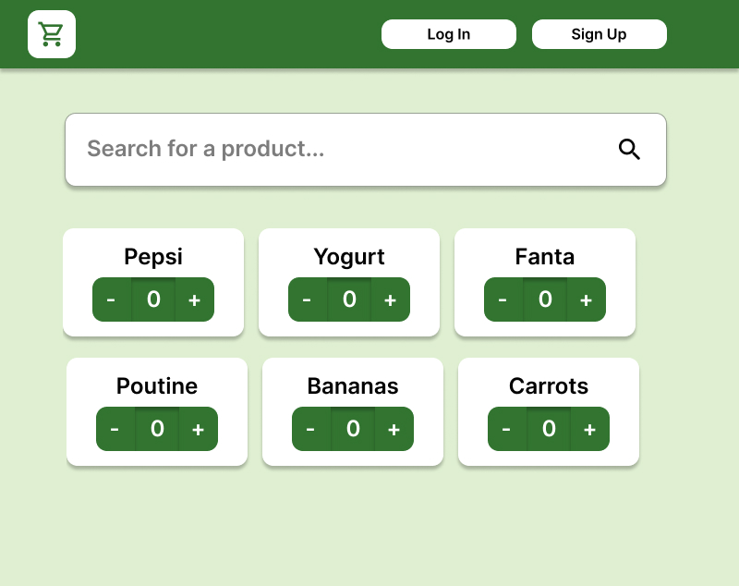

SEARCH RESULTS

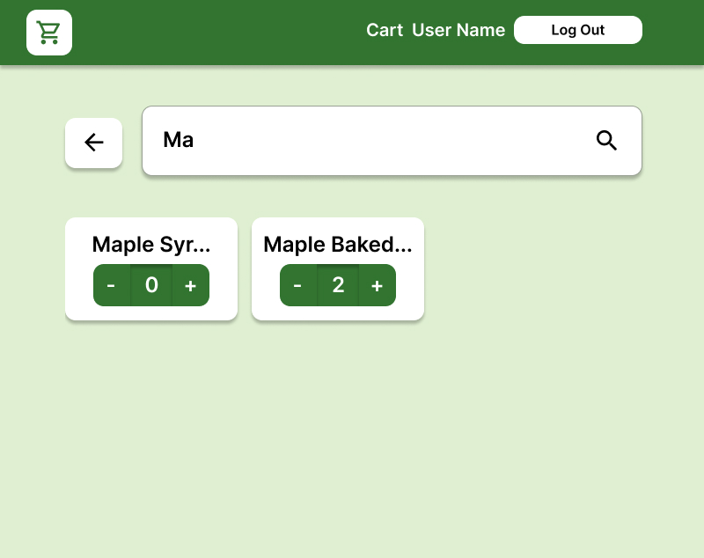

BASKET PAGE

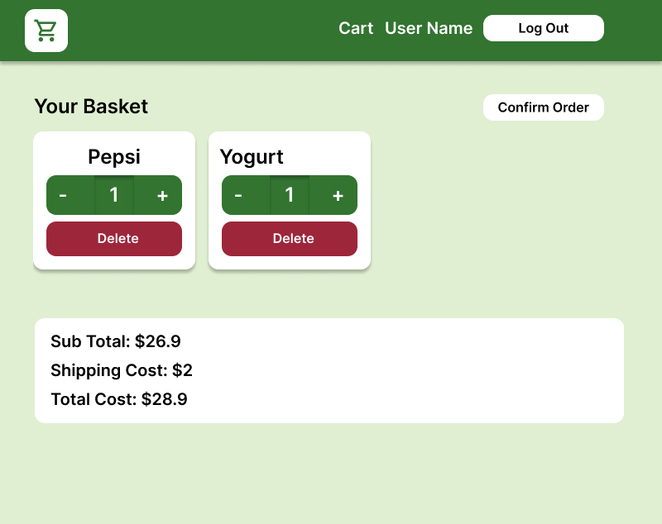

ORDER CONFIRMATION PAGE

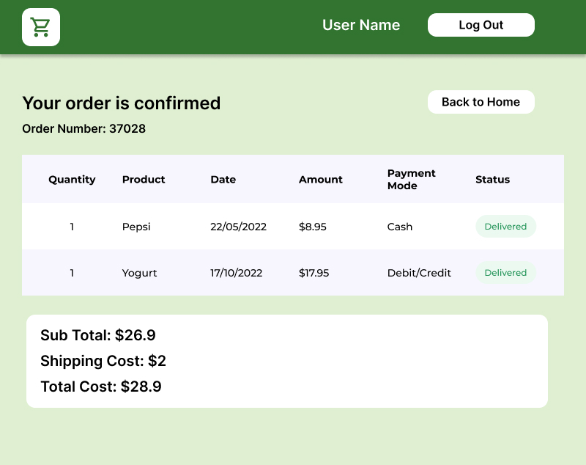

UPDATE USER INFO PAGE

