**Centennial College**

**COMP 228: Java Programming**

**LAB #1 – Java Class**

**Student:** 301318212 Ikramuddin, Syed

Due Date: Week 3

References: Learning materials for week 1, 2, textbook, and other references (if any)

Purpose: The purpose of this Lab assignment is to:

* Practice the use Java classes, Java methods, and other concepts taught.

This material provides the necessary information you need to complete the exercises.

Be sure to read the following general instructions carefully:

This lab should be completed individually by all the students.

YOU NEED TO SUBMIT THE FOLLOWING 2 DOCUMENTS IN THE DROPBOX TITLED LAB1:

1. THE FIRST ONE IS A WORD DOCUMENT. USE THIS DOCUMENT AS YOUR FIRST DELIVERABLE. DO NOT DELETE THE INSTRUCTIONS OR QUESTIONS. AT THE END OF THIS DOCUMENT SIMPLY ADD SCREEN SHOTS OF THE RUNNING STATE OF EACH EXERCISE (If there are more than 1 exercise). THE SCREEN SHOTS SHOULD COVER ALL THE ASPECTS/FUNCTIONALITIES OF EACH EXERCISE (If there are more than 1 exercise).. AFTER THE SCREEN SHOTS PLEASE COPY THE CODE FROM THE CODE WINDOW AND PASTE THE COMPLETE CODE. DO NOT GIVE ME THE SCREEN SHOTS OF THE CODE. DO NOT ZIP THIS FILE AND KEEP IT SEPARATE FROM YOUR ZIPPED PROGAM FOLDER.
2. SUBMIT ALSO ONE ZIPPED PROJECT FOLDER/FILE THAT CONTAINS ALL THE EXERISES (If there are more than 1 exercise) SEPARATELY INTO THE SAME DROP BOX.

You must name your Eclipse/IntelliJ project according to the following rule:

**YourFullName_COMP228Labnumber**

Example: **JohSmith_COMP228Lab1**

Each exercise should be placed in a separate package named *exercise1*, *exercise2*, etc.

Submit your assignment in a **zip file** that is named according to the following rule:

**YourLastName_COMP228Labnumber.zip**

Example: **JohSmith_COMP228Lab1.zip**

Apply the naming conventions for variables, methods, classes, and packages:

- *variable names* start with a *lowercase* character

- *classes* start with an *uppercase* character

- **packages** use only *lowercase* characters

- *methods* start with a *lowercase* character

**Exercise 1:**

Write a Java application that creates a Java console application to keep records of singers and displays stored record. Follow the following instructions to develop the application:

Create a class named Singers with the following specifications:

* 5 instance variables that would store the following singer data (Use recommended variable naming conventions and appropriate data type for each instance variable):
  + Singer’s id
  + Singer’s name
  + Singer’s address
  + Date of birth
  + Number of albums published
* Two constructors that would allow you to construct Singer object with no arguments and 5 arguments.
* Create Setters and getters for all the instance variables of class Singer. Make sure to have several setters that would allow you to set the values of individual instance variables of the singer object. Also create one setter that would allow you to set all the values of the instance variables at once. Create several getters that would allow you to get the current individual values of each instance variables of the Singer object.
* Create the driver class that would create 1 Singer (singer1) object with the help of the no argument constructor. Display the default values of the instance variables of this object singer1.
* Set the values of each instance variables with the help of the setter that sets all the values. Display the values.
* Now change the value of each instance variable using setter for each instance variable. Display current value of each after the changes are done. Use getters for each to accomplish this.

**Evaluation:**

|  |  |
| --- | --- |
| **Functionality** |  |
| Correct implementation of classes (instance variable declarations, constructors, getter and setter methods, etc.) | 45% |
| Correct implementation of driver classes (declaring and creating objects, calling their methods, interacting with user, displaying results) | 45% |
| **Friendly input/output** | 10% |
| **Total** | 100% |

Output:

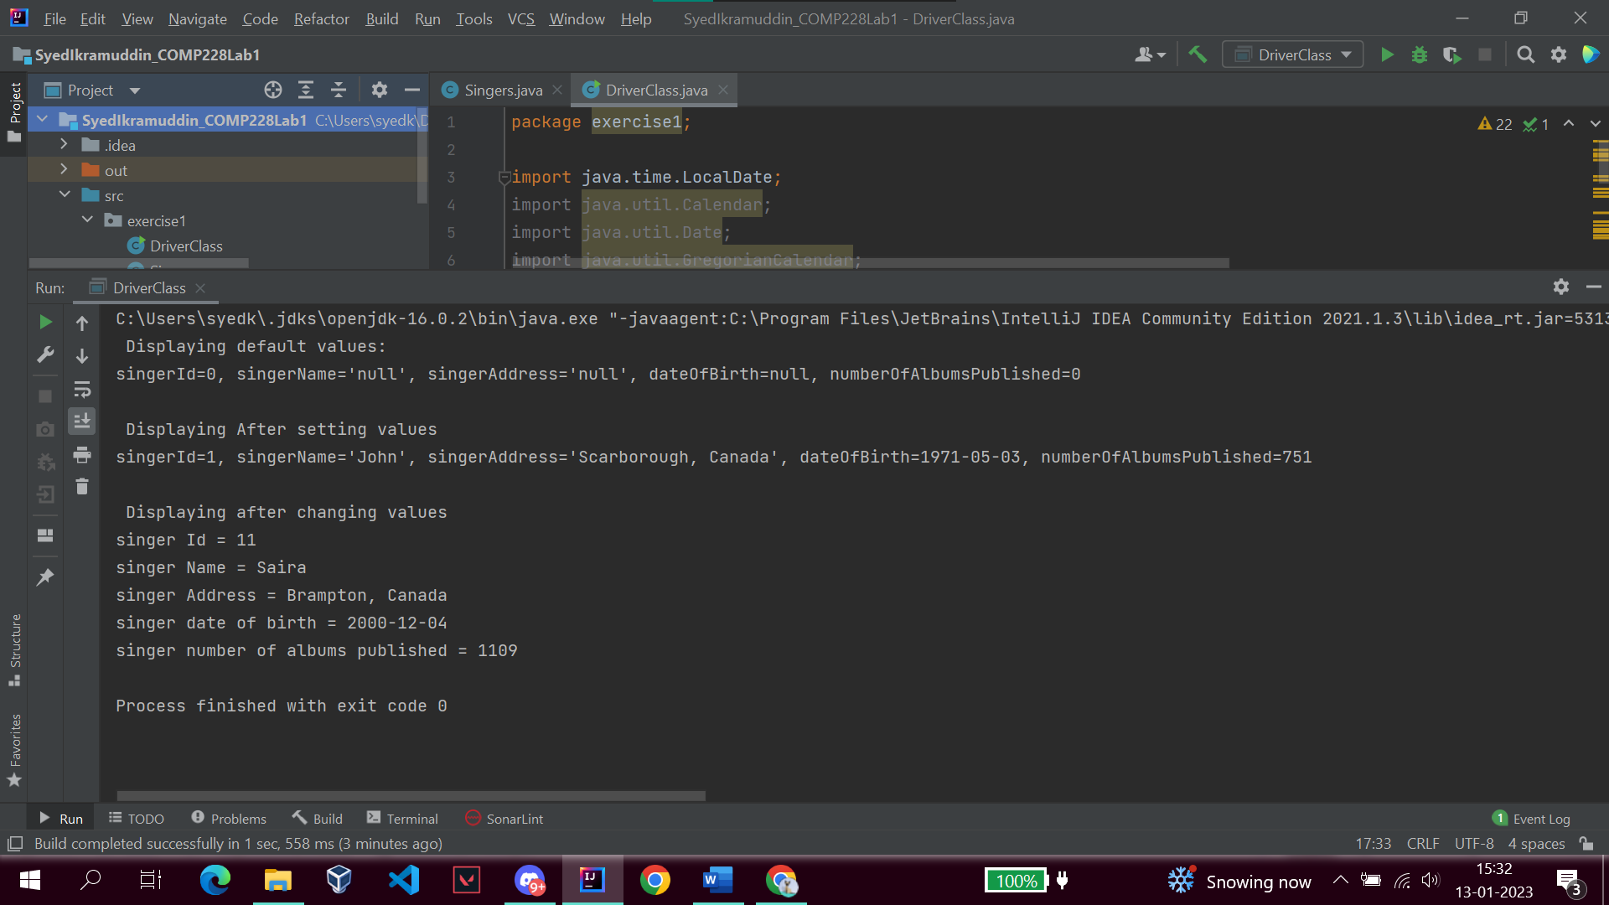

Code:

Singers.java

package exercise1;  
  
import java.time.LocalDate;  
  
public class Singers {  
 int singerId;  
 String singerName;  
 String singerAddress;  
 LocalDate dateOfBirth;  
 int numberOfAlbumsPublished;  
  
 Singers(){}  
  
 Singers(int singerId, String singerName, String singerAddress,  
 LocalDate dateOfBirth, int numberOfAlbumsPublished){  
 this.singerName = singerName;  
 this.singerId = singerId;  
 this.singerAddress = singerAddress;  
 this.dateOfBirth = dateOfBirth;  
 this.numberOfAlbumsPublished = numberOfAlbumsPublished;  
 }  
  
 public int getSingerId() {  
 return singerId;  
 }  
  
 public void setSingerId(int singerId) {  
 this.singerId = singerId;  
 }  
  
 public String getSingerName() {  
 return singerName;  
 }  
  
 public void setSingerName(String singerName) {  
 this.singerName = singerName;  
 }  
  
 public String getSingerAddress() {  
 return singerAddress;  
 }  
  
 public void setSingerAddress(String singerAddress) {  
 this.singerAddress = singerAddress;  
 }  
  
 public LocalDate getDateOfBirth() {  
 return dateOfBirth;  
 }  
  
 public void setDateOfBirth(LocalDate dateOfBirth) {  
 this.dateOfBirth = dateOfBirth;  
 }  
  
 public int getNumberOfAlbumsPublished() {  
 return numberOfAlbumsPublished;  
 }  
  
 public void setNumberOfAlbumsPublished(int numberOfAlbumsPublished) {  
 this.numberOfAlbumsPublished = numberOfAlbumsPublished;  
 }  
  
 public void setSinger(int singerId, String singerName, String singerAddress,  
 LocalDate dateOfBirth, int numberOfAlbumsPublished){  
 this.singerName = singerName;  
 this.singerId = singerId;  
 this.singerAddress = singerAddress;  
 this.dateOfBirth = dateOfBirth;  
 this.numberOfAlbumsPublished = numberOfAlbumsPublished;  
 }  
  
 @Override  
 public String toString() {  
 return  
 "singerId=" + singerId +  
 ", singerName='" + singerName + '\'' +  
 ", singerAddress='" + singerAddress + '\'' +  
 ", dateOfBirth=" + dateOfBirth+  
 ", numberOfAlbumsPublished=" + numberOfAlbumsPublished ;  
 }  
}

DriverClass.java

package exercise1;  
  
import java.time.LocalDate;  
import java.util.Calendar;  
import java.util.Date;  
import java.util.GregorianCalendar;  
import java.util.Locale;  
  
public class DriverClass {  
 public static void main(String [] args){  
 Singers singer1 = new Singers();  
 System.*out*.println(" Displaying default values:");  
 System.*out*.println(singer1);  
  
  
 singer1.setSinger(1,"John","Scarborough, Canada",LocalDate.*of*(1971,05,03),751);  
 System.*out*.println("\n Displaying After setting values");  
 System.*out*.println(singer1);  
  
 singer1.setSingerId(11);  
 singer1.setSingerName("Saira");  
 singer1.setSingerAddress("Brampton, Canada");  
 singer1.setDateOfBirth( LocalDate.*of*(2000,12,04));  
 singer1.setNumberOfAlbumsPublished(1109);  
  
 System.*out*.println("\n Displaying after changing values");  
 System.*out*.println("singer Id = "+ singer1.getSingerId());  
 System.*out*.println("singer Name = "+ singer1.getSingerName());  
 System.*out*.println("singer Address = "+ singer1.getSingerAddress());  
 System.*out*.println("singer date of birth = "+ singer1.getDateOfBirth());  
 System.*out*.println("singer number of albums published = "+ singer1.getNumberOfAlbumsPublished());  
 }  
}