**Centennial College**

**COMP 228: Java Programming**

**LAB #2 – Java Methods**

**Student:** ______________________________________________________________________

Due Date: Week 4.

Purpose: The purpose of this Lab assignment is to:

* Practice the use of instance methods in Java classes
* Practice the use of static methods in Java classes

References: Learning materials for week 3, textbook, and other references (if any)

This material provides the necessary information you need to complete the exercises.

Be sure to read the following general instructions carefully:

- This lab should be completed individually by all the students.

- You will have to demonstrate your solution in a scheduled lab session and submitting the code through **dropbox link on eCentennial**.

You must name your Eclipse project according to the following rule:

**YourFullName_COMP228Labnumber**

Example: **JohSmith_COMP228Lab2**

Each exercise should be placed in a separate package named *exercise1*, *exercise2*, etc.

Submit your assignment in a **zip file** that is named according to the following rule:

**YourLastName_COMP228Labnumber.zip**

Example: **JohSmith_COMP228Lab2.zip**

Apply the naming conventions for variables, methods, classes, and packages:

- *variable names* start with a *lowercase* character

- *classes* start with an *uppercase* character

- **packages** use only *lowercase* characters

- *methods* start with a *lowercase* character

**Exercise 1:**

Write a Java application that simulates a test. The test contains **at least five** questions about first three lectures of this course. Each question should be a multiple-choice question with 4 options.

Design a **Test** class. Use programmer-defined methods to implement your solution. For example:

* create a method to simulate the questions – *simulateQuestion*
* create a method to check the answer – *checkAnswer*
* create a method to display a random message for the user – *generateMessage*
* create a method to interact with the user - *inputAnswer*

Display the questions using methods of ***JOptionPane*** class. Use a loop to show all the questions.

For each question:

* If the user finds the right answer, display a random congratulatory message (“Excellent!”,”Good!”,”Keep up the good work!”, or “Nice work!”).
* If the user responds incorrectly, display an appropriate message and the correct answer (“No. Please try again”, “Wrong. Try once more”, “Don't give up!”, “No. Keep trying..”).
* Use random-number generation to choose a number from 1 to 4 that will be used to select an appropriate response to each answer.
* Use a switch statement to issue the responses, as in the following code:

switch ( randomObject.nextInt( 4 ) )

{

case 0:

return( "Very good!" );

……

}

At the end of the test display the number of correct and incorrect answers, and the percentage of the correct answers.

Your main class will simply create a Test object and start the test by calling **inputAnswer** method.

(5 marks)

**Exercise 2:**

Design a Lotto class with one array instance variable to hold three random integer values (from 1 to 9). Include a constructor that randomly populates the array for a lotto object. Also, include a method in the class to return the array.

Use this class to simulate a simple lotto game in which the user chooses a number between 3 and 27. *The user runs the lotto up to 5 times and each time the sum of lotto numbers is calculated*. *If the number chosen by the user matches the sum*, the user wins and the game ends. *If the number does not match the sum within five rolls*, the computer wins.

Use methods of JOptionPane class to interact with the user.

(3 marks)

**Exercise 3:**

Write a Java class that implements a set of three overloaded static methods. The methods should have different set of parameters and perform similar functionalities. Call the methods within main method and display the results.

(2 marks)

**Evaluation:**

|  |  |
| --- | --- |
| **Functionality** |  |
| Correct implementation of classes (instance variable declarations, constructors, getter and setter methods, etc.) | 40% |
| Correct implementation of driver classes (declaring and creating objects, calling their methods, interacting with user, displaying results) | 40% |
| Comments, correct naming of variables, methods, classes, etc. | 5% |
| **Friendly input/output** | 15% |
| **Total** | 100% |

**Output:**

**Exercise1:**

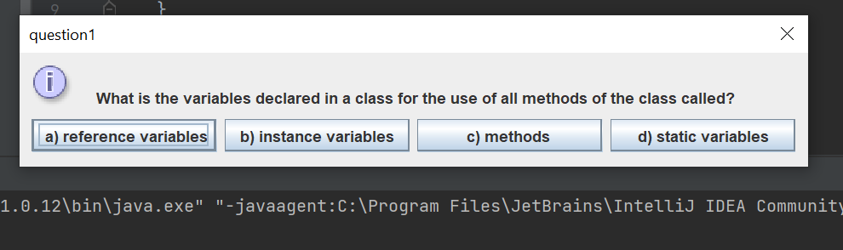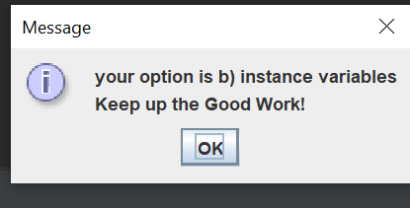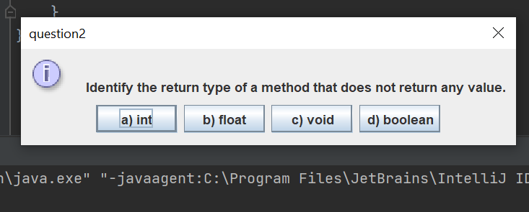

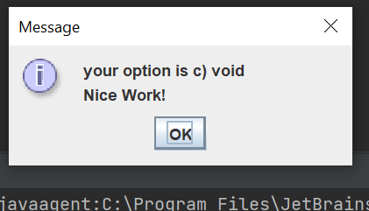

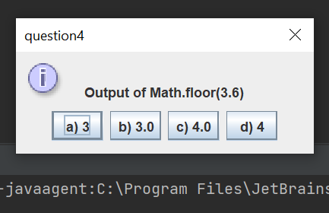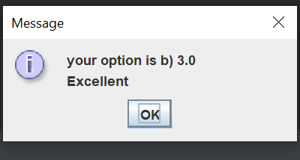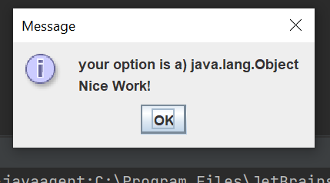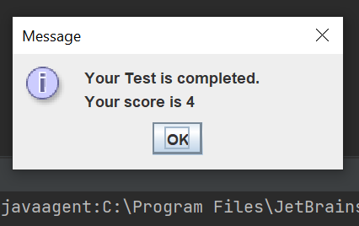

**Exercise2:**

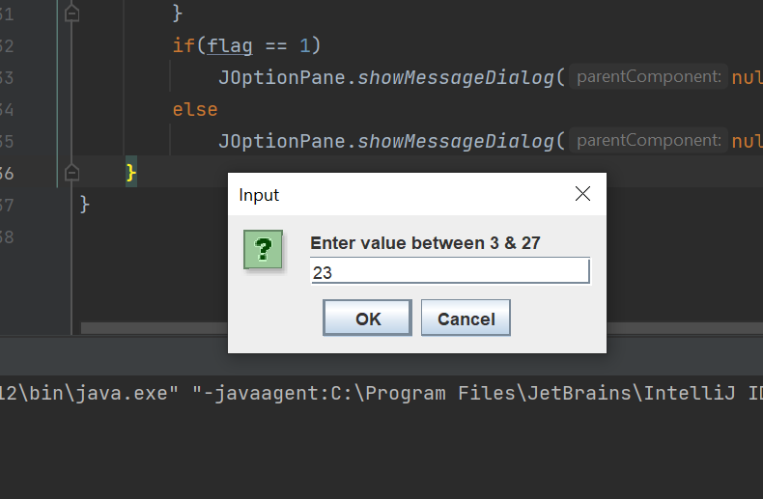

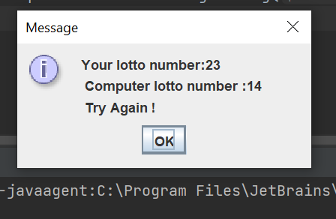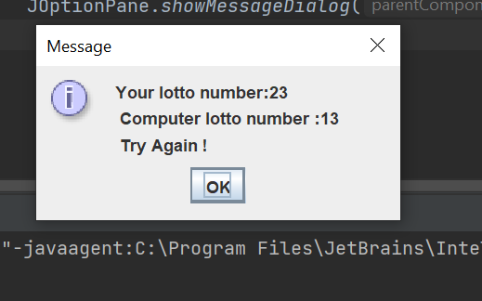

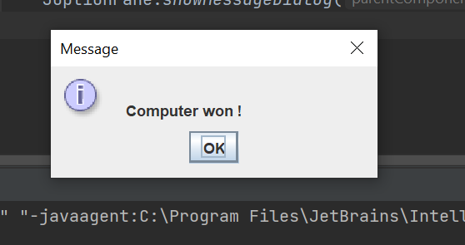

**Exercise3:**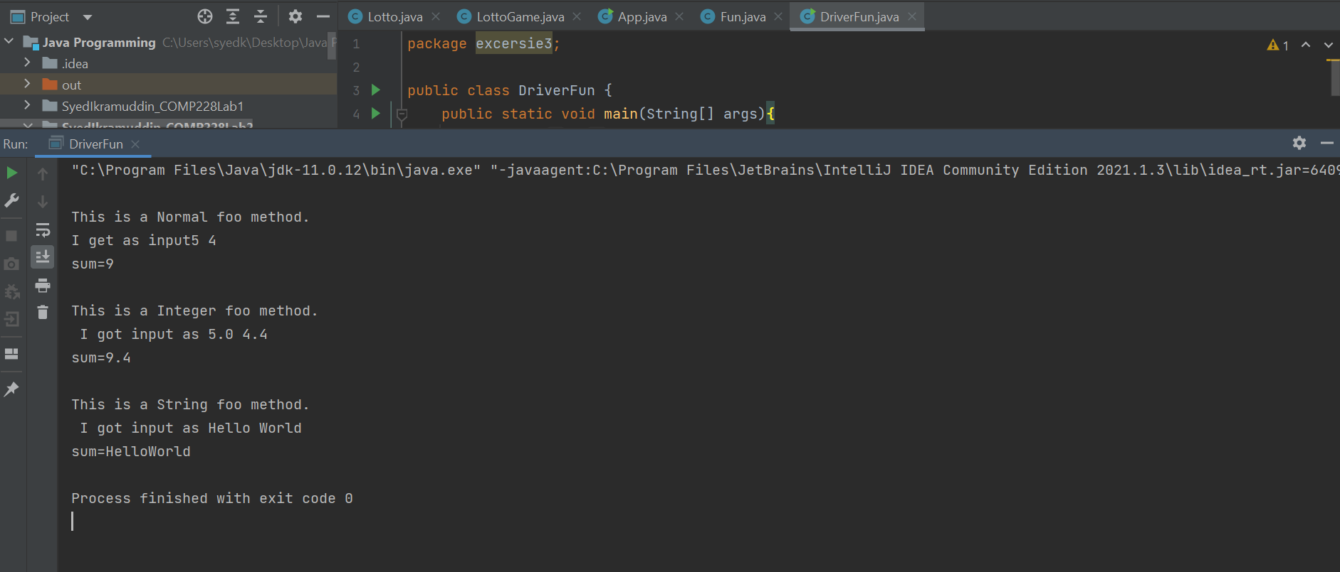

**Code:**

**Exercise1:**

**Question.java**

package excerise1;  
  
public class Question {  
 String prompt;  
 String answer;  
 String[] options;  
  
 Question(){}  
 Question (String prompt, String answer, String[] options){  
 this.prompt = prompt;  
 this.answer = answer;  
 this.options= options;  
 }  
  
 public String[] getOptions() {  
 return options;  
 }  
  
 public void setOptions(String[] options) {  
 this.options = options;  
 }  
  
 public String getPrompt() {  
 return prompt;  
 }  
  
 public void setPrompt(String prompt) {  
 this.prompt = prompt;  
 }  
  
 public String getAnswer() {  
 return answer;  
 }  
  
 public void setAnswer(String answer) {  
 this.answer = answer;  
 }  
}

**Test.java**

package excerise1;  
  
import javax.swing.*;  
  
public class Test {  
 Question question1;  
 Question question2;  
 Question question3;  
 Question question4;  
 Question question5;  
  
 Test(){  
 question1 = new Question(  
 "\n What is the variables declared in a class for the use of all methods of the class called?",  
 "b) instance variables",  
 new String[]{" a) reference variables", "b) instance variables" ,"c) methods ", "d) static variables"});  
 question2 = new Question(  
 "\n Identify the return type of a method that does not return any value.",  
 "c) void", new String[]{"a) int", "b) float", "c) void", "d) boolean"});  
 question3 = new Question(  
 "\n In which of the following is toString() method defined",  
 "a) java.lang.Object",  
 new String[]{"a) java.lang.Object", "b) java.lang.String", "c) java.lang.util", "d) None"});  
 question4 = new Question(  
 "\n Output of Math.floor(3.6)",  
 "b) 3.0",  
 new String[]{"a) 3", "b) 3.0", "c) 4.0", "d) 4"});  
 question5 = new Question(  
 "\n Identify the modifier which cannot be used for constructor",  
 "d) static",  
 new String[]{"a) public", "b) private", "c)protected" ,"d) static"});  
 }  
 Question simulateQuestion(int questionNo){  
 Question tempQuestion =null;  
 switch (questionNo){  
 case 1:  
 tempQuestion = question1;  
 break;  
 case 2:  
 tempQuestion = question2;  
 break;  
 case 3:  
 tempQuestion= question3;  
 break;  
 case 4:  
 tempQuestion= question4;  
 break;  
 case 5:  
 tempQuestion= question5;  
 break;  
 }  
 return tempQuestion;  
  
 }  
  
 int checkAnswer(int option, int questionNo){  
 int flag = 0;  
 if(questionNo == 1){  
 if(question1.options[option].equals(question1.getAnswer()))  
 flag = 1;  
 }  
 else if(questionNo == 2){  
 if(question2.options[option].equals(question2.getAnswer()))  
 flag = 1;  
 }  
 else if(questionNo == 3){  
 if(question3.options[option].equals(question3.getAnswer()))  
 flag = 1;  
 }  
 else if(questionNo == 4){  
 if(question4.options[option].equals(question4.getAnswer()))  
 flag = 1;  
 }  
 else{  
 if(question5.options[option].equals(question5.getAnswer()))  
 flag = 1;  
 }  
 return flag;  
 }  
 String generateMessage(int flag){  
 String[] correct = {"Excellent","Keep up the Good Work!", "Good Job!", "Nice Work!"};  
 String[] wrong = {"Wrong", "Try Again", "No. Please Try Again", "Dont Give Up", "No. Please, keep trying"};  
 double randomNumber = Math.*floor*((Math.*random*() * 10)%4);  
 if(flag == 1){  
 if(randomNumber == 0.0)  
 return correct[0];  
 else if(randomNumber == 1.0)  
 return correct[1];  
 else if(randomNumber == 2.0)  
 return correct[2];  
 else  
 return correct[3];  
 }  
 else{  
 if(randomNumber == 0.0)  
 return wrong[0];  
 else if(randomNumber == 1.0)  
 return wrong[1];  
 else if(randomNumber == 2.0)  
 return wrong[2];  
 else  
 return wrong[3];  
 }  
 }  
 void inputAnswer(){  
 int x, score=0;  
 String message;  
 Question tempQuestion;  
 for(int i=1;i<=5;i++) {  
 tempQuestion = simulateQuestion(i);  
 if(tempQuestion == null)  
 break;  
 String[] options= tempQuestion.getOptions();  
 x = JOptionPane.*showOptionDialog*(null, tempQuestion.getPrompt(),  
 "question" + i,  
 JOptionPane.*DEFAULT_OPTION*, JOptionPane.*INFORMATION_MESSAGE*, null, options, options[0]);  
 message = generateMessage(checkAnswer(x,i));  
 if(checkAnswer(x,i)==1)  
 score++;  
  
 JOptionPane.*showMessageDialog*(null, "your option is " + options[x]+"\n"+ message);  
  
 }  
 JOptionPane.*showMessageDialog*(null,"Your Test is completed.\nYour score is "+score);  
 }  
  
}

**App.java**

package excerise1;  
  
import javax.swing.*;  
  
public class App {  
 public static void main(String[] args){  
 Test demoTest = new Test();  
 demoTest.inputAnswer();  
 }  
}

**Exercise2:**

**Lotto.java**

package excersie2;  
  
import java.util.Random;  
  
public class Lotto {  
 int ranNum1;  
 int ranNum2;  
 int ranNum3;  
 Lotto(){  
 Random random = new Random();  
 this.ranNum1= random.nextInt(9)+1;  
 this.ranNum2= random.nextInt(9)+1;  
 this.ranNum3= random.nextInt(9)+1;  
 }  
  
 public int getRanNum1() {  
 return ranNum1;  
 }  
  
 public void setRanNum1(int ranNum1) {  
 this.ranNum1 = ranNum1;  
 }  
  
 public int getRanNum2() {  
 return ranNum2;  
 }  
  
 public void setRanNum2(int ranNum2) {  
 this.ranNum2 = ranNum2;  
 }  
  
 public int getRanNum3() {  
 return ranNum3;  
 }  
  
 public void setRanNum3(int ranNum3) {  
 this.ranNum3 = ranNum3;  
 }  
}

**LottoGame.java**

package excersie2;  
  
public class LottoGame {  
 Lotto lotto;  
 int lottoNumber;  
 void newLotto(){  
 lotto = new Lotto();  
 lottoNumber = lotto.getRanNum1() + lotto.getRanNum2() + lotto.getRanNum3();  
 }  
 int getLottoNumber(){  
 return lottoNumber;  
 }  
}

**App.java**

package excersie2;  
  
import javax.swing.*;  
  
public class App {  
 public static void main(String[] args){  
 LottoGame lottoGame = new LottoGame();  
 int flag = 0;  
 //lottoGame.newLotto();  
 //System.out.println(lottoGame.getLottoNumber()+" "+ lottoGame.lotto.getRanNum1()+" " +lottoGame.lotto.getRanNum2()+" "+lottoGame.lotto.getRanNum3());  
 //lottoGame.newLotto();  
 //System.out.println(lottoGame.getLottoNumber()+" "+ lottoGame.lotto.getRanNum1()+" " +lottoGame.lotto.getRanNum2()+" "+lottoGame.lotto.getRanNum3());  
 String value = JOptionPane.*showInputDialog*("Enter value between 3 & 27","enter value");  
 int userValue = Integer.*parseInt*(value);  
 String message;  
 for(int i = 0; i < 5; i++){  
 if(userValue <= 3 && userValue >=27){  
 message = "Wrong number: number is not between 3 and 27";  
 JOptionPane.*showMessageDialog*(null,message);  
 continue;  
 }  
 lottoGame.newLotto();  
 if(userValue == lottoGame.getLottoNumber()) {  
 JOptionPane.*showMessageDialog*(null, "Your lotto number:" + userValue +"\n Computer lotto number :"+lottoGame.getLottoNumber()+"\n Number matches ");  
 flag = 1;  
 break;  
 }  
 else{  
 JOptionPane.*showMessageDialog*(null, "Your lotto number:" + userValue +"\n Computer lotto number :"+lottoGame.getLottoNumber()+"\n Try Again !");  
 }  
 }  
 if(flag == 1)  
 JOptionPane.*showMessageDialog*(null, "\n Congratulations ! You won ");  
 else  
 JOptionPane.*showMessageDialog*(null,"\n Computer won !");  
 }  
}

**Exercise3**

**Fun.java**

package excersie3;  
  
public class Fun {  
 static void foo(int x, int y){  
 System.*out*.println("\nThis is a Normal foo method.\nI get as input"+x+" "+y );  
 System.*out*.println("sum="+(x+y));  
 }  
 static void foo(double x,double y){  
 System.*out*.println("\nThis is a Integer foo method.\n I got input as "+x+" "+y);  
 System.*out*.println("sum="+(x+y));  
 }  
 static void foo(String mssg1 ,String mssg2){  
 System.*out*.println("\nThis is a String foo method.\n I got input as "+mssg1+" "+mssg2);  
 System.*out*.println("sum="+mssg1+mssg2);  
 }  
}

**DriverFun.java**

package excersie3;  
  
public class DriverFun {  
 public static void main(String[] args){  
 Fun.*foo*(5,4);  
 Fun.*foo*(5.0,4.4);  
 Fun.*foo*("Hello","World");  
 }  
}