**Centennial College**

**COMP 228: Java Programming**

**LAB #4 – Developing UI using JavaFx**

**Studen**t: **_____________________________________________________________________**

Due Date: **Week 10**.

Purpose: The purpose of this Lab assignment is to:

1. Practice the use of JavaFx GUI event handling

References: Learning materials for weeks 7 and 8, textbook, and other references (if any)

Be sure to read the following general instructions carefully:

This lab should be completed individually by all the students.

YOU NEED TO SUBMIT THE FOLLOWING 2 DOCUMENTS IN THE DROPBOX TITLED LAB4:

1. THE FIRST ONE IS A WORD DOCUMENT. USE THIS DOCUMENT AND ADD SCREEN SHOTS OF THE RUNNING STATE OF EACH EXERCISE (If there are more than 1 exercise). DO NOT DELETE THE QUESTIONS. THE SCREEN SHOTS SHOULD FOLLOW EACH QUESTION AND COVER ALL THE ASPECTS/FUNCTIONALITIES OF EACH EXERCISE. AFTER THE SCREEN SHOTS PLEASE COPY THE CODE FROM THE CODE WINDOW AND PASTE THE COMPLETE CODE. DO NOT GIVE ME SCREEN SHOTS OF THE CODE. DO NOT ZIP THIS FILE AND KEEP IT SEPARATE FROM YOUR ZIPPED PROGAM FILE.

2. SUBMIT ALSO ONE ZIPPED PROJECT FILE THAT CONTAINS ALL THE EXERISES SEPARATELY INTO THE SAME DROP BOX.

This material provides the necessary information you need to complete the exercises.

You must name your Eclipse project according to the following rule:

**YourFullName_COMP228Labnumber**

Example: **JohSmith_COMP228Lab4**

Each exercise should be placed in a separate package named *exercise1*, *exercise2*, etc.

Submit your assignment in a **zip file** that is named according to the following rule:

**YourLastName_COMP228Labnumber.zip**

Example: **JohSmith_COMP228Lab4.zip**

Apply the naming conventions for variables, methods, classes, and packages:

- *variable names* start with a *lowercase* character

- *classes* start with an *uppercase* character

- **packages** use only *lowercase* characters

- *methods* start with a *lowercase* character

## Exercise 1

Write a Java application using JavaFx which allows the user to enter student information (see the sample design below).

#### 

#### The user will enter *full* *name*, *address,* *city, province, postal code, phone number and email* in *text field* controls. The student’s *major* (Computer Science or Business) will be selected from two *radio buttons*.

#### A combo box will display the list of *courses* for each program whenever the user selects the desired program.

#### A course will be added to a *list box w*henever the user selects a course from the corresponding combo box. Make sure that the user cannot add a course several times.

Additional information about the student will be provided from a group of *check boxes* (such as involvement in various activities, etc).

All the information about the student will be displayed in a text *area* component. Use simple JavaFX layout managers, such as FlowPane, BorderPane, and GridPane to create the JavaFX GUI of this application.

(10 marks)

**Evaluation:**

|  |  |
| --- | --- |
| **Functionality** |  |
| Correct implementation of UI | 40% |
| Correct implementation of event handling and display of results | 40% |
| Comments, correct naming of variables, methods, classes, etc. | 5% |
| **Friendly input/output** | 15% |
| **Total** | 100% |

**Output:**

Enter input and displaying on text area.

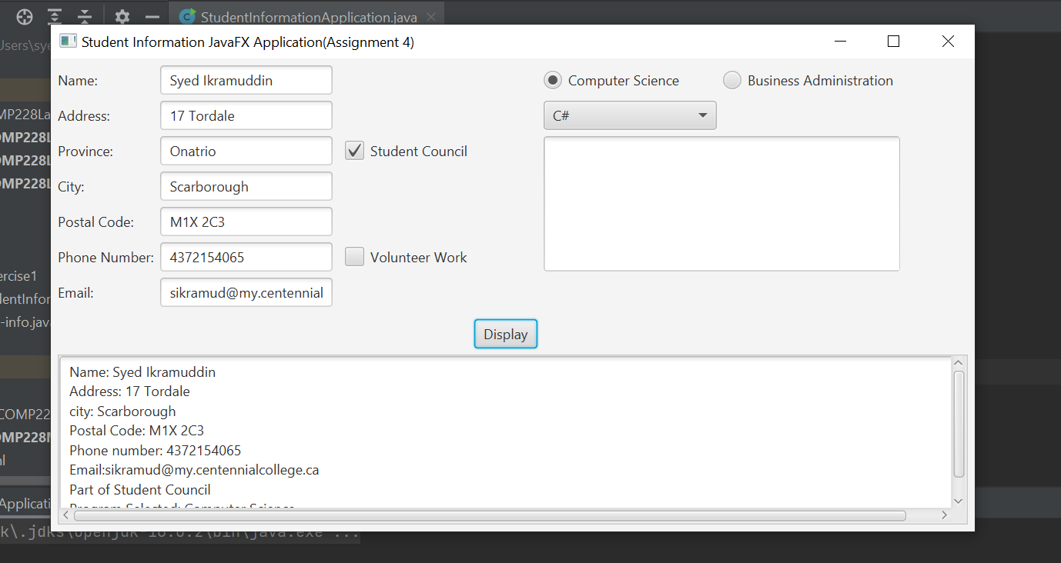

Displaying computer science Courses

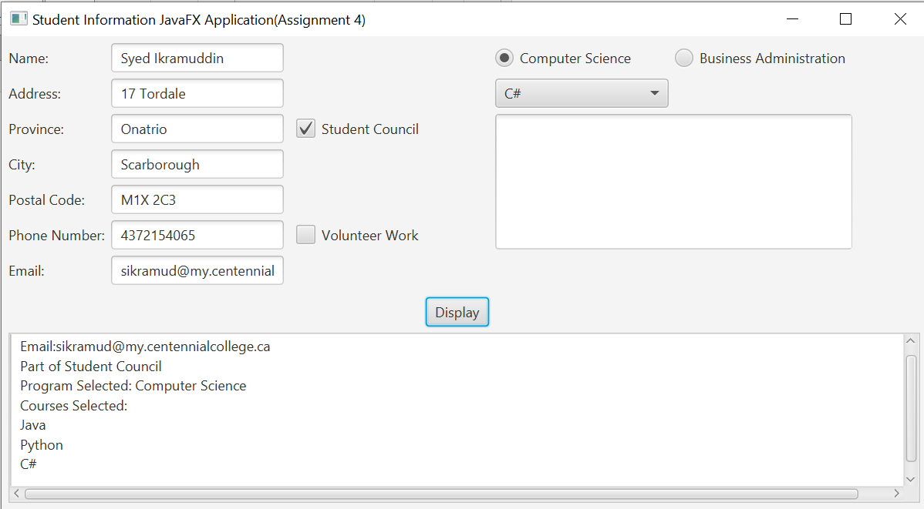

Selecting business administration and Selecting business communication twice but the course is added to list only once.

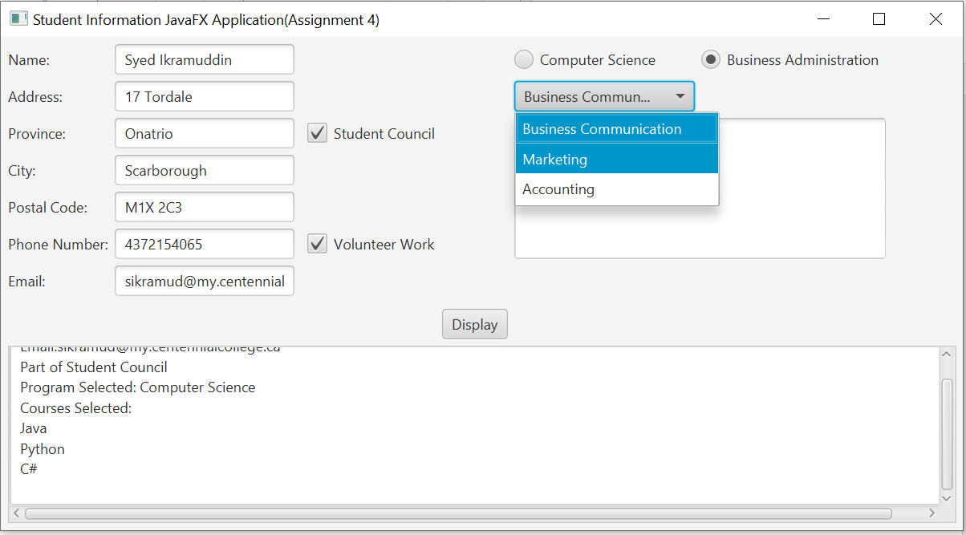

Once we display the courses selected is cleared, the list where we add courses is also cleared and the text area we display is also cleared.

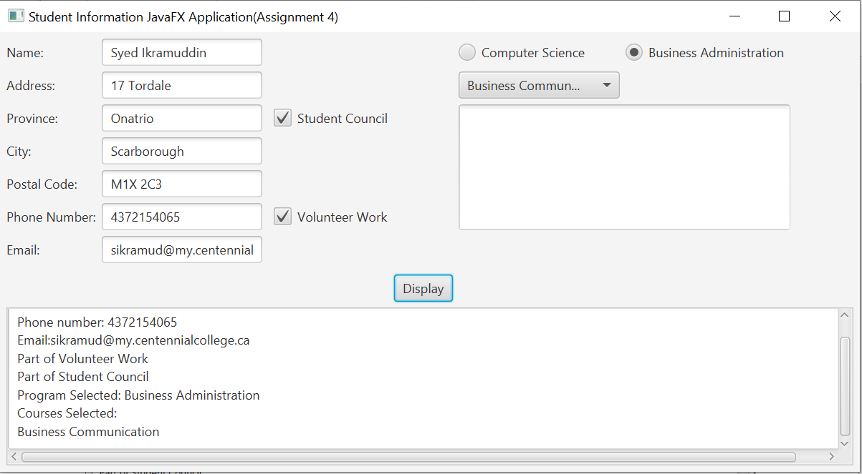

package com.exercise1;

import javafx.application.Application;

import javafx.collections.FXCollections;

import javafx.geometry.Insets;

import javafx.scene.Scene;

import javafx.scene.control.*;

import javafx.scene.layout.GridPane;

import javafx.scene.layout.StackPane;

import javafx.stage.Stage;

import javafx.scene.control.CheckBox;

import java.util.ArrayList;

import java.util.List;

public class StudentInformationApplication extends Application {

TextField nameField;

TextField addressField;

TextField provinceField;

TextField cityField;

TextField postalCodeField;

TextField phoneNumbeField;

TextField emailField;

CheckBox studentCouncilCheck;

CheckBox volunteerWorkCheck;

RadioButton computerScienceBtn;

RadioButton businessSchoolBtn;

ComboBox coursesBox;

TextArea coursesArea;

Button displayButton;

TextArea displayArea;

@Override

public void start(Stage stage) throws Exception {

GridPane gridPane = new GridPane();

gridPane.setPadding(new Insets(6,6,6,6));

gridPane.setHgap(5);

gridPane.setVgap(5);

gridPane.add(new Label("Name:"),0,0);

nameField = new TextField();

gridPane.add(nameField, 1,0);

gridPane.add(new Label("Address:"),0,1);

addressField = new TextField();

gridPane.add(addressField,1,1);

gridPane.add(new Label("Province:"),0,2);

provinceField = new TextField();

gridPane.add(provinceField,1,2);

gridPane.add(new Label("City:"),0,3);

cityField = new TextField();

gridPane.add(cityField,1,3);

gridPane.add(new Label("Postal Code:"),0,4);

postalCodeField = new TextField();

gridPane.add(postalCodeField,1,4);

gridPane.add(new Label("Phone Number:"),0,5);

phoneNumbeField = new TextField();

gridPane.add(phoneNumbeField,1,5);

gridPane.add(new Label("Email:"),0,6);

emailField = new TextField();

gridPane.add(emailField,1,6);

displayButton = new Button("Display");

gridPane.add(displayButton,5,8);

studentCouncilCheck = new CheckBox();

gridPane.add(studentCouncilCheck,3,2);

gridPane.add(new Label("Student Council"),4,2);

volunteerWorkCheck = new CheckBox();

gridPane.add(volunteerWorkCheck,3,5);

gridPane.add(new Label("Volunteer Work"),4,5);

computerScienceBtn = new RadioButton("Computer Science");

computerScienceBtn.setText("Computer Science");

gridPane.add(computerScienceBtn,6,0);

//gridPane.add(new Label("Computer Science"),7,0);

businessSchoolBtn = new RadioButton("Business Administration");

businessSchoolBtn.setText("Business Administration");

gridPane.add(businessSchoolBtn,8,0,1,1);

//gridPane.add(new Label("Business Administration"),9,0,1,1);

ToggleGroup subject = new ToggleGroup();

computerScienceBtn.setToggleGroup(subject);

businessSchoolBtn.setToggleGroup(subject);

coursesBox = new ComboBox();

coursesBox.setPrefWidth(150);

gridPane.add(coursesBox,6,1,2,1);

computerScienceBtn.setOnAction(actionEvent -> {

String[] courses = new String[]{"Java", "Python", "C#","Software Engineering"};

coursesBox.setItems(FXCollections.observableArrayList(courses));

});

businessSchoolBtn.setOnAction(actionEvent -> {

String[] courses= new String[]{"Business Communication","Marketing","Accounting"};

coursesBox.setItems(FXCollections.observableArrayList(courses));

});

List<String> selectedCourses = new ArrayList<String>();

final String[] displayCourses = {""};

coursesArea = new TextArea();

coursesArea.setPrefWidth(200);

coursesArea.setPrefHeight(100);

coursesArea.setEditable(false);

gridPane.add(coursesArea,6,2,4,4);

coursesBox.setOnAction(actionEvent -> {

if(coursesBox.getValue() == null){

return;

}

if(selectedCourses.contains(coursesBox.getValue().toString())){

return;

}

selectedCourses.add(coursesBox.getValue().toString());

displayCourses[0] += coursesBox.getValue().toString()+"\n";

coursesArea.setText(displayCourses[0]);

});

ScrollPane scrollPane = new ScrollPane();

displayArea = new TextArea();

displayArea.setPrefColumnCount(10);

displayArea.setPrefRowCount(4);

displayArea.setPrefHeight(150);

displayArea.setPrefWidth(800);

displayArea.setEditable(false);

scrollPane.setContent(displayArea);

gridPane.add(scrollPane,0,9,11,11);

displayButton.setOnAction(actionEvent -> {

String subjectValue = "";

String subjects= "";

String checkBoxContent = "";

if(volunteerWorkCheck.isSelected()){

checkBoxContent+= "Part of Volunteer Work"+"\n";

}

if(studentCouncilCheck.isSelected()){

checkBoxContent += "Part of Student Council"+"\n";

}

if(computerScienceBtn.isSelected()){

subjectValue+= "Computer Science";

}

if(businessSchoolBtn.isSelected()){

subjectValue+= "Business Administration";

}

for (String value: selectedCourses) {

subjects += value+"\n";

}

String displayText ="Name: "+nameField.getText()+"\n"+

"Address: "+addressField.getText()+"\n"+

"city: "+cityField.getText()+"\n"+

"Postal Code: "+postalCodeField.getText()+"\n"+

"Phone number: "+phoneNumbeField.getText()+"\n"+

"Email:"+emailField.getText()+"\n"+

checkBoxContent+

"Program Selected: "+subjectValue+"\n"+

"Courses Selected:"+"\n"+subjects;

displayArea.setText(displayText);

selectedCourses.clear();

coursesArea.clear();

displayCourses[0] = "";

});

StackPane root=new StackPane();

root.getChildren().add(gridPane);

Scene scene=new Scene(root,800,410);

stage.setTitle("Student Information JavaFX Application(Assignment 4)");

stage.setScene(scene);

stage.show();

}

public static void main(String[] args) {

launch(args);

}

}