**Centennial College**

**COMP 228: Java Programming**

**Hands-on Midterm Test**

**Student:** ________________________________________________________________

**Be sure to read the following general instructions carefully:**

* **This lab test must be completed individually by all the students.**
* **Save your program periodically just in case that your PC crashes.**

YOU NEED TO SUBMIT THE FOLLOWING 2 DOCUMENTS IN THE DROPBOX TITLED MidTermTest:

1. THE FIRST ONE IS A WORD DOCUMENT. USE THIS DOCUMENT AND ADD SCREEN SHOTS OF THE RUNNING STATE OF THE APPLICATION. DO NOT DELETE THE QUESTIONS. THE SCREEN SHOTS SHOULD COVER ALL THE ASPECTS/FUNCTIONALITIES OF THE APPLICATION. AFTER THE SCREEN SHOTS PLEASE COPY THE CODE FROM THE CODE WINDOW AND PASTE THE COMPLETE CODE INTO THE SAME WORD DOCUMENT. DO NOT GIVE ME SCREEN SHOTS OF THE CODE. DO NOT ZIP THIS FILE AND KEEP IT SEPARATE FROM YOUR ZIPPED PROGAM FILE.

2. SUBMIT ALSO ONE ZIPPED PROJECT/PROGRAM FILE THAT CONTAINS THE PROJECT IN ITS ENTIRITY SEPARATELY INTO THE SAME DROP BOX.

You must name your Eclipse/IntelliJ project and your Word file according to the following rule:

YourFullName_COMP228MidLabTest

Example: JohSmith_COMP228MidLabTest

Apply the naming conventions for variables, methods, classes, and packages:

- variable names start with a lowercase character

- classes start with an uppercase character

- packages use only lowercase characters

- methods start with a lowercase character

##### Exercise 1

Create an abstract class called *Book*. The class should declare the following variables:

* an instance variable that describes the *title* - String
* an instance variable that describes the *ISBN* - String
* an instance variable that describes the *publisher* - String
* an instance variable that describes the *price* - double
* an instance variable that describes the *year – integer*

Provide a toString() method that returns the information stored in the above variables.

Create the **getter** and **setter** methods for each instance variable except *price*. Provide the necessary constructors. Include *an* ***abstract*** *method* ***setPrice(double price)*** *to determine the price* for a book. Include an abstract method **getGenre()** to return the genre of the book.

Create two subclasses called *ScienceBook* and *ChildrenBook*.

Book

ChildrenBook

ScienceBook

These subclasses should override the abstract methods *setPrice* and *getGenre* of class *Book*.

Use the following rule for setting the price for a book:

* + science books will have a 10% discount per each book
  + children books will have a fixed price (specified by user).

Write a driver program (another class with **main** method) that uses the above hierarchy. In your driver program you must implement an interaction with the user.

* Use showInputDialog method to let the user input book information.
* Use showMessageDialog method to display book information including price and type for both science and children’s books.

**Evaluation:**

|  |  |
| --- | --- |
| **Functionality** |  |
| Correct implementation of classes (instance variable declarations, constructors, getter and setter methods, etc.)  Correct implementation of Inheritance/Polymorphism | 30%  20% |
| Correct implementation of driver classes (declaring and creating objects, calling their methods, interacting with user, displaying results) | 35% |
| Comments, correct naming of variables, methods, classes, etc. | 5% |
| **Friendly input/output** | 10% |
| **Total** | 100% |

**Screenshots:**

**Output:**

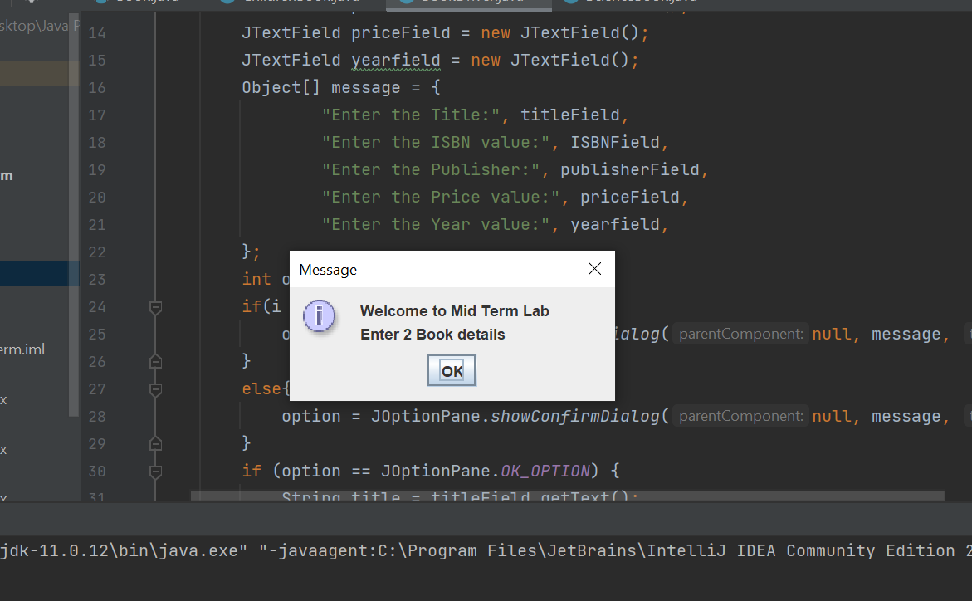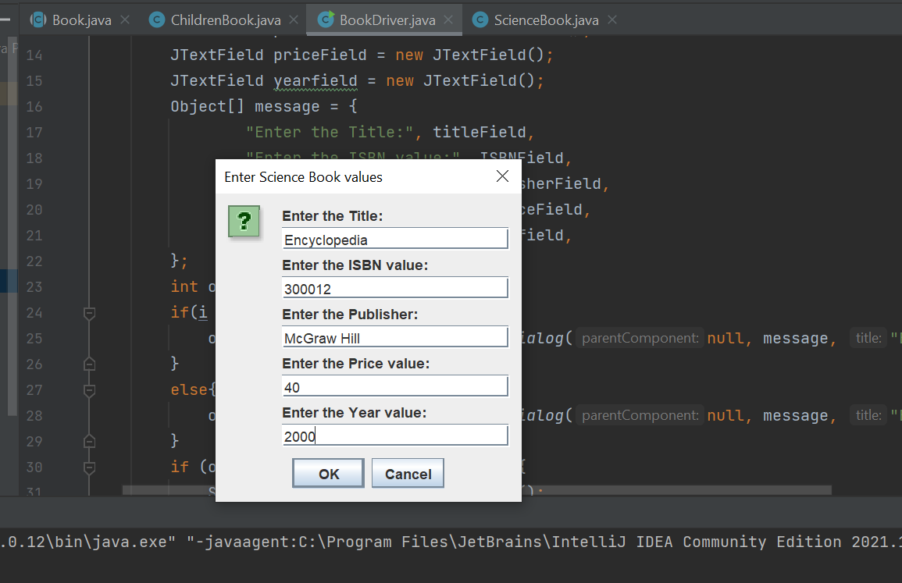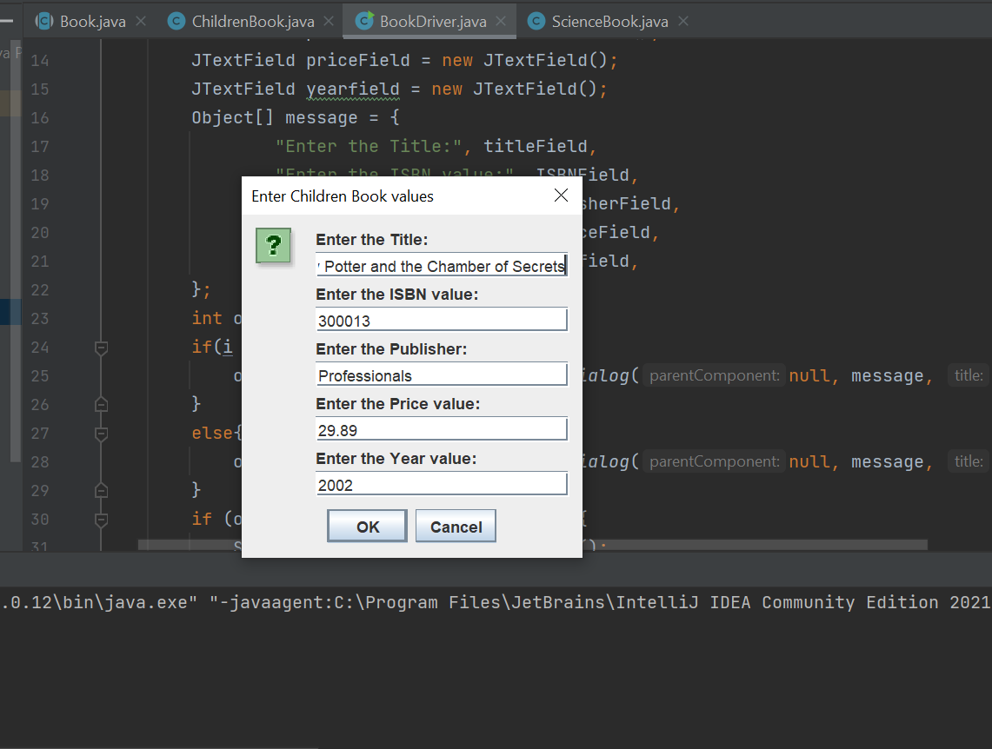

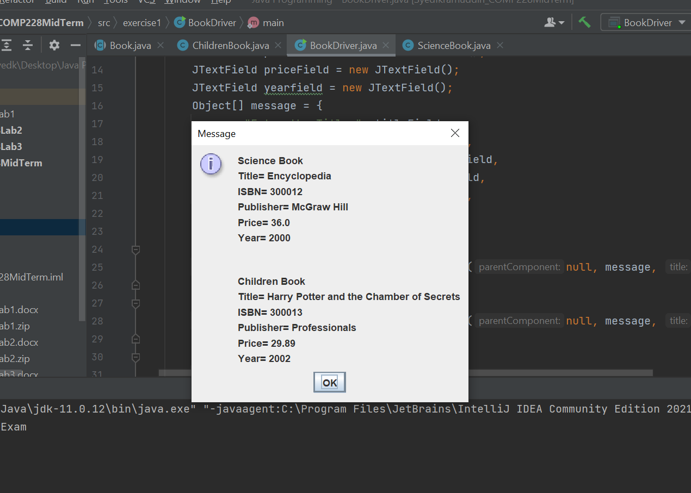

**Code:**

**Book.java**

package exercise1;

public abstract class Book {

String title;

String ISBN;

String publisher;

double price;

int year;

public Book(String title, String ISBN, String publisher, int year) {

this.title = title;

this.ISBN = ISBN;

this.publisher = publisher;

this.year = year;

}

public String getTitle() {

return title;

}

public void setTitle(String title) {

this.title = title;

}

public String getISBN() {

return ISBN;

}

public void setISBN(String ISBN) {

this.ISBN = ISBN;

}

public String getPublisher() {

return publisher;

}

public void setPublisher(String publisher) {

this.publisher = publisher;

}

public int getYear() {

return year;

}

public void setYear(int year) {

this.year = year;

}

public abstract void setPrice(double price);

public abstract String getGenre();

@Override

public String toString() {

return "\nTitle= " + title +

"\nISBN= " + ISBN +

"\nPublisher= " + publisher +

"\nPrice= " + price +

"\nYear= " + year;

}

}

**ScienceBook.java**

package exercise1;

public class ScienceBook extends Book {

public ScienceBook(String title, String ISBN, String publisher, int year) {

super(title, ISBN, publisher, year);

}

@Override

public void setPrice(double price) {

this.price = price - (price*0.1);

}

@Override

public String getGenre() {

return "Science";

}

}

**ChildrenBook.java**

package exercise1;

public class ChildrenBook extends Book{

public ChildrenBook(String title, String ISBN, String publisher, int year) {

super(title, ISBN, publisher, year);

}

@Override

public void setPrice(double price) {

this.price = price;

}

@Override

public String getGenre() {

return "Children";

}

}

**BookDriver.java**

package exercise1;

import javax.swing.*;

public class BookDriver {

public static void main(String[] args){

System.out.println("Welcome to MidTermExam");

JOptionPane.showMessageDialog(null, "Welcome to Mid Term Lab \nEnter 2 Book details");

Book[] book= new Book[2];

for(int i = 0; i<2; i++) {

/*

String titleField = JOptionPane.showInputDialog("Enter the Title:");

String ISBNField = JOptionPane.showInputDialog("Enter the ISBN value:");

String publisherField = JOptionPane.showInputDialog("Enter the Publisher:");

String priceField = JOptionPane.showInputDialog("Enter the Price:");

String yearfield = JOptionPane.showInputDialog("Enter the Year value:");

*/

// Here we are taking input all at once

JTextField titleField = new JTextField();

JTextField ISBNField = new JTextField();

JTextField publisherField = new JTextField();

JTextField priceField = new JTextField();

JTextField yearfield = new JTextField();

Object[] message = {

"Enter the Title:", titleField,

"Enter the ISBN value:", ISBNField,

"Enter the Publisher:", publisherField,

"Enter the Price value:", priceField,

"Enter the Year value:", yearfield,

};

int option;

if(i == 0){

option = JOptionPane.showConfirmDialog(null, message, "Enter Science Book values", JOptionPane.OK_CANCEL_OPTION);

}

else{

option = JOptionPane.showConfirmDialog(null, message, "Enter Children Book values", JOptionPane.OK_CANCEL_OPTION);

}

if (option == JOptionPane.OK_OPTION) {

String title = titleField.getText();

String ISBN = ISBNField.getText();

String publisher = publisherField.getText();

double price = Double.parseDouble(priceField.getText());

int year = Integer.parseInt(yearfield.getText());

if(i == 0){

book[i] = new ScienceBook(title, ISBN, publisher,year);

book[i].setPrice(price);

}

else{

book[i] = new ChildrenBook(title, ISBN, publisher, year);

book[i].setPrice(price);

}

//JOptionPane.showMessageDialog(null, title + " " + ISBN + " " + publisher + " " + price + " " + year);

}

else {

JOptionPane.showMessageDialog(null,"You clicked cancel!");

continue;

}

}

JOptionPane.showMessageDialog(null, book[0].getGenre()+" Book"+ book[0]+"\n\n\n"

+book[1].getGenre()+" Book"+ book[1]);

}

}