CENTENNIAL COLLEGE
COMP 228: JAVA PROGRAMMING
FINAL TEST (LAB PART)
Full Marks: 100

NAME: _____________________________________________________________________
STUDENT ID: _______________________________________________________________

Please read the following instructions before you do anything:
You must submit 2 documents in the drop box titled FinalLabTest:

- MS Word document:
You should take the required screen shots of the application as instructed in the space provided. The screenshots should be followed by the complete code that you would use to develop this application.

You must COPY the code used from the code window and paste the entire code into the Word document AFTER ALL the screen shots as per instructions.

DO NOT zip the Word document.

DO NOT submit any file format other than MS Word document.

- The Java zipped application:
Submit your complete zipped Java application folder in the same drop box.

Exercise - The Tasks:

- Develop a Java GUI application using JavaFx library that will connect to the Centennial College database REMOTELY and interact with an Oracle database table Doctor that has the following specifications:

The database table: Doctor
- Create an Oracle database table named Doctor using Oracle SQL Developer. The table Doctor should have the following fields:
- DocId (that represents doctor’s id, use appropriate data type, primary key).
- DocName (that represents doctor’s name, use appropriate data type).
- DocGrSal (that represents doctor’s gross monthly salary, use appropriate data type).
- Insert 5 rows of data into table Doctor. Use your own customized data (Include your name as the first DocName). Other data should be realistic in nature.)

Provide below a screenshot that displays the contents of the Oracle database table named Doctor. [15 marks]

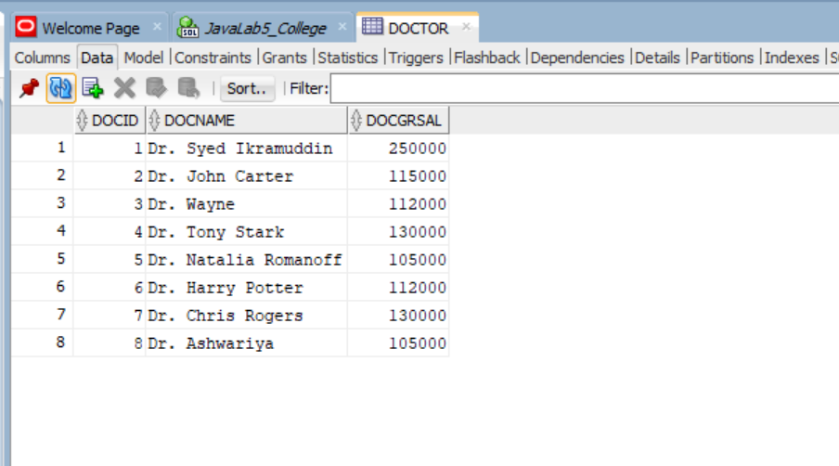

Provide below the code used to create the table Doctor and the code that you used to insert 5 rows of date into the table Doctor. [15 marks]

CREATE TABLE Doctor (
DocId NUMBER (6) PRIMARY KEY,
DocName VARCHAR (35) NOT NULL,
DocGrSal NUMBER (8,2) NOT NULL
);

INSERT INTO Doctor (DocId, DocName, DocGrSal) VALUES (1,'Dr. Syed Ikramuddin',120000);
INSERT INTO Doctor (DocId, DocName, DocGrSal) VALUES (2,'Dr. John Carter',115000);
INSERT INTO Doctor (DocId, DocName, DocGrSal) VALUES (3,'Dr. Wayne',112000);
INSERT INTO Doctor (DocId, DocName, DocGrSal) VALUES (4,'Dr. Tony Stark',130000);
INSERT INTO Doctor (DocId, DocName, DocGrSal) VALUES (5,'Dr. Natalia Romanoff',105000);
INSERT INTO Doctor (DocId, DocName, DocGrSal) VALUES (6,'Dr. Harry Potter',112000);
INSERT INTO Doctor (DocId, DocName, DocGrSal) VALUES (7,'Dr. Chris Rogers',130000);
INSERT INTO Doctor (DocId, DocName, DocGrSal) VALUES (8,'Dr. Ashwariya',105000);

COMMIT;

- In the JavaFx GUI application:

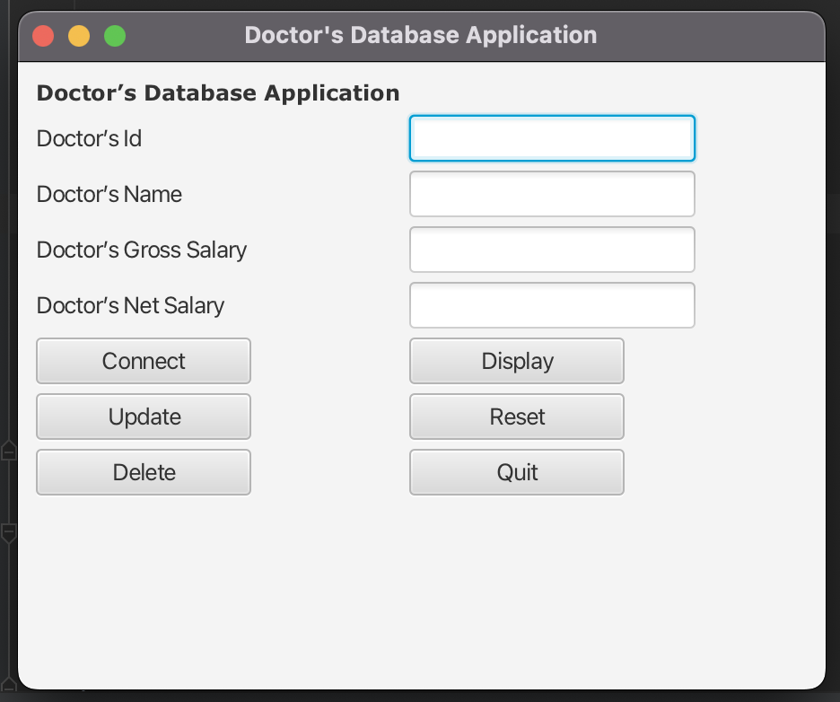
- Create a well-organized user interface as shown above with the help of an appropriate pane manager that has:
- A label that reads Doctor’s Database.
- A label that reads: Doctor’s Id.
- A text field: this field will let the user put a doctor’s id that will be queried.
- A label that reads: Doctor’s Name.
- A text field that displays the name of the doctor retrieved from the database table Doctor that relates to the doctor’s Id entered. No one should be able to modify the contents of this field.
- A label that reads Doctor’s Gross Salary.
- A text field: this field will display the doctor’s gross salary retrieved from the database table Doctor that relates to the doctor’s Id entered. Make this one editable. You may enter a new value and click the Update button and the new gross salary will replace the old one in the database table Doctor.
- A label that reads Doctor’s Net Salary.
- A text field: This content of this field is not a part of the database table Doctor. This field will contain the value of net salary of a doctor that will be calculated from the database table Doctor’s Gross Salary as per doctor’s Id entered. No one should be able to modify the contents of this field. For a particular doctor’s ID. If you update the gross salary, the net salary will change accordingly.
The net salary should be calculated using the following formula:
Net Salary = Gross Salary - (Gross Salary * .3)
e.g., If the gross salary is $100, the net salary should be
100 – (100 *.3) = 70
- A button that reads Connect: When you click this button the Centennial database will be connected to your application and a message box will confirm the user that the connection attempt was successful.
- A button Display: Displays a Record. If you put a valid doctor’s Id and click this button AFTER the connection is established, it would display the doctor’s entire record (Name, Gross Salary, and the calculated net salary) that corresponds to the doctor’s Id entered. Please do not forget to handle exception for invalid doctor’s Id with an appropriate message.
- A button that reads Update. If you change the gross salary and click this button, the gross salary of the currently displayed doctor’s ID will be updated in the database table.
- A button that reads Reset. If you click this button, it will clear the contents of all the text fields in the UI only.
- A button that reads Delete: Deletes a Record. If you enter a valid doctor’s Id and click this button, it will delete the entire record that relates to the doctor’s Id entered. Take care of an invalid Doctor’s Id.
- A button that reads Quit. If you click this button, it will disconnect the database and leave the application with an appropriate message.

- Design of a well-organized UI:

Provide below a screenshot of the completed User Interface. The interface should be well organized. No data should be displayed at this point, just the User Interface.
[20 marks]

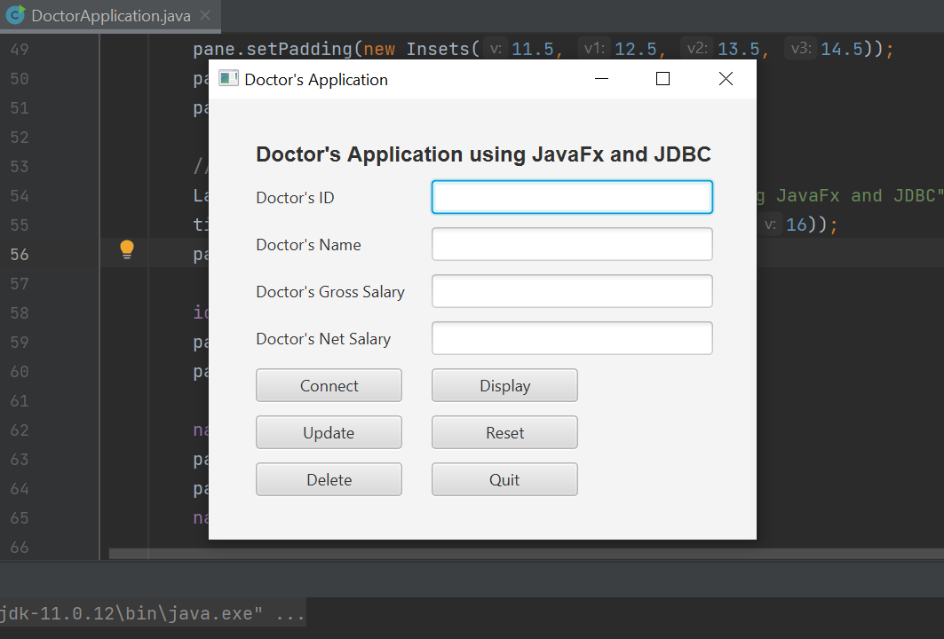

- Provide a screenshot of the user interface below with the message Connection Successful after clicking the Connect button: [10 marks]
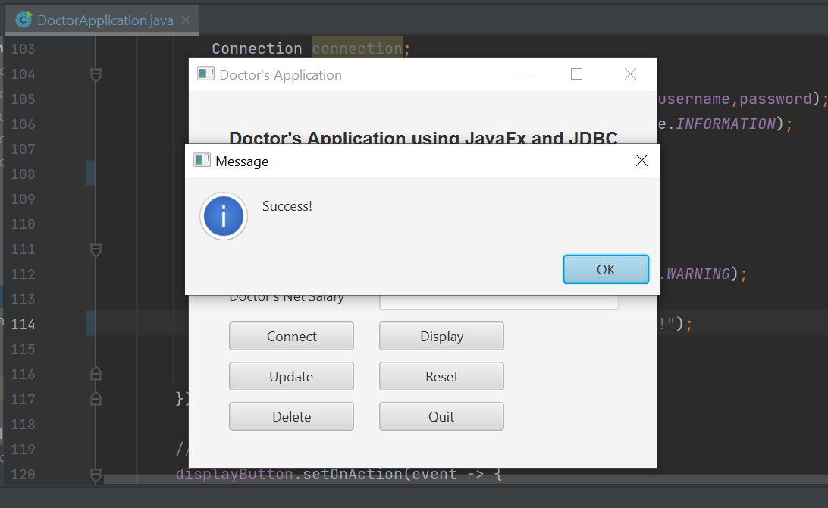

- Provide a screenshot below after clicking the Display button. It should display the record of that corresponds to the Doctor’s Id entered. [10 marks]

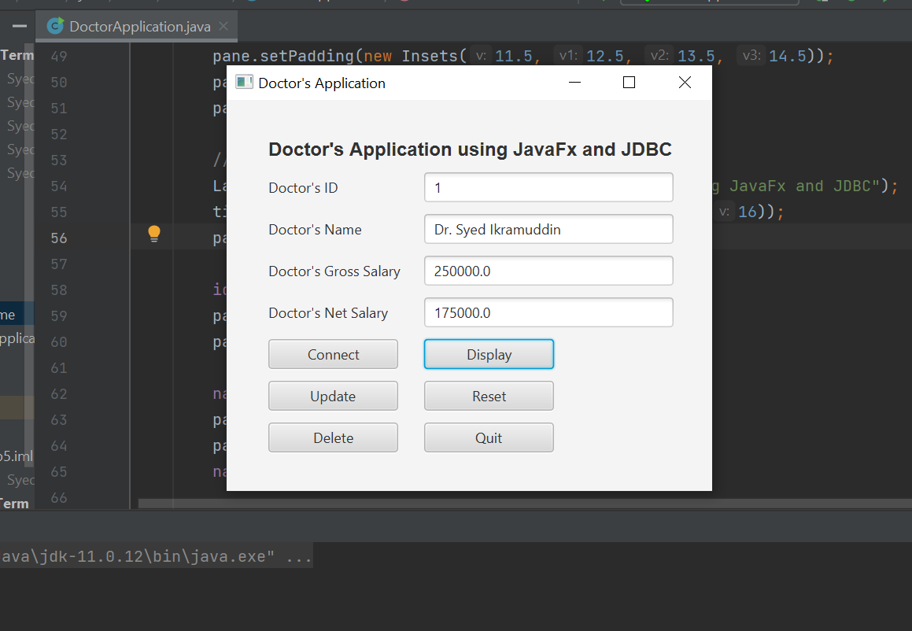

- Provide a screenshot after clicking the Delete button. This should delete one record that corresponds to the Doctor’s ID entered. This should bring you a message box that says Record Successfully Deleted. [10 marks]

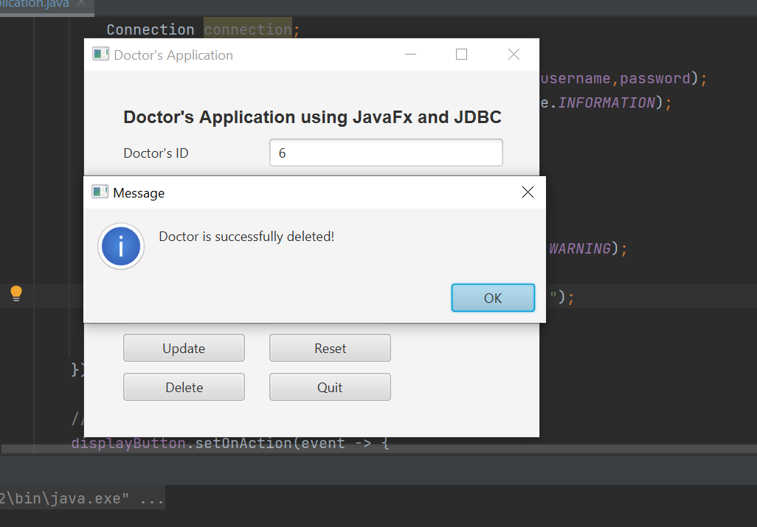

- Go to your database table and show that the DELETED record does not exist anymore. [10 marks]

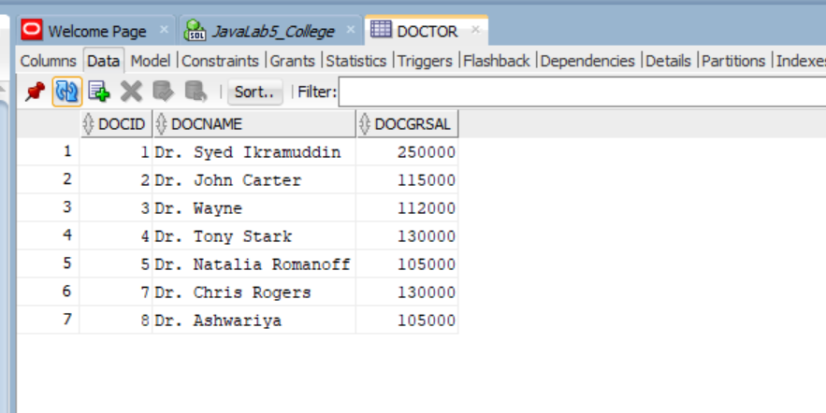
- Provide a screenshot after clicking the Quit button. It should display a message that reads You Decided to Close the Database Connection and Quit the Application.
[10 marks]

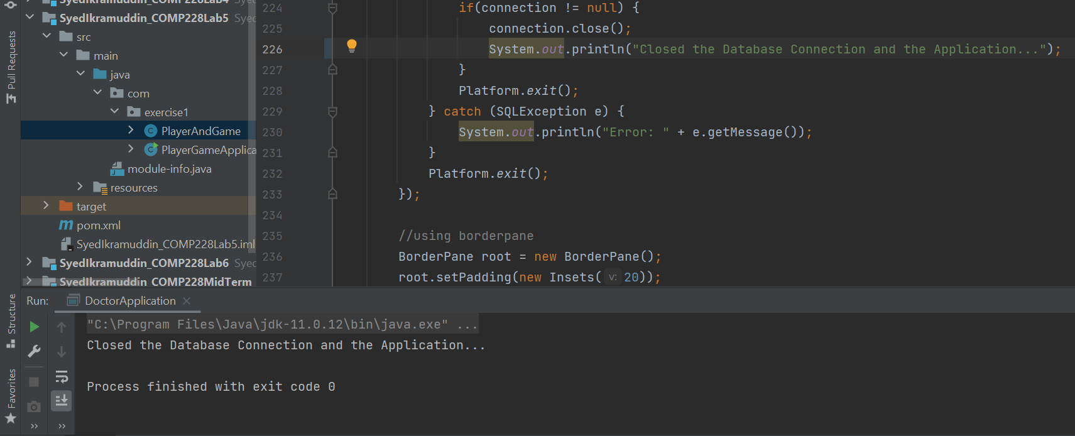

Code:

DoctorApplication.java

package com.exercise1;

import javafx.application.Application;
import javafx.application.Platform;
import javafx.geometry.Insets;
import javafx.geometry.Pos;
import javafx.scene.Scene;
import javafx.scene.control.Alert;
import javafx.scene.control.Button;
import javafx.scene.control.Label;
import javafx.scene.control.TextField;
import javafx.scene.layout.BorderPane;
import javafx.scene.layout.GridPane;
import javafx.scene.text.Font;
import javafx.scene.text.FontWeight;
import javafx.scene.text.Text;
import javafx.stage.Stage;

import java.io.IOException;
import java.sql.*;
import java.text.NumberFormat;
import java.util.Locale;

import oracle.jdbc.*;

public class DoctorApplication extends Application{

private final String url = "jdbc:oracle:thin:@199.212.26.208:1521:SQLD";
//private final String url = "jdbc:oracle:thin:@oracle1.centennialcollege.ca:1521:SQLD";
private final String username = "COMP228_W23_sy_139";
private final String password = "password";

TextField idTextField;
TextField nameTextField;
TextField grossSalaryTextField;
TextField netSalaryTextField;
Button connectButton;
Button updateButton;
Button resetButton;
Button quitButton;
Button displayButton;
Button deleteButton;

@Override
public void start(Stage primaryStage) throws IOException {

GridPane pane = new GridPane();
pane.setAlignment(Pos.CENTER);
pane.setPadding(new Insets(11.5, 12.5, 13.5, 14.5));
pane.setHgap(20);
pane.setVgap(10);

//TextFields and Texts
Label title = new Label("Doctor's Application using JavaFx and JDBC");
title.setFont(Font.font("Arial", FontWeight.BOLD, 16));
pane.add(title, 0, 0,2,1);

idTextField = new TextField();
pane.add(new Label("Doctor's ID"), 0,1);
pane.add(idTextField,1,1);

nameTextField = new TextField();
pane.add(new Label("Doctor's Name"),0,2);
pane.add(nameTextField,1,2);
nameTextField.setEditable(false);

grossSalaryTextField = new TextField();
pane.add(new Label("Doctor's Gross Salary"),0,3);
pane.add(grossSalaryTextField,1,3);

netSalaryTextField = new TextField();
pane.add(new Label("Doctor's Net Salary"),0,4);
pane.add(netSalaryTextField,1,4);
netSalaryTextField.setEditable(false);

//Application Buttons
connectButton = new Button("Connect");
pane.add(connectButton,0,5);
connectButton.setPrefWidth(110);

updateButton = new Button("Update");
pane.add(updateButton,0,6);
updateButton.setPrefWidth(110);

deleteButton = new Button("Delete");
pane.add(deleteButton,0,7);
deleteButton.setPrefWidth(110);

displayButton = new Button("Display");
pane.add(displayButton,1,5);
displayButton.setPrefWidth(110);

resetButton = new Button("Reset");
pane.add(resetButton,1,6);
resetButton.setPrefWidth(110);

quitButton = new Button("Quit");
pane.add(quitButton,1,7);
quitButton.setPrefWidth(110);

//connecting to database
connectButton.setOnAction(event ->{
Connection connection;
try{
connection = DriverManager.getConnection(url,username,password);
Alert alertSuccess = new Alert(Alert.AlertType.INFORMATION);
alertSuccess.setHeaderText(null);
alertSuccess.setContentText("Success!");
alertSuccess.showAndWait();

} catch (SQLException e) {
Alert alertFailed = new Alert(Alert.AlertType.WARNING);
alertFailed.setHeaderText(null);
alertFailed.setContentText("Connection Failed!");
alertFailed.showAndWait();
e.printStackTrace();}
});

//displaying the doctor
displayButton.setOnAction(event -> {
Connection connection;
try {
connection = DriverManager.getConnection(url,username,password);
String query = "SELECT DocName, DocGrSal FROM Doctor WHERE DocId = ?";
PreparedStatement ps = connection.prepareStatement(query);
ps.setInt(1,Integer.parseInt(idTextField.getText()));
//ps.setString(1,docIdTextField.getText());
ResultSet result = ps.executeQuery();

if (result.next()) {
nameTextField.setText(result.getString("DocName"));
grossSalaryTextField.setText(result.getString("DocGrSal"));
Double grossSalary = Double.parseDouble(result.getString("DocGrSal"));
Double netSalary = grossSalary - (grossSalary * 0.3);
grossSalaryTextField.setText(grossSalary.toString());
netSalaryTextField.setText(netSalary.toString());

} else {
Alert alert = new Alert(Alert.AlertType.WARNING);
alert.setHeaderText(null);
alert.setContentText("Doctor not found!");
alert.showAndWait();
}
} catch (SQLException e) {
throw new RuntimeException(e);
}

});

//updating the gross salary of doctor
updateButton.setOnAction(event ->{
try{
Connection connection = DriverManager.getConnection(url,username,password);
int docId1 = Integer.parseInt(idTextField.getText());
Double grossSalary = Double.parseDouble(grossSalaryTextField.getText());
String query = "UPDATE Doctor SET DocGrSal = ? WHERE DocId = ?";

PreparedStatement ps = connection.prepareStatement(query);
ps.setDouble(1, grossSalary);
ps.setInt(2, docId1);

int rowsUpdated = ps.executeUpdate();
if(rowsUpdated > 0) {
Alert alert = new Alert(Alert.AlertType.INFORMATION);
alert.setHeaderText(null);
alert.setContentText("Gross salary of the doctor updated successfully!");
alert.showAndWait();
} else {
Alert alert = new Alert(Alert.AlertType.WARNING);
alert.setHeaderText(null);
alert.setContentText("Doctor not found!");
alert.showAndWait();
}

} catch (SQLException e) {
throw new RuntimeException(e);
}
});

//clearing all fields
resetButton.setOnAction(event ->{
idTextField.clear();
netSalaryTextField.clear();
grossSalaryTextField.clear();
nameTextField.clear();
});

//delete doctor by Id
deleteButton.setOnAction(event ->{
try{
Connection connection = DriverManager.getConnection(url,username,password);
String query = "DELETE FROM Doctor WHERE DocId = ?";
PreparedStatement ps = connection.prepareStatement(query);
ps.setString(1, idTextField.getText());

int rowsDeleted = ps.executeUpdate();

if (rowsDeleted == 0) {
Alert alert = new Alert(Alert.AlertType.WARNING);
alert.setHeaderText(null);
alert.setContentText("Doctor not found!");
alert.showAndWait();
} else {
Alert alert = new Alert(Alert.AlertType.INFORMATION);
alert.setHeaderText(null);
alert.setContentText("Doctor is successfully deleted!");
alert.showAndWait();
idTextField.clear();
nameTextField.clear();
grossSalaryTextField.clear();
netSalaryTextField.clear();
}

}catch (SQLException e){
throw new RuntimeException(e);
}

});

//quit the application
quitButton.setOnAction(event ->{
try {
Connection connection = DriverManager.getConnection(url,username,password);
if(connection != null) {
connection.close();
System.out.println("Closed the Database Connection and the Application...");
}
Platform.exit();
} catch (SQLException e) {
System.out.println("Error: " + e.getMessage());
}
Platform.exit();
});

//using borderpane
BorderPane root = new BorderPane();
root.setPadding(new Insets(20));
root.setCenter(pane);

//placing the scene in the stage
Scene scene = new Scene(root);
primaryStage.setTitle("Doctor's Application");
primaryStage.setScene(scene);
primaryStage.show();

}
public static void main(String[] args) {
launch();
}
}

