2nd year I.T. Systems and Security 2019/2020

NSCC | Truro campus

Team members: Ryan Rogers, Brody Rethy, Alex Bell, Keyan Boyle

Project Charter

Security camera

Contents

Section 1 charter introduction 2

Authorization 2

Section 2 Project overview 2

Project summary 2

Project goals, outcomes, and objectives 2

Project scope 2

Milestones 2

Deliverables 3

Project costs and sources of funding 3

Dependencies 4

Project risks, assumptions, and constraints 4

Risks 4

Assumptions 4

Constraints 4

Section 3 Project organization 4

Project team structure 4

Roles and responsibilities 4

Project facilities and resources 4

# Section 1 Charter Introduction

Our deliverable is a single prototype. It is a Raspberry PI security system by utilizing MotionEyeOS, open source software project, (<https://github.com/ccrisan/motioneyeos/wiki>) and a web camera. After the presentation the equipment will become property of the NSCC IT Systems and Security program for use by future students. Its purpose is to satisfy the requirements of the Project Management course. Total costs are estimated to be under $200.00.

## Authorization

Key stakeholders

* NSCC
* Ryan Rogers
* Brody Rethy
* Alex Bell
* Keyan Boyle
* Matthew Redmond
* Funding request staff TBD

# Section 2 Project Overview

## Project summary

The project is combining an open source software project with a small low powered arm processor computer to produce a working security camera prototype. This project will involve collaboration with IT systems students and faculty to meet a common goal. The journey of this project will meet the learning outcomes for the course Project Management for IT.

The final product will be a Raspberry PI that has a static IP plugged into an access port on the 172 Network. The camera will then be able to be accessed using a web browser from any client that is on the same subnet. The camera will send video files over the 172 network to a dedicated storage virtual machine using resources that were allocated for our Linux server course.

## Project goals, outcomes, and objectives

To work collectively with students and learn project management skills.

## Project scope

1. 1 camera on 1 device working with connectivity accessible from 172 network via browser.
2. Requesting funding for materials to complete the project on time.

## Milestones

1. Creation of charter template
2. Begin population of the charter

## Deliverables

A working network security camera demonstration.

## Project costs and sources of funding

[https://www.canakit.com/](https://www.canakit.com/raspberry-pi-4-starter-kit.html)

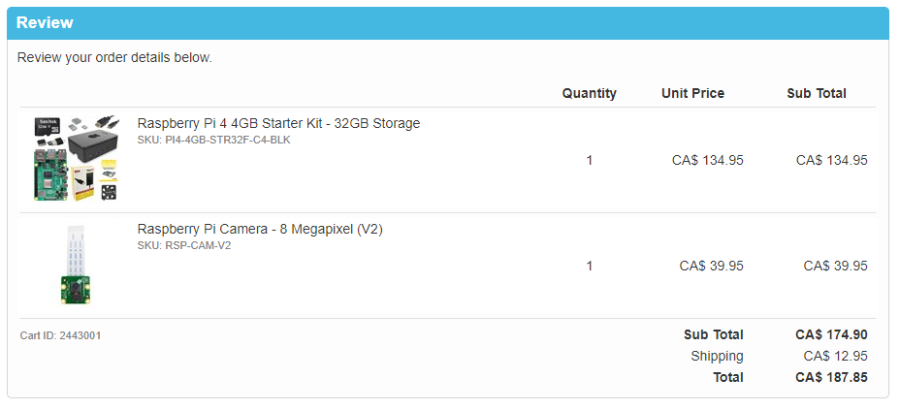

<https://www.buyapi.ca/>

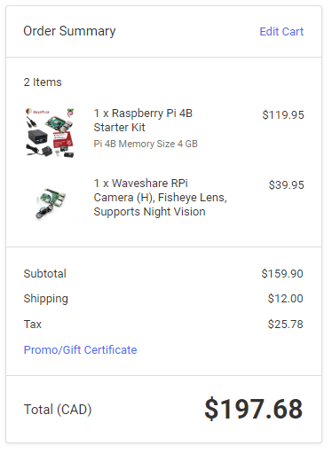

Sources of funding TBD

## Dependencies

The completion of the project will depend on our access to funding and access to lab equipment.

## Project risks, assumptions, and constraints

### Risks

* Electrical shock.
* Exposure to offensive content while browsing the internet for troubleshooting solutions.
* Group members not agreeing on parts of the project.
* Possible risks could be bugs that may occur inside the open source software.

### Assumptions

We assume that we have access to the lab P.C.s, network access to the 172 networks, use of server resources, and that we will receive our requested funding. We also assume that there will be no major issues with the software and that we have the skills to troubleshoot any issues that do arise.

### Constraints

* Time.
* Funding.
* Access to resources.

# Section 3 Project Organization

## Project team structure

Instructor and student structure.

## Roles and responsibilities

Best effort put forth by all team members to meet the requirements of the project and the course.

## Project facilities and resources

* We will be using NSCC campus library, computer labs and 172 sandbox Network
* Opensource software project instructions and forums <https://github.com/ccrisan/motioneyeos/wiki>