Aim & Objective

The aim of this electrical engineering mini project is to design and implement a Snake game on an 8x8 dot matrix display using an Arduino Uno microcontroller. The game will be controlled by a 10 k variable resistor (potentiometer) to adjust the speed of the snake's movement and a dual-axis joystick to control the direction of the snake's movements. The project will involve designing and coding the game logic, as well as interfacing the display, potentiometer, and joystick with the microcontroller.

The objectives of the project are to understand the fundamentals of microcontroller programming, interface design, and circuit design. The project will provide a hands-on learning experience in designing and implementing a game using an Arduino Uno microcontroller. The project will also develop skills in programming, problem-solving, and hardware integration. Additionally, the project will help students to understand the principles of variable resistors and dual-axis joysticks and their applications in controlling electrical devices. Overall, the project will help students to develop practical skills in electrical engineering and provide a foundation for more advanced projects in the future.

Required Components

* MAX7219 LED dot matrix display module:   
    
  This module provides an 8x8 LED dot matrix display that displays various shapes and characters. It is easy to connect to an Arduino Uno microcontroller and is essential for displaying game graphics.
* Dual Axis XY Joystick Module:   
    
  This module is used to control the movements of the snake in the game. It offers two-axis movement, making it ideal for controlling the direction of the snake in the game.
* 10k Variable Resistor (Potentiometer):   
    
  This component is used to adjust the speed of the snake. It allows you to adjust the speed of the screen according to players requirement, ensuring clear and easy play.
* Jumper and Connecting Wires:   
    
  These wires are used to connect various components to the test breadboard and the Arduino Uno microcontroller. They are easy to use and come in different lengths to suit different projects.
* Soldered Breadboard:   
    
  This breadboard is used to connect different components and create a platform to test the project before final assembly. It is an essential component of any electronics project and makes it easy to test different circuit configurations.
* 9V Battery:   
    
  This compact and powerful battery provides the power source for the project.

Working Principle

The Snake Game with 8x8 Dot Matrix Display and Arduino is a project that integrates multiple hardware components and software programming to create an exciting and immersive gaming experience. The working principle of the project starts with an Arduino Uno microcontroller board that acts as the main controller for all the components involved in the project.

The MAX7219 LED 8x8 dot matrix display module is the one of the key hardware components in this project to display various game graphics such as snakes, food and scores. The display module is connected to the microcontroller board using male-to-female jumper wires that carry signals from the microcontroller to the display module.

Another important component is the 2-axis XY joystick module used to control the direction of the snake in-game. This joystick module detects joystick movements in two axes and converts them into digital signals that the microcontroller can interpret. The joystick module connects to the microcontroller board via hard jumper wires to ensure a reliable and secure connection.

A 10k variable resistor is another important component used in the project to adjust the speed of the snake. This component connects to the microcontroller board via hard connecting wires soldered to it. Variable resistance works by adjusting the resistance value, which adjusts the speed of the snake. Adjusting the speed of the snake makes the project more challenging and addictive for players.

A solderless breadboard serves as a platform for connecting all components and testing the project before final assembly. It's a vital part of any electronic project as it allows you to test different circuit configurations and troubleshoot problems.

The software programming involved in the project involves writing code in the Arduino Integrated Development Environment (IDE) that controls the behaviour of the game components. This program is designed to interpret joystick movements and adjust the position of the snake on the LED matrix display. It also tracks scores and detects collisions between the snake and food or its own body.

Circuit Diagram

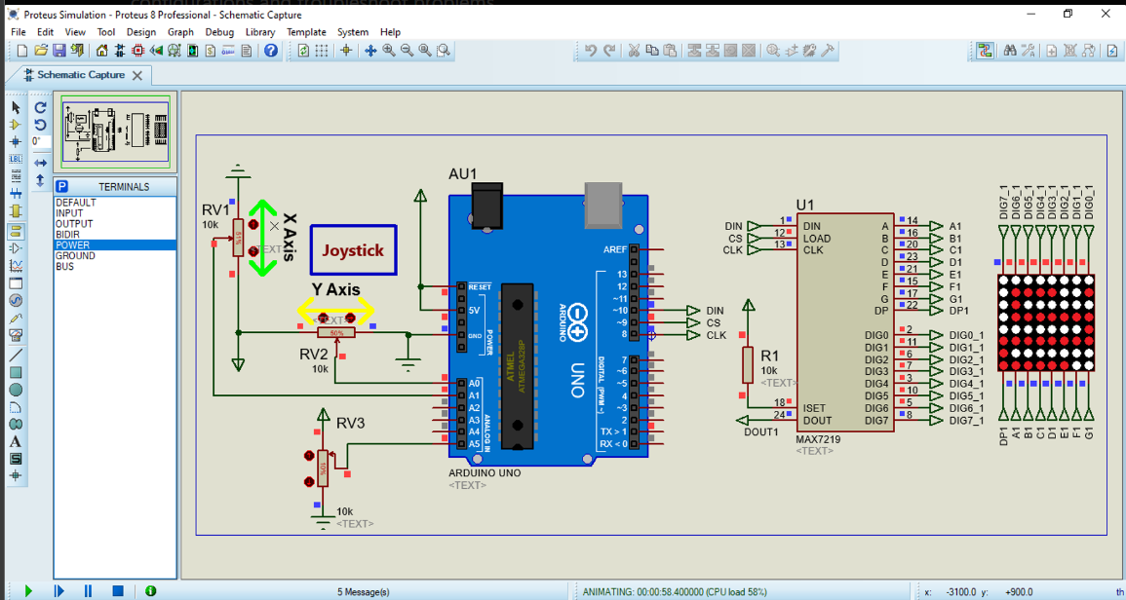

Application

One possible application of this project is an educational institution that can be used to teach basic electronics and programming concepts. A project involves connecting various hardware components, such as: Connecting the LED matrix display and joystick module to the Arduino microcontroller board requires an understanding of basic electronics and circuit design. The software programming aspect of the project involves writing code in the Arduino IDE that can be used to teach programming concepts such as conditionals and loops.

Another use for this project is entertainment and games. The Snake Game is a classic game that has been enjoyed by people of all ages for decades. By creating games from scratch using Arduino microcontroller boards and various hardware components, enthusiasts and gamers can create their own customized gaming experiences that can be shared with others.

Additionally, this project can be used to develop custom arcade-style games. The LED matrix display can be programmed to display a variety of game graphics, and a joystick module can be used to control the character's movements in the game. By integrating additional hardware components and software programming, enthusiasts can and game developers can create fun and challenging arcade-style custom games.

Conclusion

In summary, the Snake Game with 8x8 Dot Matrix Display and Arduino is a fun and engaging electronics project that demonstrates the integration of various hardware components and software programming. This project is a great way for beginners to get started with electronics and programming as it involves simple circuit connection and coding in the Arduino IDE.

Through this project, you will find an Arduino Uno microcontroller board, a MAX7219 LED 8x8 dot matrix display module, a 2-axis XY joystick module, a 10k variable resistor, a solderless breadboard, and a 9V battery holder. We've seen how these components work together to create an immersive gaming experience that challenges the skill and reflexes of the player.

Overall, this project is not only a great way to learn about electronics and programming, but it shows the potential of these areas to create engaging and fun applications. As technology continues to advance, we can expect more innovative projects that combine hardware and software to create new and exciting experiences.

References

* YouTube Tutorial :  
   <https://youtu.be/wVuRsM95jnA>
* Guide to Use Proteus :   
   <https://medium.com/@erenpaslioglu/how-to-use-proteus-guide-for-beginners-31165afd78b9>
* Guide to Use Arduino Uno :   
   <https://medium.com/iothincvit/quick-start-guide-to-arduino-and-its-working-e61e33566fbe>