Exercise_9

- List the minimum perks package.

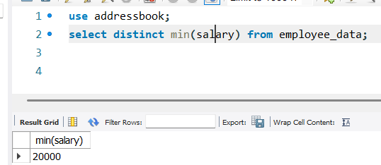

- List the maximum salary given to a “Programmer”.

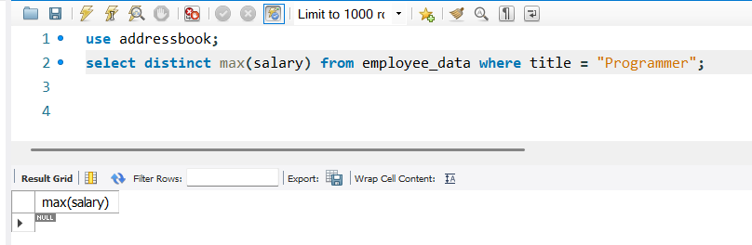

- Display the age of the oldest “Marketing Executive”

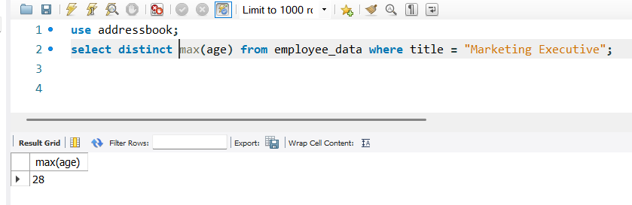

- (Tricky!) Find the first and last names of the oldest employee.
