Exercise_17

- Find and list the ids and spouse names of all employees who are married.

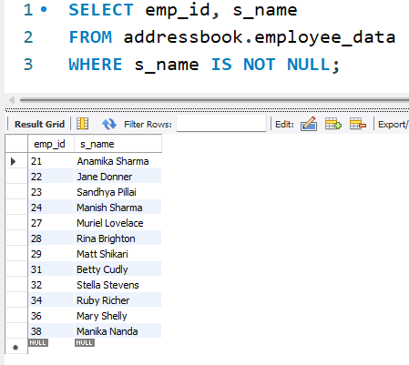

- Change the above so that the display is sorted on spouse names.

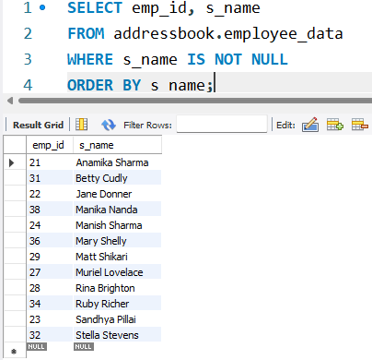

- How many employees do we have under each sex (male and female)?

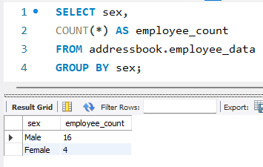

- How many of our employees are married and unmarried?

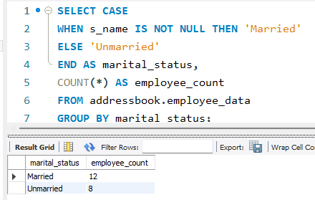

- Find the total number of children.

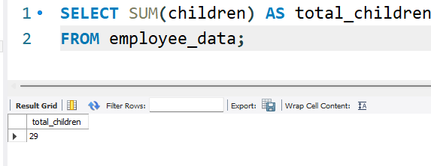

- Make unique groups of children and find the number in each group. Sort the display with the group having maximum children, at the top.

