MITRA
Mutual Initiatives to Transform Rural Areas

Project submitted in partial fulfillment for the award of the degree of
Master of Computer Application

Submitted by
Bibhuti Bhusan Majhi (2370117)

Under the Guidance of
Prachi Vijayeeta
Assistant Professor



MAY 2025

CERTIFICATE OF ORIGINALITY

This is to certify that the project report entitled “MITRA” submitted to School of Computer Application, KIIT University in partial fulfillment of the requirement for the award of the degree of MASTER OF COMPUTER APPLICATIONS (MCA), is an authentic and original work carried out by Mr. Bibhuti Bhusan Majhi with Roll no 2370117 and Regd. No. 237083103297 under the guidance of Prachi Vijayeeta.

The matter embodied in this project is genuine work done by the student and has not been submitted whether to this University or to any other University / Institute for the fulfillment of the requirements of any course of Study.

….…………………. ….………………….
Signature of the Student Signature of the Guide
Date: ………………. Date: ……………….

School of Computer Application
KIIT Deemed To Be University
Bhubaneswar

CERTIFICATE
This is to certify that the project work entitled “MITRA” Submitted by Bibhuti Bhusan Majhi. bearing roll no. 2370117, is an authentic and original work.

….…………………. ….………………….
Signature Signature
( Internal Examiner ) ( External Examiner )
Date: ………………. Date: ……………….

DECLARATION

I Bibhuti Bhusan Majhi, roll no. 2370117 do hereby declare that the project report entitled “MITRA” submitted to School of Computer Application, KIIT University, Bhubaneswar for the award of the degree of MASTER OF COMPUTER APPLICATION (MCA), is an authentic and original work carried out by me from 10th Jan 2025 to 1st May 2025 at organization name under the guidance of Prachi Vijayeeta.

.…………………….
Signature of the Student
Date: ……………….

ACKNOWLEDGEMENT

I have taken efforts in this project. However, it would not have been possible without the kind support and help of many individuals. I would like to extend my sincere thanks to all of them. I am highly indebted to Prachi Vijayeeta for their guidance and constant supervision as well as for providing necessary information regarding the project & also for their support in completing the project. I would like to express my gratitude towards my parents & member of KIIT School of Computer Application for their kind co-operation and encouragement which help me in completion of this project.

Content

1 | Introduction | 7
2 | System Analysis | 8 - 32
 | - Identification of Need | 8
 | - Feasibility Study | 10
 | - Software Requirement Specification(SRS) | 12
 | - Software Engineering Paradigm applied | 19
 | - DFD and Use Case Diagram | 28
3 | System Design | 33 - 44
 | - Modularization Details | 33
 | - User Interface (UI) Design | 36
4 | Coding | 45 - 53
 | - Comments and Description | 45
 | - Standardization of the Coding | 48
 | - Error Handling | 51
 | - Validation Checks | 53
5 | Testing | 54 - 59
 | - Functional Testing Test Cases | 54
 | - Performance Testing Test Cases | 56
 | - Security Testing Test Cases | 57
 | - Usability Testing Test Cases | 58
 | - Compatibility Testing Test Cases | 59
6 | System Security Measures | 60 - 63
 | - Validation Checks | 60
7 | Screenshots | 64
8 | Future Scope | 65 - 67
9 | Assumptions | 68
10 | Glossary | 69 - 70
11 | Bibliography | 71

Introduction

MITRA is a mobile application designed to serve as a comprehensive digital companion for farmers in rural India. The project was initiated to address the growing need for accessible agricultural information and services in rural communities. The initial vision was to create a user-friendly platform that would bridge the gap between farmers and essential agricultural resources, weather information, and farming guidance.
Rural Indian farmers often face challenges accessing timely weather information, organized farming guidance, and essential support services, leading to reduced productivity and increased risks. MITRA addresses these issues by providing a user-friendly mobile application featuring an interactive calendar integrated with weather data and activity suggestions, a directory for quick access to rural services, and simple mobile number-based authentication, acting as a comprehensive digital companion for farmers.

System Analysis
Identification of Need
      - Existing System Requirement:
Current Situation for Farmers: Farmers in rural India currently rely heavily on traditional methods, word-of-mouth, and often non-localized broadcast media (like radio or TV) for crucial agricultural information, especially weather forecasts. Planning farming activities is frequently based on past experience or general calendars, which may not account for specific crop needs or immediate weather conditions.
Accessing Support: Finding and accessing essential rural services (such as equipment rental, seed suppliers, pest control advice, or market information) often requires significant time and effort, involving travel to local towns, reliance on limited personal networks, or navigating complex government channels. Information is often fragmented and not readily available when needed.

- How Computerization is Useful:
Centralized Information Hub: This cross-platform app, MITRA, has been developed to serve as a readily accessible digital companion on smartphones, which are increasingly common in

rural areas. It centralizes critical information like localized weather forecasts, farming activity suggestions, and a directory of rural services.

Improved Planning & Decision Making: By integrating weather data directly with a farming calendar, MITRA makes it easier for farmers to plan activities like sowing, irrigation, and harvesting more effectively according to predicted conditions. This replaces guesswork with data-informed decisions.

Efficient Service Access: The app provides a searchable directory of local rural services, saving farmers time and effort compared to traditional methods of finding support. The cross-platform nature (initially Android) ensures accessibility across a wide range of common devices without needing specific hardware.

Feasibility Study
A feasibility study evaluates the project’s potential for success; therefore, perceived objectivity is an important factor in the credibility of the study for potential investors and lending institutions. There are three main types of feasibility study—separate areas that a feasibility study examines, described below.

Technical Feasibility:
The technical feasibility study basically centers on alternatives for hardware, software, and design approach to determine the functional aspects of the system. MITRA is technically feasible as it utilizes React Native and Expo, allowing development for widely available Android smartphones common in rural areas (Android 6.0+). The required open-source development tools (like VS Code, Git) are readily accessible, and the team possesses the necessary expertise. While challenges like variable internet connectivity and diverse device compatibility exist, solutions such as planned offline capabilities and responsive design address these concerns, ensuring the core functionalities can be delivered reliably on target hardware.

Operational Feasibility:
Operational feasibility is a measure of how people can work with the system and if it will function effectively once developed and installed. MITRA demonstrates operational feasibility as it's designed for the

existing infrastructure in many rural areas, requiring only basic 2G/3G internet connectivity and minimal smartphone storage (<50MB). Deployment using Firebase ensures high availability (24/7). Crucially, the user interface, built with React Native components, prioritizes simplicity and intuitiveness, aiming to be easily usable by farmers with varying levels of digital literacy. User training needs are recognized and will be addressed through in-app tutorials and potential local training sessions, supported by initial survey data indicating positive community acceptance.

Economic Feasibility:
MITRA is highly economically feasible because it is developed entirely using open-source technologies like React Native, Expo, and Firebase, which are free of cost. The necessary software for development and the hardware resources targeted (existing smartphones) incur minimal to no expense. Furthermore, leveraging the free tiers of Firebase for hosting/database and free weather API services means initial investment and ongoing operational costs are negligible. This makes the project financially viable from the outset, with potential benefits like improved crop yields for farmers offering a significant positive impact relative to the cost. Long-term sustainability can be explored through grants, NGO partnerships, or potential future premium features without requiring upfront commercial investment.

Software Requirement Specifications

Introduction
The following subsections of the SRS document provide an overview of the entire SRS, outlining the application's purpose, scope, benefits, and overall characteristics.
- Purpose:
The primary purpose of the MITRA project is to empower farmers in rural India by bridging the information gap they often face. It aims to enhance agricultural planning and productivity by providing readily accessible, localized weather information integrated with farming activity suggestions directly within an interactive calendar. Furthermore, it seeks to simplify access to essential rural support systems and services through a dedicated directory, all within a single, user-friendly mobile application designed for the specific needs and context of rural users.
- Scope:
This application provides a comprehensive suite of tools for farmers, centered around an interactive calendar that displays daily weather forecasts (temperature, conditions, humidity) and relevant farming activities. The scope includes secure user authentication via mobile number and OTP. Functionality extends to tracking farming activities, providing quick access shortcuts to key information (like irrigation or pest alerts), and offering a filterable directory of local rural services with contact details. Developed using React Native for Android (version 6.0

and above), the application integrates with external weather APIs and utilizes Firebase for backend authentication and data storage, requiring basic internet connectivity for real-time updates but planned offline capabilities for core information access.
- Benefits:
This cross-platform mobile application transforms traditional farming planning into a more data-driven digital process. Key benefits for farmers include significantly improved decision-making capabilities through the integration of weather data with farming tasks, leading to potentially better resource management and increased crop yields. It offers considerable time savings by providing a centralized directory for essential rural services, reducing the effort required to find support. The organized presentation of crop-specific activities promotes better farming practices and reduces vulnerability to weather-related risks.
- Overall Description:
MITRA is designed as a practical, easy-to-use mobile tool tailored for the rural Indian farmer. User access is secured through a simple mobile number OTP login, ensuring data privacy. The core user experience revolves around the interactive calendar, acting as a central hub for integrated weather, farming activity, and service information. The interface prioritizes clarity and intuitiveness, using clear icons and readable text suitable for varying literacy levels. The application is built for performance on common Android devices, even with limited connectivity (supporting 2G networks and offline functionality), and emphasizes reliability and data security through Firebase integration and secure coding practices.

- Product Perspective:
- User Interface:
The MITRA UI includes: Login Screen, OTP Screen, Home Dashboard, Calendar View, Date Details Screen, Rural Services List, Profile/Logout Screen.

- Hardware Interface:
MITRA utilizes standard smartphone hardware: Network Interface (Cellular/WiFi), Storage, CPU/RAM, Display. GPS is optional for potential future features.

- Product Functions:
This section provides brief details of major functionalities.

- Authentication Module:

Requirement: Collect mobile number, verify via OTP (Firebase Auth), create session, redirect to Home.

Exceptions: Network error, invalid OTP, Firebase unresponsive.

Dependencies: Firebase Auth, Network.

- Calendar Module:

Requirement: Display navigable monthly grid with weather/activity indicators. Allow date selection for details.

Exceptions: Network error, Firebase/Weather API unresponsive.

Dependencies: Logged-in user, Firebase, Weather API.

- Weather Information Module:

Requirement: Fetch and display detailed weather (temp, condition, humidity) for selected dates via Weather API.

Exceptions: Network error, Weather API error/unresponsive.

Dependencies: Weather API, Network.

- Farming Activities Module:

Requirement: Fetch user's activities from Firebase for selected date. Display list and status. Allow status update.

Exceptions: Network error, Firebase unresponsive.

Dependencies: Logged-in user, Firebase.

- Rural Services Module:

Requirement: Fetch and display filterable/searchable list of services (name, contact) from Firebase/DB.

Exceptions: Network error, Firebase unresponsive.

Dependencies: Firebase/DB.

- Logout Module:

Requirement: Clear user session/token, redirect to Login screen.

Dependencies: Logged-in user.

FUNCTIONAL REQUIREMENTS:
It deals with the functionalities required from the system which are as follows:

- This app will allow users to register and log in securely using their mobile number and OTP verification.

- This app will display an interactive monthly calendar showing integrated weather information (temperature, condition) for relevant dates.
- This app will display suggested or logged farming activities corresponding to selected dates on the calendar.
- The user can view detailed weather information (e.g., humidity, wind) for a specific day.
- The user can update the status (e.g., mark as 'completed') for their farming activities.
- This app provides a directory where users can view, search, and filter local rural services (like equipment rental, seed suppliers) and see contact information.
- This app offers 'Quick Actions' on the home screen for easy access to specific information or features.

NON-FUNCTIONAL REQUIREMENTS:
They are the quality requirements that stipulate how well a software does what it must do.
Performance: MITRA is developed using React Native (with Expo), aiming for a smooth and responsive UI. The backend is supported by Firebase (Authentication, Firestore), managed by Google, ensuring generally low latency for data operations. Firebase's offline capabilities allow basic data viewing and potential activity updates even when the device is offline, syncing when connectivity is restored. Because of this architecture, the app aims to be highly responsive under normal conditions.
Availability: This app aims for high availability for users. Being a mobile application installable on Android devices, its core functionality (especially cached data) is available whenever the user opens the app. Firebase services provide high uptime (typically >99.9%). Updates will be delivered through standard app store mechanisms, minimizing disruption.
Reliability: The app aims to be reliable, functioning correctly under expected usage patterns. During testing, it should operate stably on minimum requirement hardware (Android 6.0+, basic smartphone specs). Firebase's offline data persistence ensures that logged activity status changes are not lost during temporary internet outages, improving data reliability.
Usability: A primary focus during development is usability for rural farmers, who may have varying levels of digital literacy. The app is designed with a simple, user-friendly, and intuitive UI, using clear icons and minimal text where possible. Navigation is intended to be consistent and self-explanatory.
Portability: As a React Native app, MITRA is initially built for Android (version 6.0 and above). React Native facilitates potential future portability to iOS with significant code reuse, although platform-specific adjustments would be needed. It's designed to adapt to various Android screen sizes and resolutions.

Flexibility: The app is built using a modular component structure in React Native. Modifications or additions to specific modules (e.g., adding a new service category, enhancing the weather display) can generally be done without impacting unrelated modules. Updates are delivered via the app store, allowing for incremental feature additions or changes without altering the core installed functionality unexpectedly for the user.
Maintainability: The codebase follows standard practices (documentation, modular design, consistent naming) to ensure it is relatively easy to maintain and update over time. Using Firebase simplifies backend maintenance as infrastructure management is handled by Google. Future database schema changes, if needed, are planned to be manageable.
Installability: The app is a standard Android application, installable via typical methods (e.g., Google Play Store, direct APK installation). Installation and uninstallation follow standard Android procedures. Updates will be managed through the distribution channel (e.g., Play Store).
Reusability: While MITRA is tailored for agriculture, certain underlying components and architectural patterns have potential for reuse. For instance, the modular calendar component displaying integrated external data (weather), the authentication flow using mobile OTP via Firebase, the structure for fetching and displaying list data (like services), and the general UI/UX patterns designed for rural users could be adapted or reused in developing other community-focused applications or information portals targeting similar demographics or requiring comparable functionalities (e.g., local health information app, community notice board app). The Firebase integration patterns are also broadly applicable.

Software Engineering Paradigm
The software engineering paradigm which is also referred to as a software
process model or software development life cycle (sdlc) model is the development strategy that encompasses the process of identifiable stages that a software product undergoes during its lifetime that is a description of software in a systematic and disciplined manner. The life cycle mode used to develop this project is agile model.

- Agile model:
Agile model believes that every project needs to be handled differently and the existing methods need to be tailored to best suit the project requirements. In agile, the tasks are divided to time boxes (small time frames) to deliver specific features for a release. Iterative approach is taken and working software build is delivered after each iteration. Each build is incremental in terms of features; the final build holds all the features required by the customer. And every iteration in performed after 2 weeks of span.

- Iteration 1: Foundation & Authentication UI

Iteration
Planning
Req Analysis
Design
Building
Testing

Weeks 1-2

New Functions:
- Project Setup: Initialize React Native project with Expo, configure basic dependencies (navigation, styling).
- Firebase Project Setup: Create Firebase project, set up Firestore/Realtime Database and Authentication.
- Basic Navigation: Implement initial stack navigator for Authentication flow (Splash, Login, OTP screens) and main App flow (placeholder Home).
- UI Layout: Build static UI screens for Splash, Login (mobile input), and OTP input.
- Basic Styling: Set up global styles/theme basics (colors, fonts).
Bug Fixes:
- Resolved environment setup conflicts (Node versions, Expo CLI issues).
- Fixed initial navigation routing errors between Splash and Login.

- Iteration 2: Core Authentication & Calendar Base

Iteration
Planning
Req Analysis
Design
Building
Testing

Weeks 3-4

New Functions:
- Firebase Phone Authentication: Implement full OTP sending (via Firebase Auth or custom backend function) and verification logic.
- Session Management: Handle user login state persistence (e.g., store auth token securely). Redirect user based on auth state.
- Basic Home Screen: Implement basic layout for the Home screen after login.
- Calendar View Component: Create the core CalendarView component displaying a static monthly grid with correct days and basic styling. Date selection UI feedback (highlighting).

Bug Fixes:
- Addressed issues with secure storage of authentication tokens.
- Corrected logic for calculating days/weeks in the CalendarView grid.

- Iteration 3: Core Data Display - Weather & Activities

Iteration
Planning
Req Analysis
Design
Building
Testing

Weeks 5-6

New Functions:
- Weather API Integration: Implemented fetching and displaying basic daily weather (temperature, condition) on the calendar/date view.
- Farming Activity Display: Implemented reading and showing a list of farming activities for a selected date from the database (initially read-only).

Bug Fixes:
- Improved handling of Weather API errors and data parsing.
- Corrected date selection logic for displaying associated weather/activities.

- Iteration 4: Service Directory & Core Navigation

Iteration
Planning
Req Analysis
Design
Building
Testing

Weeks 7-8

New Functions:
- Rural Services Directory: Built the screen to display a list of services (name, contact) from the database.
- Home Screen Quick Actions UI: Added the non-functional Quick Actions section to the Home screen layout.
- Bottom Navigation: Implemented primary bottom tab navigation (Home, Calendar, Services).

Bug Fixes:
- Optimized list rendering performance for the Services Directory.
- Resolved navigation routing errors between main app sections.

- Iteration 5: Interactive Features - Activities & Services

Iteration
Planning
Req Analysis
Design
Building
Testing

Weeks 9-10

New Functions:
- Farming Activity Tracking: Enabled users to mark activities as complete/pending, updating the status in the database.
- Rural Service Filtering/Search: Implemented the logic to filter or search the services list.
- Basic User Profile: Added a screen with user info and logout functionality.

Bug Fixes:
- Fixed data synchronization issues for farming activity status updates.
- Improved performance and accuracy of service filtering/search.
- Ensured correct session termination on logout.

- Iteration 6: Offline Capability & Polish

Iteration
Planning
Req Analysis
Design
Building
Testing

Weeks 11-12

New Functions:
- Basic Offline Support: Implemented caching for essential data (weather, activities, services) for viewing without internet connectivity.
- UI/UX Refinement: Conducted final polish across the application for consistency, visual appeal, and usability based on internal reviews.

Bug Fixes:
- Resolved bugs related to offline data display and synchronization.
- Addressed remaining significant UI inconsistencies and minor performance issues.

For the MITRA project, developed using an Agile methodology, each 2-week sprint (iteration) incorporated the following key steps, ensuring continuous progress and adaptation:
- Sprint Planning:
This initial phase of each sprint involved defining the iteration's specific goal based on the overall project objectives and prioritized backlog items (user stories). The team discussed and clarified the requirements for the features targeted in that sprint. Tasks were broken down, estimated (in terms of effort/complexity), and assigned to team members. Necessary resources, like specific data requirements or API access clarifications, were identified for the upcoming two weeks.

- Requirement Analysis & Refinement:
While the foundational requirements were documented in the SRS early on, requirement analysis was an ongoing activity within each sprint. As features were developed, the team continuously refined their understanding of the specific user needs and acceptance criteria, often based on feedback from previous reviews or ongoing clarification with the product owner/stakeholders. This ensured the features built aligned closely with the intended value for the farmers.

- Design:
Within each sprint, the focus shifted to the technical design for the features being built. This involved transforming the refined requirements into a concrete implementation plan. Key activities included designing the necessary React Native components,

determining how data and state would be managed (e.g., using React Context or local state), planning the interactions between different parts of the app, and ensuring the UI/UX implementation adhered to the established design guidelines and principles suitable for the target users.

- Development (System Building):
This phase involved the core coding work for the features planned in the sprint. The MITRA application was built using React Native (managed via Expo) with JavaScript/TypeScript for the user interface and application logic. Integration with backend services was done using Firebase (specifically Authentication for login and Firestore for data storage like activities and services). Developers implemented the components, logic, and service integrations based on the designs established for the sprint, adhering to the project's coding standards.

- Testing:
Testing occurred concurrently and iteratively throughout the sprint. This included developers writing unit tests (using Jest) for critical functions and components. Integration testing verified interactions between different parts of the application. Continuous manual testing on emulators and physical devices was performed by developers and QA (if applicable) to ensure the newly developed features met the acceptance criteria, functioned correctly, and were free from significant errors or bugs before the sprint review. The goal was to produce a potentially shippable, tested increment of functionality at the end of each sprint.

Data Flow Diagram
Data Flow Diagram(DFD) is graphical representation of flow of data in an information system. It is capable of depicting incoming data flow, outgoing data flow and stored data. The DFD does not mention anything about how data flows through the system. Admin (module) login add members detail share and give feedback share & give feedback application home page member (module) login view own details pay individual maintenance fees view member details & their maintenance fees 18 there is a prominent difference between DFD and flowchart. The flowchart depicts flow of control in program modules. DFD depict flow of
data in the system at various levels. DFD does not contain any control or branch elements.
- Types of DFD
Data Flow Diagrams are either Logical or Physical.
- Logical DFD: This type of dfd concentrates on the system processes, and flow of data in the system. For example in a banking software system, how data is moved between different entities.
- Physical DFD: This type of dfd shows how the data flow is actually implemented in the system. It is more specific and close to the implementation.

- DFD Components:
DFD can represent source, destination, storage and flow of data using the following set of components -
Entity
Process
Data Store
Data Flow

- Entities - Entities are source and destination of information data. Entities are represented by a rectangle with their respective names.
- Process - Activities and action taken on the data are represented by circle or round-edged rectangles.
- Data Storage - There are two variants of data storage - it can either be represented as a rectangle with absence of both smaller sides or as an open-sided rectangle with only one side missing.
- Data Flow - Movement of data is shown by pointed arrows. Data movement is shown from the base of arrow as its source towards head of the arrow as destination.

- Context level DFD:
The context level DFD is showing the overall process which can be seen in a system, so news application two modules are here who can interact with the application and operating all the process in this system as shown in the context level DFD below:
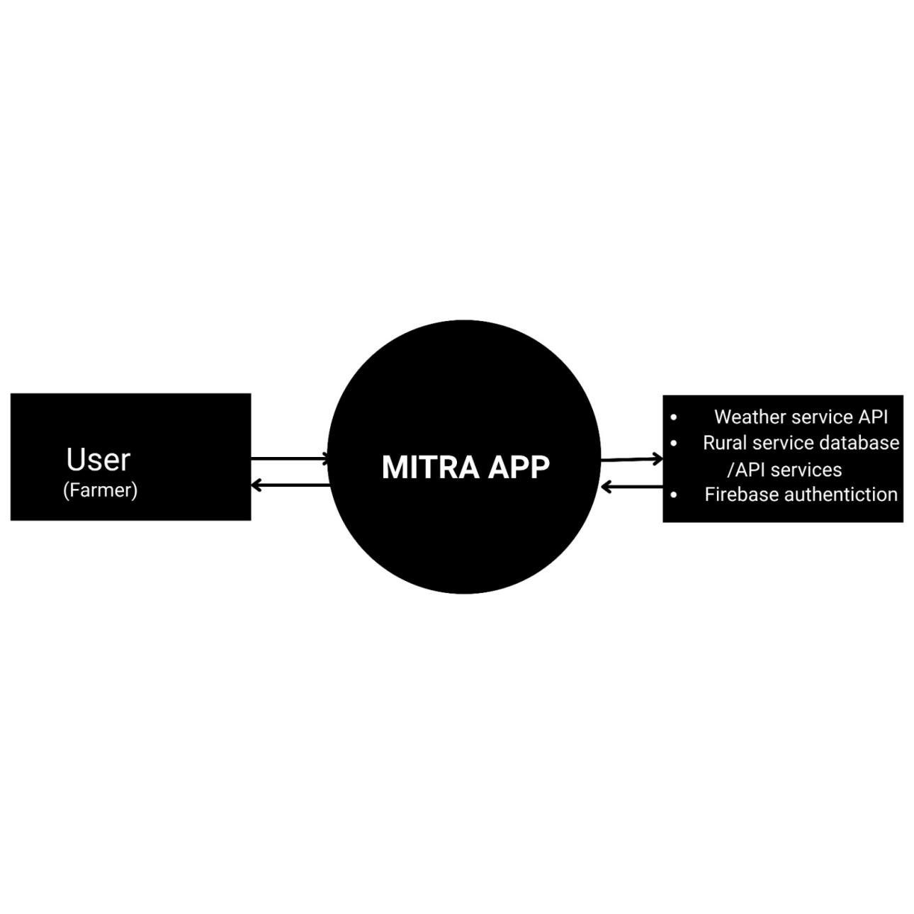
DFD Level 0

- Level 1 DFD:
Context level of DFD broken down into sub – processes consists in the news application, sub – processes are shown in the figure
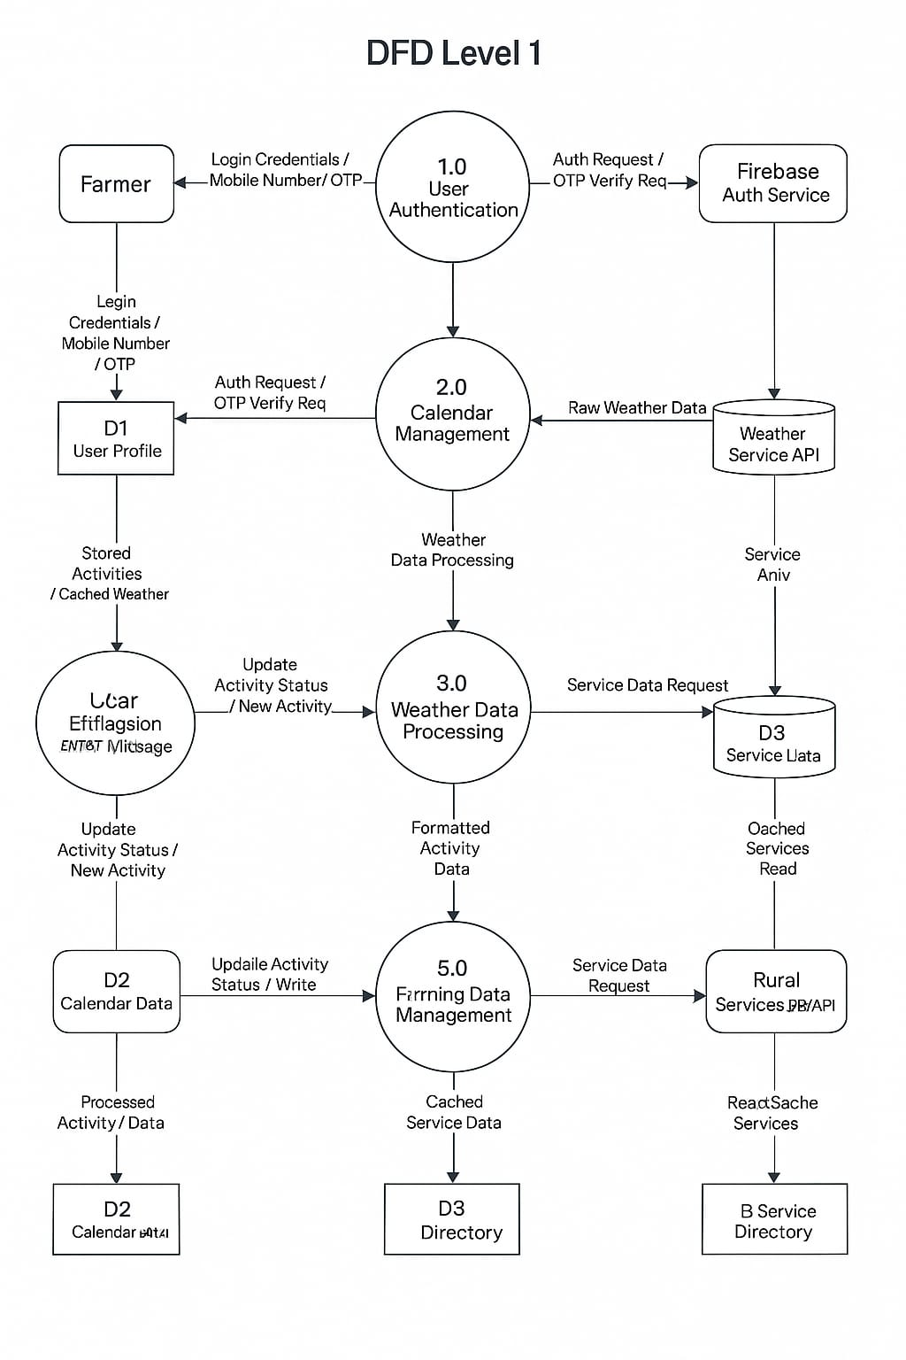
below:

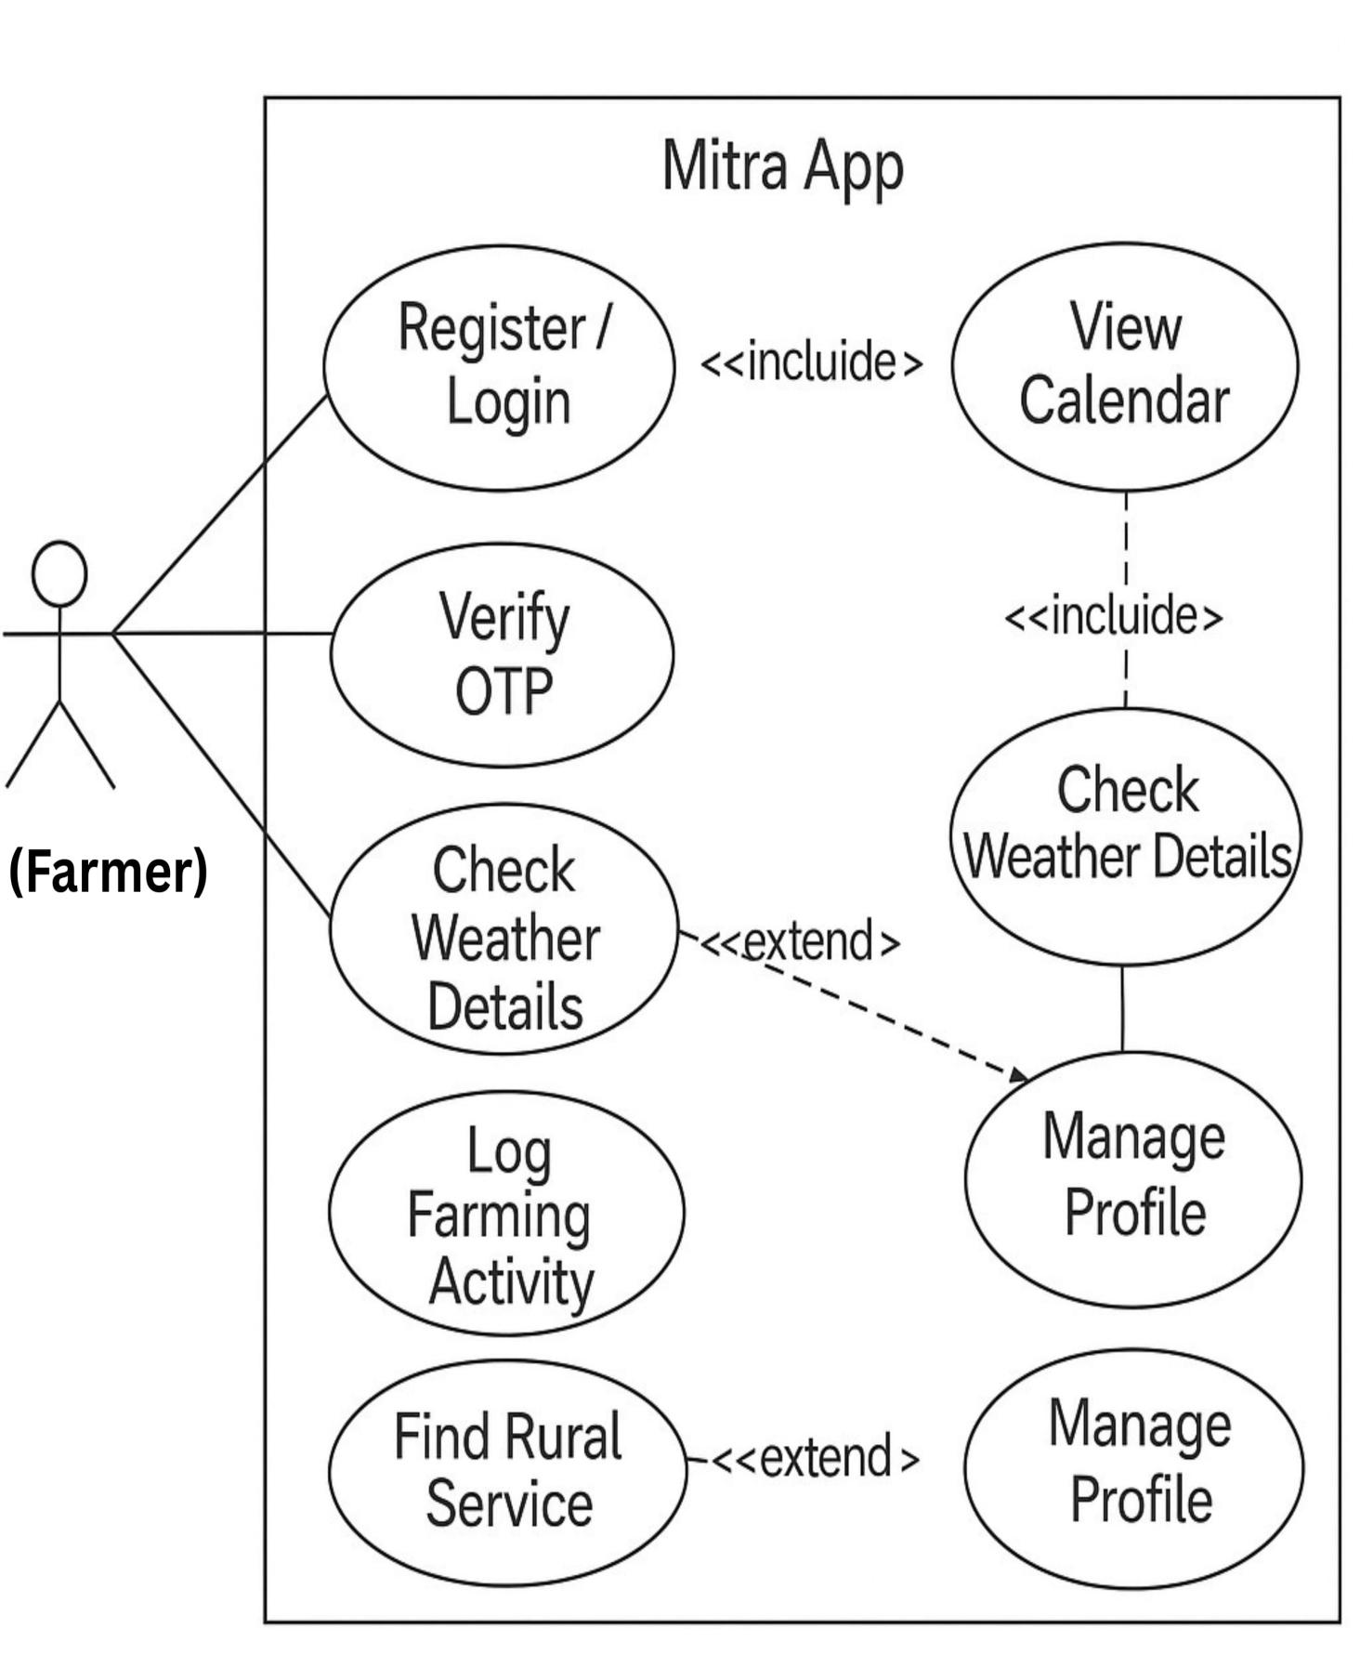
Use case diagram for MITRA

System Design

Modularization Detail:
Structured design partitions the program into small and independent modules. These are organized in a top-down manner with the details shown below. Thus, structured design uses an approach called modularization or decomposition to minimize the complexity and to manage the problem by subdividing it into smaller, functional segments from the user's perspective:
- Authentication Module:
This initial module handles user access. Farmers register and log in securely using their mobile number and a One-Time Password (OTP) verification process. This ensures that personalized calendar data, activities, and potentially saved services are associated with the correct user.

- Home Screen / Dashboard:
This serves as the main landing page after login. It provides an overview, typically showing a snapshot of the current day's weather, any immediate upcoming farming activities, and provides access points like the "Quick Actions" section and navigation to other main modules of the application.

- Calendar Module:
This is the core interactive module. It displays a monthly calendar view, allowing farmers to navigate between months. Dates are often highlighted or marked to indicate associated weather information or planned/logged farming activities. Selecting a date typically opens up more detailed information.

- Weather Information Module:
Integrated primarily with the Calendar, this module fetches and displays relevant weather data (like temperature, conditions, humidity, alerts) for specific dates or a forecast period. This information is crucial for planning farming activities.

- Farming Activities Module:
This module allows farmers to view suggested crop-specific activities for particular dates (linked via the Calendar) and track their status (e.g., pending, completed). It aims to provide organized guidance for farm management.

- Rural Services Directory Module:
This module functions as a directory or listing of essential agricultural and rural services available locally. Farmers can browse or search for services (like equipment rental, seed suppliers, labor) and find contact information. Filtering by category might be included.

- Quick Actions Module:
Typically presented on the Home Screen, this provides direct shortcuts to frequently accessed information or specific tasks, such as checking irrigation needs, viewing recent pest alerts, or
quickly navigating to the services directory without going through the main calendar flow.

- User Profile Module:
A simple module allowing users to view their registered mobile number and, importantly, provides the functionality to securely log out of the application, clearing their active session.

- Search panel and Notification:
Search panel is available to search all the available features and notification button to see the important notifications.

- Dark Mode:
Dark and light mode will give the user to choice what they prefer as per the time to give less stress to eyes.

User Interface Design:
- Design Philosophy
1. Simplicity
- Clean, uncluttered interface
- Minimal text, maximum icons
- Clear visual hierarchy
- Consistent layout

2. Accessibility
- Large touch targets
- High contrast colors
- Clear typography
- Intuitive navigation

3. Cultural Considerations
- Familiar icons
- Local language support
- Culturally appropriate colors
- Community-focused imagery

- Key Design Elements

1. Color Scheme
- Primary: #4CAF50 (Green)
- Secondary: #2196F3 (Blue)
- Accent: #FFC107 (Yellow)
- Background: #FFFFFF (White)
- Text: #333333 (Dark Gray)

2. Typography
- Headings: Roboto Bold, 24px
- Body: Roboto Regular, 16px
- Labels: Roboto Medium, 14px
- Icons: Ionicons

3. **Layout**
- Grid-based design
- Responsive components
- Flexible spacing
- Consistent padding

Screen Designs
1. Splash Screen
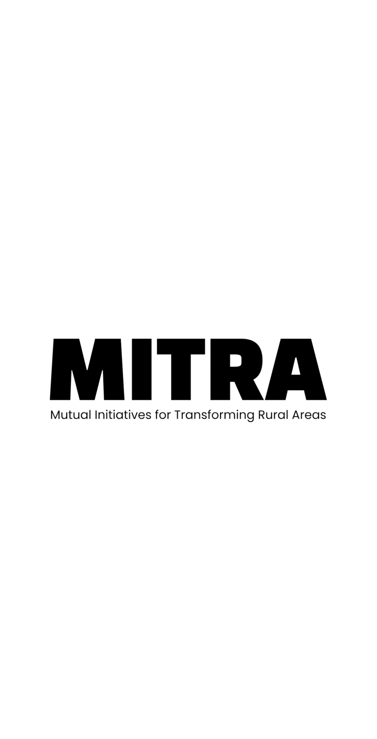
- App name

2. Login Screen
- Mobile number input
- OTP verification
- Clear instructions
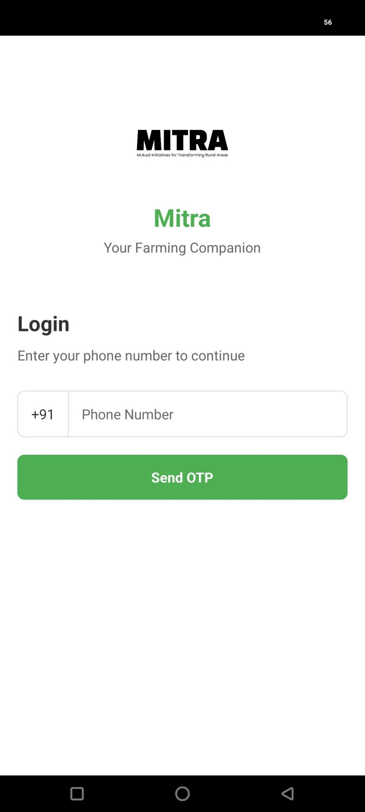
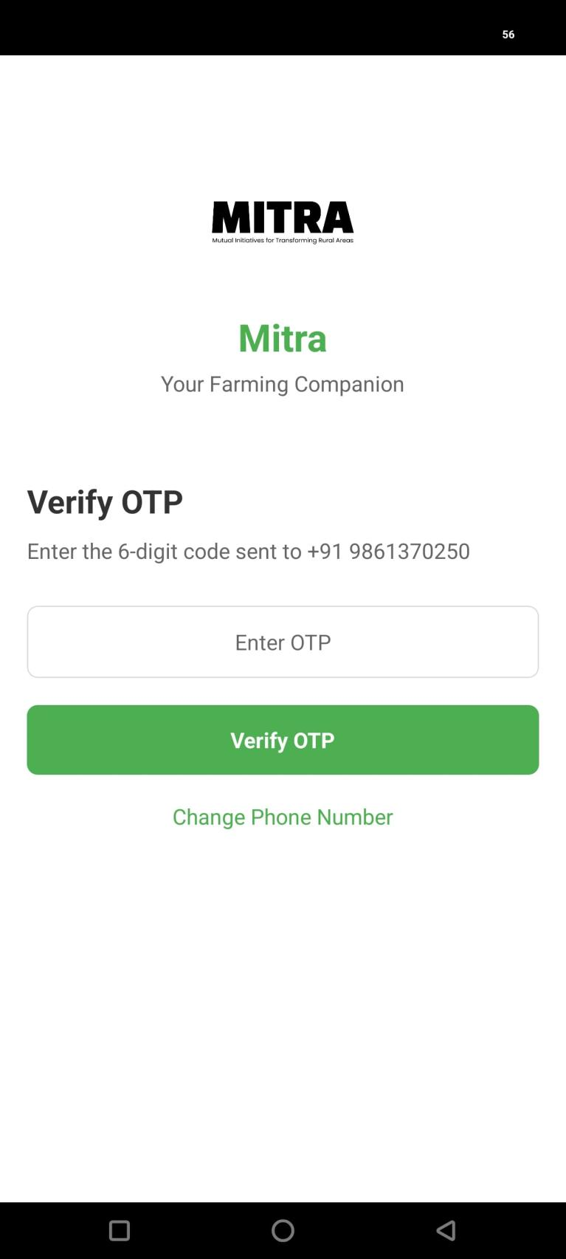
- Error handling

3. Home Screen
- Calendar view
- Quick actions
- Rural services
- Weather information

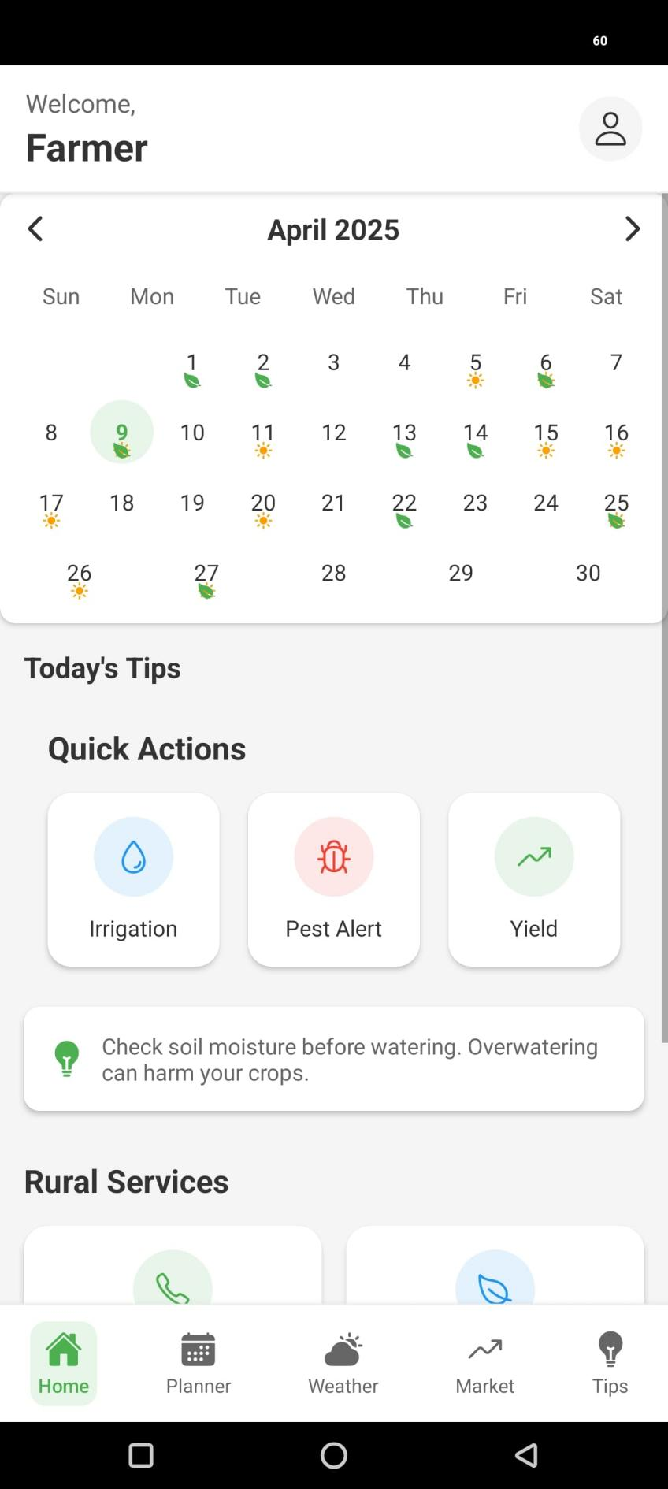

UI Components

1. Buttons
- Primary: Filled, rounded corners
- Secondary: Outlined, rounded corners
- Icon: Circular, with icon
- Text: Underlined text

2. Input Fields
- Mobile number: With country code
- OTP: 6-digit boxes
- Search: With icon
- Filter: Dropdown style

3. Cards
- Weather: With icon and details
- Activity: With status indicator
- Service: With contact info
- Alert: With warning icon

4. Navigation
- Bottom tabs
- Back button
- Close button
- Menu button

Responsive Design

1. Screen Sizes
- Small: 320px - 480px
- Medium: 481px - 768px
- Large: 769px - 1024px
- Extra Large: 1025px+

2. Adaptations
- Flexible grids
- Responsive images
- Adaptive typography
- Touch-friendly targets

3. Orientation
- Portrait mode optimized
- Landscape support
- Orientation lock
- Layout adjustments

Accessibility Features

1. Visual
- High contrast mode
- Text scaling
- Color blind support
- Clear focus indicators

2. Interaction
- Large touch targets
- Gesture support
- Voice input
- Haptic feedback

3. Content
- Screen reader support
- Alt text for images
- Clear error messages
- Help text

Design System

1. Components
- Button styles
- Input fields
- Cards
- Icons
- Typography
2. Layout
- Grid system
- Spacing rules
- Alignment guides
- Breakpoints
3. Assets
- Icon set
- Image guidelines
- Color palette
- Typography scale
4. Documentation
- Component usage
- Style guidelines
- Best practices

Coding

Comments and Description:
Well description of packages and functions are describe while coding in comments “//” and “{/* */}”.
1. File Header Comments are a crucial coding practice, placed at the top of a file, to provide essential information about the file's purpose, author, creation date, and other relevant details, aiding in code understanding and collaboration.
/**
* @file Calendar.js
* @description Calendar component for displaying monthly view with weather and farming activities
* @author MITRA Team
* @version 1.0.0
*/

2. Component Comments refers to annotations, notes, or feedback attached directly to specific user interface (UI) components during the design or development process.
/**
* Calendar Component
* @component
* @description Displays a monthly calendar with weather and farming activity information
* @param {Object} props
* @param {Date} props.selectedDate - Currently selected date
* @param {Function} props.onDatePress - Callback function when date is pressed
*/

3. Function Comments are used to explain the purpose inputs, outputs, and any important details about a function, making the code easier to understand and maintain.
/**
* Handles date selection in calendar
* @param {Date} date - Selected date
* @returns {void}
*/

4. Inline Comments are comments that appear on the same line as the code they are explaining, using symbols like "//" or "#" depending on the programming language.
// Generate calendar days for current month
const generateCalendarDays = () => {
// Get first day of month
const firstDay = new Date(currentYear, currentMonth, 1);
// Get last day of month
const lastDay = new Date(currentYear, currentMonth + 1, 0);
// ... rest of the code
};

Documentation Practices
A set of guidelines and standards for creating, maintaining, and developing documentation, ensuring accuracy, completeness, consistency, and reliability
1. Code Organization
- Logical file structure
- Clear component hierarchy
- Consistent naming conventions
- Modular design

2. Documentation Tools
- JSDoc for JavaScript documentation
- README files for components
- API documentation
- Style guide documentation

Standardization of the Coding
Code standardization involves establishing and adhering to guidelines and best practices for writing, structuring, and formatting code to ensure consistency, readability, and maintainability across a project or organization.
- Coding Standards
1. Naming Conventions

// Components: PascalCase
const Calendar = () => {};

// Functions: camelCase
const handleDatePress = () => {};

// Variables: camelCase
const selectedDate = new Date();

// Constants: UPPER_SNAKE_CASE
const MAX_RETRY_ATTEMPTS = 3;

2. File Organization

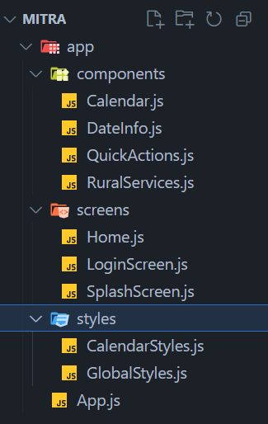

3. Import Order
// React and React Native imports
import React, { useState, useEffect } from 'react';
import { View, Text, StyleSheet } from 'react-native';
// Third-party libraries
import { Ionicons } from '@expo/vector-icons';

// Local imports
import { styles } from '../styles/CalendarStyles';

4. Component Structure
// Imports
import React from 'react';
// Component definition
const Component = () => {
// State declarations
const [state, setState] = useState();
// Effects
useEffect(() => {
// Effect code
}, []);
// Helper functions
const helperFunction = () => {
// Function code
};
// Render
return (
// JSX
);
};
// Styles

const styles = StyleSheet.create({
// Style definitions
});
// Export
export default Component;

Error Handling
- Error Handling Strategy
1. Try-Catch Blocks
try {
// Attempt operation
const result = await fetchData();
} catch (error) {
// Handle error
console.error('Error fetching data:', error);
// Show user-friendly message
Alert.alert('Error', 'Unable to fetch data. Please try again.');
}

2. Error Boundaries
class ErrorBoundary extends React.Component {
state = { hasError: false };
static getDerivedStateFromError(error) {
return { hasError: true };
}
componentDidCatch(error, errorInfo) {
// Log error
console.error('Error:', error, errorInfo);
}
render() {
if (this.state.hasError) {
return <ErrorScreen />;
}
return this.props.children;
}
}

3. API Error Handling
const fetchWeatherData = async () => {
try {
const response = await fetch(API_URL);
if (!response.ok) {
throw new Error(`HTTP error! status: ${response.status}`);
}
const data = await response.json();
return data;
} catch (error) {
// Handle specific error types
if (error.name === 'NetworkError') {
// Handle network errors
} else if (error.name === 'TypeError') {
// Handle type errors
}
throw error;
}
};

Validation Checks
1. Form Validation
const validateMobileNumber = (number) => {
const regex = /^[0-9]{10}$/;
return regex.test(number);
};
const validateOTP = (otp) => {
const regex = /^[0-9]{6}$/;
return regex.test(otp);
};
2. Data Validation
const validateDate = (date) => {
if (!(date instanceof Date)) {
return false;
}
return !isNaN(date);
};
const validateWeatherData = (data) => {
return (
data &&
typeof data.temperature === 'number' &&
typeof data.condition === 'string' &&
typeof data.humidity === 'number'
);
};
3. API Response Validation
const validateAPIResponse = (response) => {
if (!response || typeof response !== 'object') {
throw new Error('Invalid API response format');
}
if (!response.success) {
throw new Error(response.message || 'API request failed');
}
return response.data;
};

Testing

Mobile application testing is a procedure to test mobile applications for usability, functional, and consistency glitches.
Functional Testing
The functional testing of MITRA primarily focused on ensuring user interactions and core features operated as specified. The key areas validated include:

- Required fields, like mobile number and OTP inputs, function correctly and accept valid data formats.
- The application starts and stops cleanly, handling initialization as required.
- The application handles interruptions gracefully, such as incoming phone calls or SMS messages, minimizing or pausing appropriately and resuming correctly.
- The device can multitask effectively while MITRA is running in the foreground or background.
- Scrolling within lists (like Rural Services or Farming Activities) and the Calendar view is smooth and functional.
- Navigation between the main sections (Home, Calendar, Services, Profile) using the bottom navigation bar and back gestures works as expected and logically.

- MITRA coexists effectively with other installed applications, without excessively consuming memory or causing conflicts.

- The application attempts to resume state or recover gracefully after unexpected interruptions like a simulated crash or reboot (where feasible with React Native state management).
- Installation of the application package (APK) is straightforward and completes without significant errors on compatible devices.
- Core functionalities perform adequately across different network conditions typically found in rural areas (simulated 2G, 3G, WiFi).
- Basic user guidance (like input prompts or help text) is available for key functionalities.

Performance Testing
This testing aimed to ensure MITRA performs acceptably under typical usage and meets responsiveness expectations, especially considering potential limitations in rural connectivity and device hardware. General scenarios tested include:

- Application performance under varying simulated loads (e.g., many calendar entries, large service lists).
- Application responsiveness over different network types (2G, 3G, WiFi), ensuring key features remain usable even on slower connections.
- Verification that the chosen client-side architecture (React Native, component structure) delivers acceptable performance.
- Measurement of key response times, such as app launch, screen transitions, and data loading (weather, activities, services), ensuring they meet usability goals (e.g., launch under 3-4 seconds).
- Confirmation that the minimum supported Android version (Android 6.0) with typical low-to-mid-range hardware (e.g., 2GB RAM, quad-core CPU) provides an acceptable user experience.
- Assessment of background resource usage and battery consumption to ensure it's reasonable, though providing guidance on charger use for prolonged sessions might still be necessary.
- Ensuring smooth operation during network transitions (e.g., WiFi to cellular).
- Verification that Firebase offline capabilities function correctly, allowing access to cached data and syncing updates when connectivity resumes without major performance hits.

Security Testing
The primary objective was to ensure the application protects user data and adheres to basic security principles. Key areas checked include:

- The application requires proper authentication (Mobile OTP) to access personalized content (like logged activities). Sensitive data is not accessible without logging in.
- Authentication mechanisms (OTP generation, verification, session handling) are implemented securely using Firebase Authentication, minimizing risks related to unauthorized access or session hijacking.
- Measures are taken to prevent excessive OTP requests or verification attempts (rate limiting) to mitigate brute-force attacks.
- Secure storage (Expo-Secure-Store) is used for sensitive data like authentication tokens.
- Communication with backend services (Firebase, Weather API) uses HTTPS to protect data in transit.
- Firebase Security Rules are configured to ensure users can only access their own data or publicly intended data (like the general service directory).
- Basic checks against common client-side vulnerabilities (though less prevalent in native apps compared to web, considerations for input handling apply).
- Data validation is performed on inputs to ensure data integrity.

Usability Testing
Usability testing aimed to ensure MITRA is intuitive and easy to use for the target farmer audience, minimizing friction and cognitive load. Areas assessed include:

- Buttons and interactive elements (like date cells) are sufficiently large and spaced for easy tapping, considering varying screen sizes and finger sizes.
- Placement of common controls (like navigation, action buttons) is consistent across different screens.
- Icons used are visually clear, culturally appropriate (where possible), and consistently represent their intended actions.
- The application provides clear feedback for user actions (e.g., button presses, loading states).
- Text content is simple, clear, and uses font sizes that are easily readable on typical mobile screens.
- (Future) Ensure translated text fits correctly within UI elements when multi-language support is added.
- The application state updates promptly and accurately reflect user actions (e.g., marking an activity complete).

Compatibility Testing
Compatibility testing ensured that MITRA functions correctly and displays properly across a reasonable range of Android devices and versions commonly used by the target audience. Areas checked include:

- The user interface adapts correctly to different screen sizes and resolutions, ensuring text remains readable and controls are not truncated or overlapping.
- The application installs and runs without crashing on the minimum supported Android version (6.0) and newer versions.
- The application correctly handles interruptions like incoming calls or notifications and resumes appropriately on various tested devices/OS versions.
- Basic functionalities are verified across different hardware configurations (varying RAM, CPU) to ensure acceptable operation.

System Security Measures

These Measures apply to anyone who accesses or uses the MITRA application. The focus is on ensuring the security and privacy of user data and the integrity of the application.
Database/data security:
Database security testing is done to find loopholes in security mechanisms and weaknesses in the system. The main target is to determine whether data and resources are protected from potential intruders. Security testing defines a way to identify potential vulnerabilities effectively.

- Unauthorized Access to data:
A primary concern is preventing unauthorized users from accessing the database or viewing data belonging to others. MITRA addresses this by utilizing Google Firebase Authentication service for user login via mobile number and OTP. This ensures only verified users can access the application's core features. Furthermore, Firebase Security Rules are strictly implemented for the Firestore database. These rules are configured to ensure that authenticated users can only read and write data directly associated with their own unique User ID (UID), effectively preventing access to other users' calendar entries or activity logs.

- Password Cracking:
Traditional password cracking is mitigated as MITRA does not use static passwords. Instead, authentication relies on time-limited, single-use One-Time Passwords (OTPs) sent to the user's verified mobile number for each login attempt. This process is managed securely by Firebase Authentication. Additionally, rate limiting is implemented on OTP generation requests and verification attempts to prevent brute-force attacks trying to guess the OTP.

- Security Audit of Database System:
Regular security audits help ensure necessary standards are followed. While formal, extensive audits may be part of future development phases, the current system relies heavily on the robust security practices and regular audits conducted by Google for the underlying Firebase platform (Authentication, Firestore, infrastructure). Periodic internal reviews of the implemented Firebase Security Rules are conducted to ensure they remain appropriate and correctly enforce access control as the application evolves.

- Penetration Testing:
Penetration testing involves actively attempting to find and exploit security loopholes. Formal penetration testing has not been conducted for this development phase of MITRA. Security relies on the secure architecture provided by Firebase, adherence to secure coding practices (e.g., input validation, HTTPS usage), and correctly configured access
controls via Firebase Security Rules. Penetration testing remains a consideration for future, more mature versions of the application.

- Risk Finding:
Assessing potential risks is crucial. Basic security risks for MITRA related to user authentication (ensuring the right user logs in) and data authorization (ensuring users only see their own data) were identified early. These core risks are primarily addressed through the implementation choices: leveraging Firebase Authentication for secure login and Firebase Security Rules for granular data access control.
A more comprehensive risk assessment may be undertaken in future development cycles.

- Minimize Value of Your Database:
To reduce the impact of any potential breach, MITRA adheres to the principle of data minimization. Only data essential for the application's functionality is collected and stored – primarily the user's mobile number (for authentication) and user-generated/associated data like farming activities and potentially saved service preferences.
No highly sensitive personal identifiable information (PII) beyond the mobile number or financial data is stored within the application's database. Policies for removing inactive user data may be implemented in the future.

- Database Firewalls:
While MITRA utilizes a cloud-based database (Firebase Firestore), the concept of a firewall is implemented through Firebase Security Rules. These rules act as a mandatory checkpoint for every database read and write operation, evaluating requests based on user authentication status and data path logic. They effectively function as a data-level firewall, ensuring that only authorized requests according to predefined logic can interact with the database, managed within Google's secure infrastructure.
All communication between the app and Firebase services occurs over HTTPS.

- Creation of User profiles and access rights:
When a user registers via mobile number/OTP, Firebase Authentication creates a unique user profile identified by a UID. MITRA employs a simple access control model based on this profile. There aren't distinct user roles (like admin vs. user) within the app's core functionality initially. Access rights are implicitly defined and enforced by Firebase Security Rules, which typically grant a logged-in user (identified by their UID) permission to read and write data specifically nested under their own UID within the database structure (e.g., /users/{user_UID}/activities/...).
This ensures data isolation based on ownership tied directly to the authenticated user profile.

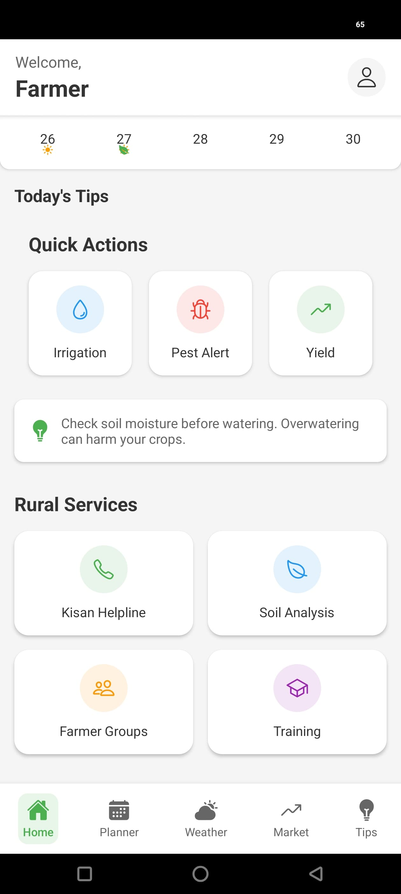
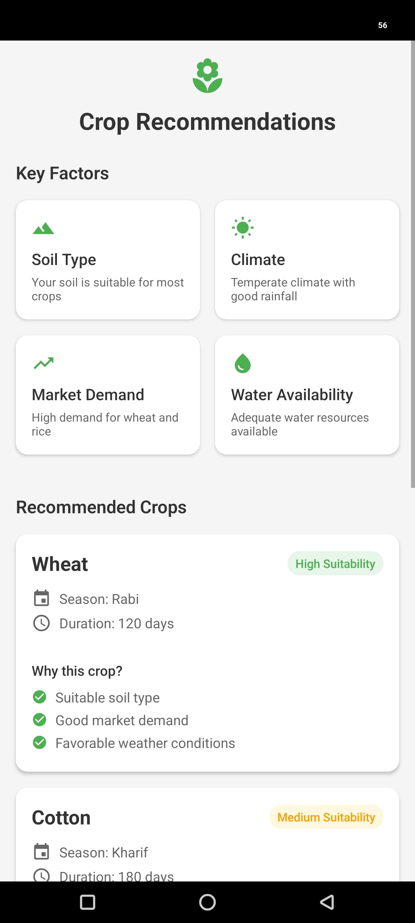
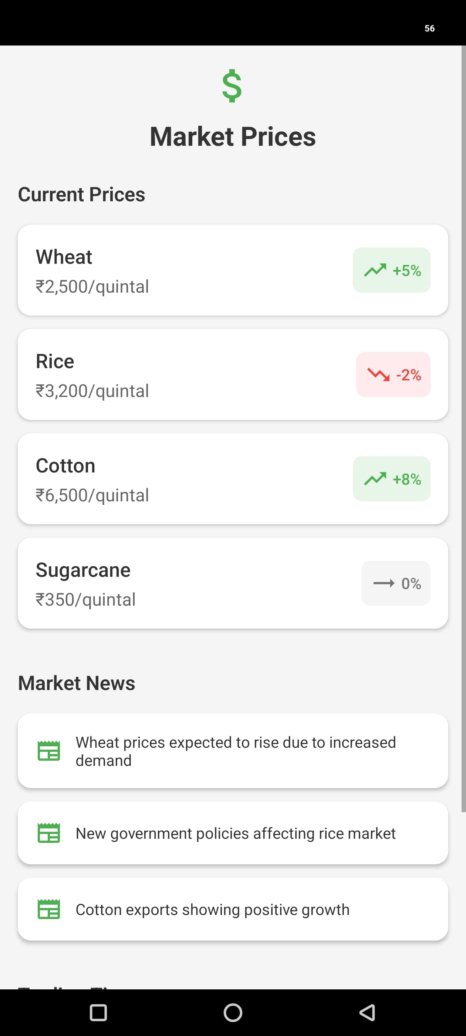
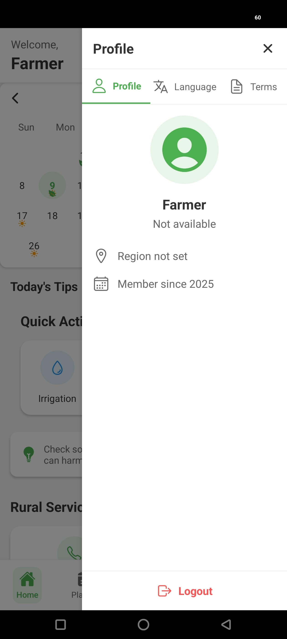
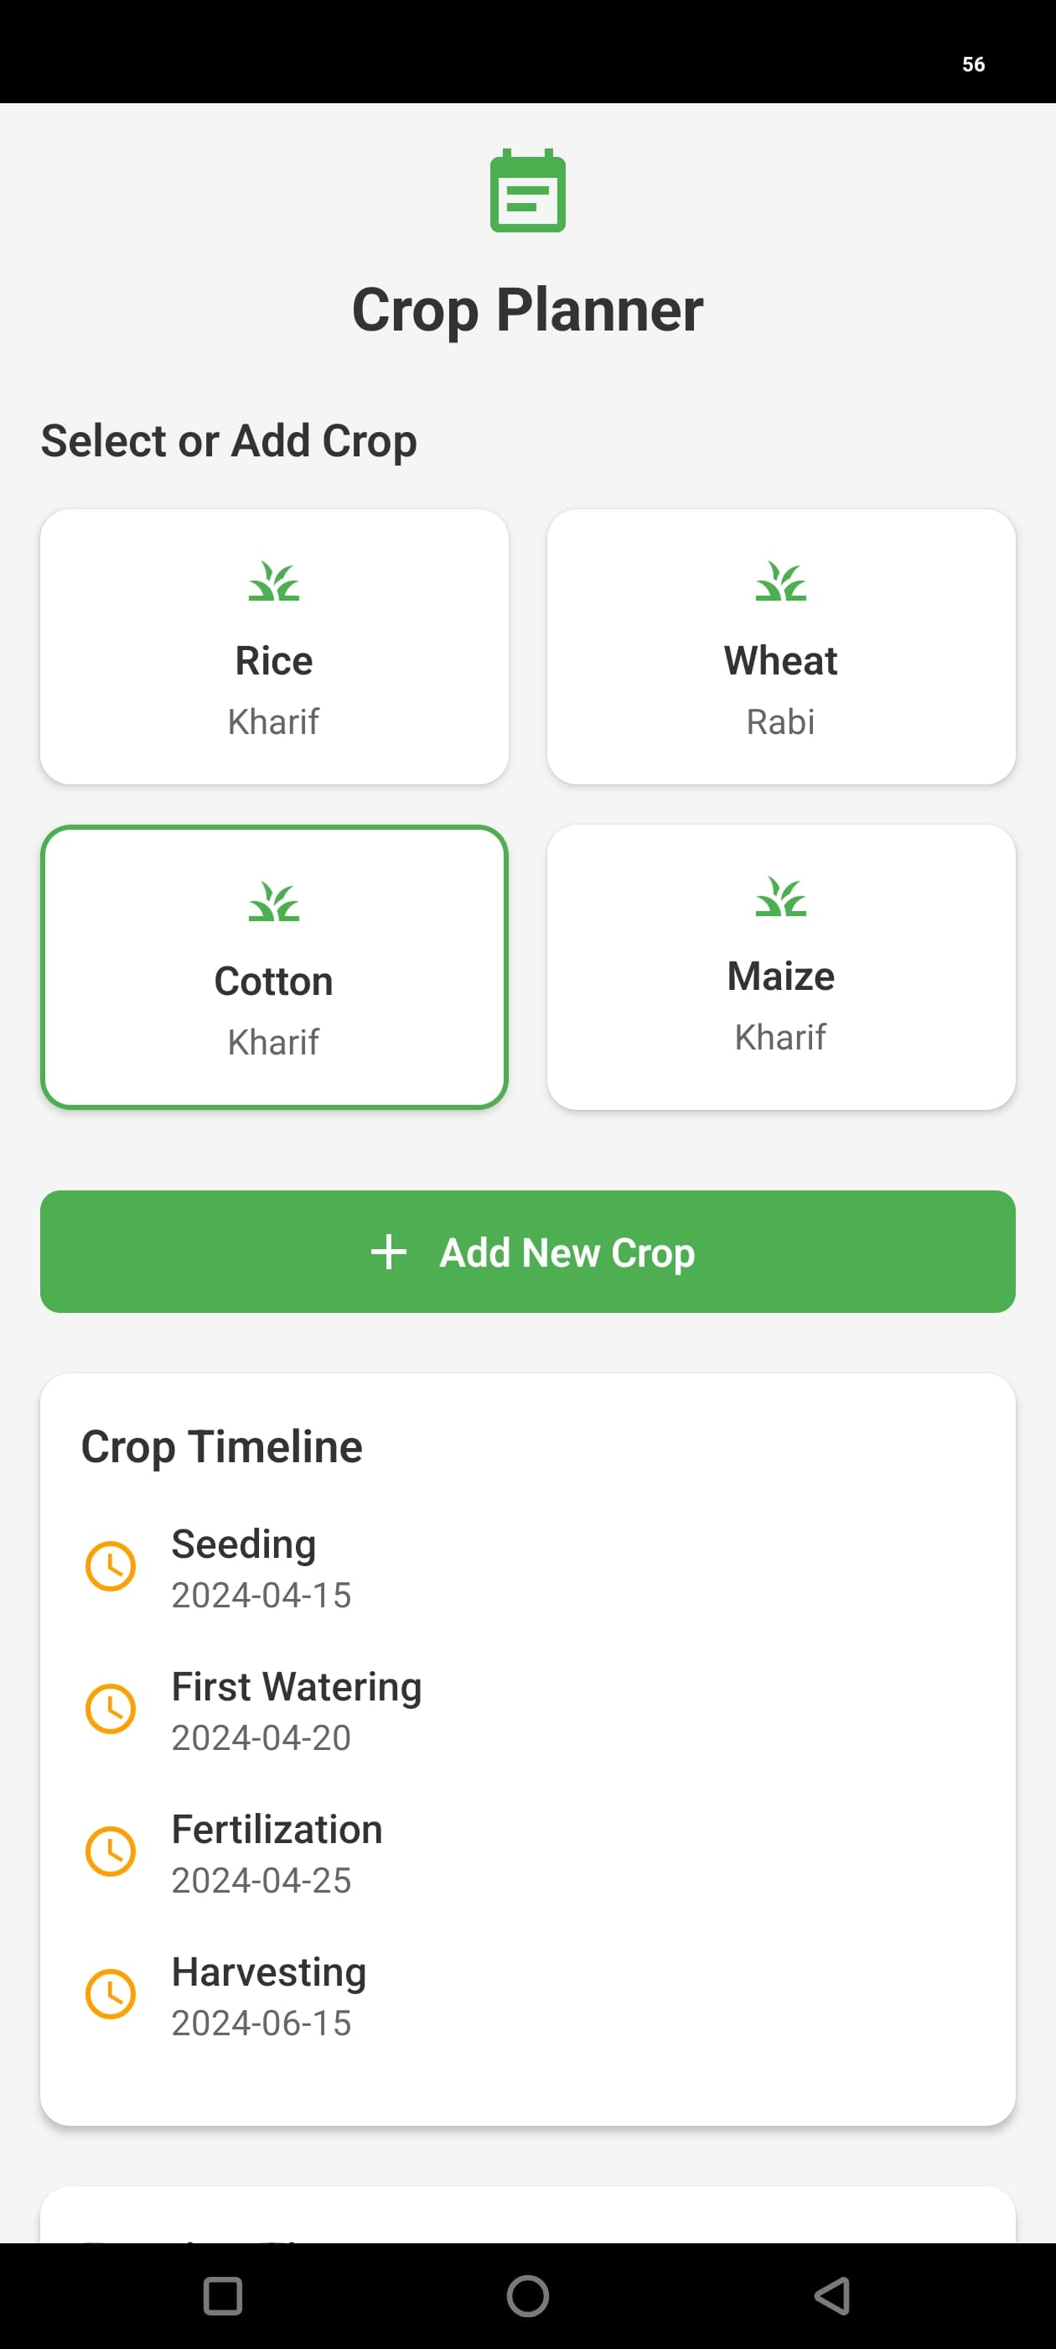
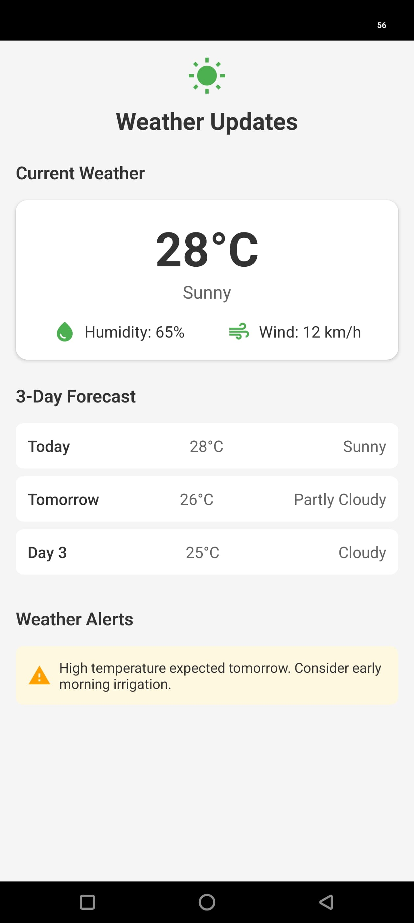
Screenshots

Future Scope
The MITRA application is designed to evolve based on user needs and technological advancements. Future development will focus on enhancing its value as a comprehensive digital tool for farmers.
Upcoming Enhancements & Features:

- Advanced Weather Integration:
- Implement real-time, location-specific weather alerts (push notifications).
- Integrate more detailed forecasting (hourly, extended periods).

- Enhanced Farming Management:
- Introduce crop planning and scheduling features.
- Enable yield prediction and cost analysis capabilities.
- Allow user customization of farming activities.

- Community & Expert Interaction:
- Build a community forum for farmer networking and knowledge sharing.
- Integrate features for direct consultation with agricultural experts.

- AI/ML Capabilities:
- Incorporate predictive analytics for yield, weather patterns, or pest/disease outbreaks.
- Explore integration with IoT/sensor data for smart farming recommendations.

- Expanded Integrations:
- Connect with relevant Government agricultural schemes and advisories.
- Integrate real-time market price information.

- Platform & User Base Expansion:
- Develop a fully supported iOS version.
- Implement multi-language support for wider regional coverage.
- Optimize for tablet devices.

- Service Marketplace & Monetization:
- Develop a marketplace for agricultural inputs, equipment rental, and labor.
- Explore premium features (e.g., advanced analytics, priority expert access).

- Further Development Considerations:

- Continuous performance optimization and enhancement of offline capabilities.
- Strengthening security measures and conducting periodic reviews.
- Building strategic partnerships with agricultural organizations and government bodies.

Assumptions
An assumption is something that is believed to be true. It’s an event that you can expect to happen during a project. However, that certainty isn’t supported by factual proof, it comes from experience. Just like dependencies and constraints, assumptions are events that are outside of the project manager’s and team’s control. But unlike constraints, which put restrictions on a project and can pose a danger to its successful completion, assumptions open possibilities for it and make it possible for the project to finish successfully. This is how you can differentiate assumptions from constraints and dependencies.
Operating System: Minimum version assumed Android 5.0 and iOS 9.
Hardware configuration: Minimum hardware configuration assumed
- Android: minimum of 1GB RAM, 1.2 GHz duel core processor.
- iOS: minimum of 1GB RAM, 1.2 GHz duel core processor.
Device screen size: Assumption of the device screen size is range from 4 inch to 6.5 inch.
GPS: Device has good GPS in it.
Battery: Device battery health is in good condition.

Glossary

Technical Terms
1. API (Application Programming Interface)
- A set of rules and protocols for building software applications
- Enables communication between different software components

2. React Native
- A JavaScript framework for building mobile applications
- Allows cross-platform development for iOS and Android

3. JWT (JSON Web Token)
- A compact, URL-safe means of representing claims between parties
- Used for secure information exchange

4. CORS (Cross-Origin Resource Sharing)
- A security feature that restricts web page requests to different domains
- Protects against unauthorized access
Domain Terms
Weather API
- Service providing weather data and forecasts
- Used for agricultural planning

Project-specific Terms
1. MITRA
- The mobile application name
- Means "friend" in Sanskrit

2. Quick Actions
- Shortcut features for common tasks
- Includes irrigation, pest alerts, yield info
3. Weather Indicators
- Visual representations of weather conditions
- Used in calendar view
Development Terms
1. Component
- Reusable UI element in React Native
- Building block of the application

2. State Management
- Handling application data and UI state
- Ensures consistent user experience

3. Navigation
- Movement between different screens
- User interface flow

Bibliography

Technical References
- https://reactnative.dev/docs/getting-started
- https://developer.mozilla.org/en-US/docs/Web/JavaScript
- https://jestjs.io/docs/getting_started
Agricultural References
- https://mausam.imd.gov.in/
- https://agriculture.gov.in/

Security References
- https://owasp.org/www-project-mobile-security/
- https://jwt.io/introduction
Design References
- https://material.io/design
- https://www.w3.org/WAI/standards-guidelines/wcag/

