Brett Fuller

11/16/2024

CSD 310 – Assignment 4.2

My first installation attempt I followed the instructions on the site listed and I got it installed and could start the service but it failed to add things to PATH and was being kind of annoying then I stumbled into a listing of installing it through homebrew and as soon as I ran that installation everything just worked! So my advice is if you’re on a mac just use homebrew.

I should note I tried to insall the recommended extension for vsCode but in order for it to work I would have to down grade the version of MySQL and then use an older no longer supported authentication method for the connection to work. In order to connect to MySQL it is requiring me to use the command shown below for the supported authentication protocol.

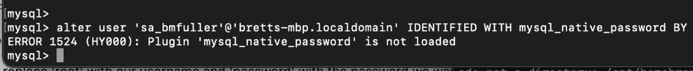

Unfortunately as you see here the mysql_native_password has been deprecated and therefore is no longer a valid option with modern versions of MySQL. Which leads to the following error when I try to authenticate.



The extension links to the github page for the project and under the issues list there is the following issue. <https://github.com/formulahendry/vscode-mysql/issues/193> This issue lists the solution as the command I used on the database that led to the plugin not loaded message and further research led me to this thread <https://stackoverflow.com/questions/78938322/mysql-authentication-plugin-issues-on-macos>

I am currently running the lts release of 8.4.3 on MacOS not even a 9.x version so I am kind of at a loss for a way forward. Is this communication method going to be required for future work in this class? Do I need to downgrade my version of MySQL and use the older insecure hashing algorithm for passwords? That seems like a bad idea but this also is not a production server and will not house any important data so it is not the end of the world but I still don’t like it.