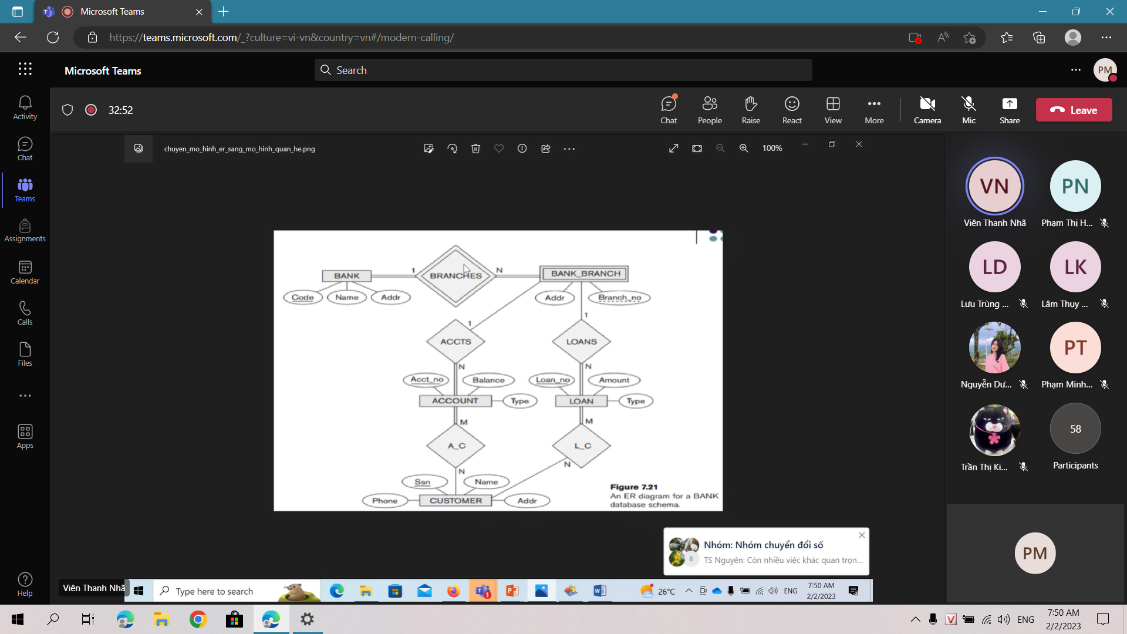

BANK (CODE, NAME, ADDR)

CUSTOMERS ( PHONE, SSN, NAME, ADDR)

ACCOUNT (ACCT_NO, BALANCE, TYPE, BRANCH_NO)

LOAN (LOAN_NO, AMOUNT, TYPE, BRANCH_NO)

BANK_BRANCH(ADDR, *CODE*, BRANCH_NO, *ACCT_NO, LOAN_NO*)

A_C(*ACCT_NO, SSN*)

L_C(*LOAN_NO, SSN*)

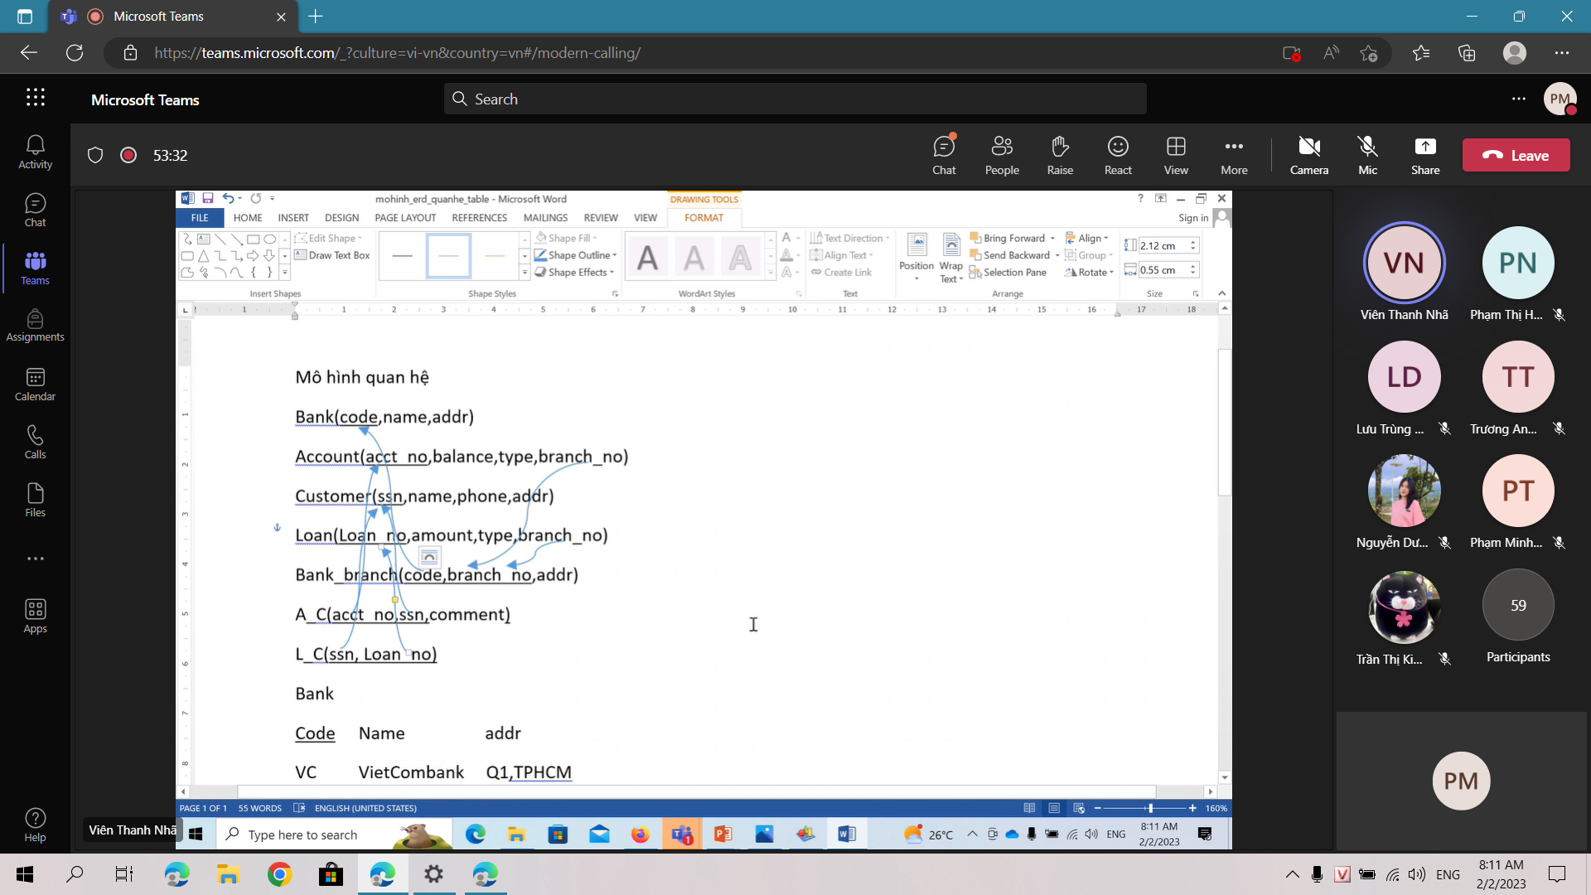

Xđ account, customer,loan,a_c,l_n

| ACCOUNT | | | | | | |
| --- | --- | --- | --- | --- | --- | --- |
| STT | ATTRIBUTE | DATATYPE | LENGTH | PRIMARY KEY | FOREIGN KEY | NOTNULL |
| 1 | ACCT_NO | nchar | 6 | x |  | x |
| 2 | BALANCE | int | 9 |  |  |  |
| 3 | TYPE | nvarchar | 200 |  |  |  |
| 4 | BRANCH_NO | nchar | 6 |  | x |  |

create table account {

acct_no nchar(6) primary key not null,

balance money(),

type nvarchar(200),

branch_no nchar(6),

foreign key (branch_no) references bank(branch_co)

}

| CUSTOMER | | | | | | |
| --- | --- | --- | --- | --- | --- | --- |
| STT | ATTRIBUTE | DATATYPE | LENGTH | PRIMARY KEY | FOREIGN KEY | NOTNULL |
| 1 | SSN | nchar | 20 | x |  | x |
| 2 | NAME | nvarchar | 200 |  |  |  |
| 3 | PHONE | nchar | 20 |  |  |  |
| 4 | ADDR | nvarchar | 200 |  |  |  |

create table customers {

ssn nchar(20) primary key notnull,

name nvarchar(200),

phone nchar(20),

addr nvarchar(200)

}

create table bank_branch {

code nchar(2) not null,

branch_no nchar(6) not null,

addr nvarchar(200),

constraint pk_bank_branch primary key(code, branch_no),

foreign key (code) references bank(code)

}

| LOAN | | | | | | |
| --- | --- | --- | --- | --- | --- | --- |
| STT | ATTRIBUTE | DATATYPE | LENGTH | PRIMARY KEY | FOREIGN KEY | NOTNULL |
| 1 | LOAN_NO | nchar | 6 | x |  | x |
| 2 | AMOUNT | int | 9 |  |  |  |
| 3 | TYPE | nvarchar | 200 |  |  |  |
| 4 | BRANCH_NO | nchar | 6 |  | x |  |

| A_C | | | | | | |
| --- | --- | --- | --- | --- | --- | --- |
| STT | ATTRIBUTE | DATATYPE | LENGTH | PRIMARY KEY | FOREIGN KEY | NOTNULL |
| 1 | ACCT_NO | nchar | 6 |  | x |  |
| 2 | SSN | nchar | 20 |  | x |  |
| 3 | COMMENT | nvarchar | 200 |  |  |  |

| L_C | | | | | | |
| --- | --- | --- | --- | --- | --- | --- |
| STT | ATTRIBUTE | DATATYPE | LENGTH | PRIMARY KEY | FOREIGN KEY | NOTNULL |
| 1 | SSN | nchar | 20 |  | x |  |
| 2 | LOAN_NO | nchar | 6 |  | x |  |



