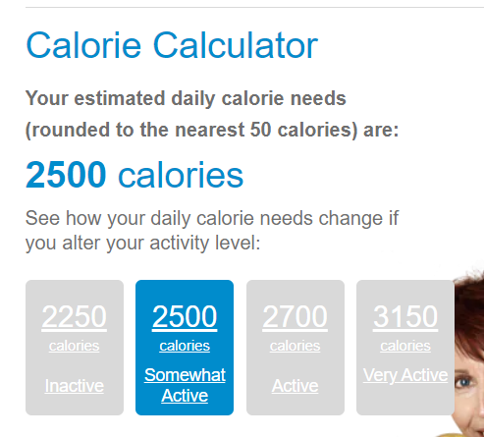

Almonds

Eggs

Milk

Green peaa

Bananas

Paneer

Beef

yoghurt