POST Requests:

* Proper Upload

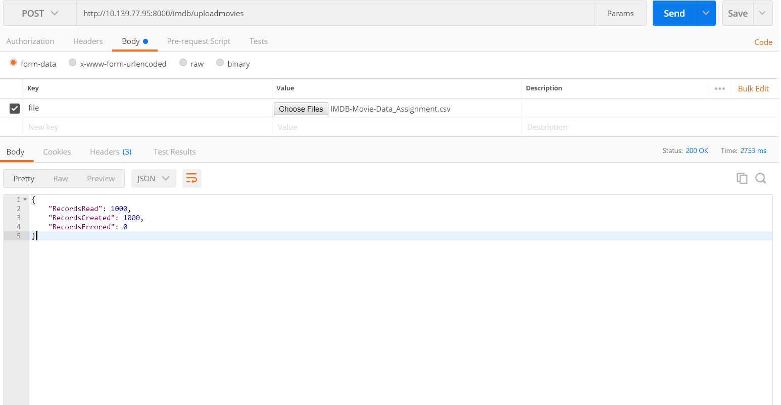

* Re-Upload with duplicates

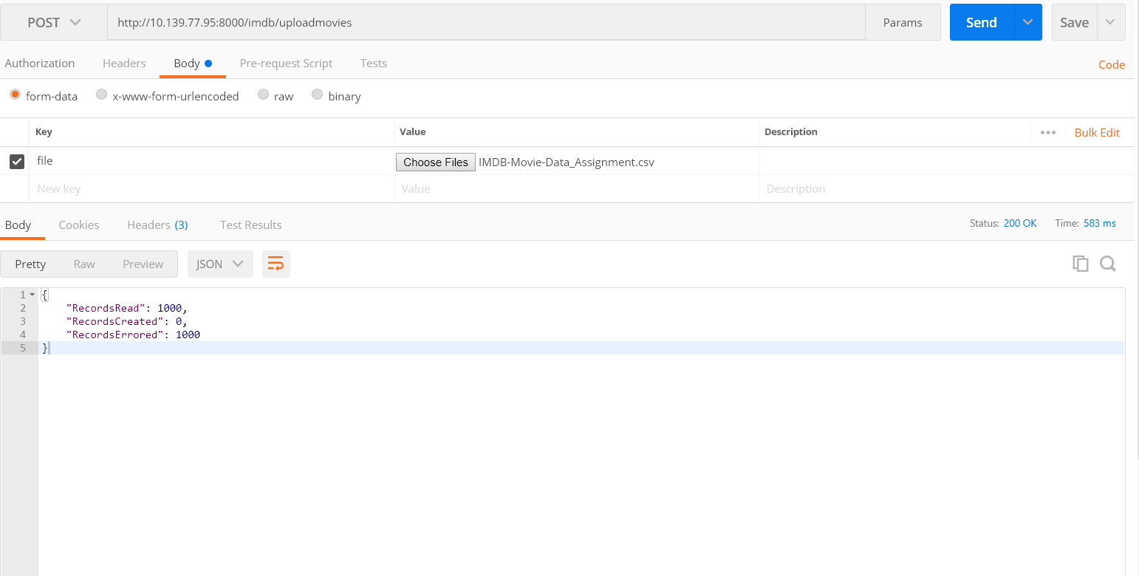

* Key named to ‘abc’ instead of ‘file’

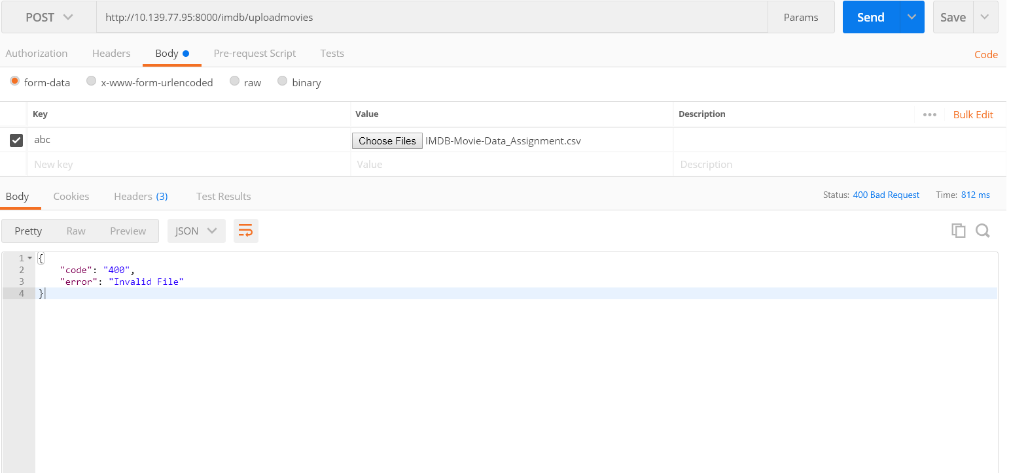

* Improper CSV with invalid columns

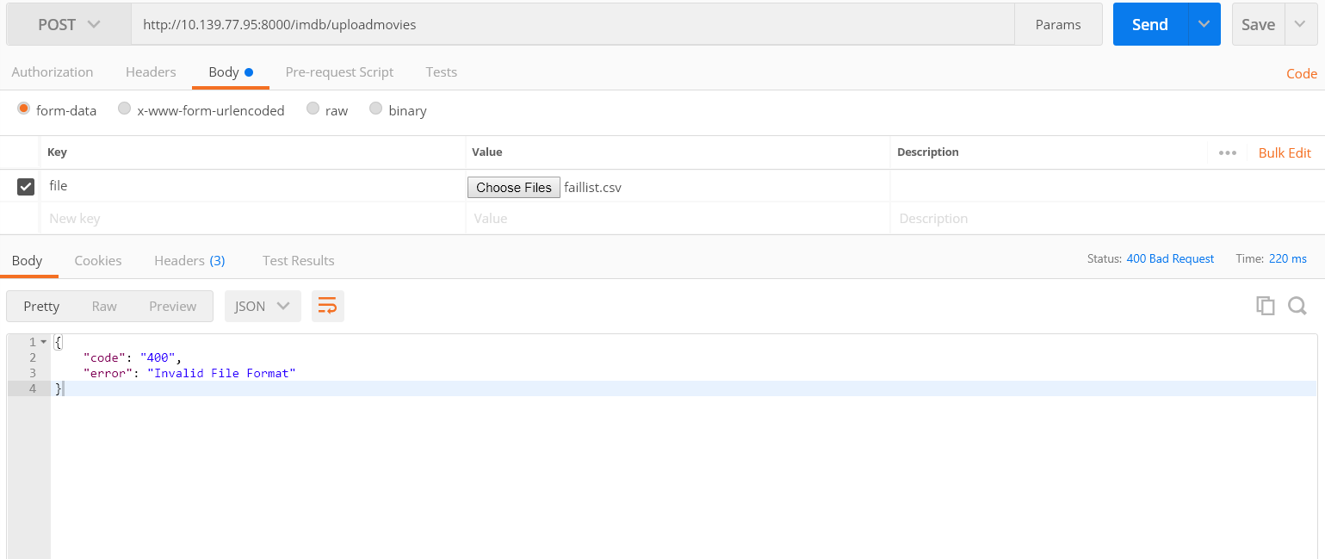

* Upload as something other than multipart/form-data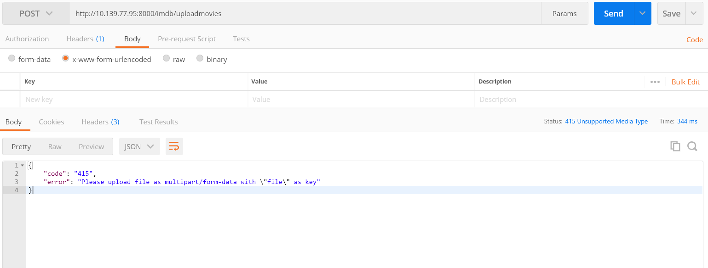

=====================================================================================

GET Requests:

* Proper GET request with year range and Genre

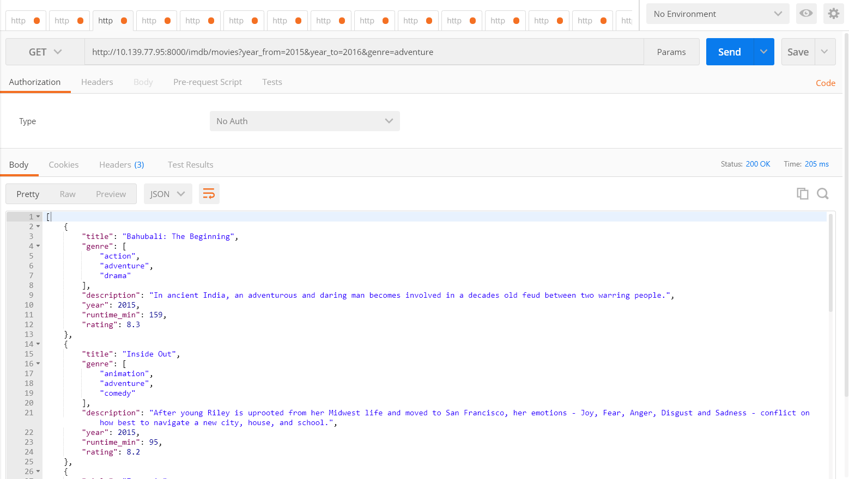

* With Default Year of 2016

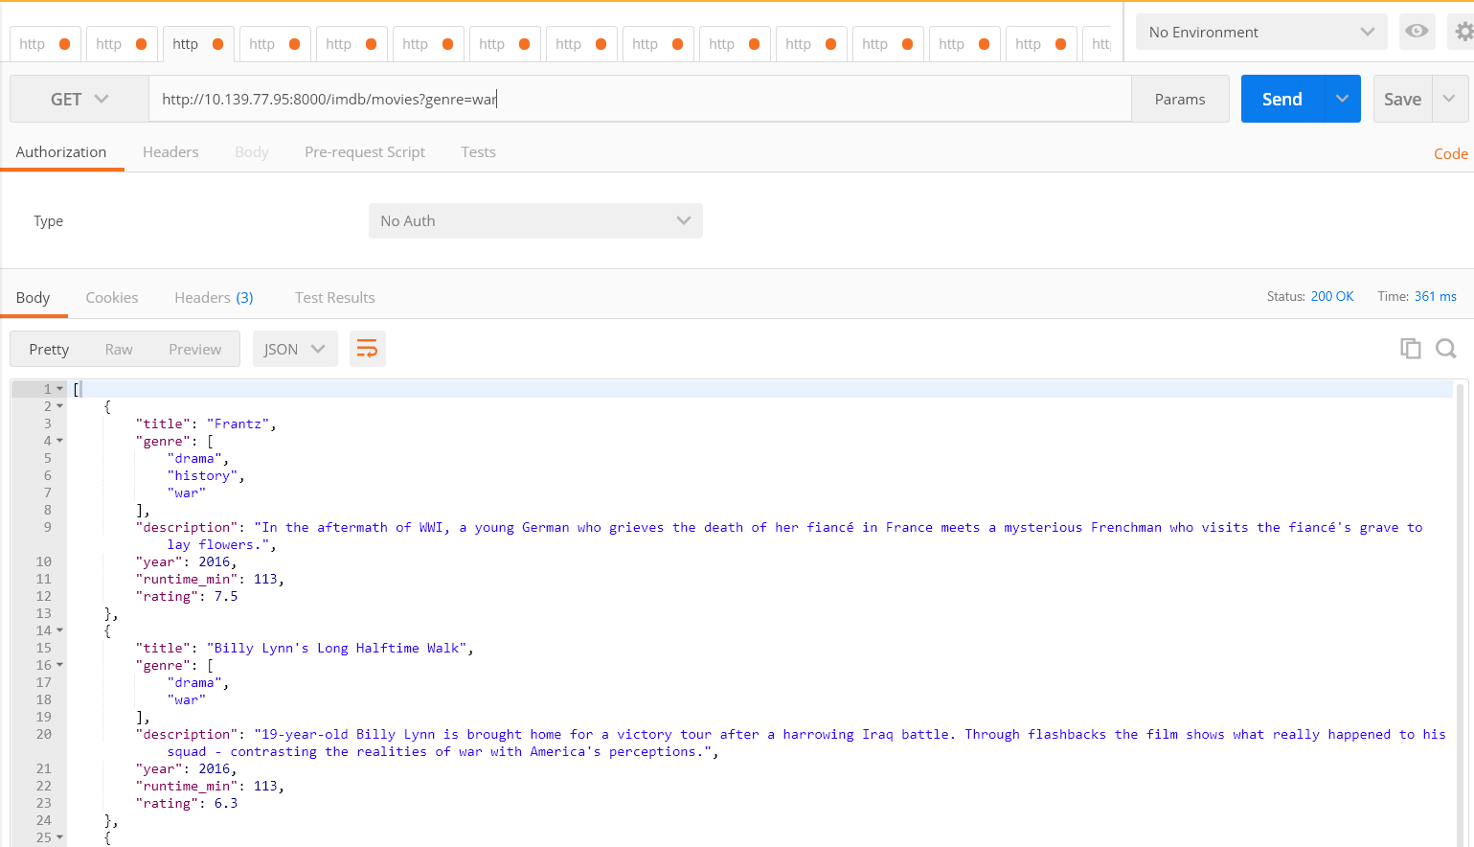

* Query Params of year 2015 and ‘war’ genre returning 2 results sorted by rating

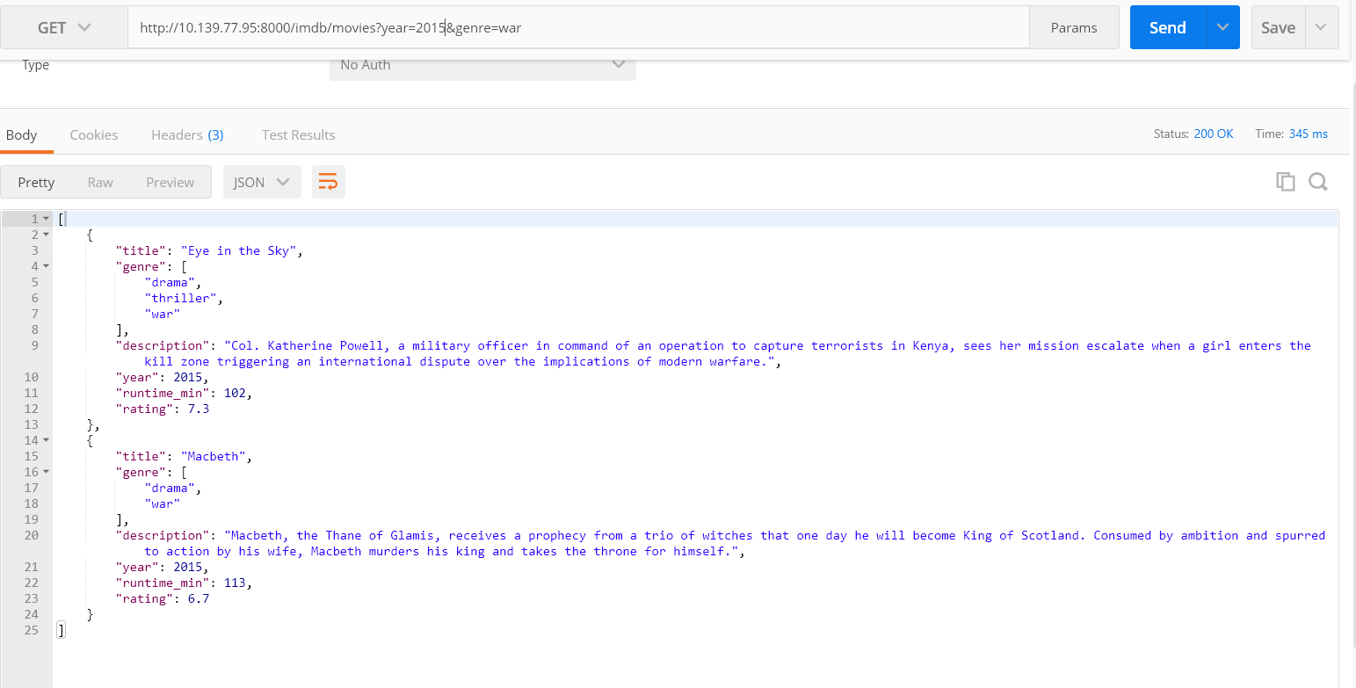

* Invalid Year

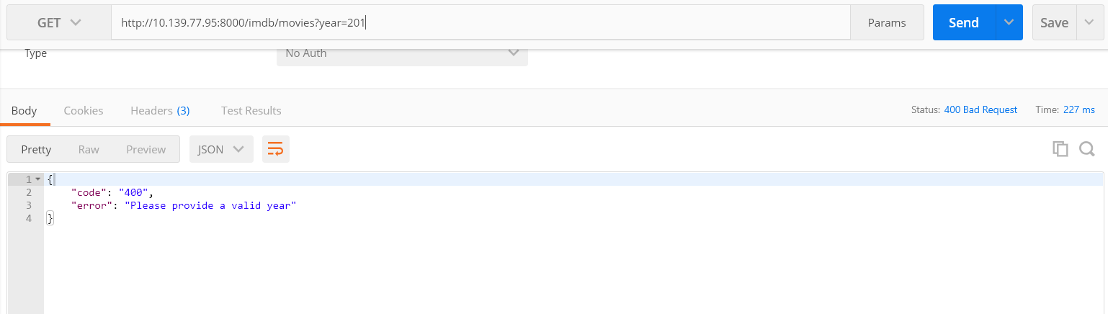

* Invalid - Year and Year range provided

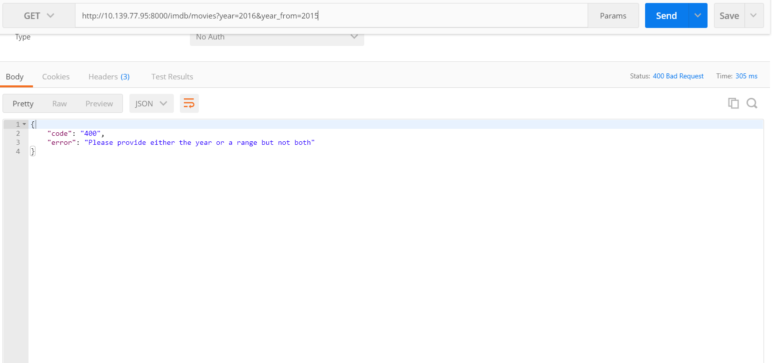

* Year_to is less than year_from

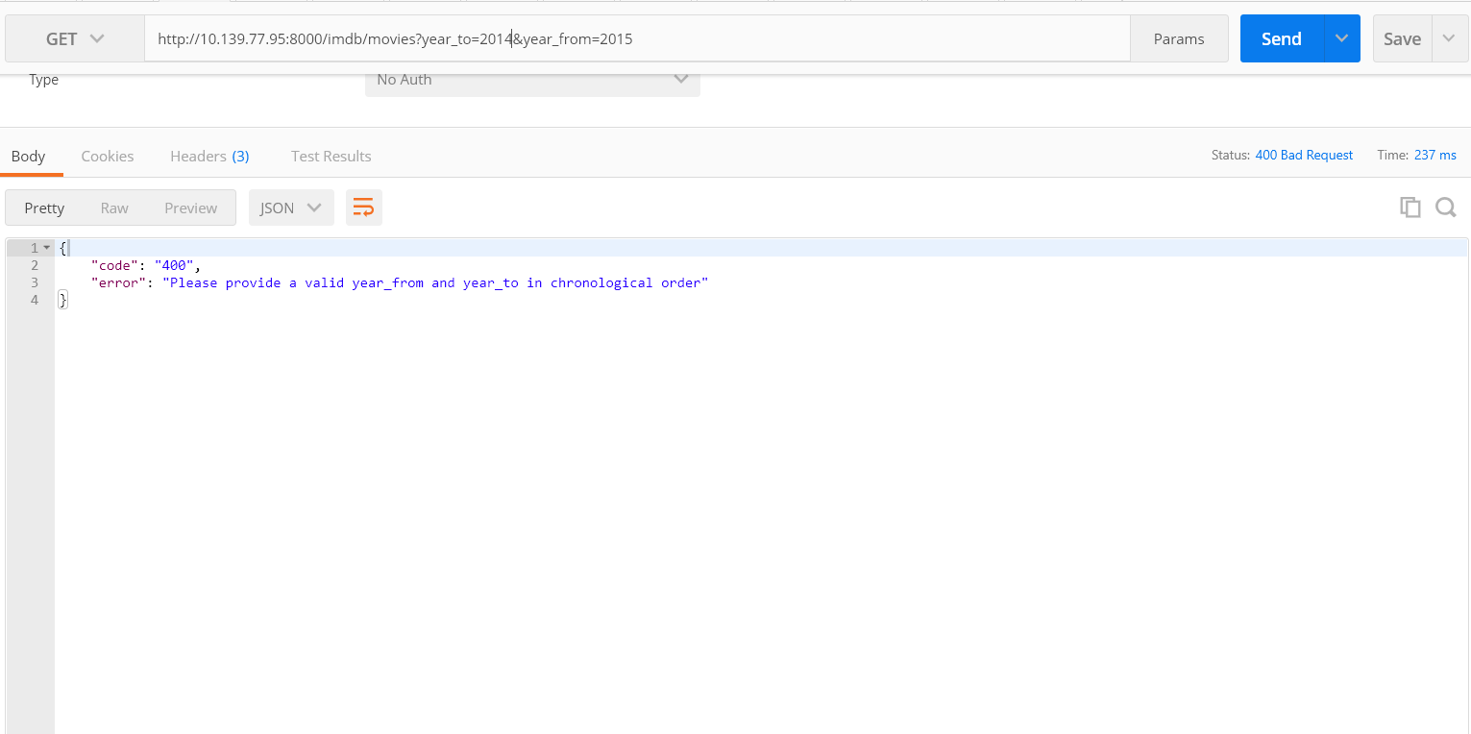

* Invalid Genre

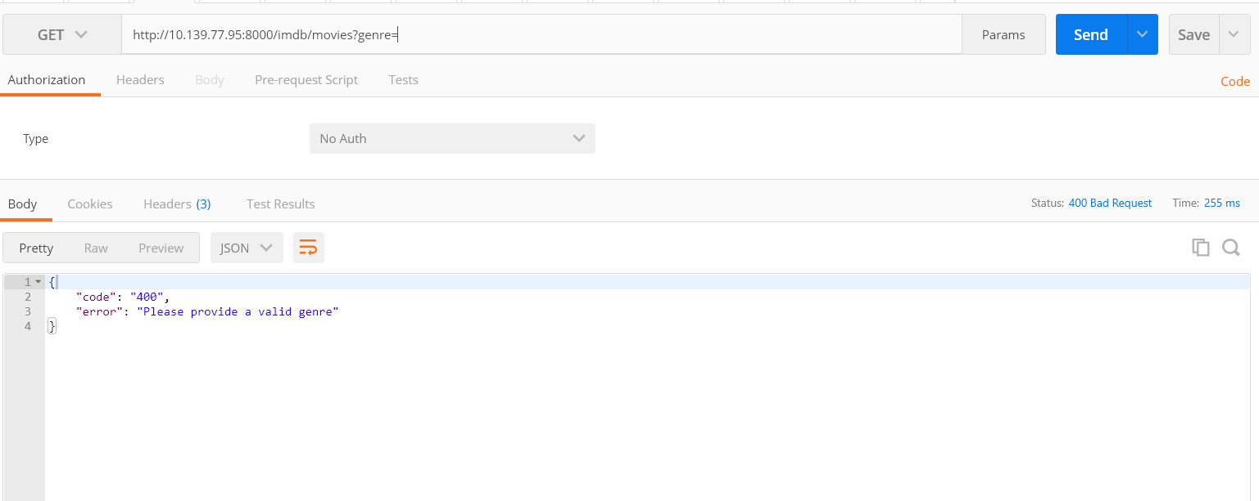

* No Content

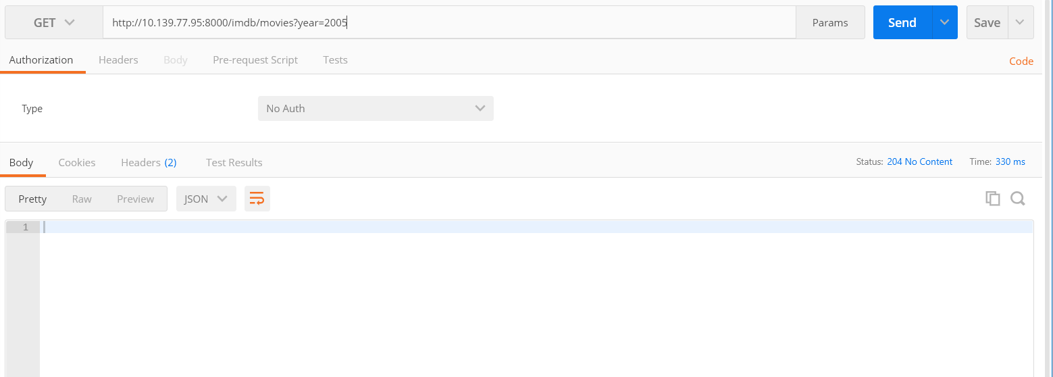

Version Endpoint:

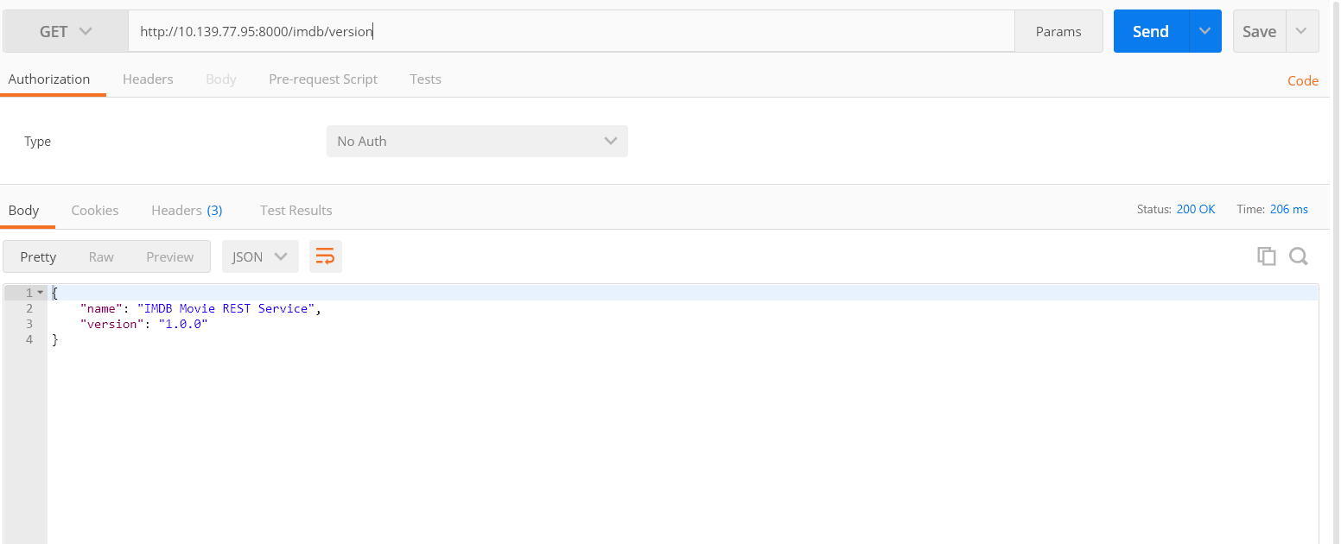

Endpoints endpoint:

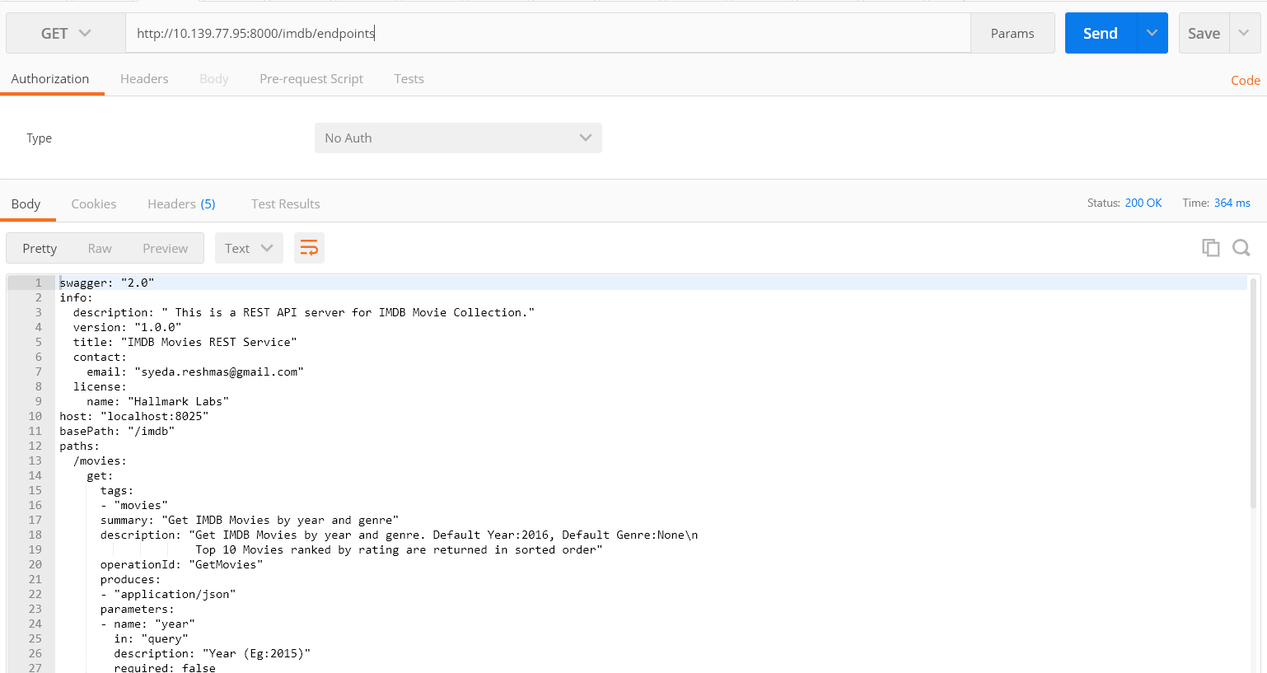

Sample of a Proper Get Request with top 10 results:

[

{

"title": "Dangal",

"genre": [

"action",

"biography",

"drama"

],

"description": "Former wrestler Mahavir Singh Phogat and his two wrestler daughters struggle towards glory at the Commonwealth Games in the face of societal oppression.",

"year": 2016,

"runtime_min": 161,

"rating": 8.8

},

{

"title": "Kimi no na wa",

"genre": [

"animation",

"drama",

"fantasy"

],

"description": "Two strangers find themselves linked in a bizarre way. When a connection forms, will distance be the only thing to keep them apart?",

"year": 2016,

"runtime_min": 106,

"rating": 8.6

},

{

"title": "Koe no katachi",

"genre": [

"animation",

"drama",

"romance"

],

"description": "The story revolves around Nishimiya Shoko, a grade school student who has impaired hearing. She transfers into a new school, where she is bullied by her classmates, especially Ishida Shouya... See full summary »",

"year": 2016,

"runtime_min": 129,

"rating": 8.4

},

{

"title": "Paint It Black",

"genre": [

"drama"

],

"description": "A young woman attempts to deal with the death of her boyfriend while continuously confronted by his mentally unstable mother.",

"year": 2016,

"runtime_min": 96,

"rating": 8.3

},

{

"title": "La La Land",

"genre": [

"comedy",

"drama",

"music"

],

"description": "A jazz pianist falls for an aspiring actress in Los Angeles.",

"year": 2016,

"runtime_min": 128,

"rating": 8.3

},

{

"title": "Hacksaw Ridge",

"genre": [

"biography",

"drama",

"history"

],

"description": "WWII American Army Medic Desmond T. Doss, who served during the Battle of Okinawa, refuses to kill people, and becomes the first man in American history to receive the Medal of Honor without firing a shot.",

"year": 2016,

"runtime_min": 139,

"rating": 8.2

},

{

"title": "Ah-ga-ssi",

"genre": [

"drama",

"mystery",

"romance"

],

"description": "A woman is hired as a handmaiden to a Japanese heiress, but secretly she is involved in a plot to defraud her.",

"year": 2016,

"runtime_min": 144,

"rating": 8.1

},

{

"title": "Zootopia",

"genre": [

"animation",

"adventure",

"comedy"

],

"description": "In a city of anthropomorphic animals, a rookie bunny cop and a cynical con artist fox must work together to uncover a conspiracy.",

"year": 2016,

"runtime_min": 108,

"rating": 8.1

},

{

"title": "Lion",

"genre": [

"biography",

"drama"

],

"description": "A five-year-old Indian boy gets lost on the streets of Calcutta, thousands of kilometers from home. He survives many challenges before being adopted by a couple in Australia. 25 years later, he sets out to find his lost family.",

"year": 2016,

"runtime_min": 118,

"rating": 8.1

},

{

"title": "Sing Street",

"genre": [

"comedy",

"drama",

"music"

],

"description": "A boy growing up in Dublin during the 1980s escapes his strained family life by starting a band to impress the mysterious girl he likes.",

"year": 2016,

"runtime_min": 106,

"rating": 8

}

]