Table of Contents
Introduction 1
Setup and Installation 1
Required Tools and Dependencies 1
Tool Features and Functionalities 2
How to Use the Tool 3
Output: 5
Version 2: Added Shodan & Virus Total 5
Output: 6

Advanced Vulnerability Assessment Tool: User Guide

Introduction
The Advanced Vulnerability Assessment Tool is a comprehensive solution designed for educational and authorized security assessments. This guide provides detailed instructions on setup, usage, and the functionality of the tool to help clients understand its capabilities.
Legal Disclaimer
This tool is intended for educational and authorized vulnerability assessments only. Ensure that you have explicit permission to scan and assess the target systems. Unauthorized use may be illegal and subject to penalties.

Setup and Installation

Required Tools and Dependencies
To set up and run the tool, follow these steps:
- Download and Install Visual Studio Code (Optional)
  - Visual Studio Code is recommended for editing and running the code.
- Install Python (Required)
  - Python Download Page
- Install Necessary Python Libraries Open a terminal or command prompt and execute the following commands:
pip install python-whois
pip install python-nmap
pip install scapy
pip install dnspython
- Install Npcap for Windows (Required)
  - Visit the official website: Npcap Download
  - During installation, check the options:
    - "Install Npcap in WinPcap API-compatible mode."
    - Allow all users to access Npcap.
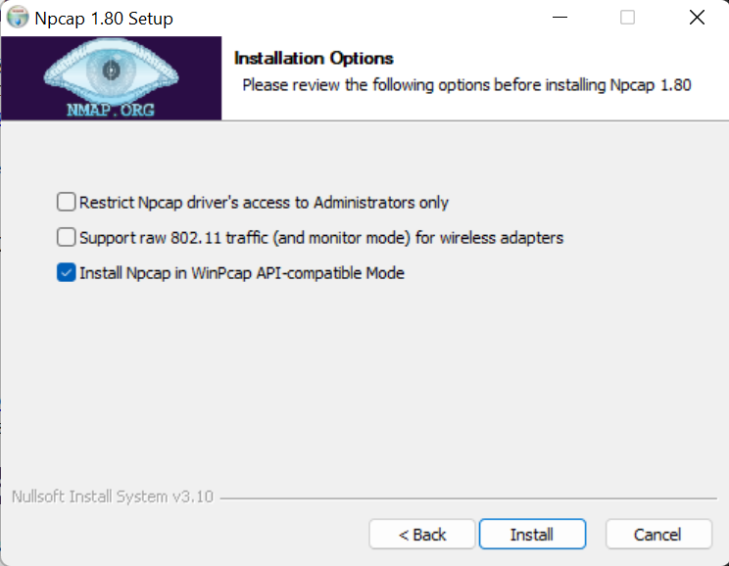
- Restart the System This ensures proper driver initialization.

Tool Features and Functionalities
1. Hostname to IP Resolution
Converts domain names into IP addresses for further scanning.
2. Location Information Retrieval
Fetches location data of the target IP using the ipinfo.io API.
3. Subdomain Enumeration
Brute-forces common subdomains such as www, mail, and test to discover additional points of entry.
4. SSL Certificate Information Retrieval
Fetches and displays SSL certificate details like issuer, subject, and validity period.
5. SYN Scan
Performs a SYN scan to check if ports are open.
6. UDP Scan
Identifies open or filtered UDP ports.
7. TCP Connect Scan
Scans ports using TCP connect and detects open ports with their corresponding services.
8. Nmap Port and Service Detection Scan
Uses python-nmap for advanced service and port detection.
9. Directory Brute-forcing
Attempts to discover common directories such as /admin, /login, and /dashboard.
10. OS Fingerprinting
Displays detailed system information of the scanning machine.
11. Ping Target Availability
Checks the availability of the target through ICMP requests.
12. WHOIS Information Retrieval
Fetches domain registration details using python-whois.

How to Use the Tool
Step 1: Run the Script
In the terminal (VScode), execute:
python scanner.py
Step 2: Enter Target Information
The tool will prompt you:
Enter the target IP or website (e.g., 192.168.1.1 or example.com):
Enter a valid target IP or domain name.
Step 3: Scanning Process
The tool performs the following scans:
- OS fingerprinting
- Ping target check
- Location retrieval
- SSL certificate check
- WHOIS information retrieval
- Subdomain enumeration
- Directory brute-forcing
- TCP, SYN, and UDP scans
- Nmap service detection
Step 4: Review the Results
The tool outputs detailed scan results in the terminal, including open ports, subdomains, directory findings, and system information.
Step 5: Stop the Scan (Optional)
Press CTRL + C to stop the scan at any time.
Additional Notes
- Root Privileges: Some scans (like SYN scans) may require administrative privileges.
- Ethical Use: Always ensure proper authorization before scanning any system.
- Error Handling:
  - Error: Unable to resolve hostname. Ensure the domain is valid and reachable.
  - Error retrieving SSL certificate: Verify the target supports HTTPS.
Troubleshooting
If the tool fails to work correctly, check:
- Internet connection
- Python library installations (pip list)
- Npcap installation
- Proper permissions for scanning tasks
Security and Ethical Considerations
Always adhere to ethical guidelines and legal constraints when using the tool. Unauthorized scanning can lead to legal consequences.

Output:
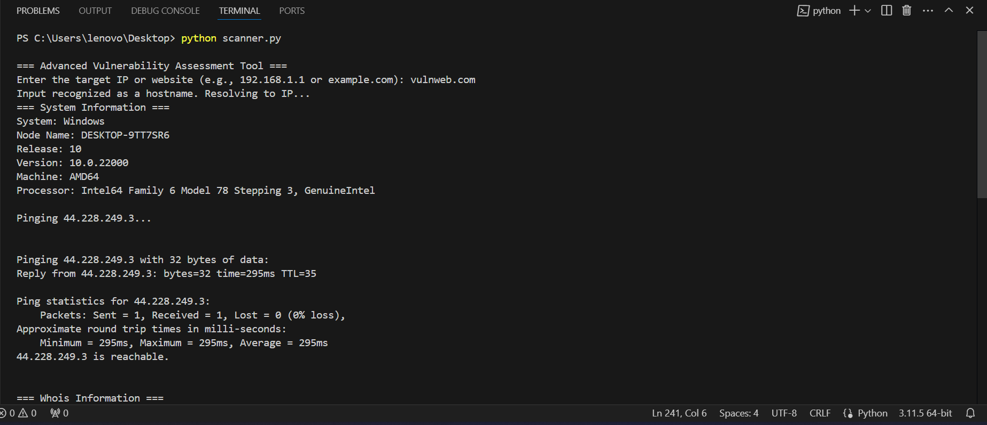
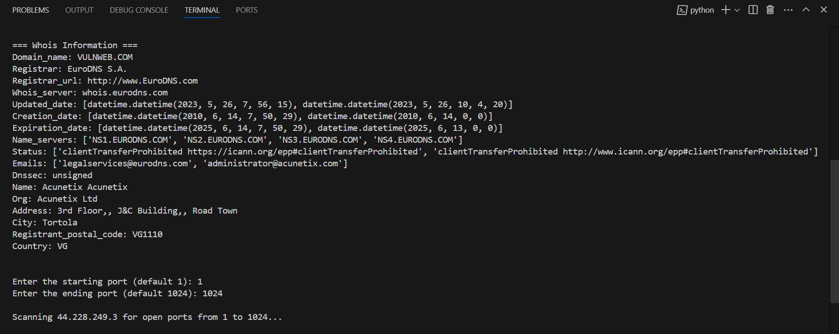
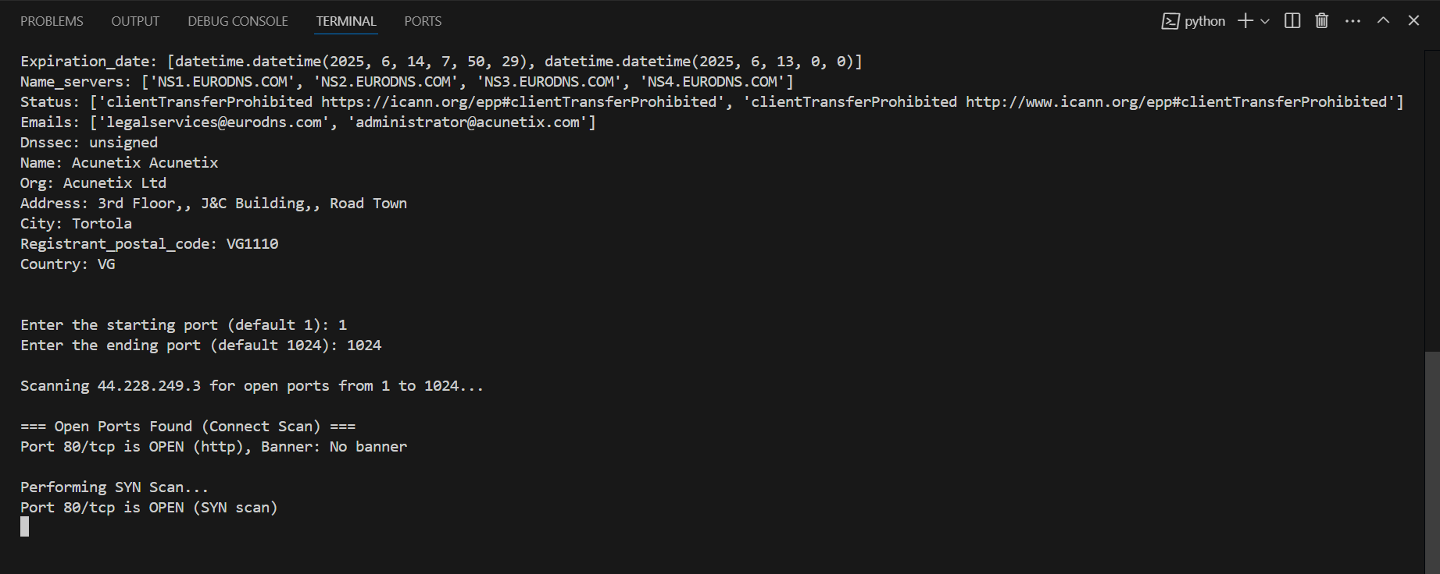

Version 2: Added Shodan & Virus Total
Required download:
pip install shodan

To run this code, you will need proper authorization to use these tools for your commercial purpose and will place the both tools api keys by creating accounts and replacing the api key in code to this position:
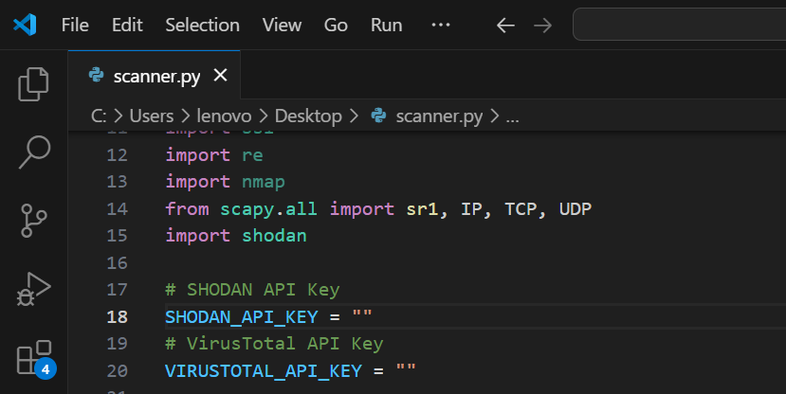
You can get both API keys from there websites:
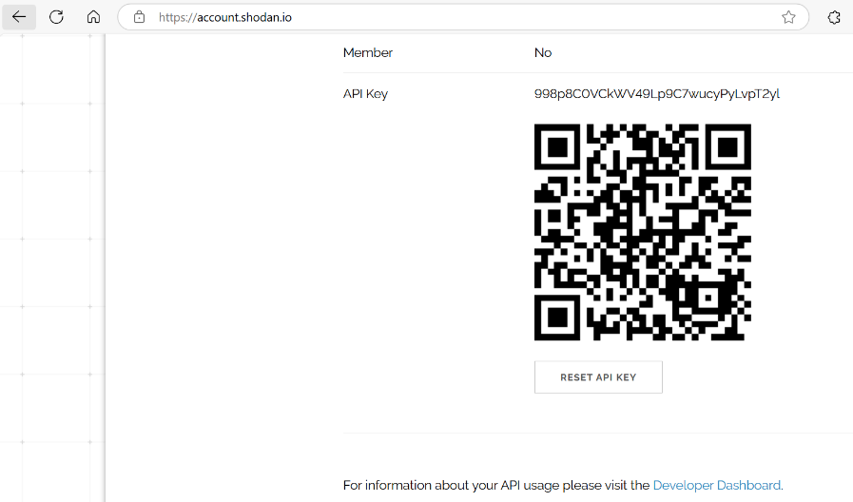
Figure 1: Shodan API Key
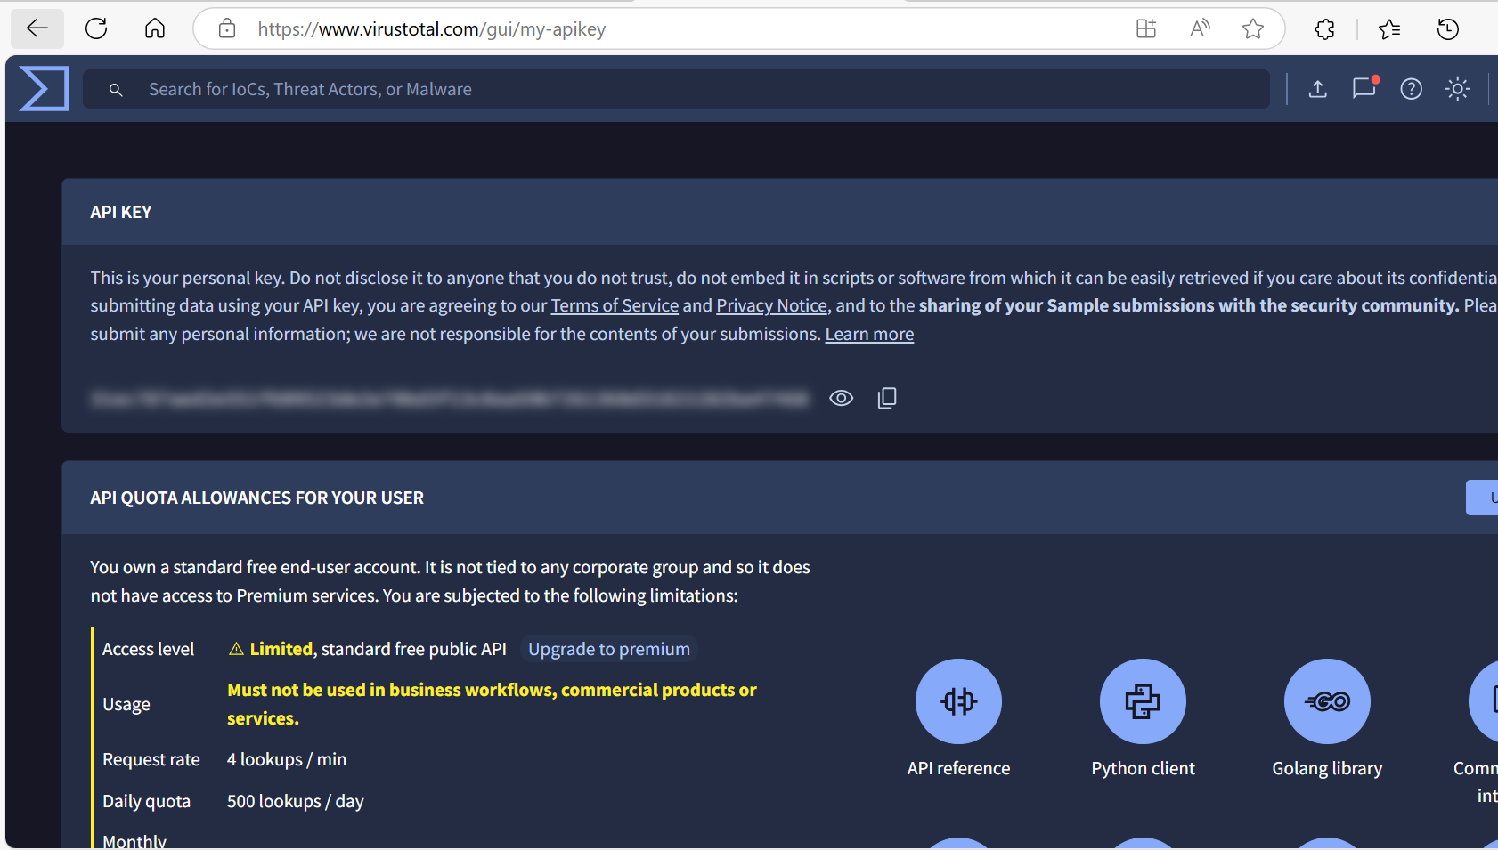
Figure 2: Virus Total API key

Output:
PS C:\Users\lenovo\Desktop> python scanner.py

=== Advanced Vulnerability Assessment Tool ===
Enter the target IP or website (e.g., 192.168.1.1 or example.com): vulnweb.com
=== System Information ===
System: Windows
Node Name: DESKTOP-9TT7SR6
Release: 10
Version: 10.0.22000
Machine: AMD64
Processor: Intel64 Family 6 Model 78 Stepping 3, GenuineIntel

Pinging 44.228.249.3 with 32 bytes of data:
Reply from 44.228.249.3: bytes=32 time=295ms TTL=35

Ping statistics for 44.228.249.3:
Packets: Sent = 1, Received = 1, Lost = 0 (0% loss),
Approximate round trip times in milli-seconds:
Minimum = 295ms, Maximum = 295ms, Average = 295ms
44.228.249.3 is reachable.

=== Location Information ===
Ip: 44.228.249.3
City: Boardman
Region: Oregon
Country: US
Org: AS16509 Amazon.com, Inc.
Loc: 45.8399,-119.7006
Skipping SSL Certificate check for domain targets.

=== VirusTotal Information ===
Reputation: 0
Last Analysis Stats: {'malicious': 0, 'suspicious': 0, 'undetected': 32, 'harmless': 62, 'timeout': 0}

=== VirusTotal Information ===

=== VirusTotal Information ===
Reputation: 0
Last Analysis Stats: {'malicious': 0, 'suspicious': 0, 'undetected': 32, 'harmless': 62, 'timeout': 0}

Error fetching Shodan data: Access denied (403 Forbidden)

=== Port Scanning Results ===
Port 80/tcp is OPEN, Banner: No banner

=== SYN Scan Results ===
Port 80/tcp is OPEN (SYN scan)

=== UDP Scan Results ===
Port 53/udp is OPEN or FILTERED

=== VirusTotal Information ===
Reputation: 0
Last Analysis Stats: {'malicious': 0, 'suspicious': 0, 'undetected': 32, 'harmless': 62, 'timeout': 0}

Error fetching Shodan data: Access denied (403 Forbidden)

=== Port Scanning Results ===
Port 80/tcp is OPEN, Banner: No banner

=== SYN Scan Results ===
Port 80/tcp is OPEN (SYN scan)

=== UDP Scan Results ===
Port 53/udp is OPEN or FILTERED

=== SYN Scan Results ===
Port 80/tcp is OPEN (SYN scan)

=== UDP Scan Results ===
Port 53/udp is OPEN or FILTERED
Port 53/udp is OPEN or FILTERED
Port 123/udp is OPEN or FILTERED
Port 161/udp is OPEN or FILTERED

