Americans Lean Against Invading Cuba — but Republicans Stand Apart
Opposition to using U.S. military force to overthrow the Cuban government outweighs support roughly 2-to-1, and Republicans are the only group where supporters outnumber opponents.
Source: CHIP50 (Civic Health and Institutions Project / COVID States Project), Wave 38, fielded May 14–June 1, 2026. Item asked of 3,819 respondents (unweighted) out of ~16,628 in the wave. All figures are weighted estimates.

Executive summary
- Opposition leads support nearly 2-to-1. A combined 46.3% of Americans oppose using military force to overthrow Cuba's government (31.5% strongly), versus 24.6% who support it; 29.2% neither support nor oppose (Figure 1).
- Partisanship is the defining divide. Among Strong Republicans, 50.3% support military force (vs. 22.1% opposed) — the only group where a majority supports it — while support falls to 9.4% among lean Democrats, the most opposed group of all. All three Republican groups are net supportive; every independent and Democratic group is net opposed (Figure 2).
- The youngest adults are the most opposed. Only 11.6% of 18–20-year-olds support military force (60.5% oppose), versus a peak of 30.1% support among those 31–40 — an inverted-U pattern that holds under controls (Figure 7).
- More-educated Americans oppose at higher rates. 54.2% of graduate-degree holders oppose, versus 39.0% of high-school graduates; support rates, by contrast, are relatively flat across education (Figure 3).
- The gender gap is descriptive only. Men are more supportive than women (29.6% vs. 19.6% support), but the difference does not survive statistical controls; income shows no consistent pattern (Figures 4, 5).
- Hispanic respondents are the most supportive group. 28.7% support military force, the highest of any racial or ethnic group and above White respondents (25.2%); the gap holds under controls (Figure 8).

Context
The question was fielded as the United States sharply escalated pressure on Cuba in the spring of 2026. After U.S. forces captured Venezuelan leader Nicolás Maduro on January 3, 2026, the Trump administration halted Venezuelan oil deliveries to Cuba and pressed other suppliers to do the same, deepening the island's economic crisis; in May 2026 it added new sanctions, unsealed an indictment against former leader Raúl Castro, increased surveillance overflights, and sent the USS Nimitz carrier strike group into the Caribbean, while President Trump publicly mused that he “will have the honor of taking Cuba.” Analysts at CSIS, surveying five possible military scenarios, nonetheless judged a full-scale U.S. invasion the least likely outcome (CSIS, June 3, 2026).
That posture is part of a broader second-term pattern of expanded U.S. military force abroad — including the Caribbean buildup, strikes on alleged drug-trafficking boats from September 2025, and the operation that captured Maduro (Council on Foreign Relations, March 3, 2026). The survey item asked respondents directly where they stood on the military option.

Findings
The item read: “Would you support or oppose the US using military force to overthrow the current Cuban government?” Responses run 1 = strongly oppose to 5 = strongly support, with 3 = neither support nor oppose. “Not sure” responses are excluded. The topline (Figure 1 and Table 1) is the full weighted distribution; demographic breakdowns (Figures 2–8) collapse the scale into Oppose (1–2), Neither (3), and Support (4–5) as weighted percentages within each group. The Hispanic-by-party breakdown (Figure 9 and Table 9) instead reports weighted means, since a two-way response distribution is not available from the tools. Rows may not sum to exactly 100 due to rounding.
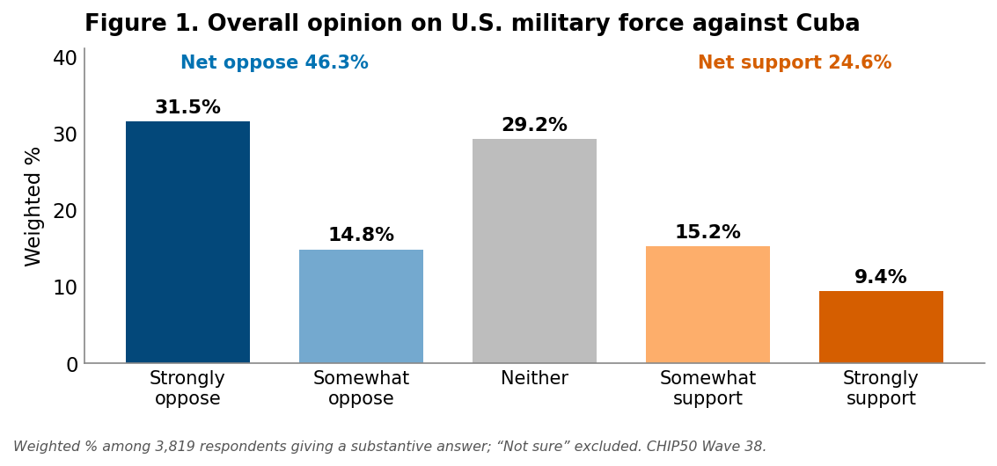
Table 1. Overall opinion on U.S. military force against Cuba (Wave 38; weighted %).
Response | Weighted %
Strongly oppose (1) | 31.5
Somewhat oppose (2) | 14.8
Neither support nor oppose (3) | 29.2
Somewhat support (4) | 15.2
Strongly support (5) | 9.4
Net oppose (1–2) | 46.3
Net support (4–5) | 24.6
Weighted % among 3,819 respondents giving a substantive answer; “Not sure” excluded. The five response categories sum to 100; net rows are subtotals.

By party (7-point identification)
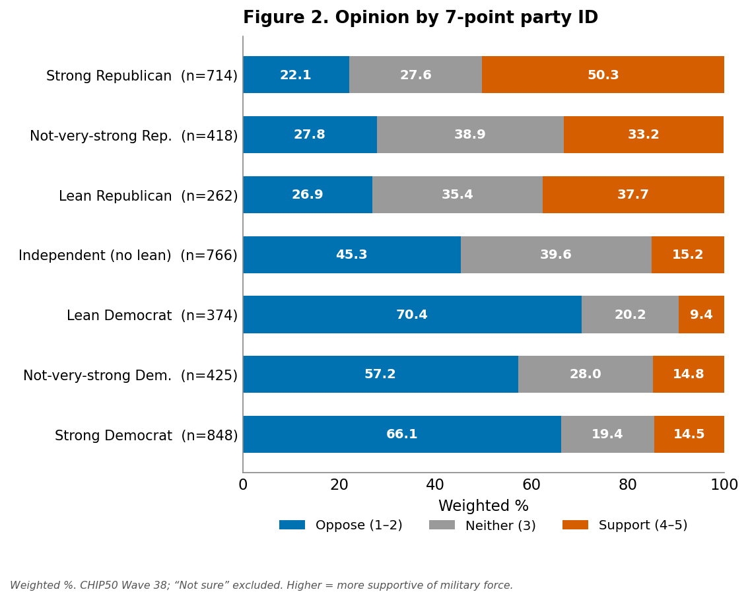
Partisanship is the sharpest cleavage in the data. All three Republican groups are net supportive — supporters outnumber opponents — peaking among Strong Republicans, the only group where a majority supports military force (50.3% support vs. 22.1% oppose). Every independent and Democratic group is net opposed. The gradient is close to monotonic, with two wrinkles: lean Republicans are marginally more supportive than not-very-strong Republicans, and lean Democrats are the single most opposed group of all (70.4% oppose, just 9.4% support) — slightly beyond strong Democrats. The partisan gap is overwhelmingly significant under controls, making it the most meaningful difference in the survey.

By education
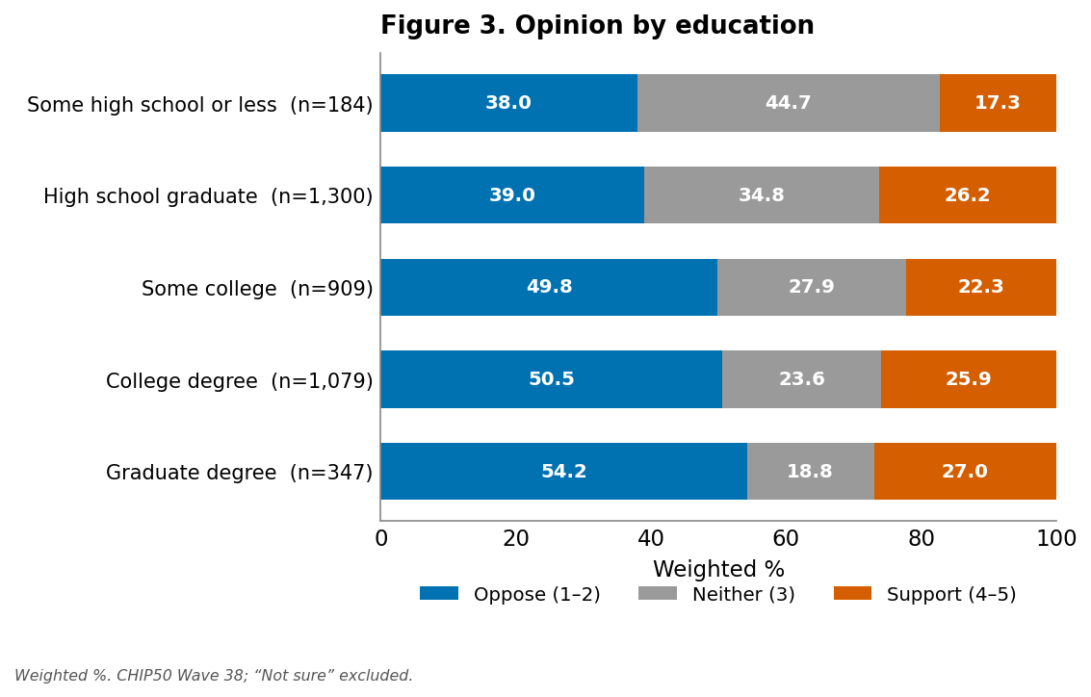
The education pattern is mainly an opposition gradient: opposition rises steadily with education, from 39.0% among high-school graduates to 54.2% among graduate-degree holders, while support rates stay relatively flat (roughly 22–27%, apart from the lowest-education group). The downward shift in the underlying scale is statistically significant under controls.

By gender
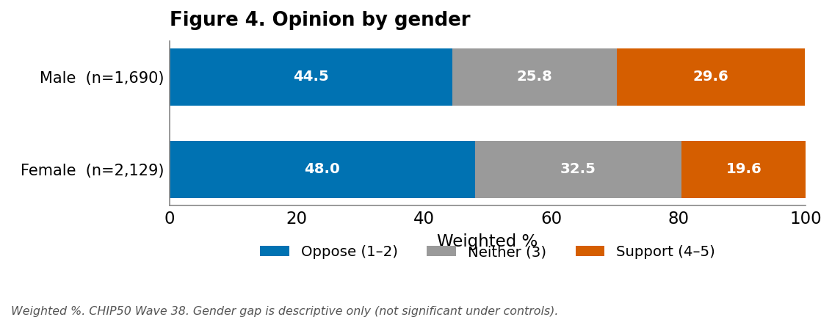
Men are descriptively more supportive than women (29.6% vs. 19.6% support). This difference does not reach statistical significance once other characteristics are held constant (regression p = 0.07), so it should be read as descriptive only — part of the raw gap reflects men's different partisan composition.

By income
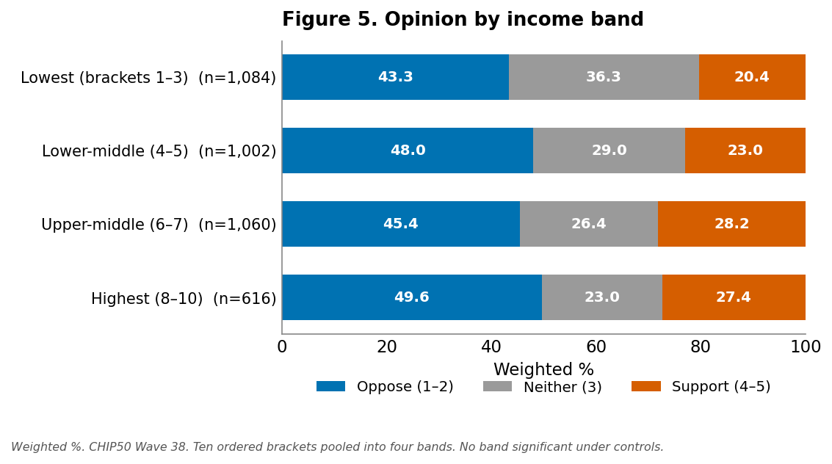
Pooled into four bands, support edges up modestly with income — from about 20% in the lowest band to roughly 27–28% in the upper bands — while the share with no opinion falls (36% to 23%). No income band is significant under controls, however, so this descriptive drift should not be over-read. (The survey's ten ordered income brackets are pooled here by summing weighted counts and recomputing shares; dollar ranges are not carried in the tool output. A separate “prefer not to say” category, n = 57, is excluded.)

By rurality
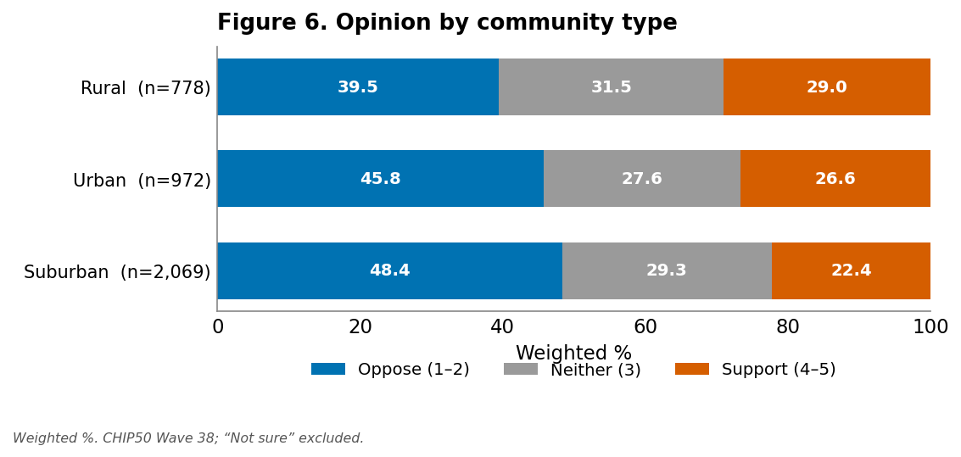
Suburban respondents are the least supportive group (22.4% support, 48.4% oppose). Both rural and urban residents are modestly more supportive, and both gaps remain significant under controls — the pattern is a suburban trough rather than a simple rural-urban line.

By age
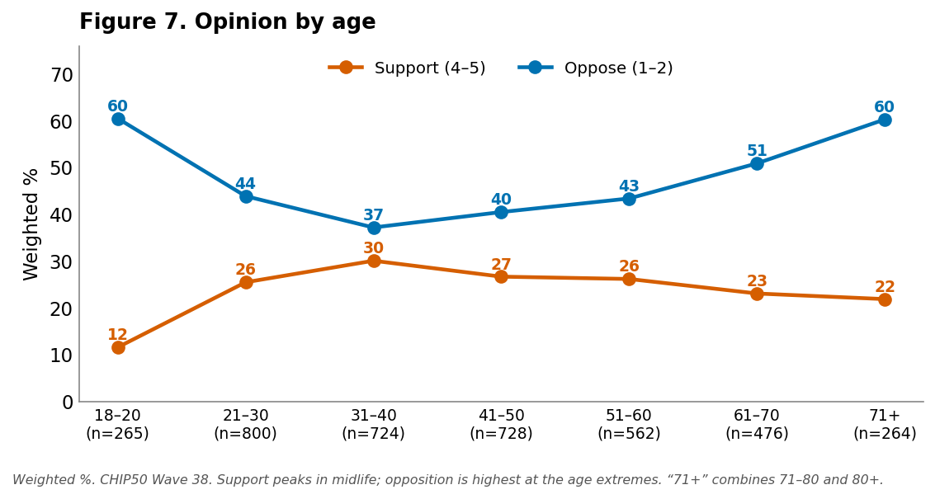
Support is lowest at the two ends of the age range and peaks in midlife (around 31–50). The youngest adults stand out as the most opposed of any age group (60.5% oppose, just 11.6% support), and opposition climbs again among the oldest, reaching 60.3% in the combined 71-and-over group. The midlife elevation is statistically significant under controls. (The 71–80 and 80-and-over brackets are combined here, by summing weighted counts and recomputing shares, because several response cells in the small 80-and-over group fell below n < 10; the regression retains the finer age_cat_8 coding.)

By race and ethnicity
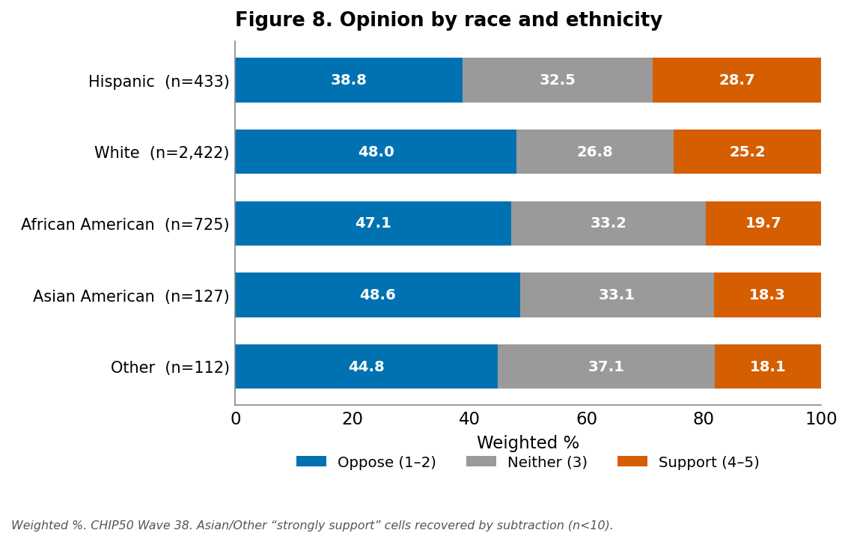
Hispanic respondents are the most supportive group (28.7% support) — the only group more supportive than White respondents, and a gap that remains significant under controls. The other groups are descriptively less supportive than White respondents. The lower raw support among African American respondents (19.7%), however, is a composition effect rather than a race effect: because Black respondents lean heavily Democratic, holding party and other factors constant actually leaves them more supportive than White respondents, not less (see Appendix A). Differences for Asian American and Other respondents are not significant under controls, and the Other category is small and heterogeneous.

Hispanic support by party
Because the Hispanic finding is notable, the breakdown below splits support by Hispanic status and party. Unlike the figures above, it reports the weighted mean on the 1–5 scale (1 = strongly oppose … 5 = strongly support; 3 = neither), because the tools do not return a two-way Oppose/Neither/Support distribution.
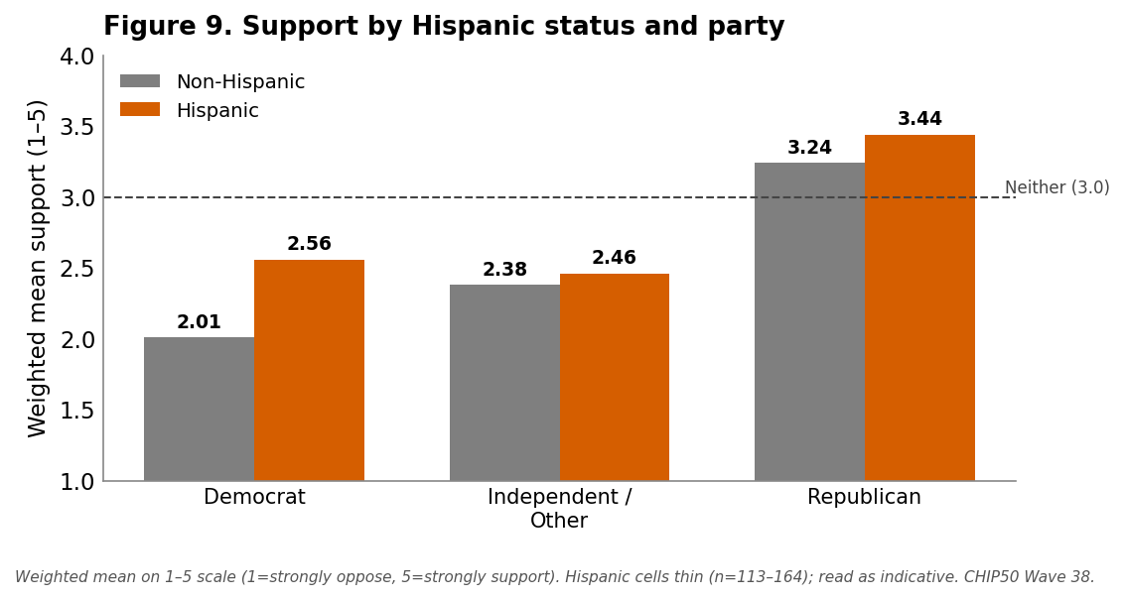
Table 9. Support for military force by Hispanic status and party (weighted mean, 1–5).
 | Democrat | Independent / Other | Republican
Non-Hispanic | 2.01 (n = 1,114) | 2.38 (n = 1,246) | 3.24 (n = 1,020)
Hispanic | 2.56 (n = 164) | 2.46 (n = 156) | 3.44 (n = 113)
Hispanic − non-Hispanic | +0.54 | +0.08 | +0.20
Weighted mean on the 1–5 support scale. Hispanic cells are thin (n = 113–164) and should be read as indicative.
The Hispanic elevation is concentrated among Democrats: Hispanic Democrats are markedly more supportive than non-Hispanic Democrats (2.56 vs. 2.01), while the gap is small among Republicans and negligible among independents. Two caveats travel with this table: the Hispanic cells are thin (113–164 respondents), so the cell figures are indicative rather than precise; and while being Hispanic is a significant predictor of support within Democrats, the cross-party difference in the Hispanic effect is suggestive rather than statistically established (see Appendix A).

Methods
Data. CHIP50 (Civic Health and Institutions Project, a 50-State Survey; successor to the COVID States Project), Wave 38, fielded May 14–June 1, 2026. Non-probability online panel, weighted to be population-representative. The support_cuba item was asked of 3,819 respondents (unweighted) who gave a substantive 1–5 answer, out of ~16,628 wave respondents; it appears to have been asked of a subset of the wave, which is a reliability caveat carried throughout.
Measures. Outcome support_cuba: “Would you support or oppose the US using military force to overthrow the current Cuban government?”, a 1–5 ordinal scale (1 = strongly oppose, 3 = neither, 5 = strongly support). “Not sure” is coded 0 (not the −99 sentinel); the analysis tools return only the 1–5 responses, so “Not sure” is excluded from all distributions and the regression, and is not treated as a scale point.
Estimation. All estimates are survey-weighted. The topline is the full weighted five-point distribution (generate_marginals). Demographic breakdowns (Figures 2–8) are the weighted percentage in each group choosing Oppose (1–2), Neither (3), and Support (4–5), computed from the per-group five-point distribution (get_ordinal_distribution_by_demographic); category cells with n < 10 are suppressed. The Hispanic-by-party breakdown (Table 9) reports weighted means of the 1–5 scale per cell (generate_crosstab_multi), because the tools do not return a two-way Oppose/Neither/Support distribution; its Hispanic cells (n = 113–164) are thin. In the age figure, the 71–80 and 80-and-over brackets are combined into “71 and over” by summing weighted response counts and recomputing shares. In the income figure, the survey's ten ordered brackets are pooled into four bands by summing weighted response counts and recomputing shares; the top bracket's individually suppressed cells (n < 10) were recovered exactly by subtraction before pooling. In the race figure, the “strongly support” cells for Asian American (n = 8) and Other (n = 6) respondents fell below n < 10 and were each recovered exactly by subtraction from the group's weighted total. The multivariate model is a survey-weighted OLS / WLS (run_ols_regression) of support_cuba on party7, education_cat, gender, income_cat_10, urban_type, and age_cat_8, fit on the 1–5 scale; a supplementary model adds race_cat_5 (reference White) and is the basis for the race/ethnicity significance statements. A further supplementary model adds trump_gen (Trump approval) as a proxy for general Trump-era support; the intended Iran military-force control from the prior cycle is not exposed by the current backend and could not be run. The 7-point party measure (party7: 1 = Strong Republican … 7 = Strong Democrat, 4 = pure Independent) was validated against the 3-point breakdown. Standard errors are model-based, not design-based. The income “prefer not to say” category (code 11) is excluded from interpretation.
Significance discipline. Differences are described as “meaningful” only where the regression coefficient is significant at p < .05 (party, education, age, rurality). The gender gap (p = .07) is presented as descriptive only. Income shows no significant pattern. Crosstab gaps are descriptive and are not framed as causal.

Appendix A — Analytic Memo
This is the internal technical memo for the report, retained here as an appendix. It covers the multivariate results, the interaction and distinctiveness checks, candidate storylines, consistency with prior evidence, and suggested follow-up analyses.

Multivariate findings
A single survey-weighted OLS regression (WLS) of support_cuba on the six standard demographics, using the 7-point party scale (n = 3,807; R² = 0.212; references: Strong Republican [party7 = 1], high-school graduate, female, suburban, lowest income, age 18–20) yields:
- Party dominates. Every group is significantly less supportive than Strong Republicans (the reference, all p < .01). The gradient is steep and only loosely monotonic: not-very-strong Republicans (−0.39) and lean Republicans (−0.27) sit just below strong Republicans, then a large drop to Independents (−1.06) and the Democratic groups (−1.17 to −1.55). Lean Democrats are the single most opposed group (−1.55), slightly beyond strong Democrats (−1.35). No other predictor approaches this magnitude, and moving from the 3-point to the 7-point scale lifts model R² from 0.166 to 0.212.
- Education is a real, modest negative. College (−0.21), graduate (−0.27), and some-college (−0.15) respondents are all significantly below high-school graduates on the scale (p < .01). Note from the rate figure that this works mainly through higher opposition among the more educated rather than lower support. “Some high school or less” is not distinguishable from the high-school baseline.
- Age is curvilinear. Relative to 18–20-year-olds, support rises through midlife — 21–30 (+0.37), 31–40 (+0.48), 41–50 (+0.40), 51–60 (+0.25), all significant — then flattens; 61–70 (+0.16) is now borderline (p = .06), and the 71-and-over brackets are not different from the youngest group.
- Rurality survives controls. Both rural (+0.12, p = .03) and urban (+0.15, p < .001) residents are more supportive than suburbanites — a suburban trough.
- Gender washes out. With the finer party control the male coefficient is +0.05 (p = .22) — clearly non-significant; the descriptive 10-point male-female support-rate gap largely reflects partisan composition.
- Income is null. No income category is significant; there is no monotonic gradient.
- Race/ethnicity (supplementary model). Adding race_cat_5 to the model (reference White; R² rises from 0.212 to 0.219) shows two significant effects: Hispanic respondents are more supportive than White respondents (+0.25, CI 0.15–0.36, p < .001) and African American respondents are also more supportive net of controls (+0.23, CI 0.10–0.35, p < .001). The African American result is the noteworthy one: descriptively Black support is the second-lowest (19.7%), but that reflects heavy Democratic identification — once partisanship is held constant, Black respondents are relatively more supportive, a textbook suppression effect. Asian American (+0.03) and Other (−0.12) are not significant. The Hispanic elevation is robust and substantively interesting given the Cuban-American community's distinct politics, though race_cat_5 does not separate Cuban-Americans from other Hispanic respondents. Note: in a prior, fuller specification that also controlled for opinion on military action toward Iran, the Black effect washed out while the Hispanic effect persisted — so the African American result is the more fragile of the two.
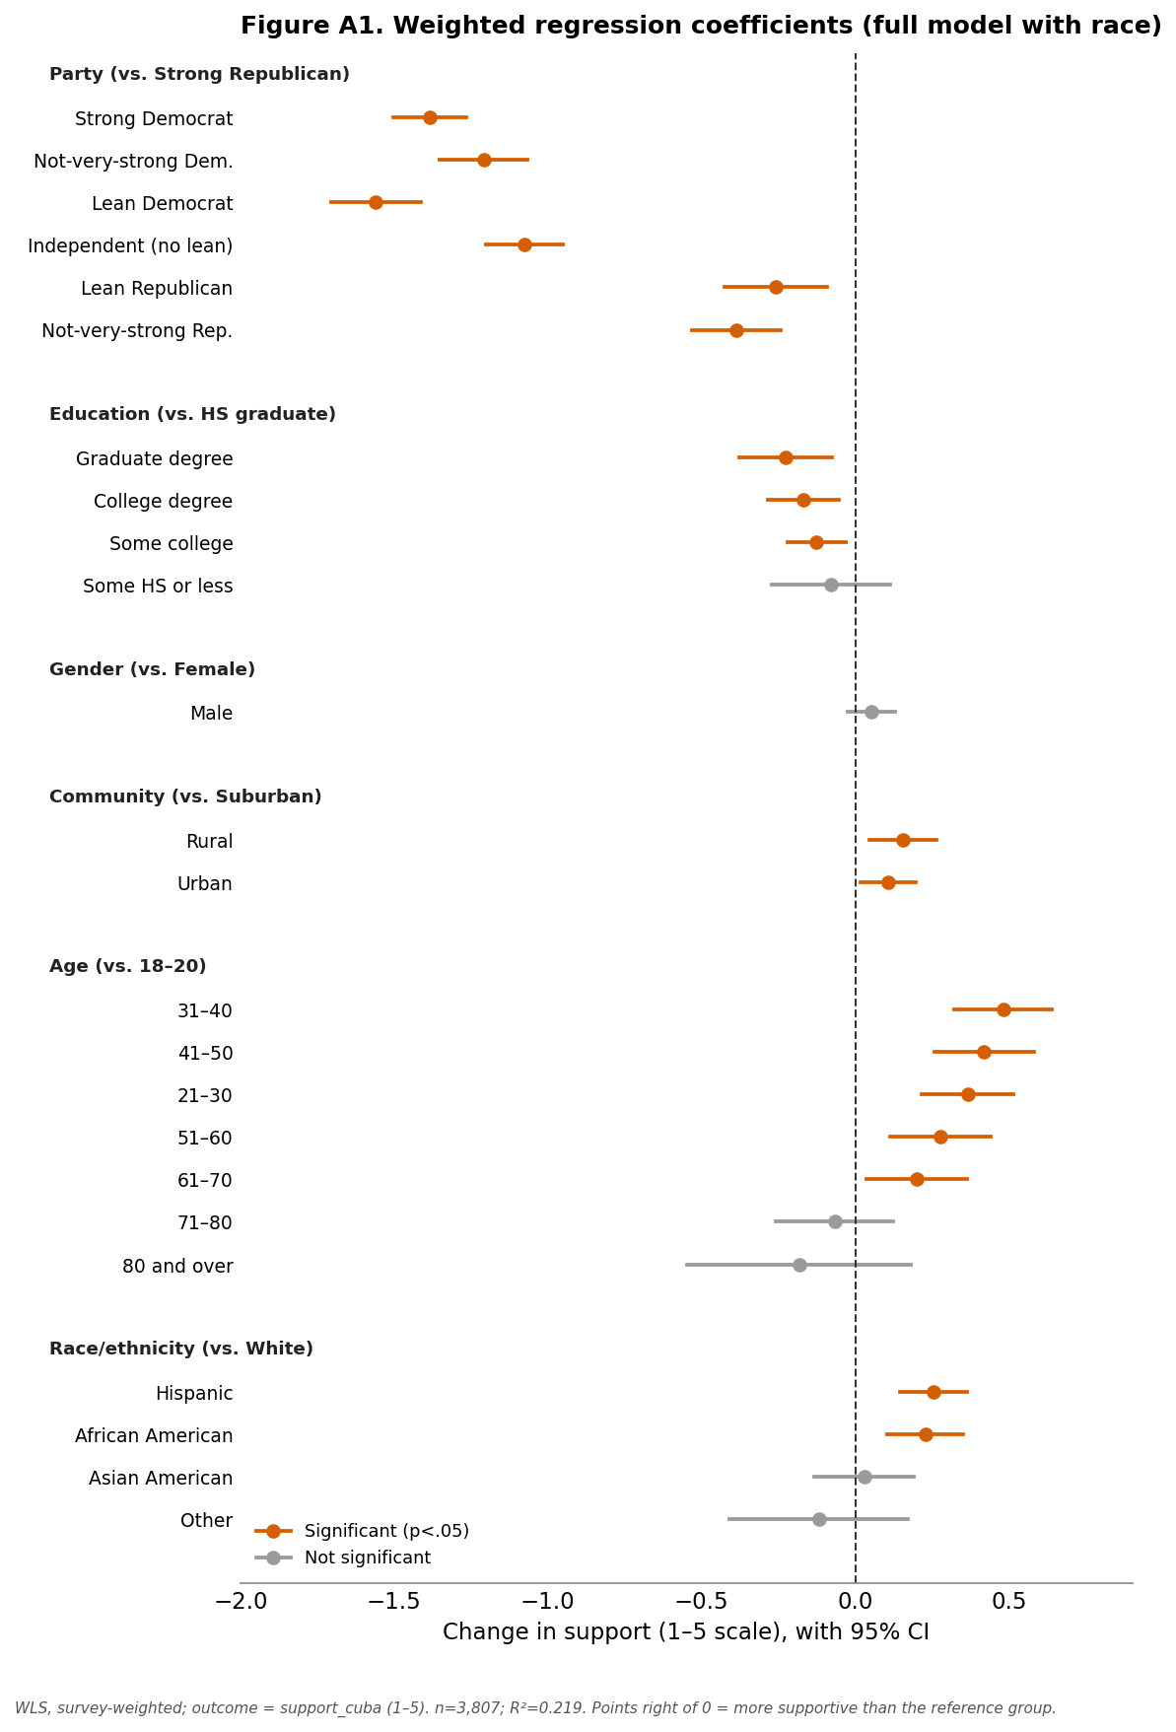
What survives controls vs. the descriptive breakdowns: the party, education, age, and rurality patterns all hold; the gender gap does not; income was never a pattern to begin with.

Hispanic support × partisanship (interaction check)
This breakdown is reported publicly as Table 9 / Figure 9. The supporting analysis: weighted means by Hispanic status × party show the Hispanic advantage is concentrated among Democrats (Hispanic Democrats 2.56 vs. non-Hispanic Democrats 2.01, a +0.54 gap), versus +0.20 among Republicans and ~0 among independents. Stratified regressions with the full control set confirm the asymmetry — being Hispanic significantly predicts support within Democrats (+0.33, p = .0002) but not within Republicans (+0.19, p = .07).
On promoting it to a public table. It carries a real, defensible nuance — the Hispanic elevation is mostly a Hispanic-Democrat phenomenon, plausibly a Cuban-American signal (though the data can't isolate Cuban-Americans) — so it was added as Table 9 at the editor's request. Two caveats must travel with it and are stated in the Findings text: (1) the cross-party difference in the Hispanic effect is not firmly significant — the Democrat (+0.33) and Republican (+0.19) Hispanic slopes have overlapping confidence intervals, so the interaction is suggestive, not established; and (2) the Hispanic cells are thin (113–164 respondents), so the cell means are indicative. If a Hispanic/Cuban-American angle becomes the lead, it would warrant a dedicated treatment with a sharper Cuban-American measure rather than these thin cells.

Is Cuba support distinctive, or just Trump-era hawkishness?
The ideal test adds a parallel military-force item as a placebo for general appetite for Trump-era force: the prior Cuba cycle used opinion on military action toward Iran for exactly this. That Iran item is not exposed by the current backend — confirmed by probing (support_iran, iran); like support_cuba and race_cat_5, foreign-policy items appear and disappear from the tool — so it could not be reproduced here, and no other available variable is a parallel military/foreign-policy item. As the closest available proxy for general pro-Trump sentiment I substituted `trump_gen` (Trump approval, 1 = most disapproving … 5 = most approving). Important caveat: Trump approval is near-definitionally partisan, so it is a weaker instrument than the Iran item — “controlling” for it partly just re-controls for party, and the two are collinear. It is therefore a good test for the Hispanic question but a poor one for cleanly separating “Cuba-specific” from “generic military hawkishness” in the partisan gap.
Adding trump_gen to the full model lifts R² from 0.219 to 0.335. Trump approval is a powerful predictor (+0.45 per scale point, p < .001), and it absorbs most of the party7 gradient — once it is in the model, only lean Democrats remain distinctly more opposed than Strong Republicans. That is consistent with partisan Cuba-hawkishness operating largely through general support for Trump, but because of the collinearity this absorption partly reflects measurement overlap rather than a clean decomposition.
The robust takeaway concerns race, which is not entangled in that collinearity: Hispanic respondents remain significantly more supportive net of Trump approval (+0.20, CI 0.10–0.30, p < .001) — only modestly down from +0.25 without the control. So the Hispanic elevation is not merely a reflection of Hispanic Trump support; something distinctively Cuba (plausibly the Cuban-American dimension) persists. African American respondents also survive this control (+0.20, p < .001) — but note that in the prior cycle's cleaner Iran-based control the Black effect washed out, so it is control-dependent and remains the more fragile of the two, whereas the Hispanic effect survives both. I can run the exact Iran-controlled specification if that item is restored to the backend; until then this Trump-approval proxy is the best available stand-in.

Candidate storylines
- “Partisanship, not Cuba.” (strongest hook) Strong Republicans are the only group where a majority backs military force (50.3% support), while support collapses to single digits among lean Democrats (9.4%); all three Republican groups are net supportive and every Democratic and independent group net opposed — a divide larger than any age, education, or geographic difference. Rationale: clearest, most defensible, most newsworthy contrast, and it tracks the partisan ownership of the current Cuba pressure campaign.
- “Even amid a pressure campaign, the public won't back regime-change force.” Net opposition (46.3%) nearly doubles net support (24.6%) at the very moment the administration is escalating. Rationale: ties directly to the verified news peg and the CSIS judgment that invasion is the least likely scenario.
- “Gen Z is the most dovish.” The youngest adults (18–20) are the single most opposed group, at 60.5% oppose / 11.6% support. Rationale: vivid and counter to a “young = anti-establishment hawk” assumption; secondary angle.
- “The diploma divide is an opposition divide.” More-educated Americans oppose at higher rates, even as their support holds steady. Rationale: a nuance the rate framing reveals that the means concealed; good supporting color.

Consistency with prior evidence
The topline level (about a quarter supportive, just under half opposed, with a large neutral middle) is consistent with the long-running pattern in U.S. polling that publics are reluctant to endorse regime-change military operations absent a direct threat, and with the partisan structure of hawkishness in the Trump era. Independent benchmarking is limited because support_cuba is a researcher-submitted CHIP50 item with no published companion report, and the specific “overthrow the Cuban government” wording is not, to our knowledge, matched by a concurrent public poll; external comparisons should be made cautiously and are flagged as approximate.

Additional analyses worth running
- A parallel military-force control. The cleanest way to separate Cuba-specific attitudes from general Trump-era hawkishness is to control for opinion on another use of force (e.g., Iran). The Iran item used in the prior cycle is not currently exposed by the backend; rerun the exact specification if Iran is restored.
- Cuban-American identification specifically. The Hispanic × party check above is the strongest lead: the Hispanic elevation is driven by Hispanic Democrats. race_cat_5 lumps all Hispanic respondents together, so probing any available national-origin or state (e.g., Florida) detail would sharpen whether this is a Cuban-American signal, since Cuban-American politics differ sharply from other Hispanic groups.

Appendix B — Methodological Evaluation
A candid internal assessment of how far the analysis can be pushed, separate from the findings. Each issue is tagged by severity — Minor, Moderate, or Material — and the bottom line states which conclusions are and are not threatened.
Bottom line up front. The headline results — opposition roughly doubles support, and a steep partisan divide in which Republicans are the only net-supportive bloc — are large, internally consistent, and robust across the descriptive and multivariate views; none of the issues below overturns them. What the issues do is bound how hard specific subgroup numbers and the distinctiveness claim should be pushed.

Measurement and coding
“Not sure” excluded (Moderate). “Not sure” is coded 0 and dropped, so every estimate is conditional on holding an opinion. If “Not sure” is sizeable and non-random, the support/oppose split describes the opinion-holding public, not all adults. The distribution tools return only the 1–5 responses, so the count of “Not sure” was not retrieved; obtaining it to report an opinion-holding rate is the single cheapest improvement to the report.
Scale direction and value labels (Minor, controlled). The 5 = strongly support direction was verified against the questionnaire, and labels were checked because a prior cycle surfaced a tool value-label mismatch. Residual risk is low.
Missing income dollar ranges (Minor). income_cat_10 dollar bands are not carried in the tool output, so income is labeled by bracket rank rather than dollars. This limits interpretability of the income result, which is null and not a headline.
party7 coding (Minor, controlled). The 7-point direction and group sizes were validated against the 3-point split before use.

Sampling, weighting, and inference
Non-probability online panel (Material, inherent). CHIP50 is a non-probability panel weighted to population targets. Weighting corrects observable demographic imbalance, not unobserved selection, and no design-based margin of error strictly applies. All point estimates should be read as model-based, not as draws from a probability sample.
Item asked of a subset (Moderate). The item reached 3,819 of ~16,628 wave respondents. If that subset was a random split it is harmless; if assignment correlated with attitudes, subgroup composition could be skewed. The tool does not document how the subset was drawn, so this is carried as a reliability caveat.
Model-based standard errors (Moderate). Regression SEs come from WLS treating survey weights as frequency weights; they do not capture the panel's design and weighting variance and most likely understate true uncertainty. Coefficients sitting near a threshold — the gender gap (p = .07) and the 61–70 age term (p = .06) — should be treated as approximate, which is why the report calls the gender gap descriptive only.
Multiple comparisons (Moderate). Eight demographic breakdowns plus a large coefficient table mean some p < .05 results will be false positives. No formal correction was applied; the mitigation is leaning on the regression rather than the crosstabs and foregrounding only large, theory-consistent effects (party, education, age, rurality).

Small cells, suppression, and recovery
Recovered and pooled cells (Moderate). Several cells fell below n < 10 — the 80-and-over brackets, the top income brackets, and the Asian American and Other “strongly support” cells — and were either pooled or recovered exactly by subtraction from weighted totals. The arithmetic is exact, but the underlying cells remain thin, so those specific shares (oldest group; Asian/Other support) carry more sampling noise than their clean appearance suggests.
Hispanic × party cells (Material for that table only). Table 9's Hispanic cells (n = 113–164) are thin, and the interaction it suggests — a larger Hispanic effect among Democrats — has overlapping confidence intervals across party. The table is framed throughout as indicative, and the cross-party difference is explicitly not claimed as established.

Descriptive vs. causal, and the distinctiveness test
Crosstab gaps are descriptive (Moderate, controlled). The report disciplines every descriptive gap against the regression: it downgrades the gender gap and the income drift, and it correctly reframes low Black raw support as a partisan-composition (suppression) effect rather than a race effect.
Trump-approval proxy (Material for one sub-question). The ideal placebo — a parallel Iran use-of-force item — is unavailable, so trump_gen stands in. Because Trump approval is collinear with party, it cannot cleanly separate “Cuba-specific” from “generic hawkishness” in the partisan gap, and the report says so. The claim that survives the proxy — the Hispanic effect persists net of Trump approval — is the robust one; the partisan-absorption result is suggestive only.

Coverage and provenance instability
Unstable variable exposure (Material, external). support_cuba was absent from the variable catalog yet computes; race_cat_5 was empty in earlier testing but populated here; the Iran item available in a prior cycle is now absent. The backend's variable exposure is inconsistent across sessions, which is a genuine reproducibility risk — a rerun may not return the same columns. Every key variable used here was confirmed via live calls, but version and provenance metadata are thin.
No published benchmark (Moderate). support_cuba is a researcher-submitted item with no published companion report and no concurrent public poll matching the “overthrow” wording, so external validation is limited. The topline is consistent with the general reluctance to endorse regime change, but that is a soft check, not a benchmark.

Net assessment
The strongest claims — the ~2-to-1 opposition headline and the partisan divide — rest on large effects that are stable across methods and would survive any reasonable reweighting or correction. The appropriately hedged claims are the three the report already flags: the Hispanic × party interaction (thin cells), the clean separation of Cuba-specific from generic hawkishness (collinear proxy), and anything resting on recovered thin cells (oldest group; Asian/Other support). Two low-cost steps would raise confidence the most: retrieving the “Not sure”/0 count to report an opinion-holding rate, and rerunning with the Iran control if the backend restores it.

