Broad, Bipartisan Support for a Constitutional Amendment to Stop Gerrymandering — but a Big Undecided Middle
Nearly half of Americans (47.6%) support a constitutional amendment to stop gerrymandering and only 16.4% oppose one — roughly a 3-to-1 margin — but more than a third are neutral or unsure, and the gaps between groups are differences in support versus uncertainty, not support versus opposition.
Source: CHIP50 (Civic Health and Institutions Project / COVID States Project), Wave 38. Item gerry_amend, answered by 16,611 of 16,628 wave respondents (unweighted). All figures are weighted estimates.
Question wording (questionnaire-confirmed): “Would you support or oppose a constitutional amendment that would prohibit states from redrawing congressional district boundaries to help one political party win more seats?” Response options: 1 = strongly support, 2 = somewhat support, 3 = neither support nor oppose, 4 = somewhat oppose, 5 = strongly oppose, 6 = not sure.

Executive summary
- Support outweighs opposition about 3-to-1. 47.6% support an amendment (27.3% strongly), versus 16.4% opposed (8.7% strongly). But 23.6% pick “neither” and 12.5% say they are not sure, so a combined ~36% sit in the middle (Figure 1).
- It is broadly bipartisan, with disengaged independents — not Republicans — as the low point. Majorities of Strong Democrats (59.8% support), Strong Republicans (51.7%), and most partisan groups back the amendment; pure independents are lowest at 27.6%, driven by a very high 25.1% “not sure.” Under controls, Strong and Lean Democrats are significantly more supportive than Strong Republicans, and independents significantly less (Figure 2).
- Support rises steeply with education. 66.1% of graduate-degree holders support an amendment versus 26.9% of those with some high school or less; the difference is significant under controls and is mostly a gap in certainty — opposition is similar across education levels (Figure 4).
- White respondents are the most supportive group. 51.9% of White respondents support, versus roughly 40–41% of Black, Hispanic, and Asian American respondents — a gap that survives controls. Crucially, opposition is similar across all groups (~16–20%); the difference is higher “neither/not sure” shares among non-White respondents, not higher opposition (Figure 3).
- The through-line is engagement, not polarization. Men, higher-income, older (71+), and more-educated respondents are all more supportive — the profile of higher political engagement — while opposition stays low (~14–20%) in every single group. Variation across demographics is overwhelmingly support-versus-uncertainty (Figures 5–8).

Context
The survey was fielded in Wave 38 (spring 2026 [UNVERIFIED: metadata tool returned null field dates for Wave 38; confirm against CHIP50 wave documentation]), during a sustained national fight over partisan redistricting. Through early 2026, mid-decade redistricting battles — including a Republican-led redraw in Texas [CITATION NEEDED: Texas Tribune / AP / Brennan Center redistricting tracker] and a Democratic-led ballot response in California (Proposition 50) [CITATION NEEDED: California Secretary of State results / Ballotpedia / AP], alongside litigation in several states [CITATION NEEDED: name the specific cases/states] — kept gerrymandering unusually prominent in the news and put the idea of structural reform (independent commissions, and proposals for federal or state constitutional limits) on the agenda. The gerry_amend item asks respondents directly whether they would support amending the Constitution to stop the practice.
Source verification pending: the bracketed [CITATION NEEDED] / [UNVERIFIED] tags above mark every specific claim not yet confirmed against a live source (web retrieval was not available in this pass). Each must be fetched, confirmed to support the claim, and replaced with a real citation — or removed — before publication.

Findings
The item (verified wording above) is a six-point response: 1 = strongly support, 2 = somewhat support, 3 = neither support nor oppose, 4 = somewhat oppose, 5 = strongly oppose, 6 = not sure. The topline (Figure 1 and Table 1) shows the full distribution; demographic breakdowns (Figures 2–8) collapse it into Support (1–2), Neither (3), Oppose (4–5), and Not sure (6) as weighted percentages within each group, with unweighted n shown for reliability. Rows may not sum to exactly 100 due to rounding.
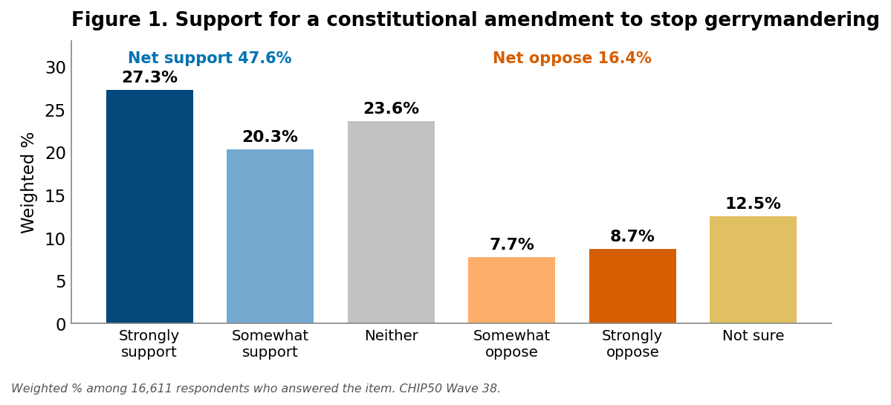
Table 1. Overall opinion on a constitutional amendment to stop gerrymandering (Wave 38; weighted %).
Response | Weighted %
Strongly support (1) | 27.3
Somewhat support (2) | 20.3
Neither support nor oppose (3) | 23.6
Somewhat oppose (4) | 7.7
Strongly oppose (5) | 8.7
Not sure (6) | 12.5
Net support (1–2) | 47.6
Net oppose (4–5) | 16.4
Weighted % among 16,611 respondents who answered the item; “Not sure” (6) is a substantive option, shown separately and not treated as a scale point.

By party (7-point identification)
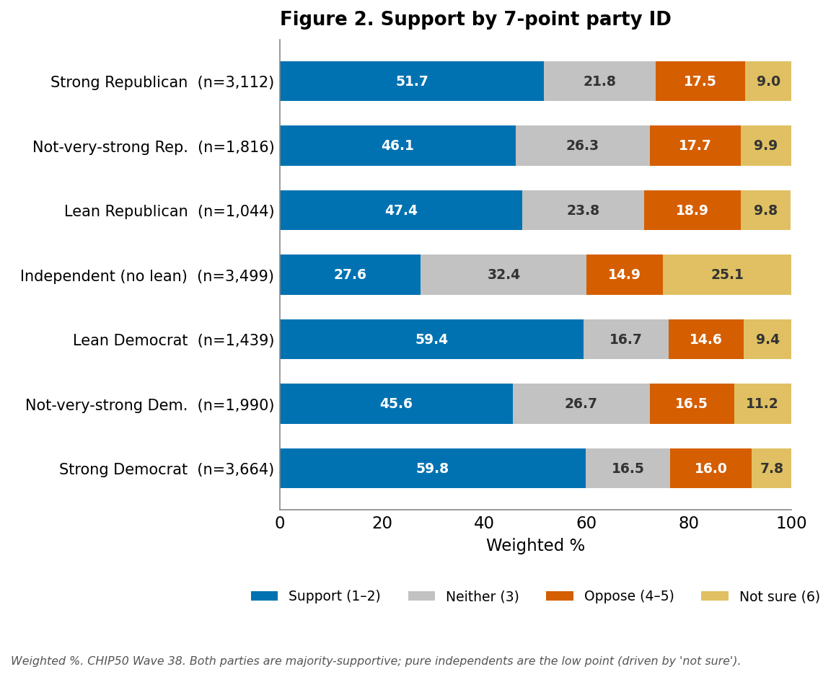
Support is a majority or near-majority in every partisan group except pure independents. Strong Democrats (59.8%) and Lean Democrats (59.4%) are the most supportive, but Strong Republicans (51.7%) are also majority-supportive, and opposition never exceeds ~19% in any group. Pure independents stand out not as opponents (14.9% oppose) but as the least engaged: a quarter (25.1%) are not sure and another third are neutral. Under controls, Strong and Lean Democrats are significantly more supportive than Strong Republicans, while independents are significantly less supportive; the within-Republican groups are statistically indistinguishable from Strong Republicans.

By race and ethnicity
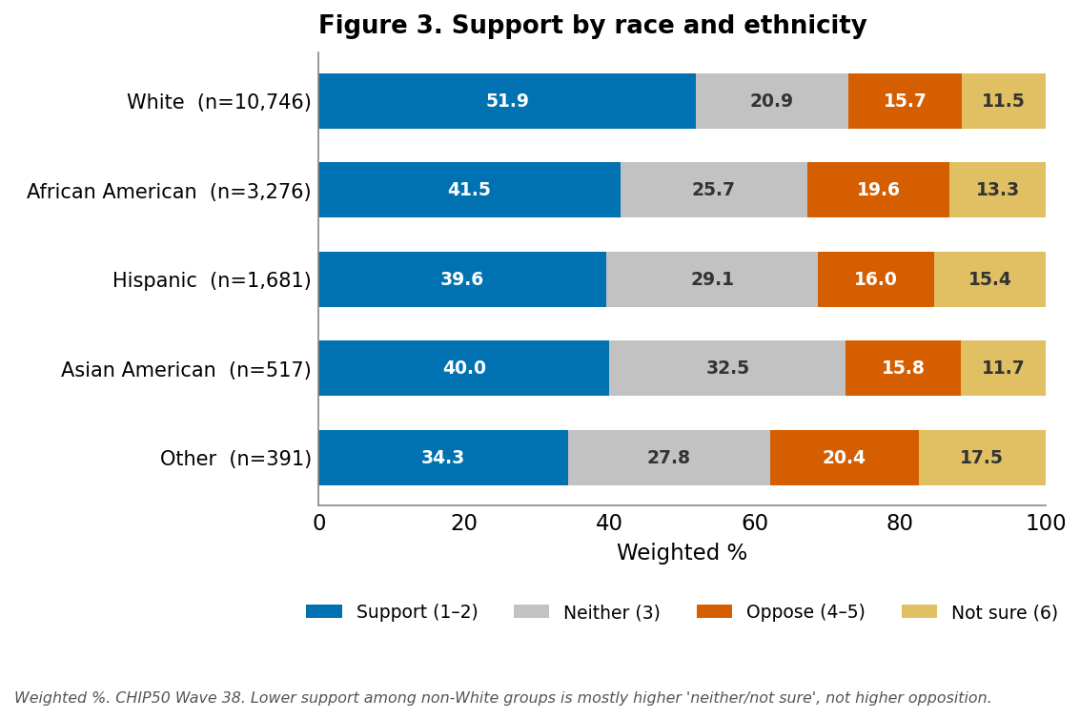
White respondents are the most supportive group (51.9%), and that edge persists after controlling for party, education, income, age, and gender. The lower support among Black, Hispanic, and Asian American respondents (about 40–41%) is, however, a gap in certainty rather than opposition: opposition is similar across all groups (roughly 16–20%), while non-White respondents are more likely to choose “neither” or “not sure.” In other words, every racial/ethnic group opposes the amendment at about the same low rate; they differ in how many have settled on support.

By education
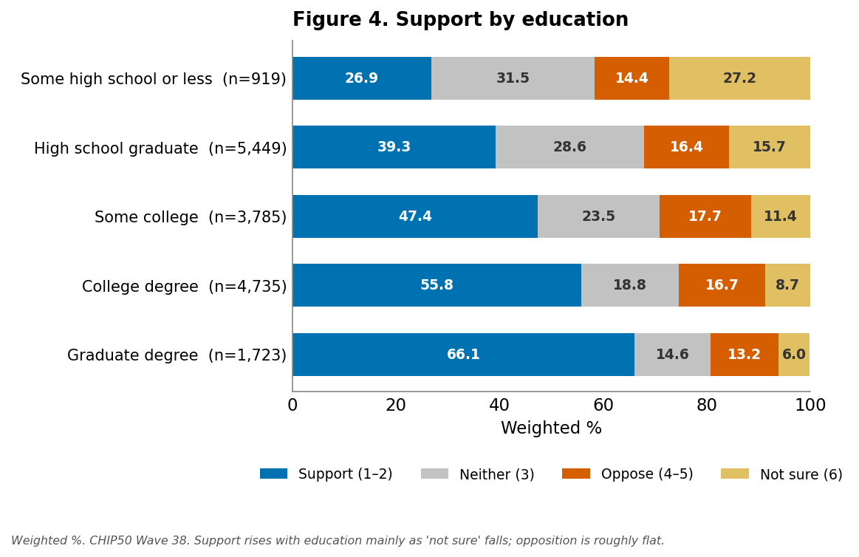
Support climbs steadily with education, from 26.9% among those with some high school or less to 66.1% among graduate-degree holders — a 39-point spread that is highly significant under controls. As with race, this is mainly a certainty gradient: “not sure” falls from 27.2% to 6.0% across the education range, while opposition barely moves (13–18%).

By gender
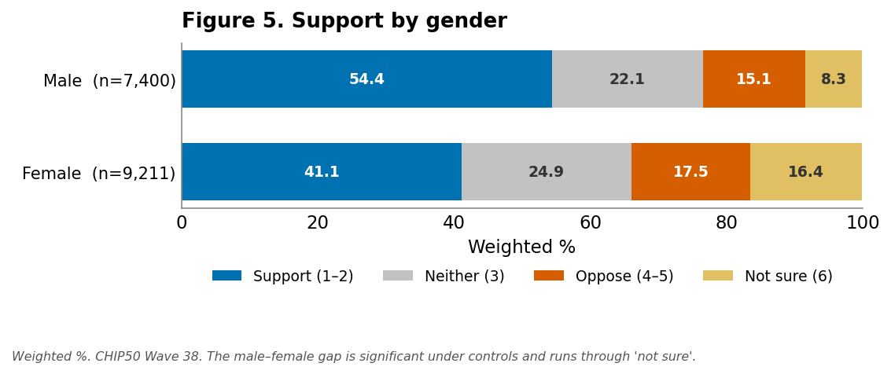
Men are notably more supportive than women (54.4% vs. 41.1%), and the gap remains significant after controls. Women are about twice as likely to be unsure (16.4% vs. 8.3%); opposition is similar for both.

By income
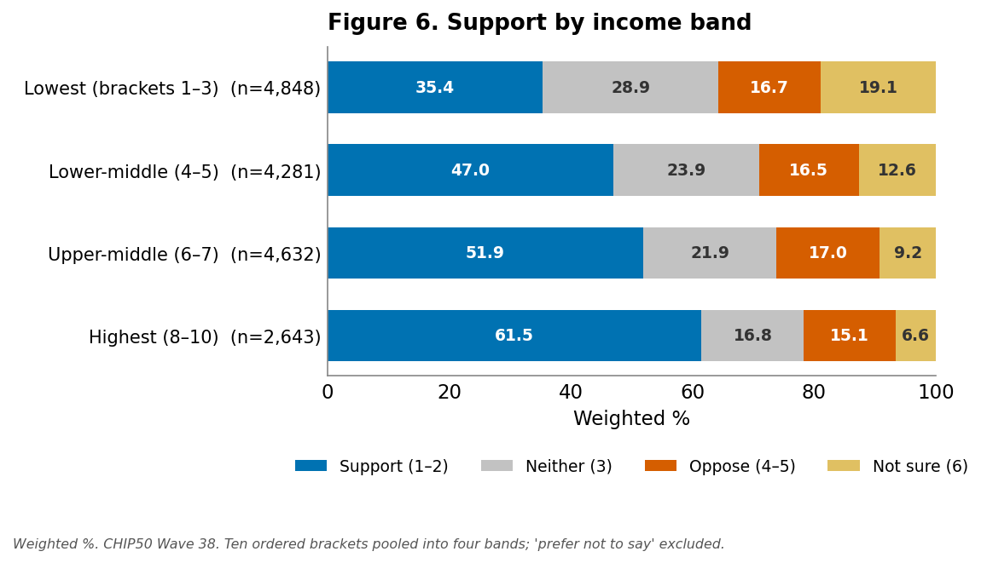
Support rises monotonically with income, from 35.4% in the lowest band to 61.5% in the highest; the income terms are significant under controls. The pattern again runs through uncertainty (not-sure falls from 19.1% to 6.6%) rather than opposition (flat near 15–17%). (The ten ordered income brackets are pooled into four bands by summing weighted counts and recomputing shares; the “prefer not to say” category, n = 208, is excluded.)

By community type
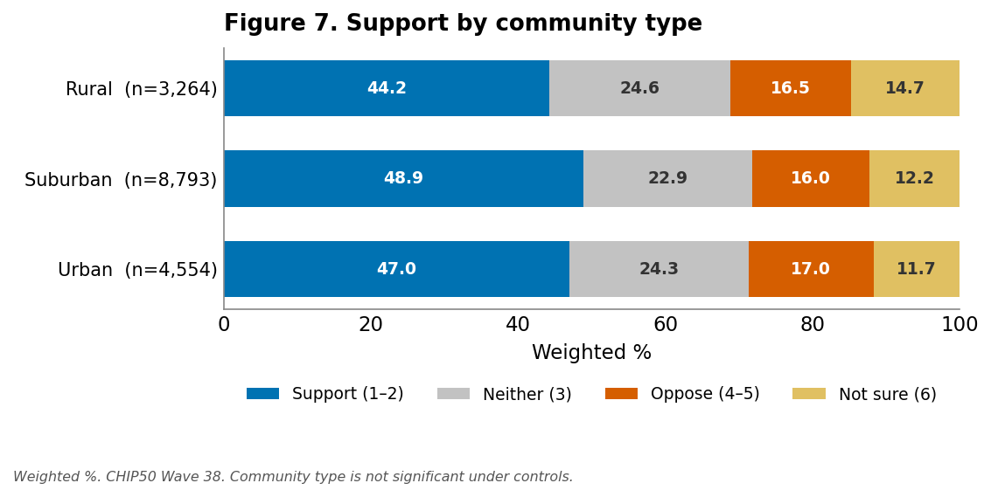
Community type matters little: support runs 44–49% across rural, suburban, and urban respondents, and neither rural nor urban differs significantly from suburban under controls. Opposition is essentially identical (~16–17%) everywhere.

By age
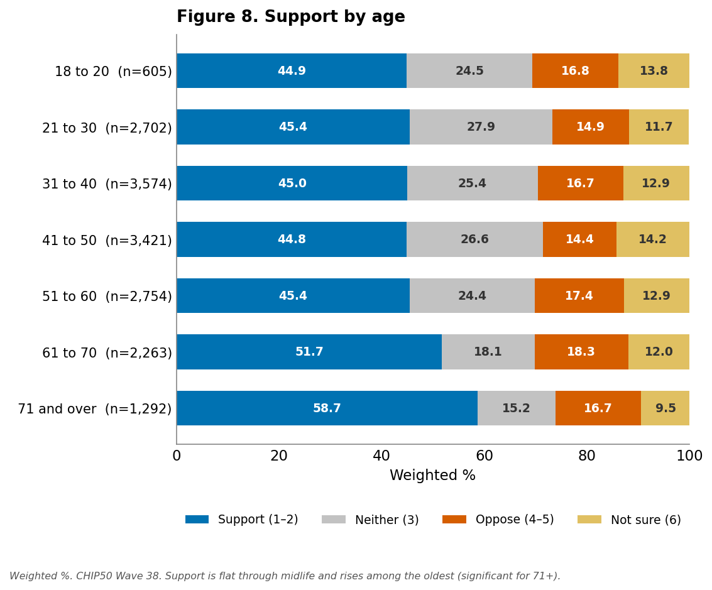
Support is flat at about 45% through middle age and then rises among older respondents, reaching 58.7% for those 71 and over. Under controls only the oldest groups (71–80 and 80+) are significantly more supportive than the youngest; the middle-age groups are statistically indistinguishable. (The 71–80 and 80-and-over brackets are combined here by summing weighted counts; the regression retains the finer age_cat_8 coding.) Opposition is again low and flat across the life course.

Further findings: geographic variation
Support is strikingly uniform across the country. Aggregating states into the four Census regions (summing weighted counts) — the reliable unit, since most individual states are too small to read on their own — every region lands within a few points of the 47.6% national figure, and opposition is low everywhere (Figure 9 and Table 9). The Northeast is modestly the most supportive (50.8%) and the South the least (46.4%), a spread of about four points; opposition ranges only from 14.9% (Northeast) to 17.7% (West).
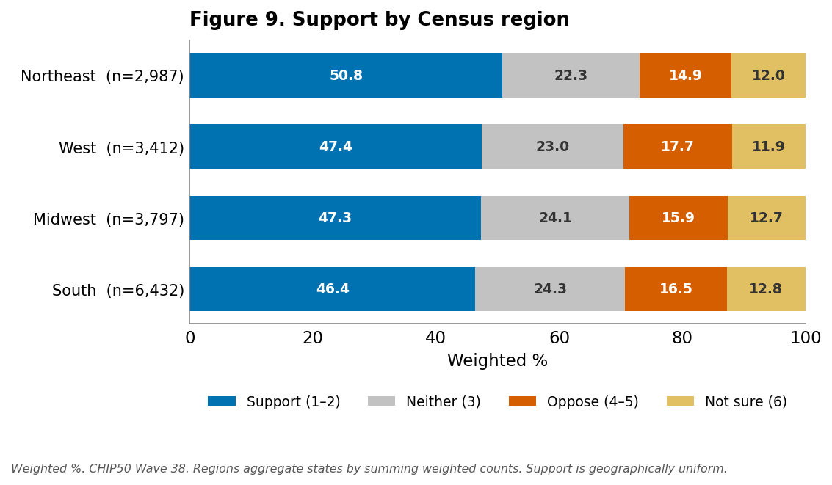
Table 9. Opinion by Census region (weighted %).
Region | Support (1–2) | Neither (3) | Oppose (4–5) | Not sure (6) | Unwtd n
Northeast | 50.8 | 22.3 | 14.9 | 12.0 | 2,987
Midwest | 47.3 | 24.1 | 15.9 | 12.7 | 3,797
South | 46.4 | 24.3 | 16.5 | 12.8 | 6,432
West | 47.4 | 23.0 | 17.7 | 11.9 | 3,412
Regions aggregate the 50 states and D.C. by summing weighted response counts and recomputing shares.
At the state level the apparent range is wider — about 39% to 59% support — but most of that spread is sampling noise: state samples run from ~126 (Vermont) to ~884 (Texas), and the smaller states carry margins of roughly ±8–10 points before even accounting for the panel's weighting. Among states with reliable samples (n ≥ 400; Figure 10), support runs from about 43% to 55% — higher in New York (54.7%), Pennsylvania (52.5%), Ohio (51.1%), Virginia (50.9%), and Florida (50.7%), and lower in California (43.4%), Texas (44.0%), and Michigan (45.8%). This geography does not track partisanship: deep-blue New York is the highest of the large states while deep-blue California is among the lowest, and red-leaning Ohio and Florida sit above average while the Deep South is lowest. As elsewhere in the data, the lower-support states differ mainly through larger “neither/not sure” shares, not higher opposition.
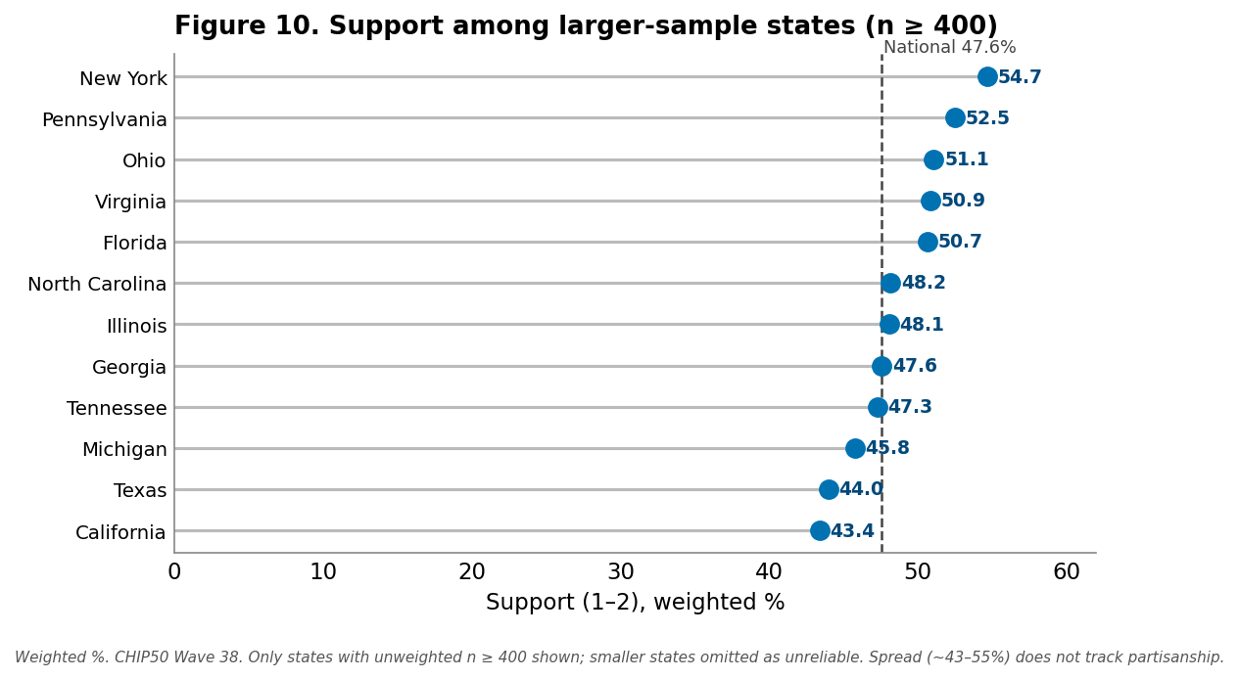
CHIP50 weights target national, not within-state, representativeness, so state-level estimates are indicative only and are not a substitute for state polls. Three “somewhat oppose” cells (Arkansas, Minnesota, Vermont) were suppressed at n < 10 and approximated in the regional totals, which is immaterial at the regional level.

Methods
Data. CHIP50 (Civic Health and Institutions Project, a 50-State Survey; successor to the COVID States Project), Wave 38, the most recent wave (fielded spring 2026; the metadata tool did not return field dates for this wave). Non-probability online panel, weighted to be population-representative; unweighted wave n = 16,628. The gerry_amend item was answered by 16,611 respondents (unweighted) — essentially the full wave, so unlike some items it was not asked of a subset. Note: gerry_amend, gerry_eval, and gerry_state_aware are absent from the tool's variable catalog yet compute for Wave 38 (the catalog has previously omitted fielded items); all were confirmed via live calls.
Measure. Outcome gerry_amend, questionnaire wording “Would you support or oppose a constitutional amendment that would prohibit states from redrawing congressional district boundaries to help one political party win more seats?” — a six-point item coded 1 = strongly support … 5 = strongly oppose, 6 = not sure. The tools expose no value labels; this coding was independently inferred during analysis and has since been confirmed against the questionnaire. “Not sure” (6) is treated as a substantive non-scale response: shown as its own category in all distributions and excluded from the regression scale.
Estimation. All estimates are survey-weighted. The topline is the full weighted six-category distribution (generate_marginals). Demographic breakdowns (Figures 2–8) are the weighted percentage in each group choosing Support (1–2), Neither (3), Oppose (4–5), and Not sure (6), from the per-group six-category distribution (get_ordinal_distribution_by_demographic); cells with n < 10 are suppressed. The income figure pools the ten ordered brackets into four bands by summing weighted counts (“prefer not to say,” n = 208, excluded); the age figure combines 71–80 and 80-and-over into “71 and over.” The Census-region breakdown (Figure 9 / Table 9) sums per-state weighted response counts (get_ordinal_distribution_by_demographic by state) into the four regions; three suppressed “somewhat oppose” cells (Arkansas, Minnesota, Vermont) were approximated and are immaterial at the regional level. The multivariate model is a survey-weighted OLS / WLS (run_ols_regression) of gerry_amend on party7 (dummy-coded), race_cat_5, education_cat, gender, income_cat_10, urban_type, and age_cat_8, fit on the 1–5 scale with “not sure” (6) and income category 11 filtered out (n = 14,211; references: Strong Republican, White, high-school graduate, female, suburban, lowest income, age 18–20). Standard errors are model-based, not design-based.
Significance discipline. Differences are called “significant” only where the regression coefficient is significant at p < .05 (party Democrat/independent contrasts, race, education, income, gender, age 71+). Community type is not significant and is described as flat. Crosstab gaps are otherwise descriptive; the recurring “certainty, not opposition” observation describes the four-way distributions, not a causal claim.

Appendix A — Analytic Memo
This is the internal technical memo for the report, retained here as an appendix. It covers the scale-direction verification, the multivariate results, candidate storylines, consistency with prior evidence, and suggested follow-up analyses.

Establishing the scale direction (now questionnaire-confirmed)
When the report was first built, the tools exposed no value labels for gerry_amend, and direction was not assumable — the project's support_cuba item runs 1 = strongly oppose → 5 = strongly support, the opposite of the convention. Four independent signals nonetheless pointed the same way and underpinned the 1 = strongly support … 5 = strongly oppose, 6 = not sure reading:
- Shared “not sure” tail. gerry_amend has a 6th category at 12.45%; its companion item gerry_eval has a structurally identical 6th category at 13.76%. A trailing ~12–14% “not sure” option is the natural common element, so value 6 is “not sure,” not a scale extreme.
- Standard six-point battery. 1–5 as strongly-support → strongly-oppose with a trailing not-sure is the canonical CHIP50/Pew support format, and the symmetric shape fits it.
- Internal coherence with party. Reading 1–2 as support, both parties' strong identifiers are majority-supportive and disengaged independents are the low point. The reverse reading would make Strong Democrats (59.8% in categories 1–2) the group most opposed to stopping gerrymandering, which is not credible.
- External plausibility. Anti-gerrymandering / independent-redistricting reforms consistently draw broad, often bipartisan majorities in public polling, with low opposition — matching the 47.6% support / 16.4% oppose shape, not its inverse.
Confirmed. The questionnaire has since verified this coding exactly, including category 3 = “neither support nor oppose” (not a second don't-know). The four checks correctly predicted the direction; no figures or findings change. One framing point the verified wording adds: the question names partisan intent explicitly (“to help one political party win more seats”), a consensus-friendly framing that plausibly contributes to the broad, bipartisan support and the uniformly low opposition seen across groups.

Multivariate findings
A survey-weighted OLS (WLS) of gerry_amend on the seven predictors, fit on the 1–5 scale with “not sure” (6) excluded and income “prefer not to say” excluded (n = 14,211; R² = 0.063; references: Strong Republican, White, high-school graduate, female, suburban, lowest income, age 18–20). The outcome is coded so that higher = more opposed, so a negative coefficient means more supportive (Figure A1).
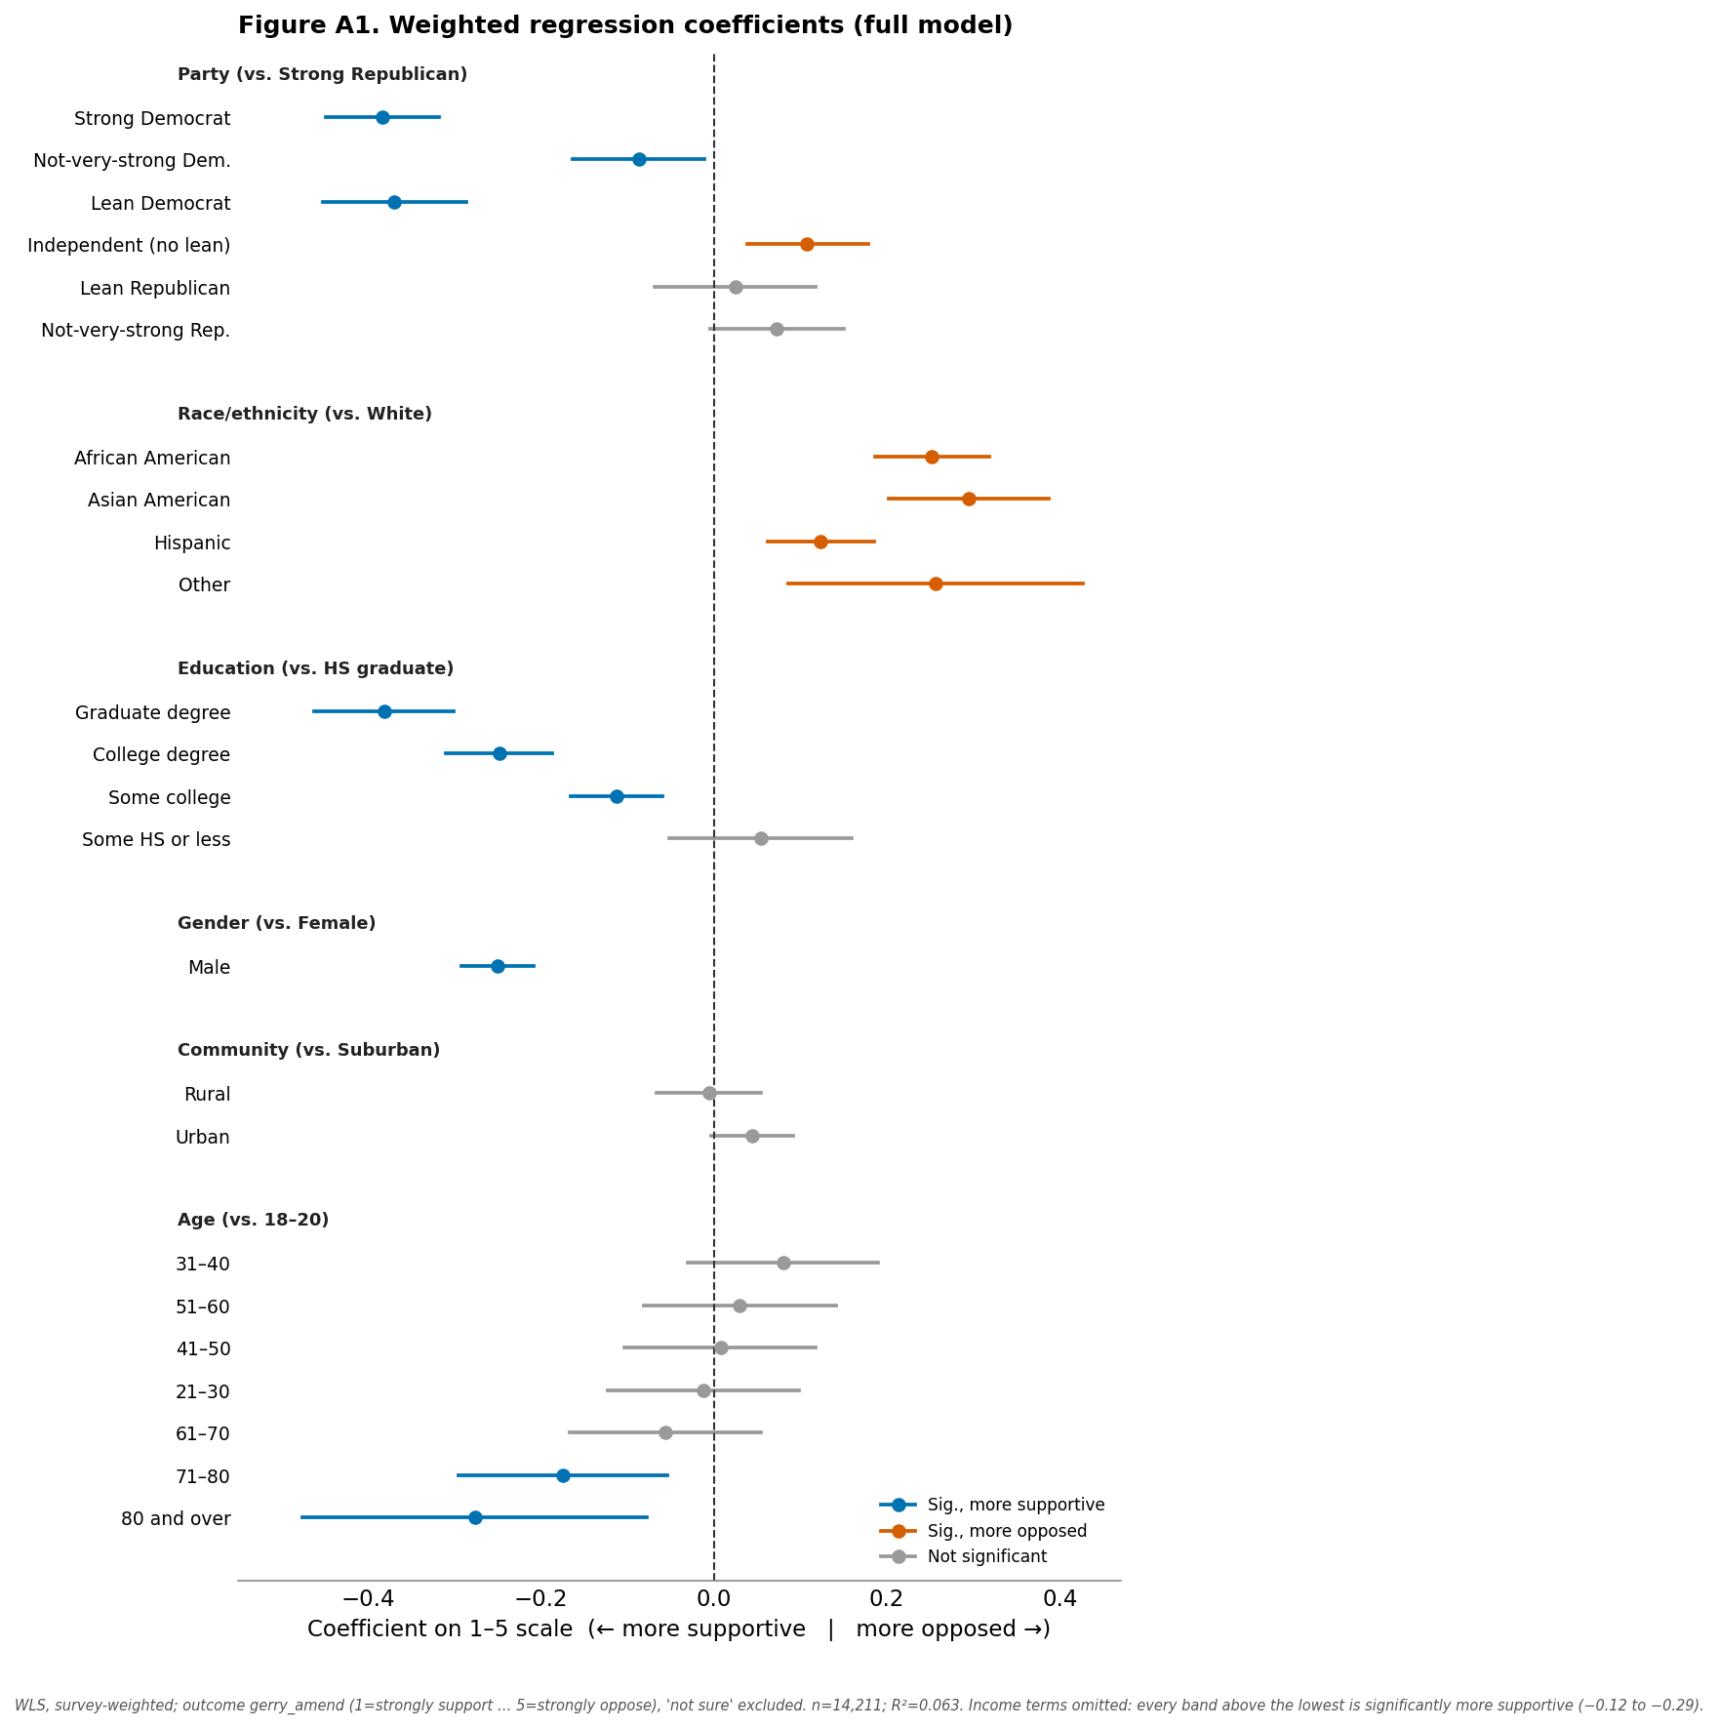
- Low R² is itself the headline. Demographics explain only ~6% of the variance — far less than a typical polarized issue. Support is broad and cuts across groups; what little structure exists is an engagement gradient, not a cleavage. (With n = 14,211, even small effects reach significance, so “significant” here does not mean “large.”)
- Party is not a simple left–right line. Relative to Strong Republicans, Strong Democrats (−0.38) and Lean Democrats (−0.37) are significantly more supportive, and Not-very-strong Democrats modestly so (−0.09). Independents are significantly less supportive (+0.11). Lean and Not-very-strong Republicans are indistinguishable from Strong Republicans. The gradient is “engaged partisans (especially Democrats) support; disengaged independents lag,” not “left supports, right opposes.”
- Race/ethnicity: all minority groups less supportive than White, net of controls. African American (+0.25), Asian American (+0.29), Hispanic (+0.12), and Other (+0.26) are all significantly higher (less supportive) than White respondents. Because opposition rates are similar across race, this reflects more “neither/not sure” among non-White respondents on the opinion-holders' scale — lower crystallized support, not higher opposition. It should not be framed as minority opposition to reform.
- Education: strong, monotonic. College (−0.25) and graduate (−0.38) respondents are much more supportive than high-school graduates; some-college (−0.11) also significant; some-high-school-or-less is indistinguishable from the baseline.
- Income: monotonic and significant. Every band above the lowest is significantly more supportive (−0.12 to −0.29), rising with income.
- Gender: men more supportive. Male is −0.25 — a real, sizeable gap that survives controls.
- Age: only the oldest differ. 71–80 (−0.17) and 80+ (−0.28) are significantly more supportive than 18–20; all middle-age groups are flat under controls.
- Community type: null. Neither rural nor urban differs significantly from suburban.
What survives controls vs. the descriptive tables: party (Dem vs. Rep direction, and the independent trough), race, education, income, gender, and old age all hold; community type washes out; the apparent mid-life age differences wash out.

Candidate storylines
- “3-to-1 support for an anti-gerrymandering amendment — and it's bipartisan.” (strongest hook) Net support (47.6%) is nearly triple opposition (16.4%), majorities of both Strong Republicans and Strong Democrats back it, and opposition tops out below 20% in every group. Rationale: the clearest, most newsworthy, most defensible finding, and it lands against the assumption that everything is polarized.
- “The opposition isn't opposition — it's 'don't know.'” A combined ~36% are neutral or unsure, and almost every demographic gap (race, education, income, gender) is a gap in certainty, not in opposition. Rationale: a genuinely counterintuitive, well-supported reframing; the single most analytically interesting feature of the data.
- “An engagement divide.” The groups that are more politically engaged — more-educated, higher-income, older, men, strong partisans — are more supportive; the disengaged (independents, low-education, low-income, younger, women with high “not sure”) are uncertain, not opposed. Rationale: ties the demographic results into one mechanism.
- “White Americans are the most supportive — but minorities aren't opposed.” A careful, easily-misread finding worth telling precisely. Rationale: good nuance piece; requires the certainty-vs-opposition framing to avoid distortion.

Consistency with prior evidence
The topline (a plurality-to-near-majority supportive, opposition in the mid-teens, and a large undecided bloc) is consistent with the long-running finding in U.S. polling that redistricting-reform and independent-commission measures draw broad, frequently bipartisan support but at relatively low salience, leaving many respondents without a firm view. The bipartisan character also matches the pattern that “good-government” process reforms attract cross-party majorities even when elite actors are polarized. These are directional comparisons; gerry_amend wording differs from other instruments, so external matches are approximate and should be source-verified in polish.

Additional analyses worth running
- Use the rest of the battery. Two companion items were fielded in the same wave: gerry_eval (apparent severity-of-problem rating) and gerry_state_aware (3 categories; ~51% in the trailing “not sure/unaware” category). Modeling support on perceived-severity and awareness would test what drives the large undecided middle. (Their value labels are likewise unexposed and would need verification.)
- Model the “not sure” explicitly. Given that ~36% are neutral/unsure and most demographic gaps run through uncertainty, a two-stage approach — who holds an opinion at all, then support vs. oppose among opinion-holders — would describe the structure better than a single 1–5 scale (which an ordered-logit would also fit more appropriately than OLS).
- Geographic variation (evaluated — see Further findings). Support is geographically uniform and does not track partisanship. Worthwhile extensions: line states up against concrete redistricting context (recent mid-decade redraws, independent commissions, pending ballot measures), and fit a multilevel / small-area model to stabilize the noisy small-state estimates.
- Mediation of the race gap. Test whether the education/income/engagement gradient accounts for the White-vs-minority support gap, since that gap appears to be about crystallized support rather than opposition.

Appendix B — Methodological Evaluation
A candid internal assessment of how far the analysis can be pushed, separate from the findings. Each issue is tagged Minor, Moderate, or Material.
Bottom line up front. The headline results — broad ~3-to-1 support, majorities in both parties, low opposition everywhere, and a structure in which group gaps are differences in certainty rather than opposition — are large, internally consistent, and robust. None of the issues below overturns them. What the issues bound is the size of subgroup differences and any causal reading of the engagement gradient.

Measurement and coding
Value labels were unlabeled, now resolved (Minor). The tools returned only numeric codes; the 1–5 + not-sure coding was inferred from four converging signals and has since been confirmed against the questionnaire, so direction is no longer a risk. The catalog's omission of the entire gerrymandering battery (gerry_amend, gerry_eval, gerry_state_aware) is a provenance flag, not a data-quality one — all were confirmed via live calls.
The large middle (Moderate). “Neither” (23.6%) and “not sure” (12.5%) together are ~36% of responses. The report keeps both visible and excludes only “not sure” from the regression scale, treating “neither” as the 3-point midpoint — a defensible choice, but the support/oppose split is, in effect, conditional on having moved off the fence, and the demographic “gaps” are mostly differences in who is still on it. The report states this repeatedly; readers should not read low-support groups as opposed.

Sampling, weighting, and inference
Non-probability online panel (Material, inherent). CHIP50 is a non-probability panel weighted to population targets. Weighting corrects observable demographic imbalance, not unobserved selection, and no design-based margin of error strictly applies; treat all point estimates as model-based.
Model-based standard errors and significance inflation (Moderate). Regression SEs come from WLS treating weights as frequency weights and understate true uncertainty. Separately, with n = 14,211 even trivial effects clear p < .05 — so “significant” should not be read as “large.” The R² of 0.063 is the honest summary: demographics barely move support. Several reported gaps (e.g., gender −0.25, some age contrasts) are statistically clear but modest on a five-point scale.
Functional form (Moderate). OLS on a 1–5 scale with “not sure” dropped is a reasonable first pass, but an ordered-logit or an explicit two-part (opine / then support) model would fit the heavy middle better and is the recommended next step.
Multiple comparisons (Moderate). Eight demographic breakdowns plus a region cut and a large coefficient table mean some p < .05 results are false positives; no formal correction was applied. Mitigation: leaning on the regression and foregrounding only large, theory-consistent patterns.

Small cells, suppression, and geography
State estimates are noisy (Material for state reads; handled). Per-state samples (n ≈ 126–884) give the smallest states margins around ±8–10 points before design effects. The report addresses this by aggregating to four Census regions (stable) and restricting state commentary to n ≥ 400, explicitly treating the raw 39–59% state range as mostly noise. Three “somewhat oppose” cells (AR, MN, VT) were suppressed at n < 10 and approximated; immaterial at the regional level. CHIP50 weights are national, not within-state, so state figures are indicative only.

Coverage, provenance, and benchmarking
Provenance gaps (Moderate). The gerrymandering battery is undocumented in the catalog, Wave 38 field dates were not returned by the metadata tool, and the companion items' labels are unverified. None affects the headline, but it limits reproducibility and means the companion-item analyses await label confirmation.
No published benchmark; context unverified (Moderate). gerry_amend has no published companion report, and the Context section's redistricting claims were not web-verified in this pass. The topline is consistent with the general pattern that redistricting reform polls broadly and bipartisanly, but that is a soft check; live source confirmation is the main outstanding pre-publication task.

Net assessment
The strongest claims — ~3-to-1 support, bipartisan majorities, low and flat opposition, and the certainty-not-opposition structure of every demographic gap — rest on large, stable patterns that would survive any reasonable reweighting or correction. The appropriately hedged claims, already flagged in the report, are: the absolute size of demographic differences (significant but small), any causal reading of the engagement gradient, and state-level specifics (noise). Two low-cost improvements would raise confidence most: confirming and attaching the Context sources, and refitting with an ordered-logit / two-part model plus the companion battery items once their labels are verified.

