Who Is Taking GLP-1 Drugs — and How That Changed Across 2025
GLP-1 use rose across nearly every demographic group between two 2025 survey waves. The steep income, education, and midlife concentration largely persisted — but the gender gap widened and the age gap narrowed as younger adults caught up.
Source: COVID States Project / CHIP50 survey, Waves 35 and 38. Wave 35 fielded April 10 – June 5, 2025 (unweighted n = 31,062); Wave 38 field dates are not recorded in the wave metadata (unweighted n = 16,628). All percentages are weighted estimates. Both waves are analyzed throughout; “Δ” denotes the Wave 38 minus Wave 35 difference in points.

Executive summary
- Use rose broadly. The share currently taking a GLP-1 rose from 7.1% (W35) to 8.94% (W38), and “considering / interested” rose from 10.99% to 14.69%. Current use increased in almost every demographic group examined (Figures 1–7).
- The income gradient persisted and stayed steep. The highest income pair (brackets 9–10) had the highest current use in both waves (12.16% → 15.58%); in the model, the top brackets carry roughly 2–2.5× the odds of the lowest bracket (bracket 9 OR 2.99 in W35, 2.47 in W38) (Figures 5, 8).
- The age gap narrowed. Under-40 and midlife adults gained the most (31–40: +3.3 points), while the oldest group (71 and over) was the exception — essentially flat (−0.7 points). In the model the midlife peak compressed, and the 71–80 coefficient fell from above to below the 31–40 reference (OR 1.52 → 0.70) (Figures 7, 8).
- The gender gap widened. Women’s current use rose faster than men’s (7.3% → 9.82% vs. 6.89% → 8.02%), and the female effect strengthened in the model (OR 1.17 → 1.40) (Figures 4, 8).
- Stable structure elsewhere. Republicans remained highest and Independents lowest in both waves (Republican 8.91% → 11.55%); the graduate-degree premium held (OR 1.67 → 1.74); and there was no significant urban/rural difference in either wave (Figures 2, 3, 6, 8).
- Discontinuation is substantial. Former users are a growing group — “previously took” rose from 4.18% to 5.47% of adults — and roughly 37% of everyone who has ever used a GLP-1 is not currently taking one (stable across waves; derived from Figure 1). Most former users report only one to two years on the drug (Figure 10, Table 11).
- Use runs opposite to clinical need. Obesity (~40% of adults) and diabetes (~12%) are both more common among lower-income and less-educated adults, yet GLP-1 use here is concentrated among the higher-income and more-educated — an access gap the late-2025 coverage expansion targets (Context).

Context
GLP-1 receptor agonists — semaglutide (Ozempic, Wegovy) and tirzepatide (Mounjaro, Zepbound) — were at the center of an unusually active policy year. During Wave 35’s spring-2025 field window, the FDA had just declared the semaglutide shortage resolved (Feb. 21, 2025) and was winding down the shortage-era flexibility that had let compounding pharmacies sell cheaper copies; the grace periods for compounded semaglutide ended in April and May 2025, pushing many patients toward brand-name products that often listed above $1,000 per month.
Affordability remained the dominant frame later in the year. On Nov. 6, 2025, the White House announced agreements with Eli Lilly and Novo Nordisk to cut GLP-1 prices and, for the first time, extend Medicare and Medicaid coverage of these drugs for obesity, with monthly cash prices on the planned TrumpRx platform falling toward roughly $350 and a $50 Medicare copay. Against that backdrop, the broad rise in use documented here — alongside a persistent income gradient — speaks directly to the access debate.
Who would clinically need these drugs. GLP-1 medications are indicated for type 2 diabetes and, increasingly, for obesity — and both conditions are common and unevenly distributed. About 40% of U.S. adults have obesity (CDC/NHANES, 2021–2023), peaking at 46% among adults aged 40–59; roughly 12% of adults have diabetes (CDC, 2023). Critically, that need runs in the opposite direction from the use pattern in this report on the two steepest dimensions. Diabetes prevalence is higher among adults with less education (13.1% for less-than-high-school vs. 6.9% for more-than-high-school) and falls as income rises; obesity is likewise higher among adults with less education and unevenly distributed by race. Because GLP-1 use in this survey is concentrated among higher-income and more-educated Americans, the groups with the greatest medical need appear least likely to be taking these drugs — the central access tension the November 2025 coverage expansion is meant to ease. (Age is the one dimension where need and use roughly align — both rise into midlife — though the oldest adults, who carry a high diabetes burden, show low use, consistent with Medicare’s historical non-coverage.)

Findings

Topline and trend
GLP-1 status shifted toward more use and more interest. “Not taking / no interest” fell from 73.27% to 69.18%, while every use-and-interest category rose. “Ever used” (currently + previously) was 11.28% in W35 and 14.41% in W38.
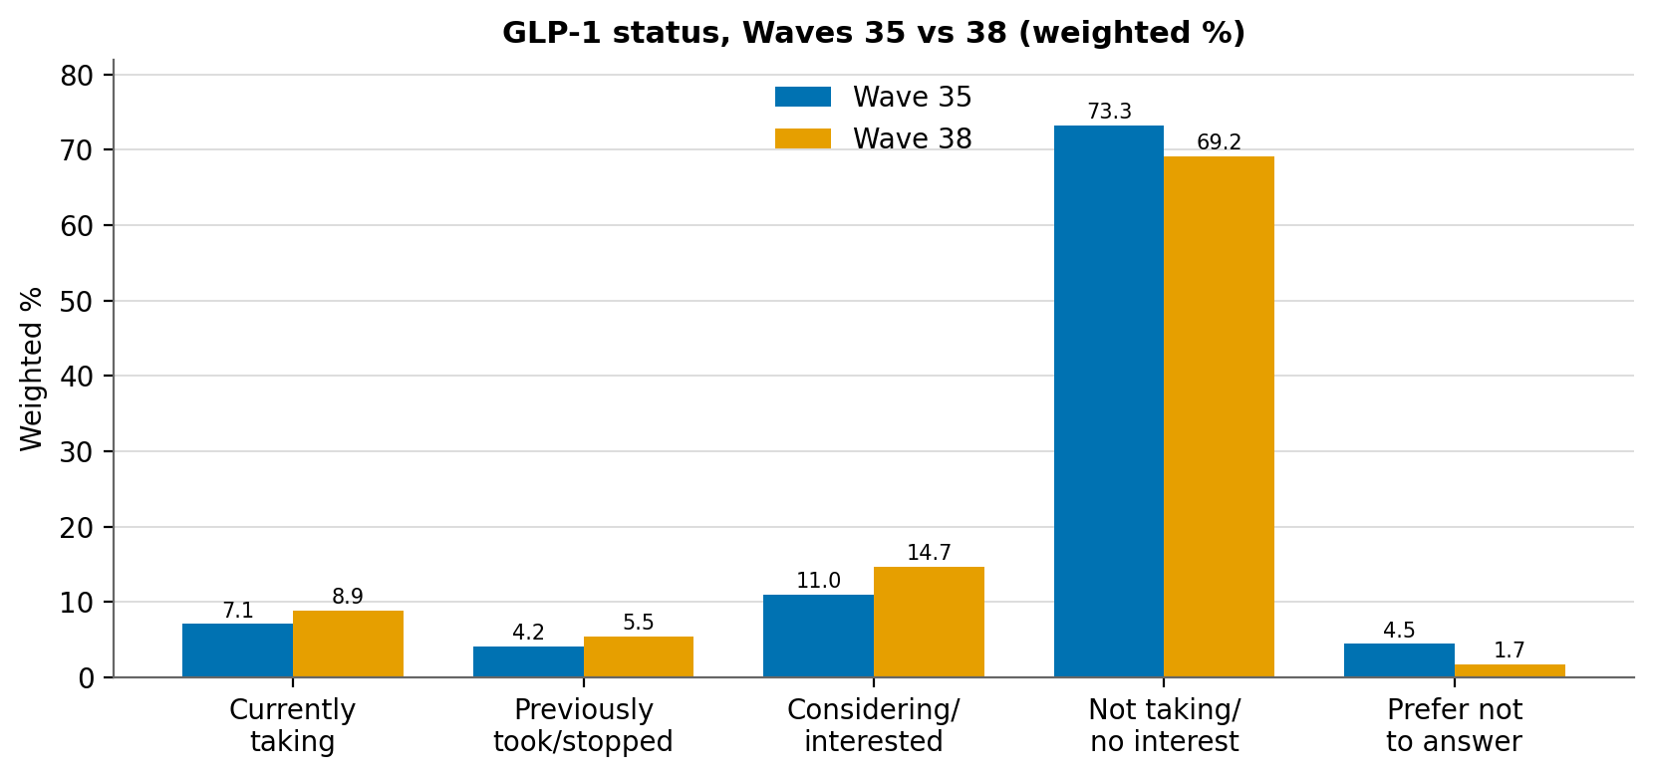
Figure 1. GLP-1 status, weighted %, Waves 35 and 38. Survey-weighted estimates; the fifth category is “Prefer not to answer” in both questionnaires. Full values in Table 1 (Data appendix).

By party
The structure is stable: Republicans highest, Independents/Others distinctly lowest, in both waves. Current use rose most among Republicans (+2.6 points).
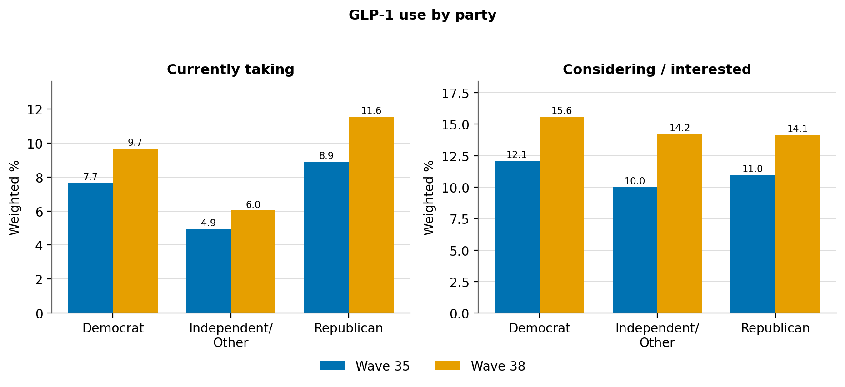
Figure 2. Current use and consideration by party, weighted %. Tool: get_categorical_crosstab(ozempic, party3). Full values in Table 2 (Data appendix).

By education
The education gradient is steep and rises with attainment: graduate-degree holders report the highest current use and rose the most (+3.2 points), while the high-school-or-less group sits well below.
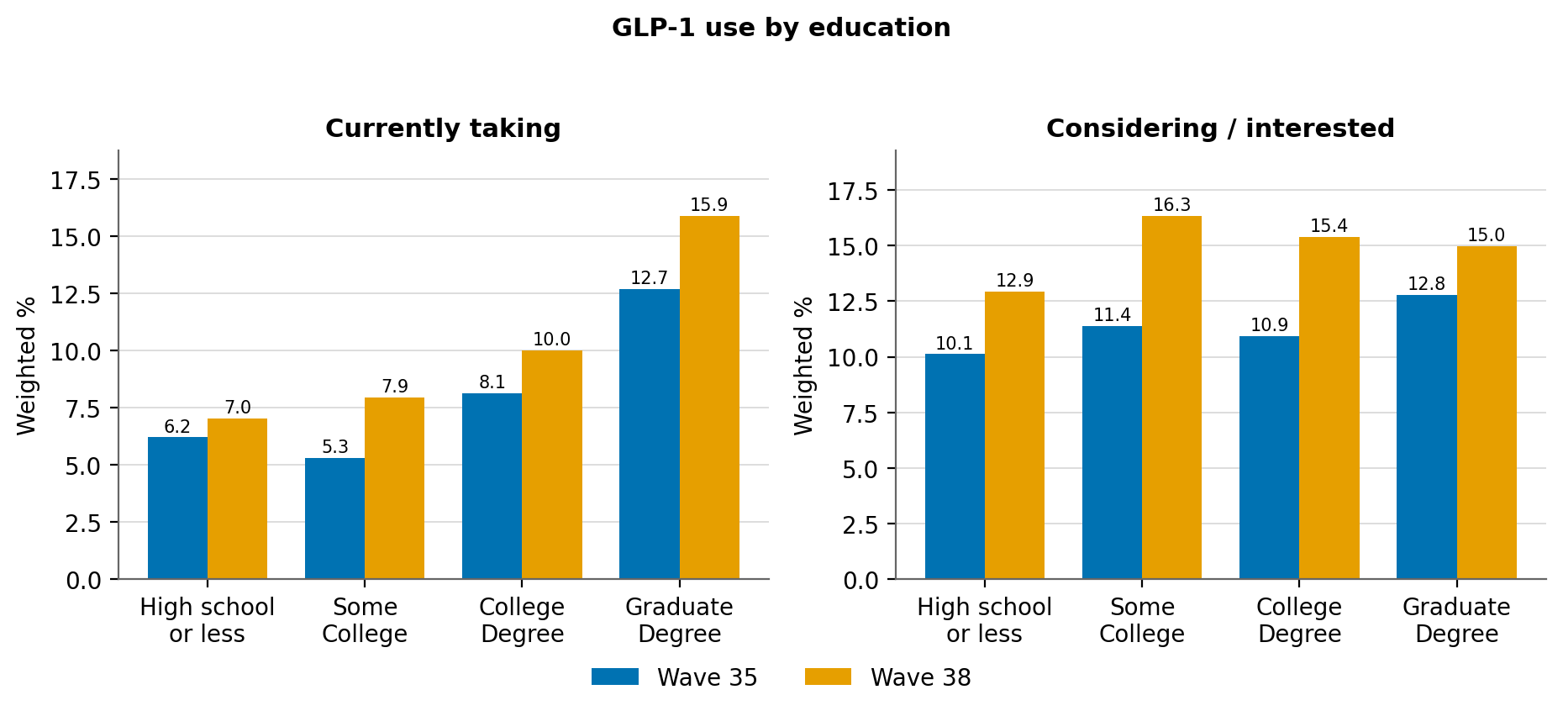
Figure 3. Current use and consideration by education, weighted %. “Some High School or Less” and “High School Graduate” are combined into “High school or less” by summing weighted population counts. Full values in Table 3 (Data appendix).

By gender
The previously small gender gap widened: women’s current use rose 2.5 points versus 1.1 for men, and the consideration gap widened as well.
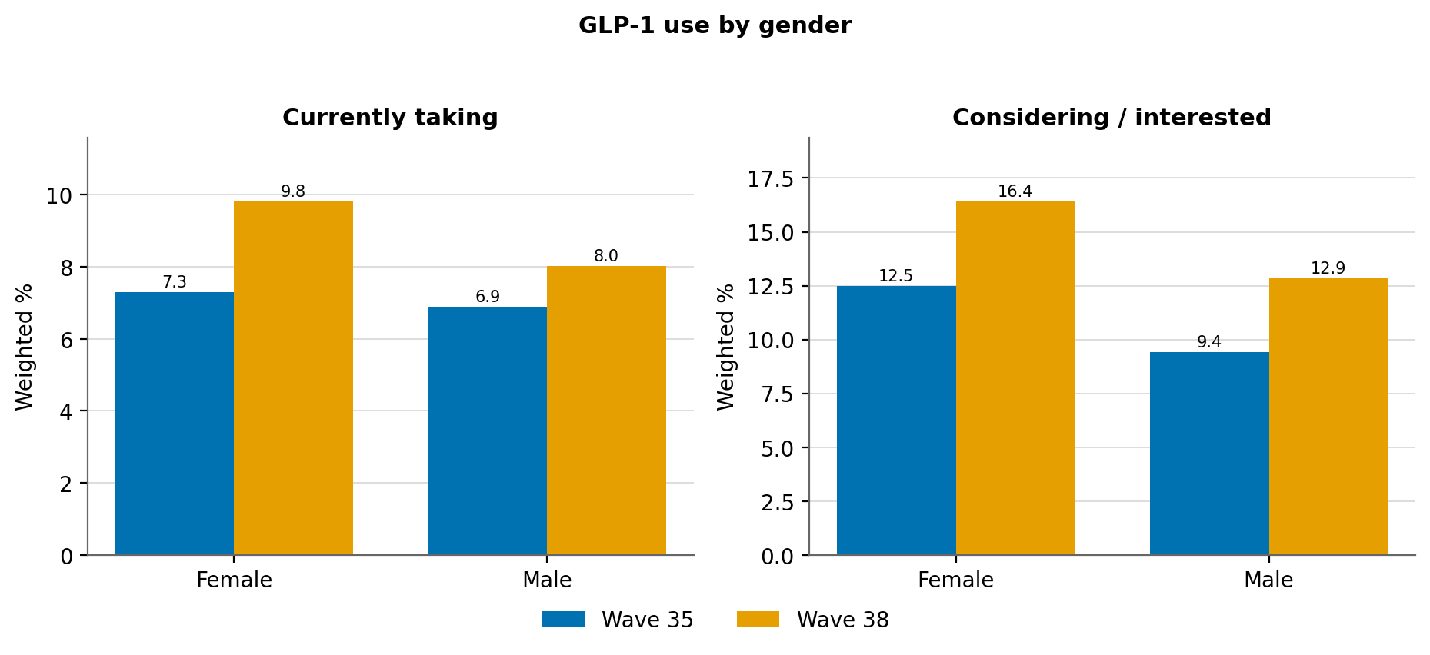
Figure 4. Current use and consideration by gender, weighted %. Tool: get_categorical_crosstab(ozempic, gender). Full values in Table 4 (Data appendix).

By income
Current use rose across the income distribution while keeping its steep shape: the highest income pair (brackets 9–10) leads in both waves and rose the most. Brackets pair the survey’s ordered income_cat_10 codes (1 = lowest to 10 = highest); a “prefer not to say” code (11) is excluded.
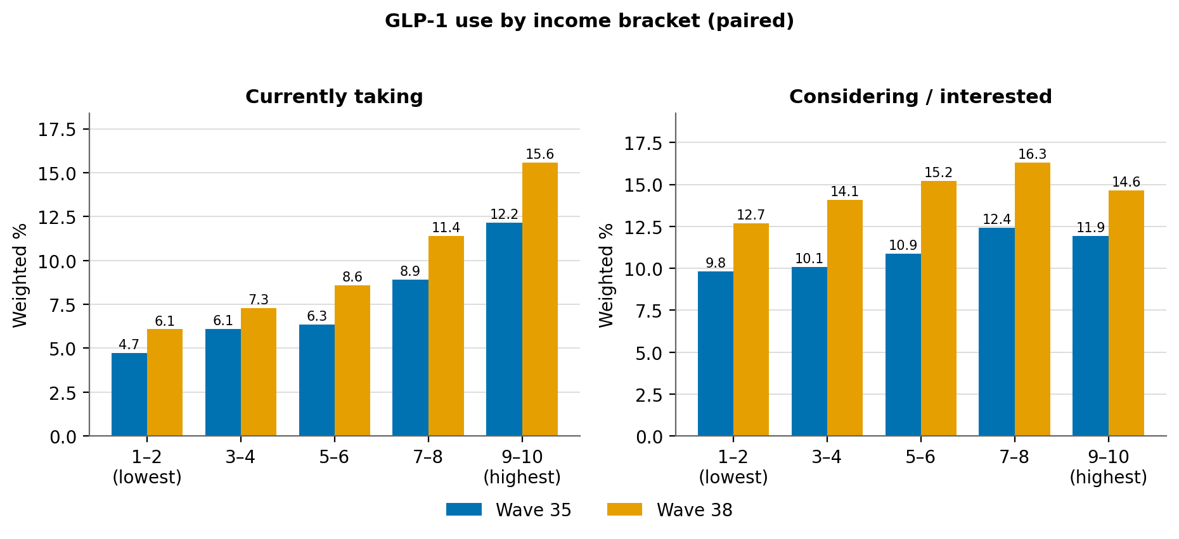
Figure 5. Current use and consideration by income bracket (paired), weighted %. Adjacent brackets combined by summing weighted population counts (not by averaging percentages). Full values in Table 5 (Data appendix).

By rurality
Current use rose roughly in parallel across rural, suburban, and urban respondents and stayed essentially flat across them in both waves — a descriptive non-difference confirmed by the model (Figure 8).
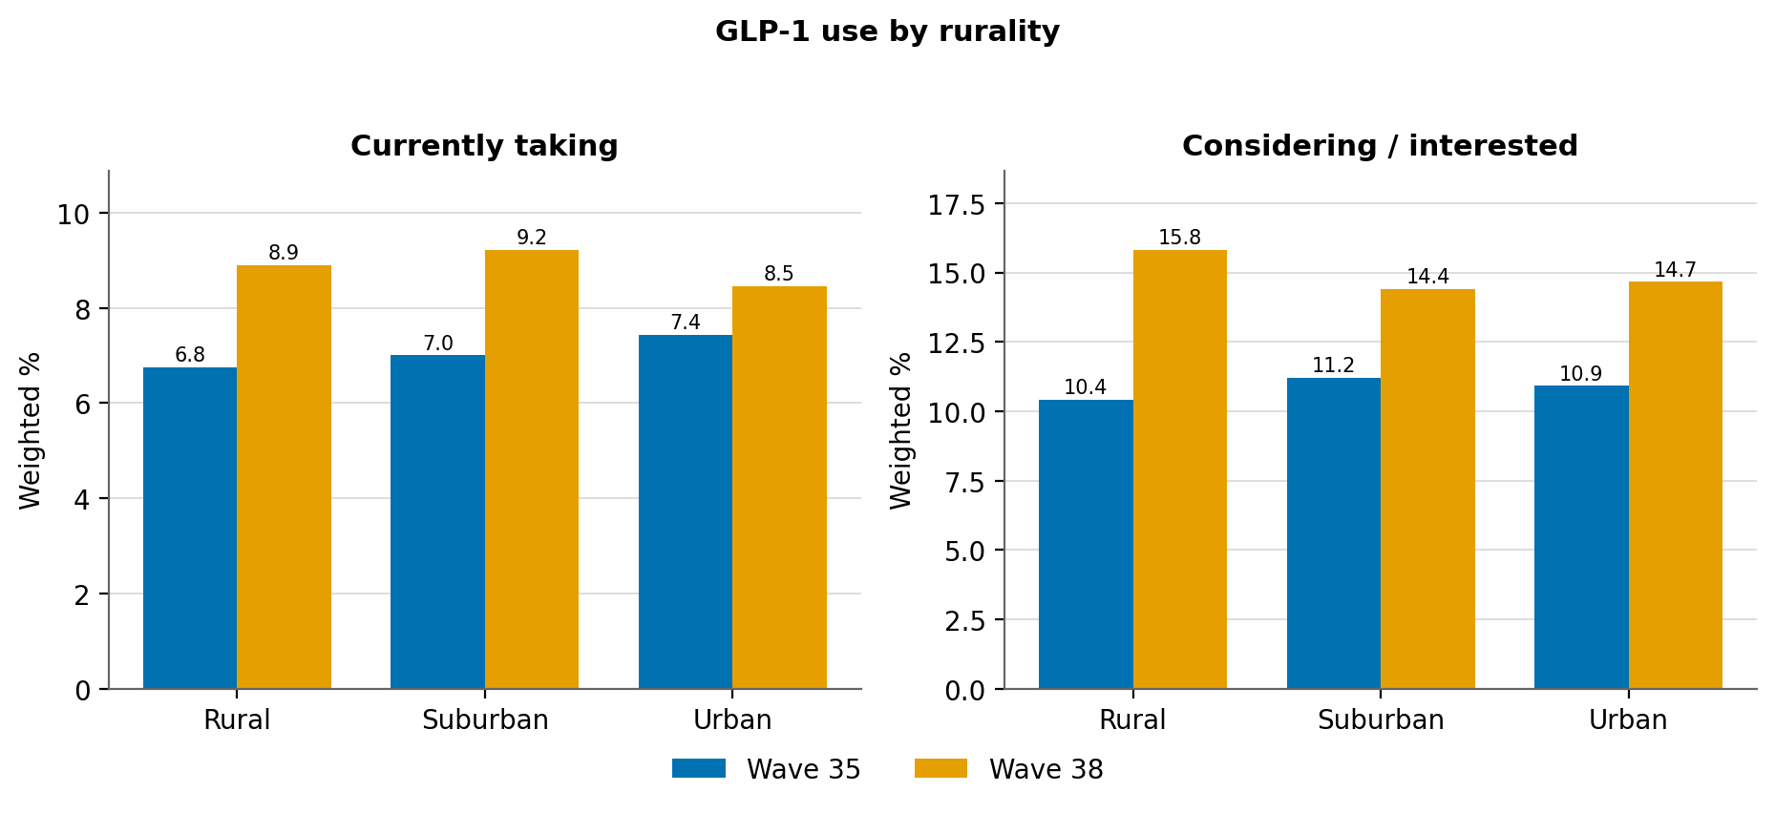
Figure 6. Current use and consideration by rurality, weighted %. Tool: get_categorical_crosstab(ozempic, urban_type). Full values in Table 6 (Data appendix).

By age
The age gap narrowed. Use rose across most groups, fastest among adults under 50 and in the early-60s, while the oldest group (71 and over) was the exception — flat to slightly lower. The midlife concentration remains.
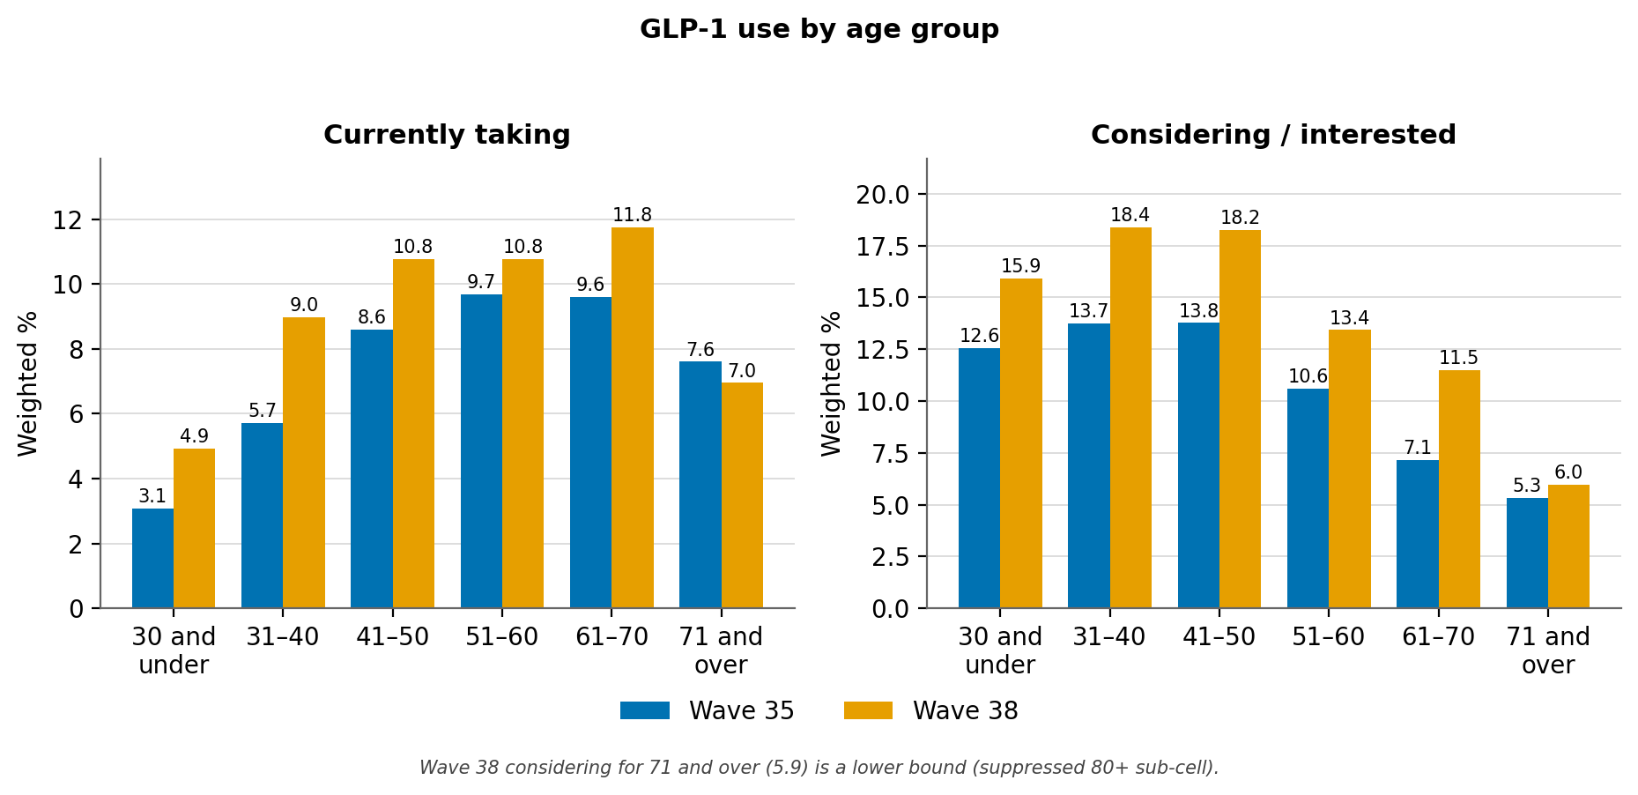
Figure 7. Current use and consideration by age group, weighted %. “18–20” and “21–30” are combined into “30 and under,” and “71–80” and “80 and over” into “71 and over.” The Wave 38 “considering” figure for 71 and over is a lower bound (a suppressed 80+ sub-cell is excluded). Full values in Table 7 (Data appendix).

Multivariate model
A survey-weighted logistic regression of current use (currently taking vs. never; “previously took” excluded) on all six demographics, run separately in each wave, shows which patterns are independent of the others — and which shifted. The structure is stable, with three movements: the female effect strengthened, the older-age advantage eroded, and education resolved toward a clear graduate-degree premium. The model uses the original (finer) categories; the combined groupings used in the descriptive figures are not applied here.
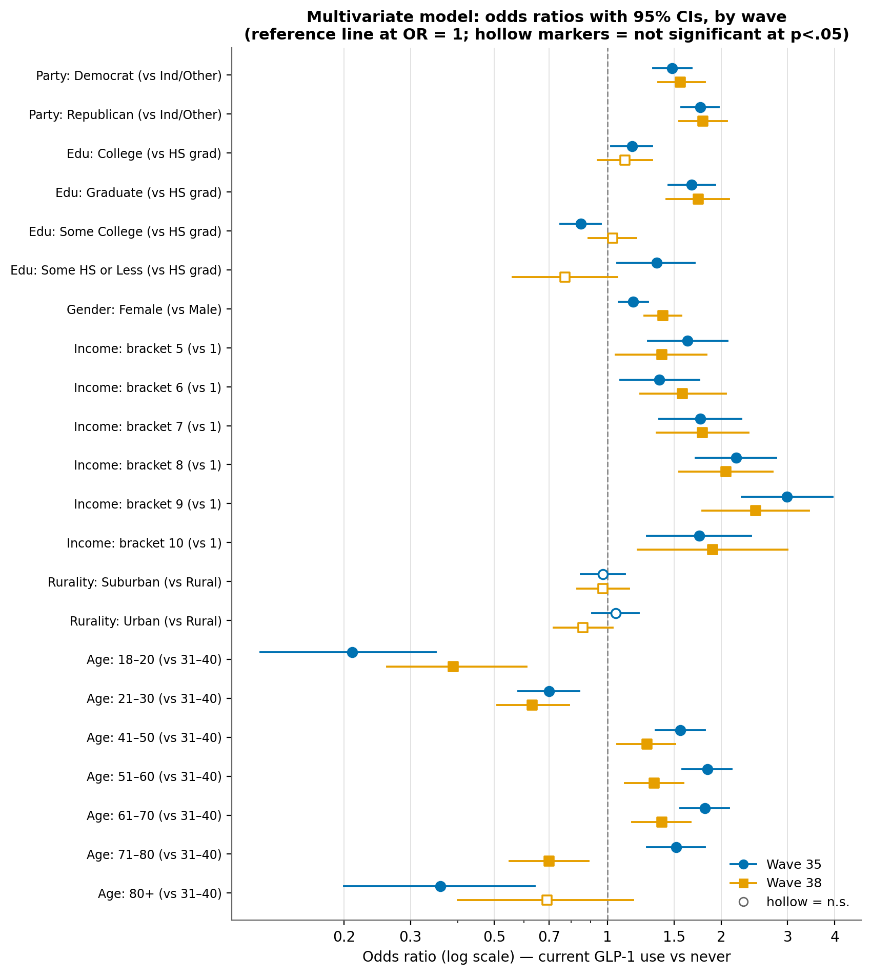
Figure 8. Logistic regression of current GLP-1 use, odds ratios with 95% CIs, by wave. References: Independent/Other, HS Graduate, Male, income bracket 1, Rural, age 31–40. Hollow markers are not significant at p<.05. Standard errors are model-based, not design-based. W35: n=29,718, McFadden pseudo-R²=0.052; W38: n=15,443, pseudo-R²=0.047. Full values in Table 8 (Data appendix).

Further findings

Why current and former users say they take GLP-1s
The substantive reason categories are the same in both waves — Diabetes, Weight loss, and Both — so the item is comparable across waves; Wave 38 adds a small “prefer not to answer” option. The stated reason shifted from diabetes toward weight loss: diabetes-only fell from 34.48% to 27.75% while weight-loss-only rose from 37.83% to 41.90%; the “both” share held steady near 27–28%. Because that movement is larger than Wave 38’s 2.95% “prefer not to answer” share, the direction holds even after allowing for the new option.
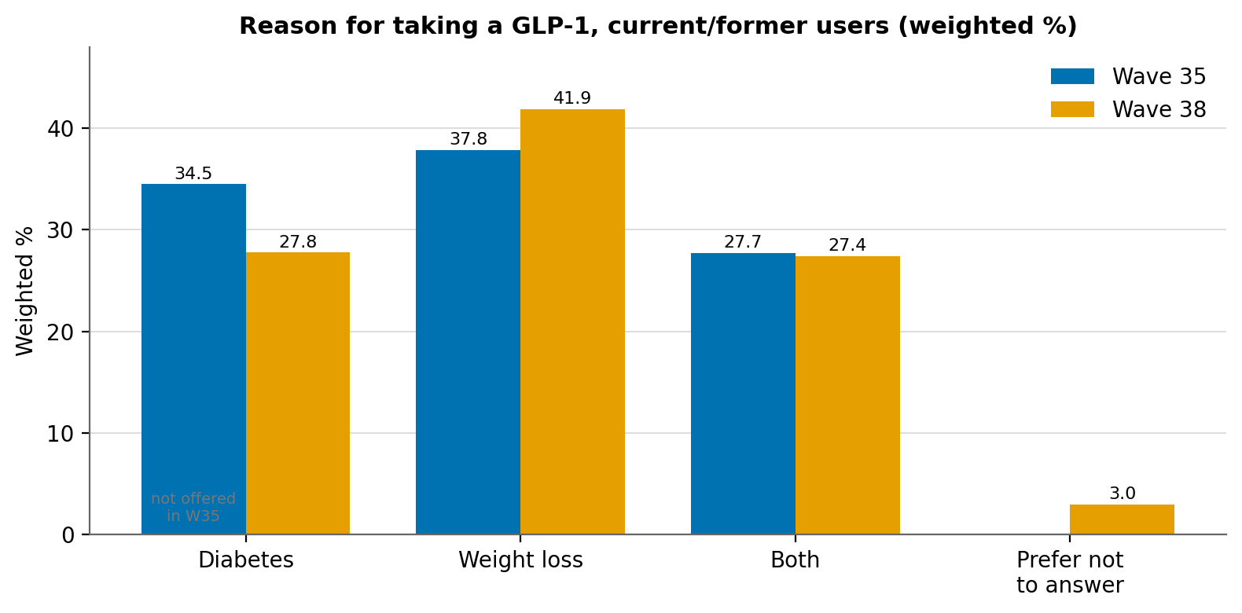
Figure 9. Reason for taking a GLP-1, weighted %, current/former users. Wave 35 offered no “prefer not to answer” option (shown as a gap). Full values in Table 9 (Data appendix).

How long users have been on GLP-1s
Among ever-users who reported a whole-year duration, most have been on a GLP-1 for only one or two years — consistent with a recently surging drug class — and the tenure mix is essentially unchanged between waves even as the user population grew.
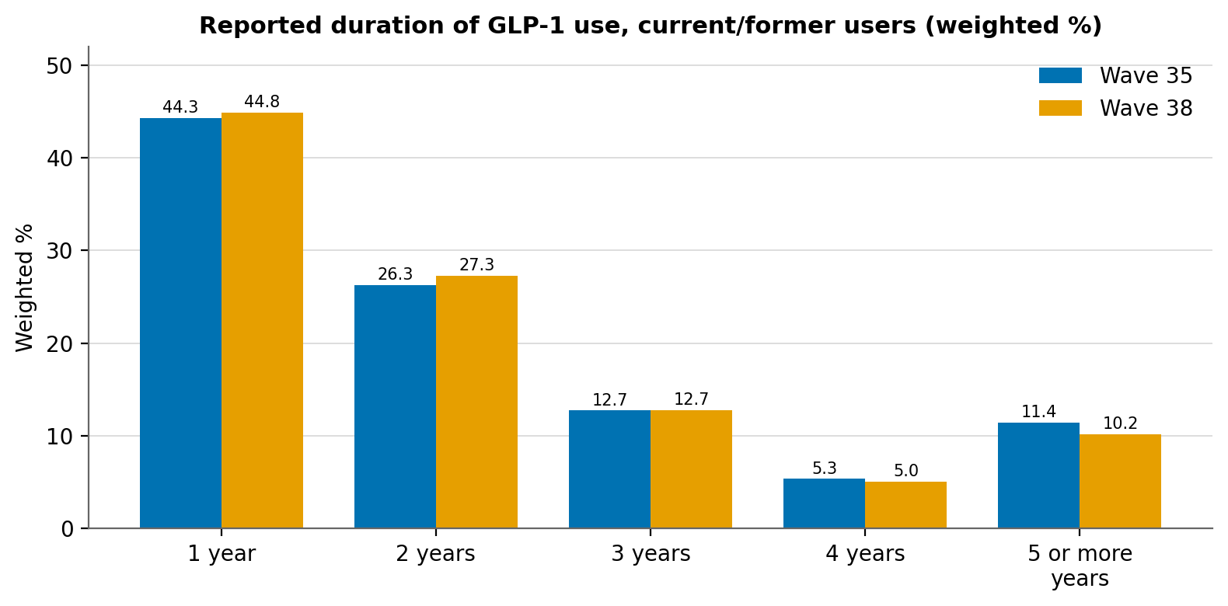
Figure 10. Reported duration of GLP-1 use, weighted %, current/former users. “5 or more years” combines the 5- to 10+-year responses (so small suppressed long-duration cells are included). A sub-one-year duration is captured separately in months and is not shown. Full values in Table 10 (Data appendix).

Former users — who has stopped taking GLP-1s
Former use (“previously took / stopped”) rose across almost every group between the waves, and is generally highest in the same groups where current use is highest — graduate-degree holders, higher-income brackets, midlife adults, and Republicans. Read carefully: a higher former-use rate mostly reflects higher overall uptake in a group (more people ever started, so more have since stopped), not necessarily a greater tendency to quit.
At the population level, “previously took” rose from 4.18% to 5.47% of all adults, and former users represent a roughly stable 37% of all ever-users (4.18 / 11.28 in W35; 5.47 / 14.41 in W38 — a derived ratio of the two topline cells, not a tool output).
Table 11. Former GLP-1 use (“previously took / stopped”), weighted %, by demographic
Demographic | Group | Former use W35 % | Former use W38 % | Δ (pts)
Party | Democrat | 4.21 | 5.33 | +1.12
Party | Independent/Other | 3.06 | 4.19 | +1.13
Party | Republican | 5.37 | 7.17 | +1.80
Education | High school or less | 3.26 | 4.41 | +1.15
Education | Some College | 4.11 | 4.96 | +0.85
Education | College Degree | 4.42 | 5.94 | +1.52
Education | Graduate Degree | 6.87 | 9.35 | +2.48
Gender | Female | 4.23 | 5.41 | +1.18
Gender | Male | 4.12 | 5.54 | +1.42
Income | 1–2 (lowest) | 3.10 | 3.62 | +0.52
Income | 3–4 | 3.89 | 5.27 | +1.38
Income | 5–6 | 3.56 | 5.17 | +1.61
Income | 7–8 | 5.39 | 6.96 | +1.57
Income | 9–10 (highest) | 6.05 | 6.39+ | —
Rurality | Rural | 3.99 | 5.64 | +1.65
Rurality | Suburban | 3.82 | 5.04 | +1.22
Rurality | Urban | 4.92 | 6.17 | +1.25
Age | 30 and under | 4.62 | 4.76 | +0.14
Age | 31 to 40 | 4.94 | 6.76 | +1.82
Age | 41 to 50 | 4.77 | 6.00 | +1.23
Age | 51 to 60 | 4.55 | 6.00 | +1.45
Age | 61 to 70 | 3.42 | 5.17 | +1.75
Age | 71 and over | 1.43+ | 3.26+ | —
Income brackets paired, and “30 and under,” “high school or less,” and “71 and over” combined by summing weighted population counts. A “+” marks a figure computed from available cells only because a sub-cell is suppressed (n<10), so it is a lower bound. This reports who stopped, not why; reasons for stopping are fielded but not exposed by the analysis tools.

Methods
- Source. COVID States Project / CHIP50, Waves 35 and 38. Wave 35 fielded April 10 – June 5, 2025 (unweighted n = 31,062); Wave 38 field dates are null in the wave metadata (unweighted n = 16,628). All estimates are survey-weighted; unweighted n is shown only as a reliability cue.
- Outcome. ozempic (1 = Currently taking, 2 = Previously took/stopped, 3 = Considering/interested, 4 = Not taking/no interest, 5 = Prefer not to answer). The regression uses derived ozempic_current (1 = currently taking vs. 0 = never; “stopped” excluded).
- Sources by figure. Figures 1, 9, 10: generate_marginals_by_wave. Figures 2–7 and Table 11: get_categorical_crosstab (one demographic each, both waves). Figure 8: run_logistic_regression per wave (weighted; W38 model excludes income code 11). External obesity/diabetes prevalence in Context is from CDC/NHANES sources, not the survey.
- Income coding. income_cat_10 is an ordered 1–10 bracket (no dollar ranges). Code 11 (“prefer not to say”) appeared only in Wave 38 and is excluded from the income figure and the W38 model.
- Suppression. Cells with n < 10 are suppressed and reported as such; no suppressed value is inferred. A “+” marks a combined estimate that excludes a suppressed sub-cell (a lower bound).
- Labels. All categorical labels are taken from the W35 and W38 questionnaires, which are authoritative where the analysis tool’s value labels differ.
- Inference caveats. Standard errors are model-based (not design-based); pseudo-R² is modest in both waves (~0.05), typical for individual-level adoption models. Descriptive gaps are described as descriptive; only regression coefficients flagged significant are treated as independent associations, and cross-wave changes are described as shifts, not as established causal trends. No causal language is attached to any descriptive comparison.

Data appendix — full-precision tables
Exact weighted percentages underlying the figures above. All values are survey-weighted estimates.
Table 1. GLP-1 status, weighted %
Status | W35 % | W38 % | Δ (pts)
Currently taking | 7.10 | 8.94 | +1.84
Previously took / stopped | 4.18 | 5.47 | +1.29
Considering / interested | 10.99 | 14.69 | +3.70
Not taking / no interest | 73.27 | 69.18 | −4.09
Prefer not to answer | 4.47 | 1.71 | −2.76
Table 2. By party
Group | Take W35 | Take W38 | Δ | Consider W35 | Consider W38 | Δ
Democrat | 7.65 | 9.68 | +2.03 | 12.09 | 15.60 | +3.51
Independent/Other | 4.94 | 6.03 | +1.09 | 10.01 | 14.23 | +4.22
Republican | 8.91 | 11.55 | +2.64 | 10.97 | 14.14 | +3.17
Table 3. By education (HS-or-less combined)
Group | Take W35 | Take W38 | Δ | Consider W35 | Consider W38 | Δ
High school or less | 6.20 | 7.01 | +0.81 | 10.12 | 12.92 | +2.80
Some College | 5.29 | 7.93 | +2.64 | 11.40 | 16.34 | +4.94
College Degree | 8.13 | 9.99 | +1.86 | 10.93 | 15.38 | +4.45
Graduate Degree | 12.67 | 15.88 | +3.21 | 12.77 | 14.99 | +2.22
Table 4. By gender
Group | Take W35 | Take W38 | Δ | Consider W35 | Consider W38 | Δ
Female | 7.30 | 9.82 | +2.52 | 12.49 | 16.42 | +3.93
Male | 6.89 | 8.02 | +1.13 | 9.42 | 12.86 | +3.44
Table 5. By income bracket (paired)
Group | Take W35 | Take W38 | Δ | Consider W35 | Consider W38 | Δ
1–2 (lowest) | 4.72 | 6.08 | +1.36 | 9.82 | 12.69 | +2.87
3–4 | 6.10 | 7.30 | +1.20 | 10.07 | 14.07 | +4.00
5–6 | 6.35 | 8.59 | +2.24 | 10.86 | 15.22 | +4.36
7–8 | 8.91 | 11.40 | +2.49 | 12.43 | 16.31 | +3.88
9–10 (highest) | 12.16 | 15.58 | +3.42 | 11.93 | 14.63 | +2.70
Table 6. By rurality
Group | Take W35 | Take W38 | Δ | Consider W35 | Consider W38 | Δ
Rural | 6.75 | 8.90 | +2.15 | 10.40 | 15.82 | +5.42
Suburban | 7.00 | 9.22 | +2.22 | 11.19 | 14.40 | +3.21
Urban | 7.43 | 8.46 | +1.03 | 10.91 | 14.66 | +3.75
Table 7. By age group (combined ends); “+” = lower bound (suppressed 80+ sub-cell)
Group | Take W35 | Take W38 | Δ | Consider W35 | Consider W38 | Δ
30 and under | 3.07 | 4.92 | +1.85 | 12.55 | 15.93 | +3.38
31 to 40 | 5.71 | 8.98 | +3.27 | 13.74 | 18.39 | +4.65
41 to 50 | 8.60 | 10.76 | +2.16 | 13.77 | 18.24 | +4.47
51 to 60 | 9.68 | 10.77 | +1.09 | 10.59 | 13.43 | +2.84
61 to 70 | 9.60 | 11.75 | +2.15 | 7.14 | 11.48 | +4.34
71 and over | 7.60 | 6.95 | −0.65 | 5.33 | 5.95+ | +0.62
Table 8. Logistic regression — odds ratios (95% CI); n.s. = not significant at p<.05
Predictor (vs. reference) | W35 OR (95% CI) | W38 OR (95% CI)
Party: Democrat (vs Ind/Other) | 1.48 (1.32–1.67) | 1.56 (1.36–1.81)
Party: Republican (vs Ind/Other) | 1.76 (1.57–1.97) | 1.79 (1.55–2.07)
Edu: College (vs HS grad) | 1.16 (1.02–1.31) | 1.11 (0.94–1.31) n.s.
Edu: Graduate (vs HS grad) | 1.67 (1.45–1.93) | 1.74 (1.43–2.10)
Edu: Some College (vs HS grad) | 0.85 (0.75–0.96) | 1.03 (0.89–1.19) n.s.
Edu: Some HS or Less (vs HS grad) | 1.35 (1.06–1.70) | 0.77 (0.56–1.06) n.s.
Gender: Female (vs Male) | 1.17 (1.07–1.28) | 1.40 (1.25–1.57)
Income: bracket 5 (vs 1) | 1.63 (1.28–2.08) | 1.39 (1.05–1.83)
Income: bracket 6 (vs 1) | 1.37 (1.08–1.75) | 1.58 (1.22–2.06)
Income: bracket 7 (vs 1) | 1.76 (1.37–2.26) | 1.78 (1.35–2.36)
Income: bracket 8 (vs 1) | 2.19 (1.71–2.80) | 2.06 (1.55–2.74)
Income: bracket 9 (vs 1) | 2.99 (2.27–3.95) | 2.47 (1.78–3.42)
Income: bracket 10 (vs 1) | 1.75 (1.27–2.40) | 1.90 (1.20–3.00)
Rurality: Suburban (vs Rural) | 0.97 (0.85–1.11) n.s. | 0.97 (0.83–1.14) n.s.
Rurality: Urban (vs Rural) | 1.05 (0.91–1.21) n.s. | 0.86 (0.72–1.03) n.s.
Age: 18–20 (vs 31–40) | 0.21 (0.12–0.35) | 0.39 (0.26–0.61)
Age: 21–30 (vs 31–40) | 0.70 (0.58–0.84) | 0.63 (0.51–0.79)
Age: 41–50 (vs 31–40) | 1.56 (1.34–1.81) | 1.27 (1.06–1.51)
Age: 51–60 (vs 31–40) | 1.84 (1.58–2.13) | 1.33 (1.11–1.59)
Age: 61–70 (vs 31–40) | 1.81 (1.56–2.10) | 1.39 (1.16–1.66)
Age: 71–80 (vs 31–40) | 1.52 (1.27–1.81) | 0.70 (0.55–0.89)
Age: 80+ (vs 31–40) | 0.36 (0.20–0.64) | 0.69 (0.40–1.17) n.s.
Table 9. Reason for taking a GLP-1, weighted %, current/former users
Reason | W35 % | W38 % | Δ (pts)
Diabetes | 34.48 | 27.75 | −6.73
Weight loss | 37.83 | 41.90 | +4.07
Both | 27.69 | 27.39 | −0.30
Prefer not to answer | not offered | 2.95 | —
Table 10. Reported duration of use, weighted %
Duration | W35 % | W38 %
1 year | 44.28 | 44.83
2 years | 26.26 | 27.26
3 years | 12.71 | 12.74
4 years | 5.34 | 5.02
5 or more years | 11.41 | 10.15

