Conference page design – cersion 1
- Header part: https://akcongress.com/isic2026/
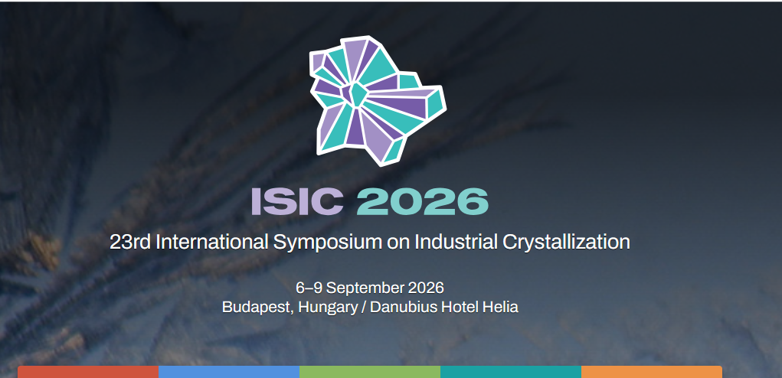
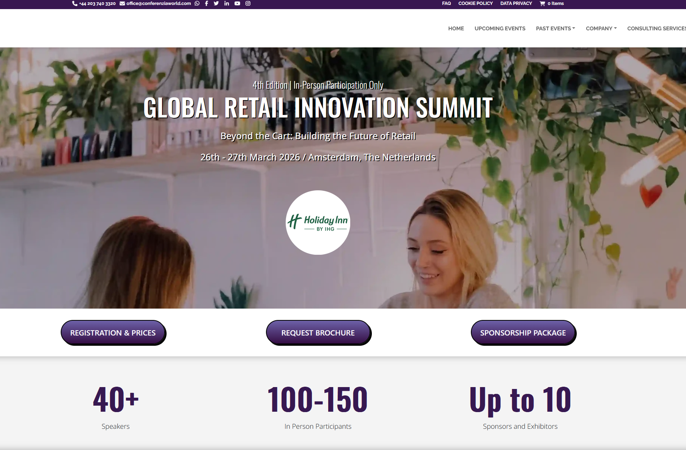
https://ibbce.com/
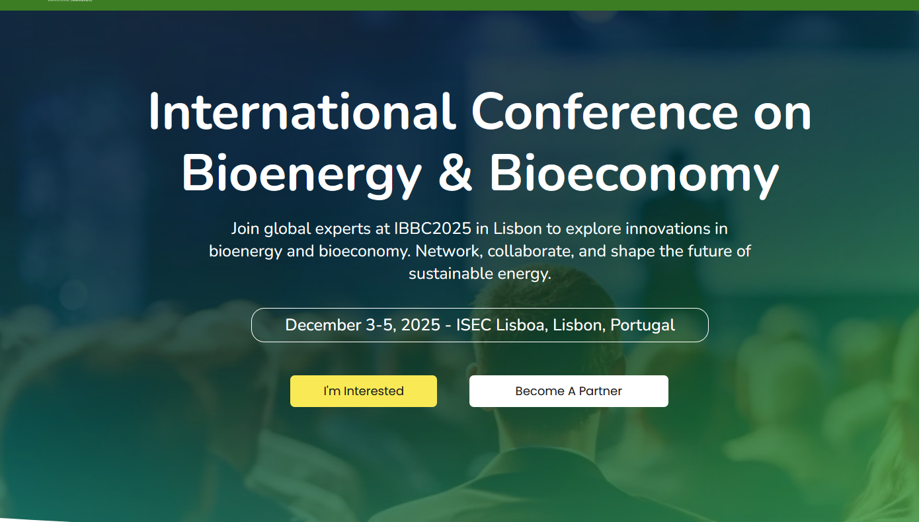
- Why to Attend:

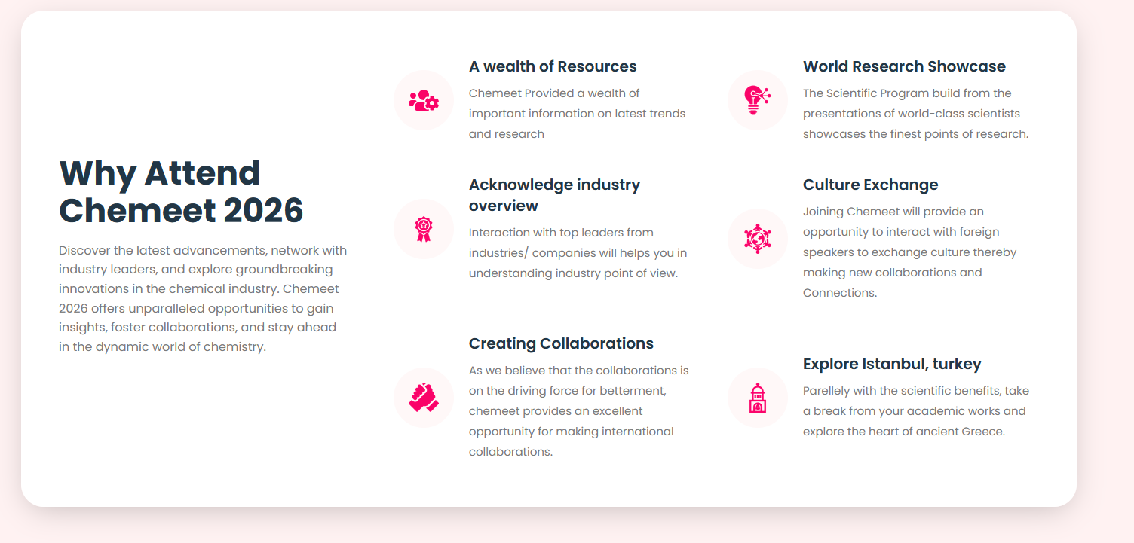
- 
- Add testimonials section
- Venue section is good but it is similar to Prezentis
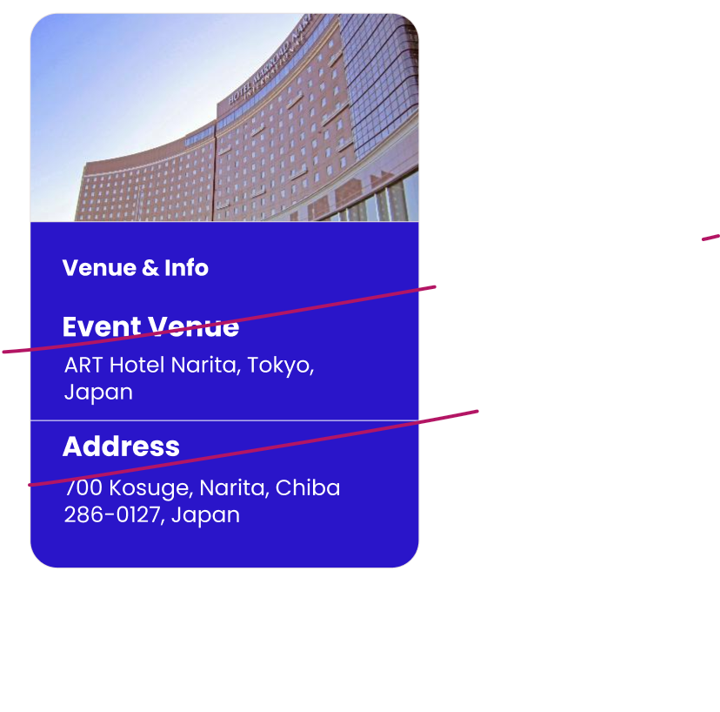
- Change Conference gallery and video part design
- Change footer design.
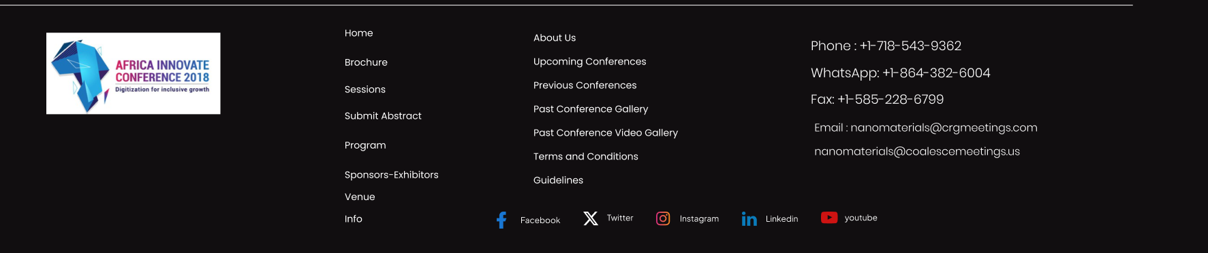
- Conference part report
