Name: Kian Dadkhah Shokrollahi SID: 119369205

Workshop 10 Walkthrough

This program allows an instance of Server to establish a multithreaded server which allows multiple clients to connect for a chat. The Server’s constructor allows for the passing of a ServerSocket object, which is initialized to open port 8000 inside the main of the Server class. Once this object is instanciated and passed to the Server object’s constructor, the startServer() method is called on the server.

This allows the server to listen for incoming connections, at which point it will print a message to the console indicating a new connection from the specified local socket address and port number. When a new Client connects, the ClientHandler class facilitates transfer of BufferedInput and BufferedOutput between the Client and the Server via multi-threading. Further, each received message is also done through seperate thread in order to increase the performance of the application and prevent hold ups from the server.

Let’s test this out by compiling and running an instance of Server, and then two instances of Client.

I will pass in my name “Kian” as the username of this first Client, and “Joe” as the second Client.

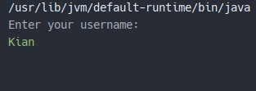 Client 1 output

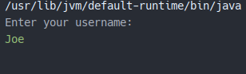 Client 2 output

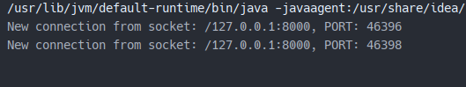

Server output

Now let’s send some messages between Kian and Joe. Additionally, we can see that Kian was notified by the Server that a new user by the name of Joe has entered the chat.

