**TECH ARJUNAS   
Project Name: Rakshak  
Problem ID: SS42**

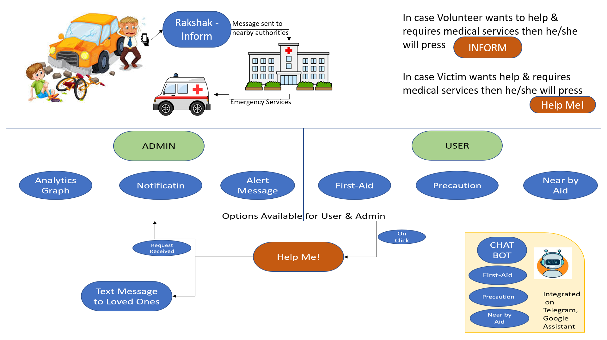

PLATFORMS

* Spyder
* Ngrok
* Firebase
* Fast2SMS.com
* Jupyter
* Sublime
* DialogFlow
* Google Console

TECHNOLOGIES

* Python
* JavaScript
* Java
* HTML 5
* Flask
* ChatBot
* CSS