Aim: Write the Verilog code for designing T-flip flop using D-flip-flop.
IDE: EDA Playground

Theory:
A flip flop in digital electronics is a circuit with two stable states that can be used to store binary data. The stored data can be changed by applying varying inputs. Flip-flops and latches are fundamental building blocks of digital electronics systems used in computers, communications, and many other types of systems. Both are used as data storage elements.

It is the basic storage element in sequential logic. But first, let’s clarify the difference between a latch and flip-flops.

Flip Flop Types
There are basically 4 types of flip-flops in digital electronics:

- SR Flip-Flop
- JK Flip-Flop
- D Flip-Flop
- T Flip-Flop

T Flip-Flop

A T flip-flop is like a JK flip-flop. These are basically single-input versions of JK flip-flops. This modified form of the JK is obtained by connecting inputs J and K together. It has only one input along with the clock input.

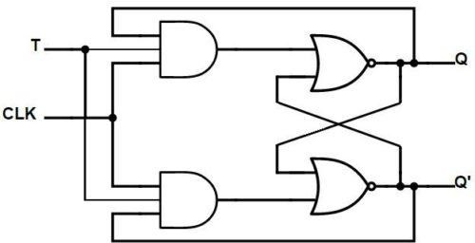
T flip flop

These flip-flops are called T flip-flops because of their ability to complement their state i.e. Toggle, hence they are named Toggle flip-flops.

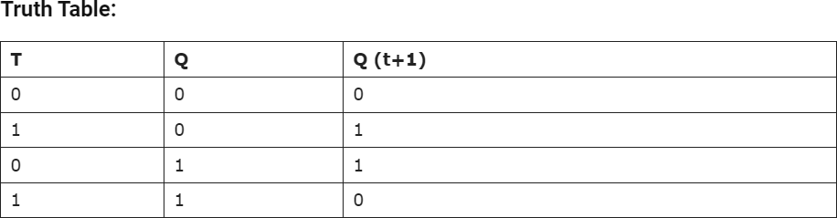

D Flip-Flop

D flip-flop is a better alternative that is very popular with digital electronics. They are commonly used for counters and shift registers and input synchronization.

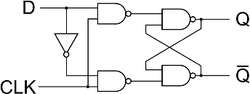
D Flip-Flop

In the D flip-flops, the output can only be changed at the clock edge, and if the input changes at other times, the output will be unaffected.

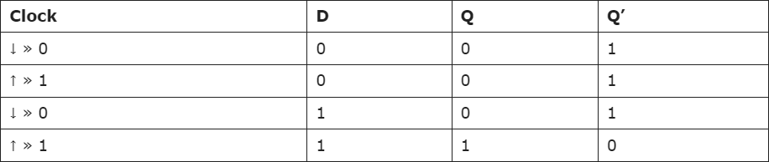

Pre Lab Exercise:

- What is use of T Flipflop?
A T (Toggle) Flip-Flop is used to change its output state whenever the input T is equal to 1. When T = 0, the flip-flop holds the previous output, and when T = 1, the output toggles from 0 to 1 or from 1 to 0. T flip-flops are mainly used in counters, frequency division circuits, and digital systems where switching between two states is required. They are useful in designing binary counters and control circuits.

- How T and D flip flop are vary from each other?

T Flip-Flop | D Flip-Flop
T stands for Toggle | D stands for Data or Delay
Output toggles when T = 1 | Output follows input D

T Flip-Flop | D Flip-Flop
When T = 0, output remains same | Output becomes same as input
Mainly used in counters | Mainly used in registers and memory
Input equation: Q(next) = T ⊕ Q | Input equation: Q(next) = D
Changes state repeatedly when enabled | Stores the input value

Verilog Code:

// D Flip-Flop module d_flipflop(
input D, input clk, output reg Q
);

always @(posedge clk) begin
Q <= D;
end endmodule

// T Flip-Flop using D Flip-Flop module t_flipflop_using_d(
input T, input clk, output Q
);

wire D;
wire Q_internal;

// relation between D and T flipflop assign D = T ^ Q_internal;

// instantiate D flipflop d_flipflop dff(
.D(D),
.clk(clk),
.Q(Q_internal)
);

assign Q = Q_internal; endmodule

Test-bench:
module tb_t_flipflop_using_d; reg T, clk;
wire Q;

t_flipflop_using_d uut(
.T(T),
.clk(clk),
.Q(Q)
);

initial begin
clk = 0;
forever #5 clk = ~clk; end

initial begin
$display("T | Q"); T = 0; #10;
$display("%b | %b", T, Q);

T = 1; #10;
$display("%b | %b", T, Q);

T = 1; #10;
$display("%b | %b", T, Q);

T = 0; #10;
$display("%b | %b", T, Q);

T = 1; #10;
$display("%b | %b", T, Q);

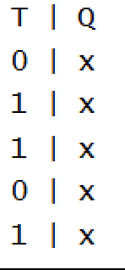
$finish; end endmodule Results:

Observation and Result Analysis:

The T flip-flop is an important sequential circuit used to toggle the output between two states. It is mainly used in counters and frequency divider circuits. The D flip-flop, on the other hand, is used to store and transfer data, as its output directly follows the input. The main difference between T and D flip-flops lies in their operation, where the T flip-flop changes state when the input is 1, while the D flip-flop stores the input value. Both flip-flops are widely used in digital electronics for designing memory elements and sequential logic circuits.

Post Lab Exercise:
a. Write verilog code, test bench and output for Conversion of SR-flip flop using JK-flip-flop.

Verilog Code:

// JK Flip-Flop module jk_flipflop(
input J, input K, input clk, output reg Q
);

always @(posedge clk) begin
case({J,K})

2'b00: Q = Q; // Hold
2'b01: Q = 0; // Reset
2'b10: Q = 1; // Set 2'b11: Q = ~Q; // Toggle

endcase end

endmodule

// SR Flip-Flop using JK Flip-Flop module sr_using_jk(
input S, input R, input clk, output Q
);

jk_flipflop jk1(
.J(S),
.K(R),
.clk(clk),
.Q(Q)

);

endmodule

Testbench:
module tb_sr_using_jk; reg S, R, clk;
wire Q;

sr_using_jk uut(
.S(S),
.R(R),
.clk(clk),
.Q(Q)
);

initial begin
clk = 0;
forever #5 clk = ~clk; end

initial begin

$display("S R | Q");

// Hold
S=0; R=0; #10;
$display("%b %b | %b", S, R, Q);

// Reset
S=0; R=1; #10;
$display("%b %b | %b", S, R, Q);

// Set
S=1; R=0; #10;
$display("%b %b | %b", S, R, Q);

// Both 1 condition S=1; R=1; #10;
$display("%b %b | %b", S, R, Q);

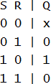
$finish; end endmodule Results:

