Aim: Write the Verilog code for,
- Design of Basic logic gates(AND,OR,NOT,NOR,NAND,EX-OR,EX NOR)
- Designing of various logic circuits.

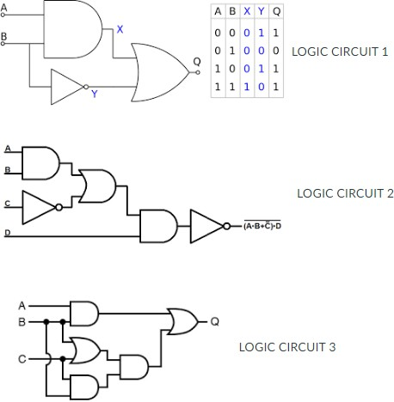

IDE: EDA Playground

Theory:
Pre Lab Exercise:
  - What is the difference between Combinational and Sequential circuits?
Combinational circuits produce output based only on present input values, while sequential circuits produce output based on present inputs as well as previous states (memory). Sequential circuits use feedback and often require a clock signal.
  - How can you implement and/or/not gate using NAND/NOR?

NAND and NOR gates are called universal gates because AND, OR, and NOT gates can be implemented using only NAND gates or only NOR gates.
Using NAND gates:
- NOT gate is obtained by connecting both inputs of a NAND gate together, which produces the complement of the input.
- AND gate is obtained by first performing NAND operation and then inverting the output using another NAND gate.
- OR gate is obtained by first inverting the inputs using NAND gates and then applying NAND operation to the
inverted inputs (based on De Morgan’s law).
Using NOR gates:
- NOT gate is obtained by connecting both inputs of a NOR gate together.
- OR gate is obtained by NOR operation followed by inversion using another NOR gate.
- AND gate is obtained by first inverting the inputs using NOR gates and then applying NOR operation to those
outputs (using De Morgan’s law).

  - Simplify this logic gate circuit, which uses nothing but NAND gates to accomplish a certain logic function:
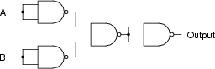
Also, Mention Logic function and Truth table for the same.

Simplifies logic function:

This is equivalent to NOR operation: Truth Table:

F = A̅ B̅

𝐹 = (𝐴 + 𝐵)′

A B Output F = A̅B̅
0 0 1
0 1 0
1 0 0
1 1 0

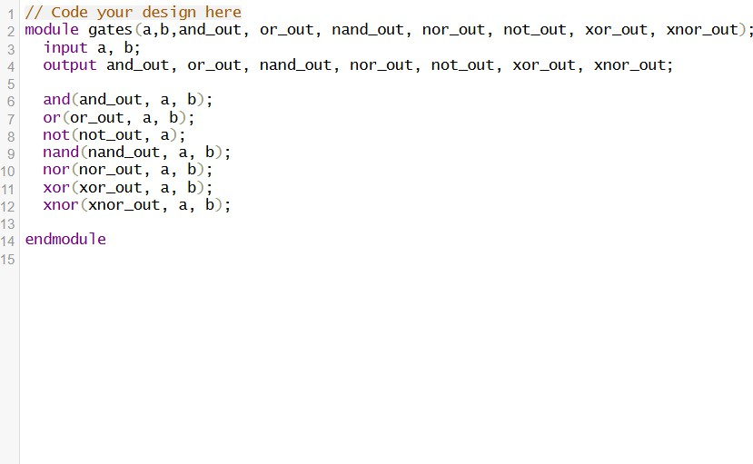
Verilog Code:
Test-bench:

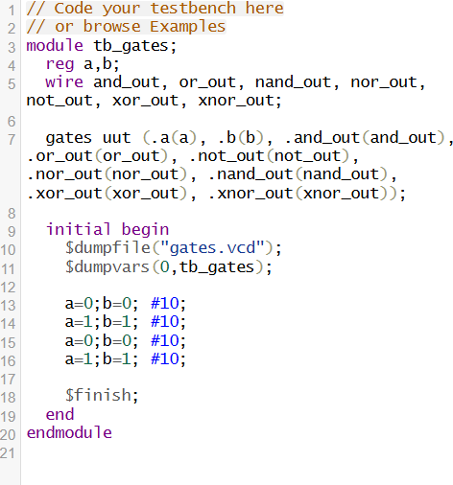
Results:
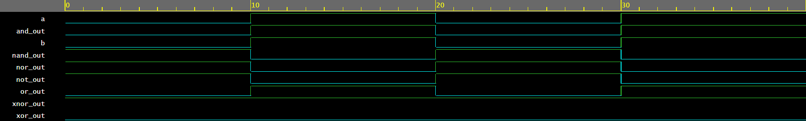

Observation and Result Analysis:
The Verilog code for basic logic gates (AND, OR, NOT, NAND, NOR, XOR, XNOR) was simulated successfully using a testbench. The output waveforms obtained matched the expected truth table values for all input combinations of a and b. Each gate performed its intended logical operation correctly. The simulation verifies that Verilog gate primitives can be used to model digital logic circuits accurately. Hence, the functionality of all basic logic gates was confirmed.

Post Lab Exercise:
a. An automobile manufacturer needs a logic circuit to perform a specific task in its new line of cars. These cars will be equipped with a “headlight left on” alarm that sounds any time these two conditions are met: headlights on and ignition switch off. Draw the schematic diagram of a logic gate circuit that will implement this alarm, constructed entirely out of NAND gates. Also write verilog with data flow modeling style for the same.
Schematic:
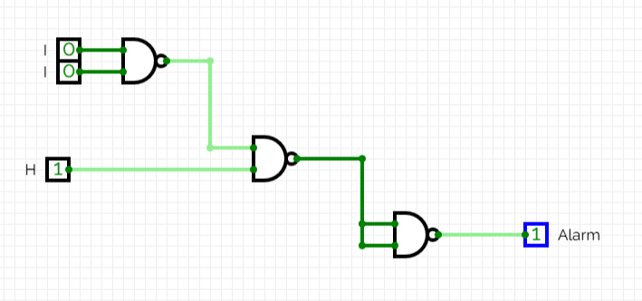
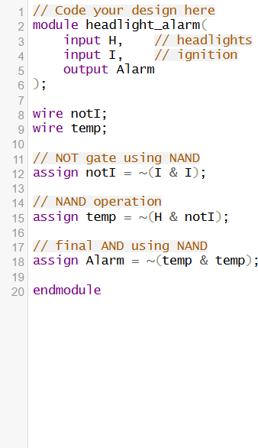
Verilog Code:

Testbench:
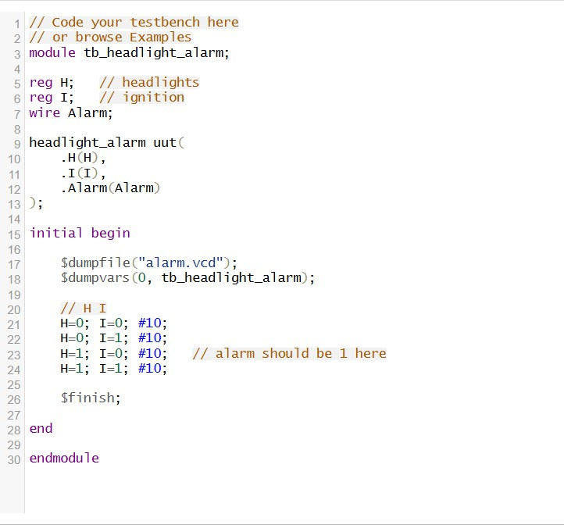
Results:
