Aim: Write the Verilog code for designing 1 bit half adder and full adder circuit.
IDE: EDA Playground

Theory:
Half adder
It adds two binary digits where the input bits are termed as augend and addend and the result will be two outputs one is the sum and the other is carry. To perform the sum operation, XOR is applied to both the inputs, and AND gate is applied to both inputs to produce carry.
Sum= A XOR B
Carry = A AND B
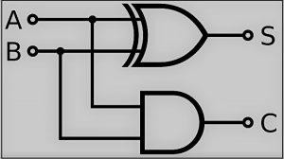
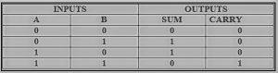
Full Adder
Full-adder has three inputs and two outputs, he first two inputs are A and B and the third input is an input carry as C-IN. When a full-adder logic is designed, you string eight of them together to create a byte-wide adder and cascade the carry bit from one adder to the next.
Sum = (A ⊕ B) ⊕ Cin
Carry = A.B + (A ⊕B)

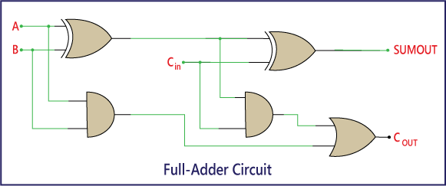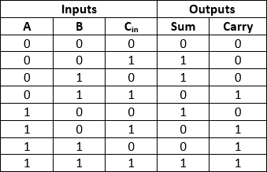

Pre Lab Exercise:
- What is use of adder in processor?
An adder is used in a processor to perform arithmetic operations, mainly addition of binary numbers. It is a fundamental part of the Arithmetic Logic Unit (ALU). Adders are used for operations such as addition, subtraction (using 2’s complement), address calculation, incrementing program counter, and performing various mathematical computations required during instruction execution.

- What is limitation of half adder?

The main limitation of a half adder is that it cannot handle carry input from a previous stage. It can only add two single binary bits and produce sum and carry output. Therefore, it is not suitable for adding multi-bit binary numbers directly, because carry from previous bit addition cannot be included.

- How many AND, OR and EXOR gates are required for the configuration of full adder?

A full adder requires:
  - 2 AND gates
  - 1 OR gate
  - 2 EXOR (XOR) gates

Verilog Code:

Half Adder:
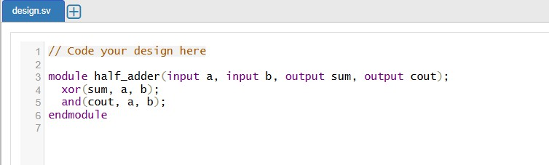

Full Adder:
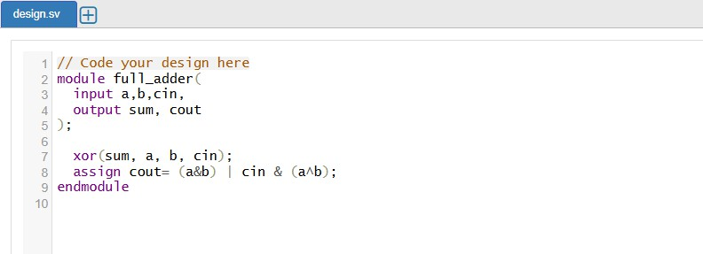

Test-bench:

Half Adder:
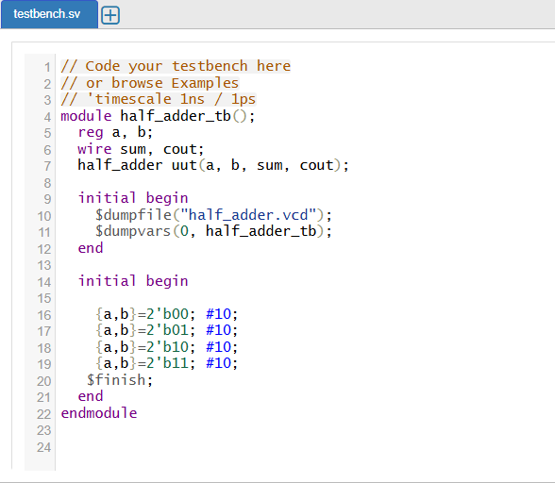

Full Adder:
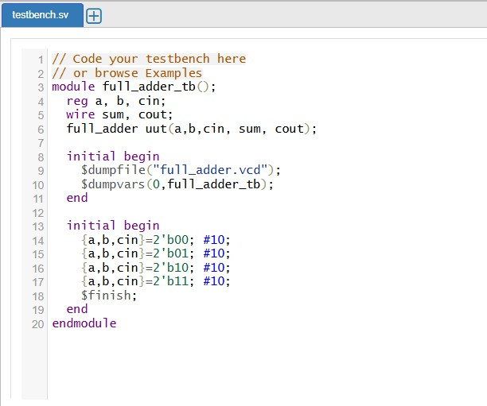

Results:

Half Adder:
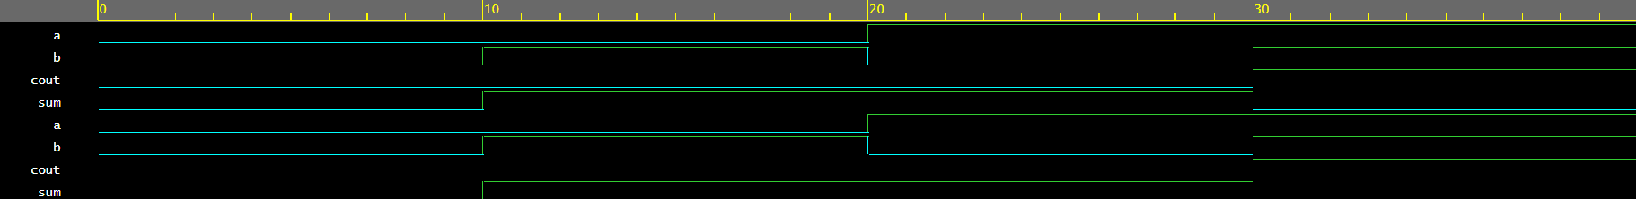
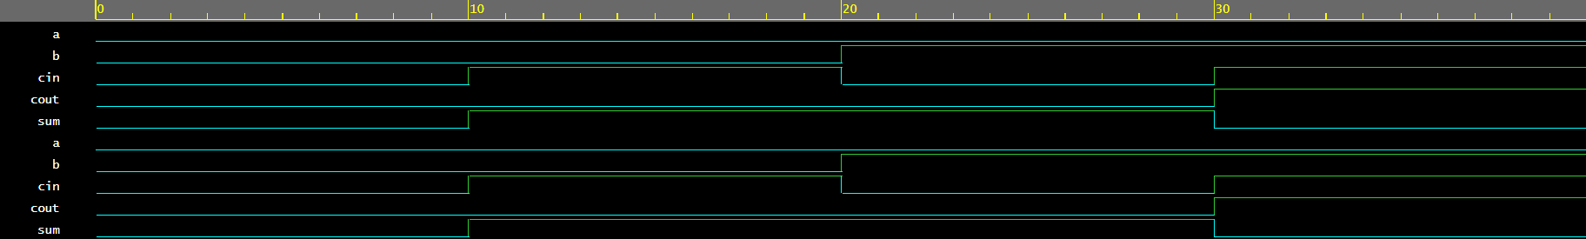
Full Adder:

Observation and Result Analysis:

In this experiment, 1-bit Half Adder and Full Adder circuits were successfully designed and implemented using Verilog. The Half Adder was used to add two binary inputs and produced Sum and Carry outputs, while the Full

Adder was able to add three inputs (including carry input) and generate correct Sum and Carry outputs. Simulation results verified that the outputs matched the expected truth tables for all input combinations. This experiment demonstrated the basic concept of binary addition and the importance of adders as fundamental building blocks in digital systems and processors.

Post Lab Exercise:
- Design One full adder using two half adder and one or gate.

Verilog Code:
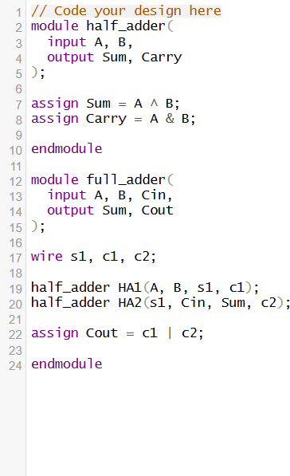

Testbench:
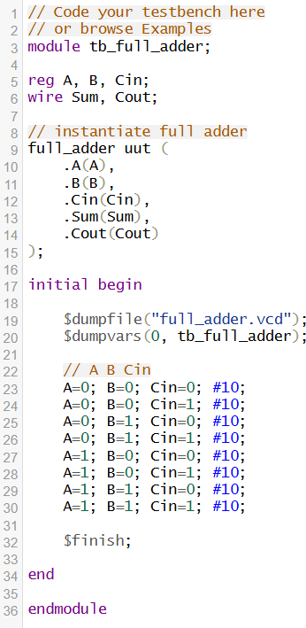

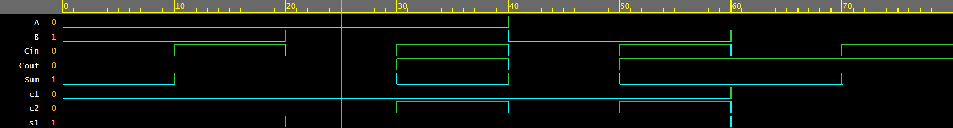
Results:

- Design full substrator circuit using data flow modeling style

Verilog Code:
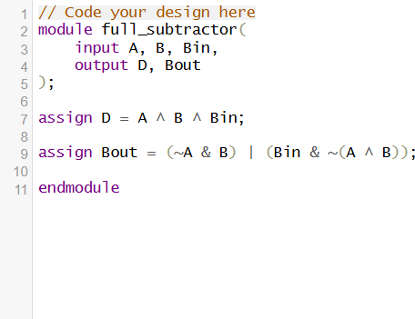
Testbench:
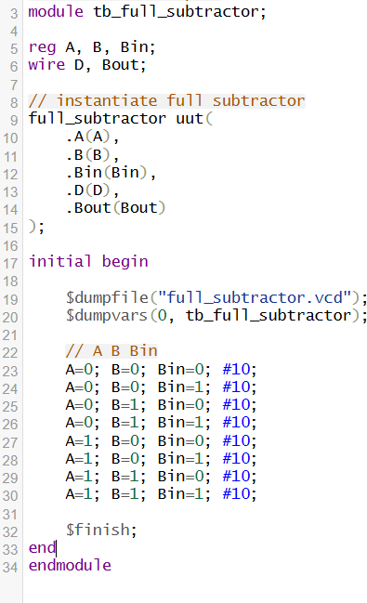

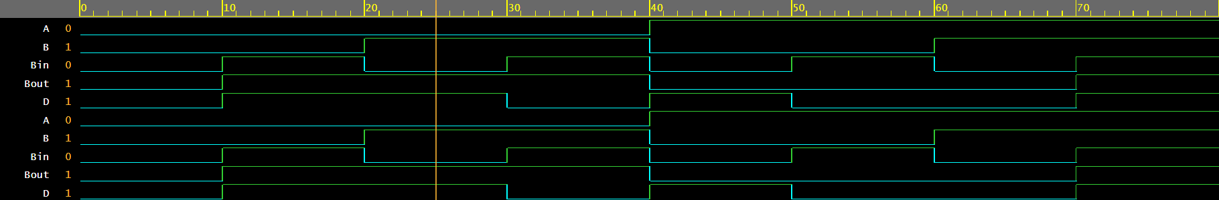
Results:

