Aim: Write the Verilog code for designing 4x16 decoder with 2x4 decoder
IDE: EDA Playground

Theory:

A decoder is one of many types of combinational circuits. I’t has multiple input lines and multiple output lines but has no selector lines like MUX and DEMUX. The decoder aids in the translation/decoding of information encoded by the encoder. As a result, it reverses the encoder's work. The decoder converts n bits of data input into two power n coded outputs.
Decoders are used in microprocessors, memory chips, and other data transfer circuits to select different I/O devices and other data transfer circuits. In a computer, a decoder is used to decode memory addresses.

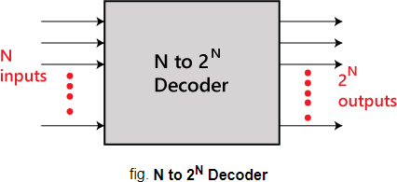
Implementing 4 * 16 Decoder using 2 * 4 Decoder

2*4 Decoder has two input lines and four output lines, and it chooses one of the lines based on various input combinations.
4*16 Decoder has four inputs and sixteen outputs, and it chooses one line based on various input combinations. Four 2*4 encoders are required to produce 16 outputs and 1 extra 2*4 decoder is required to enable the decoder when creating 4*16 decoders. As a result, a total of 5 decoders are required. But output at a time will be generated by 1 decoder only at a time.

Circuit Diagram
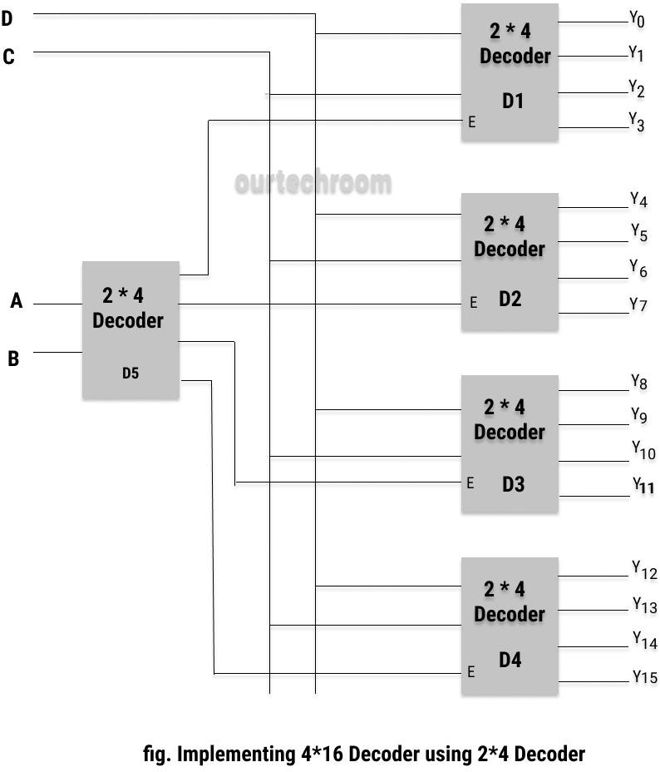
Here, A-lines indicate MSB, and D-lines indicate LSB.

- When A = 0 , B = 0 , CD( any 00 or 01 or 10 or 11) , D1 Decoder is selected.
- When A = 0 , B = 1 , CD( any 00 or 01 or 10 or 11) , D2 Decoder is selected.
- When A = 1 , B = 0 , CD( any 00 or 01 or 10 or 11) , D3 Decoder is selected.
- When A = 1 , B = 1 , CD( any 00 or 01 or 10 or 11) , D4 Decoder is selected.

This concludes that selecting Decoder (D1, D2, D3, D4) only depends on the D5 decoder. Now the output Y0 to Y15 are generated with the various input value.

ABCD Input Lines | Decoder Enabled | Output Lines
0000 | D1 Decoder | Y0
0001 | D1 Decoder | Y1
0010 | D1 Decoder | Y2
0011 | D1 Decoder | Y3
0100 | D2 Decoder | Y4
0101 | D2 Decoder | Y5
0110 | D2 Decoder | Y6
0111 | D2 Decoder | Y7
1000 | D3 Decoder | Y8
1001 | D3 Decoder | Y9
1010 | D3 Decoder | Y10
1011 | D3 Decoder | Y11
1100 | D4 Decoder | Y12
1101 | D4 Decoder | Y13
1110 | D4 Decoder | Y14
1111 | D4 Decoder | Y15

Pre Lab Exercise:
- What is Decoder circuit?
A decoder is a combinational logic circuit that converts coded binary input into a set of output lines, where only one output is active at a time for each input combination. It performs the reverse operation of an encoder.
Decoders are commonly used in memory address decoding, instruction decoding in processors, and display systems.
- Draw gate level circuit of 2x4 line decoder?
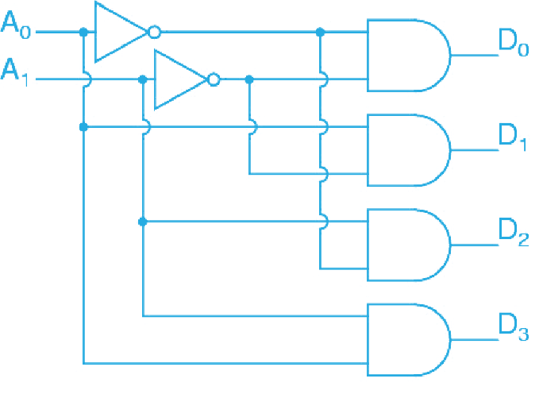

- BCD to Seven segment conversion is which kind of process and why ?
BCD to Seven Segment conversion is a decoding process because it converts BCD (Binary Coded Decimal) input into seven output signals that control the segments of a display. Each BCD input combination activates specific segments (a–g) to represent decimal digits (0–9). Hence, it translates coded input into a readable visual output, which is the function of a decoder.

Verilog Code:

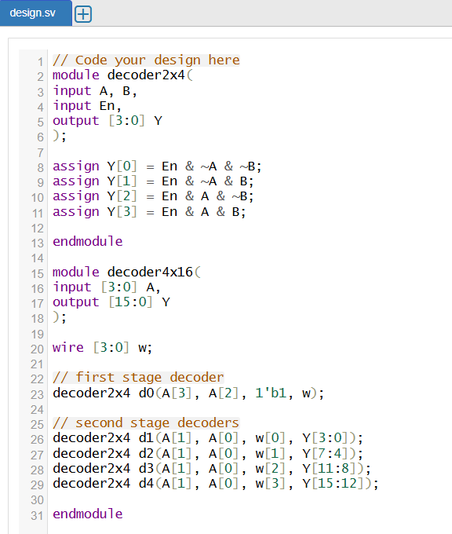

Test-bench:

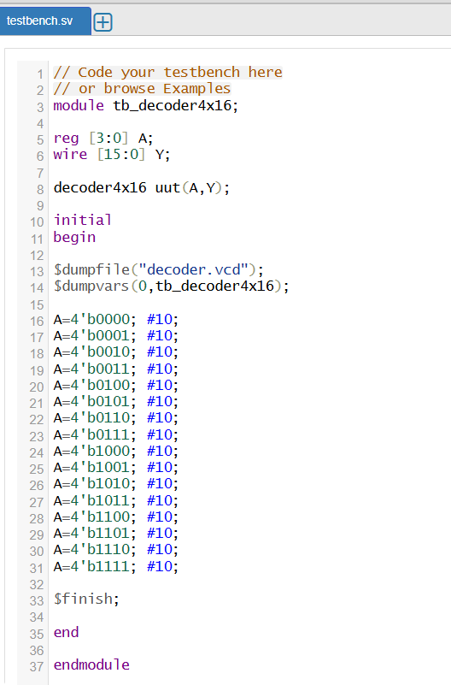

Results:

Observation and Result Analysis:
In this experiment, a 4×16 decoder was successfully designed using multiple 2×4 decoders in Verilog. The circuit was implemented using enable logic to activate only one output line for each input combination. Simulation results verified that for every 4-bit input, only one corresponding output becomes HIGH. This experiment demonstrates the use of hierarchical design to build complex decoders from smaller decoder blocks, which are widely used in memory addressing and digital systems.

Post Lab Exercise:
- Write verilog code, test bench and output for 3:8 decoder.
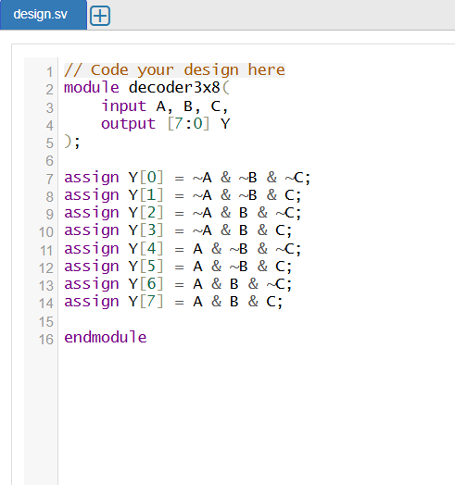
Verilog Code:
Testbench:

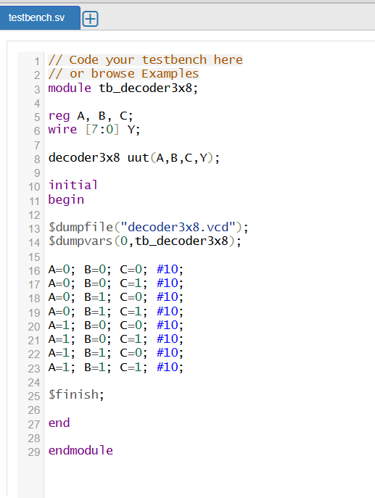
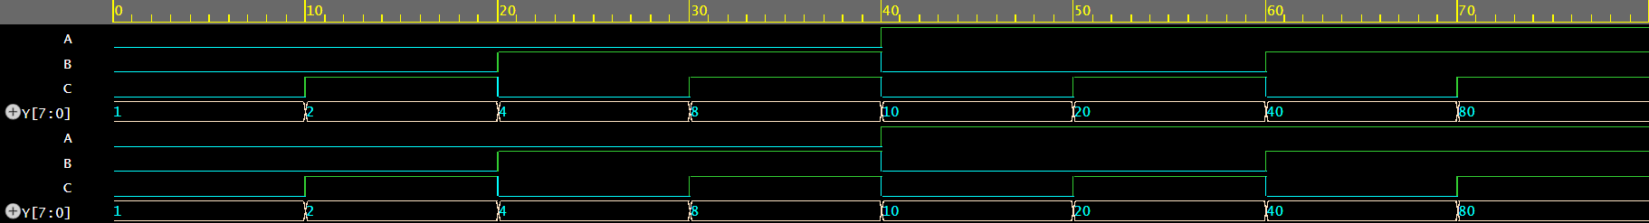
Results:

- Write verilog code, test bench and output for 3:8 decoder with enabled output.
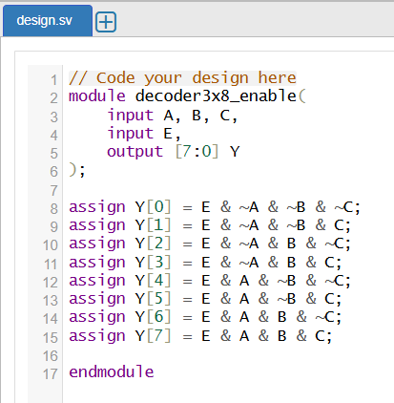
Verilog Code:
Testbench:
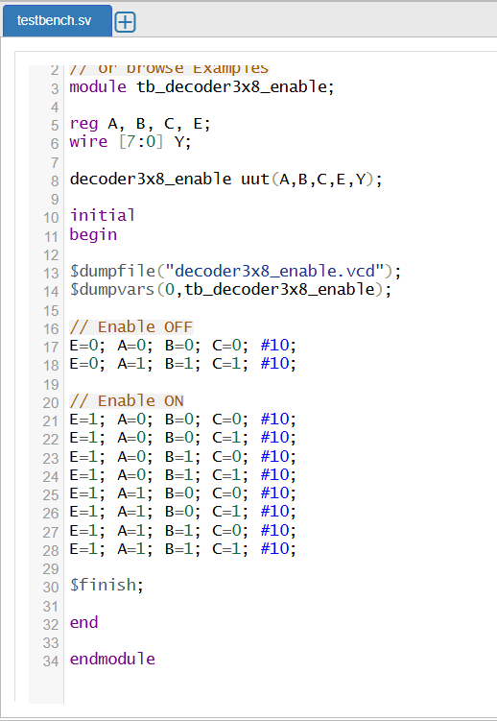

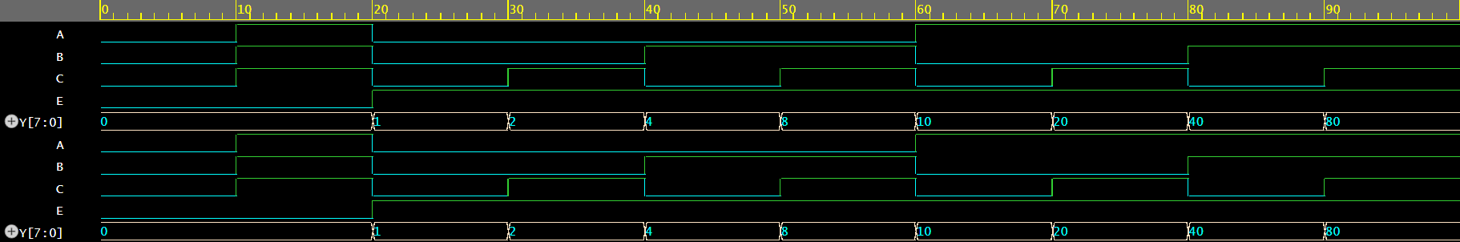
Results:

