Aim: Write the Verilog code for designing binary to gray code converter circuit.
IDE: EDA Playground

Theory:
Gray Code is similar to binary code except its successive number differs by only a single bit. Hence, it has importance in communication systems as it minimizes error occurrence. They are also useful in rotary, optical encoders, data acquisition systems, etc.
Let’s see binary numbers and their equivalent gray code in the below table.

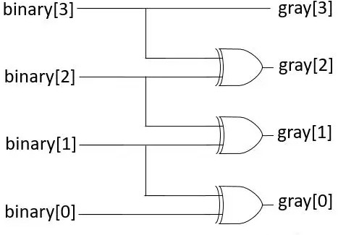

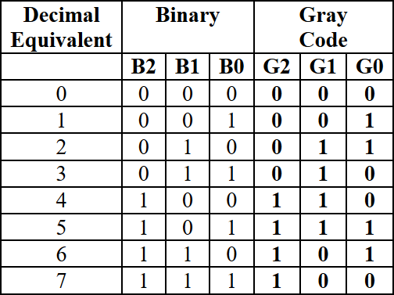

Pre Lab Exercise:
- What is binary to gray conversion?
Binary to Gray conversion is the process of converting a binary number into Gray code.
Gray code is a special binary number system in which only one bit changes at a time between consecutive numbers, reducing errors in digital systems such as encoders and communication circuits.
- what would be gray code for decimal 50?

Step 1: Convert decimal 50 to binary 50₁₀ = 110010₂

Step 2: Convert binary to Gray
0
Binary | 1 | 1 | 0 | 0 | 1
Gray | 1 | 0 | 1 | 0 | 1

1

Gray code = 101011

- What is difference between binary to gray conversion and gray to binary conversion?

Binary → Gray Conversion Gray → Binary Conversion
Converts binary number into Gray code Converts Gray code into binary number MSB remains same MSB remains same

Other bits obtained using XOR of adjacent binary bits
Other bits obtained using XOR of previous binary result with current Gray bit

Used to reduce bit change errors Used to retrieve original binary data
Example: 1101 → 1011 Example: 1011 → 1101

Verilog Code:
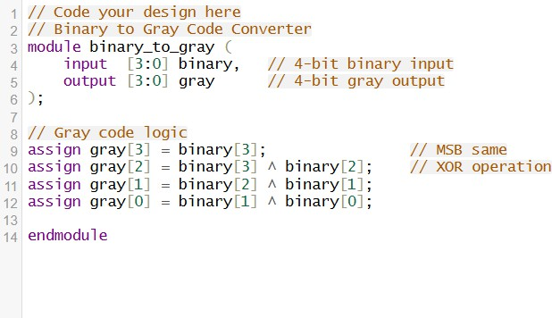

Test-bench:

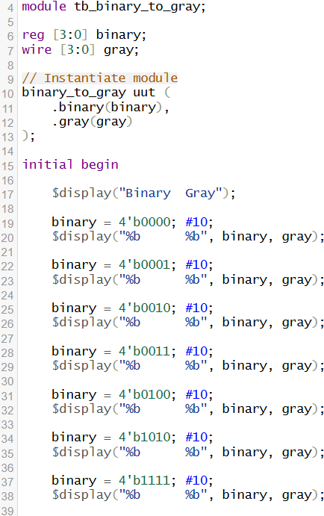

Results:
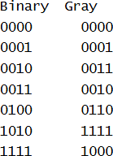

Observation and Result Analysis:
The Binary to Gray code converter was successfully designed and implemented using Verilog. The circuit converts binary input into Gray code output such that only one bit changes between consecutive values, which helps in reducing errors in digital communication and encoder systems. The simulation results from the testbench verified that the output Gray code matched the expected values for different binary inputs, confirming the correctness of the design.

Post Lab Exercise:
- Write verilog code, test bench and output for gray to binary code.
Verilog Code:
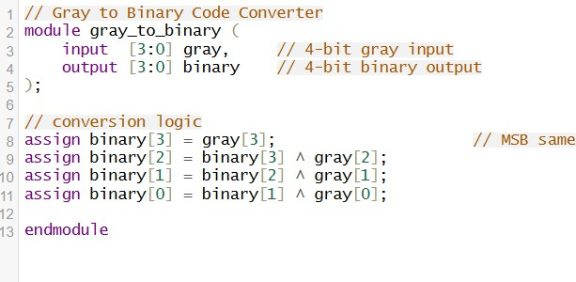

Testbench:

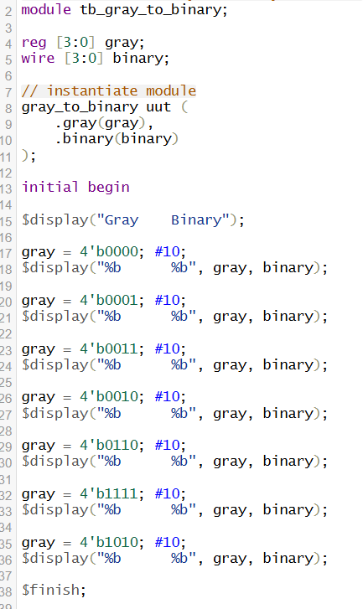

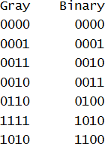
Results:

- Write verilog code, test bench and output for binary to excess-3 code.

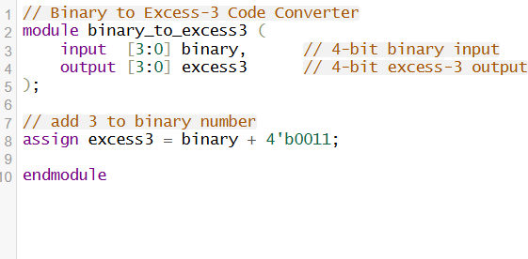
Verilog Code:
Testbench:
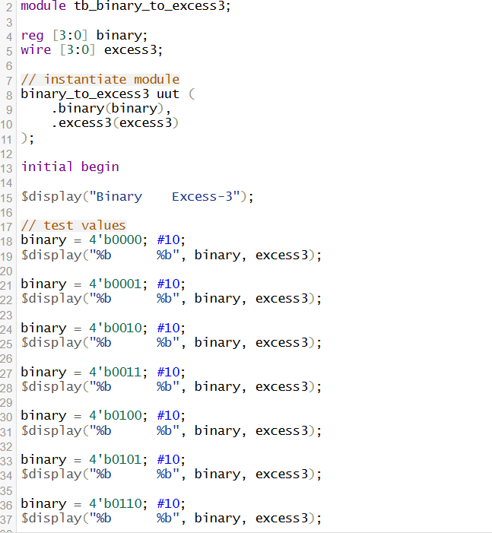

Results:
