Aim: Write the Verilog code for designing BCD to seven segment decoder circuit.
IDE: EDA Playground
Theory:
The Binary Coded Decimal (BCD) encoding method uses binary patterns to encode each decimal value (from 0 to 9), generally of 4-bits.
In contrast, a seven-segment display is an electrical device that displays Hexadecimal digits using seven Light Emitting Diodes (LEDs) arranged in a specific pattern (common cathode or common anode type) (in this case, decimal numbers, as input, are BCD, i.e., 0-9).
7-Segment LED displays are of two types:
- Common Cathode Type (CCT) - This form of the display works by connecting all seven of the LEDs' cathodes to ground or -Vcc (thus, common cathode), which causes the LEDs to display numbers when a "HIGH" signal is applied to each anode.
- Common Anode Type (CAT) - The seven LEDs in this display have all seven of their anodes linked to a battery or +Vcc, and when a 'LOW' signal is applied to each individual cathode, the LEDs display numbers.
The separate LED segments of a seven-segment display are not directly powered. However, for it to function, we first convert our decimal number to its BCD equivalent signal, and then a BCD to seven-segment decoder converts that signal into the form supplied to the seven-segment display.
The seven-segment decoder, which has four input lines and seven output lines (a, b, c, d, e, f, and g), receives this BCD (A, B, C, and D) input. The output is provided to a seven-segment LED display that shows the decimal number depending on the inputs.

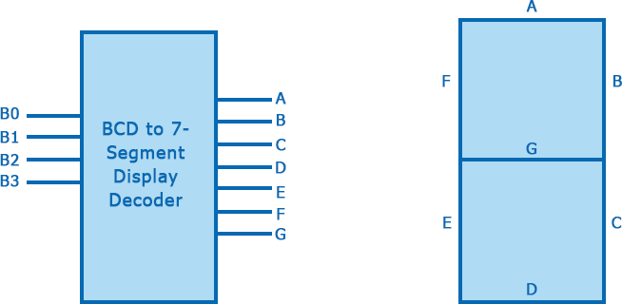

The truth table of Common Cathode Type BCD to the seven-segment decoder is given below:

Decimal Number | INPUT Lines |  |  |  |  | OUTPUT Lines
 | A | B |  | C | D | a | b | c | d | e | f | g
0 | 0 | 0 | 0 |  | 0 | 1 | 1 | 1 | 1 | 1 | 1 | 0
1 | 0 | 0 | 0 |  | 1 | 0 | 1 | 1 | 0 | 0 | 0 | 0
2 | 0 | 0 | 1 |  | 0 | 1 | 1 | 0 | 1 | 1 | 0 | 1
3 | 0 | 0 | 1 |  | 1 | 1 | 1 | 1 | 1 | 0 | 0 | 1
4 | 0 | 1 | 0 |  | 0 | 0 | 1 | 1 | 0 | 0 | 1 | 1
5 | 0 | 1 | 0 |  | 1 | 1 | 0 | 1 | 1 | 0 | 1 | 1
6 | 0 | 1 | 1 |  | 0 | 1 | 0 | 1 | 1 | 1 | 1 | 1

7 | 0 | 1 | 1 | 1 | 1 | 1 | 1 | 0 | 0 | 0 | 0
8 | 1 | 0 | 0 | 0 | 1 | 1 | 1 | 1 | 1 | 1 | 1
9 | 1 | 0 | 0 | 1 | 1 | 1 | 1 | 1 | 0 | 1 | 1
Important points:

- For a seven-segment LED display of the Common Anode type, all we need to do is swap all of the '0's and '1's on the output side, i.e., for a, b, c, d, e, f, and g, swap all of the '1's for '0's, and use k-map to solve.
- In the above truth table, the combinations of inputs represent the digits from 0 to 1.
- The range of BCD numbers is 0 to 9, and the rest of the inputs are invalid.
Pre Lab Exercise:

- What is BCD ?
BCD (Binary Coded Decimal) is a coding system in which each decimal digit (0–9) is represented separately by its 4-bit binary equivalent. Instead of converting the whole number into binary, each decimal digit is encoded individually.
Example:
Decimal 59
5 → 0101
9 → 1001

BCD = 0101 1001

- How to convert decimal to BCD?

To convert a decimal number into BCD, each digit of the decimal number is converted individually into its 4-bit binary equivalent. The binary equivalents of all digits are then combined to form the BCD representation.

Example: Convert decimal 47 into BCD 4 = 0100
7 = 0111

BCD = 0100 0111
Thus, BCD conversion is done digit by digit.

- During design of BCD to 7-Segment decoder, what value is initialized to display 9 and How?
(a) 5 BH (b) 70 H (c) 73 H (d) 7B H
(d) 7B H
To display the decimal digit 9 on a seven-segment display, the segments a, b, c, d, f, and g must glow, while segment e remains OFF. The corresponding binary value for this combination is 1111011, which is equal to 7B in hexadecimal form. Therefore, the value initialized to display 9 is 7B H.

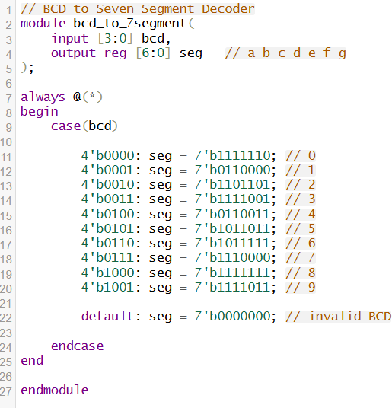
Verilog Code:

Test-bench:
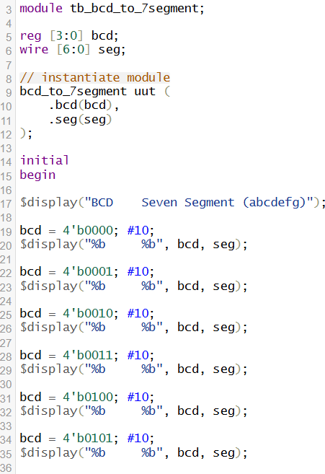
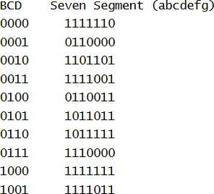
Results:

Observation and Result Analysis:
The BCD to Seven Segment Decoder was successfully studied and implemented using Verilog HDL. BCD representation helps in displaying decimal digits in digital systems by converting each decimal digit into its 4- bit binary form. The decoder converts the BCD input into appropriate signals required to glow the corresponding segments of the seven-segment display. The correct segment pattern was verified for digits 0 to 9, confirming proper functioning of the circuit. This decoder is widely used in digital clocks, calculators, and display systems.

Post Lab Exercise:
- Write verilog code, test bench and output for decimal to binary.

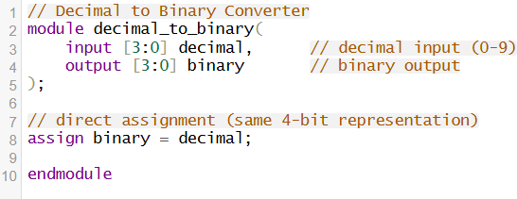
Verilog Code:
Testbench:
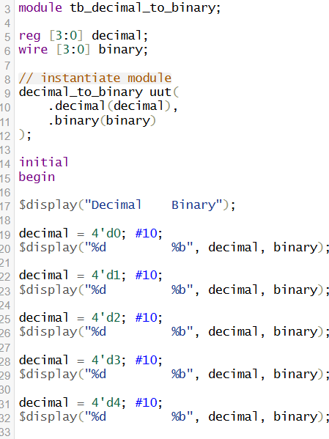

Results:
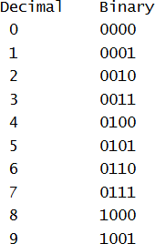

- Write verilog code, test bench and output for binary to BCD.

Verilog Code:
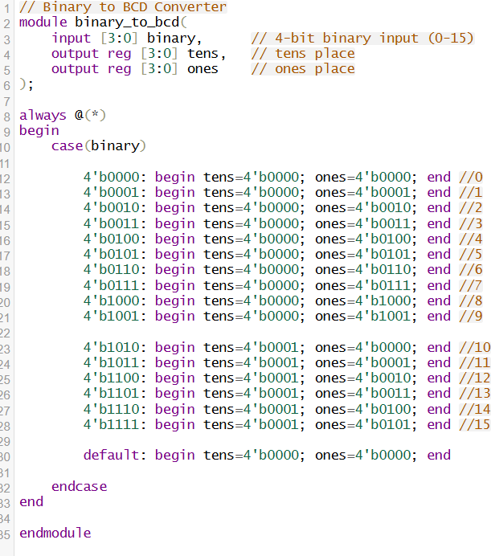

Testbench:

// Testbench for Binary to BCD Converter module tb_binary_to_bcd;
reg [3:0] binary;
wire [3:0] tens;
wire [3:0] ones;

// instantiate module binary_to_bcd uut(
.binary(binary),
.tens(tens),
.ones(ones)
);
initial begin
$display("Binary BCD(tens ones)"); binary = 4'b0000; #10;
$display("%b %b %b", binary, tens, ones);

binary = 4'b0001; #10;
$display("%b %b %b", binary, tens, ones);

binary = 4'b0010; #10;
$display("%b %b %b", binary, tens, ones);

binary = 4'b0011; #10;
$display("%b %b %b", binary, tens, ones);

binary = 4'b0100; #10;
$display("%b %b %b", binary, tens, ones);

binary = 4'b0101; #10;
$display("%b %b %b", binary, tens, ones);

binary = 4'b0110; #10;
$display("%b %b %b", binary, tens, ones);

binary = 4'b0111; #10;
$display("%b %b %b", binary, tens, ones);

binary = 4'b1000; #10;
$display("%b %b %b", binary, tens, ones);

binary = 4'b1001; #10;
$display("%b %b %b", binary, tens, ones);

binary = 4'b1010; #10;
$display("%b %b %b", binary, tens, ones);
binary = 4'b1011; #10;
$display("%b %b %b", binary, tens, ones);
binary = 4'b1100; #10;
$display("%b %b %b", binary, tens, ones);

binary = 4'b1101; #10;
$display("%b %b %b", binary, tens, ones);
binary = 4'b1110; #10;
$display("%b %b %b", binary, tens, ones);

binary = 4'b1111; #10;
$display("%b %b %b", binary, tens, ones);

$finish; end endmodule Results:

